Supplementary Online Materials: The onset of the Neanderthal world: Exploring ecological niche dynamics and technological variability across Marine Isotope Stages 12, 11 and 10. (Timbrell et al.)
Supplementary Tables
Supplementary Table S1. Sensitivity analysis of overlap analysis for resampled climatic layers (100 iterations) for the four phases.

 | Overlap using artificial median layer | Median overlap of permuted climatic layers | Percentile of distribution corresponding to the original overlap | Proportion permutations returning p-values < 0.05
MIS 12 vs MIS 11c | 0.27 | 0.05 | 0.04 | 0.01
MIS 11c vs MIS 11ab | 0.31 | 0.27 | 0.23 | 0.00
MIS 11ab vs MIS 10 | 0.37 | 0.33 | 0.29 | 0.00

Supplementary Table S1. PC scores for each occurrence point for the individual ellipsoid models for MIS 12, MIS 11c, MIS 11ab and MIS 10. Note that some of these occurrences reflect more than one site/occupation.
Group | Latitude | Longitude | PC1 | PC2 | PC3 | PC4 | PC5
MIS12 | 52.34 | 0.56 | -2.49 | -2.05 | -2.38 | -2.91 | -0.13
MIS12 | 49.87 | 2.34 | -1.97 | -0.36 | -2.80 | -1.84 | -0.31
MIS12 | 42.79 | 2.66 | 0.32 | 0.75 | -2.23 | 0.17 | -0.41
MIS12 | 42.11 | 14.01 | -0.16 | 0.49 | -1.86 | -0.49 | 0.32
MIS11c | 52.30 | 0.64 | -0.15 | 0.18 | -2.37 | 0.58 | -0.04
MIS11c | 51.42 | 0.32 | -0.47 | 0.90 | -1.82 | 0.72 | -0.26
MIS11c | 51.94 | -0.28 | -0.22 | 0.67 | -2.28 | 0.74 | 0.07
MIS11c | 52.10 | 1.15 | 0.01 | 0.17 | -2.30 | 0.74 | -0.25
MIS11c | 39.51 | -8.62 | 2.34 | 4.38 | 1.01 | -0.18 | -1.43
MIS11c | 42.35 | -3.52 | 1.62 | 0.40 | -1.18 | -1.03 | 0.39
MIS11c | 41.16 | -2.50 | 1.76 | -0.39 | -0.94 | -0.98 | 0.63
MIS11c | 47.15 | 2.14 | 0.37 | -0.13 | -1.05 | 1.31 | 0.34
MIS11c | 48.50 | -4.49 | -1.27 | 3.70 | -0.79 | 0.58 | -1.34
MIS11c | 48.38 | 2.85 | 0.77 | -0.25 | -1.24 | 1.27 | 0.33
MIS11ab | 52.35 | 1.19 | -1.39 | -1.83 | -2.15 | -1.15 | 0.03
MIS11ab | 42.35 | -3.52 | 0.38 | 0.67 | -2.73 | -1.95 | 0.11
MIS11ab | 41.08 | 1.18 | 2.01 | 1.72 | -1.71 | -0.23 | -0.03
MIS11ab | 43.70 | 7.25 | 0.15 | 1.51 | -0.95 | -0.69 | 0.36
MIS11ab | 41.52 | 14.16 | -0.38 | 0.03 | -1.29 | -0.40 | 0.44
MIS11ab | 41.54 | 13.51 | 1.20 | 1.28 | -0.49 | -0.23 | 0.41
MIS10 | 42.35 | -3.52 | -0.50 | 1.01 | -3.73 | -2.46 | -0.12
MIS10 | 37.40 | -4.41 | 1.92 | 2.79 | -0.76 | -2.93 | -0.69
MIS10 | 39.07 | -0.42 | 3.33 | 2.78 | -1.92 | -0.07 | -1.56
MIS10 | 49.85 | 2.35 | -1.97 | -0.36 | -2.80 | -1.84 | -0.31
MIS10 | 49.26 | 1.07 | -1.81 | 0.27 | -3.25 | -1.70 | -0.27
MIS10 | 43.70 | 7.25 | -0.59 | 1.55 | -1.48 | -1.39 | 0.30
MIS10 | 42.79 | 2.66 | 0.32 | 0.75 | -2.23 | 0.17 | -0.41
MIS10 | 43.70 | 6.05 | -1.66 | 0.85 | -2.03 | -1.14 | 0.46
MIS10 | 44.95 | 1.00 | -1.61 | 1.35 | -3.41 | -0.27 | 0.23
MIS10 | 41.91 | 12.20 | 1.63 | 1.86 | -1.04 | -0.90 | -0.49

Supplementary Table S3. Median bioclimatic variables occupied at each occurrence, used within the principal components analysis to construct ellipsoid models. Note that some of these occurrences reflect more than one site/occupation.

Group | Lat | Lon | bio01 | bio04 | bio05 | bio06 | bio07 | bio10 | bio11 | bio12 | bio13 | bio14 | bio15 | bio16 | bio17 | npp
MIS12 | 52.34 | 0.56 | 1.26 | 757.59 | 12.51 | -7.52 | 19.61 | 11.20 | -7.17 | 601.78 | 75.08 | 30.66 | 28.30 | 210.49 | 110.82 | 278.57
MIS12 | 49.87 | 2.34 | 3.79 | 618.34 | 12.80 | -3.33 | 15.85 | 11.85 | -3.13 | 669.38 | 75.57 | 28.84 | 22.82 | 210.38 | 121.99 | 328.78
MIS12 | 42.79 | 2.66 | 9.14 | 563.30 | 17.72 | 2.63 | 15.19 | 16.53 | 3.15 | 600.34 | 72.72 | 25.58 | 25.07 | 185.89 | 114.82 | 443.97
MIS12 | 42.11 | 14.01 | 8.43 | 624.47 | 17.58 | 1.03 | 16.71 | 16.46 | 1.59 | 663.46 | 75.12 | 36.84 | 24.04 | 214.24 | 124.46 | 329.33
MIS11c | 52.30 | 0.64 | 8.95 | 565.70 | 17.50 | 2.08 | 15.62 | 16.28 | 2.67 | 616.38 | 63.88 | 37.04 | 14.02 | 178.63 | 126.83 | 474.88
MIS11c | 51.42 | 0.32 | 9.25 | 534.25 | 17.79 | 2.76 | 14.90 | 16.35 | 3.40 | 733.95 | 79.29 | 46.73 | 20.71 | 231.23 | 148.36 | 495.94
MIS11c | 51.94 | -0.28 | 9.36 | 537.84 | 17.81 | 2.73 | 14.91 | 16.51 | 3.34 | 658.29 | 68.17 | 42.64 | 14.81 | 195.76 | 140.86 | 460.05
MIS11c | 52.10 | 1.15 | 9.28 | 560.24 | 17.80 | 2.19 | 15.60 | 16.51 | 3.00 | 598.89 | 62.57 | 36.60 | 15.87 | 178.00 | 124.44 | 511.26
MIS11c | 39.51 | -8.62 | 15.40 | 469.94 | 22.52 | 9.56 | 12.77 | 21.60 | 9.91 | 987.31 | 143.62 | 8.36 | 60.25 | 418.72 | 54.97 | 387.47
MIS11c | 42.35 | -3.52 | 10.62 | 635.19 | 20.27 | 2.89 | 17.80 | 18.93 | 3.52 | 564.99 | 69.93 | 17.23 | 35.71 | 188.70 | 69.92 | 272.67
MIS11c | 41.16 | -2.50 | 10.32 | 697.73 | 21.32 | 2.26 | 19.42 | 19.42 | 2.75 | 517.74 | 63.81 | 16.84 | 33.60 | 167.22 | 71.92 | 288.27
MIS11c | 47.15 | 2.14 | 10.89 | 637.46 | 20.60 | 2.94 | 17.84 | 19.03 | 3.62 | 672.89 | 77.44 | 44.53 | 15.27 | 182.92 | 148.65 | 530.49
MIS11c | 48.50 | -4.49 | 10.43 | 409.47 | 16.34 | 5.50 | 10.80 | 15.61 | 5.87 | 1118.70 | 139.39 | 45.71 | 34.76 | 400.19 | 162.05 | 498.18
MIS11c | 48.38 | 2.85 | 11.16 | 640.82 | 20.78 | 3.20 | 17.89 | 19.38 | 3.88 | 606.43 | 68.53 | 38.90 | 14.86 | 169.48 | 132.37 | 524.09
MIS11ab | 52.35 | 1.19 | 4.98 | 706.03 | 15.46 | -3.74 | 18.81 | 14.10 | -3.30 | 590.59 | 63.43 | 36.76 | 17.57 | 177.88 | 115.03 | 417.95
MIS11ab | 42.35 | -3.52 | 7.78 | 554.00 | 15.85 | 0.89 | 15.16 | 14.92 | 1.46 | 521.95 | 64.78 | 18.61 | 33.90 | 167.01 | 75.00 | 197.85
MIS11ab | 41.08 | 1.18 | 12.10 | 535.11 | 20.12 | 5.90 | 14.34 | 19.12 | 6.32 | 527.84 | 68.63 | 15.18 | 36.73 | 191.01 | 94.11 | 320.82
MIS11ab | 43.70 | 7.25 | 10.04 | 583.45 | 18.73 | 3.23 | 15.59 | 17.50 | 3.53 | 859.57 | 98.52 | 27.29 | 30.28 | 276.77 | 125.89 | 279.68
MIS11ab | 41.52 | 14.16 | 8.51 | 651.42 | 18.02 | 1.03 | 17.31 | 16.85 | 1.32 | 718.42 | 82.18 | 37.33 | 22.14 | 231.07 | 137.39 | 363.76
MIS11ab | 41.54 | 13.51 | 11.92 | 617.29 | 20.81 | 4.47 | 16.68 | 19.78 | 4.92 | 740.63 | 91.75 | 28.25 | 33.25 | 257.33 | 106.52 | 320.17
MIS10 | 42.35 | -3.52 | 6.07 | 492.00 | 12.87 | -0.25 | 13.17 | 12.18 | 0.40 | 518.77 | 62.58 | 20.06 | 32.34 | 165.07 | 80.79 | 155.05
MIS10 | 37.40 | -4.41 | 10.42 | 525.59 | 18.95 | 4.88 | 14.20 | 17.50 | 5.08 | 657.45 | 102.35 | 4.18 | 67.64 | 299.88 | 26.11 | 116.69
MIS10 | 39.07 | -0.42 | 13.52 | 450.26 | 20.41 | 9.03 | 11.51 | 19.59 | 9.14 | 405.49 | 69.18 | 2.08 | 54.38 | 174.24 | 32.13 | 432.36
MIS10 | 49.85 | 2.35 | 4.64 | 618.70 | 12.07 | -2.62 | 15.63 | 11.42 | -2.25 | 678.98 | 78.52 | 30.20 | 22.67 | 214.82 | 126.26 | 322.03
MIS10 | 49.26 | 1.07 | 5.02 | 564.78 | 12.01 | -1.53 | 13.98 | 11.24 | -1.24 | 682.62 | 74.45 | 28.86 | 22.01 | 204.10 | 131.08 | 296.53
MIS10 | 43.70 | 7.25 | 8.43 | 569.38 | 16.36 | 1.89 | 14.85 | 15.40 | 2.21 | 847.19 | 101.80 | 28.80 | 30.62 | 280.96 | 128.12 | 220.74
MIS10 | 42.79 | 2.66 | 9.68 | 548.26 | 17.27 | 3.01 | 14.74 | 16.38 | 3.55 | 619.92 | 71.04 | 26.77 | 24.24 | 180.74 | 117.62 | 449.78
MIS10 | 43.70 | 6.05 | 6.67 | 576.24 | 14.78 | 0.00 | 15.19 | 13.72 | 0.34 | 859.41 | 93.03 | 39.22 | 20.60 | 262.97 | 160.40 | 264.05
MIS10 | 44.95 | 1.00 | 7.25 | 476.00 | 13.48 | 1.19 | 12.15 | 12.92 | 1.61 | 729.90 | 74.30 | 49.00 | 13.44 | 198.45 | 162.31 | 322.40
MIS10 | 41.91 | 12.20 | 11.56 | 556.98 | 19.52 | 5.01 | 14.72 | 18.48 | 5.41 | 639.62 | 89.55 | 13.60 | 45.56 | 246.94 | 74.09 | 315.02

Supplementary Table S4. Variable loadings on each Principal component (PC) used for the ellipsoid niche models, with proportion of variance explained by each PC in brackets.
 | PC1 (0.53) | PC2 (0.25) | PC3 (0.10) | PC4 (0.07) | PC5 (0.03)
Bio01 | 0.33 | 0.17 | 0.17 | 0.24 | 0.06
Bio04 | 0.05 | -0.47 | 0.36 | -0.10 | -0.16
Bio05 | 0.33 | -0.02 | 0.29 | 0.19 | 0.21
Bio06 | 0.27 | 0.34 | -0.00 | 0.22 | 0.06
Bio07 | 0.05 | -0.47 | 0.37 | -0.06 | 0.18
Bio10 | 0.34 | -0.01 | 0.28 | 0.17 | 0.16
Bio11 | 0.27 | 0.33 | 0.02 | 0.24 | 0.04
Bio12 | -0.30 | 0.22 | 0.30 | 0.06 | 0.09
Bio13 | -0.26 | 0.26 | 0.41 | -0.05 | -0.13
Bio14 | -0.34 | 0.04 | 0.07 | 0.24 | 0.28
Bio15 | 0.24 | 0.16 | 0.33 | -0.48 | -0.38
Bio16 | -0.26 | 0.27 | 0.40 | -0.10 | -0.15
Bio17 | -0.34 | 0.07 | 0.09 | 0.25 | 0.32
NPP | -0.09 | -0.30 | 0.11 | 0.62 | -0.70

Supplementary Table S5. Coefficients from Kruskal-Wallis and post-hoc Dunn tests to assess statistically significant pairwise differences in PC scores and raw climatic variables at occurrences during MIS 12, MIS 11c, MIS 11ab and MIS 10 (see Supplementary Figure S1). Statistically significant differences are denoted by (*), and once corrected using Benjamini–Hochberg correction (**), and represent p < 0.05.

 | Kruskal-Wallis x² | MIS 11ab -MIS 10 | MIS 11c -MIS 10 | MIS 12 - MIS 10 | MIS 11c – MIS 11ab | MIS 12 – MIS 11ab | MIS 12 – MIS11c
PC1 | 4.17 | 0.95 | 1.19 | -0.90 | 0.09 | -1.58 | -1.81
PC2 | 4.96 | -0.89 | -1.47 | -2.10 * | -0.39 | -1.22 | -0.99
PC3 | 5.67 | 1.39 | 1.80 | -0.47 | 0.18 | -1.54 | -1.83
PC4 | 11.80 * | 0.56 | 3.15 ** | 0.09 | 2.17 * | -0.37 | -2.29 *
PC5 | 5.51 | 2.22 * | 1.14 | 0.12 | -1.23 | -1.67 | -0.75
Bio01 | 7.82 * | 0.68 | 1.80 | -1.28 | 0.88 | -1.72 | -2.64 **
Bio04 | 5.64 | 1.74 | 1.04 | 2.09 | -0.84 | 0.53 | 1.31
Bio05 | 8.89 * | 1.46 | 2.49 * | -0.42 | 0.70 | -1.55 | -2.30 *
Bio06 | 5.47 | 0.23 | 1.24 | -1.36 | 0.84 | -1.44 | -2.30 *
Bio07 | 9.65* | 2.21 * | 2.18 * | 2.63 | -0.32 | 0.65 | 0.98
Bio10 | 6.74 | 1.44 | 2.06 * | -0.44 | 0.34 | -1.55 | -2.00 *
Bio11 | 5.80 | 0.12 | 1.32 | -1.36 | 1.02 | -1.35 | -2.36 *
Bio12 | 0.30 | -0.25 | -0.15 | -0.54 | 0.12 | -0.29 | -0.42
Bio13 | 1.12 | -0.57 | -1.04 | -0.31 | -0.33 | 0.18 | 0.48
Bio14 | 2.87 | 0.13 | 1.57 | 0.60 | 1.23 | 0.44 | -0.60
Bio15 | 1.54 | 0.15 | -1.04 | -0.38 | -1.05 | -0.47 | 0.40
Bio16 | 0.61 | -0.34 | -0.76 | -0.12 | -0.32 | 0.16 | 0.45
Bio17 | 1.17 | -0.35 | 0.69 | -0.26 | 0.95 | 0.04 | -0.78
NPP | 9.84 * | 0.38 | 2.97 ** | 0.94 | 2.19 * | 0.56 | -1.31

Supplementary Table S6. Broad groupings of individual technologies studied in this analysis (all assemblages, n = 39), with associated codes, and results of the Wilcoxon’s signed-ranks tests determining the statistical significance of the relationship between each technology and statistical significance. Statistically significant differences are denoted by (*) and represent p < 0.05.
 |  | Wilcoxon signed rank test
 | Technology | p | t
 | Fire | 0.09 | 173
Lithic technocomplex | Unipolar (U) | 0.42 | 80.5
Lithic technocomplex | Orthogonal (O) | 0.59 | 140
Lithic technocomplex | Centripetal (C) | 0.49 | 184.5
Lithic technocomplex | Levallois (L) | 0.09 | 178
Lithic technocomplex | Discoidal (D) | 0.26 | 184.5
Levallois techniques (sub-category of Levallois) | Unipolar (U) | 0.53 | 9
Levallois techniques (sub-category of Levallois) | Preferential (E) | 0.75 | 10
Levallois techniques (sub-category of Levallois) | Centripetal (C) | 0.24 | 6
Levallois techniques (sub-category of Levallois) | Non-diagnostic (Other) | 1 | 8
Large Cutting Tools | Bifaces (B) | 0.65 | 27
Large Cutting Tools | Cleavers (C) | 0.67 | 133.5
Large Cutting Tools | Picks (P) | 0.41 | 34.5
Large Cutting Tools | Others (O) | 0.07 | 213/5
Biface types (sub-category of Bifaces) | Oval (BO) | 0.18 | 178.5
Biface types (sub-category of Bifaces) | Pointed (BP) | 1 | 60
Biface types (sub-category of Bifaces) | Bifaces on flakes (BF) | 0.96 | 144.5
Flake tools | Denticulates-notches > (D) | 1 | 161.5
Flake tools | Scrapers > (S) | 0.04 * | 205.5
Flake tools | Scrapers  denticulates (SD) | 0.55 | 125.5
Platform preparation | Non-preparation (NP) | 0.44 | 30
Platform preparation | Preparation (P) | 0.38 | 141.5
Raw materials | Flint (F) | 0.11 | 115.5
Raw materials | Limestone (L) | 0.92 | 56.5
Raw materials | Multiple (M) | 0.92 | 191

Supplementary Table S7. List of the 48 assemblages included in this analysis, demonstrating those which are considered to be duplicates (Duplicate ID) as they occupy the same cell in the model.

Unique ID | Duplicate ID | Site | Longitude | Latitude | Niche group | Suitability | Region
1 | 1 | Beeches Pit | 0.64 | 52.30 | MIS 11c | 0.83 | UK
2 | 2 | Hoxne - Lower | 1.19 | 52.35 | MIS 11ab | 0.08 | UK
3 | 2 | Hoxne - Upper | 1.19 | 52.35 | MIS 11ab | 0.08 | UK
4 | 1 | Elveden | 0.67 | 52.38 | MIS 11c | 0.83 | UK
5 | 1 | Barnham | 0.75 | 52.37 | MIS 11c | 0.83 | UK
6 | 3 | Swanscombe - UMG | 0.32 | 51.42 | MIS 11c | 0.96 | UK
7 | 4 | Hitchin | -0.28 | 51.94 | MIS 11c | 0.79 | UK
8 | 3 | Swanscombe – LG/LL | 0.32 | 51.42 | MIS 11c | 0.96 | UK
9 | 5 | Warren Hill | 0.56 | 52.34 | MIS 12 | 0.02 | UK
10 | 5 | High Lodge Bed E | 0.55 | 52.35 | MIS 12 | 0.02 | UK
11 | 6 | Clacton | 1.15 | 52.10 | MIS 11c | 0.73 | UK
12 | 7 | Aroeira | -8.62 | 39.51 | MIS 11c | 0.00 | Iberia
13 | 8 | Galería - GIIa | -3.52 | 42.35 | MIS 11c | 0.49 | Iberia
14 | 9 | Gran Dolina TD10.1 | -3.52 | 42.35 | MIS 10 | 0.06 | Iberia
15 | 10 | Gran Dolina TD10.2 | -3.52 | 42.35 | MIS 11ab | 0.48 | Iberia
16 | 8 | Gran Dolina TD10.3 | -3.52 | 42.35 | MIS 11c | 0.49 | Iberia
17 | 9 | Gran Dolina TD10.4 | -3.52 | 42.35 | MIS 11c | 0.49 | Iberia
18 | 11 | La Cansaladeta | 1.18 | 41.08 | MIS 11ab | 0.60 | Iberia
19 | 12 | Cueva del Ángel | -4.41 | 37.40 | MIS 10 | 0.31 | Iberia
20 | 13 | Cueva de Bolomor | -0.42 | 39.07 | MIS 10 | 0.03 | Iberia
21 | 14 | Ambrona | -2.50 | 41.16 | MIS 11c | 0.18 | Iberia
22 | 15 | La Noira | 2.14 | 47.15 | MIS 11c | 0.37 | Central/Northern France
23 | 16 | Menez Dregan | -4.49 | 48.50 | MIS 11c | 0.05 | Central/Northern France
24 | 17 | La Celle | 2.85 | 48.38 | MIS 11c | 0.43 | Central/Northern France
25 | 18 | Cagny la Garenne I | 2.34 | 49.87 | MIS 12 | 0.27 | Central/Northern France
26 | 19 | Ferme de l'Epinette | 2.35 | 49.85 | MIS 10 | 0.37 | Central/Northern France
27 | 20 | Saint-Pierre-les-Elbeuf | 1.07 | 49.26 | MIS 10 | 0.30 | Central/Northern France
28 | 18 | Cagny la Garenne II | 2.34 | 49.87 | MIS 12 | 0.27 | Central/Northern France
29 | 21 | Terra Amata | 7.25 | 43.70 | MIS 11ab | 0.28 | Southern France
30 | 22 | Vaufrey XII | 7.25 | 43.70 | MIS 10 | 0.36 | Southern France
31 | 23 | L'Arago C | 2.66 | 42.79 | MIS 10 | 0.75 | Southern France
32 | 24 | L'Arago E-G | 2.66 | 42.79 | MIS 12 | 0.76 | Southern France
33 | 25 | Baume Bonne | 6.05 | 43.70 | MIS 10 | 0.38 | Southern France
34 | 26 | La Micoque | 1.00 | 44.95 | MIS 10 | 0.04 | Southern France
35 | 24 | L'Arago D | 2.75 | 42.79 | MIS 12 | 0.76 | Southern France
36 | 27 | Torre in Pietra | 12.20 | 41.91 | MIS 10 | 0.62 | Southern France
37 | 28 | Guado Sa Nicola | 14.16 | 41.52 | MIS 11ab | 0.46 | Italy
38 | 29 | Campo Grande | 13.51 | 41.54 | MIS 11ab | 0.18 | Italy
39 | 30 | Valle Guimentina | 14.01 | 42.11 | MIS 12 | 0.60 | Italy

Supplementary Table S8. Proportion of significant p-values from the permuted Wilcoxon tests comparing values extracted from site coordinates from the artificial median climatic layers against resampled climatic layers from across each time period. Shaded grey are the axes used to create the niche models.
 | MIS 12 | MIS 11c | MIS 11ab | MIS 10
PC1 | 0.00 | 0.00 | 0.00 | 0.12
PC2 | 0.00 | 0.00 | 0.00 | 0.11
PC3 | 0.33 | 0.33 | 0.33 | 0.39
PC4 | 0.12 | 0.07 | 0.45 | 0.54
PC5 | 0.00 | 0.00 | 0.06 | 0.05
Bio01 | 0.00 | 0.00 | 0.00 | 0.08
Bio04 | 0.00 | 0.00 | 0.00 | 0.32
Bio05 | 0.00 | 0.00 | 0.00 | 0.19
Bio06 | 0.00 | 0.20 | 0.00 | 0.03
Bio07 | 0.00 | 0.16 | 0.00 | 0.50
Bio10 | 0.00 | 0.00 | 0.00 | 0.15
Bio11 | 0.00 | 0.11 | 0.00 | 0.03
Bio12 | 0.00 | 0.00 | 0.00 | 0.00
Bio13 | 0.09 | 0.00 | 0.00 | 0.00
Bio14 | 0.00 | 0.00 | 0.00 | 0.00
Bio15 | 0.00 | 0.00 | 0.00 | 0.00
Bio16 | 0.00 | 0.00 | 0.00 | 0.00
Bio17 | 0.00 | 0.00 | 0.00 | 0.00
NPP | 0.05 | 0.00 | 0.00 | 0.08

Supplementary Table S10. Calibration results for MIS 11c. Statistical significance is assessed using the partial_ROC test (pval_pROC), omission rates refer to the proportion of testing data known to be in suitable areas but predicted as unsuitable, and prevalence is the proportion of environmental space predicted as suitable. Good models are expected to have low omission rates and low prevalence. The selected parameterization is highlighted in bold.

Variable set | Mean AUC ratio at 5% | pval pROC | Omission rate | Prevalence E space
PC1, PC2, PC3 | 1.71 | <0.001 | 0.00 | 0.60
PC1, PC2, PC4 | 1.90 | <0.001 | 0.00 | 0.75
PC1, PC2, PC5 | 1.64 | <0.001 | 0.00 | 0.61
PC1, PC3, PC4 | 1.84 | <0.001 | 0.00 | 0.72
PC1, PC3, PC5 | 1.80 | <0.001 | 0.00 | 0.62
PC1, PC4, PC5 | 1.89 | <0.001 | 0.00 | 0.73
PC2, PC3, PC4 | 1.75 | <0.001 | 0.00 | 0.91
PC2, PC3, PC5 | 1.58 | <0.001 | 0.00 | 0.63
PC2, PC4, PC5 | 1.87 | <0.001 | 0.00 | 0.70
PC3, PC4, PC5 | 1.80 | <0.001 | 0.00 | 0.89

Supplementary Table S11. Results from Moran’s I test of spatial autocorrelation
 | Observed | Expected | sd | p.value
Suitability | -0.03 | -0.02 | 0.01 | 0.71
Fire | -0.02 | -0.03 | 0.02 | 0.42
Unipolar | -0.07 | -0.03 | 0.02 | 0.98
Orthogonal | -0.03 | -0.03 | 0.02 | 0.64
Centripetal | -0.17 | -0.03 | 0.02 | 1.00
Levallois | -0.05 | -0.03 | 0.02 | 0.86
Discoidal | -0.14 | -0.03 | 0.02 | 1.00
Levallois unipolar | -0.19 | -0.03 | 0.06 | 1.00
Levallois centripetal | -0.29 | -0.03 | 0.06 | 1.00
Levallois preferential | -0.14 | -0.03 | 0.06 | 0.98
Levallois other | -0.13 | -0.03 | 0.05 | 0.98
Bifaces | -0.05 | -0.03 | 0.02 | 0.96
Picks | -0.06 | -0.03 | 0.02 | 0.98
Cleavers | -0.10 | -0.03 | 0.02 | 1.00
LCT other | -0.09 | -0.03 | 0.02 | 1.00
Oval biface | -0.04 | -0.03 | 0.02 | 0.80
Pointed biface | -0.01 | -0.03 | 0.02 | 0.16
Biface on flake | -0.12 | -0.03 | 0.02 | 1.00
Scrapers > | -0.02 | -0.03 | 0.02 | 0.33
Denticulates – notches > | -0.03 | -0.03 | 0.02 | 0.51
Scrapers - denticulates | -0.08 | -0.03 | 0.02 | 1.00
Flint | -0.18 | -0.03 | 0.02 | 1.00
Limestone | -0.05 | -0.03 | 0.02 | 0.96
Multiple | -0.30 | -0.03 | 0.02 | 1.00
Platform preparation | -0.11 | -0.03 | 0.02 | 1.00
Non-prepared platforms | -0.04 | -0.03 | 0.02 | 0.69

Supplementary Figures
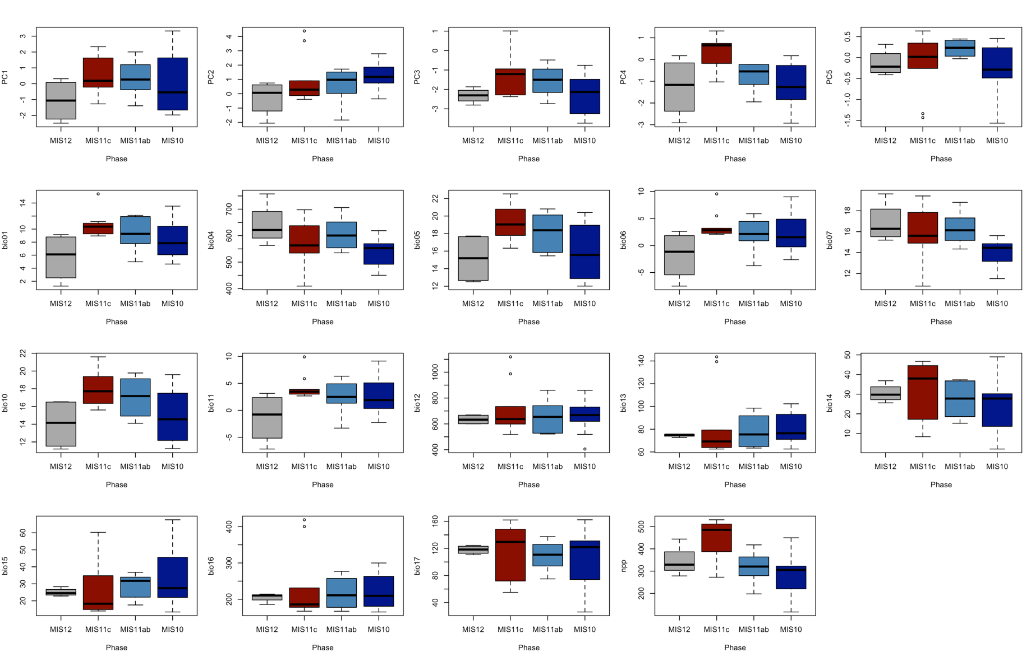
Supplementary Figure S1. Boxplots of principal component (PCs) scores and individual bioclimatic variables for MIS 12, MIS 11c, MIS 11ab and MIS 10 (see Supplementary Table S5 for statistical tests of differences).

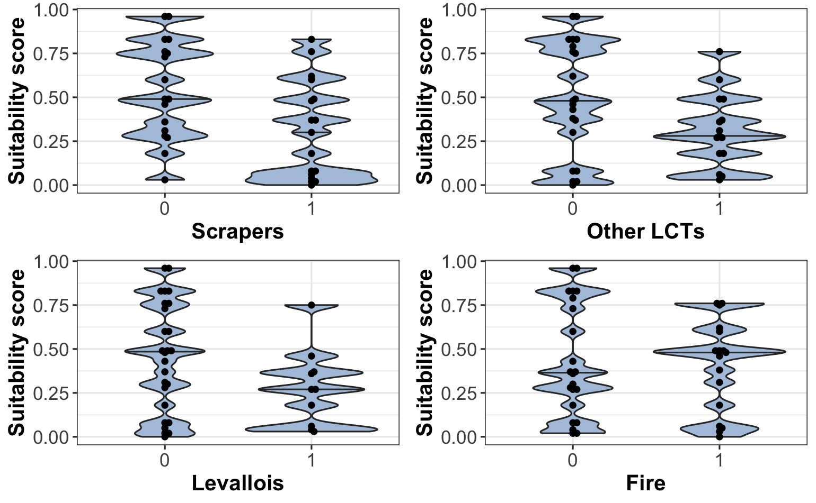
Supplementary Figure S2. Density plot showing the statistically significant relationship between suitability scores and the presence (1) and absence (0) of individual technologies.

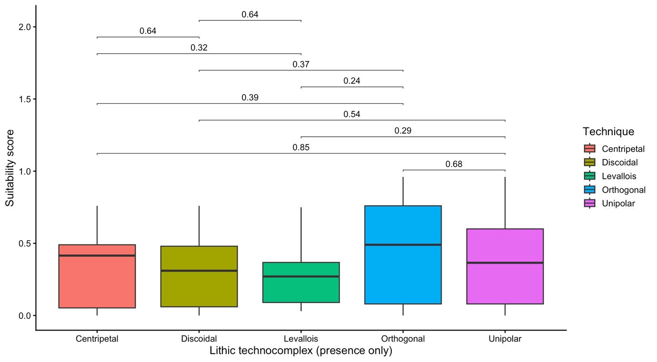
Supplementary Figure S3. Boxplots highlighting the suitability scores of assemblages with each technique present, as well as pairwise comparisons using Wilcoxon tests, highlighting that none are statistically significant. Benjamini–Hochberg correction was used on the p-values.

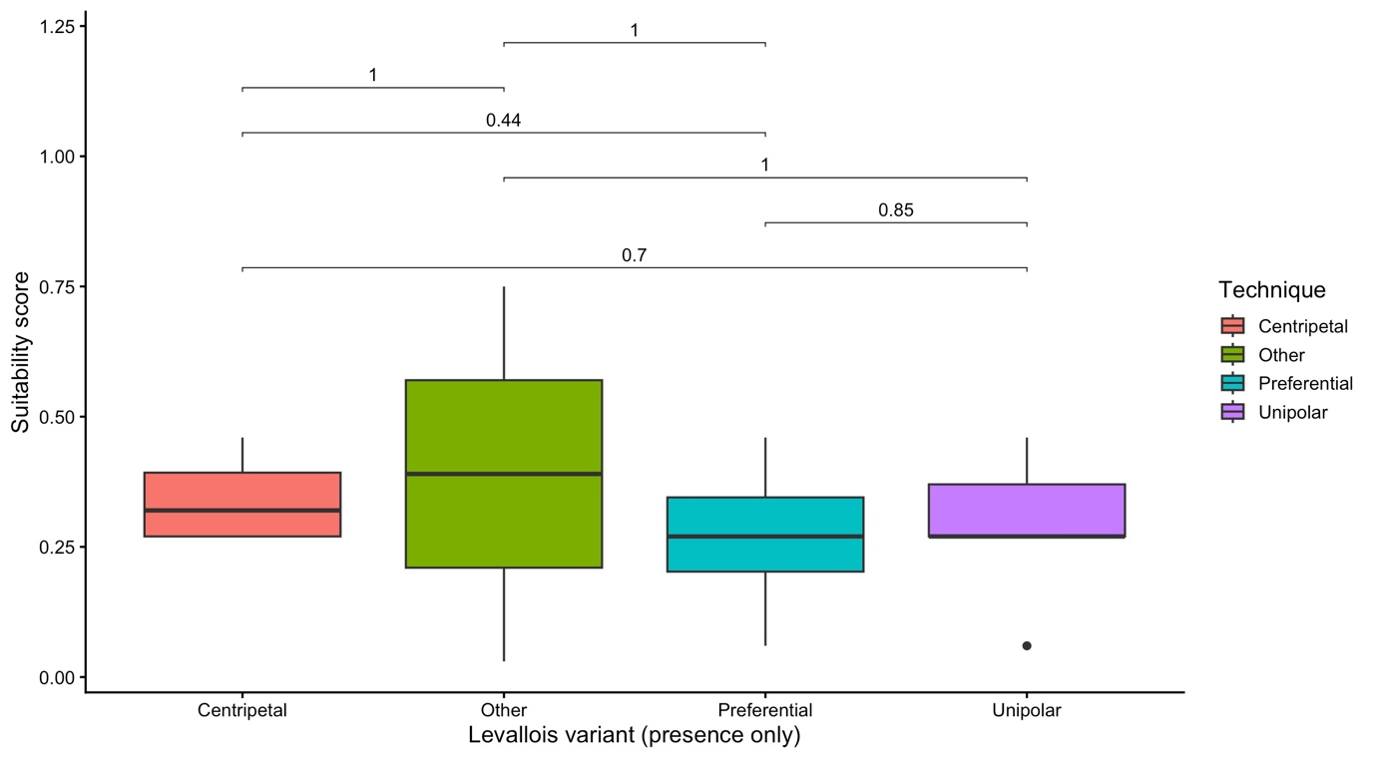
Supplementary Figure S4. Boxplots highlighting the suitability scores of assemblages with each Levallois type present, as well as pairwise comparisons using Wilcoxon tests, highlighting that none are statistically significant. Benjamini–Hochberg correction was used on the p-values.

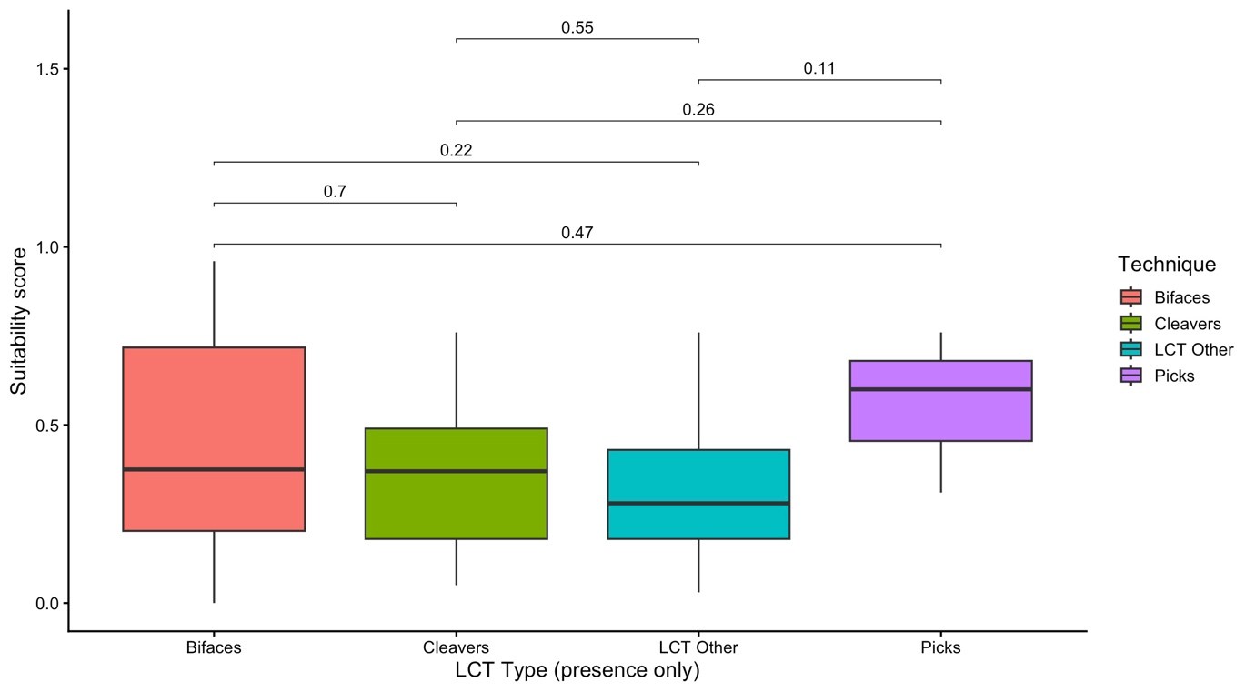
Supplementary Figure S5. Boxplots highlighting the suitability scores of assemblages with each LCT present, as well as p-values from pairwise comparisons using Wilcoxon tests, highlighting that none are statistically significant. Benjamini–Hochberg correction was used on the p-values.

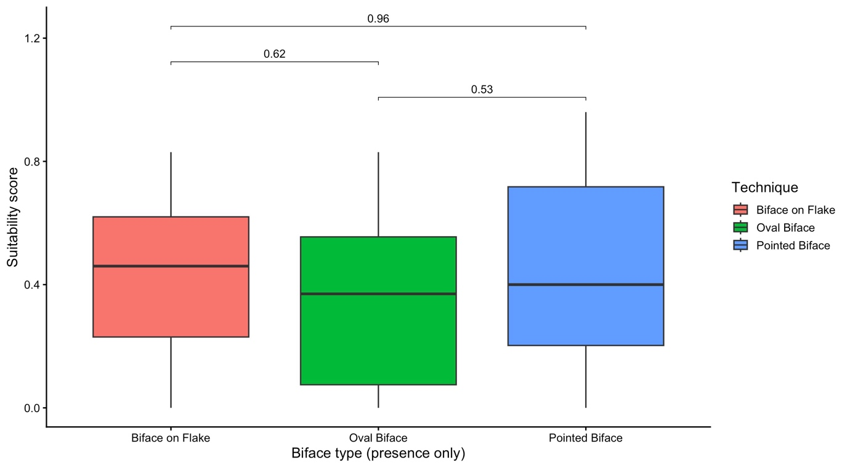
Supplementary Figure S6. Boxplots highlighting the suitability scores of assemblages with each biface type present, as well as p-values from pairwise comparisons using Wilcoxon tests, highlighting that none are statistically significant. Benjamini–Hochberg correction was used on the p-values.

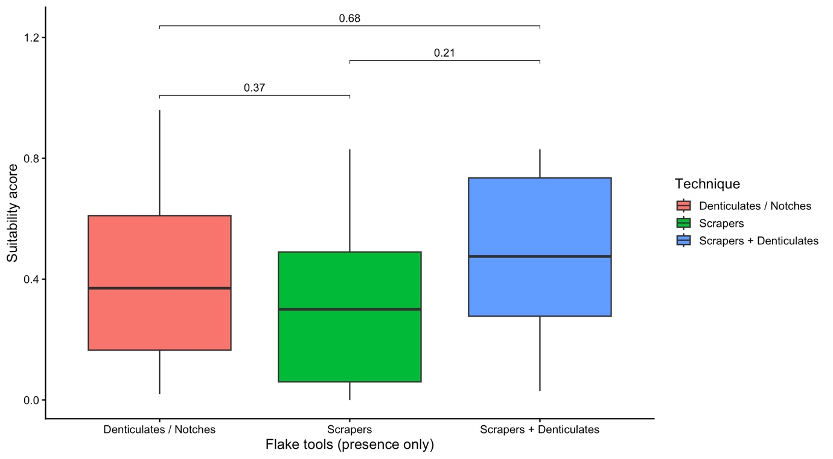
Supplementary Figure S7. Boxplots highlighting the suitability scores of assemblages with each flake tool category present, as well as p-values from pairwise comparisons using Wilcoxon tests, highlighting that none are statistically significant. Benjamini–Hochberg correction was used on the p-values.

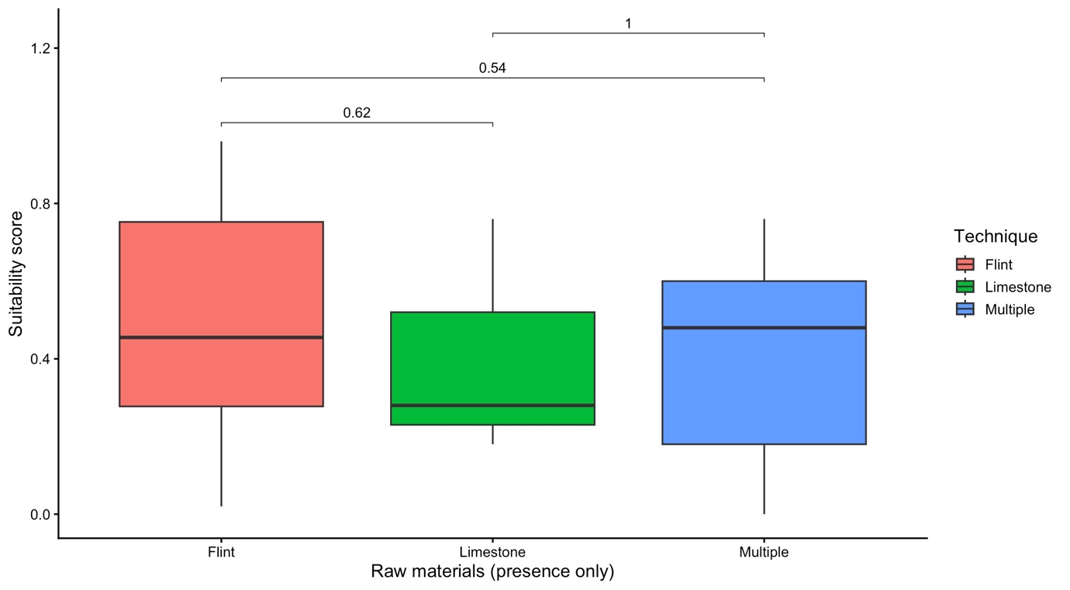
Supplementary Figure S8. Boxplots highlighting the suitability scores of assemblages with each raw material category, as well as p-values from pairwise comparisons using Wilcoxon tests, highlighting that flint and multiple raw materials show significant differences. Benjamini–Hochberg correction was used on the p-values.
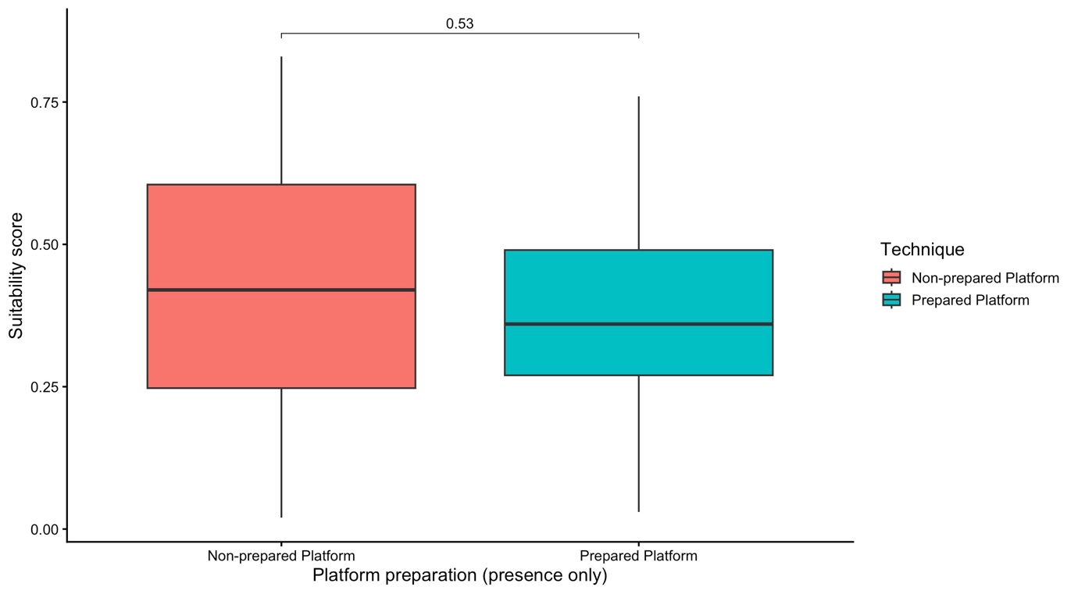
Supplementary Figure S9. Boxplots highlighting the suitability scores of assemblages with each raw material category, as well as p-values from pairwise comparisons using Wilcoxon tests, highlighting that none are statistically significant. Benjamini–Hochberg correction was used on the p-values.
​​

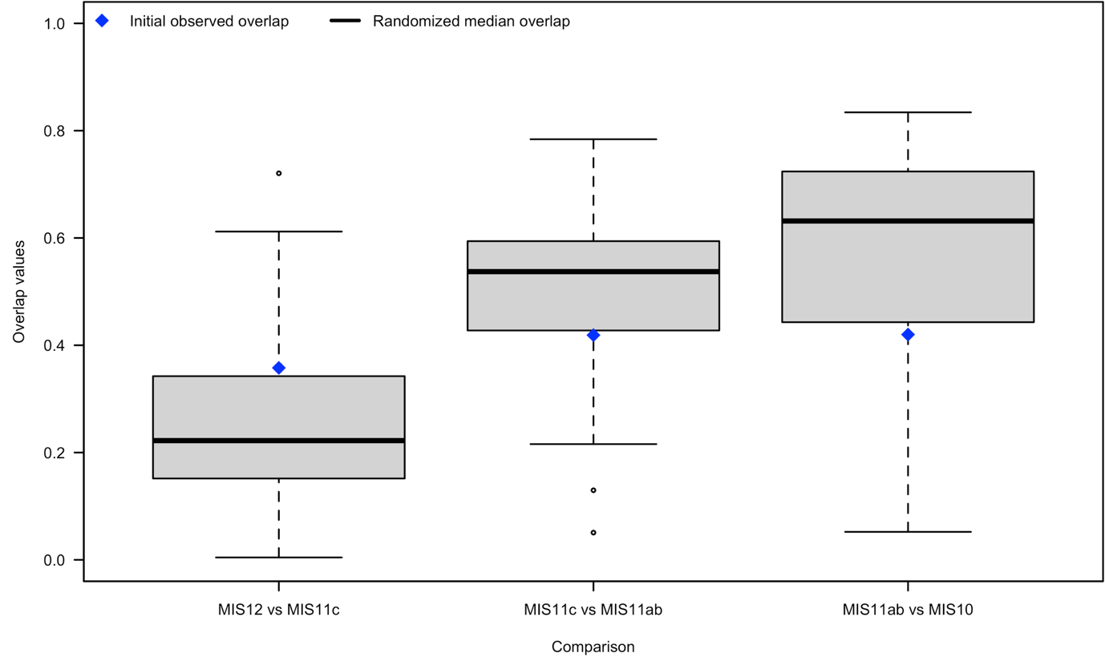
Supplementary Figure S10. Distribution of overlap values from the randomization procedure assigning occurrences to periods across 100 iterations, with the initial observed overlap in blue.

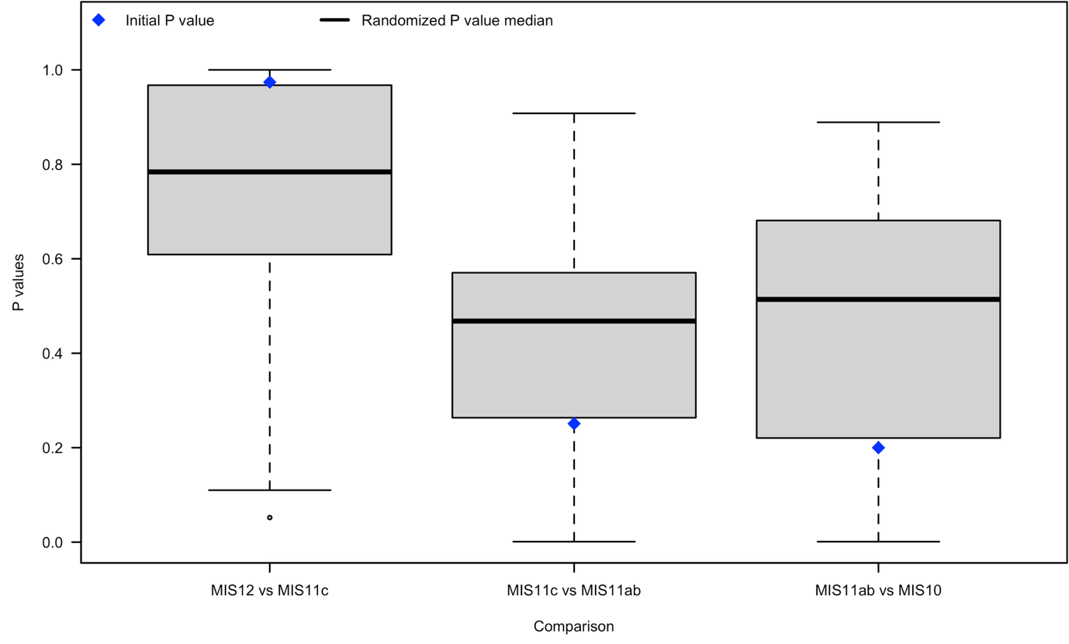
Supplementary Figure S11. Distribution of p-values from the randomization procedure assigning occurrences to periods across 100 iterations, with the initial observed p-value in blue.

