Supplementary Materials for
Multielement absorption-edge complementarity in liquid metal amalgams enables Pb-free, lightweight, and flexible X-ray shielding
Yunlong Bai^{a,b,c}, Li Liu^{d}, Zhaosen Yuan^{a,b,e}, Jun Su^{a,b,c}, Tangzhen Guan^{a,b,c}, Zhen Zhang^{a,b,c}, Yujing Liu^{f}, Minghui Guo^{a,b,c}, Jianbo Tang^{g*}, Wei Rao^{a,b,c*}

ªState Key Laboratory of Cryogenic Science and Technology, Technical Institute of Physics and Chemistry, Chinese Academy of Sciences, Beijing 100190, China
^{b}Beijing Key Lab of CryoBiomedical Engineering, Technical Institute of Physics and Chemistry, Chinese Academy of Sciences, Beijing 100190, China
^{c}School of Future Technology, University of Chinese Academy of Sciences, Beijing, 100049, China
^{d}School of Chemical and Biomolecular Engineering, University of Sydney, Sydney, New South Wales, 2008, Australia
^{e}School of Science, China University of Geosciences (Beijing), Beijing, 100083, China
^{f}School of Information Science and Technology, Beijing Forestry University, Beijing, China
^{g}Department of Materials Science and Engineering, School of Engineering and Research Centre for Industries of the Future, Westlake University, Hangzhou, Zhejiang, China
*Corresponding author. Email: jianbotang@westlake.edu.cn; weirao@mail.ipc.ac.cn
The PDF file includes:
Supplementary Figs. 1 to 10
Supplementary Tables 1 to 9
References
Supplementary Fig. 1 | X-ray shielding characteristics of different metallic elements. a, Variation of the mass attenuation coefficient of Ga metal at the K-absorption edge resonance. b, Relationship between the number of absorption edges and atomic number. c, Selection criteria for the 27-element metal in the LMA strain. ª Lethal dose less than 500 mg/kg. ^{b} Bismuth (Bi) exists in nature as the most stable isotope Bi-209, with a half-life of approximately 1.9×10¹⁹ years—far exceeding the age of the universe—and can thus be considered stable in conventional applications.

Supplementary Fig. 2 | Optimization of liquid metal amalgams for X-ray Shielding. a-c, The liquid metal amalgams (GaInSn)+M_{X}/N_{(1-X)} exhibits the following properties: (i), Photon distribution at the output surface. (ii), Transmissivity. Au and Pt (a), Ir (b), Os (c). Notes: the volume ratio between liquid metal and solid metal in the diagram remains constant at 1:1. The varying physical quantity is the mass ratio of different metals within the solid metal. The “Photon relative counting” here refers to the ratio of the total number of photons compared to the absence of any shielding material. Since different photon energies cause varying degrees of damage to the human body, air specific kinetic energy is selected instead of photon count as the basis for calculating transmissivity. x, X-ray energy spectrum at 100 kVp tube voltage for the reference radiation aluminum (Al) filter recommended by IEC 61331-2014. The “relative” refers to the total number of photons. y, Solid-state metallic elements exhibit near-normal distribution. The horizontal axis represents atomic number, while the vertical axis shows mass percentage.
Supplementary Fig. 2 (continued) | Re (d), Rh (e), W (f), Pd (g), Ta (h), Hf (i).
Supplementary Fig. 2 (continued) | Lu (j), Yb (k), Tm (l), Bi (m), Ag (n), Er (o).
Supplementary Fig. 2 (continued) | Ho (p), Dy (q), Tb (r), Gd (s), Sm (t), Nd (u).
Supplementary Fig. 2 (continued) | La (v), Pr (w).

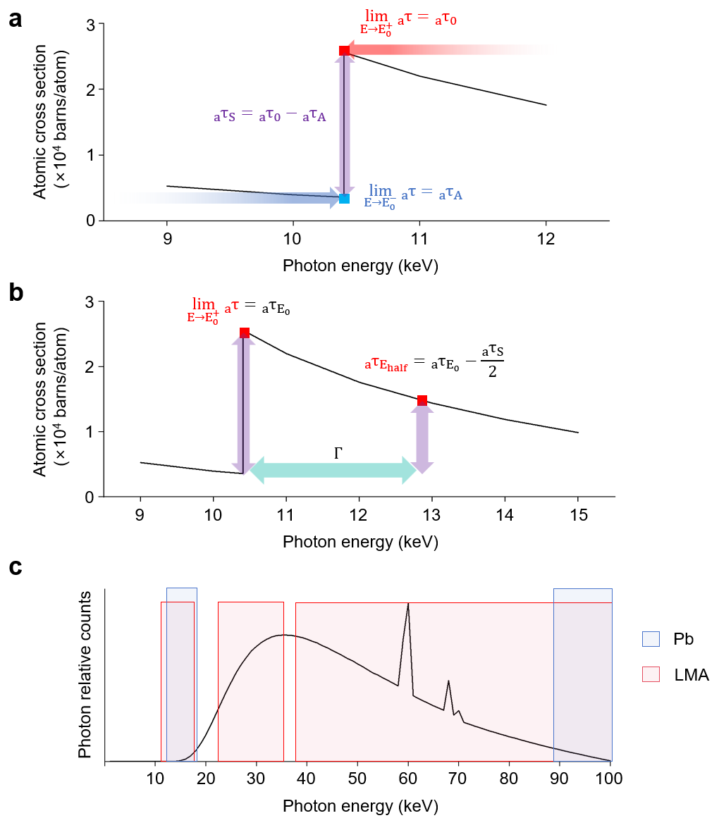
Supplementary Fig. 3 | Patterns of change in the atomic cross section for absorption at edge resonance levels. a, Classification basis for photoelectric effect atomic cross sections. b, Resonant energy level range of the absorption edge based on the Breit-Wigner formula. c, Comparison of the actual energy coverage ranges corresponding to different absorption edges for Pb (containing a total of 9 resonance absorption edges) and LMA (containing a total of 208 absorption edges). Notes: 1. Each absorption edge does not act at a single photon energy point, but rather significantly increases the material’s mass attenuation coefficient for X-rays over a continuous energy range near that point, thereby enhancing shielding effectiveness; The width and position of this influence range vary depending on the type of absorption edge (e.g., K, L, M, etc., shell levels) and the atomic number of the material. 2. Low-energy absorption edges below the 10 keV threshold are omitted because the proportion of incident photons in this energy range is too small.
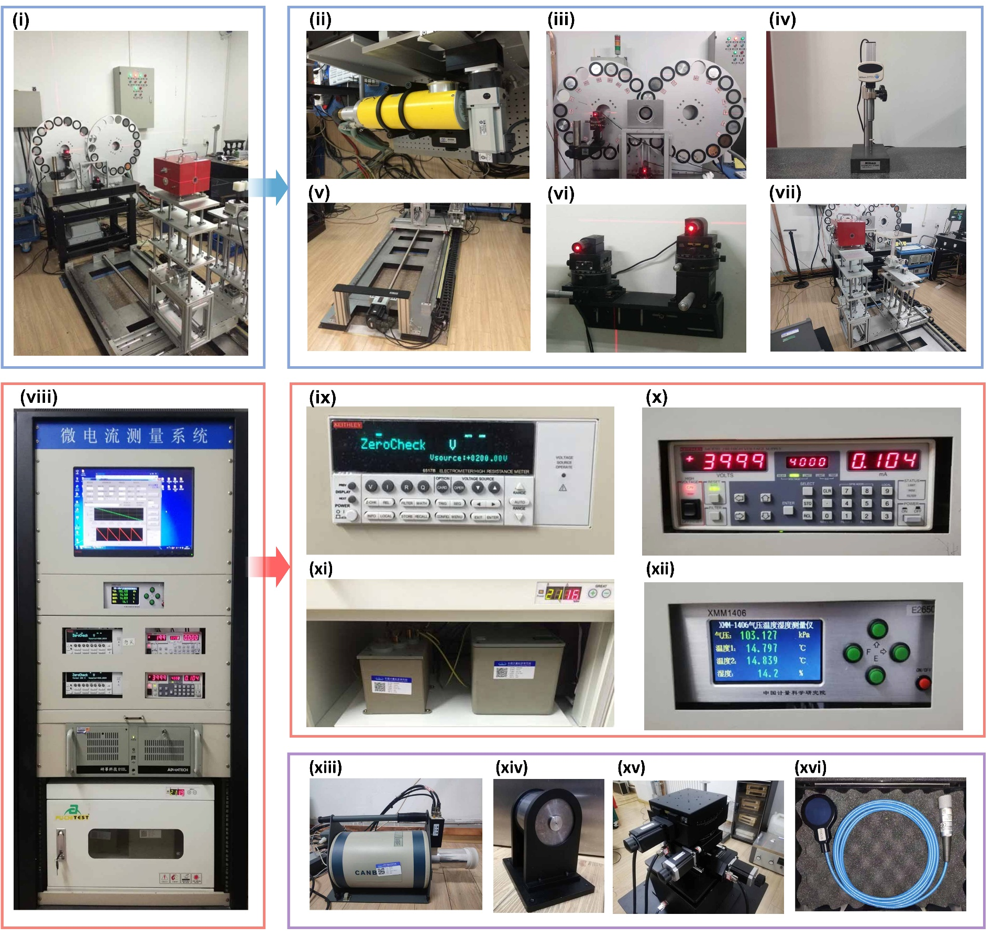
Supplementary Fig. 4 | Schematic and actual photos of air-relative kinetic energy testing. a, Schematic diagram of the narrow beam measurement method. X-ray transmission testing platform. b, Test equipment. (i) Physical diagram of low-energy X-Ray reference device; (ii) X-ray tube; (iii) Dual-disc filtration system for low-energy X-ray reference device; (iv) Nikon MFC 101 altimeter; (v) Mobile guide rail for low-energy X-ray reference device; (vi) Stage for low-energy X-ray reference device; (vii) Laser positioning system; (viii) Microcurrent measurement system; (ix) Keithley 6517B electrometer; (x) Keithley 248 high-voltage meter; (xi) High-precision standard capacitor; (xii) XMM-1406 barometric pressure, temperature, and humidity meter; (xiii) High-purity germanium detector; (xiv) Tungsten alloy sleeve aperture; (xv) Four-axis alignment stage; (xvi) TW 34069 flat-panel ionization chamber.
Supplementary Fig. 5 | Comparison of mass attenuation coefficient between mainly liquid metal elements (Ga, In, Sn) and organic elements (C, H, O).
Supplementary Fig. 6 | Photon distribution at the output surface of LM+Bi_{X}W _{(1-X)}, where X denotes the mass fraction and the gradient is 0.1. The volume ratio of liquid metal to solid metal is 1:1, and the selection of liquid metal is consistent with Fig. 1c(ii).

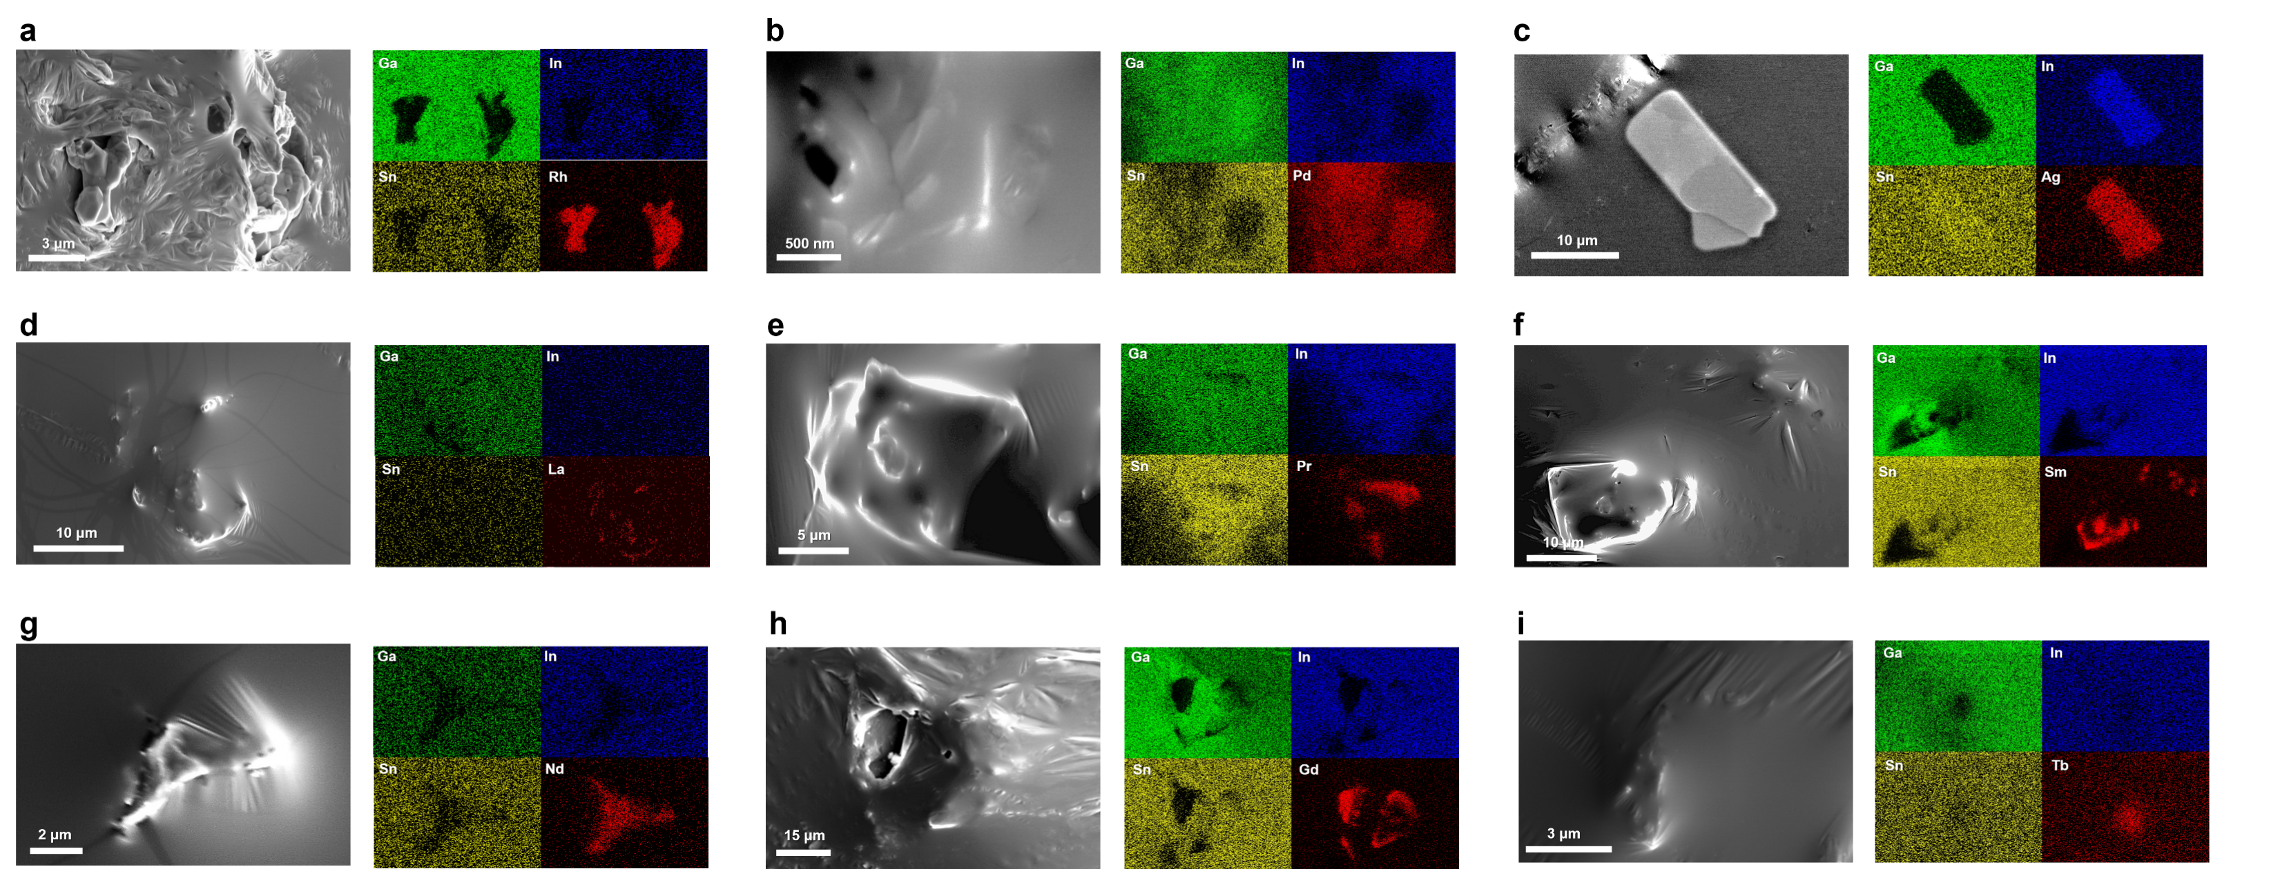
Supplementary Fig. 7 | a-l, SEM images and elemental surface distribution analysis of liquid metal (Ga-In-Sn ternary) after grinding with solid metal powder. Rh (a), Pd (b), Ag (c), La (d), Pr (e), Nd (f), Sm (g), Gd (h), Tb (i). The scale bar indicated in the figure.
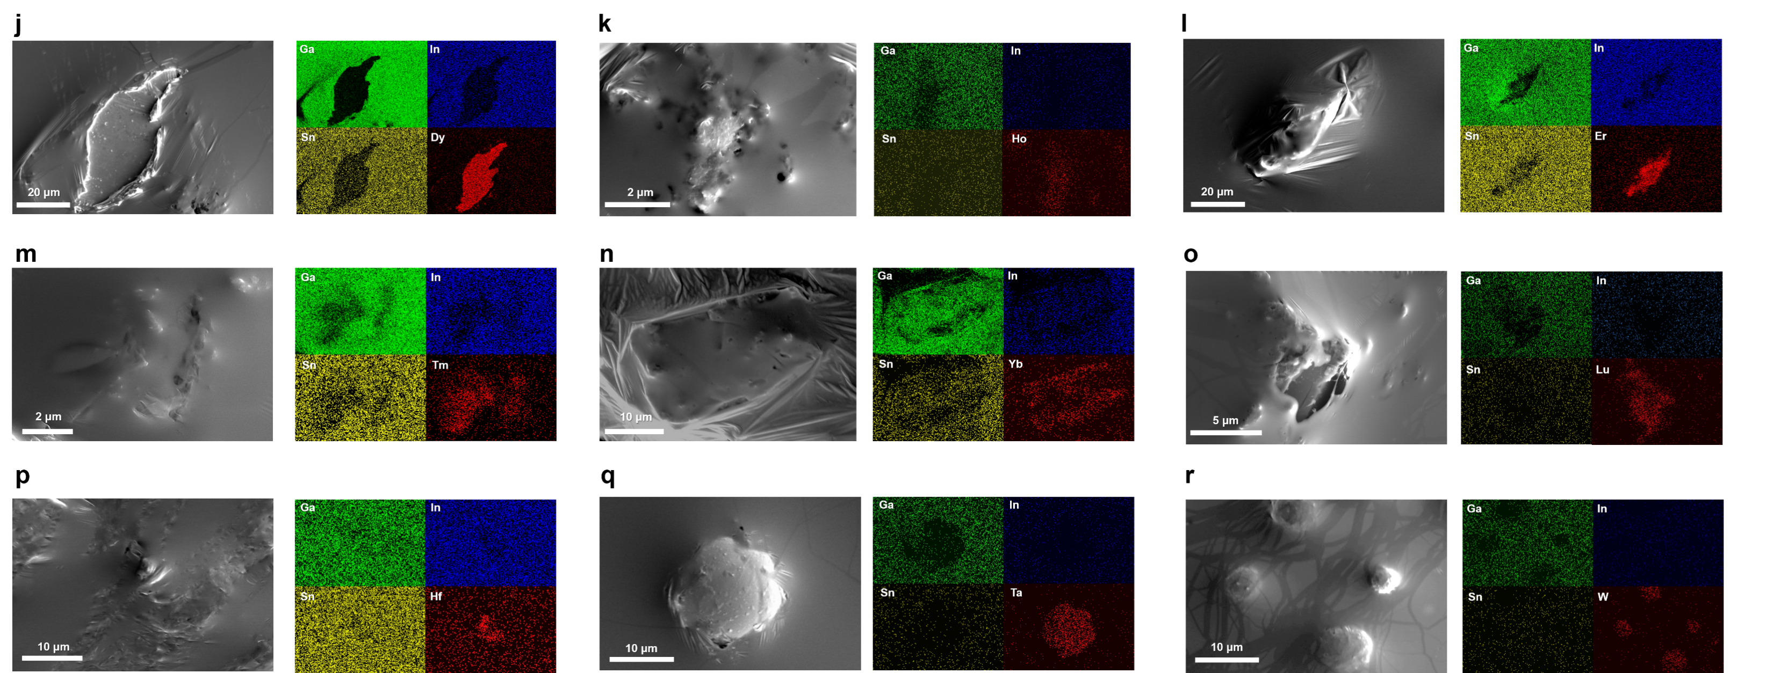
Supplementary Fig. 7 (continued) | Dy (j), Ho (k), Er (l), Tm (m), Yb (n), Hf (o), Lu (p), Ta (q), W (r).
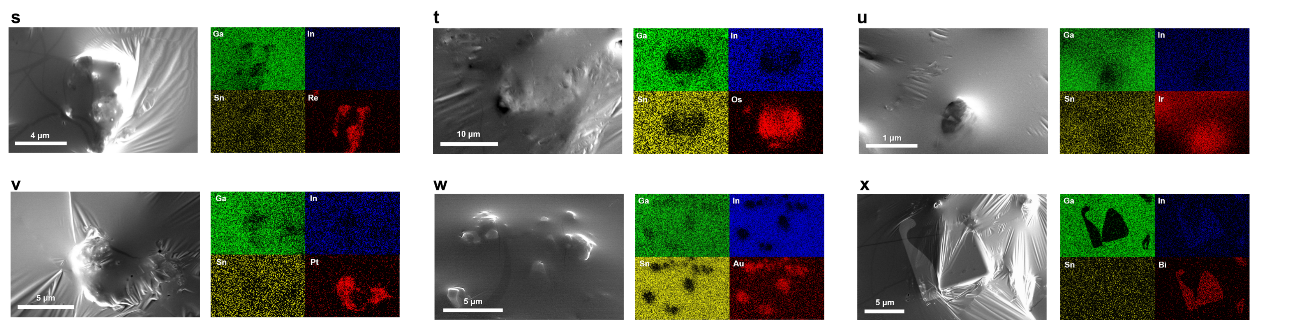
Supplementary Fig. 7 (continued) | Re (s), Os (t), Ir (u), Pt (v), Au (w), Bi (x).
Supplementary Fig. 8 | Characterization tests for LMA. a, EDS test results for LMA composed of 27 metallic elements. Note: Signals in the range below 0.08825 keV were omitted due to excessive intensity, and signals in the range above 10 keV were omitted due to insufficient intensity. The vertical axis is on a logarithmic scale. Since the liquid metal covers the surface of the solid metal, the proportion of liquid metal is relatively high. b, The XRD test result for LMA composed of 27 metallic elements. (i) A photograph showing a layer of liquid paraffin applied in advance under oxygen-free conditions prior to testing to prevent oxidation of certain metals. Note: Since liquids do not have a crystalline structure, liquid metals are indicated by the orange-shaded areas, and liquid paraffin is indicated by the green-shaded areas.
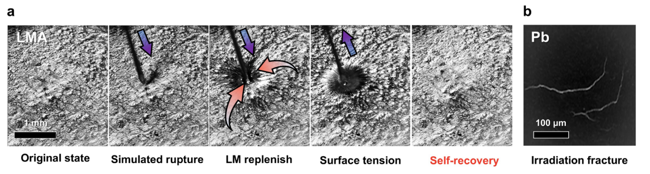
Supplementary Fig. 9 | Analysis of irradiation cracking. a, Puncture-induced irradiation cracking on simulated surfaces and the self-healing process of LMA. b, SEM image of irradiation cracking in Pb.

Supplementary Fig. 10 | Validation of LMA's shielding performance in C57BL/6 mouse experiments. a, Relative DNA concentration in bone marrow. b, Cell viability c, Weight change. d, Assessment of small intestinal injury in C57BL/6 mice using H&E staining and TUNEL staining.
Supplementary Table 1 | The composition of the optimized LMA used in this study
 | Metallic element | Mass ratio (wt%)
Liquid metal matrix | Ga | 23.572
Liquid metal matrix | In | 13.669
Liquid metal matrix | Sn | 9.252
Solid metal | Pt | 0.006
Solid metal | Au | 0.023
Solid metal | Ir | 0.029
Solid metal | Os | 0.038
Solid metal | Re | 0.041
Solid metal | Rh | 0.034
Solid metal | W | 0.073
Solid metal | Pd | 0.105
Solid metal | Ta | 0.150
Solid metal | Hf | 0.214
Solid metal | Lu | 0.305
Solid metal | Yb | 0.436
Solid metal | Tm | 0.623
Solid metal | Bi | 0.231
Solid metal | Ag | 0.577
Solid metal | Er | 1.923
Solid metal | Ho | 2.060
Solid metal | Dy | 2.943
Solid metal | Tb | 6.541
Solid metal | Gd | 7.008
Solid metal | Sm | 10.012
Solid metal | Nd | 14.302
Solid metal | La | 5.297
Solid metal | Pr | 0.535
Supplementary Table 2 | Absorption edge resonance of LMA within the 1-100 keV X-ray energy range.
Resonance energy (keV) and element (absorption edge)
1.005 | Nd(M4) |  | 2.206 | Au(M5) |  | 2.206 | Au(M5) |  | 8.708 | Tb(L1)
1.08 | Sm(M5) |  | 2.263 | Lu(M2) |  | 2.263 | Lu(M2) |  | 8.918 | Ho(L2)
1.106 | Sm(M4) |  | 2.281 | W(M3) |  | 2.281 | W(M3) |  | 8.944 | Yb(L3)
1.115 | Ga(L3) |  | 2.291 | Au(M4) |  | 2.291 | Au(M4) |  | 9.046 | Dy(L1)
1.123 | La(M3) |  | 2.307 | Tm(M1) |  | 2.307 | Tm(M1) |  | 9.244 | Lu(L3)
1.142 | Ga(L2) |  | 2.365 | Hf(M2) |  | 2.365 | Hf(M2) |  | 9.264 | Er(L2)
1.185 | Gd(M5) |  | 2.367 | Re(M3) |  | 2.367 | Re(M3) |  | 9.394 | Ho(L1)
1.204 | La(M2) |  | 2.398 | Yb(M1) |  | 2.398 | Yb(M1) |  | 9.561 | Hf(L3)
1.217 | Gd(M4) |  | 2.457 | Os(M3) |  | 2.457 | Os(M3) |  | 9.617 | Tm(L2)
1.241 | Tb(M5) |  | 2.469 | Ta(M2) |  | 2.469 | Ta(M2) |  | 9.751 | Er(L1)
1.242 | Pr(M3) |  | 2.491 | Lu(M1) |  | 2.491 | Lu(M1) |  | 9.881 | Ta(L3)
1.275 | Tb(M4) |  | 2.551 | Ir(M3) |  | 2.551 | Ir(M3) |  | 9.978 | Yb(L2)
1.295 | Dy(M5) |  | 2.575 | W(M2) |  | 2.575 | W(M2) |  | 10.12 | Tm(L1)
1.297 | Nd(M3) |  | 2.58 | Bi(M5) |  | 2.58 | Bi(M5) |  | 10.21 | W(L3)
1.298 | Ga(L1) |  | 2.601 | Hf(M1) |  | 2.601 | Hf(M1) |  | 10.35 | Lu(L2)
1.333 | Dy(M4) |  | 2.645 | Pt(M3) |  | 2.645 | Pt(M3) |  | 10.37 | Ga(K)
1.337 | Pr(M2) |  | 2.682 | Re(M2) |  | 2.682 | Re(M2) |  | 10.49 | Yb(L1)
1.351 | Ho(M5) |  | 2.688 | Bi(M4) |  | 2.688 | Bi(M4) |  | 10.54 | Re(L3)
1.361 | La(M1) |  | 2.708 | Ta(M1) |  | 2.708 | Ta(M1) |  | 10.74 | Hf(L2)
1.392 | Ho(M4) |  | 2.743 | Au(M3) |  | 2.743 | Au(M3) |  | 10.87 | Lu(L1)
1.403 | Nd(M2) |  | 2.792 | Os(M2) |  | 2.792 | Os(M2) |  | 10.87 | Os(L3)
1.409 | Er(M5) |  | 2.82 | W(M1) |  | 2.82 | W(M1) |  | 11.14 | Ta(L2)
1.42 | Sm(M3) |  | 2.909 | Ir(M2) |  | 2.909 | Ir(M2) |  | 11.22 | Ir(L3)
1.453 | Er(M4) |  | 2.932 | Re(M1) |  | 2.932 | Re(M1) |  | 11.27 | Hf(L1)
1.468 | Tm(M5) |  | 3.004 | Rh(L3) |  | 3.004 | Rh(L3) |  | 11.54 | W(L2)
1.511 | Pr(M1) |  | 3.026 | Pt(M2) |  | 3.026 | Pt(M2) |  | 11.56 | Pt(L3)
1.515 | Tm(M4) |  | 3.049 | Os(M1) |  | 3.049 | Os(M1) |  | 11.68 | Ta(L1)
1.528 | Yb(M5) |  | 3.146 | Rh(L2) |  | 3.146 | Rh(L2) |  | 11.92 | Au(L3)
1.541 | Sm(M2) |  | 3.148 | Au(M2) |  | 3.148 | Au(M2) |  | 11.96 | Re(L2)
1.544 | Gd(M3) |  | 3.173 | Ru(L3) |  | 3.173 | Ru(L3) |  | 12.1 | W(L1)
1.575 | Nd(M1) |  | 3.174 | Ir(M1) |  | 3.174 | Ir(M1) |  | 12.38 | Os(L2)
1.576 | Yb(M4) |  | 3.177 | Bi(M3) |  | 3.177 | Bi(M3) |  | 12.53 | Re(L1)
1.588 | Lu(M5) |  | 3.296 | Pt(M1) |  | 3.296 | Pt(M1) |  | 12.82 | Ir(L2)
1.611 | Tb(M3) |  | 3.33 | Ru(L2) |  | 3.33 | Ru(L2) |  | 12.97 | Os(L1)
1.639 | Lu(M4) |  | 3.341 | Rh(L1) |  | 3.341 | Rh(L1) |  | 13.27 | Pt(L2)
1.662 | Hf(M5) |  | 3.351 | Ag(L3) |  | 3.351 | Ag(L3) |  | 13.42 | Ir(L1)
1.676 | Dy(M3) |  | 3.425 | Au(M1) |  | 3.425 | Au(M1) |  | 13.42 | Bi(L3)
1.688 | Gd(M2) |  | 3.524 | Ag(L2) |  | 3.524 | Ag(L2) |  | 13.73 | Au(L2)
1.716 | Hf(M4) |  | 3.604 | Ru(L1) |  | 3.604 | Ru(L1) |  | 13.88 | Pt(L1)
1.723 | Sm(M1) |  | 3.696 | Bi(M2) |  | 3.696 | Bi(M2) |  | 14.35 | Au(L1)
1.735 | Ta(M5) |  | 3.73 | In(L3) |  | 3.73 | In(L3) |  | 15.71 | Bi(L2)
1.741 | Ho(M3) |  | 3.806 | Ag(L1) |  | 3.806 | Ag(L1) |  | 16.39 | Bi(L1)
1.768 | Tb(M2) |  | 3.929 | Sn(L3) |  | 3.929 | Sn(L3) |  | 23.22 | Rh(K)
1.793 | Ta(M4) |  | 3.938 | In(L2) |  | 3.938 | In(L2) |  | 24.35 | Ru(K)
1.809 | W(M5) |  | 3.999 | Bi(M1) |  | 3.999 | Bi(M1) |  | 25.51 | Ag(K)
1.812 | Er(M3) |  | 4.156 | Sn(L2) |  | 4.156 | Sn(L2) |  | 27.94 | In(K)
1.823 | Re(M5) |  | 4.238 | In(L1) |  | 4.238 | In(L1) |  | 29.2 | Sn(K)
1.842 | Dy(M2) |  | 4.465 | Sn(L1) |  | 4.465 | Sn(L1) |  | 38.92 | La(K)
1.872 | W(M4) |  | 5.483 | La(L3) |  | 5.483 | La(L3) |  | 41.99 | Pr(K)
1.881 | Gd(M1) |  | 5.891 | La(L2) |  | 5.891 | La(L2) |  | 43.57 | Nd(K)
1.885 | Tm(M3) |  | 5.964 | Pr(L3) |  | 5.964 | Pr(L3) |  | 46.83 | Sm(K)
1.923 | Ho(M2) |  | 6.208 | Nd(L3) |  | 6.208 | Nd(L3) |  | 50.24 | Gd(K)
1.949 | Re(M4) |  | 6.266 | La(L1) |  | 6.266 | La(L1) |  | 52 | Tb(K)
1.95 | Yb(M3) |  | 6.44 | Pr(L2) |  | 6.44 | Pr(L2) |  | 53.79 | Dy(K)
1.96 | Os(M5) |  | 6.716 | Sm(L3) |  | 6.716 | Sm(L3) |  | 55.62 | Ho(K)
1.967 | Tb(M1) |  | 6.721 | Nd(L2) |  | 6.721 | Nd(L2) |  | 57.49 | Er(K)
2.006 | Er(M2) |  | 6.835 | Pr(L1) |  | 6.835 | Pr(L1) |  | 59.39 | Tm(K)
2.024 | Lu(M3) |  | 7.126 | Nd(L1) |  | 7.126 | Nd(L1) |  | 61.33 | Yb(K)
2.031 | Os(M4) |  | 7.243 | Gd(L3) |  | 7.243 | Gd(L3) |  | 63.31 | Lu(K)
2.04 | Ir(M5) |  | 7.312 | Sm(L2) |  | 7.312 | Sm(L2) |  | 65.35 | Hf(K)
2.047 | Dy(M1) |  | 7.514 | Tb(L3) |  | 7.514 | Tb(L3) |  | 67.42 | Ta(K)
2.09 | Tm(M2) |  | 7.737 | Sm(L1) |  | 7.737 | Sm(L1) |  | 69.53 | W(K)
2.108 | Hf(M3) |  | 7.79 | Dy(L3) |  | 7.79 | Dy(L3) |  | 71.68 | Re(K)
2.116 | Ir(M4) |  | 7.93 | Gd(L2) |  | 7.93 | Gd(L2) |  | 73.87 | Os(K)
2.122 | Pt(M5) |  | 8.071 | Ho(L3) |  | 8.071 | Ho(L3) |  | 76.11 | Ir(K)
2.128 | Ho(M1) |  | 8.252 | Tb(L2) |  | 8.252 | Tb(L2) |  | 78.39 | Pt(K)
2.173 | Yb(M2) |  | 8.358 | Er(L3) |  | 8.358 | Er(L3) |  | 80.72 | Au(K)
2.194 | Ta(M3) |  | 8.376 | Gd(L1) |  | 8.376 | Gd(L1) |  | 90.53 | Bi(K)
2.202 | Pt(M4) |  | 8.581 | Dy(L2) |  | 8.581 | Dy(L2)
2.206 | Er(M1) |  | 2.206 | Er(M1) |  | 8.648 | Tm(L3)
Total absorption edge resonance counts: 208
Supplementary Table 3 | Absorption edge resonance of Pb within the 1-100 keV X-ray energy range.
Resonance energy (keV) | Absorption edge
2.484 | M5
2.586 | M4
3.066 | M3
3.554 | M2
3.851 | M1
13.04 | L3
15.20 | L2
15.86 | L1
88.00 | K
Total absorption edge resonance counts: 9

Supplementary Table 4 | Range of Influence of Energy Levels at the Absorption Edges of Different Elements in LMA.
Atomic Number | Element | Absorption Edge | Resonance Energy | Pre-resonance atomic cross section | Post-resonance atomic cross section | Atomic cross-section difference before and after resonance | Atomic cross section reduced by half the difference | The corresponding energy levels of the atomic cross section with a half reduction in the difference
31 | Ga | K | 10.37 | 3589 | 25630 | 22041 | 14609.5 | 12.92
45 | Rh | K | 23.22 | 1843 | 10960 | 9117 | 6401.5 | 28.65
46 | Pd | K | 24.35 | 1772 | 10430 | 8658 | 6101 | 30.04
47 | Ag | K | 25.51 | 1706 | 9922 | 8216 | 5814 | 31.45
49 | In | K | 27.94 | 1585 | 9023 | 7438 | 5304 | 34.38
50 | Sn | K | 29.2 | 1530 | 8592 | 7062 | 5061 | 36.19
57 | La | K | 38.92 | 1215 | 6395 | 5180 | 3805 | 47.52
59 | Pr | K | 41.99 | 1145 | 5891 | 4746 | 3518 | 51.2
60 | Nd | K | 43.57 | 1112 | 5663 | 4551 | 3387.5 | 53.08
62 | Sm | K | 46.83 | 1051 | 5243 | 4192 | 3147 | 57.08
64 | Gd | K | 50.24 | 995.4 | 4866 | 3870.6 | 2930.7 | 61.07
65 | Tb | K | 52 | 969.2 | 4688 | 3718.8 | 2828.6 | 63.14
66 | Dy | K | 53.79 | 944.3 | 4522 | 3577.7 | 2733.15 | 65.28
67 | Ho | K | 55.62 | 920.4 | 4360 | 3439.6 | 2640.2 | 67.59
68 | Er | K | 57.49 | 897.8 | 4204 | 3306.2 | 2550.9 | 70.01
69 | Tm | L1 | 10.12 | 77000 | 88840 | 11840 | 82920 | 10.39
69 | Tm | K | 59.39 | 875.8 | 4102 | 3226.2 | 2488.9 | 70.77
70 | Yb | L1 | 10.49 | 74040 | 85420 | 11380 | 79730 | 10.77
70 | Yb | K | 61.33 | 855 | 3923 | 3068 | 2389 | 74.44
71 | Lu | L2 | 10.35 | 58660 | 80120 | 21460 | 69390 | 11.61
71 | Lu | L1 | 10.87 | 71170 | 82100 | 10930 | 76635 | 11.17
71 | Lu | K | 63.31 | 835 | 3793 | 2958 | 2314 | 76.76
72 | Hf | L2 | 10.74 | 56150 | 76740 | 20590 | 66445 | 12.09
72 | Hf | L1 | 11.27 | 68330 | 78820 | 10490 | 73575 | 11.58
72 | Hf | K | 65.35 | 815.4 | 3665 | 2849.6 | 2240.2 | 79.13
73 | Ta | L2 | 11.14 | 53800 | 73590 | 19790 | 63695 | 12.5
73 | Ta | L1 | 11.68 | 65580 | 75640 | 10060 | 70610 | 12
73 | Ta | K | 67.42 | 796.9 | 3545 | 2748.1 | 2170.95 | 81.55
74 | W | L3 | 10.21 | 28090 | 71250 | 43160 | 49670 | 14.08
74 | W | L2 | 11.54 | 51550 | 70580 | 19030 | 61065 | 12.97
74 | W | L1 | 12.1 | 63050 | 72710 | 9660 | 67880 | 12.44
74 | W | K | 69.53 | 779 | 3429 | 2650 | 2104 | 84.02
75 | Re | L3 | 10.54 | 27390 | 69080 | 41690 | 48235 | 14.53
75 | Re | L2 | 11.96 | 49470 | 67780 | 18310 | 58625 | 13.44
75 | Re | L1 | 12.53 | 60640 | 69930 | 9290 | 65285 | 12.88
75 | Re | K | 71.68 | 762 | 3319 | 2557 | 2040.5 | 86.57
76 | Os | L3 | 10.87 | 26710 | 66980 | 40270 | 46845 | 14.98
76 | Os | L2 | 12.38 | 47480 | 65090 | 17610 | 56285 | 13.92
76 | Os | L1 | 12.97 | 58310 | 67240 | 8930 | 62775 | 13.31
76 | Os | K | 73.87 | 745.3 | 3209 | 2463.7 | 1977.15 | 89.33
77 | Ir | L3 | 11.22 | 26030 | 65050 | 39020 | 45540 | 15.41
77 | Ir | L2 | 12.82 | 45520 | 62550 | 17030 | 54035 | 14.41
77 | Ir | L1 | 13.42 | 56050 | 64620 | 8570 | 60335 | 13.79
77 | Ir | K | 76.11 | 729 | 3105 | 2376 | 1917 | 92.06
78 | Pt | L3 | 11.56 | 25410 | 63050 | 37640 | 44230 | 15.86
78 | Pt | L2 | 13.27 | 43710 | 60050 | 16340 | 51880 | 14.91
78 | Pt | L1 | 13.88 | 53970 | 62220 | 8250 | 58095 | 14.26
78 | Pt | K | 78.39 | 713.8 | 3039 | 2325.2 | 1876.4 | 93.38
79 | Au | L3 | 11.92 | 24800 | 61170 | 36370 | 42985 | 16.35
79 | Au | L2 | 13.73 | 41970 | 57710 | 15740 | 49840 | 15.48
79 | Au | L1 | 14.35 | 51950 | 59850 | 7900 | 55900 | 14.75
79 | Au | K | 80.72 | 698.8 | 2912 | 2213.2 | 1805.4 | 97.38
83 | Bi | L3 | 13.42 | 22520 | 54140 | 31620 | 38330 | 15.28
83 | Bi | L2 | 15.71 | 35630 | 49140 | 13510 | 42385 | 17.67
83 | Bi | L1 | 16.39 | 44500 | 51270 | 6770 | 47885 | 16.84
83 | Bi | K | 90.53 | 644.2 | 2561 | 1916.8 | 1602.6 | 109.1

Supplementary Table 5 | Range of Influence of Energy Levels at the Absorption Edges of Pb.
Atomic Number | Element | Absorption Edge | Resonance Energy | Pre-resonance atomic cross section | Post-resonance atomic cross section | Atomic cross-section difference before and after resonance | Atomic cross section reduced by half the difference | The corresponding energy levels of the atomic cross section with a half reduction in the difference
82 | Pb | L3 | 13.04 | 23050 | 55770 | 32720 | 39410 | 17.88
82 | Pb | L2 | 15.2 | 37080 | 51100 | 14020 | 44090 | 17.1
82 | Pb | L1 | 15.86 | 46230 | 53270 | 7040 | 49750 | 16.3
82 | Pb | K | 88 | 657.1 | 2644 | 1986.9 | 1650.5 | 105.9

Supplementary Table 6 | Comparison of LMA with existing flexible X-Ray shielding materials.
X-ray shielding metallic elements | Flexible elastomer | Thickness (cm) | Density (g/cm³) | Surface density (g/cm²) | Transmittance (%) | Blocking rate (%) | Lead equivalent (mmPb) | Linear attenuation coefficient (cm⁻¹) | Mass attenuation coefficient (cm²/g) | Thickness required for maximum protection standard (mm) | Mass required for maximum protection standard (g) | Ref.
Gd | NR | 1.000 | 1.10 | 1.100 | 58.500 | 41.500 | 0.020 | 0.54 | 0.49 | 246.413 | 27.105 | [47]
Gd | NR | 1.000 | 1.20 | 1.200 | 46.700 | 53.300 | 0.033 | 0.76 | 0.63 | 152.818 | 18.338 | [47]
Bi | PVC | 0.300 | 1.60 | 0.480 | 77.492 | 22.508 | 0.010 | 0.85 | 0.53 | 152.853 | 24.457 | [36]
Bi+W | TPV | 0.200 | 1.12 | 0.038 | 83.000 | 17.000 | 0.008 | 0.93 | 0.83 | 125.090 | 2.345 | [22]
Bi | PVC | 0.300 | 1.63 | 0.489 | 75.427 | 24.573 | 0.011 | 0.94 | 0.58 | 141.478 | 23.061 | [36]
W | TPV | 0.200 | 1.13 | 0.038 | 81.000 | 19.000 | 0.009 | 1.05 | 0.93 | 116.141 | 2.189 | [22]
Gd | NR | 0.200 | 1.19 | 0.238 | 80.816 | 19.184 | 0.120 | 1.07 | 0.89 | 8.333 | 0.992 | [41]
Ba | WPU | 1.200 | 1.40 | 1.680 | 26.080 | 73.920 | 0.085 | 1.12 | 0.80 | 70.846 | 9.918 | [39]
Bi | NR | 0.250 | 1.10 | 0.275 | 73.345 | 26.655 | 0.011 | 1.24 | 1.12 | 109.014 | 11.992 | [45]
Bi | PVC | 0.300 | 1.78 | 0.534 | 68.113 | 31.887 | 0.014 | 1.28 | 0.72 | 107.273 | 19.095 | [36]
Bi | PVC | 0.300 | 1.79 | 0.537 | 65.902 | 34.098 | 0.015 | 1.39 | 0.77 | 98.566 | 17.643 | [36]
Bi | NR | 0.250 | 1.22 | 0.305 | 70.469 | 29.531 | 0.013 | 1.40 | 1.12 | 97.779 | 11.929 | [45]
Gd | NR | 1.000 | 1.36 | 1.360 | 24.400 | 75.600 | 0.093 | 1.41 | 1.04 | 53.968 | 7.340 | [47]
Bi+W | TPV | 0.200 | 1.30 | 0.074 | 72.500 | 27.500 | 0.012 | 1.61 | 1.24 | 84.475 | 3.134 | [22]
Bi | PVC | 0.300 | 1.90 | 0.570 | 61.693 | 38.307 | 0.018 | 1.61 | 0.85 | 83.766 | 15.915 | [36]
Bi | NR | 0.250 | 1.31 | 0.328 | 64.888 | 35.112 | 0.016 | 1.73 | 1.32 | 78.998 | 10.349 | [45]
Ba | NR | 0.250 | 1.45 | 0.362 | 64.565 | 35.435 | 0.016 | 1.75 | 1.21 | 78.018 | 11.284 | [40]
Bi | PVC | 0.300 | 1.97 | 0.591 | 59.156 | 40.844 | 0.020 | 1.75 | 0.89 | 75.855 | 14.943 | [36]
Bi+W | TPV | 0.200 | 1.30 | 0.074 | 70.000 | 30.000 | 0.013 | 1.78 | 1.38 | 76.843 | 2.847 | [22]
Bi | PVC | 0.300 | 2.04 | 0.612 | 57.235 | 42.765 | 0.021 | 1.86 | 0.91 | 70.324 | 14.346 | [36]
Bi | NR | 0.100 | 1.52 | 0.152 | 83.000 | 17.000 | 0.070 | 1.86 | 1.23 | 7.143 | 1.086 | [42]
Gd | NR | 0.200 | 1.35 | 0.270 | 68.660 | 31.340 | 0.220 | 1.88 | 1.39 | 4.545 | 0.614 | [41]
Bi | PDMS | 0.610 | 2.10 | 1.281 | 31.000 | 69.000 | 0.066 | 1.92 | 0.91 | 46.178 | 9.697 | [30]
Bi | PDMS | 0.610 | 1.88 | 1.147 | 31.000 | 69.000 | 0.066 | 1.92 | 1.02 | 46.178 | 8.681 | [29]
Bi | PVA | 0.055 | 3.05 | 0.168 | 89.776 | 10.224 | 0.006 | 1.96 | 0.64 | 44.169 | 13.472 | [34]
Bi | PDMS | 0.800 | 1.88 | 1.504 | 20.400 | 79.600 | 0.116 | 1.99 | 1.06 | 34.409 | 6.469 | [29]
Gd | PU | 0.500 | 1.43 | 0.715 | 36.935 | 63.065 | 0.050 | 1.99 | 1.39 | 50.000 | 7.150 | [32]
Bi | ER | 0.064 | 1.80 | 0.114 | 87.940 | 12.060 | 0.007 | 2.02 | 1.10 | 47.741 | 8.593 | [33]
Pb | PVA | 0.053 | 2.64 | 0.140 | 89.666 | 10.334 | 0.006 | 2.06 | 0.78 | 42.392 | 11.192 | [34]
Gd | NR | 1.000 | 1.46 | 1.460 | 12.700 | 87.300 | 0.195 | 2.06 | 1.41 | 25.684 | 3.750 | [47]
Bi | PVC | 0.300 | 2.09 | 0.627 | 53.100 | 46.900 | 0.025 | 2.11 | 1.01 | 59.616 | 12.460 | [36]
Pb | PVA | 0.049 | 3.15 | 0.154 | 90.102 | 9.898 | 0.006 | 2.13 | 0.68 | 39.826 | 12.545 | [34]
Gd | PVA | 0.056 | 2.68 | 0.150 | 88.453 | 11.547 | 0.007 | 2.19 | 0.82 | 42.838 | 11.481 | [34]
Gd | PU | 0.500 | 1.46 | 0.730 | 33.000 | 67.000 | 0.060 | 2.22 | 1.52 | 41.667 | 6.083 | [32]
Ce | PDMS | 0.108 | 1.51 | 0.162 | 78.427 | 21.573 | 0.009 | 2.26 | 1.50 | 56.758 | 8.548 | [31]
Pb | PVA | 0.055 | 3.66 | 0.201 | 88.161 | 11.839 | 0.007 | 2.29 | 0.63 | 41.623 | 15.234 | [34]
Bi | PVC | 0.300 | 1.55 | 0.465 | 50.015 | 49.985 | 0.029 | 2.31 | 1.49 | 52.589 | 8.151 | [35]
Bi | PVC | 0.350 | 1.20 | 0.420 | 44.087 | 55.913 | 0.037 | 2.34 | 1.95 | 47.902 | 5.748 | [35]
Bi+W | TPV | 0.200 | 1.48 | 0.111 | 62.500 | 37.500 | 0.017 | 2.35 | 1.59 | 57.623 | 3.192 | [22]
Pb | PVA | 0.058 | 2.12 | 0.123 | 87.238 | 12.762 | 0.007 | 2.35 | 1.11 | 42.426 | 8.994 | [34]
Bi | PDMS | 0.820 | 2.66 | 2.181 | 14.500 | 85.500 | 0.170 | 2.35 | 0.89 | 24.062 | 6.400 | [29]
Gd | PU | 0.500 | 1.56 | 0.780 | 29.816 | 70.184 | 0.070 | 2.42 | 1.55 | 35.714 | 5.571 | [32]
Bi | NR | 0.250 | 1.31 | 0.328 | 53.660 | 46.340 | 0.025 | 2.49 | 1.88 | 50.814 | 6.657 | [45]
Bi | PDMS | 0.870 | 2.20 | 1.914 | 11.200 | 88.800 | 0.219 | 2.52 | 1.14 | 19.832 | 4.363 | [28]
Bi+W | TPV | 0.200 | 1.47 | 0.110 | 60.000 | 40.000 | 0.019 | 2.55 | 1.74 | 52.273 | 2.872 | [22]
Bi | PDMS | 0.200 | 1.88 | 0.376 | 59.900 | 40.100 | 0.019 | 2.56 | 1.36 | 52.068 | 9.789 | [29]
Ba | NR | 0.250 | 1.71 | 0.428 | 51.299 | 48.701 | 0.027 | 2.67 | 1.56 | 46.184 | 7.905 | [40]
Ba | WPU | 1.200 | 1.91 | 2.298 | 3.916 | 96.084 | 0.473 | 2.70 | 1.41 | 12.690 | 2.430 | [39]
Bi | PVA-PVP | 0.100 | 1.32 | 0.132 | 76.192 | 23.808 | 0.030 | 2.72 | 2.06 | 16.667 | 2.200 | [37]
Bi | NR | 0.500 | 2.34 | 1.170 | 25.000 | 75.000 | 0.090 | 2.77 | 1.18 | 27.872 | 6.522 | [43]
Bi | PDMS | 0.620 | 2.89 | 1.792 | 17.300 | 82.700 | 0.141 | 2.83 | 0.98 | 22.005 | 6.359 | [30]
Bi | PDMS | 0.620 | 2.66 | 1.649 | 17.300 | 82.700 | 0.141 | 2.83 | 1.06 | 22.005 | 5.853 | [29]
Bi | PDMS | 0.640 | 2.20 | 1.408 | 15.900 | 84.100 | 0.155 | 2.87 | 1.31 | 20.701 | 4.554 | [28]
Bi+W | TPV | 0.200 | 1.64 | 0.146 | 55.000 | 45.000 | 0.023 | 2.99 | 1.82 | 42.894 | 3.131 | [22]
Gd | NR | 1.000 | 1.51 | 1.510 | 4.700 | 95.300 | 0.425 | 3.06 | 2.02 | 11.763 | 1.776 | [47]
Bi | NR | 0.100 | 2.08 | 0.208 | 73.000 | 27.000 | 0.130 | 3.15 | 1.51 | 3.846 | 0.800 | [42]
Bi | NR | 0.250 | 1.58 | 0.395 | 45.498 | 54.502 | 0.034 | 3.15 | 1.98 | 36.324 | 5.739 | [45]
Ce | PDMS | 0.102 | 1.17 | 0.119 | 71.663 | 28.337 | 0.012 | 3.28 | 2.80 | 41.585 | 4.870 | [31]
Bi | NR | 0.250 | 1.92 | 0.480 | 43.387 | 56.613 | 0.038 | 3.34 | 1.74 | 33.208 | 6.376 | [45]
W | PDMS | 0.110 | 1.65 | 0.181 | 68.379 | 31.621 | 0.014 | 3.47 | 2.10 | 39.626 | 6.538 | [31]
Bi+W | TPV | 0.200 | 1.62 | 0.144 | 50.000 | 50.000 | 0.029 | 3.47 | 2.14 | 35.038 | 2.524 | [22]
Ce | PDMS | 0.103 | 1.29 | 0.133 | 69.830 | 30.170 | 0.013 | 3.47 | 2.70 | 39.450 | 5.077 | [31]
Gd | PU | 0.500 | 1.44 | 0.720 | 17.397 | 82.603 | 0.140 | 3.50 | 2.43 | 17.857 | 2.571 | [32]
W | PVC | 0.190 | 1.28 | 0.243 | 49.157 | 50.843 | 0.030 | 3.74 | 2.92 | 32.153 | 4.116 | [35]
Gd | PU | 0.500 | 1.56 | 0.780 | 15.397 | 84.603 | 0.160 | 3.74 | 2.40 | 15.625 | 2.438 | [32]
Bi+W | TPV | 0.200 | 1.79 | 0.179 | 47.000 | 53.000 | 0.032 | 3.78 | 2.11 | 30.949 | 2.764 | [22]
Bi | PDMS | 0.840 | 4.55 | 3.822 | 3.600 | 96.400 | 0.495 | 3.96 | 0.87 | 8.486 | 3.861 | [29]
Ba | WPU | 1.200 | 2.58 | 3.097 | 0.823 | 99.177 | 0.816 | 4.00 | 1.55 | 7.353 | 1.897 | [39]
Bi+W | TPV | 0.200 | 1.78 | 0.178 | 44.000 | 56.000 | 0.037 | 4.10 | 2.31 | 27.271 | 2.428 | [22]
Bi | PDMS | 0.200 | 2.66 | 0.532 | 42.900 | 57.100 | 0.038 | 4.23 | 1.59 | 26.017 | 6.921 | [29]
W | PDMS | 0.105 | 1.37 | 0.143 | 64.191 | 35.809 | 0.016 | 4.23 | 3.10 | 32.226 | 4.399 | [31]
Bi | NR | 0.250 | 1.85 | 0.463 | 33.875 | 66.125 | 0.058 | 4.33 | 2.29 | 21.711 | 4.017 | [45]
Bi | PVA-PVP | 0.100 | 1.41 | 0.141 | 64.682 | 35.318 | 0.050 | 4.36 | 3.09 | 10.000 | 1.410 | [37]
W | PVC | 0.160 | 1.15 | 0.184 | 49.790 | 50.210 | 0.029 | 4.36 | 3.79 | 27.790 | 3.196 | [35]
Bi | PDMS | 0.630 | 3.67 | 2.312 | 5.800 | 94.200 | 0.371 | 4.52 | 1.23 | 8.491 | 3.116 | [30]
Bi | PDMS | 0.630 | 4.55 | 2.867 | 5.800 | 94.200 | 0.371 | 4.52 | 0.99 | 8.491 | 3.863 | [29]
Bi | PDMS | 0.210 | 2.20 | 0.462 | 37.800 | 62.200 | 0.048 | 4.63 | 2.11 | 21.836 | 4.804 | [28]
Bi | NR | 0.100 | 2.61 | 0.261 | 62.000 | 38.000 | 0.190 | 4.78 | 1.83 | 2.632 | 0.687 | [42]
W | PDMS | 0.101 | 1.21 | 0.123 | 61.291 | 38.709 | 0.018 | 4.82 | 3.98 | 27.896 | 3.381 | [31]
Bi | NR | 0.250 | 2.32 | 0.580 | 26.847 | 73.153 | 0.081 | 5.26 | 2.27 | 15.363 | 3.564 | [45]
Bi | NR | 0.100 | 3.10 | 0.310 | 59.000 | 41.000 | 0.210 | 5.28 | 1.70 | 2.381 | 0.738 | [42]
Bi | PVA-PVP | 0.100 | 1.49 | 0.149 | 57.620 | 42.380 | 0.070 | 5.51 | 3.70 | 7.143 | 1.064 | [37]
Bi | NR | 1.000 | 1.96 | 1.960 | 0.341 | 99.659 | 0.915 | 5.68 | 2.90 | 5.465 | 1.071 | [44]
Bi | PVC | 0.120 | 1.06 | 0.127 | 49.742 | 50.258 | 0.029 | 5.82 | 5.49 | 20.801 | 2.205 | [35]
Pb | PVC | 0.110 | 1.28 | 0.141 | 51.522 | 48.478 | 0.027 | 6.03 | 4.71 | 20.506 | 2.625 | [35]
Bi | PVA-PVP | 0.100 | 1.57 | 0.157 | 54.637 | 45.363 | 0.090 | 6.04 | 3.85 | 5.556 | 0.872 | [37]
Bi | ER | 0.072 | 1.90 | 0.136 | 64.820 | 35.180 | 0.016 | 6.05 | 3.10 | 22.597 | 4.293 | [33]
Bi | NR | 1.000 | 1.98 | 1.980 | 0.199 | 99.801 | 0.949 | 6.22 | 3.14 | 5.271 | 1.044 | [44]
Bi | NR | 1.000 | 1.97 | 1.970 | 0.175 | 99.825 | 0.955 | 6.35 | 3.22 | 5.238 | 1.032 | [44]
Bi | NR | 1.000 | 1.96 | 1.960 | 0.131 | 99.869 | 0.966 | 6.64 | 3.39 | 5.178 | 1.015 | [44]
Bi | NR | 1.000 | 2.00 | 2.000 | 0.124 | 99.876 | 0.967 | 6.69 | 3.35 | 5.169 | 1.034 | [44]
Bi | NR | 1.000 | 2.03 | 2.030 | 0.115 | 99.885 | 0.970 | 6.77 | 3.33 | 5.156 | 1.047 | [44]
Bi | NR | 1.000 | 1.97 | 1.970 | 0.111 | 99.889 | 0.971 | 6.80 | 3.45 | 5.151 | 1.015 | [44]
Bi | NR | 1.000 | 2.04 | 2.040 | 0.106 | 99.894 | 0.972 | 6.85 | 3.36 | 5.144 | 1.049 | [44]
Bi | NR | 1.000 | 2.00 | 2.000 | 0.096 | 99.904 | 0.975 | 6.95 | 3.48 | 5.130 | 1.026 | [44]
Bi | PVA-PVP | 0.100 | 1.64 | 0.164 | 49.401 | 50.599 | 0.110 | 7.05 | 4.30 | 4.545 | 0.745 | [37]
W | PVC | 0.100 | 1.28 | 0.128 | 48.334 | 51.666 | 0.031 | 7.27 | 5.68 | 16.357 | 2.094 | [35]
W | PVC | 0.090 | 1.34 | 0.121 | 51.577 | 48.423 | 0.027 | 7.36 | 5.49 | 16.815 | 2.253 | [35]
Bi | PDMS | 0.200 | 4.55 | 0.910 | 22.900 | 77.100 | 0.101 | 7.37 | 1.62 | 9.936 | 4.521 | [29]
Bi | NR | 0.100 | 3.56 | 0.356 | 47.000 | 53.000 | 0.300 | 7.55 | 2.12 | 1.667 | 0.593 | [42]
W | NR | 0.360 | 2.33 | 0.840 | 5.300 | 94.700 | 0.394 | 8.16 | 3.50 | 4.569 | 1.066 | [46]
Pb | PVC | 0.080 | 1.32 | 0.106 | 49.705 | 50.295 | 0.029 | 8.74 | 6.62 | 13.846 | 1.828 | [35]
Pb | PVC | 0.070 | 1.29 | 0.090 | 51.914 | 48.086 | 0.026 | 9.37 | 7.26 | 13.259 | 1.710 | [35]
Bi | WPU | 0.227 | 1.41 | 0.322 | 10.000 | 90.000 | 0.243 | 10.13 | 7.16 | 4.680 | 0.662 | [38]
Bi | ER | 0.092 | 1.70 | 0.157 | 37.450 | 62.550 | 0.049 | 10.64 | 6.20 | 9.448 | 1.606 | [33]
Bi | ER | 0.152 | 2.00 | 0.303 | 18.600 | 81.400 | 0.130 | 11.10 | 5.40 | 5.844 | 1.169 | [33]
Bi | PVC | 0.050 | 1.31 | 0.066 | 53.149 | 46.851 | 0.025 | 12.64 | 9.65 | 9.956 | 1.304 | [35]
W | NR | 0.150 | 2.33 | 0.350 | 15.000 | 85.000 | 0.164 | 12.65 | 5.42 | 4.560 | 1.064 | [46]
Pb | PVC | 0.050 | 1.50 | 0.075 | 52.703 | 47.297 | 0.026 | 12.81 | 8.54 | 9.778 | 1.467 | [35]
Bi | ER | 0.215 | 2.20 | 0.472 | 5.200 | 94.800 | 0.399 | 13.78 | 6.20 | 2.689 | 0.592 | [33]
LMA |  | 0.078 | 7.23 | 0.567 | 1.324 | 98.676 | 0.700 | 55.44 | 7.67 | 0.557 | 0.405 | This work
Notes: 1. LMA provides both X-ray shielding and inherent flexibility. 2. All data in the table represent shielding capabilities at the X-ray tube voltage of 100 kVp. 3. The maximum protection standard refers to 0.5 mmPb. 4. Metal elements used for X-ray shielding do not necessarily exist as pure metallic elements within the elastomer; in some formulations, they are present as ionic compounds or metal oxides. 5. Mass required for maximum protection standard denotes the mass required per unit area (1 cm²). 6. Cerium (Ce) and gadolinium (Gd) are classified as lanthanide elements. 7. In flexible elastomers, ER denotes epoxy resin; NR denotes natural rubber; PDMS denotes silicone rubber; PU denotes polyurethane; PVA denotes polyvinyl alcohol; PVA-PVP denotes polyvinyl alcohol and polyvinylpyrrolidone; PVC denotes polyvinyl chloride; TPV denotes thermoplastic vulcanizate; WPU denotes waterborne polyurethane. 8. Due to LMA's fluidity, thickness uniformity cannot be guaranteed; thus, calculations are based on density and areal density. 9. The true density of the LMA was measured using a true density analyzer (PENTAPYC5200e, Kanta Instruments, USA) based on the helium displacement method. A known mass of the liquid metal sample was placed into the sample chamber. The chamber was evacuated to remove air from the sample pores and the surrounding space, after which high‑purity helium gas was introduced. Pressure changes in the empty reference chamber and the sample‑containing chamber were precisely recorded by pressure sensors. The true volume of the sample was then calculated using the ideal gas equation, and the true density was subsequently determined from the mass‑to‑volume ratio. 10. The table is sorted based on the linear attenuation coefficient. 11. Despite the LMA's exceptionally high linear attenuation coefficient, it remains underestimated due to the sharpening effect observed in the attenuation process of X-rays from continuous energy spectra.
Supplementary Table 7 | Mixing enthalpy (kJ/mol) between two different elements. The mixing enthalpy between Ga and other elements is relatively negative, indicating preferable chemical compatibility^{49,50}.
 | Ga | Rh | Pd | Ag | In | Sn | La | Pr | Nd | Sm | Gd | Tb | Dy | Ho | Er | Tm | Yb | Lu | Hf | Ta | W | Re | Os | Ir | Pt | Au | Bi
Ga
Rh | -25
Pd | -42 | 2
Ag | -5 | 10 | -7
In | 3 | -8 | -31 | -2
Sn | 1 | -13 | -34 | -3 | 0
La | -41 | -50 | -82 | -30 | -39 | -53
Pr | -41 | -53 | -83 | -30 | -37 | -52 | 0
Nd | -40 | -53 | -83 | -29 | -37 | -51 | 0 | 0
Sm | -40 | -84 | -84 | -30 | -36 | -51 | 0 | 0 | 0
Gd | -40 | -54 | -84 | -29 | -36 | -51 | 0 | 0 | 0 | 0
Tb | -40 | -56 | -85 | -29 | -35 | -50 | 0 | 0 | 0 | 0 | 0
Dy | -40 | -55 | -84 | -29 | -35 | -50 | 0 | 0 | 0 | 0 | 0 | 0
Ho | -39 | -54 | -83 | -29 | -35 | -49 | 0 | 0 | 0 | 0 | 0 | 0 | 0
Er | -40 | -57 | -85 | -29 | -34 | -49 | 1 | 0 | 0 | 0 | 0 | 0 | 0 | 0
Tm | -39 | -56 | -85 | -29 | -34 | -49 | 1 | 0 | 0 | 0 | 0 | 0 | 0 | 0 | 0
Yb | -27 | -28 | -62 | -28 | -34 | -43 | 8 | 9 | 9 | 10 | 10 | 11 | 11 | 11 | 12 | 12
Lu | -40 | -87 | -87 | -30 | -34 | -49 | 1 | 0 | 0 | 0 | 0 | 0 | 0 | 0 | 0 | 0 | 14
Hf | -34 | -80 | -80 | -13 | -18 | -35 | 15 | 13 | 13 | 11 | 11 | 10 | 10 | 10 | 9 | 9 | 38 | 8
Ta | -10 | -45 | -52 | 15 | 13 | -3 | 33 | 29 | 29 | 27 | 27 | 25 | 25 | 26 | 23 | 23 | 58 | 21 | 3
W | 11 | -9 | -6 | 43 | 38 | 27 | 32 | 26 | 26 | 24 | 24 | 21 | 21 | 22 | 19 | 19 | 56 | 16 | -6 | -7
Re | 3 | 1 | 6 | 38 | 29 | 20 | 3 | -2 | -2 | -4 | -4 | -7 | -7 | -5 | -9 | -9 | 28 | -12 | -30 | -24 | -4
Os | -7 | 2 | 8 | 28 | 16 | 9 | -21 | -26 | -26 | -28 | -28 | -30 | -29 | -28 | -31 | -31 | 4 | -34 | -48 | -38 | -10 | -1
Ir | -21 | 1 | 6 | 16 | 0 | -5 | -48 | -52 | -51 | -53 | -53 | -55 | -55 | -53 | -56 | -56 | -22 | -59 | -68 | -52 | -16 | -3 | -1
Pt | -38 | -2 | 2 | -1 | -21 | -25 | -80 | -82 | -82 | -84 | -83 | -85 | -84 | -83 | -86 | -85 | -54 | -88 | -90 | -66 | -20 | -4 | 0 | 0
Au | -19 | 7 | 0 | -6 | -11 | -10 | -73 | -73 | -73 | -74 | -74 | -74 | -74 | -72 | -74 | -74 | -59 | -75 | -63 | -32 | 12 | 20 | 18 | 13 | 4
Bi | 4 | -21 | -21 | 2 | -1 | 1 | -58 | -56 | -55 | -54 | -54 | -53 | -52 | -52 | -51 | -55 | -51 | -30 | 9 | 45 | 40 | 29 | 14 | -8 | 2 | 1

Supplementary Table 8 | A Comparison of Commercial Lead-Rubber and LMA.
Performance | Physical Quantity | Pb-based |  | LMA-based
X-ray shielding | Attenuation coefficient (/cm) | 9 | ⭐ | 55 | ⭐⭐⭐⭐⭐
Lightweight | Mass required per square meter to provide 0.5 mm of lead equivalent protection (kg) | 8 | ⭐ | 4 | ⭐⭐
Flexibility | Physical form | Solid | ⭐ | Rheid | ⭐⭐⭐⭐
Sustainability | Lead content (wt%) | 47 | ⭐ | 0 | ⭐⭐⭐⭐
Stretchability | Strain rate (%) | 130 | ⭐ | 1000 | ⭐⭐⭐⭐⭐
Notes: 1. The rating is based on a subjective assessment of physical parameter data. 2. The sustainability of LMA is evaluated by taking into account the potential toxicity of certain metals. 3. The tensile test refers to the composite material consisting of LMA coated on SIS.

Supplementary Table 9 | Description of Metal Raw Materials in the LMA.
Element Name | Symbol | Specifications | Purity | Procurement Company
Gallium | Ga | Bead | ≥99.99% | Lingke Element Technology Co., Ltd.
Indium | In | Strip | ≥99.99% | Lingke Element Technology Co., Ltd.
Tin | Sn | Bead | ≥99.99% | Shanghai Maoguo Nanotechnology Co., Ltd.
Rhodium | Rh | 200 mesh | ≥99.95% | Jiangxi Zhongxi Metal Materials Co., Ltd.
Palladium | Pd | 200 mesh | ≥99.99% | Jiangxi Zhongxi Metal Materials Co., Ltd.
Silver | Ag | 5 μm | ≥99.9% | Jiangxi Zhongxi Metal Materials Co., Ltd.
Lanthanum | La | 200 mesh | ≥99.5% | Jiangxi Zhongxi Metal Materials Co., Ltd.
Praseodymium | Pr | 200 mesh | ≥99.5% | Jiangxi Zhongxi Metal Materials Co., Ltd.
Neodymium | Nd | 200 mesh | ≥99.5% | Jiangxi Zhongxi Metal Materials Co., Ltd.
Samarium | Sm | 200 mesh | ≥99.9% | Jiangxi Zhongxi Metal Materials Co., Ltd.
Gadolinium | Gd | 200 mesh | ≥99.9% | Jiangxi Zhongxi Metal Materials Co., Ltd.
Terbium | Tb | 200 mesh | ≥99.9% | Jiangxi Zhongxi Metal Materials Co., Ltd.
Dysprosium | Dy | 200 mesh | ≥99.9% | Jiangxi Zhongxi Metal Materials Co., Ltd.
Holmium | Ho | 200 mesh | ≥99.9% | Jiangxi Zhongxi Metal Materials Co., Ltd.
Erbium | Er | 200 mesh | ≥99.9% | Jiangxi Zhongxi Metal Materials Co., Ltd.
Thulium | Tm | 200 mesh | ≥99.9% | Jiangxi Zhongxi Metal Materials Co., Ltd.
Ytterbium | Yb | 200 mesh | ≥99.9% | Jiangxi Zhongxi Metal Materials Co., Ltd.
Lutetium | Lu | 200 mesh | ≥99.99% | Jiangxi Zhongxi Metal Materials Co., Ltd.
Hafnium | Hf | 15-53 μm | ≥99.9% | Qinghe County Enyi Metal Materials Co., Ltd.
Tantalum | Ta | 500 mesh | ≥99.97% | Zhuyu Welding Materials Co., Ltd.
Tungsten | W | 200 mesh | ≥99.99% | Qinghe County Jie Kai Welding Materials Co., Ltd.
Rhenium | Re | 15 μm | ≥99.99% | Shandong Xinbaiyi Metal Materials Co., Ltd.
Osmium | Os | 300 mesh | ≥99.95% | Hebei Zengcen Trading Co., Ltd.
Iridium | Ir | 20 μm | ≥99.99% | Shanghai Jieyu Electronic Technology Co., Ltd.
Platinum | Pt | 300 mesh | ≥99.95% | Jiangsu Huanya Electric Heating Instrument Co., Ltd.
Gold | Au | 1 μm | ≥99.999% | Qinghe County Jiarun Metal Materials Co., Ltd.
Bismuth | Bi | 500 mesh | ≥99.99% | Hunan Zhongcai Shengte New Materials Technology Co., Ltd.

References
1. Wang, S. et al. X-ray–induced acoustic computed tomography: 3D X-ray absorption imaging from a single view. Sci. Adv. 10, eads1584 (2024).
2. Nicholls, R. J. et al. Understanding irradiation damage in high-temperature superconductors for fusion reactors using high resolution X-ray absorption spectroscopy. Commun. Mater. 3, 52 (2022).
3. Sutanto, J. et al. Radiography in industry: using X-rays and gamma rays for quality control of metals. Int. J. Adv. Sci. Eng. Inf. Technol. 16, 244 (2026).
4. Samara, E. T., Saltybaeva, N., Merce, M. S., Gianolini, S. & Ith, M. Systematic literature review on the benefit of patient protection shielding during medical X-ray imaging: towards a discontinuation of the current practice. Phys. Med. 94, 102-109 (2022).
5. Tan, A. W. C. et al. Advances in elastomeric composites for radiation shielding: a comprehensive review. Int. J. Smart Nano Mater. 17, 2679500 (2026).
6. Wang, J. et al. Emerging sustainable lead-free X-ray shielding materials: design strategies and future perspectives. ACS Appl. Mater. Interfaces 18, 4590-4610 (2026).
7. Wu, S., Bao, J., Gao, Y., Hu, W. & Lu, Z. Review on flexible radiation-protective clothing materials. J. Mater. Sci. 59, 8109-8133 (2024).
8. Ihsani, R. N., Heryanto, H., Gareso, P. L. & Tahir, D. Innovative radiation shielding: a review natural polymer-based aprons with metal nanoparticle fillers. Polym.-Plast. Technol. Mater. 63, 738-755 (2024).
9. Badran, H. M., Mourad, M. M. & Sharshar, T. Effective shielding elements and oxides for medical X-ray applications. Appl. Radiat. Isot. 229, 112402 (2026).
10. Griffiths, D. J. Introduction to electrodynamics. (Cambridge University Press, Cambridge, 2023).
11. Bogard, J. S., Downing, D. J., Coleman, R. L., Eckerman, K. F. & Turner, J. E. Atoms, Radiation, and Radiation Protection. (John Wiley & Sons, Weinheim, 2022).
12. Liu, Y. et al. Fabrication, characterization and optimization design of flexible materials for X-ray shielding with high efficiency. Radiat. Phys. Chem. 226, 112265 (2025).
13. Wang, X. et al. Non-toxic soft shielding materials for wearable X-ray protection. npj Soft Matter 1, 10 (2025).
14. Wang, K. et al. Flexible low‐melting point radiation shielding materials: soft elastomers with GaInSnPbBi high‐entropy alloy inclusions. Macromol. Mater. Eng. 306, 2100457 (2021).
15. Evans D.S., P. A. Thermal analysis of Ga-In-Sn system. Met. Sci. 12, 411-414 (1978).
16. Doccioli, C., Sera, F., Francavilla, A., Cupisti, A. & Biggeri, A. Association of cadmium environmental exposure with chronic kidney disease: a systematic review and meta-analysis. Sci. Total Environ. 906, 167165 (2024).
17. Tepper, K. et al. Methylmercury demethylation and volatilization by animals expressing microbial enzymes. Nat. Commun. 16, 1117 (2025).
18. Lennartson, A. Toxic thallium. Nat. Chem. 7, 610-610 (2015).
19. Mitra, P., Sharma, S., Purohit, P. & Sharma, P. Clinical and molecular aspects of lead toxicity: an update. Crit. Rev. Clin. Lab. Sci. 54, 506-528 (2017).
20. Schwerdtfeger, P., Smits, O. R. & Pyykkö, P. The periodic table and the physics that drives it. Nat. Rev. Chem. 4, 359-380 (2020).
21. Ribeiro, P. G. et al. Rare earths as emerging trace element contaminants in the soil. Curr. Pollut. Rep. 10, 443-458 (2024).
22. Wang, B. et al. A comparative study between pure bismuth/tungsten and the bismuth tungsten oxide for flexible shielding of gamma/X rays. Radiat. Phys. Chem. 208, 110906 (2023).
23. Gerward, L., Guilbert, N., Jensen, K. B. & Levring, H. WinXCom—a program for calculating X-ray attenuation coefficients. Radiat. Phys. Chem. 71, 653-654 (2004).
24. Stöhr, J. The nature of X-rays and their interactions with matter. (Springer, Cham, 2023).
25. Henner, V. & Belozerova, T. Analysis of overlapping resonances with unitary Breit–Wigner and K-matrix approaches. Particles 5, 451-487 (2022).
26. Eder, H. & Schlattl, H. IEC 61331-1: a new setup for testing lead free X-ray protective clothing. Phys. Med. 45, 6-11 (2018).
27. Islam, S. MATXCOM—an x-ray/gamma-ray attenuation calculator for arbitrary materials based on EPICS2023 evaluated photon data library. Radiat. Phys. Chem. 229, 112433 (2025).
28. Yılmaz, S. N., Akbay, İ. K. & Özdemir, T. A metal-ceramic-rubber composite for hybrid gamma and neutron radiation shielding. Radiat. Phys. Chem. 180, 109316 (2021).
29. Yılmaz, S. N., Güngör, A. & Özdemir, T. The investigations of mechanical, thermal and rheological properties of polydimethylsiloxane/bismuth(III) oxide composite for X/gamma ray shielding. Radiat. Phys. Chem. 170, 108649 (2020).
30. Özdemir, T. & Yılmaz, S. N. Mixed radiation shielding via 3‑layered polydimethylsiloxane rubber composite containing hexagonal boron nitride, boron(III) oxide, bismuth(III) oxide for each layer. Radiat. Phys. Chem. 152, 17-22 (2018).
31. GILYS, L. Development and investigation of lead-free radiation protection elements providing effective absorption of ionising radiation (Kaunas University of Technology, Kaunas, Lithuania, 2023).
32. Wu, J.-K. et al. Gd³⁺ ionic nano-aggregate clusters enable metallopolymers redox electrolytes as high-performance flexible radiation shielding. Compos. Sci. Technol. 231, 109817 (2023).
33. Yu, L., Yap, P. L., Santos, A., Tran, D. & Losic, D. Lightweight bismuth titanate (Bi₄Ti₃O₁₂) nanoparticle‑epoxy composite for advanced lead‑free X‑ray radiation shielding. ACS Appl. Nano Mater. 4, 7471-7478 (2021).
34. CACIK, F. Production of X‑ray protection material using electrospinning device and nanomaterial (Necmettin Erbakan University, Institute of Science, Konya, Turkey, 2022).
35. Asari Shik, N. & Gholamzadeh, L. X-ray shielding performance of the EPVC composites with micro- or nanoparticles of WO₃, PbO or Bi₂O₃. Appl. Radiat. Isot. 139, 61-65 (2018).
36. Poltabtim, W. et al. X‑ray shielding, mechanical, physical, and water absorption properties of wood/PVC composites containing bismuth oxide. Polymers 13, 2212 (2021).
37. Bijanu, A. et al. Flexible, chemically bonded Bi-PVA–PVP composite for enhanced diagnostic X-ray shielding applications. J. Inorg. Organomet. Polym. Mater. 33, 2279-2291 (2023).
38. Koyuncu, B., Aral, N., Candan, C. & Nergis, B. Bismuth oxide nanoparticles/waterborne polyurethane-coated fabrics for ionizing radiation protection. J. Coat. Technol. Res. 21, 969-978 (2024).
39. Xu, X. et al. Study of construction of innovative barite/waterborne polyurethane/low‑density polyethylene composites for enhanced X‑ray shielding performance. Polymers 17, 451 (2025).
40. Thumwong, A. et al. A comparative study on X-ray shielding and mechanical properties of natural rubber latex nanocomposites containing Bi₂O₃ or BaSO₄: experimental and numerical determination. Polymers 14, 3654 (2022).
41. Poltabtim, W. et al. Dual X-ray-and neutron-shielding properties of Gd₂O₃/NR composites with autonomous self-healing capabilities. Polymers 14, 4481 (2022).
42. Liu, W. et al. Flexible lightweight Bi₂O₃-rubber based materials for X-ray protection. Radiat. Phys. Chem. 216, 111395 (2024).
43. Lim-aroon, P., Wimolmala, E., Sombatsompop, N. & Saenboonruang, K. Manufacturing process and properties of lead-free natural rubber sponge for use in X-ray and gamma ray shielding applications. IOP Conf. Ser. Mater. Sci. Eng. 526, 012015 (2019).
44. Toyen, D., Wimolmala, E. & Saenboonruang, K. Multi-layered composites of natural rubber (NR) and bismuth oxide (Bi₂O₃) with enhanced X-ray shielding and mechanical properties. Polymers 15, 2717 (2023).
45. Thumwong, A., Wimolmala, E., Markpin, T., Sombatsompop, N. & Saenboonruang, K. Enhanced X-ray shielding properties of NRL gloves with nano-Bi₂O₃ and their mechanical properties under aging conditions. Radiat. Phys. Chem. 186, 109530 (2021).
46. Monzen, H., Kanno, I., Fujimoto, T. & Hiraoka, M. Estimation of the shielding ability of a tungsten functional paper for diagnostic x-rays and gamma rays. J. Appl. Clin. Med. Phys. 18, 325-329 (2017).
47. La, L. B. T. et al. X-ray protection, surface chemistry and rheology of ball-milled submicron Gd₂O₃ aqueous suspension. Colloids Surf. A 501, 75-82 (2016).
48. Wang, D. et al. Liquid metal combinatorics toward materials discovery. Adv. Mater. 35, 2303533 (2023).
49. Cao G, et al. Liquid metal for high-entropy alloy nanoparticles synthesis. Nature 619, 73-77 (2023).
50. Takeuchi A, Inoue A. Classification of bulk metallic glasses by atomic size difference, heat of mixing and period of constituent elements and its application to characterization of the main alloying element. Mater. Trans. 46, 2817-2829 (2005).

