Supplementary Material
Joint Sarcopenia-Frailty Phenotypes and Subsequent Falls and Hip Fracture in Older Chinese Adults: A Seven-Year CHARLS Study
Supplementary Tables S1–S6 and Figures S1–S2

Supplementary methods
Exposure reconstruction and validation. The expanded wave-1 joint phenotype was reconstructed from the baseline CHARLS variables because the available original RDS-derived phenotype contained fewer participants. Among 2,666 overlapping participants, agreement between the reconstructed and RDS-derived four-category phenotypes was 98.5%.
Missing-data and follow-up analyses. Baseline covariates were multiply imputed using 20 datasets. Complete-case analyses, BMI-adjusted analyses, analyses requiring all three primary follow-up waves, age ≥45-year analyses, inverse-probability-of-follow-up weighting, and hip-fracture follow-up extended through 2020 were prespecified sensitivity analyses. IPCW weights were truncated at the 1st and 99th percentiles.
Absolute-risk uncertainty. Standardized cumulative risks were evaluated using 500 community-cluster bootstrap resamples. The additive interaction was defined as Risk11 − Risk10 − Risk01 + Risk00, where 1 indicates presence and 0 absence of sarcopenia or frailty.
Table S1. Baseline characteristics of the hip-fracture cohort by joint sarcopenia-frailty phenotype
Characteristic | Overall | Neither | Sarcopenia only | Frailty only | Sarcopenia + frailty | SMD
Participants, n | 4884 | 2378 | 1636 | 527 | 343
Age, years | 67.59 (6.22) | 66.16 (5.36) | 69.48 (6.86) | 66.75 (5.67) | 69.87 (6.40) | 0.381
Women | 2413 (49.4) | 880 (37.0) | 1015 (62.0) | 273 (51.8) | 245 (71.4) | 0.396
Rural residence | 3169 (64.9) | 1390 (58.5) | 1196 (73.1) | 324 (61.5) | 259 (75.5)
Education
Illiterate/primary incomplete | 2795 (57.3) | 1107 (46.6) | 1121 (68.6) | 309 (58.6) | 258 (75.2) | 0.377
Primary | 1241 (25.4) | 700 (29.4) | 342 (20.9) | 135 (25.6) | 64 (18.7)
Middle school | 575 (11.8) | 381 (16.0) | 113 (6.9) | 67 (12.7) | 14 (4.1)
High school or above | 269 (5.5) | 189 (8.0) | 57 (3.5) | 16 (3.0) | 7 (2.0)
Married/partnered | 3911 (80.1) | 2034 (85.5) | 1205 (73.7) | 431 (81.8) | 241 (70.3) | 0.22
Current smoking | 1521 (31.1) | 825 (34.7) | 489 (29.9) | 123 (23.3) | 84 (24.5)
Current drinking | 1511 (30.9) | 874 (36.8) | 445 (27.2) | 124 (23.5) | 68 (19.8)
Body mass index, kg/m² | 22.94 (3.86) | 24.82 (3.45) | 19.95 (2.12) | 25.67 (3.20) | 19.99 (2.27) | 1.296
Frailty index | 0.16 (0.10) | 0.13 (0.06) | 0.13 (0.06) | 0.32 (0.06) | 0.31 (0.05) | 2.124
Data are mean (standard deviation) or n (%), calculated among nonmissing observations. SMD, standardized mean difference.
Table S2. Endpoint-specific sample flow and observed outcomes
Endpoint | Age ≥60 with phenotype | Analytic cohort | Events | Persons | Person-periods
Falls | 5355 | 3987 | 1415 | 3987 | 9203
Hip fracture | 5355 | 4884 | 197 | 4884 | 12785
Person-periods are discrete visit intervals contributed before the first observed event or last observed follow-up.
Table S3. Missingness of prespecified baseline covariates in the endpoint-specific cohorts
Variable | Falls missing, n | Falls missing, % | Hip fracture missing, n | Hip fracture missing, %
Age | 0 | 0.00 | 0 | 0.00
Sex | 0 | 0.00 | 0 | 0.00
Residence | 0 | 0.00 | 0 | 0.00
Education | 3 | 0.08 | 4 | 0.08
Marital status | 0 | 0.00 | 0 | 0.00
Current smoking | 0 | 0.00 | 0 | 0.00
Current drinking | 0 | 0.00 | 0 | 0.00
Body mass index | 0 | 0.00 | 0 | 0.00
Outcomes and joint phenotype were not imputed. Baseline covariates were handled using 20-fold multiple imputation in the primary models.
Table S4. Multiplicative and additive interaction between sarcopenia and frailty
Outcome | Multiplicative interaction HR (95% CI) | P value | Additive interaction RD, pp (95% CI) | Bootstrap replicates
Falls | 0.95 (0.72–1.25) | 0.709 | -1.7 (-11.4 to 7.6) | 500
Hip fracture | 0.79 (0.41–1.51) | 0.470 | -1.1 (-5.4 to 2.9) | 500
RD, risk difference; pp, percentage points. The additive interaction is Risk11 − Risk10 − Risk01 + Risk00. Confidence intervals for additive interaction are percentile intervals from community-cluster bootstrap resampling.
Table S5. Sensitivity analyses of the joint sarcopenia-frailty phenotype
Outcome | Analysis | n | Joint phenotype | HR (95% CI) | P value
Falls | Primary MI cloglog | 3987 | Sarcopenia only | 1.02 (0.89–1.16) | 0.799
Falls | Primary MI cloglog | 3987 | Frailty only | 1.45 (1.20–1.75) | <0.001
Falls | Primary MI cloglog | 3987 | Sarcopenia + frailty | 1.40 (1.15–1.69) | <0.001
Falls | Complete case | 3984 | Sarcopenia only | 1.02 (0.90–1.16) | 0.771
Falls | Complete case | 3984 | Frailty only | 1.45 (1.20–1.75) | <0.001
Falls | Complete case | 3984 | Sarcopenia + frailty | 1.40 (1.15–1.69) | <0.001
Falls | + BMI adjustment | 3984 | Sarcopenia only | 1.00 (0.85–1.18) | 0.957
Falls | + BMI adjustment | 3984 | Frailty only | 1.45 (1.20–1.76) | <0.001
Falls | + BMI adjustment | 3984 | Sarcopenia + frailty | 1.38 (1.10–1.72) | 0.005
Falls | Complete 3-wave follow-up | 2935 | Sarcopenia only | 1.03 (0.89–1.19) | 0.678
Falls | Complete 3-wave follow-up | 2935 | Frailty only | 1.29 (1.03–1.62) | 0.025
Falls | Complete 3-wave follow-up | 2935 | Sarcopenia + frailty | 1.31 (1.04–1.64) | 0.021
Falls | Age ≥45 years | 4096 | Sarcopenia only | 1.02 (0.90–1.16) | 0.746
Falls | Age ≥45 years | 4096 | Frailty only | 1.49 (1.23–1.80) | <0.001
Falls | Age ≥45 years | 4096 | Sarcopenia + frailty | 1.43 (1.18–1.73) | <0.001
Falls | IPCW | 3987 | Sarcopenia only | 1.02 (0.89–1.16) | 0.803
Falls | IPCW | 3987 | Frailty only | 1.43 (1.18–1.74) | <0.001
Falls | IPCW | 3987 | Sarcopenia + frailty | 1.40 (1.16–1.70) | <0.001
Hip fracture | Primary MI cloglog | 4884 | Sarcopenia only | 1.23 (0.87–1.75) | 0.236
Hip fracture | Primary MI cloglog | 4884 | Frailty only | 1.97 (1.29–3.01) | 0.002
Hip fracture | Primary MI cloglog | 4884 | Sarcopenia + frailty | 1.91 (1.13–3.21) | 0.015
Hip fracture | Complete case | 4880 | Sarcopenia only | 1.24 (0.87–1.76) | 0.229
Hip fracture | Complete case | 4880 | Frailty only | 1.97 (1.29–3.01) | 0.002
Hip fracture | Complete case | 4880 | Sarcopenia + frailty | 1.91 (1.13–3.21) | 0.015
Hip fracture | + BMI adjustment | 4880 | Sarcopenia only | 1.38 (0.86–2.22) | 0.183
Hip fracture | + BMI adjustment | 4880 | Frailty only | 1.95 (1.27–2.97) | 0.002
Hip fracture | + BMI adjustment | 4880 | Sarcopenia + frailty | 2.13 (1.14–3.98) | 0.017
Hip fracture | Complete 3-wave follow-up | 3603 | Sarcopenia only | 1.35 (0.92–1.98) | 0.129
Hip fracture | Complete 3-wave follow-up | 3603 | Frailty only | 1.83 (1.13–2.98) | 0.014
Hip fracture | Complete 3-wave follow-up | 3603 | Sarcopenia + frailty | 1.53 (0.80–2.93) | 0.194
Hip fracture | Age ≥45 years | 5006 | Sarcopenia only | 1.22 (0.87–1.73) | 0.250
Hip fracture | Age ≥45 years | 5006 | Frailty only | 1.91 (1.25–2.92) | 0.003
Hip fracture | Age ≥45 years | 5006 | Sarcopenia + frailty | 1.86 (1.11–3.13) | 0.019
Hip fracture | IPCW | 4884 | Sarcopenia only | 1.22 (0.86–1.73) | 0.270
Hip fracture | IPCW | 4884 | Frailty only | 1.95 (1.27–2.99) | 0.002
Hip fracture | IPCW | 4884 | Sarcopenia + frailty | 1.91 (1.14–3.19) | 0.014
Hip fracture | Follow-up through 2020 | — | Sarcopenia only | 1.28 (0.94–1.73) | 0.112
Hip fracture | Follow-up through 2020 | — | Frailty only | 1.83 (1.22–2.75) | 0.003
Hip fracture | Follow-up through 2020 | — | Sarcopenia + frailty | 2.12 (1.37–3.29) | <0.001
Neither sarcopenia nor frailty is the reference. MI, multiple imputation; IPCW, inverse-probability-of-follow-up weighting. The 2020 extension was available only for hip fracture.
Table S6. Standardized 7-year cumulative risks and excess events by joint phenotype
Outcome | Joint phenotype | Standardized risk, % (95% CI) | Risk difference vs neither, pp | Excess events per 1,000
Falls | Neither | 37.8 (35.7–39.9) | 0.0 | 0.0
Falls | Sarcopenia only | 38.3 (35.2–41.1) | 0.5 | 4.9
Falls | Frailty only | 49.5 (43.1–56.5) | 11.7 | 116.6
Falls | Sarcopenia + frailty | 48.3 (42.0–54.3) | 10.4 | 104.4
Hip fracture | Neither | 3.8 (2.9–4.7) | 0.0 | 0.0
Hip fracture | Sarcopenia only | 4.6 (3.5–5.8) | 0.9 | 8.6
Hip fracture | Frailty only | 7.3 (4.8–9.8) | 3.5 | 34.8
Hip fracture | Sarcopenia + frailty | 7.0 (4.1–10.2) | 3.3 | 32.7
Confidence intervals for standardized risks are from 500 community-cluster bootstrap resamples. Risk-difference and excess-event columns are point estimates relative to the neither group.

Supplementary figures
Figure S1. Sensitivity analyses of the joint sarcopenia-frailty phenotype. Points and bars show hazard ratios and 95% confidence intervals from the indicated discrete-time complementary log-log models. Neither condition is the reference. MI, multiple imputation; IPCW, inverse probability of censoring/follow-up weighting. The 2020 extension is available only for hip fracture.
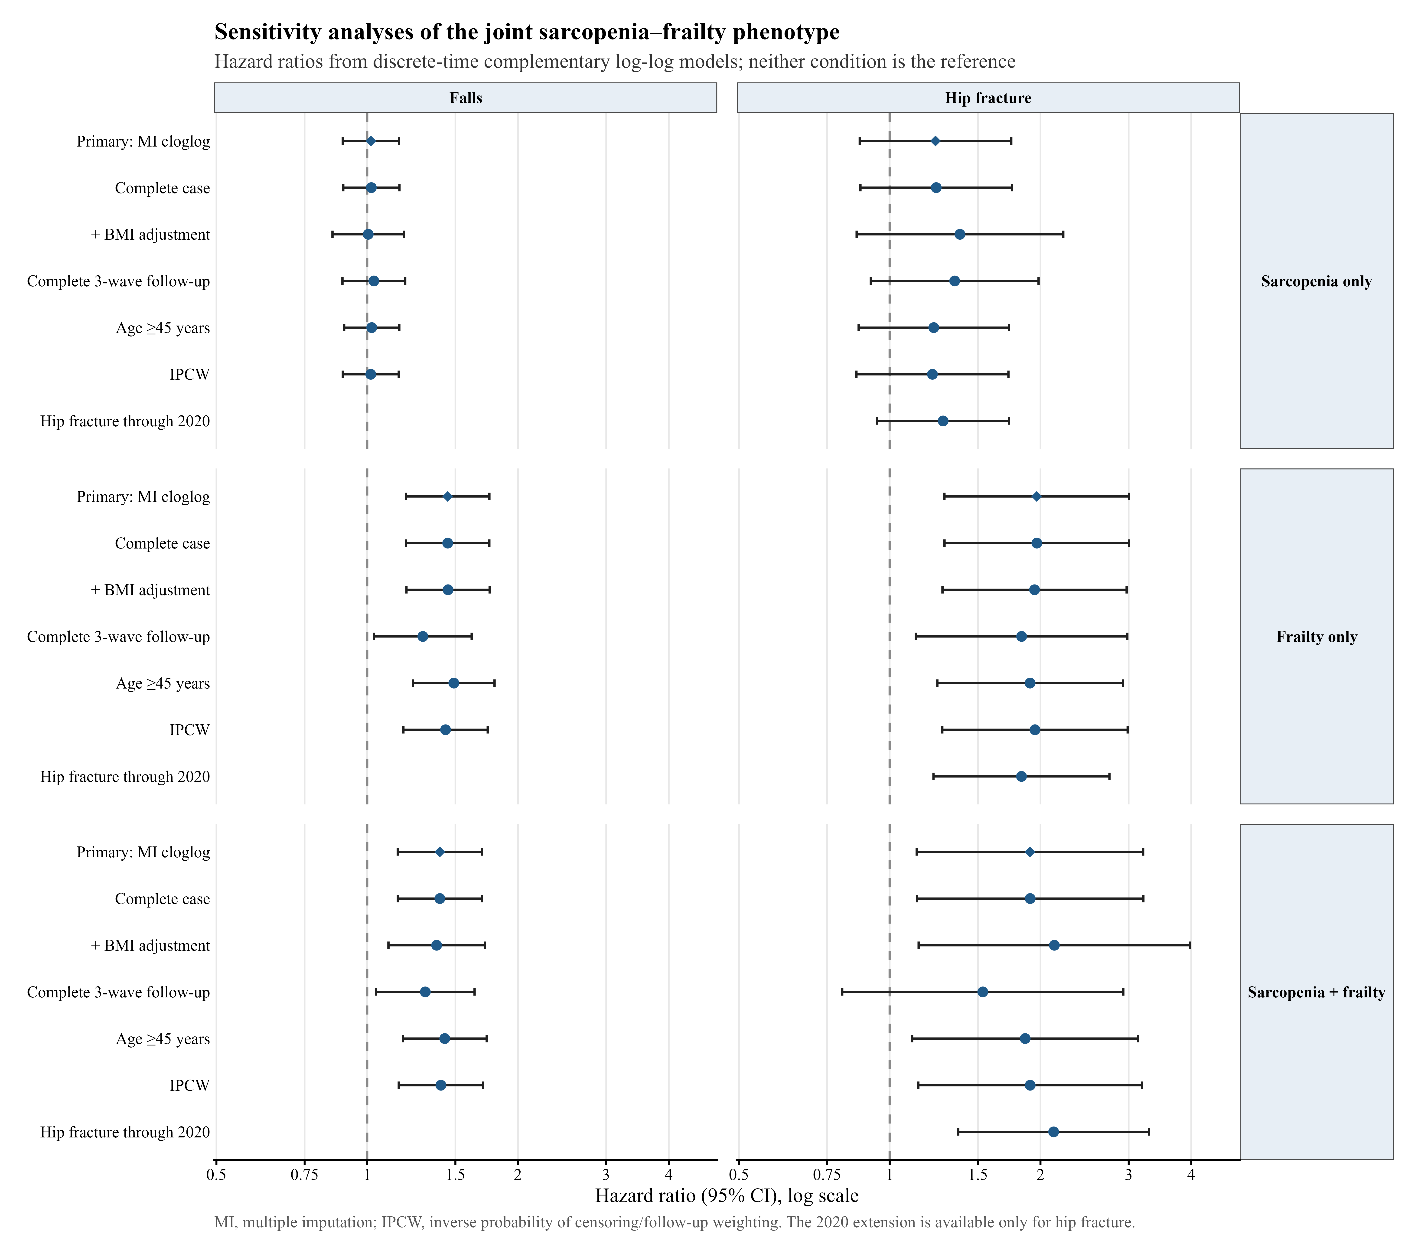
Figure S2. Multiplicative and additive interaction between sarcopenia and frailty. Panel A shows the sarcopenia×frailty interaction HR from the primary multiply imputed discrete-time model; the dashed line denotes HR=1. Panel B shows the standardized-risk additive interaction in percentage points with 95% community-cluster bootstrap confidence intervals; the dashed line denotes a risk difference of 0.
