Supplementary File for: Integrated Detection and Classification of Low-Frequency Earthquakes Using a PhaseNet-Based Deep Learning Framework

Kengo Shimojo ^{1*}, Makoto Naoi ², Shiro Hirano ³, Bogdan Enescu ^{4,5}

^{1*} Meteorological Research Institute, Tsukuba, Japan

² Department of Earth and Planetary Sciences, Faculty of Science, Hokkaido University, Sapporo, Japan

³ Department of Global Environment and Disaster Prevention Sciences, Faculty of Science and Technology, Hirosaki University, Hirosaki, Japan

⁴ Department of Geophysics, Graduate School of Science, Kyoto University, Kyoto, Japan

⁵National Institute for Earth Physics, Magurele-Bucharest, Romania

*Corresponding author. Kengo Shimojo, E-mail: shimojo@mri-jma.go.jp.

Contents of this file
- Text S1-S6: supplementary text with explanations
- References for the citations in Text S1 - S6
- Fig. S1-S13

Text S1. Evaluation of Picking Performance
Figure S1 illustrates the procedure used to evaluate picking performance. Figure S1a shows a synthetic three-component velocity waveform sampled at 100 Hz. A 30.01-s window, beginning 6 s before the first labeled phase, is used as input to the model. The waveform is intentionally constructed to represent a case in which an unlabeled S wave from a low-frequency earthquake (LFE) is superimposed on labeled ordinary-earthquake phases (OP and OS).
Figure S1b shows the corresponding output probabilities for the five classes. These probability traces are also synthetic and are provided solely for illustrative purposes. Figure S1c shows the unified P- and S-wave probability traces derived from Fig. S1b.
First, a peak-detection algorithm (Virtanen et al., 2020) is applied to the unified P- and S-wave probability traces (Fig. S1c), and local maxima exceeding a predefined threshold of 0.05 are extracted. In Fig. S1c, one P-wave peak is identified at 6.02 s, whereas S-wave peaks are identified at 6.03, 12.10, 12.47, and 23.00 s. A candidate peak is discarded if (1) the other phase has a higher probability at the same time, or (2) a larger peak of the same phase type exists within ±1 s. The remaining peaks are defined as predicted arrival times. Accordingly, the S-wave peak at 6.03 s is removed because the P-wave probability is larger at that time, and the S-wave peak at 12.47 s is removed because a larger S-wave peak exists at 12.10 s. The resulting predicted arrival times are 6.02 s for the P wave and 12.10 and 23.00 s for the S wave. Predicted arrival times that differ from all labeled arrival times by more than 0.5 s, such as the prediction at 23.00 s, are not counted as true positives in the picking-performance evaluation.
Next, the five-class probabilities at each predicted arrival time are examined. The class with the highest probability among the four non-noise classes is assigned as the predicted class. If no predicted arrival time exists within an evaluation interval, probabilities of the four non-noise classes are defined as zero. In Fig. S1b, OP has the highest probability at 6.02 s and is therefore assigned as the predicted class. Likewise, LS has the highest probability at 12.10 s and is assigned as the predicted class. To evaluate false earthquake detections in background noise, the 2-s interval starting 4 s before the ordinary-earthquake P-wave arrival is treated as true noise. The class probabilities at each predicted arrival time are also retained for constructing the precision-recall curves shown in Fig. 2.
Finally, the predicted arrival times and classes are compared with the labels in the test dataset. A prediction is counted as a true positive if a labeled phase of the same phase type exists within ±0.5 s of the predicted arrival time and the predicted class matches the label. The example shown in Figs. S1a-c corresponds to the first three lines of Fig. S1d (Trace ID: 1). The OP label at 6.00 s is counted as a true positive because it matches the predicted OP class at 6.02 s. In contrast, the OS label at 12.20 s is counted as a mismatch because the predicted class is LS. If no predicted arrival time exists within ±0.5 s of a labeled pick, as in the fifth row of Fig. S1d (Trace ID: 3; Label: LP), the pick is treated as a false negative and the corresponding prediction is regarded as noise. Picks located within 0.5 s of the window boundary, such as S waves occurring after 29.5 s, are excluded to avoid bias in the distribution of arrival-time residuals shown in Fig. 4.

Text S2. Seismic Activity around the 2000 Western Tottori Prefecture Earthquake (M_{JMA} 7.3)
Figure S3b shows the results of automatic hypocenter determination using FC model picking thresholds of 0.25 for P waves and 0.10 for S waves. A total of 235 hypocenters were determined, and LIKE values were successfully calculated for all events.
Among these events, 90 match hypocenters listed in the JMA catalog. For ordinary earthquakes, all 82 cataloged events were successfully recovered, and all exhibited LIKE values below 0.001. In contrast, only 8 of the 18 LFEs listed in the JMA catalog were recovered. Of the 10 LFEs that were not detected, 8 had fewer than four detectable P-wave picks in the JMA catalog. Because the automatic hypocenter determination procedure requires at least four P-wave picks (Fig. S2b), these events were likely excluded owing to their weak or indistinct P-wave arrivals.
The remaining 145 automatically determined hypocenters do not match events in the JMA catalog. Visual inspection of waveforms recorded at nearby stations confirmed that all these events correspond to genuine local seismic events. Events corresponding to LFEs listed in the JMA catalog are indicated by red-outlined symbols in Fig. S3b. The minimum LIKE value among the eight matched LFEs is 0.18. Using the threshold proposed in Section 3 (LIKE ≥ 0.05), 20 events are classified as LFEs. In addition to the LFEs matching the JMA catalog, several LFE-classified events were identified near a cluster located approximately 5 km south of station N.HKTH (Fig. S3b), at depths of around 30 km, where LFEs frequently occur in the JMA catalog (hereafter referred to as region T). Visual inspection indicates that these previously uncataloged events exhibit waveforms and travel-time patterns similar to those of cataloged LFEs (Fig. S3c).
Two additional events with LIKE ≥ 0.67 were determined at depths of approximately 30 km south of region T. However, LFEs were simultaneously reported in region T in the JMA catalog. Examination of the waveforms revealed multiple closely spaced P- and S-wave arrivals at several stations, with some stations recording multiple picks within a few seconds. These observations suggest that several nearby LFEs occurred in rapid succession and were incorrectly associated into single events during the phase-association process, resulting in spurious hypocenter locations outside region T.
Events with LIKE ≥ 0.05 are also observed outside known LFE source regions at depths shallower than 20 km. Based on waveform inspection and aerial photographs near the epicenters, these events are interpreted as quarry blasts (Fig. S3d). Such events remain even when the LIKE threshold is increased to values greater than 0.7, indicating that the present method cannot reliably distinguish quarry blasts from genuine LFEs. Some quarry blasts were located at depths of approximately 10 km; however, this likely reflects incorrect phase association. Because quarry blasts often lack a clear S-wave onset, later arrivals following the S-wave window may have been picked and associated as S waves, causing near-surface events to be located artificially at greater depths.

Text S3. Ordinary Earthquakes and LFEs for Setting the LIKE Threshold
We determined the LIKE threshold used to discriminate LFEs from ordinary earthquakes. Figure S4 shows the distribution of hypocenters used for threshold calibration. As ordinary-earthquake data, we selected 6,198 hypocenters shallower than 50 km from the JMA catalog within the Chugoku-Shikoku region (33.7°-35.7°N, 130.8°-134.6°E) during the period from 1 February 2024 to 31 January 2025. As LFE data, we used 3,636 events in the Chugoku-Shikoku region, including 3,583 tectonic tremors along the Nankai Trough, and 1,287 non-tremor LFE hypocenters that occurred elsewhere in Japan during the same period. Figure S5 shows the FC model scores obtained by applying the model to continuous waveform data around the catalog pick times associated with these events. When the integrated P- and S-wave picking threshold was set to 0.05, the FC model successfully picked 181,142 of the 206,275 catalog picks available for the phase-association procedure.
We then used the LP and LS scores of these picks to evaluate whether each detected event corresponds to an LFE. Figure S6 shows the frequency distributions of the mean and median LP scores and the mean and median LS scores calculated for each event. The number of events included in each panel differs depending on whether usable P- or S-wave picks were available and whether the corresponding LP- or LS-based statistic could be calculated. For ordinary earthquakes, LP- and LS-based statistics were successfully calculated for 6,187 events. For LFEs, LP-based statistics were obtained for 966 events, corresponding to approximately one-third of the total LFE dataset, whereas LS-based statistics were obtained for 3,060 events. For both LP and LS scores, the median values provide better discrimination between ordinary earthquakes and LFEs than the corresponding mean values. We therefore adopted the median LP and LS scores as the definitions of PLIKE and SLIKE, respectively.
The ability to discriminate LFEs from ordinary earthquakes also improves as the number of stations contributing to the calculation of PLIKE or SLIKE increases. Figure S7a shows the relationship between the number of available stations and the recall rate for each event type when events with PLIKE or SLIKE ≥ 0.05 are classified as LFEs and those below this threshold are classified as ordinary earthquakes. In all cases, the recall rate becomes higher and more stable as the number of contributing stations increases. This result indicates that, when both PLIKE and SLIKE are available for a given event, it is reasonable to adopt the value calculated from the larger number of stations as the representative LIKE value.
As a result, LIKE values were computed for 6,193 ordinary earthquakes and 3,060 LFEs including 1,720 tremors (Figs. S4 and S5e). When the optimized P- and S-wave picking thresholds of 0.25 and 0.10, respectively, are applied as described in Section 3, the number of LFEs for which LIKE can be computed decreases to 2,720, whereas the number of ordinary earthquakes remains unchanged. Except for one event, all LFEs that become unavailable under these stricter picking thresholds correspond to tremor events.

Text S4. Seismic Activity Listed in the JMA Catalog in the Northern Yamaguchi Region
Figure S9a shows the distribution of JMA-catalog hypocenters shallower than 50 km during the study period. A total of 2,694 hypocenters were reported within the mapped region. Among them, 21 events are classified as LFEs, all of which occur within the swarm region, indicated by the dashed line in Fig. S9a. Whereas ordinary crustal earthquakes in the surrounding region are concentrated at depths shallower than approximately 20 km and intraslab seismicity occurs mainly at depths greater than ~40 km, both LFEs and ordinary earthquakes occur at intermediate depths of approximately 20-40 km within the swarm region.
Figure S9b shows an enlarged view of the swarm region. Ordinary earthquakes are concentrated within a zone approximately 5-10 km across, centered near 34.45°N, 131.57°E, and form a cluster at depths of roughly 20-30 km. In contrast, LFEs occur mainly at depths of 30-40 km and extend approximately 10 km westward from the western edge of the ordinary-earthquake cluster. Overall, hypocentral depths become progressively deeper toward the west and shallower toward the east.
As shown in Fig. S9c, magnitudes in the swarm region range from M_{JMA} -0.3 to 1.8. Excluding three events for which magnitudes were not assigned, LFEs have magnitudes between M_{JMA} -0.2 and 1.0. The cumulative number of earthquakes begins to increase in early March and accelerates markedly during mid-March and again in early April.
Figures S9d-f show the temporal evolution of hypocentral depth, latitude, and longitude. The sequence began with three LFEs that occurred on 1-2 February at depths of approximately 38-39 km near the western edge of the deep cluster. This initial activity was followed by a 19-day quiescent period. A single event then occurred on 21 February at a depth of approximately 34 km, slightly east of the initial cluster. Renewed LFE activity started on 26 February near the western edge of the main cluster at depths of around 34 km, after which hypocenters migrated eastward and upward to depths of approximately 30 km by early March. Ordinary earthquakes first appeared in early March and subsequently became more active near the western edge of the main cluster at depths of around 30 km, while LFE activity ceased after 8 March. Thereafter, ordinary-earthquake hypocenters progressively migrated toward shallower depths (25-30 km) and eastward across the main cluster, accompanied by temporal variations in seismicity rate and focal depth.

Text S5. Derivation of FI and f_{p}
In Nakajima and Hasegawa (2021; hereafter NH), the peak frequency (f_{p}) and frequency index (FI; Buurman and West, 2010) were calculated for JMA-catalog earthquakes with magnitudes of 0 ≤ M_{JMA} ≤ 2.5 using power spectra derived from 3-s waveform windows beginning 0.3 s before the S-wave arrival. By comparing the distributions of LFEs and ordinary earthquakes, NH showed that many LFEs exhibit lower f_{p} and FI values than ordinary earthquakes. Furthermore, because more than 80% of LFEs were distributed below f_{p} = 4 Hz and FI = -0.75, NH adopted these values as criteria for redefining LFEs in the JMA catalog and suggested the existence of previously unrecognized LFE activity in both space and time.
The FI and f_{p} values used in the present study were calculated following the procedure of NH. First, a fast Fourier transform was applied to a 3-s waveform window beginning 0.3 s before the S-wave arrival, using the east-west component recorded at stations located within 50 km of the hypocenter. The maximum spectral amplitude in the 2-5 Hz band was defined as the low-frequency amplitude (A_{L}), whereas the maximum amplitude in the 10-15 Hz band was defined as the high-frequency amplitude (A_{H}). The frequency index was then calculated as FI = log₁₀(A_{L}/A_{H}).
For the peak frequency f_{p}, the Fourier spectrum was sampled at intervals of 0.33 Hz, and a three-point moving average was calculated at each frequency sample. The frequency corresponding to the maximum smoothed spectral amplitude was defined as f_{p}.
To ensure data quality, a 2-15 Hz band-pass filter was applied to all waveforms. The maximum amplitude within a 3-s window beginning 30 s before the P-wave arrival was defined as the noise amplitude, whereas the maximum amplitude within a 3-s window beginning 0.3 s before the S-wave arrival was defined as the signal amplitude. Only events for which at least three stations exhibited a signal-to-noise ratio greater than 2 were included in the analysis.
Figure S10 presents representative examples of swarm events and their corresponding FI and f_{p} analyses. Figure S10a shows an event that occurred during the initial stage of the second activation of the swarm (26 February 2025) and corresponds to an LFE listed in the JMA catalog. Figure S10b shows an event that occurred in early April with LIKE = 0.101, exceeding the threshold for LFE classification. Figure S10c shows an event with LIKE = 0.025, slightly below the threshold, whereas Fig. S10d shows an event with LIKE = 0.000. For each event, the power spectrum at station N.MTMH used to determine f_{p} is shown in Fig. S10e. Notably, the event shown in Fig. S10b exhibits f_{p} = 4.34 Hz and FI = -0.28, which are lower than those of the cataloged LFE (f_{p} = 7.35 Hz and FI = -0.19; Fig. S10a).

Text S6. Stationary ETAS Analysis for JMA Hypocenters in the Northern Yamaguchi Region
A stationary Epidemic-Type Aftershock Sequence (ETAS) model (Ogata, 1988) was fitted to seismicity in the swarm region listed in the JMA catalog, and model parameters were estimated using the maximum-likelihood method (Fig. S11). The lower magnitude threshold was set to M_{c} = 0.5 based on the magnitude-frequency distribution (Wiemer and Wyss, 2000).
For the period before the onset of swarm activity on 1 February 2025 (135 events), the estimated parameters are a background seismicity rate of μ = 0.021, an aftershock productivity parameter of K = 0.012, a short-term aftershock suppression parameter of c = 0.000, a magnitude-productivity scaling parameter of α = 1.215, and an aftershock decay exponent of p = 0.902. For the swarm period after 1 February 2025, the corresponding estimates are μ = 0.254, K = 0.055, c = 0.013, α = 0.639, and p = 1.444.
It should be noted that all earthquakes before the onset of the swarm occurred at depths shallower than 20 km, whereas the swarm activity was concentrated at greater depths. Therefore, the two periods do not represent the same seismogenic volume, and direct comparison of the estimated parameters should be interpreted with caution. Nevertheless, the lower α value during the swarm period indicates that aftershock productivity depends less strongly on mainshock magnitude, a characteristic commonly associated with swarm-type seismicity (Ogata, 1992). In addition, the substantially larger background rate μ suggests a greater contribution from events that cannot be explained solely by earthquake-to-earthquake triggering.
Previous studies have reported significant temporal changes in the ETAS background rate associated with swarm activity and have interpreted such changes as evidence for aseismic processes, including slow slip or fluid migration (e.g., Kumazawa and Ogata, 2013). Consistent with these observations, the combination of a lower α value and an elevated μ value during the swarm period suggests that processes other than conventional earthquake triggering may have contributed to the overall seismicity rate.

References
Buurman H, West ME (2010) Seismic precursors to volcanic explosions during the 2006 eruption of Augustine Volcano. In: Power JA, Coombs ML, Freymueller JT (eds) The 2006 eruption of Augustine Volcano, Alaska. US Geological Survey Professional Paper 1769, chap 2, 17 pp. https://doi.org/10.3133/pp17692
Kumazawa T, Ogata Y (2013) Quantitative description of induced seismic activity before and after the 2011 Tohoku-Oki earthquake by nonstationary ETAS models. J Geophys Res Solid Earth 118:6165-6182. https://doi.org/10.1002/2013JB010259
Nakajima J, Hasegawa A (2021) Prevalence of shallow low-frequency earthquakes in the continental crust. J Geophys Res Solid Earth 126:e2020JB021391. https://doi.org/10.1029/2020JB021391
Ogata Y (1988) Statistical models for earthquake occurrences and residual analysis for point processes. J Am Stat Assoc 83:9-27. https://doi.org/10.1080/01621459.1988.10478560
Ogata Y (1992) Detection of precursory relative quiescence before great earthquakes through a statistical model. J Geophys Res 97:19845-19871. https://doi.org/10.1029/92JB00708
Virtanen P, Gommers R, Oliphant TE, Haberland M, Reddy T, Cournapeau D et al (2020) SciPy 1.0: fundamental algorithms for scientific computing in Python. Nat Methods 17:261-272. https://doi.org/10.1038/s41592-019-0686-2
Wiemer S, Wyss M (2000) Minimum magnitude of completeness in earthquake catalogs: examples from Alaska, the western United States, and Japan. Bull Seismol Soc Am 90:859-869
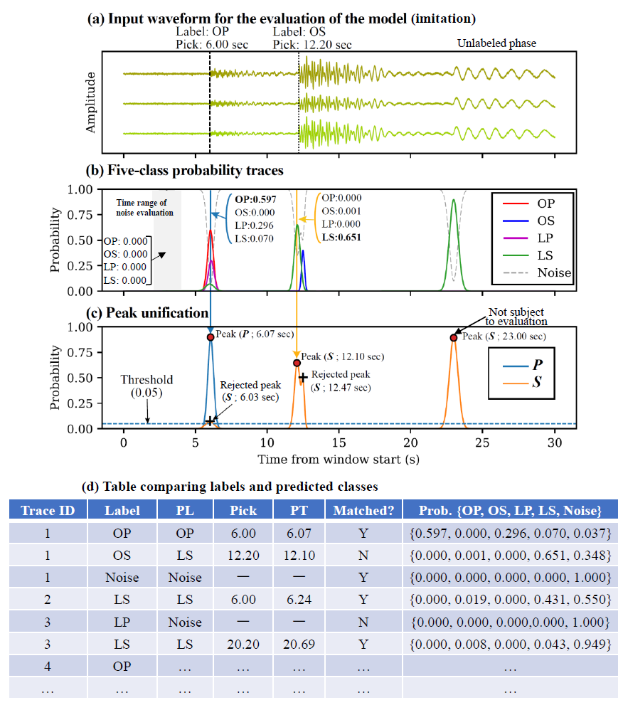
Fig. S1. Schematic illustration of the procedure used to evaluate FC model picking performance. (a) Illustrative input waveform used for model evaluation; (b) Synthetic five-class probability traces generated for explanatory purposes; (c) Peak unification of P- and S-wave probability traces derived from (b); (d) Example of the comparison between labels and model predictions. “PL” and “PT” denote the predicted class and predicted arrival-time, respectively.

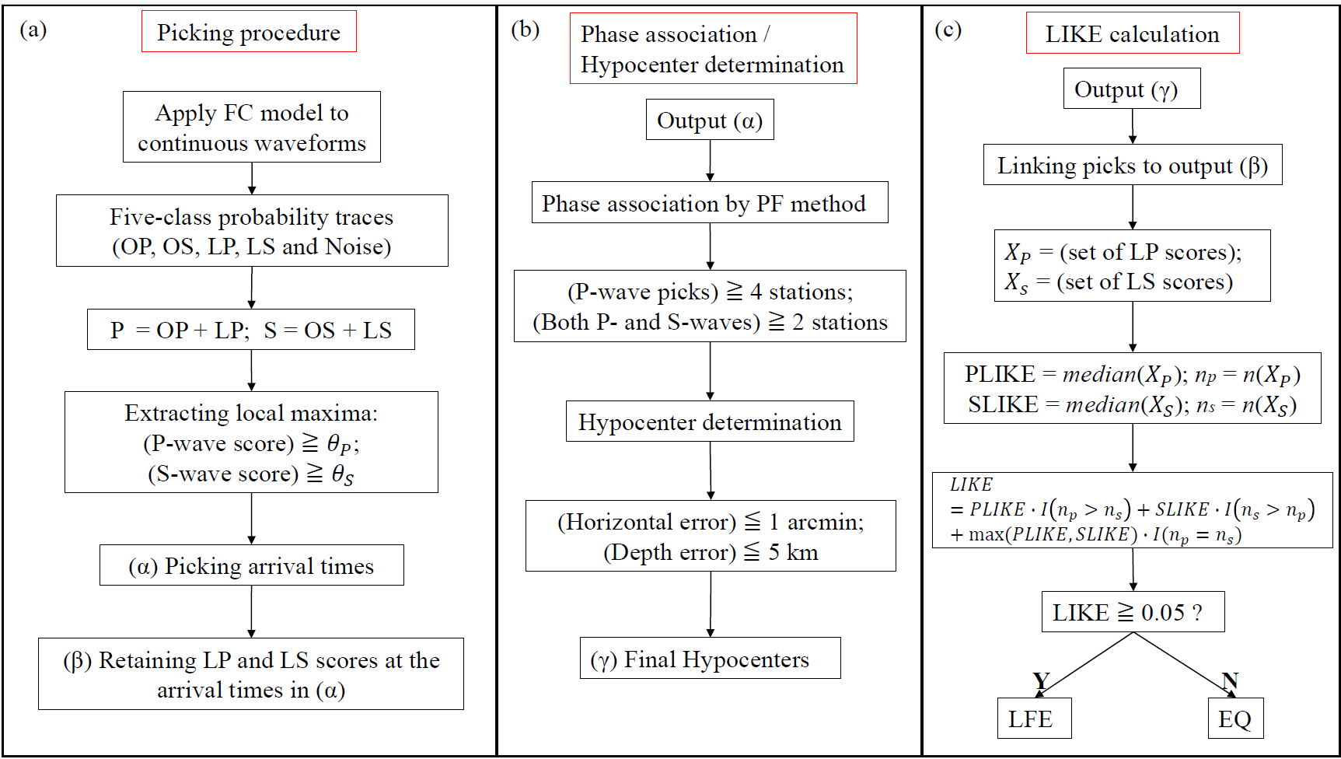Fig. S2. Flowchart of the method used in this study. (a) Procedure for phase picking. θ_{P} and θ_{S} denote the P- and S-wave picking thresholds, respectively. In this study, θ_{P} = 0.25 and θ_{S} = 0.10 were used as the optimal threshold combination for final hypocenter determination; (b) Procedure for phase association and hypocenter determination; (c) Procedure for LIKE calculation. The symbol I(·) in the fifth box from the top denotes the indicator function.

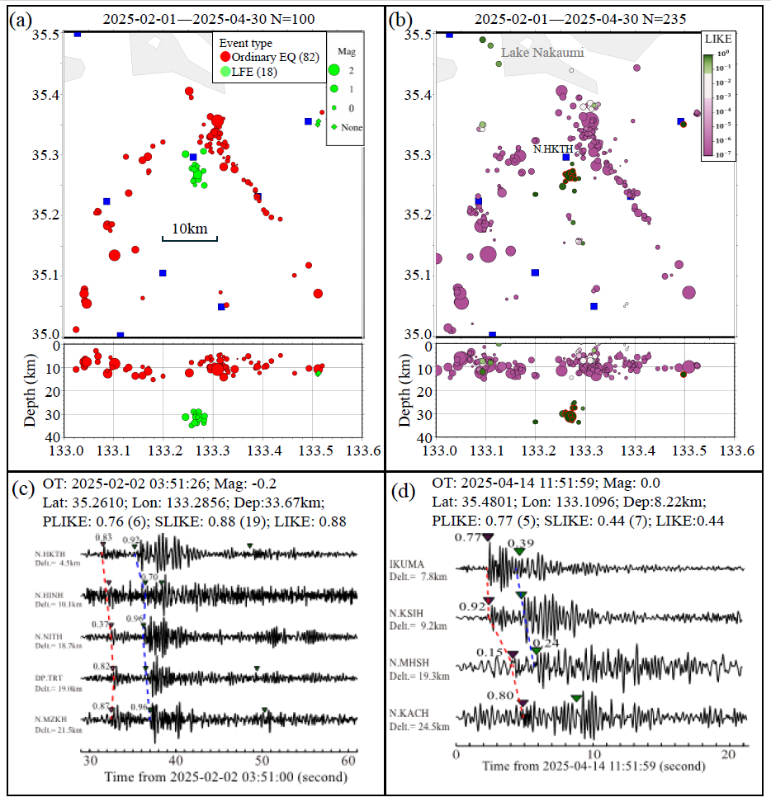
Fig. S3. Results of automatic phase picking and hypocenter determination for the region surrounding the 2000 Western Tottori earthquake (M_{JMA} 7.3; same area as Fig. 6b) during the period from 1 February to 30 April 2025. (a) Hypocenters listed in the JMA catalog. Red and green symbols denote ordinary earthquakes and LFEs, respectively. Diamonds indicate events for which no magnitude was assigned; (b) Automatically determined hypocenters colored by LIKE value. Events outlined in red correspond to LFEs listed in the JMA catalog; (c) Waveforms of events with LIKE ≥ 0.05 after application of a 2-Hz high-pass filter. Red and blue dashed lines connect the P- and S-wave picks assigned to the same event during phase association, respectively. Purple and green inverted triangles indicate the P- and S-wave picks, respectively, and the corresponding LP and LS scores are shown beside the arrival times; (d) Waveforms of a quarry blast located near Lake Nakaumi.

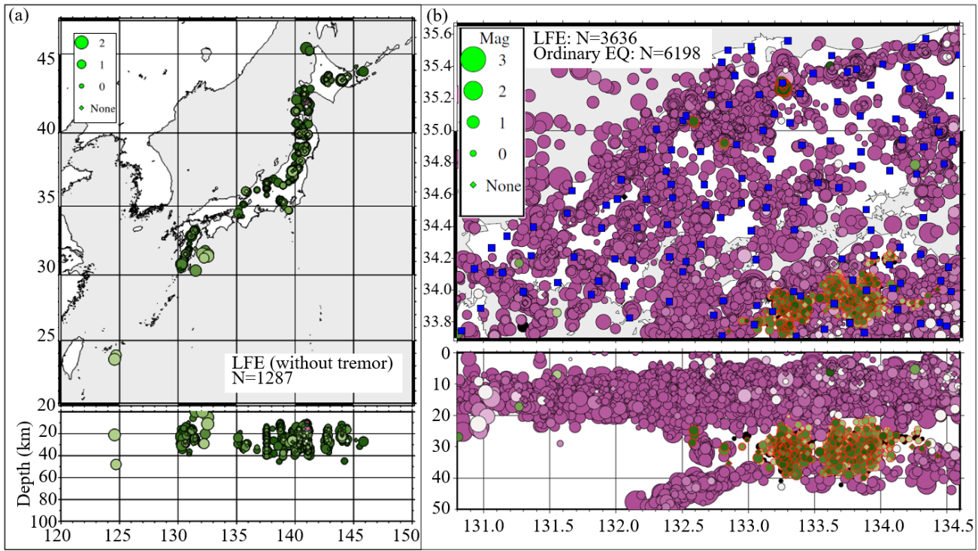
Fig. S4. Hypocenters corresponding to the calibration dataset used to determine the LIKE threshold for LFE classification. (a) LFEs listed in the JMA catalog throughout Japan, excluding tectonic tremor along the Nankai Trough, during the period from February 2024 to January 2025. Circle and diamond colors indicate LIKE values using the same color scale as in Fig. 8a; (b) All earthquakes in the Chugoku–Shikoku region during the same period. Red circles indicate cataloged LFEs. Black circles and diamonds indicate events for which LIKE could not be calculated.

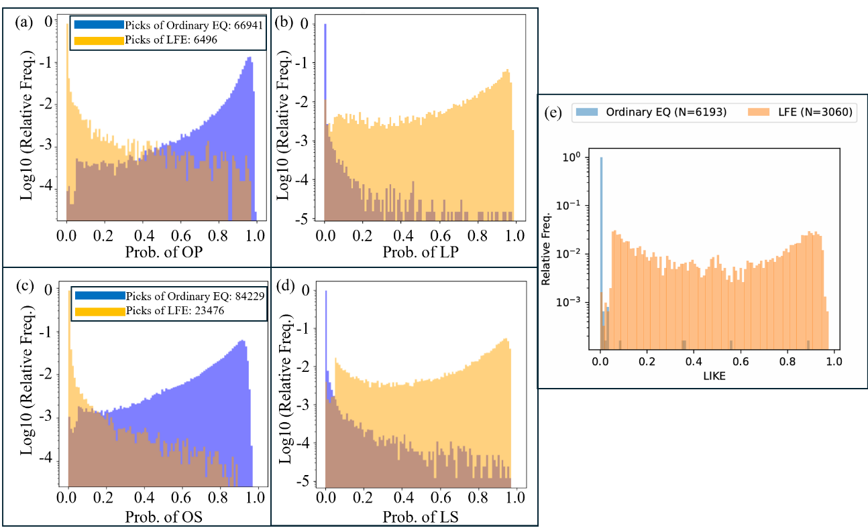
Fig. S5. Relative frequency distributions of the FC model scores obtained from continuous waveforms associated with the events shown in Fig. S4. (a) OP scores for P-wave picks; (b) LP scores for P-wave picks; (c) OS scores for S-wave picks; (d) LS scores for S-wave picks; (e) Distribution of LIKE values calculated from the LP and LS scores shown in (b) and (d). This panel corresponds to Fig. 7, except that the horizontal axis is shown on a linear scale.

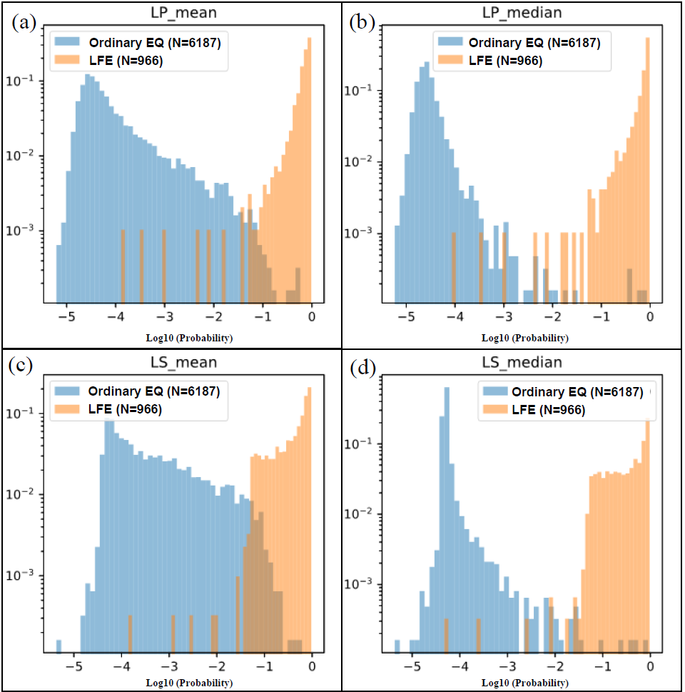
Fig. S6. Relative frequency distributions of the mean and median LP and LS scores. (a) Mean LP scores. (b) Median LP scores. (c) Mean LS scores. (d) Median LS scores.

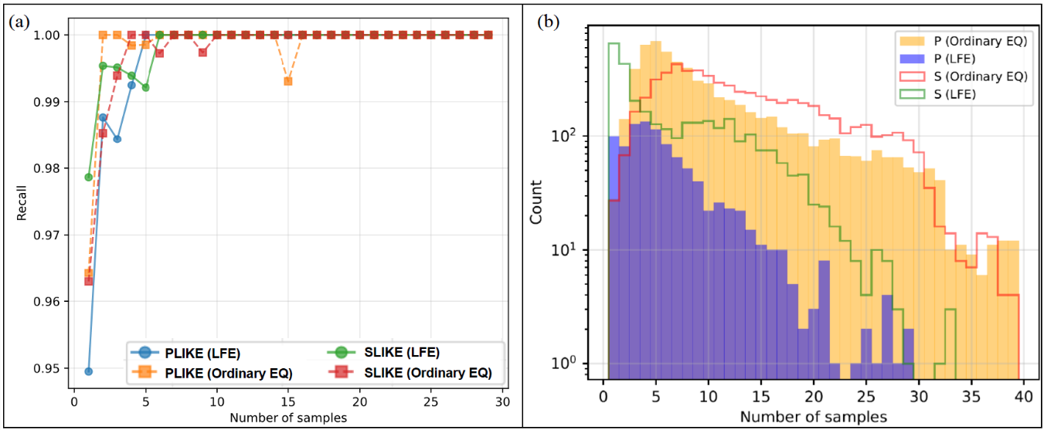
Fig. S7. Effect of the number of contributing stations on LFE classification performance. (a) Recall as a function of the number of stations contributing to the calculation of PLIKE or SLIKE, using an LFE classification threshold of 0.05; (b) Frequency distribution of the number of stations contributing to the calculation of PLIKE or SLIKE.

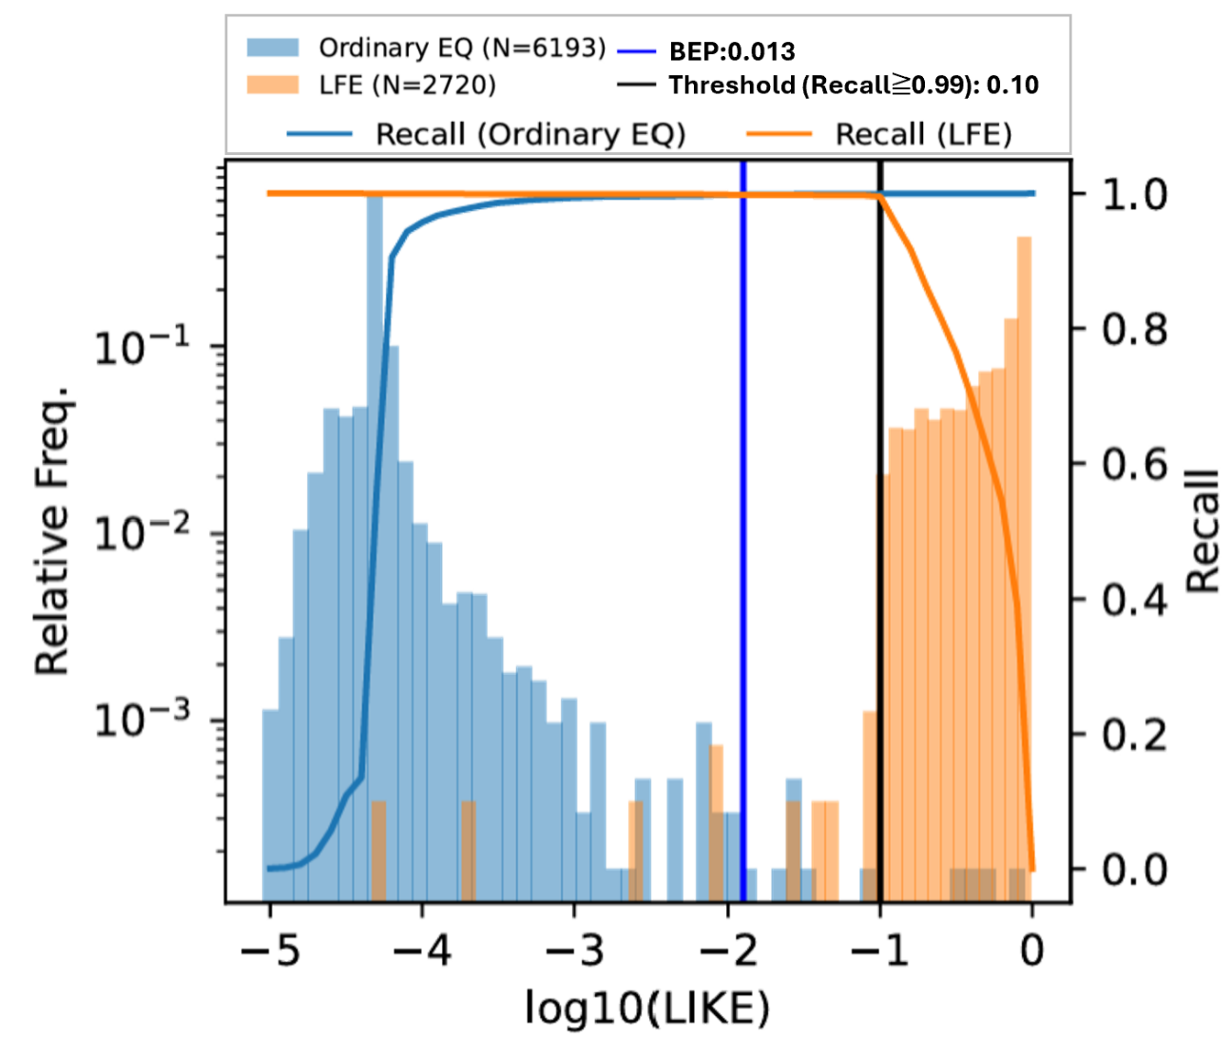
Fig. S8. Relative frequency distribution of LIKE values, corresponding to Fig. 7 but obtained using P- and S-wave picking thresholds of 0.25 and 0.10, respectively.

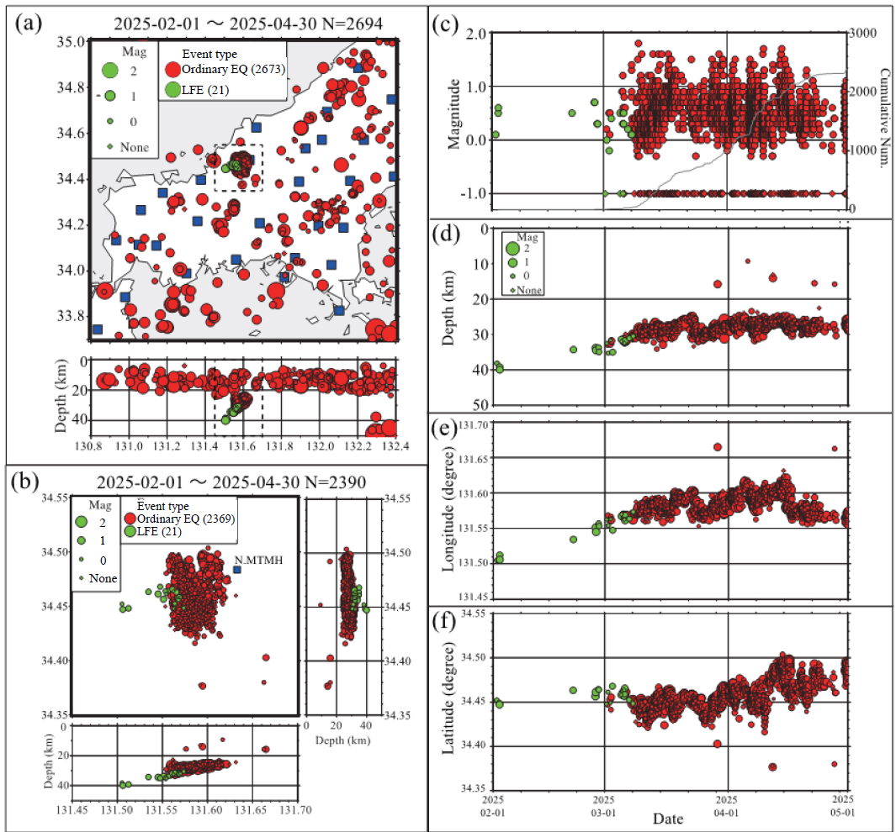
Fig. S9. Distribution of hypocenters listed in the JMA catalog. (a) Map view of the region surrounding Yamaguchi Prefecture. Blue squares indicate the velocity stations used in this study. The black dashed line outlines the swarm region shown in (b); (b) Enlarged map view of the swarm region outlined by the black dashed line in (a); (c) Temporal distribution of magnitude. Green and red diamonds plotted at M_{JMA} = −1 indicate events for which no magnitude was assigned. The gray solid line shows the cumulative number of earthquakes; (d) Temporal distribution of hypocentral depth; (e) Temporal distribution of longitude; (f) Temporal distribution of latitude.

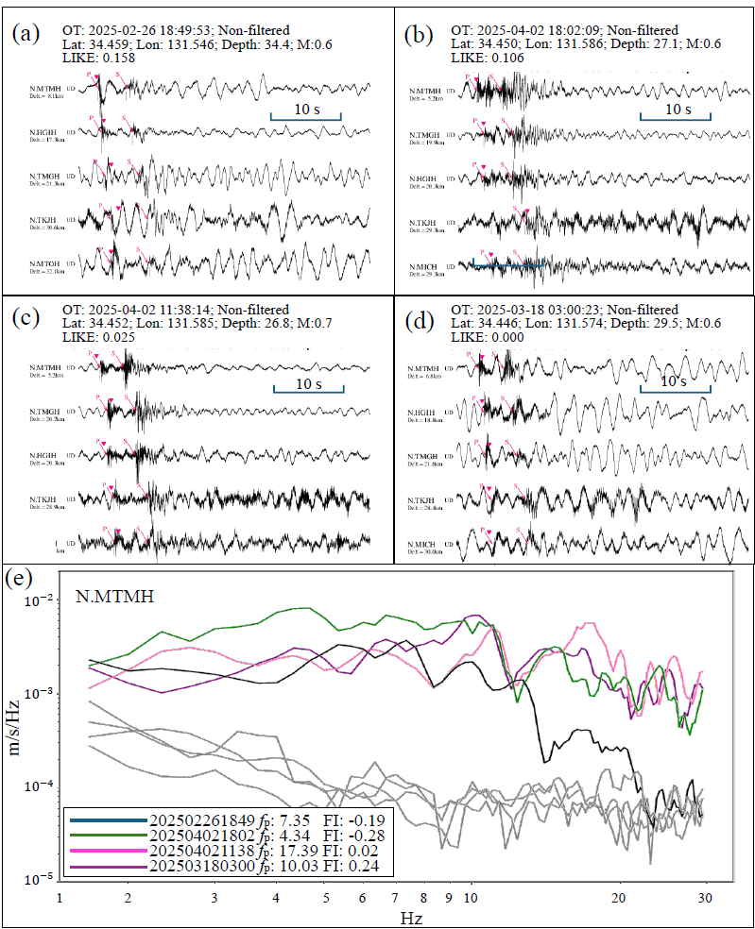
Fig. S10. Examples of waveform analysis for events in the swarm region and their corresponding f_{p} and FI values. (a) Raw vertical-component waveforms recorded at five stations near an event that occurred in the western part of the swarm region. This event is also cataloged as an LFE in the JMA catalog; (b) Waveforms of an event with LIKE ≥ 0.05; (c) Waveforms of an event with a LIKE value slightly below 0.05; (d) Waveforms of an event with a LIKE value below the classification threshold; (e) Smoothed power spectra obtained using a three-point moving average (0.66-Hz moving-average window) of the east–west component at station N.MTMH used to estimate f_{p} for the four events shown in (a)–(d). The gray curve shows the noise spectrum, calculated from the 3-s time window immediately preceding the P-wave arrival.
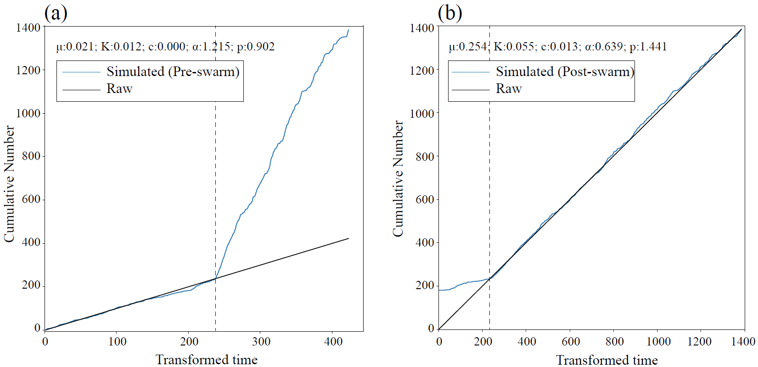
Fig. S11. Results of fitting a stationary ETAS model to seismicity before (a) and after (b) 00:00 on 1 February 2025, using earthquakes with M_{JMA} ≥ 0.5 in the swarm region listed in the JMA catalog since 1 January 2010. The black curve shows the observed cumulative number of earthquakes, and the blue curve shows the cumulative number expected from the fitted stationary ETAS model.

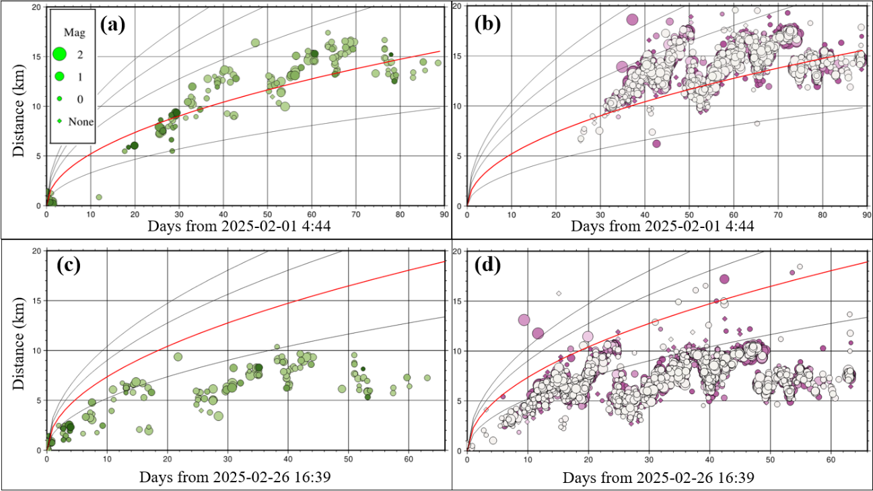
Fig. S12. Time–distance distributions of LFE-classified and non-LFE-classified events in the swarm region (depth ≥ 20 km). (a) LFE-classified events relative to the onset of the swarm activity (1 February); (b) Non-LFE-classified events using the same reference time as in (a); (c) LFE-classified events relative to the reactivation of the swarm on 26 February; (d) Non-LFE-classified events for the same reference time as in (c).

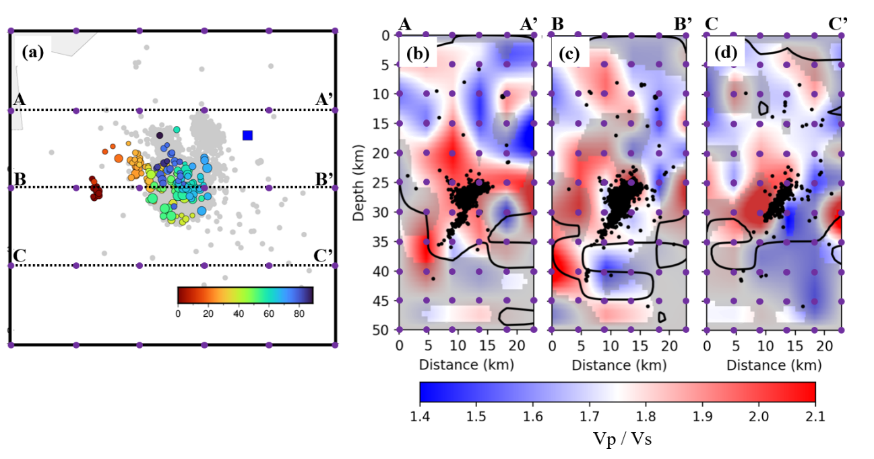
Fig. S13. Cross-sections of the V_{P}/V_{S} ratio. (a) Grid configuration used for the velocity-structure inversion, overlain by the distribution of LFE-classified events (same as Fig. 9a). The grid spacing is 0.05° (approximately 5 km) in the horizontal direction and 5 km in depth; (b)–(d) Cross-sections of the V_{P}/V_{S} ratio along profiles A–A′, B–B′, and C–C′ shown in (a). Black dots indicate all hypocenters located within 5 km of each cross-section. Gray shading indicates regions where the checkerboard resolution recovery rate is less than 0.2. The black contour denotes DWS = 50, which approximately delineates the boundary between well-resolved and poorly resolved regions.

