Supplementary data

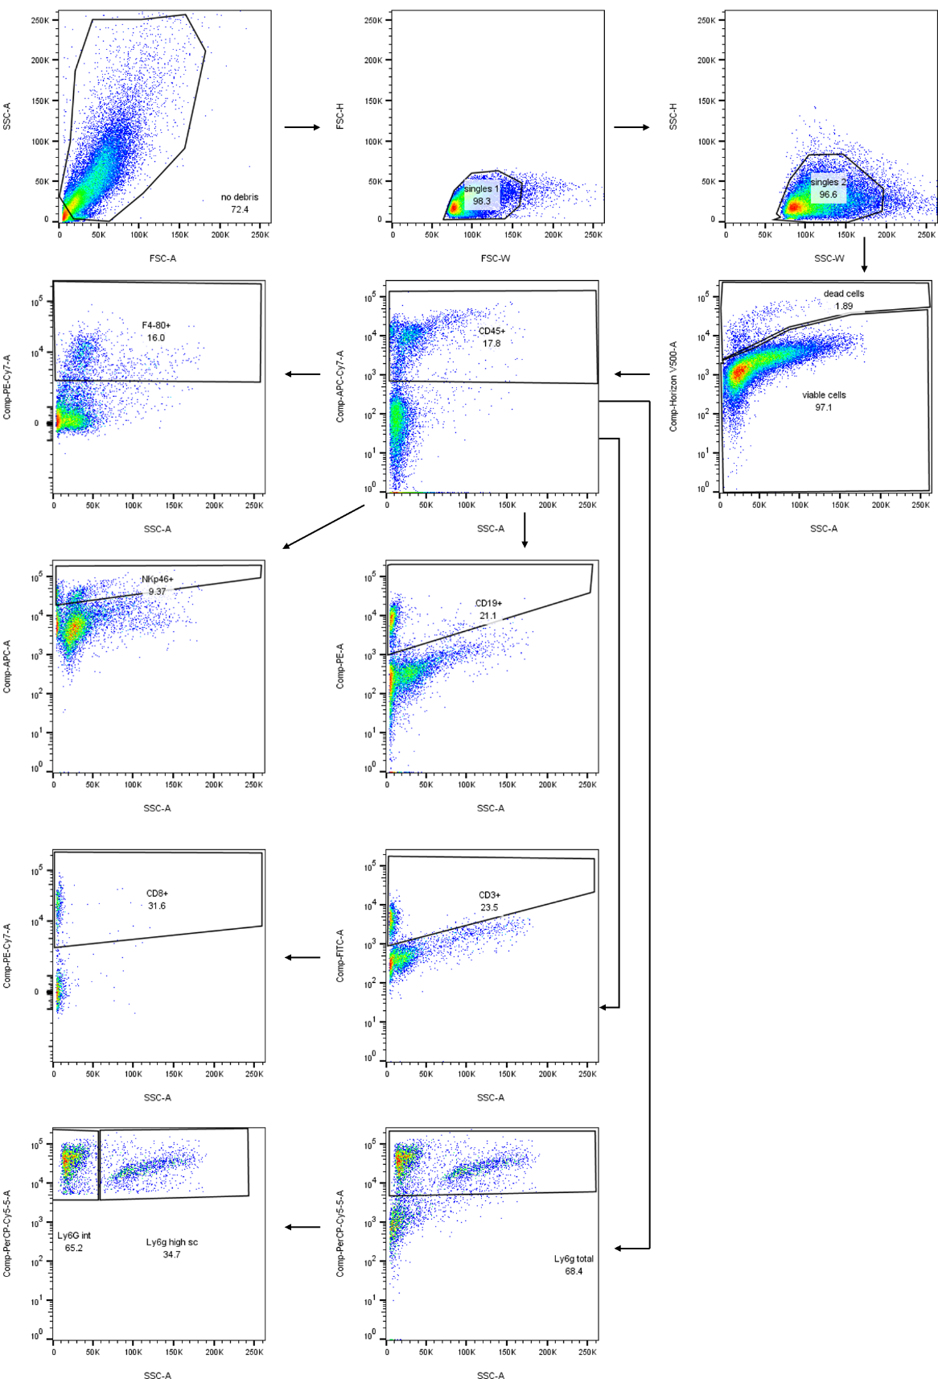

Supplementary figure 1: Gating strategy flow cytometric analysis

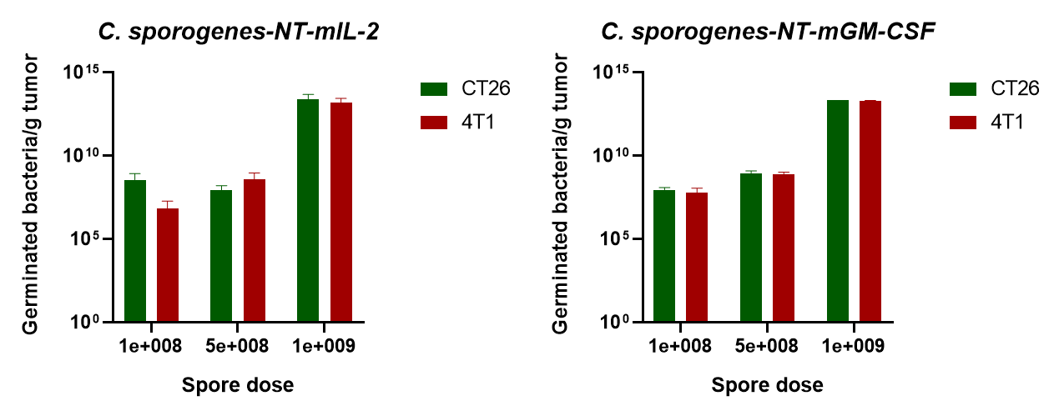

Supplementary figure 2: Intravenously administered spore dose versus levels of intratumoral germinated bacteria per gram tumor for CT26 and 4T1. Data represents the mean ± SD of 3 tumors per dose per model.

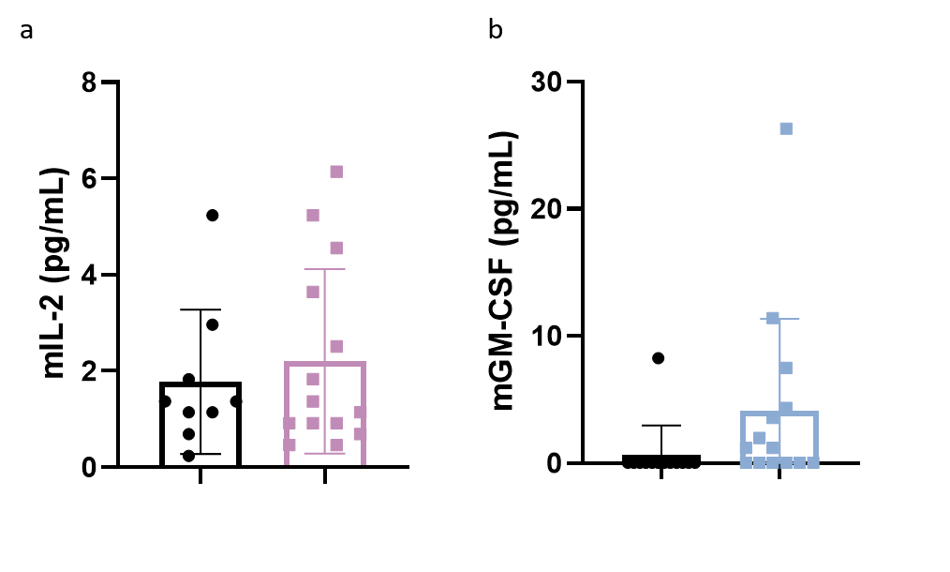
Supplementary figure 3: Plasma levels of mIL-2 (a) and mGM-CSF (b) compared to vehicle as measured by ELISA at day 7 post spore-injection N=9-14 animals per group.

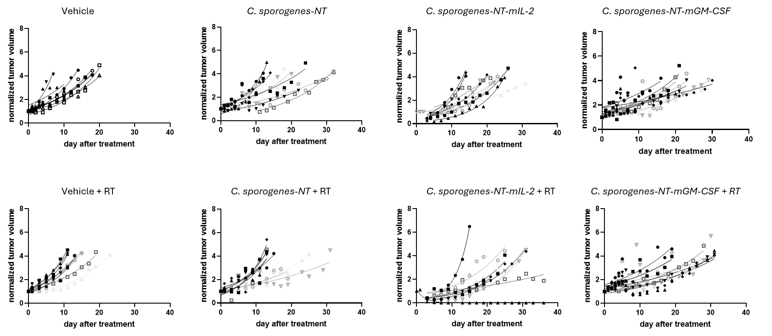
Supplementary figure 4: Normalized, i.e. to volume at start treatment, individual tumor volumes per experimental group.

