Supplementary material

A: Artefactual clustering and ascertainment bias in genotyping
The structure of this project involved co-analysis of two separately sequenced datasets containing samples of Southern Stuttering frogs (Mixophyes australis). The first dataset sequenced for this project contained the founders of Symbio Wildlife Park’s conservation breeding program and some reintroduced individuals and the second from Mahony et al. (2023) which contains M. australis from across its range as well as several other species within the Mixophyes genus. For analyses, we removed species other than M. australis, however our co-analysis was still affected by the two datasets being derived from different SNP panels. This caused ascertainment bias, where sample sizes and the populations in which SNPs are discovered affect downstream analyses (Lachance and Tishkoff, 2013; Nazareno et al., 2017; Dokan et al., 2021). This causes an effect where a dataset sampled across many divergent species ends up with relatively few SNPs, while a dataset from closely related populations has many SNPs (Fig. S1). When we co-analysed the two datasets, this caused Symbio conservation dataset samples to cluster separately from all wild population samples, this is seen visually in a PCoA* (Fig. S2 and S3). This artefactual clustering may be due to batch effects, where non-biological differences such as differing library methods and sequencing tools or different sample sets for SNP discovery mean that loci are not comparable across datasets (Lou and Therkildsen, 2022). These batch effects can result in missing data due to differences in enzyme cut sites, differences in read depth and different SNP discovery panels (Yi and Latch, 2022).
To test whether this clustering was data-driven or biologically meaningful, we conducted two phylogenetic analyses. Unlike clustering approaches, phylogenetic methods explicitly model sequence evolution and infer relationships based on shared ancestry (Yang and Rannala, 2012), providing an alternative framework to assess whether this clustering reflects true evolutionary history. We find across two phylogenetic methods: Maximum likelihood (Fig. S4: IQ-TREE 2 (Minh et al. 2020)) and multispecies coalescent (Fig. S5: SVDQuartets (Chifman and Kubatko, 2014)) the Symbio conservation population clusters within other M. australis wild samples (tree rooted with M. balbus as outgroup), ruling out the possibility of these samples belonging to a cryptic species. We also calculated F_{ST}* values and fixed differences* between conservation population and wild populations, including M. balbus to represent a baseline for species-level divergence. We recover moderate F_{ST} values, consistent not with species level divergence, but with population structure (Table S1). Our fixed differences analysis finds 94 fixed differences between the Symbio conservation population and wild populations S1-3 (Table S2). These values are more consistent with species level divergence which is particularly surprising given the Symbio conservation population represents the same species as the wild samples and is sourced most closely to the wild S2 population.
To test this further, we ran several population clustering analyses for visualisation of admixture between groups. We first ran STRUCTURE*, finding across both analyses, the Symbio conservation population clustered separately to the wild populations with almost no admixture (Fig. S6 and S7). We also ran sNMF* (sparse non-negative matrix factorization) which also clustered the Symbio conservation population separately but did infer more admixture with wild populations (Fig. S8). These findings further support that ascertainment bias is causing artefactual genetic distance (Rafalksi, 2011) in our co-analysed dataset. To overcome this, we chose to analyse conservation and wild datasets independently in the main manuscript and apply corrections to reduce bias where possible.
*All analyses presented here were run using the same methods and parameter inputs as those in the main manuscript
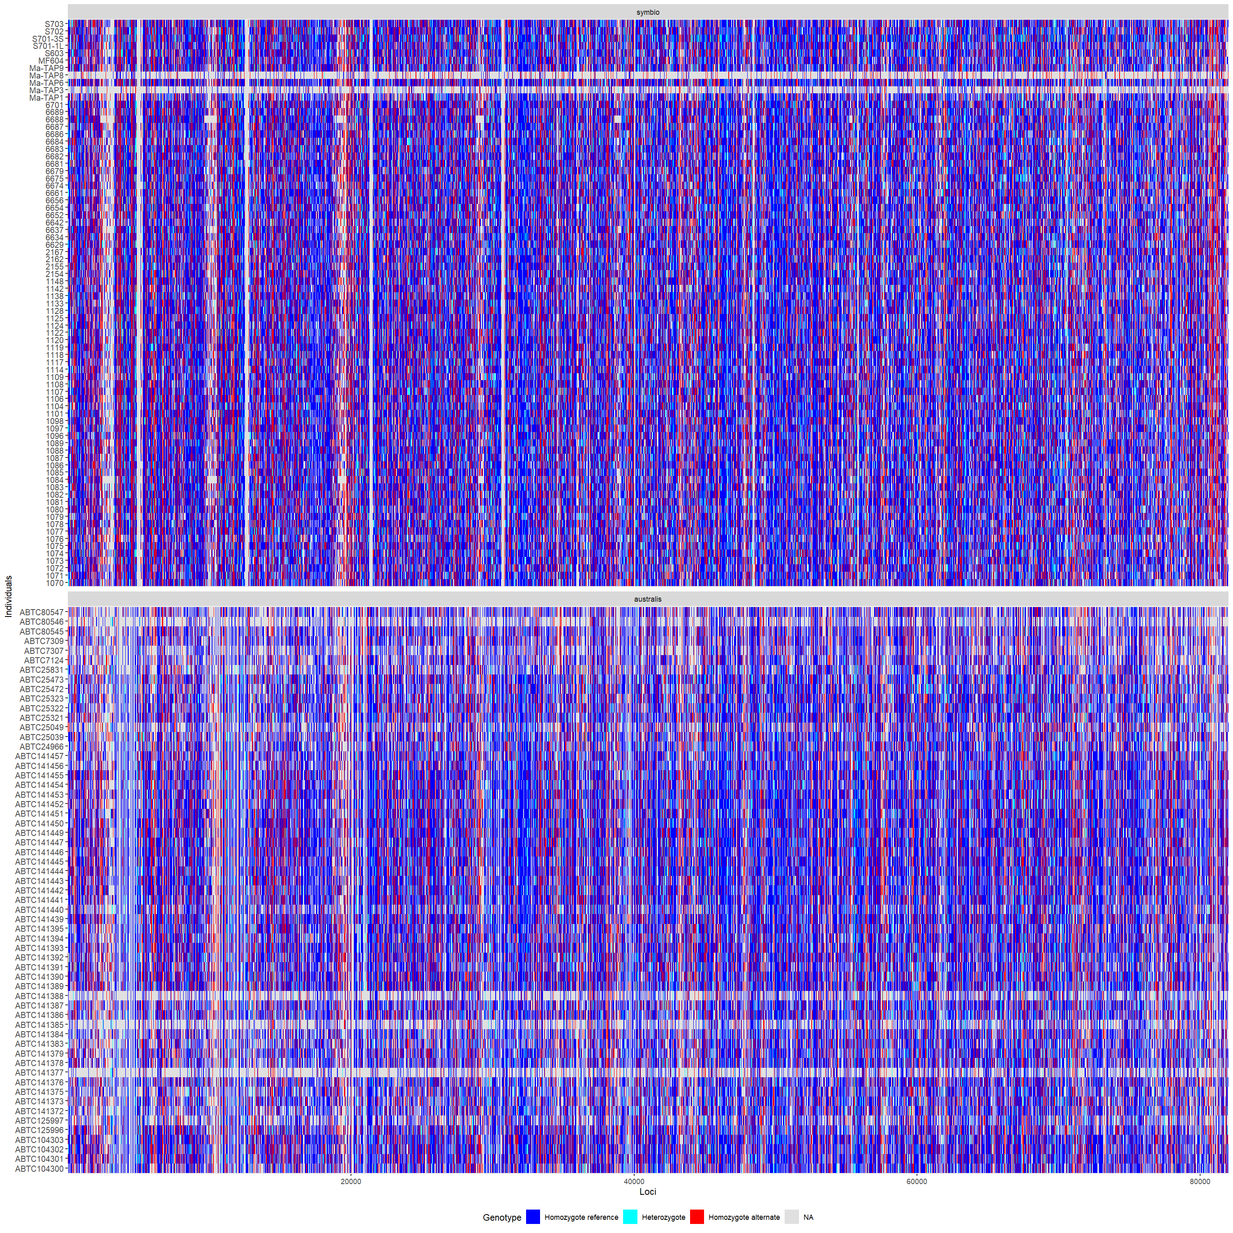
Figure S1: Smearplots comparing loci from both datasets. Top: conservation dataset, bottom: wild dataset.

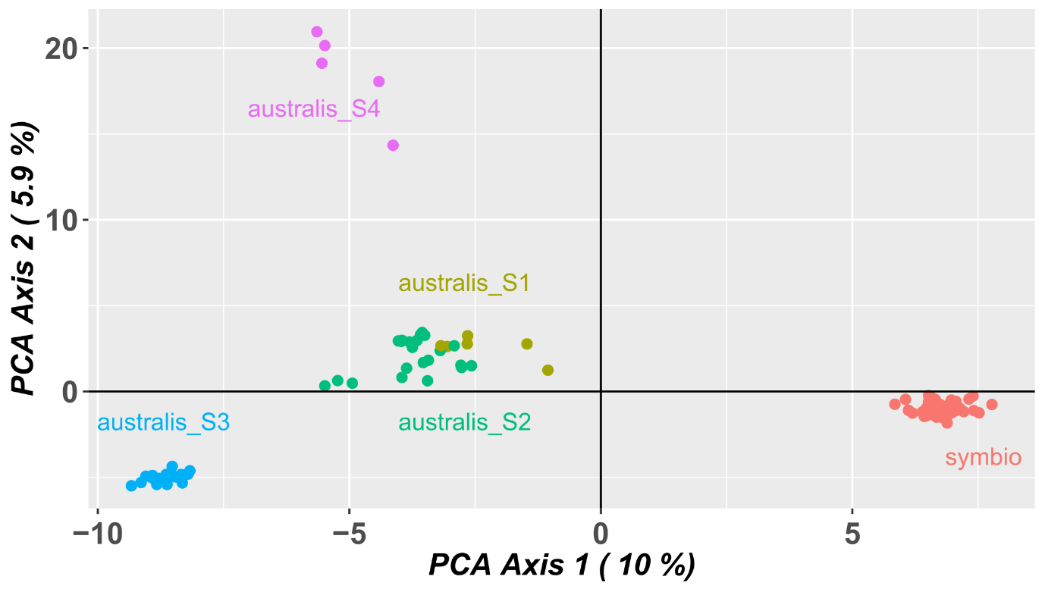
Figure S2: Results of a Principal Coordinates Analysis (PCoA) for combined dataset. Visual inspection shows great differentiation between conservation ‘Symbio’ and wild populations ‘australis S1-4’) (axis 1 = 10%, axis 2 = 5.9%). Figure created in R using dartRverse package.

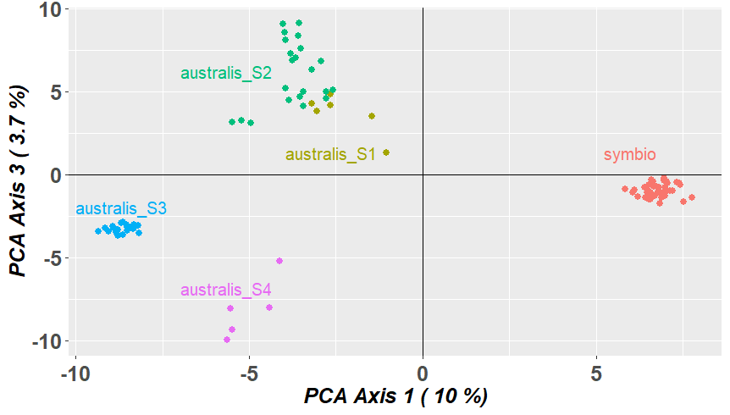
Figure S3: Results of a Principal Coordinates Analysis (PCoA) for combined dataset (Axes 1 and 3). Visual inspection shows great differentiation between conservation ‘Symbio’ and wild populations ‘australis S1-4’) (axis 1 = 10%, axis 2 = 3.7%). Figure created in R using dartRverse package.

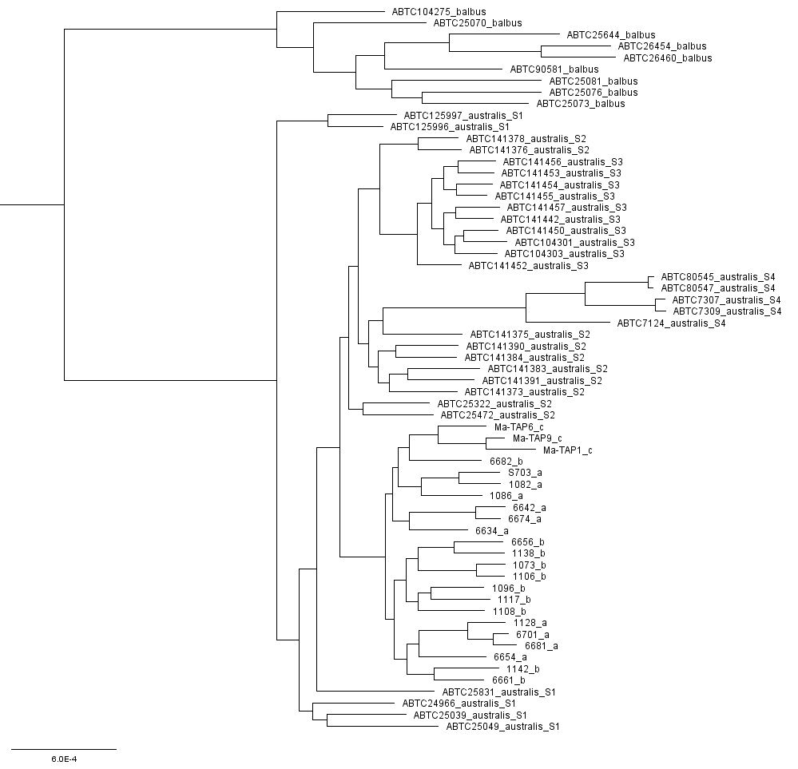
Figure S4: Maximum likelihood phylogenetic tree created using IQ-TREE. Populations denoted by suffix on each individual ID. Mixophyes balbus utilised as outgroup.

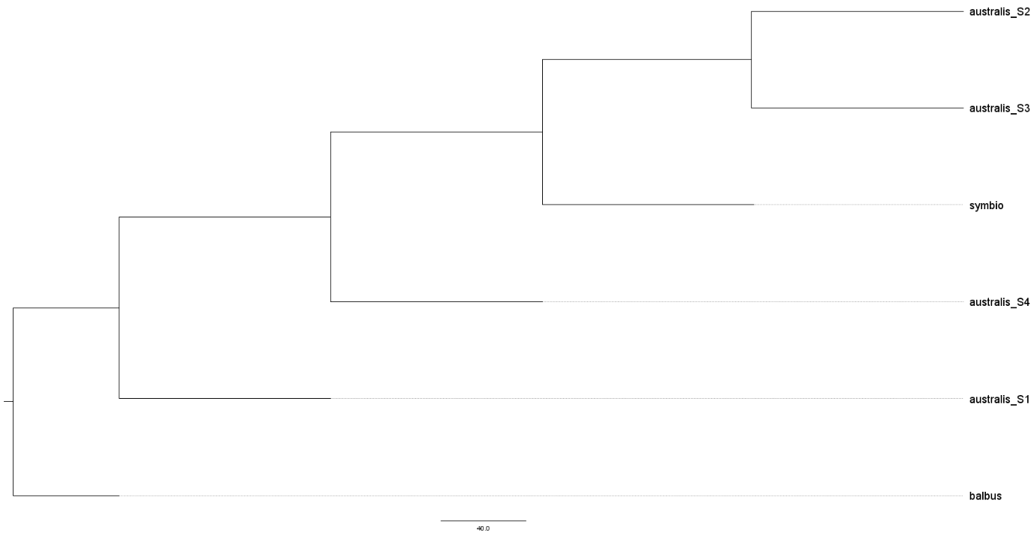
Figure S5: SVDQ tree of wild and conservation datasets combined. Conservation populations A and B combined and named ‘Symbio’. M. balbus utilised as an outgroup.

Table S1: Table of F_{ST} values between of wild and conservation populations. Bottom triangle shows F_{ST} values and top triangle shows P-values (100 bootstraps).
 | M. balbus | S1 | S2 | S3 | S4 | A+B
M. balbus | - | 0 | 0 | 0 | 0 | 0
S1 | 0.418675 | - | 0 | 0 | 0 | 0
S2 | 0.508816 | 0.115958 | - | 0 | 0 | 0
S3 | 0.579867 | 0.219414 | 0.130668 | - | 0 | 0
S4 | 0.567485 | 0.34545 | 0.321789 | 0.447325 | - | 0
A+B | 0.500709 | 0.15234 | 0.118553 | 0.186482 | 0.333677 | -

Table S2: Table of fixed differences for the combined dataset. Bottom triangle: number of fixed differences, top triangle: P-values (100 bootstraps).
 | A+B | S1 | S2 | S3 | S4 | M. balbus
A+B | - | 0 | 0 | 0 | 0 | 0
S1 | 94 | - | 1 | 0.99 | 0.97 | 0
S2 | 94 | 0 | - | 0.65 | 0 | 0
S3 | 94 | 3 | 0 | - | 0 | 0
S4 | 146 | 97 | 58 | 89 | - | 0
M. balbus | 346 | 264 | 305 | 308 | 558 | -

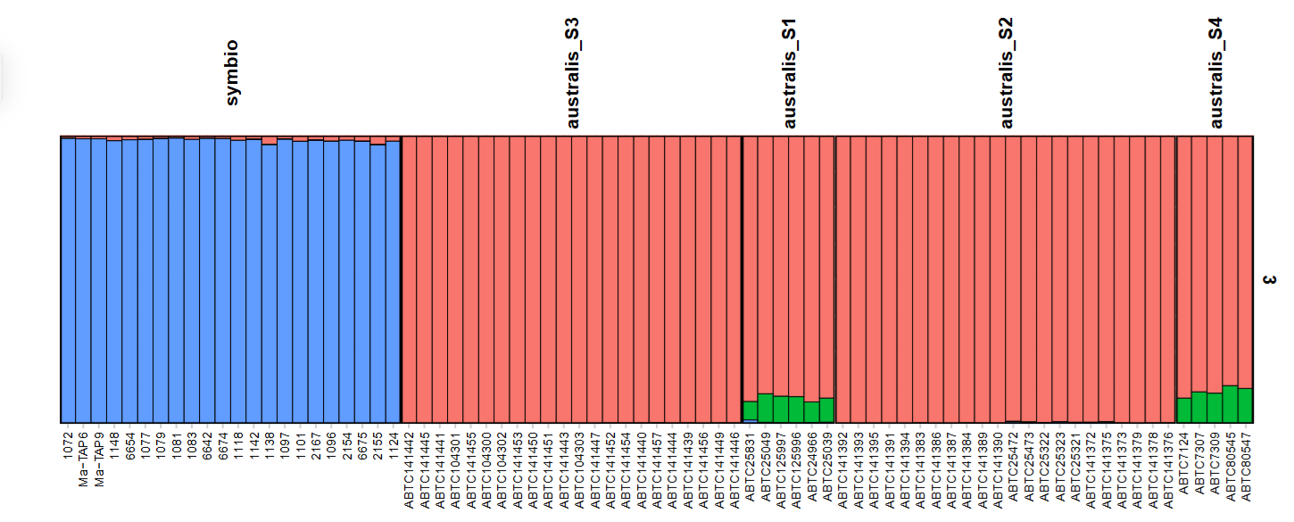
Figure S6: Ancestry coefficients for each individual in conservation and wild combined dataset estimated via STRUCTURE, allowing admixture, without correlated frequency. Colours denote genetic clusters (K=3).
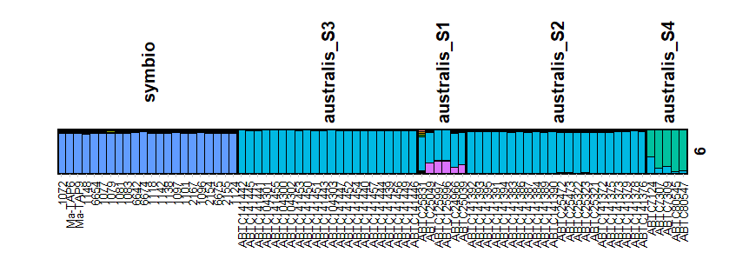
Figure S7: Ancestry coefficients for each individual in conservation and wild combined dataset estimated via STRUCTURE, allowing admixture, with correlated frequency. Colours denote genetic clusters (K=6).

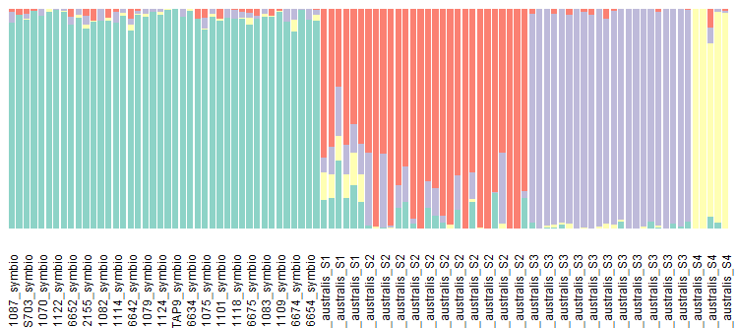
Figure S8: Ancestry coefficients for each individual in conservation and wild combined dataset estimated via sNMF. Colours denote genetic clusters (K=4).

B: Filtering strategy
Changes to the default filtering pipeline are detailed in Table S1. Population structure analyses for the wild population were unchanged from the default pipeline whereas the conservation population dataset had an increased threshold for loci call rate due to the higher number of loci recovered for this dataset (17611 versus 7227 loci after filtering). For the population clustering analysis using STRUCTURE we filtered out loci under linkage disequilibrium using function ‘gl.filter.ld’ as STRUCTURE assumes loci are unlinked. For diversity analyses, loci with a call rate below 99% were removed as these methods are also sensitive to missing data but are still robust with fewer loci. For heterozygosity estimates each population was subset to 5 individuals and filtered separately following recommendations by Sopniewski and Catullo (2024). For the estimation of autosomal heterozygosity, this dataset was not filtered for secondaries as this method requires secondaries for estimation of invariant loci. For relatedness analyses population 3 (the reintroduced population) was removed as it is not part of the conservation breeding program and represents a generation released prior to the establishment of the program. Loci with call rate below 95% were removed for relatedness analyses as the conservation dataset had more loci to work with than the combined wild and conservation datasets. A subset of the conservation founders containing the 26 unreleased individuals retained for conservation breeding was also filtered separately.
Table S3: Table outlining changes to default filtering strategy and resultant number of loci and individuals, based on the dataset used and analysis method.
Analysis method | Dataset used | Changes to default filtering strategy | Number of loci after filtering | Number of individuals after filtering
Population structure (conservation) | Conservation population | Loci call rate increased (SNPs with <95% removed) | 17611 | 75
Population structure (wild) | Wild population | None | 7227 | 57
Population structure - STRUCTURE (wild) | Wild population | Filtered out loci under linkage disequilibrium using function ‘gl.filter.ld’ | 6992 | 57
Diversity | Conservation + Wild combined | Loci call rate increased (SNPs with <99% removed) | 4131 | 130
Diversity (heterozygosity) | Conservation + Wild combined | Each population subset to 5 individuals and filtered individually. Loci call rate increased (SNPs with <99% removed) | between 2000-5000 | 5 per population (C only consists of 3)
Diversity (autosomal heterozygosity) | Conservation + Wild combined | Each population subset to 5 individuals and filtered individually. Loci call rate increased (SNPs with <99% removed). No secondaries filter (for estimation of invariant loci) | Between 1000-5000 | 5 per population (C only consists of 3)
Relatedness | Conservation population | Population C removed. Loci call rate increased (SNPs with <95% removed) | 19050 | 72
Relatedness (breeders) | Conservation population | Filtered to individuals retained for conservation breeding. Loci call rate increased (SNPs with <95% removed) | 17044 | 26

C: Supplementary figures for the main manuscript
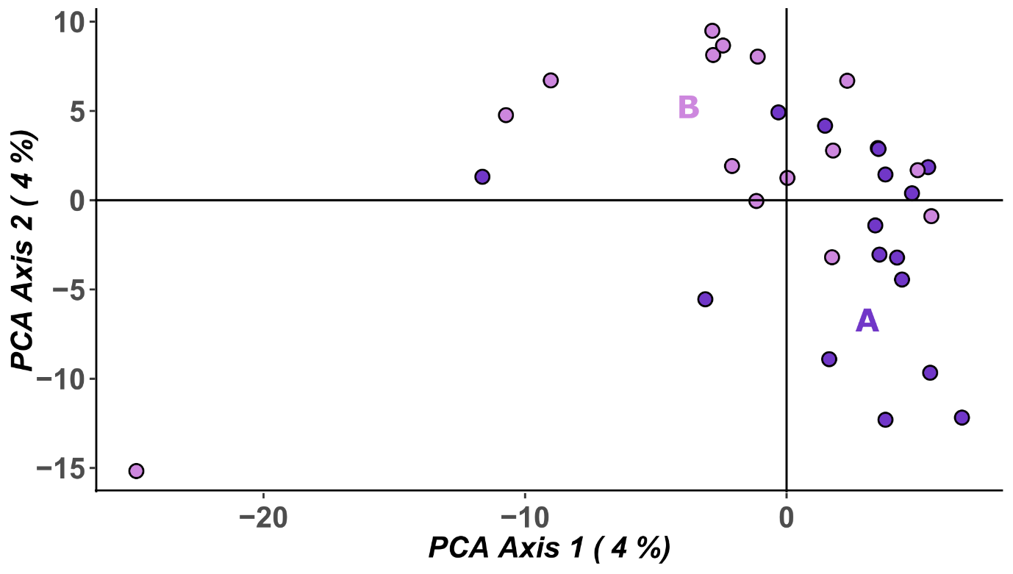
Figure S9: Results of a Principal Coordinates Analysis (PCoA) on the conservation breeding population with parent-offspring filter applied. Visual inspection shows little evidence of genetic structure or differentiation between populations (axis 1 = 4%, axis 2 = 4%).

Table S4: Table of fixed differences between conservation populations A, B and reintroduced population R1. Bottom triangle shows number of fixed differences and top triangle shows P-values (100 bootstraps).
 | A | B | R1
A | - | 0.5146 | 1
B | 0 | - | 1
R1 | 0 | 0 | -

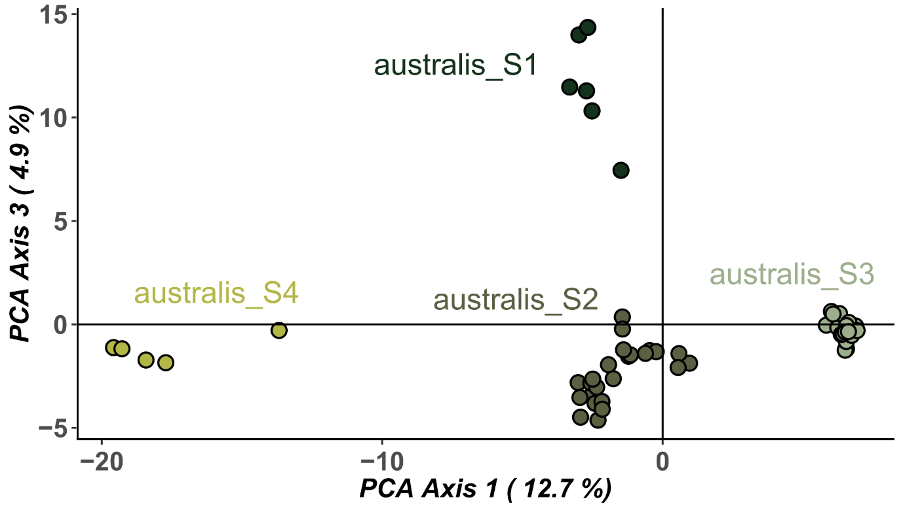
Figure S10: Results of a Principal Coordinates Analysis (PCoA) for wild populations S1-4. Visual inspection shows some genetic structure and differentiation between populations (axis 1 = 12.7%, axis 3 = 4.9%).

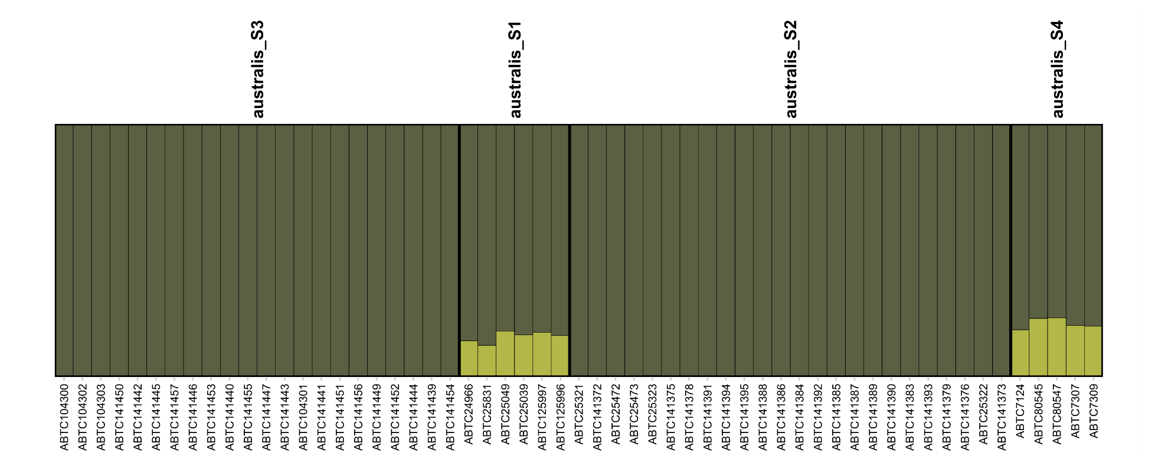
Figure S11: Ancestry coefficients from STRUCTURE analysis using admixture model with uncorrelated allele frequency (K=2). Individuals organised by population.

Table S5: Heterozygosity values for populations A and B of Symbio’s conservation breeding program founders.
Population | n | Ho (+- SE) | He (+- SE) | FIS (+- SE)
A | 35 | 0.294 (0.003) | 0.303 (0.002) | 0.099 (0.006)
B | 37 | 0.315 (0.003) | 0.312 (0.002) | 0.072 (0.006)

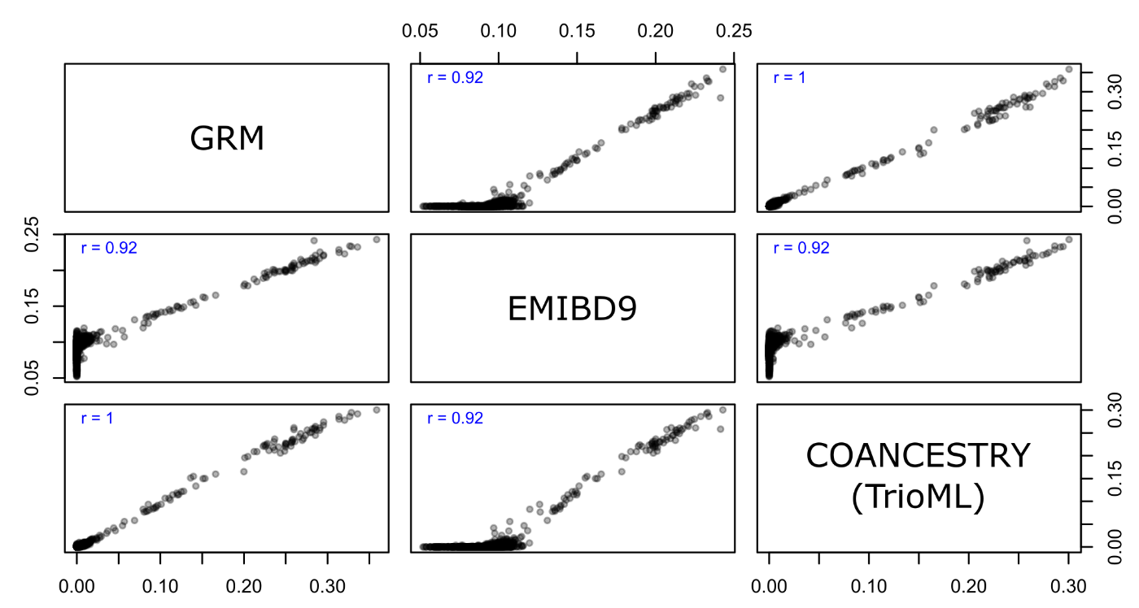
Figure S12: Pairwise scatterplot matrix, with correlation coefficients, comparing estimates for each pairwise comparison across GRM, EMIBD9 and TrioML methods.

D: Government and policy
From a NSW Government perspective, the ‘Plan for Nature’ and the ‘NSW Biodiversity Conservation Strategy’ focus on conserving biodiversity across landscapes and maintaining the resilience of species within those landscapes. Where genetic sampling is insufficient to support detailed population genomic analyses, identifying phylogenetic clades provides a practical means of recognising and conserving geographically distinct evolutionary lineages, helping to retain phylogenetic diversity across a species' range. This approach supports strategic conservation planning by providing an ecologically meaningful framework for assessing the relative vulnerability of different clades and strengthening our ability to identify, monitor and report on threats that may affect their long-term persistence. Continued genetic sampling across the geographic range of threatened species such as Mixophyes australis is essential for adaptive conservation management. As additional samples become available, they provide an increasingly robust evidence base for monitoring changes in genetic diversity, population structure and connectivity through time, detecting emerging genetic risks such as isolation or loss of diversity, and evaluating the effectiveness of management interventions. Ongoing genetic monitoring therefore enables conservation actions to be refined as new information becomes available, ensuring that management remains responsive to changing environmental conditions and supports the long-term evolutionary resilience of the species.

Reference list
Chifman, J., Kubatko, L., 2014. Quartet Inference from SNP Data Under the Coalescent Model. Bioinformatics 30, 3317–3324. https://doi.org/10.1093/bioinformatics/btu530
Dokan, K., Kawamura, S., Teshima, K.M., 2021. Effects of single nucleotide polymorphism ascertainment on population structure inferences. G3 Genes|Genomes|Genetics 11, jkab128. https://doi.org/10.1093/g3journal/jkab128
Lachance, J., Tishkoff, S.A., 2013. SNP ascertainment bias in population genetic analyses: Why it is important, and how to correct it. BioEssays 35, 780–786. https://doi.org/10.1002/bies.201300014
Lou, R.N., Therkildsen, N.O., 2022. Batch effects in population genomic studies with low‐coverage whole genome sequencing data: Causes, detection and mitigation. Molecular Ecology Resources 22, 1678–1692. https://doi.org/10.1111/1755-0998.13559
Mahony, M.J., Bertozzi, T., Guzinski, J., Hines, H.B., Donnellan, S.C., 2023. A new species of barred frog, Mixophyes (Anura: Myobatrachidae) from south-eastern Australia identified by molecular genetic analyses. Zootaxa 5297, 301–336. https://doi.org/10.11646/zootaxa.5297.3.1
Minh, B.Q., Schmidt, H.A., Chernomor, O., Schrempf, D., Woodhams, M.D., Von Haeseler, A., Lanfear, R., 2020. IQ-TREE 2: New Models and Efficient Methods for Phylogenetic Inference in the Genomic Era. Molecular Biology and Evolution 37, 1530–1534. https://doi.org/10.1093/molbev/msaa015
Nazareno, A.G., Bemmels, J.B., Dick, C.W., Lohmann, L.G., 2017. Minimum sample sizes for population genomics: an empirical study from an Amazonian plant species. Molecular Ecology Resources 17, 1136–1147. https://doi.org/10.1111/1755-0998.12654
Rafalski, J.A., 2011. Genomic tools for the analysis of genetic diversity. Plant Genet. Res. 9, 159–162. https://doi.org/10.1017/S1479262111000104
Sopniewski, J., Catullo, R.A., 2024. Estimates of heterozygosity from single nucleotide polymorphism markers are context‐dependent and often wrong. Molecular Ecology Resources 24, e13947. https://doi.org/10.1111/1755-0998.13947
Yang, Z., Rannala, B., 2012. Molecular phylogenetics: principles and practice. Nat Rev Genet 13, 303–314. https://doi.org/10.1038/nrg3186
Yi, X., Latch, E.K., 2022. Nonrandom missing data can bias Principal Component Analysis inference of population genetic structure. Molecular Ecology Resources 22, 602–611. https://doi.org/10.1111/1755-0998.13498

