A selective resonance Rayleigh scattering method for trace vitamin B2 based on molecularly imprinted nanosilver probe
Yue Luo^{1,2}, Dan Li^{1,2}, Chongning Li^{1,2*}, Guiqing Wen^{1,2}, Aihui Liang^{1,2*}，Zhiliang Jiang^{1,2*}
¹ Key Laboratory of Ecology of Rare and Endangered Species and Environmental Protection (Guangxi Normal University), Ministry of Education, Guilin 541004, China;
² Guangxi Key Laboratory of Environmental Pollution Control Theory and Technology, Guilin 541004, China.

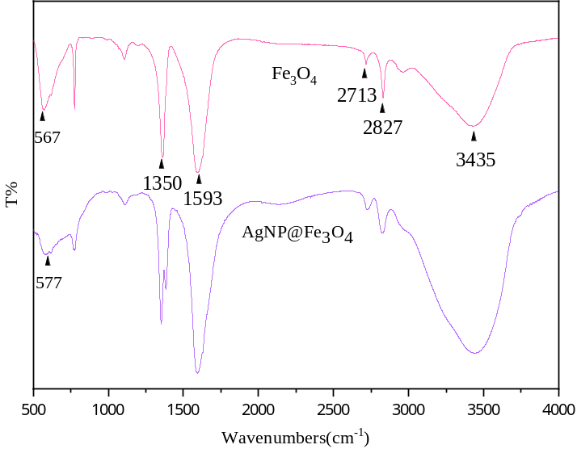
Figure S1 Fourier transform infrared spectra of Fe₃O₄ and Fe₃O₄@AgNP

A | B
C | D
E | F
Figure S2 RRS and Abs spectra of Fe₃O₄@AgNP, Fe₃O₄ and AgNP
A: RRS spectra of Fe₃O₄@AgNP (5, 10, 15, 20, 25, 30, 35 mg/L); B: Abs spectra of Fe₃O₄@AgNP (5, 10, 15, 20, 25, 30, 35 mg/L); C: RRS spectra of Fe₃O₄ (5, 10, 15, 20, 25, 30, 35 mg/L); D: Abs spectra of Fe₃O₄ (5, 10, 15, 20, 25, 30, 35 mg/L); E: RRS spectra of AgNP (17.3, 21.6, 25.9, 30.2, 34.6, 38.9, 43.2 mg/L); F: Abs spectra of AgNP (4.3, 6.5, 8.6, 13.0, 17.3, 21.6 mg/L).
The arrow represents concentration from low to high.

Figure S3 Stability of 25 mg/L Fe₃O₄ _{50nm}@AgNP nanosol.

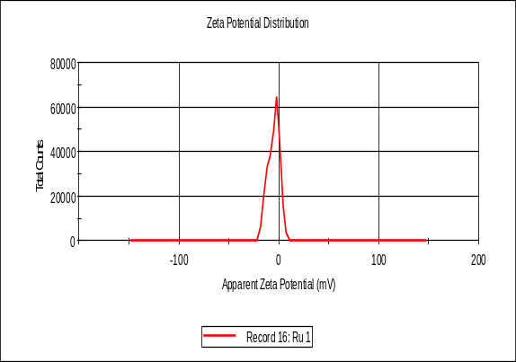  -5.09mV  A | 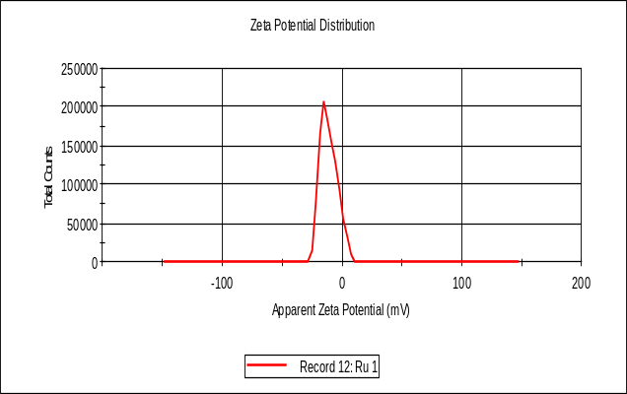  B  -10.9mV
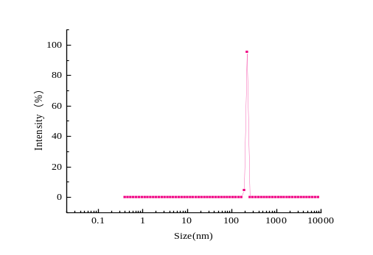
Figure S4 Zeta potential and particle size analysis of Fe₃O₄@AgNP, AgNP and Fe₃O₄
A: Potentiometric distribution diagram of 0.05 g/L Fe₃O₄; B: Potentiometric distribution diagram of 0.10 g/L Fe₃O₄@AgNP; C: Particle size distribution diagram of 0.10 g/L Fe₃O₄@AgNP

A  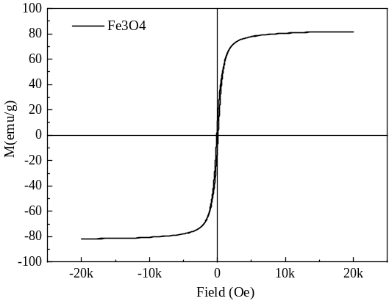 | B  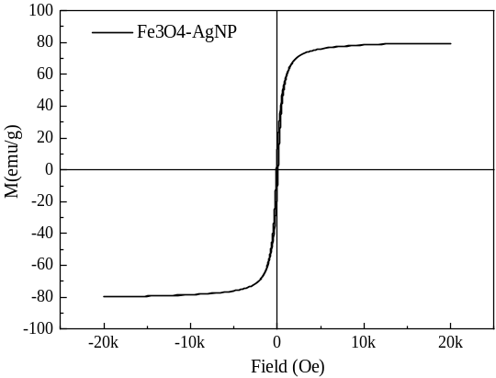
Figure S5 Hysteresis curve
A: Fe₃O₄; B: AgNP@Fe₃O₄.

Figure S6 Absorption spectra of Fe₃O₄@AgNP elution
Rinse frequency from the first to the fifth time.

A | B
C | D
E | F
Figure S7 Selection of preparation conditions for Fe₃O₄@AgNP
A: 0.04 mmol VB₂, Fe₃O₄ (10, 25, 35, 45, 55) mmol, 0.02 mmol AgNO₃, 0.2 mmol sodium citrate, 0.6 mmol H₂O₂, 0.06 mmol NaBH₄, 10 min, 250 ℃; B: 0.04 mmol VB₂, 35 mg Fe₃O₄, AgNO₃ (0.01, 0.02, 0.03, 0.04) mmol, 0.2 mmol sodium citrate, 0.6 mmol H₂O₂, 0.06 mmol NaBH₄, 10 min, 250 ℃; C: 0.04 mmol VB₂, 35 mg Fe₃O₄, 0.02 mmol AgNO₃, 0.2 mmol sodium citrate (0.05, 0.1, 0.2, 0.3,0.4)mmol, 0.6 mmol H₂O₂, 0.06 mmol NaBH₄, 15 min, 250 ℃; D: 0.04 mmol VB₂, 35 mg Fe₃O₄, 0.02 mmol AgNO₃, 0.3 mmol sodium citrate, H₂O₂ ( 0.2, 0.4, 0.6, 0.8, 1), 0.06 mmol NaBH₄, 15 min, 250 ℃; E: 0.04 mmol VB₂, 35 mg Fe₃O₄, 0.02 mmol AgNO₃, 0.3 mmol sodium citrate, 0.6 mmol H₂O₂, 0.06 mmol NaBH₄, 15 min, 250 ℃; F: 0.04 mmol VB₂, 35 mg Fe₃O₄, 0.02 mmol AgNO₃, 0.3 mmol sodium citrate, 0.6 mmol H₂O₂, 0.06 mmol NaBH₄, 15 min, temperature (210, 220, 230, 240, 250) ℃;

A | B  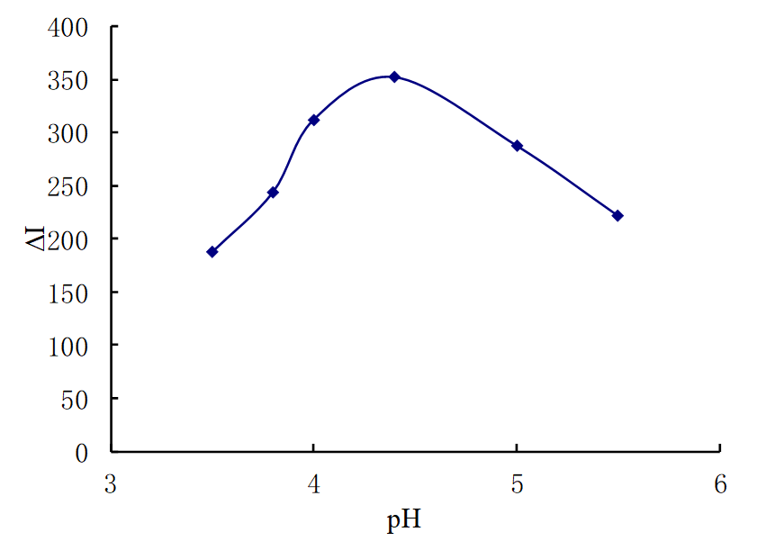
Figure S8 Condition optimization of Fe₃O₄@AgNP analysis system.
A: Effect of Fe₃O₄@AgNP; B: Effect of pH.

Table S1 The influence of foreign substance on the RRS determination
Foreign substance | Multiple | Relative error  (%) | Foreign substance | Multiple | Relative error  (%)
Mn²⁺ | 1000 | -6.5% | Cd²⁺ | 1000 | -3.7%
Mg²⁺ | 1000 | 7.5% | As³⁺ | 1000 | 5.3%
CO₃²⁻ | 1000 | 4.1% | SO₄²⁻ | 1000 | -8.1%
NO₂⁺ | 1000 | 5.4% | Fe³⁺ | 900 | -6.3%
Ni²⁺ | 1000 | 4.3% | Vitamin B₆ | 1000 | 6.7%
I⁻ | 1000 | 0.86% | Nicotinamide | 1000 | 2.1%

