Table S1. Differences in sediment physicochemical properties among sampling sites.
Sites | AK | AP | CEC | DOC | Moisture | NH₄⁺-N | NO₃⁻-N | pH | SOC | TK | TN | TP
GDK | 161.3±9.49a | 46.35±6.88a | 17.72±1.27a | 282.16±10.23a | 47.49±1.21a | 40.5±11.93a | 0.45±0.01ab | 7.75±0.07c | 12.85±0.71a | 25.37±0.24b | 1.41±0.03a | 0.86±0.02c
XXH | 137.6±7.28b | 41.69±1.57a | 15.18±1.11b | 202.31±19.79c | 44.2±5.13a | 42.82±10.24a | 0.42±0.04b | 8.1±0.03a | 11.13±0.26b | 26.71±0.98a | 1.21±0.08b | 0.93±0.01a
MH | 142.4±38.64b | 42.35±9.87a | 16.49±3.59ab | 233.11±65.42b | 47.85±9.97a | 21.29±3.67b | 0.48±0.12ab | 8.07±0.06a | 10.41±0.92c | 25.63±2.33b | 1.15±0.22b | 0.94±0.01a
HLM | 104.3±2.67c | 32.32±0.71b | 9.13±0.67c | 134.34±10.84d | 29.57±1.17b | 37.71±2.91a | 0.5±0.02a | 7.93±0.06b | 11.29±0.18b | 21.5±0.2c | 0.86±0.03c | 0.9±0.03b
NJG | 83.9±6.42d | 25.28±1.48c | 7.45±0.71d | 105.45±8.86e | 30.6±1.69b | 19.23±3.76b | 0.31±0.04c | 7.95±0.1b | 9.11±0.21d | 20.39±0.15d | 0.7±0.02d | 0.87±0.04c
Data are presented as mean ± SD (n = 10). Different lowercase letters indicate significant differences among sampling sites (Fisher’s LSD test, p < 0.05)
Table S2. Differences in sediment physicochemical properties between upstream and downstream sediments of the Three Gorges Dam.
 | Upstream | Downstream | Change (%) | T-value | df | p-value
Moisture | 46.51±6.50 | 30.09±1.51 | 35.32 | 13.315 | 33.53 | <0.001 | ***
NO₃⁻-N | 0.45±0.07 | 0.40±0.10 | 10.65 | 1.780 | 31.00 | 0.0848
NH₄⁺-N | 34.87±13.31 | 28.47±10.03 | 18.35 | 1.936 | 47.19 | 0.0589
pH | 7.97±0.17 | 7.94±0.08 | 0.43 | 0.956 | 44.23 | 0.344
SOC | 11.46±1.24 | 10.20±1.13 | 11.02 | 3.728 | 43.34 | <0.001 | ***
DOC | 239.19±51.00 | 119.89±17.68 | 49.88 | 11.795 | 38.49 | <0.001 | ***
TN | 1.26±0.17 | 0.78±0.09 | 37.84 | 12.773 | 45.36 | <0.001 | ***
TP | 0.91±0.04 | 0.89±0.04 | 2.70 | 2.109 | 43.39 | 0.0408 | *
TK | 25.90±1.53 | 20.95±0.60 | 19.13 | 15.987 | 40.54 | <0.001 | ***
AP | 43.47±7.08 | 28.80±3.79 | 33.73 | 9.492 | 46.24 | <0.001 | ***
AK | 147.10±24.82 | 94.10±11.51 | 36.03 | 10.171 | 43.77 | <0.001 | ***
CEC | 16.46±2.45 | 8.29±1.09 | 49.64 | 16.034 | 43.04 | <0.001 | ***
Data are presented as mean ± SD. Group differences were assessed using Welch’s t-test. Change (%) denotes the absolute percentage change of the downstream group relative to the upstream group (reference), calculated as |(downstream − upstream)/upstream| × 100%. Significance levels: *** p < 0.001; ** p < 0.01; * p < 0.05; ns, not significant.

Table S3. Differences in viral abundance and α-diversity between upstream and downstream sediments of the Three Gorges Dam.
 | Upstream | Downstream | Change (%) | T-value | df | p-value | Sig.
Abundance | 6.05±2.81×10⁹ | 2.41±1.23×10⁹ | 60.08 | 6.233 | 42.65 | <0.001 | ***
Shannon diversity (H′) | 1.84±0.05 | 1.74±0.06 | 5.38 | 5.992 | 31.85 | <0.001 | ***
Richness index | 213.27±5.82 | 208.60±5.40 | 2.19 | 2.901 | 42.92 | 0.00585 | **
Pielou’s evenness (J′) | 0.34±0.01 | 0.33±0.01 | 4.99 | 5.739 | 30.85 | <0.001 | ***
Data are presented as mean ± SD. Group differences were assessed using Welch’s t-test. Change (%) denotes the absolute percentage change of the downstream group relative to the upstream group, calculated as |(downstream − upstream)/upstream| × 100%. Significance: *** p < 0.001; ** p < 0.01; * p < 0.05; ns, not significant.

Table S4. Differences in bacterial abundance and α-diversity between upstream and downstream sediments of the Three Gorges Dam.
 | Upstream | Downstream | Change (%) | T-value | df | p-value | Sig.
Abundance | 6.43±3.38×10¹¹ | 2.47±0.99×10¹¹ | 61.56 | 6.030 | 36.09 | <0.001 | ***
Shannon diversity (H′) | 7.54±0.05 | 7.34±0.07 | 2.66 | 10.758 | 31.85 | <0.001 | ***
Richness index | 31311.70±359.50 | 30876.00±279.95 | 1.39 | 4.804 | 46.73 | <0.001 | ***
Pielou’s evenness (J′) | 0.73±0.00 | 0.71±0.01 | 2.53 | 10.251 | 31.60 | <0.001 | ***
Data are presented as mean ± SD. Group differences were assessed using Welch’s t-test. Change (%) denotes the absolute percentage change of the downstream group relative to the upstream group, calculated as |(downstream − upstream)/upstream| × 100%. Significance: *** p < 0.001; ** p < 0.01; * p < 0.05; ns, not significant.

Table S5. Significance analyses of the effects of sampling sites and the dam on viral community composition and structure based on three statistical methods.
Effect factors | adonis* |  | ANOSIM^{ǂ} |  | MRPP§
Effect factors | F | p& | R | p& | δ | p&
Sampling sites | 18.09 | < 0.001 | 0.46 | < 0.001 | 0.38 | < 0.001
Dams | 28.09 | < 0.001 | 0.40 | < 0.001 | 0.21 | < 0.001
All three tests are non-parametric multivariate analyses based on between-sample dissimilarity.
adonis (PERMANOVA), permutational multivariate analysis of variance based on a distance matrix, with F as the pseudo-F statistic; the R statistic of ANOSIM indicates the degree of between-group separation; δ of MRPP is the mean within-group distance. All p-values were obtained from permutation tests (999 permutations).

Table S6. Differences in topological parameters of the virus–bacteria co-occurrence networks between upstream and downstream sediments of the Three Gorges Dam.
Variable | Upstream | Downstream | Change (%) | T-value | df | p-value | Sig.
Node | 17907.07±3289.34 | 9478.15±644.69 | 47.07 | 13.648 | 32.27 | <0.001 | ***
Edge | 112380.33±49909.50 | 43359.45±1972.02 | 61.42 | 7.566 | 29.14 | <0.001 | ***
Positive edge | 112374.07±49906.35 | 43350.50±1975.00 | 61.42 | 7.566 | 29.14 | <0.001 | ***
Average density (1×10⁴) | 6.63±0.78 | 9.84±1.77 | 48.44 | -7.642 | 24.05 | <0.001 | ***
Diameter | 14.93±1.26 | 16.00±0.00 | 7.14 | -4.646 | 29.00 | <0.001 | ***
Average path length | 4.32±0.34 | 5.29±0.82 | 22.61 | -5.035 | 23.30 | <0.001 | ***
Data are presented as mean ± SD. Group differences were assessed using Welch’s t-test. Change (%) denotes the absolute percentage change of the downstream group relative to the upstream group (reference), calculated as |(downstream − upstream)/upstream| × 100%. Significance: *** p < 0.001; ** p < 0.01; * p < 0.05; ns, not significant.

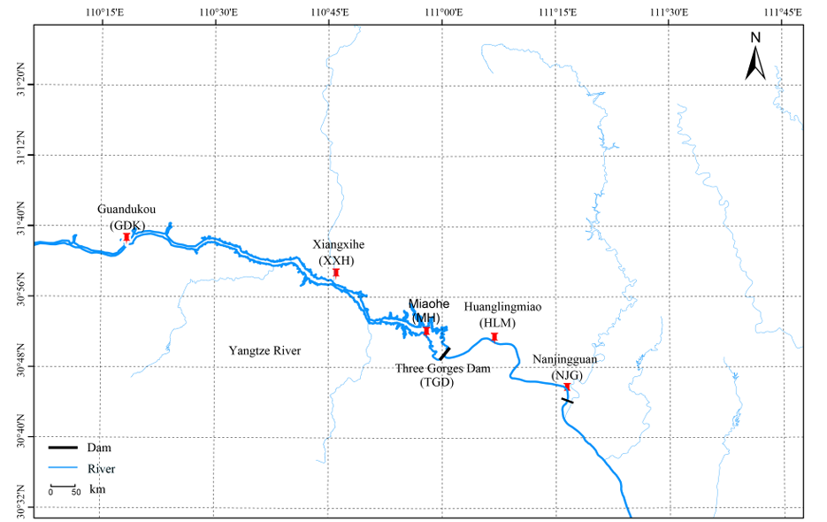
Fig. S1. Overview of the sampling area, showing the geographic locations of the five sampling sites along the upstream–downstream gradient of the Three Gorges Dam (upstream: GDK, XXH, MH; downstream: HLM, NJG).

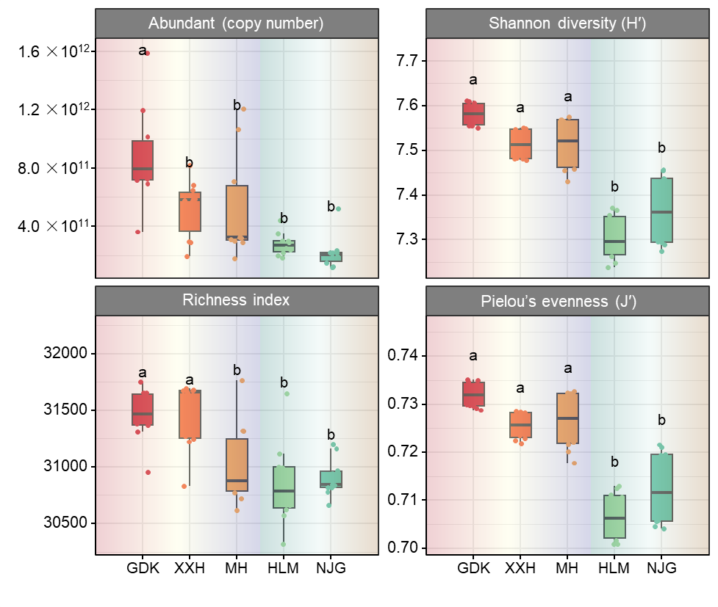
Fig. S2. Diversity analysis of bacterial communities at the different sampling sites. Abundance: the absolute abundance of the bacterial community. Shannon diversity index (H′): the diversity of the bacterial community. Richness index: species richness of the bacterial community. Pielou’s evenness index (J′): the evenness of species distribution within the bacterial community. Different lowercase letters indicate significant differences among sampling sites.

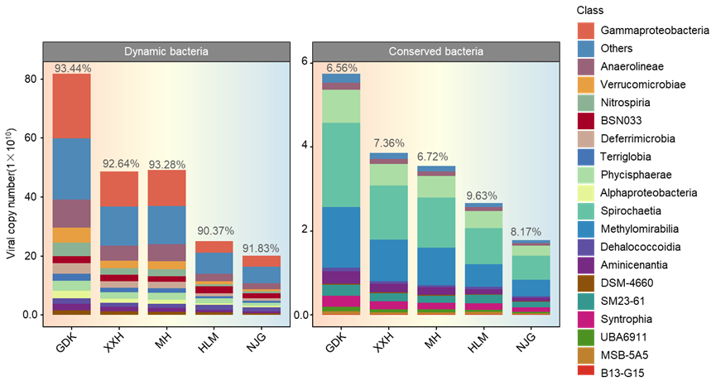
Fig. S3. Distribution of dynamic and conserved bacterial taxa at the different sampling sites.

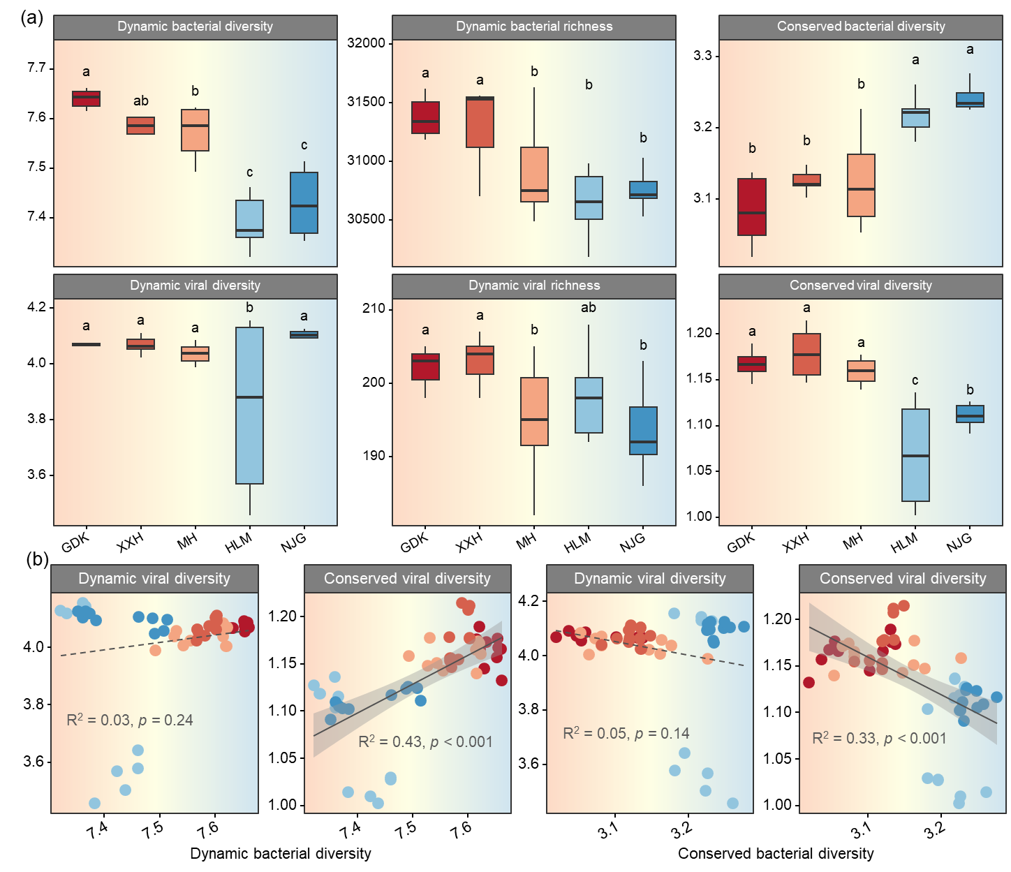
Fig. S4. Diversity of bacterial and viral communities and their correlation analyses. (a) Diversity and richness of the dynamic and conserved bacterial and viral communities at the different sampling sites; (b) correlation analyses between bacterial and viral diversity.

Fig. S5. Conserved interaction network between bacteria and viruses.

