Supplementary Information
A Clinically Translatable Passive Microfluidic Workflow for Human Sperm Preparation Across Variable Baseline Sperm Concentrations
Damir Mukhamedyarov^{1,2,3}, Almas Rakhymzhanov⁴, Shyray Ashimova^{1,2}, Alina Abdykadyr¹, Sergey Yegorov¹, Dinara Makhadiyeva³, Gulsim Kulsharova¹*
¹ Nazarbayev University, Astana, Kazakhstan
² Eurasian National University, Astana, Kazakhstan
³ EcoMed Plus Clinic for Reproductive Medicine, Astana, Kazakhstan
⁴ KAUST Core Labs, King Abdullah University of Science & Technology, Thuwal, Saudi Arabia

Supplementary Information
This file contains supplementary methods, computational modelling details, supplementary results, and supplementary figures supporting the main manuscript.

Supplementary Methods
Video of a microfluidic chip operation is provided as a separate .mov file

S1. Microfluidic device architecture and fabrication
The passive microfluidic device comprised three functional chambers: a proximal loading chamber for introducing semen, a lateral waste chamber for collecting excess sample, and a distal collection chamber for recovering selected sperm. The loading and collection chambers were interconnected by an array of 200 parallel microchannels engraved into the bottom PMMA substrate. Each microchannel was 20 mm long, 130 μm deep, and 200 μm wide. The 20-mm channel length was selected to provide sufficient migration distance for passive motility-based selection while maintaining a stable fluidic interface during loading and sperm recovery. During initial device tuning, shorter channels were more susceptible to liquid instability during manual loading and collection, resulting in less consistent operation. The 200-channel configuration represented the highest channel density consistently achievable while maintaining dimensional accuracy over the available device area. Adjacent channels were spaced at approximately 250 μm center-to-center, corresponding to the effective laser spot size and fabrication resolution and minimizing thermal overlap between adjacent laser passes.
a 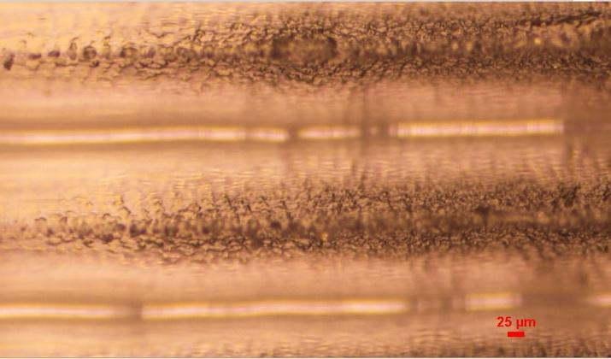 | b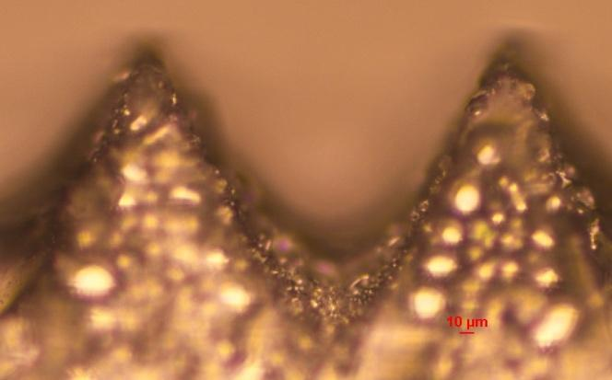
c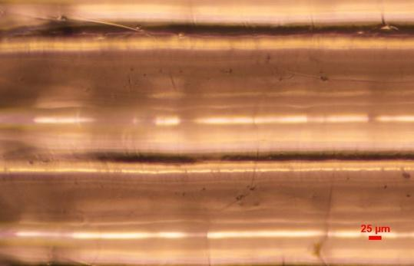 | d
Figure S1. Optical characterization of the laser-fabricated channel surface before and after chloroform-vapour treatment. a, untreated channel surface, top view; b, untreated channel surface, side view; c, chloroform-treated surface, top view; d, chloroform-treated surface, side view.

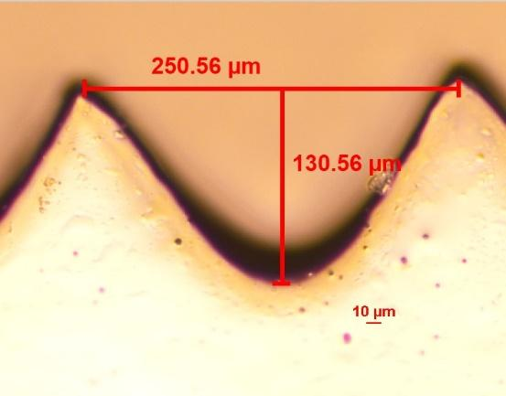
The three PMMA layers were aligned and thermally bonded in a programmable oven under light uniaxial compression. The thermal cycle consisted of heating to 137 °C over 30 min, holding at 137 °C for 30 min, and cooling to room temperature. Following bonding, assembled devices were inspected for visible defects, leakage and delamination. No fluid leakage or delamination was observed in the assembled devices.

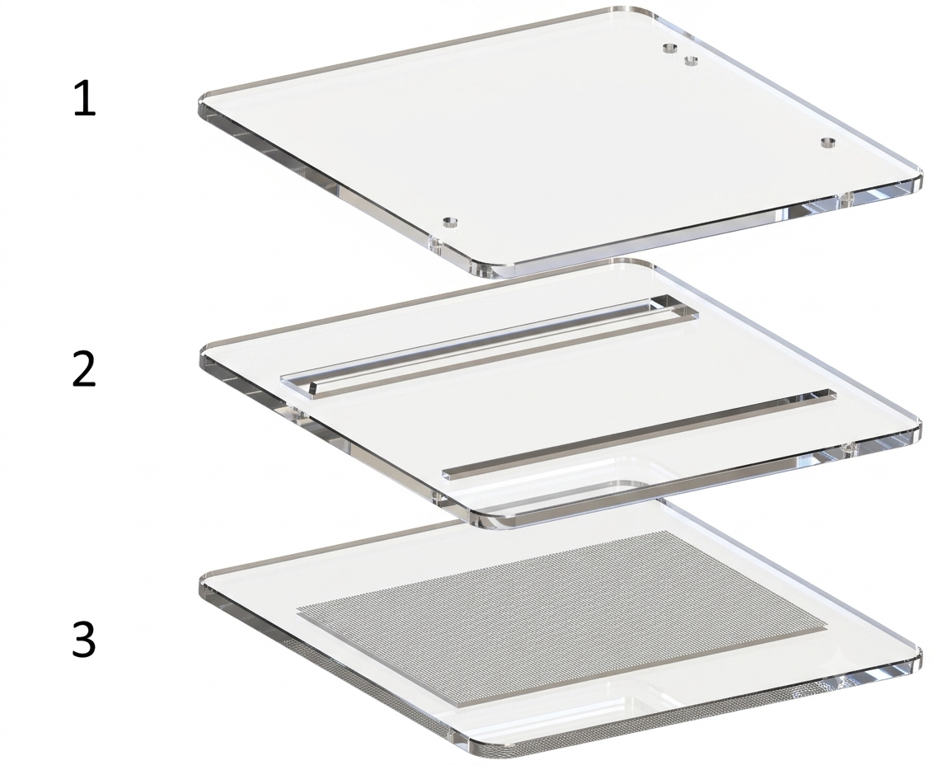
Figure S2. Exploded view of the three-layer laser-fabricated PMMA device. Layer 1, top cover plate with inlet/outlet ports; Layer 2, middle layer containing the loading, collection and waste chambers; Layer 3, bottom layer containing the parallel laser-engraved microchannels.
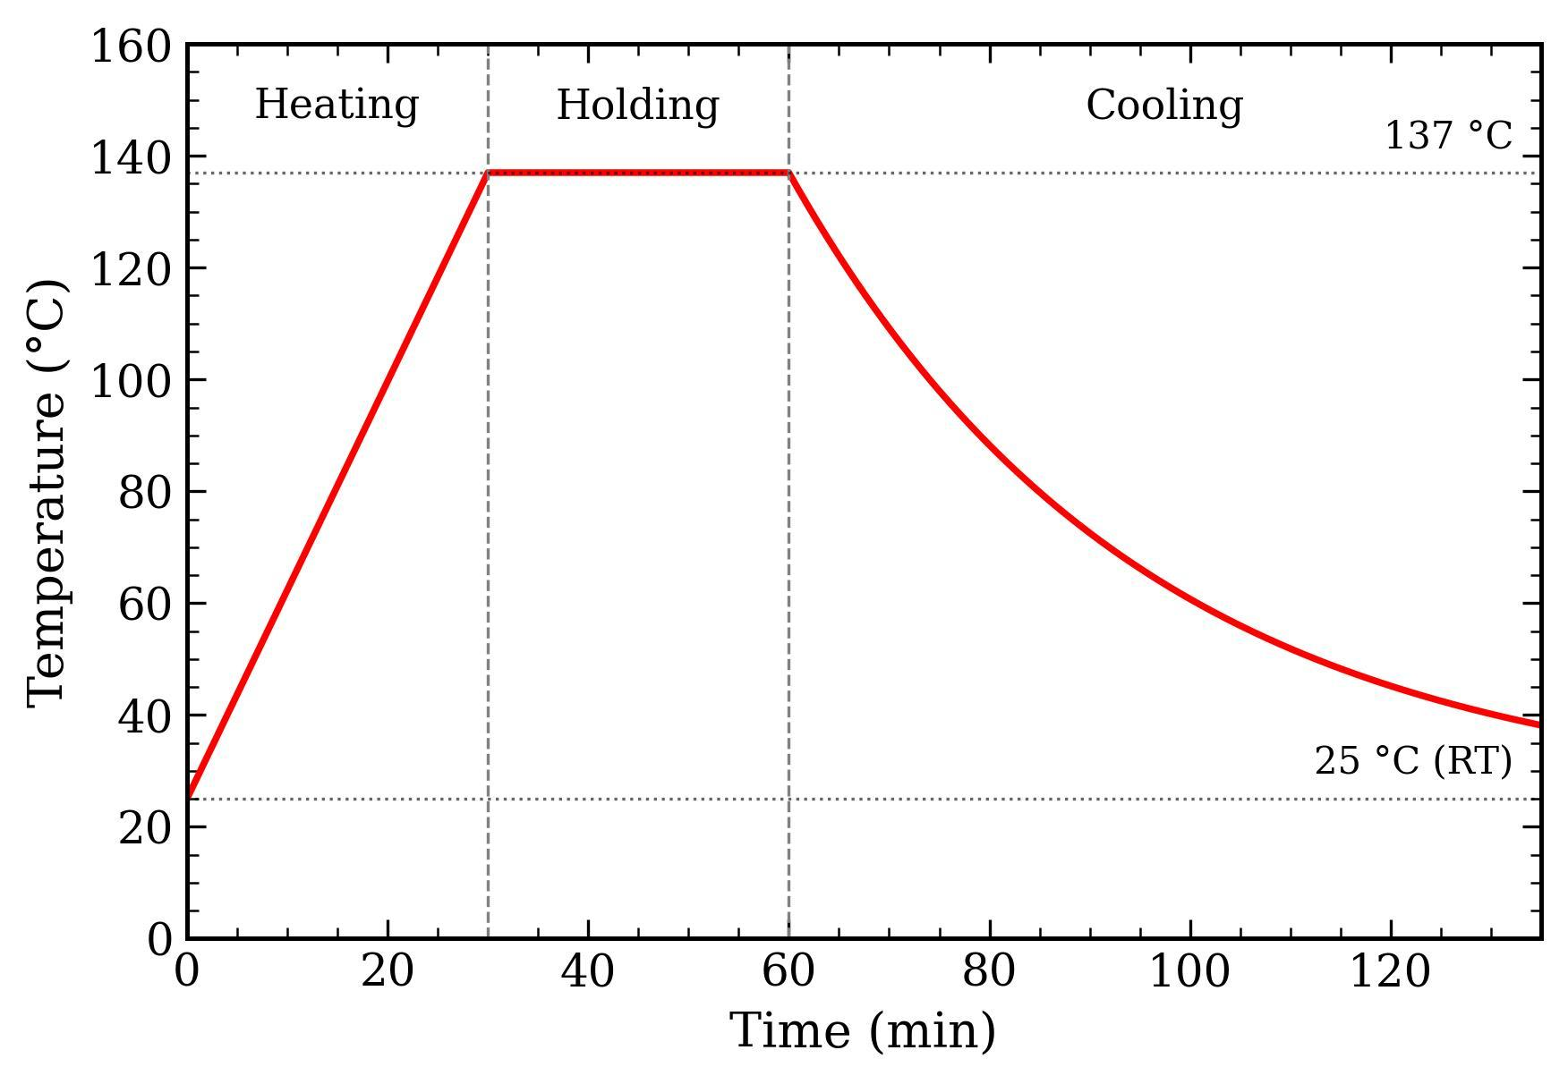
Figure S3. Thermal bonding profile used for assembly of the three-layer PMMA device. The cycle consisted of a 30-min ramp to 137 °C, a 30-min hold at 137 °C, followed by cooling to room temperature.

S2. Device sterilization
Following fabrication and bonding, microfluidic devices were sterilized by electron-beam irradiation at the Radiation Sterilization Unit of the Institute of Nuclear Physics (INP), Almaty, Kazakhstan. The irradiation procedure was selected to provide terminal microbial inactivation while maintaining the structural integrity and relevant surface characteristics of the PMMA device.

S3. Biocompatibility assessment
Biocompatibility of the fabricated PMMA microfluidic devices was evaluated before their use for sperm preparation. Devices were subjected to HSSA according to a protocol. Briefly, comparative test between evaluated plastic used in the laboratory and tested sample consumables for sperm survive in 24 hours. The resulting biological response was assessed by measuring cell viability. Devices were considered biocompatible when no difference is observed from a control.

S4. Sperm DNA integrity assessment
Sperm DNA integrity was assessed using the sperm chromatin dispersion (SCD) assay with the GoldCyto DNA Kit (MICROPTIC S.L., Barcelona, Spain) according to the manufacturer's instructions. Sperm suspensions obtained from native semen, DGC, and microfluidic sorting were embedded in low-melting-point agarose on pretreated microscope slides. The slides were subjected to acid denaturation, lysis, dehydration and staining before examination by bright-field microscopy using the CASA imaging system. Spermatozoa with intact DNA exhibited large or medium-sized halos of dispersed chromatin surrounding the sperm head, whereas spermatozoa with fragmented DNA showed small, absent or degraded halos. At least 100 spermatozoa were evaluated per sample by an experienced operator who was blinded to treatment group whenever feasible. DNA integrity was expressed as the percentage of spermatozoa with intact chromatin, and the DNA fragmentation index (DFI) was calculated as the percentage of spermatozoa with fragmented DNA.

S5. Sperm morphology assessment
Sperm morphology was assessed by bright-field microscopy using standard morphological staining procedures in accordance with the World Health Organization Laboratory Manual for the Examination and Processing of Human Semen, 6th edition (2021). At least 100 spermatozoa were evaluated for each sample by a skilled embryologist blinded to treatment assignment. Spermatozoa were classified as morphologically normal only when the head, acrosome, midpiece and flagellum met the applicable WHO reference criteria. The percentage of morphologically normal spermatozoa was reported as the normal morphology value.

S6. Computational modelling
We modelled a simplified sperm sorting microfluidic device as a three-dimensional straight microchannel composed of an inlet chamber, a long channel segment and an outlet chamber, all aligned along the x-axis. The inlet chamber (Domain 1) was a rectangular block with volume 2 × V channel. The central channel (Domain 2) had R = 10e −4 × 0.0002 m semi-circular cross-section and a length of 15 and 20 mm. The outlet chamber volume (Domain 3) was V channel. The three subdomains were joined end-to-end using a Form Union operation in COMSOL Multiphysics (COMSOL AB, Burlington, MA, USA), so adjacent faces were shared and no gaps existed between domains. The bottom wall of the device was defined as the plane z = 0.
Each sperm cell was modelled as an active point particle representing the sperm head and proximal midpiece. Based on reported human sperm dimensions and a mean cell volume of ~17.4 μm³,we used an effective radius of 6 μm and a mass of 1.7 × 10⁻¹⁴ kg.
To represent motility heterogeneity, the population was divided into four subgroups with fixed swim speeds taken directly from the simulation: 0, 20, 40, and 60 μm/s. The 0 μm/s group represents immotile sperm. Motile groups were mapped to clinical grades by assigning 20 μm/s as Grade B (slower motile) and 40–60 μm/s as Grade A (progressive). For N = 1000 sperm, the number in each group was set using prescribed fractions at release.
The surrounding medium was assumed quiescent (no imposed flow), so motion is dominated by self-propulsion. Sperm were released uniformly in the inlet chamber with random initial directions. Trajectories were computed using COMSOL’s Mathematical Particle Tracing interface, which enables direct prescription of motility and custom forces without solving a background flow field (COMSOL documentation). All solid walls were treated as reflecting boundaries (specular bounce). Sperm leaving through the downstream outlet plane were removed from the simulation and counted as reaching the outlet. A weak attraction toward the bottom wall in the long channel was included to reproduce near-surface accumulation reported experimentally this attraction was applied smoothly along the channel and was defined to vanish at the wall.
Short-range interparticle repulsion was implemented to prevent overlapping when sperm came within approximately twice the effective radius. A speed-limiting damping term was also included to prevent collision-driven speed spikes by reducing speed only when a particle exceeded its assigned target speed. Finally, oscillatory motility was represented by prescribing group-specific lateral oscillations consistent with CASA/ML-derived (Computer-Assisted Sperm Analysis/Machine Learning-derived) trajectory features such as ALH (Amplitude of Lateral Head displacement) and BCF (Beat Cross Frequency).
a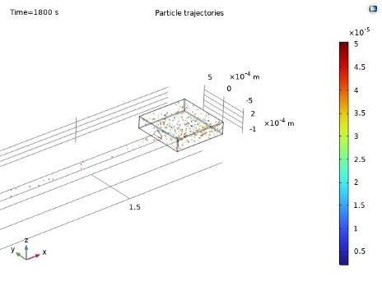 | b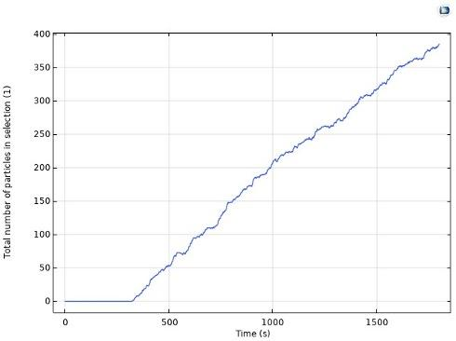
c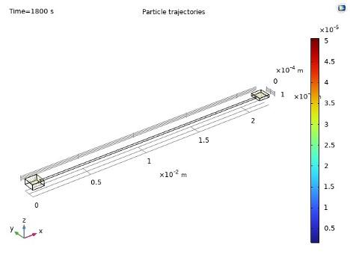 | d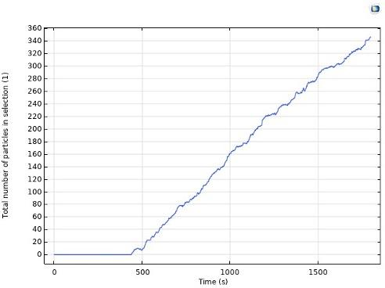
Figure S4. COMSOL simulation of sperm transport through 15- and 20-mm microchannels. A, simulated sperm trajectories at t = 1800 s for the 15-mm channel; B, cumulative number of particles entering the outlet chamber for the 15-mm channel; C, simulated trajectories for the 20-mm channel; D, cumulative outlet particle count for the 20-mm channel. The simulations demonstrate a delayed onset of outlet arrival followed by progressive accumulation of motile particles and a lower outlet count for the longer channel over the same simulation interval.

COMSOL modelling was conducted to compare 15- and 20-mm channel lengths in sperm sorting performances in a single channel scenario (Fig.4S). The simulated sperm distribution at t = 1800 s for N = 1000 particles under no imposed flow conditions is presented in Figure 3A. The particles were colored based on their vertical position (z). By the end of the simulation, most sperm cells still occupied the space at the inlet chamber or the proximal part of the microchannel, while only a small number of them have moved towards the the outlet chamber. Since in this simulation, the transport distance is longer than the moderate swimming speeds used This can be explained by the long transport distance (≈15 mm) compared with the moderate swimming speeds used in the model. Additionally, a mild but consistent propensity of sperm cells to occupy the regions near the bottom wall can be observed. This behavior reflects the implemented bottom-attraction term and agrees with experimental observations that sperm tend to swim very close to surfaces (“slither” swimming). Importantly, the sperm does not collapse into a single layer at the bottom: random initial directions, wall reflections, interparticle interactions, and oscillatory motion maintain a noticeable spread across the cross-section, producing heterogeneous trajectories rather than identical paths. Figure 2b quantifies outlet transport by plotting the cumulative number of sperm that enters the outlet chamber (Domain 3) as a function of time. The curve remains at zero for approximately the first 350 - 400 s, showing that no sperm reaches the outlet immediately after release. This initial delay matches a simple travel-time estimate for the fastest swimmers: a 15 mm channel length and velocity of 40 μm/s give a minimum travel time of about 375 s. After this onset, the cumulative count rises almost linearly, indicating continuous arrival of sperm with different speeds and path histories. By t = 1800 s, around 380 out of 1000 sperm (≈38%) have entered the outlet chamber, while the remainder are still distributed in the inlet chamber or along the channel. The small step-like fluctuations around the overall upward trend reflect the discrete arrival of individual particles and the stochastic nature of the model (random initial direction, oscillations, and interactions with walls and neighboring sperm). Together, the trajectory snapshot and the cumulative outlet count show that the model captures both the spatial distribution of sperm inside the device and the time-dependent build-up of sperm in the collection region, providing a clear quantitative measure of transport and retention under no-flow conditions.
Figure 3c shows the sperm trajectories at 𝑡=1800 for the longer device (20 mm channel). Compared with the 15 mm case, more sperm remain near the inlet and proximal channel, and fewer reach the outlet by the end of the simulation. The color map (vertical position z) indicates that sperm still explores the channel height, with a mild preference toward lower 𝑧-values due to the near-bottom bias in the model. Figure 4S shows the cumulative number of sperm entering the outlet domain (Domain 3) over time. The curve stays at zero until roughly 450 -500, consistent with the minimum travel time for the fastest swimmers across a 20 mm channel (20 mm/0.04mm). After this lag, the outlet counts increases approximately linearly. By 𝑡=1800, about 345 - 350 sperm (≈35% of 1000) have reached the outlet, confirming that increasing the channel length reduces outlet throughput within the same simulation time window.
viscous drag of the medium. To reach the collection chamber, a spermatozoon must maintain a net forward velocity of at least vₑ_{ff} ≥ L/t. For L = 20 mm and t = 30 min, this threshold is approximately 11.1 µm/s. Many sperm can reach this speed briefly but sustaining it over 20 mm requires intact mitochondrial function for ATP generation, normal axonemal structure for efficient beat mechanics, and—indirectly—low DNA fragmentation, which is associated with reduced metabolic output. The channel thus simultaneously selects for motility, structural integrity, and metabolic capacity through a single physical criterion: can the cell swim 20 mm in 30 minutes?
Three physical mechanisms account for sperm selection. First, morphological drag: sperm with abnormal head shapes or flagellar defects experience higher drag and generate asymmetric torques while swimming. This pushes them off-axis, leading to wall collisions and reducing net forward progress. Secondly, non-progressive trajectories: sperm with elevated DNA fragmentation often swim in circles or oscillate without net displacement. In a 200-µm-wide channel, these cells are less likely to accumulate sufficient axial distance to reach the outlet within 30 minutes. Thirdly, metabolic exhaustion: sperm with impaired mitochondrial function run out of ATP before completing the 20 mm traverse. Their velocity decreases progressively until they come to rest in the channel. As a result, cells collected at the outlet are enriched for progressive motility, normal morphology, and genomic integrity—primarily through endurance-based selection rather than centrifugation or chemical gradients.
COMSOL simulations were performed to validate the microchannel design and determine an appropriate migration distance for passive sperm selection. Simulations demonstrated an initial delay before sperm reached the outlet chamber, followed by a gradual increase in sperm accumulation as progressively motile cells traversed the microchannel. Figure 4S shows the sperm trajectories at 𝑡=1800 for the longer device (20 mm channel). Compared with the 15 mm case, more sperm remain near the inlet and proximal channel, and fewer reach the outlet by the end of the simulation. The color map (vertical position z) indicates that sperm still explores the channel height, with a mild preference toward lower 𝑧-values due to the near-bottom bias in the model. Figure 4B shows the cumulative number of sperm entering the outlet domain (Domain 3) over time. The curve stays at zero until roughly 450 -500, consistent with the minimum travel time for the fastest swimmers across a 20 mm channel (20 mm/0.04mm). After this lag, the outlet counts increases approximately linearly. By 𝑡=1800, about 345 - 350 sperm (≈35% of 1000) have reached the outlet, confirming that increasing the channel length reduces outlet throughput within the same simulation time window.

S7. Translational proof-of-concept using ICSI
An intracytoplasmic sperm injection (ICSI) proof-of-concept study was conducted to assess the compatibility of the proposed passive microfluidic sperm preparation workflow with routine assisted reproductive technology (ART) procedures. This experiment was performed independently of the primary sperm-quality evaluation and was intended to determine whether sperm recovered from the microfluidic device could be used directly in standard clinical embryology procedures.
Following the participating IVF clinic’s standard operating procedures, experienced embryologists performed conventional ICSI using microfluidically selected sperm from three independent semen samples under routine laboratory conditions. Mature metaphase II (MII) oocytes were injected using an inverted micromanipulation system and maintained under standard embryo culture conditions. Fertilization was assessed 16–18 h after injection based on the presence of two pronuclei (2PN). Embryo development was subsequently monitored using routine morphological and time-lapse assessment.
Embryological outcomes were evaluated using established clinical criteria, including the pronuclear (PN) score, embryo iDAScore, and final clinical disposition. The iDAScore is a fully automated, convolutional neural network-based algorithm that predicts embryo viability from time-lapse imaging data. For contextual comparison, embryos generated during the same study period using sperm prepared by conventional density gradient centrifugation (DGC) were evaluated using the same criteria. The PN score and iDAScore distributions, together with the final embryo disposition, are presented in Fig. X5.
A total of 19 embryos generated using microfluidically selected sperm and 18 embryos generated using DGC-prepared sperm were evaluated. The PN score distributions were highly similar between the two groups, with a median score of 2.0 in both groups. The mean PN score was also comparable between the microfluidic and DGC groups (1.79 vs. 1.83, respectively; p = 0.84). The iDAScore showed substantial overlap between the groups, with mean values of 7.41 and 7.91 for the microfluidic and DGC groups, respectively (p = 0.5243).
The final embryological disposition was also assessed descriptively. In the microfluidic group, 10 of 19 embryos (52.6%) were cryopreserved, while the remaining 9 embryos (47.4%) were classified as other outcomes, including discard or awaiting clinical decision. In the DGC group, 6 of 18 embryos (33.3%) were cryopreserved, 3 (16.7%) underwent fresh embryo transfer, and 9 (50.0%) were classified as other outcomes (Fig. S5).
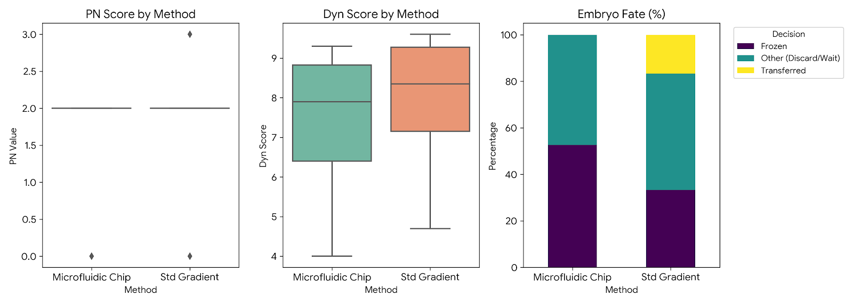
Figure S5. Exploratory embryological outcomes following ICSI using microfluidically selected versus DGC-prepared sperm.
Overall, sperm selected using the passive microfluidic chip were successfully used for conventional ICSI without modification of the standard embryology workflow. Comparable PN scores and overlapping iDAScore distributions provide preliminary evidence that microfluidically selected sperm can support routine embryo production and assessment. The higher proportion of embryos cryopreserved in the microfluidic group is also consistent with the feasibility of incorporating the device into clinical ART workflows. However, given the small number of clinical cases and the exploratory nature of this proof-of-concept study, these observations should not be interpreted as evidence of clinical superiority over DGC. Larger, appropriately powered studies are required to determine whether differences in embryo development, cryopreservation, transfer, and pregnancy outcomes are reproducible.

S8. Secondary analysis across three baseline sperm concentration groups
An exploratory secondary analysis was performed to examine whether the passive microfluidic workflow remained effective across the full range of baseline sperm concentrations represented in the cohort. Samples were divided into three approximately equal-sized groups: >115 × 10⁶ mL⁻¹ (n = 15), 40–115 × 10⁶ mL⁻¹ (n = 15), and <40 × 10⁶ mL⁻¹ (n = 14). The 115 × 10⁶ mL⁻¹ threshold was selected to obtain balanced subgroup sizes and was not intended to represent a biological or clinical cutoff.
Across all three groups, microfluidic processing produced high post-processing DNA integrity, progressive motility and total motility despite substantial differences in baseline semen quality. DNA integrity increased from 90.97 ± 5.78%, 85.11 ± 8.70% and 84.47 ± 9.53% in the >115, 40–115 and <40 × 10⁶ mL⁻¹ groups, respectively, to 98.40 ± 1.72%, 97.67 ± 2.60% and 96.65 ± 2.64% after microfluidic processing. High progressive motility reached 82.48 ± 7.03%, 80.27 ± 5.48% and 77.25 ± 12.14%, while total motility reached 96.23 ± 2.56%, 94.74 ± 5.26% and 92.67 ± 7.56%, respectively.
Samples in the <40 × 10⁶ mL⁻¹ group showed the greatest absolute improvements in progressive and total motility despite substantially poorer baseline semen quality. The recovered sperm concentration was higher in this group (9.46 ± 9.21 × 10⁶ mL⁻¹) than in the >115 and 40–115 × 10⁶ mL⁻¹ groups (4.69 ± 4.59 and 2.32 ± 1.59 × 10⁶ mL⁻¹, respectively). This difference primarily reflects the additional low-speed pre-concentration step used for reduced-concentration samples before chip loading and should not be interpreted as an intrinsic concentration-enrichment effect of the microfluidic device.

Supplementary Table S1. Sperm quality parameters across three baseline concentration groups
Parameter | Method | >115 × 10⁶/mL  (n = 15) | 40–115 × 10⁶/mL  (n = 15) | <40 × 10⁶/mL  (n = 14)
Sperm concentration (×10⁶/mL) | RAW | 139.06 ± 26.11 | 70.17 ± 24.50 | 26.10 ± 8.29
 | DGC | 41.42 ± 19.09 | 14.49 ± 8.53 | 8.15 ± 5.52
 | CHIP | 4.69 ± 4.59 | 2.32 ± 1.59 | 9.46 ± 9.21
DNA integrity (% non-fragmented) | RAW | 90.97 ± 5.78 | 85.11 ± 8.70 | 84.47 ± 9.53
 | DGC | 97.13 ± 3.62 | 94.49 ± 4.83 | 89.04 ± 14.53
 | CHIP | 98.40 ± 1.72 | 97.67 ± 2.60 | 96.65 ± 2.64
High progressive motility (%) | RAW | 29.92 ± 8.61 | 29.21 ± 13.85 | 24.24 ± 15.99
 | DGC | 59.49 ± 14.13 | 59.94 ± 12.50 | 36.16 ± 19.19
 | CHIP | 82.48 ± 7.03 | 80.27 ± 5.48 | 77.25 ± 12.14
Total motility (%) | RAW | 83.25 ± 14.94 | 63.97 ± 17.25 | 50.81 ± 17.94
 | DGC | 90.75 ± 6.72 | 83.91 ± 9.14 | 60.69 ± 18.72
 | CHIP | 96.23 ± 2.56 | 94.74 ± 5.26 | 92.67 ± 7.56
Normal morphology (%) | RAW | 3.10 ± 1.58 | 3.29 ± 3.54 | 2.14 ± 3.39
 | DGC | 5.30 ± 3.09 | 5.33 ± 3.96 | 1.50 ± 1.87
 | CHIP | 8.33 ± 3.81 | 5.40 ± 3.11 | 3.36 ± 3.52
Values are mean ± SD. RAW, native semen before processing; DGC, density-gradient centrifugation; CHIP, passive microfluidic sperm sorting.

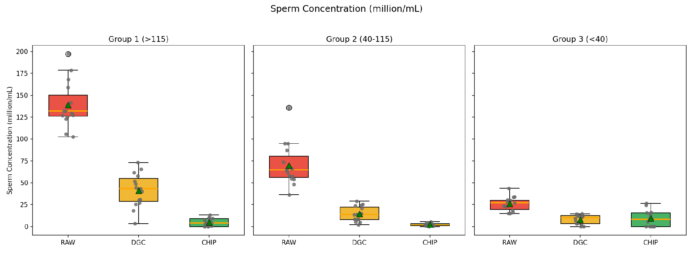
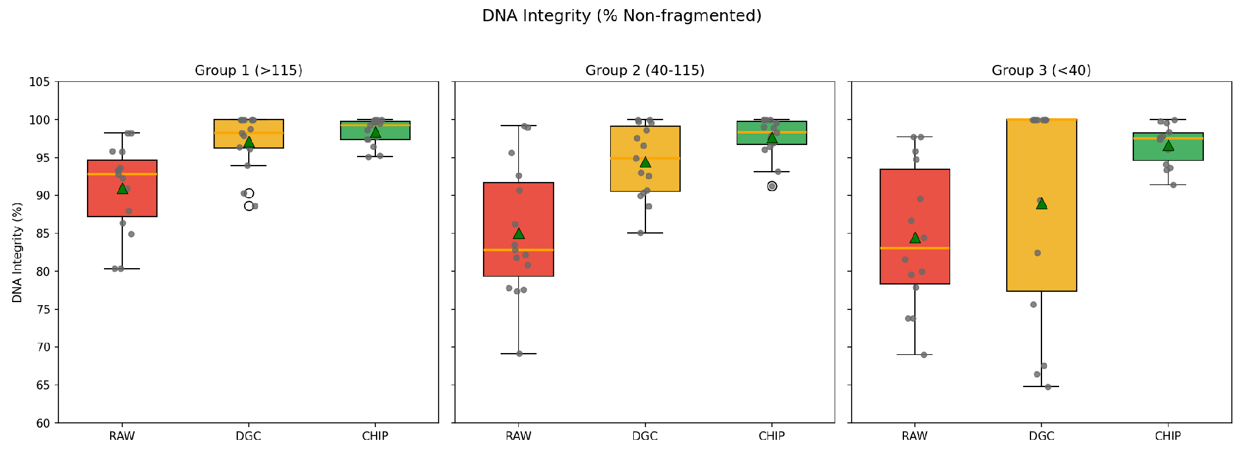
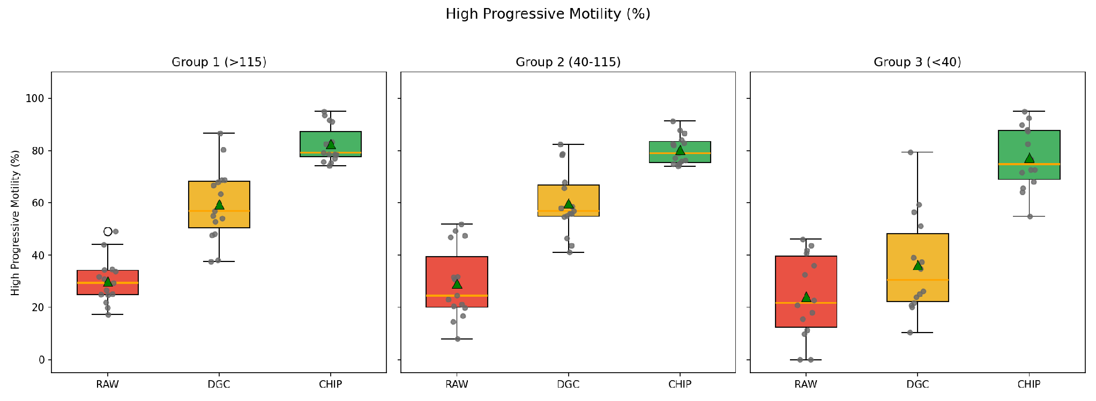
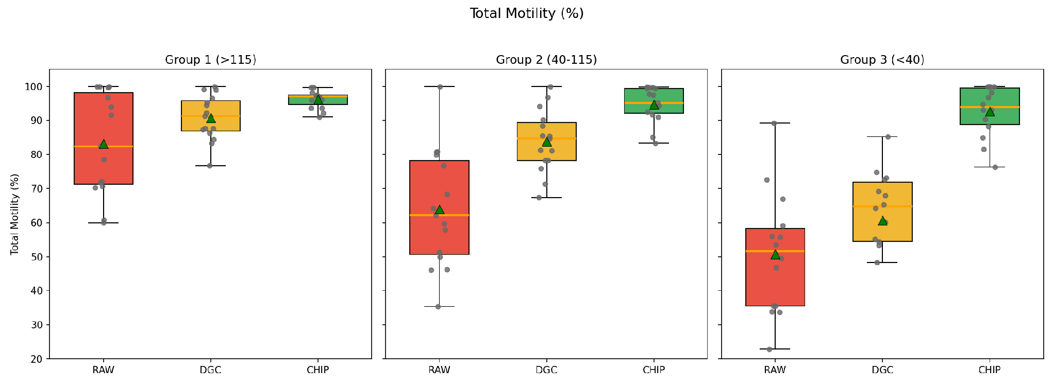
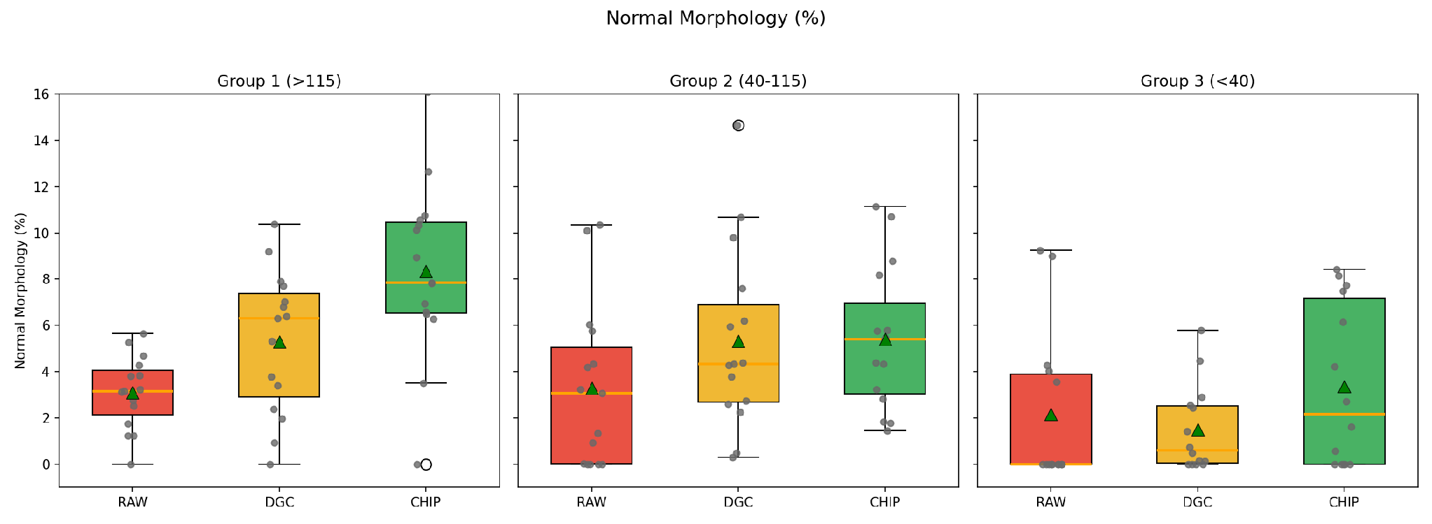
Figure S6. Boxplots comparing RAW, DGC (density gradient centrifugation), and CHIP (microfluidic sorting) processing methods across three baseline sperm concentration groups: Group 1 (>115 million/mL, N=15), Group 2 (40–115 million/mL, N=15), and Group 3 (<40 million/mL, N=14; Samples 1 and 2 excluded).

