SUPPLEMENTARY MATERIALS
NPC-EVs promote anti-inflammation and facilitate microglial phagocytosis via regulating lipid metabolism dependent on TREM2-centric pathway in stroke mice

Lin Zhang^{1#}, Wei Wei^{2,3#}, Wenqiang Xin^{2,3#}, Guoqiang Hou¹, Xinhang Xu¹, Xiaolan Yang¹, Yaohua Pan¹*, Feng Jia^{1,4}*, and Xiaohua Zhang¹*

¹ Department of Neurosurgery, Ren Ji Hospital, Shanghai Jiao Tong University School of Medicine, Shanghai, China
² Department of Neurosurgery, The First Affiliated Hospital, Jiangxi Medical College, Nanchang University, Nanchang, Jiangxi, China
³ Jiangxi Key Laboratory of Neurological Diseases, The First Affiliated Hospital, Jiangxi Medical College, Nanchang University, Nanchang, Jiangxi, China
⁴ Department of Neurosurgery, Nantong First People’s Hospital, Affiliated Hospital 2 of Nantong University, Nantong, Jiangsu, China
# These authors contributed equally to this work.

*Correspondence:
Yaohua Pan, MD., Department of Neurosurgery, Ren Ji Hospital, Shanghai Jiao Tong University School of Medicine, No.1630 Dongfang Road, 200127 Shanghai, China, Phone: +86-021-68383710, E-mail: 1542612058@qq.com
Feng Jia, Ph.D., Department of Neurosurgery, Ren Ji Hospital, Shanghai Jiao Tong University School of Medicine, No.1630 Dongfang Road, 200127 Shanghai, China, Phone: +86-021-68383710, E-mail: projiafeng@163.com
Xiaohua Zhang, MD., Department of Neurosurgery, Ren Ji Hospital, Shanghai Jiao Tong University School of Medicine, No.1630 Dongfang Road, 200127 Shanghai, China, Phone: +86-021-68383710, E-mail: zxh1969@aliyun.com

Supplementary Table 1—Major Resources

REAGENT/RESOURCE | SOURCE | IDENTIFIER | APPLICATION
Ⅰ. Antibodies
CD68 | BioRad | MCA341F | 2 µg/ml (for IF)
Iba1 | WAKO | 011-27911 | 2 µg/ml (for IF)
NeuN | Abcam | ab104225 | 2 µg/ml (for IF)
Tuj-1 | Abcam | ab18207 | 2 µg/ml (for IF)
CD206 | Abcam | ab64693 | 2 µg/ml (for IF)
Nile Red | Thermo Fisher Scientific | N1142 | 0.1 μg/ml (for analysis of phagocytosis)
LRP1 | Cell Signaling Technology | #64099 | 0.5 µg/ml (for WB)
MerTK | Abcam | ab300136 | 0.5 µg/ml (for WB)
CX3CR1 | Thermo Fisher Scientific | PA5-19910 | 1 µg/ml (for WB)
β-actin | Abcam | ab6276 | 0.2 µg/ml (for WB)
Caspase-3 | Thermo Fisher Scientific | 700182 | 2 µg/ml (for IF)
Bcl-2 | Cell Signaling Technology | #3498 | 0.5 µg/ml (for WB)
Bax | Abcam | ab7977 | 0.5 µg/ml (for WB)
Caspase-3 | Cell Signaling Technology | #9662 | 0.5 µg/ml (for WB)
cleaved Caspase-3 | Cell Signaling Technology | #9661 | 0.5 µg/ml (for WB)
TREM2 | Abcam | ab305103 | 0.5 µg/ml (for WB)
ABCA1 | Abcam | ab7360 | 0.5 µg/ml (for WB)
LXR α | Abcam | ab41902 | 0.5 µg/ml (for WB)
CD206 | Abcam | ab64693 | 2 µg/ml (for IF)
Ⅱ. Chemicals and Recombinant Proteins
L-glutamine | Thermo Fisher Scientific | 25030024 | 100 μl L-glutamine in 10 ml medium
Trypsin-EDTA 0.25% | Thermo Fisher Scientific | 25200-056 | undiluted
Poly-D-lysine | Sigma-Aldrich | P6407 | 5mg PDL in 50 ml H₂O (0.1 mg/mL)
Poly-L-ornithine | Sigma-Aldrich | P3655 | 5mg PLO in 50 ml H₂O (0.1 mg/mL)
Laminin | Sigma-Aldrich | L2020 | 2 μg/ml in PBS
Penicillin/streptomycin | Thermo Fisher Scientific | 15140122 | 500 μl pen/strep in 50 ml medium
B27 | Thermo Fisher Scientific | 17504001 | 1ml B27 in 50 ml medium
DAPI | AppliChem | A1001 | 1 µg/ml in PBS/TBS
Cytotoxicity Detection Kit (LDH releasing assay) | Roche，Merck Group | No.04744926001 | According to the manufacturer’s instruction
In Situ Cell Death Detection Kit (TUNEL staining) | Roche，Merck Group | No.12156792910 | Add total volume (50 μl) of Enzyme Solution to the remaining 450 μl Label Solution to obtain 500 μl TUNEL reaction mixture.

WB: Western blot
IF: Immunofluorescence staining
Supplementary Table 2—Primer sequence

 | Forward (5′-3′) | Reverse (5′-3′)
IL-1β | GCAACTGTTCCTGAACTCAACT | ATCTTTTGGGGTCCGTCCAACT
IL-10 | AGAAAAGAGAGCTCCATCATGC | TTATTGTCTTCCCGGCTGTACT
TNFα | AAGCCTGTAGCCCACGTCGTA | GGCACCACTAGTTGGTTGTCTTTG
TGF-β1 | CCTGTCCAAACTAAGGC | GGTTTTCTCATAGATGGCG
β-actin | CGTGCGTGACATCAA AGAGA | CCC AAGAAGGAAGGCTGG A

Supplementary Table 3—Score sheet for tightrope test

Score | Time (s) | Platform arrival
20 | 1-6 | +
19 | 7-12 | +
18 | 13-18 | +
17 | 19-24 | +
16 | 25-30 | +
15 | 31-36 | +
14 | 37-42 | +
13 | 43-48 | +
12 | 49-54 | +
11 | 55-60 | +
10 | 55-60 | −
9 | 49-54 | −
8 | 43-48 | −
7 | 37-42 | −
6 | 31-36 | −
5 | 25-30 | −
4 | 19-24 | −
3 | 13-18 | −
2 | 7-12 | −
1 | 1-6 | −
0 | 0 | −

The tightrope test was performed three times on each test day, and the mean values were calculated. The results were assessed according to both time on the rope (in seconds) and platform arrival (“+” for arrival and “−” for non-arrival). The scores ranged from 0 (minimum) to 20 (maximum).

Supplementary full scans of Western blots

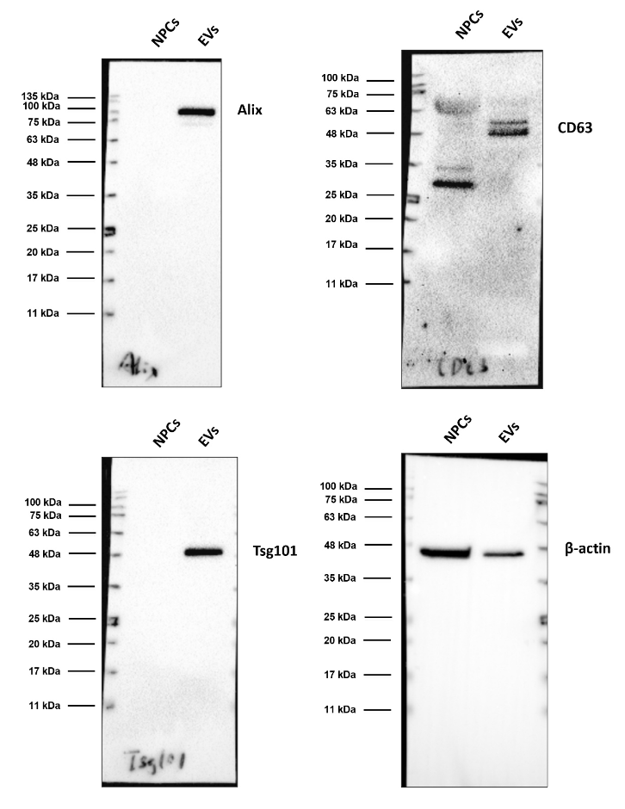
Figure 1-B.

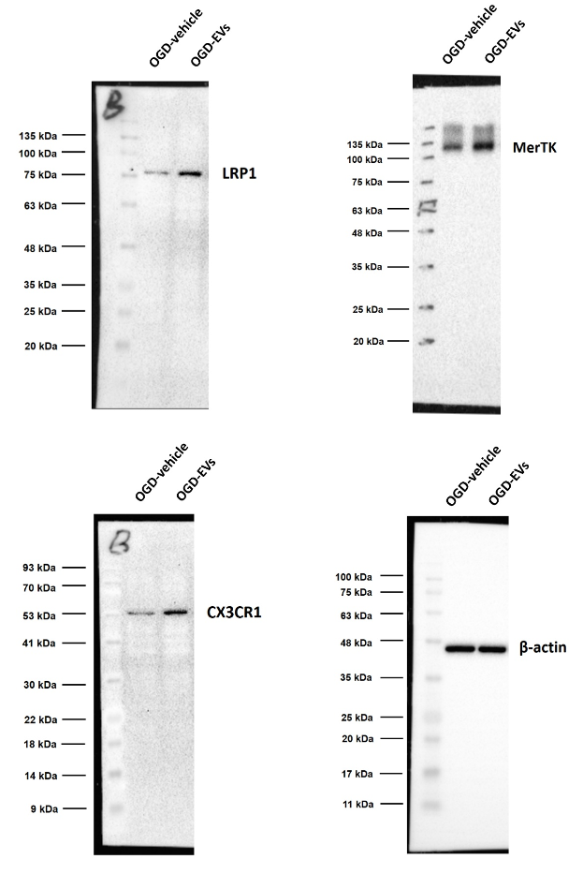
Figure 5-D.

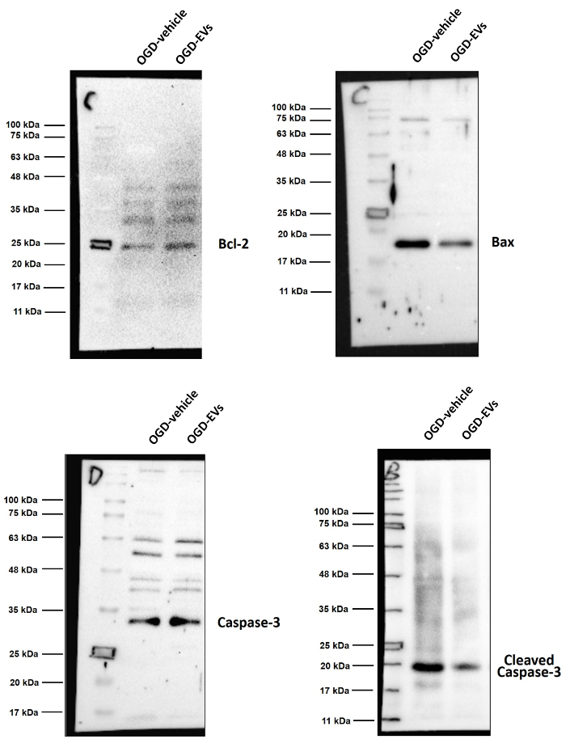
Figure 6-G.
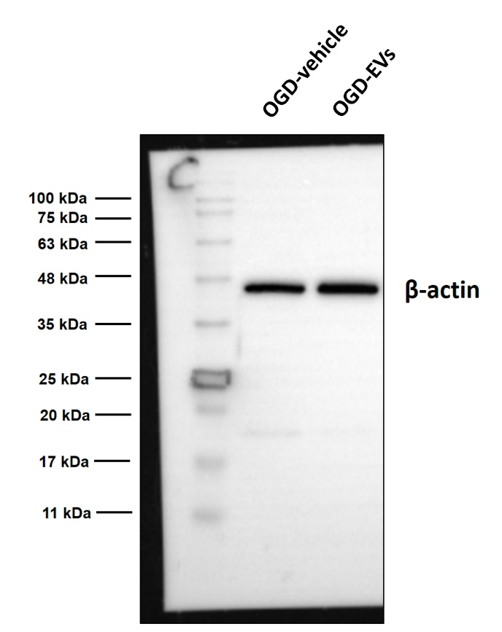
Figure 6-G.
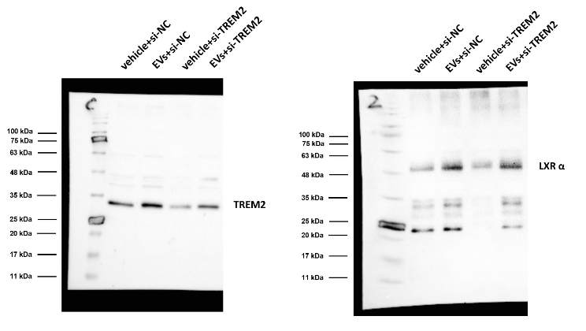
Figure 7-F.
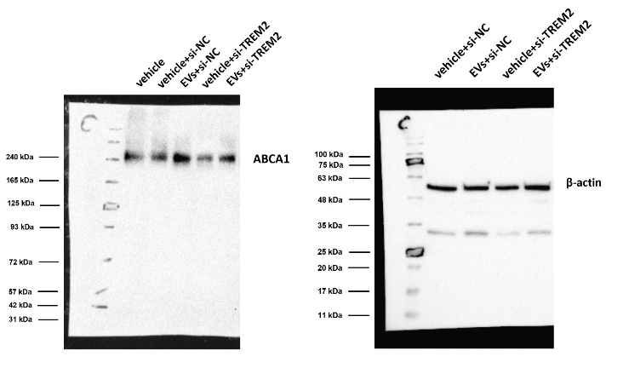
Figure 7-F.

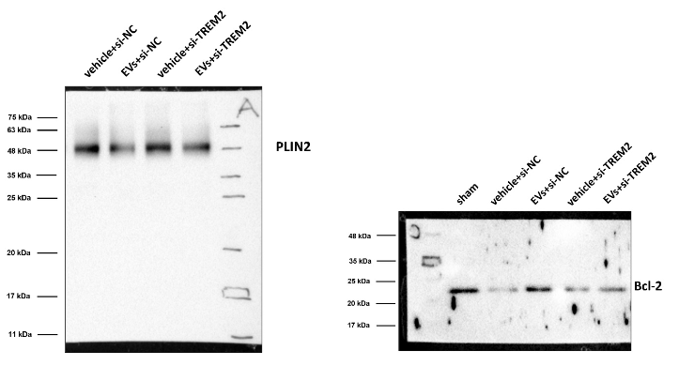
Figure 7-K.
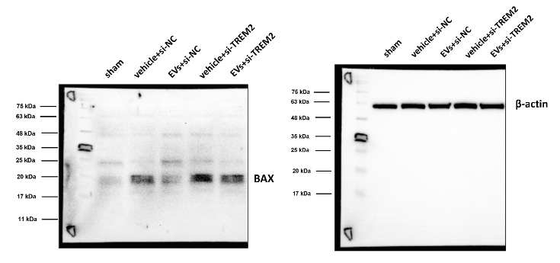
Figure 7-K.

