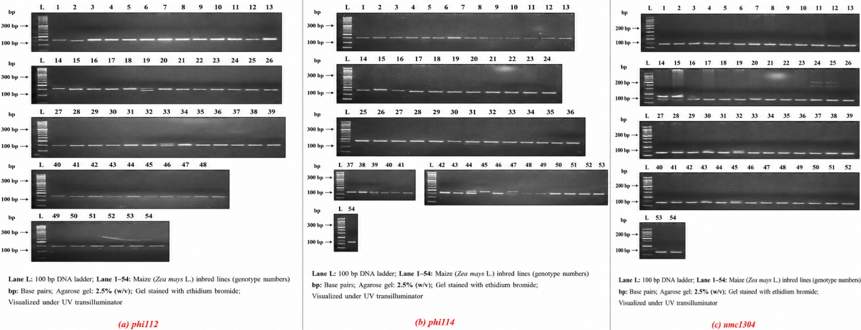
Figure S1. Representative PCR amplification profiles of selected SSR markers (a) phi112 (b) phi114 and (c) umc1304 in 54 maize inbred lines

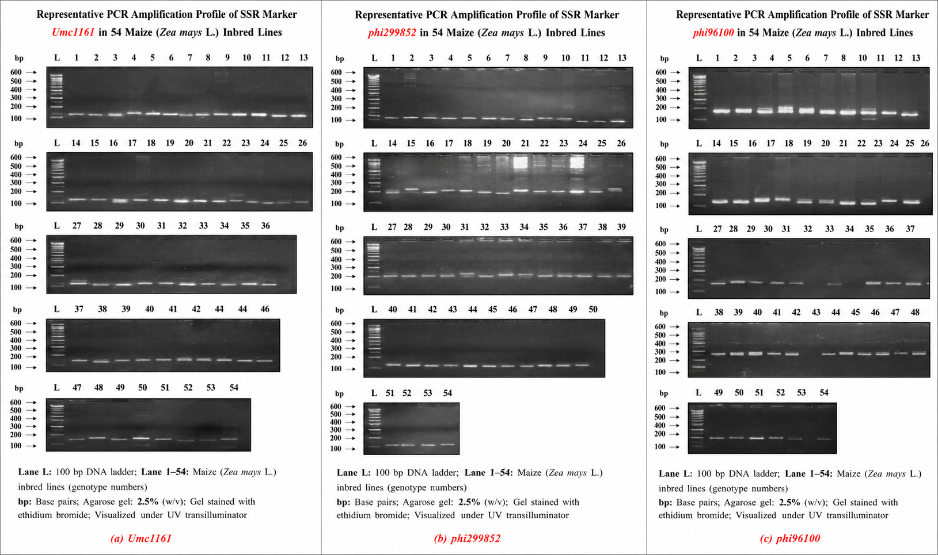
Figure S2. Representative PCR amplification profiles of SSR markers (a) umc1161, (b) phi299852, and (c) phi96100 in 54 maize inbred lines.

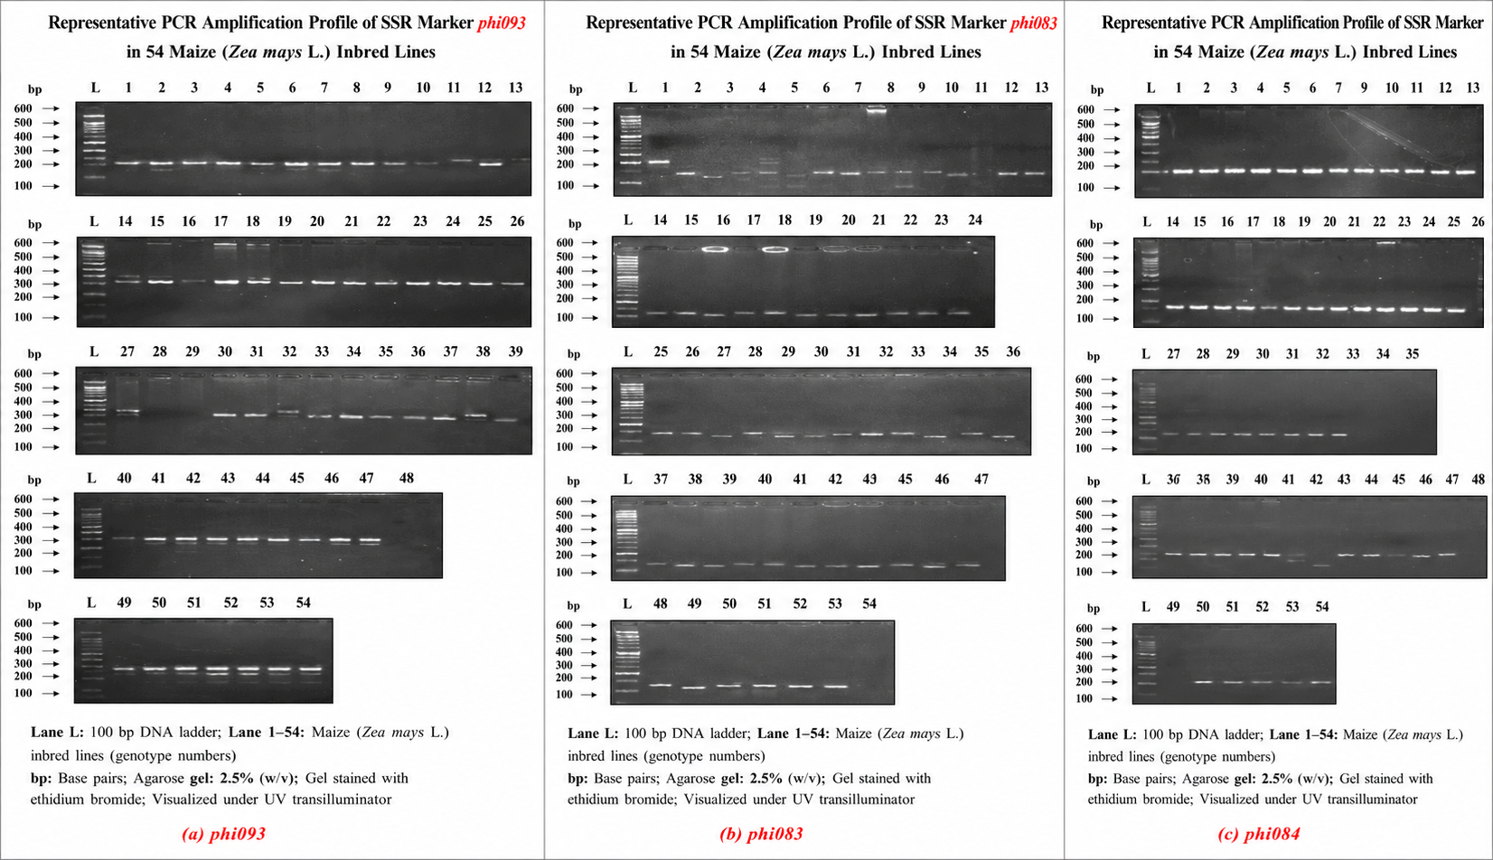
Figure S3. Representative PCR amplification profiles of SSR markers (a) phi093, (b) phi083, and (c) phi084 in 54 maize inbred lines.

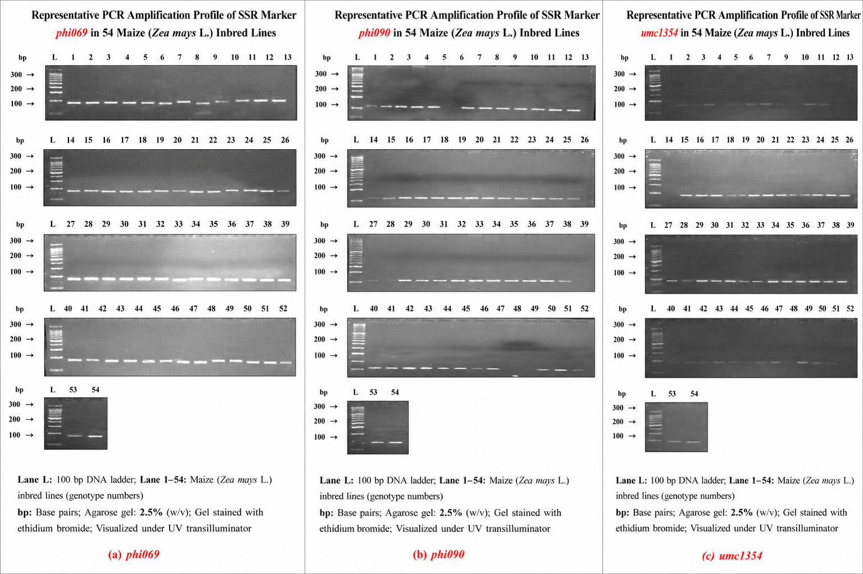
Figure S4. Representative PCR amplification profiles of SSR markers (a) phi069, (b) phi090, and (c) umc1354 in 54 maize inbred lines.

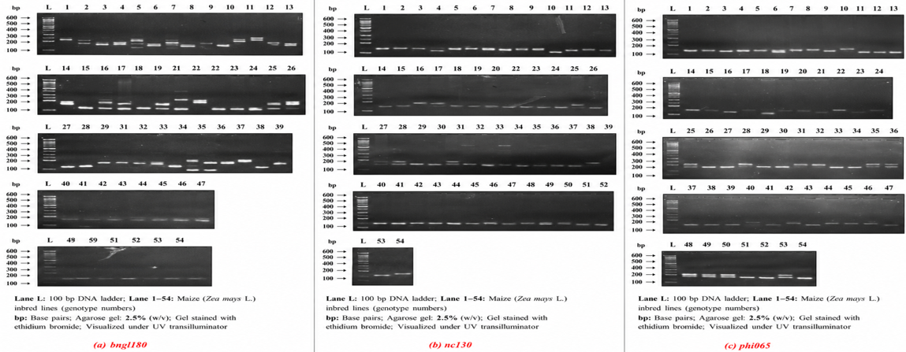
Figure S5. Representative PCR amplification profiles of SSR markers (a) bngl180, (b) nc130, and (c) phi065 in 54 maize inbred lines

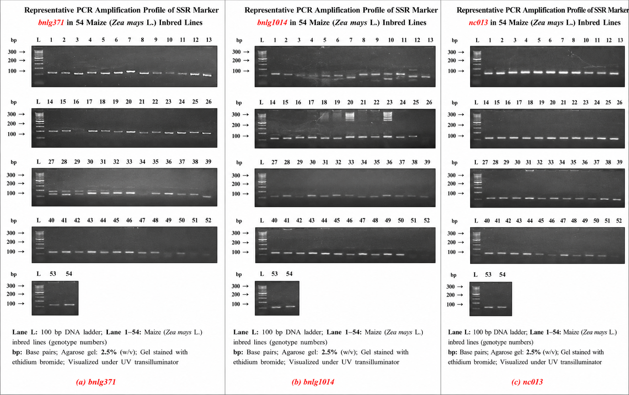
Figure S6. Representative PCR amplification profiles of SSR markers (a) bnlg371, (b) bnlg371, and (c) nc013 in 54 maize inbred lines.

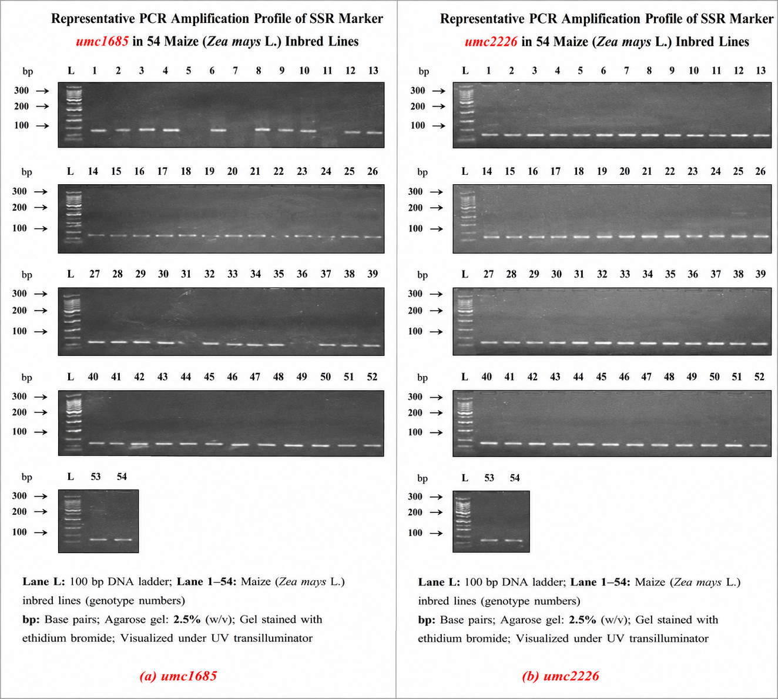
Figure S7. Representative PCR amplification profiles of SSR markers (a) umc1685, (b) umc2226, and in 54 maize inbred lines.

