Necessary Supplementary Materials
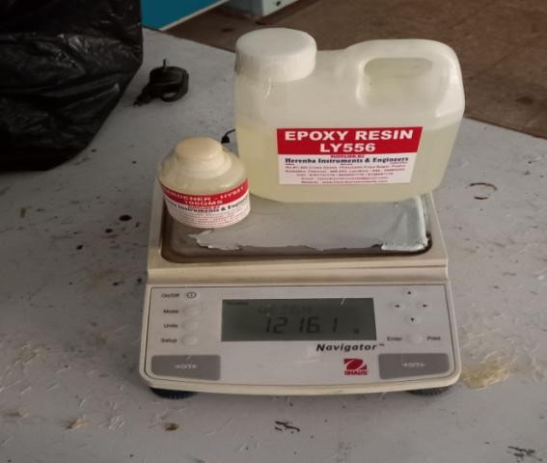

Fig.(S1): Polymer resin used in the study
.

Fig.(S2): Mold releasing agent

Supplementary Equations (S3)

Determining the fraction of mass in fiber and the matrix
The total composite mass is the sum of the matrix mass and fiber mass, expressed as
𝑀𝑐= 𝑀𝑚+𝑀𝑓 Eq. (1)
The fiber mass fraction is calculated as the mass of the fiber divided by the total mass, represented as
𝐹𝑖𝑏𝑒𝑟 𝑚𝑎𝑠𝑠 𝑓𝑟𝑎𝑐𝑡ion𝑛= ^{Mass} ^{of} ^{fiber}
Total mass

𝑀𝑓= (𝑀𝑓𝑀𝑚+) Eq. (2)

The matrix mass fraction is obtained similarly,

𝑀𝑎𝑡𝑟𝑖𝑥 𝑚𝑎𝑠𝑠 𝑓𝑟𝑎𝑐𝑡𝑖𝑜𝑛= ^{𝑚𝑎𝑠𝑠} ^{𝑜𝑓} ^{𝑚𝑎𝑡𝑟𝑖𝑥}
𝑡𝑜𝑡𝑎𝑙 𝑚𝑎𝑠𝑠
𝑀𝑚= 𝑀𝑚𝑀𝑚+𝑀𝑓
Consequently,
𝑀𝑓+𝑀𝑐=1 Eq. (3)

Determining the volume of mass in the fiber and matrix
Volume of the fiber is calculated as the mass of the fiber divided by the density of the fiber, expressed as

𝑉𝑓= ^{𝑀𝑓}
𝜌𝑓
Eq. (4)

Similarly, the volume of the matrix is determined by the mass of the matrix divided by the density of the matrix

𝑉𝑜𝑙𝑢𝑚𝑒 𝑜𝑓 𝑡ℎ𝑒 𝑚𝑎𝑡𝑟𝑖𝑥= ^{𝑚𝑎𝑠𝑠} ^{𝑜𝑓} ^{𝑚𝑎𝑡𝑟𝑖𝑥}
𝑑𝑒𝑛𝑠𝑖𝑡𝑦 𝑜𝑓 𝑡ℎ𝑒 𝑚𝑎𝑡𝑟𝑖𝑥
Eq. (5)

𝑉𝑚= ^{𝑀𝑚}
𝜌𝑚

𝑉𝑐= 𝑉𝑚+𝑉𝑓

𝐹𝑖𝑏𝑒𝑟 𝑣𝑜𝑙𝑢𝑚𝑒 𝑓𝑟𝑎𝑐𝑡𝑖𝑜𝑛= ^{𝑣𝑜𝑙𝑢𝑚𝑒} ^{𝑜𝑓} ^{𝑓𝑖𝑏𝑒𝑟}
𝑡𝑜𝑡𝑎𝑙 𝑣𝑜𝑙𝑚𝑒

𝑉𝑓= ^{𝑉𝑓}
𝑉𝐹+𝑉𝑚

𝑀𝑎𝑡𝑟𝑖𝑥 𝑣𝑜𝑙𝑢𝑚𝑒 𝑓𝑟𝑎𝑐𝑡𝑖𝑜𝑛= 𝑣𝑜𝑙𝑢𝑚𝑒 𝑜𝑓 𝑚𝑎𝑡𝑟𝑖𝑥𝑡𝑜𝑡𝑎𝑙 𝑣𝑜𝑙𝑢𝑚𝑒

𝑉𝑚= ^{𝑉𝑚}
𝑉𝐹+𝑉𝑚

𝑉𝑓= 𝑀𝑓+𝜌𝑚
𝑀𝑓 𝜌𝑚+𝑀𝑚𝜌𝑓
And;
𝑉𝑀= 𝑀𝑚+𝜌𝑓
𝑀𝑓 𝜌𝑚+𝑀𝑚𝜌𝑓

Determining the composite density (𝛒𝐜)
The density is calculated using the equation provided in Eq. 6. ρ c= 𝑇𝑜𝑡𝑎𝑙 𝑚𝑎𝑠𝑠
𝑇𝑜𝑡𝑎𝑙 𝑣𝑜𝑙𝑢𝑚𝑒

= 𝑚𝑎𝑠𝑠 𝑜𝑓 𝑚𝑎𝑡𝑟𝑖𝑥𝑇𝑜𝑡𝑎𝑙 +𝑚𝑎𝑠𝑠 𝑜𝑓 𝑐𝑎𝑡𝑎𝑙𝑦𝑠𝑡&𝑎𝑐𝑐𝑒𝑙𝑒𝑟𝑎𝑡𝑜𝑟+ mass of fiber

Eq. (6)

𝑇𝑜𝑡𝑎𝑙 𝑣𝑜𝑙𝑢𝑚𝑒
𝑇𝑜𝑡𝑎𝑙 𝑉𝑜𝑙𝑢𝑚𝑒
𝑇𝑜𝑡𝑎𝑙 𝑣𝑜𝑙𝑢𝑚𝑒

¹ = ^{0.3} + ^{0.7} = ρ c= 1.24 ¹ = ^{0.1} + ^{0.9} = ρ c= 0.824

𝞀 𝐶
1.4
1.2
𝞀 𝐶
1.4
1.2

Since Mf= 30 %( 0.3) and Mass of matrix Mm= 70 % (0.7) for sample 1 and sample 2
For sample 3 and 4 Mf= 10 %( 0.1) and Mass of matrix Mm= 90 % (0.9)

Supplementary Equations (S4)
- The composite specimen's volume is determined by multiplying its length, width, and thickness, expressed
Vc= length ×width× thickness
Using specific dimensions, such as 25cm in length, 7cm in width, and 1cm in thickness, the calculation yields 175 𝑐𝑚³
= 25cm×7cm×1cm = 175 𝑐𝑚³
- Mass of the composite (mc) = volume of the composite (vc) × density of the composite (ρc)
The composite mass (mc) is calculated by multiplying the composite volume (vc) by the density of the composite ( ρc), given as
M c =vc× ρc
= 175 𝑐𝑚³ × 1.24 g/𝑐𝑚³ = 217 gram Eq. (7)

  - Determination of Volume and Mass fraction for Milling Sample Preparation
The specimen dimensions were determined considering factors like the number of slots created by the end mill cutters, the diameter of the end mill cutters, and the gaps between slots. In this study, each sample will undergo a total of 9 milling operations, using end mill cutters with a 20mm diameter and a 10mm gap between two slots.
The specimen dimensions are as follows: 250mm in width, 70mm in length, and 10mm in thickness. To find the volume of the specimen, the length, width, and thickness are multiplied together.
- The composite specimen's volume is determined by multiplying its length, width, and thickness, expressed
Vc= length ×width× thickness
Using specific dimensions, such as 25cm in length, 7cm in width, and 1cm in thickness, the calculation yields 175 𝑐𝑚³
= 25cm×7cm×1cm = 175 𝑐𝑚³
- Mass of the composite (mc) = volume of the composite (vc) × density of the composite (ρc)
The composite mass (mc) is calculated by multiplying the composite volume (vc) by the density of the composite ( ρc), given as
M c =vc× ρc
= 175 𝑐𝑚³ × 1.24 g/𝑐𝑚³ = 217 gram

For sample 1 and 2:

For sample 3 and 4

mf = Mf×mc = 0.3 ×217 g = 65.1 gram mm = Mm × mc = 0.7 × 217 g = 151.9 gram

mf = Mf×mc = 0.1 ×217 g = 21.7 gram

mm = Mm × mc = 0.9 × 217 g = 195.3 gram

Supplementary Equations (S5)
    - Determination of Volume and mass fraction for Compression Strength Sample Preparation
- The composite volume is determined by the formula: (vc) = 80 mm × 60 mm × 4mm
= 14cm×6cm×0.4cm = 33.6 𝑐𝑚³
- The mass is determined by (mc) = volume of the composite (vc) ×density of the composite (ρc)
mc = 33.6 cm3 × 1.24 g/cm3 = 45 g
Since we do have 4 different samples the mass and fiber content is determined as follows;
- Mass of the fiber for sample 1and 2 = mass fraction of the fiber × mass of the composite
= 0.3 × 45
mf = 13.5 g
- Mass of the matrix for sample 1 and 2 = mass fraction of the matrix × mass of the composite
= 0.7 × 45 mm = 31.5 gram
- Mass of the fiber for sample 3 and 4 = mass fraction of the matrix × mass of the composite
0.1× 45= 4.5 gram
- Mass of the matrix for sample 1 and 2 = mass fraction of the matrix × mass of the composite
0.9× 45 mm= 40.5 gram
    - Determination of Volume and mass fraction for Flexural Strength
- vc = 140 mm × 60 mm × 3.2 mm

= 14 cm ×6 cm*×0.32 cm =29 𝑐𝑚³
- mc = volume of the composite (vc) ×density of the composite (ρc)
mc = 29 cm3 × 1.24 g/cm3 mc = 35.96 gram
- Fiber mass determination for sample 1 and 2 = mass fraction of the fiber ×mass of the composite
= 0.3 × 35.55 gram
mf = 10.788 gram
- Matrix mass determination for sample 1 and 2 = mass fraction of the matrix × mass of the composite
= 0.7 × 35.55 g
mm = 25.17 gram
- Fiber mass for sample 3 and 4 = mass fraction of the matrix × mass of the composite
= 0.1 × 35.55 g
mm = 3.357 gram
- Matrix mass for sample 3 and 4 = mass fraction of the matrix × mass of the composite
= 0.9 × 35.55 g
mm = 30.195 gram

    - Determination of Volume and mass fraction for Impact Strength
- Vc = 140 mm × 60 mm *×3 mm
= 14 cm×6 cm×0.3 cm =28 𝑐𝑚³
- Mc = volume of the composite (vc) ×density of the composite (ρc)
mc = 28𝑐𝑚³ × 1.24 g/𝑐𝑚³

= 34.72 gram
- Fiber mass for sample 1 and 2 = mass fraction of the fiber × mass of the composite
= 0.3 × 34.72g
mf = 10.42 gram
- Matrix mass for sample 1 and 2 = mass fraction of the matrix ×mass of the composite
= 0.7 × 34.72 g
mm = 24.3 gram
- Fiber mass for sample 1 and 2 = mass fraction of the matrix ×mass of the composite
= 0.1 × 34.72 g
mm = 3.472 gram
- Matrix mass for sample 1 and 2 = mass fraction of the matrix ×mass of the composite
= 0.9 × 34.72 g
mm = 31.248 gram
    - Determination of Volume and mass fraction for Tensile Strength
- Vc = 250 mm × 25 mm ×3 mm
= 25 cm×2.5 cm×0.3 cm =18 . 75𝑐𝑚³
- Mc = volume of the composite (vc) ×density of the composite (ρc)
mc = 18. 75𝑐𝑚³ × 1.24 g/𝑐𝑚³
= 23.25g
- Fiber mass for sample 1 and 2 = mass fraction of the fiber × mass of the composite
= 0.3 × 23.25gram
mf = 6.975gram
- The matrix mass for sample 1 and 2 = mass fraction of the matrix ×mass of the composite

= 0.7 × 23.25 gram
mm = 16.275 gram
- The fiber mass of the sample 3 and 4 = mass fraction of the matrix ×mass of the composite
= 0.1 × 23.25 gram
mm = 2.375 gram
- The matrix mass for sample 3 and 4 = mass fraction of the matrix ×mass of the composite
= 0.9 × 23.25 gram
mm = 20.925 gram

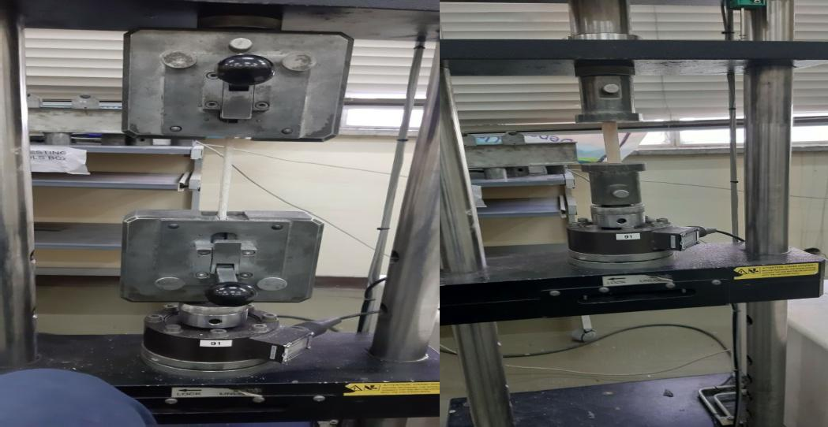
a) Tensile testing b) Compression testing


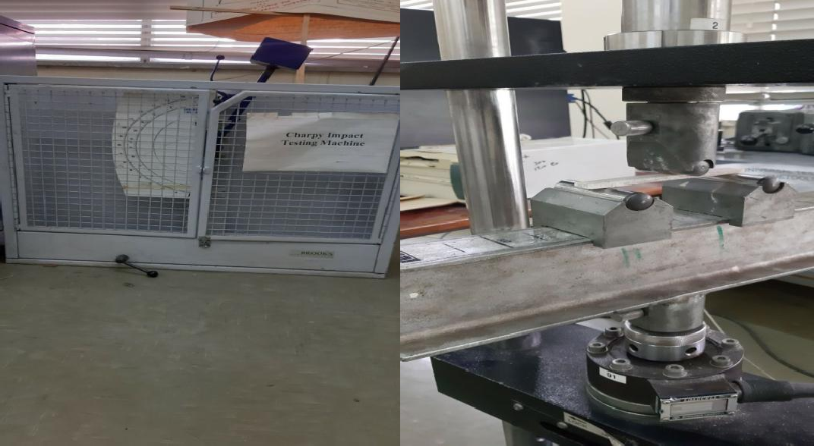
Yes
Converging?
No
Yes
Tuning the neural network's architecture
Selecting the neural network's decision function
Define the objective function
Obtain the optimal parameters
Train the network
Initialize the population
Bio-inspired evolution (Reproduction, crossover,
Training the neural network to learn from data
Engineering the experiment
Defining the problem

c) Impact testing d) Flexural testing
Figs. S3: Mechanical Testing machines

Fig.S4: The combined Artificial Neural Network (ANN) and Genetic Algorithm (GA) methodology for modeling and forecasting Material Removal Rate (MRR) and surface roughness
Table S1: Variable factors that influence the level of output

Variable factors | Machine Vibration | Workers skill | Improper alignment | Fiber material type

Table S2: Testing variables and characteristics of quality

Quality characteristics | Surface roughness, material removal rate
Specimen material | Sisal-cotton fiber-reinforced polyester composite
Cutting tool material | High-speed steel (HSS)
Operating machine | CNC milling machine
Cutting tool diameter | 20 mm
Cutting tool geometry | End mills with a two-flute twisted design

Table S3: Layouts of L9 (3³)) orthogonal array for the experiment

Experimen tNumber | L9(3³) Orthogonal Array
Experimen tNumber | Input parameters
Experimen tNumber | Spindle speed (rpm) | Feed rate (mm/min) | Depth of cut (mm)
1 | 1000 | 100 | 1
2 | 1000 | 200 | 1.5
3 | 1000 | 300 | 2
4 | 1400 | 100 | 1.5

5 | 1400 | 200 | 2
6 | 1400 | 300 | 1
7 | 2000 | 100 | 2
8 | 2000 | 200 | 1
9 | 2000 | 300 | 1.5

Additional Supplementaries Supplementary 1 Compression Test Results Sample 1
Stress Vs. Elongation
45
40
35
30
25
20
15
10
5
0
Stress Vs. Elongation
0 1 2 3 4
Sample 2

Stress Vs. Elongation
45
40
35
30
25
20
15
10
5
0
Stress Vs. Elongation
0 1 2 3 4 5
Sample 3
Stress Vs. Elongation
45
40
35
30
25
20
15
10
5
0
Stress Vs. Elongation
0 1 2 3 4 5
Sample 4

Stress Vs. Elongation
45
40
35
30
25
20
15
10
5
0
Stress Vs. Elongation
0 1 2 3 4 5

Tensile Test Results Sample 1
Stress Vs. Elongation
70
60
50
40
Stress Vs.
Elongation
30
20
10
0
0
1
2
3
4
5

Sample 2

Stress Vs. Elongation
60

50

40

30
Stress Vs. Elongation
20

10

0
0
1
2
3
4

Sample 3
Stress Vs. Elongation
60

50

40

30
Stress Vs. Elongation
20

10

0
0
1
2
3
4
5
Sample 4

Stress Vs. Elongation
60

50

40

30
Stress Vs.
Elongation
20

10

0
0
1
2
3
4
5

Result of Flexural Strength
S1
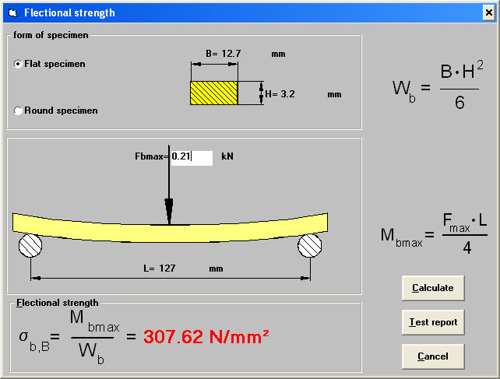

S 2

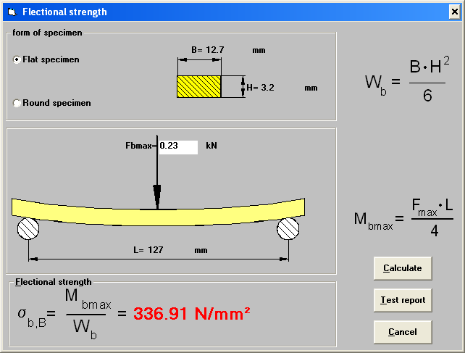
S 3
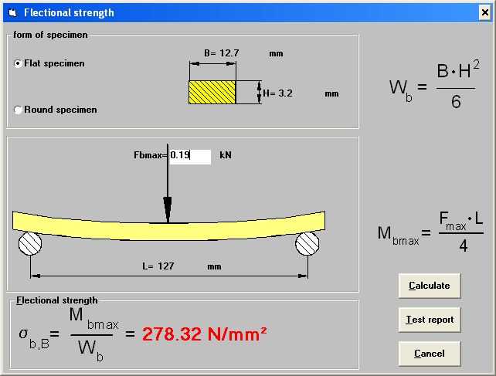
S 4

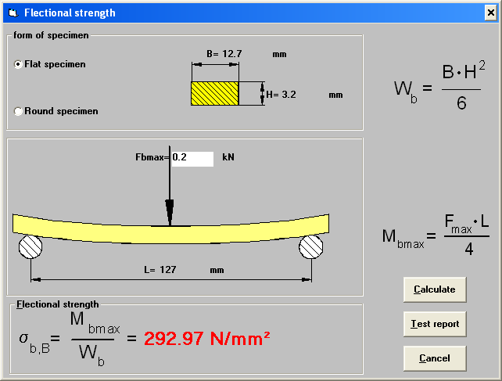
Supplementary 2

VOGEL Germany Surface Roughness Tester Specification

Measurement | Description
Reading | 0.01µm/1 inch
Measuring range for Ra | 0.05-10 µm
Measuring range for Rt | 0.1-50 µm
Tracing length | 6 mm

Milling Machine Specification

Type | Vertical Milling
Structure | CNC Bed type mill

Spindle power range | ≥ 3.7 Kw
Spindle frequency control | 60 - 4000 rpm
Maximum worktable size | ≥700 × ≥300 mm
X/Y/Z axis travel length | X ≥500 mm  Y ≥ 300 mm  Z ≥ 400 mm
Brand name | HNC
Model number | XK713
Positioning accuracy (Whole distance) | 0.04 mm
Rapid movement speed in the X / Y / Z axial direction | ≥ 8 / ≥ 8 / ≥ 8 m / min

Cutting Tool Specification

Material | High-Speed Steel
Diameter | 20×20
Length | 50-150 mm
Coating | AlCrN
Type | N
Twist Angle | 30°

Polymer Resin Specification

Properties | EPOXY Ly556 | Hardener HY951
Visual Appearance | Medium viscosity colorless | Brownish-yellow color liquid
Viscosity at room temperature | 9000-12000 MPa | 500-1000 MPa
Density at room temperature | 1.13-1.16 gm/cc | 0.946gm/cc
Mixture ratio( Part by weight) | 100 | 10

Supplementary 3

Surface Roughness Results
Sample One
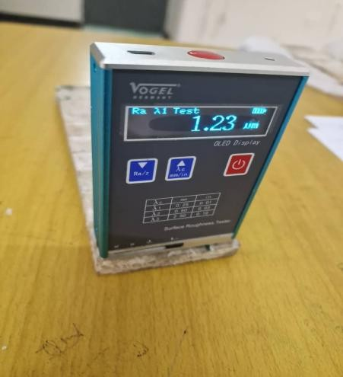
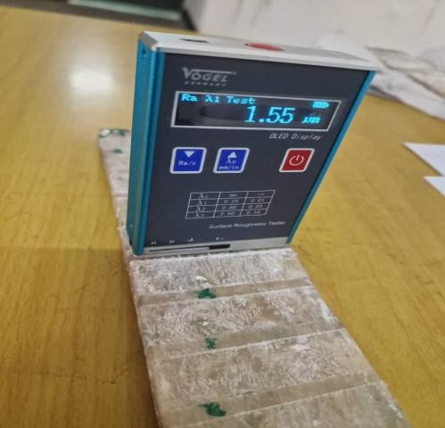
Experiment One Experiment Two

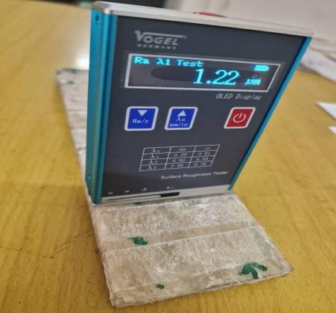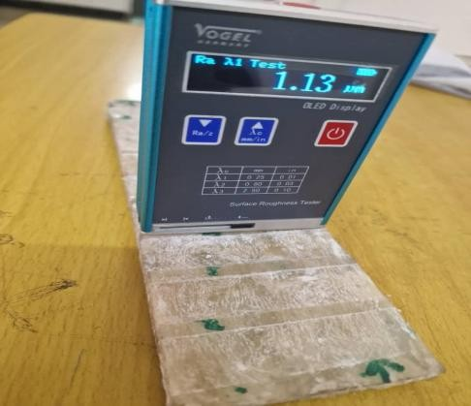
Experiment Three Experiment Four

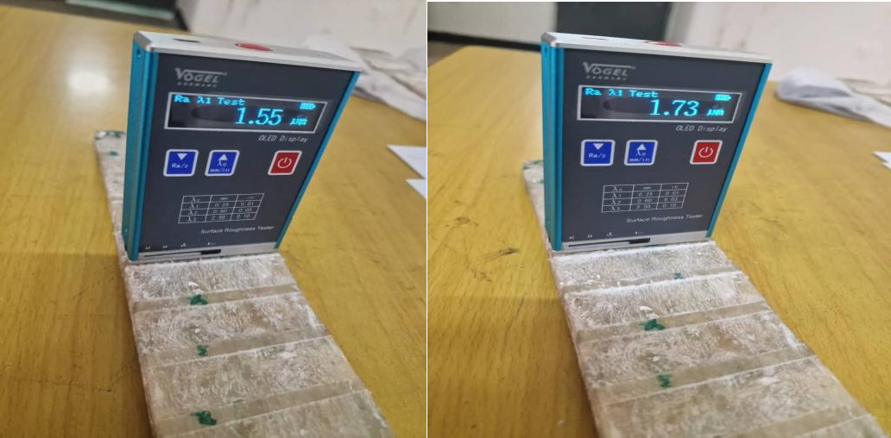
Experiment Five Experiment Six

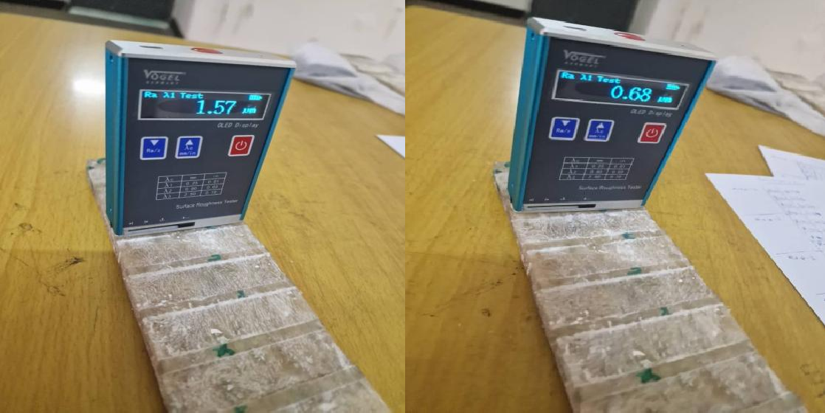
Experiment
Seven Experiment Eight

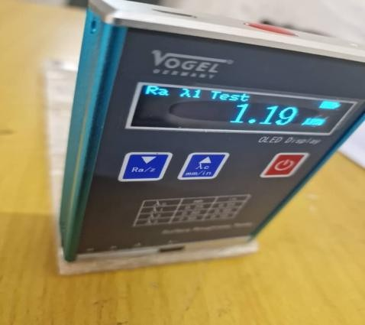

Experiment Nine

Sample Two

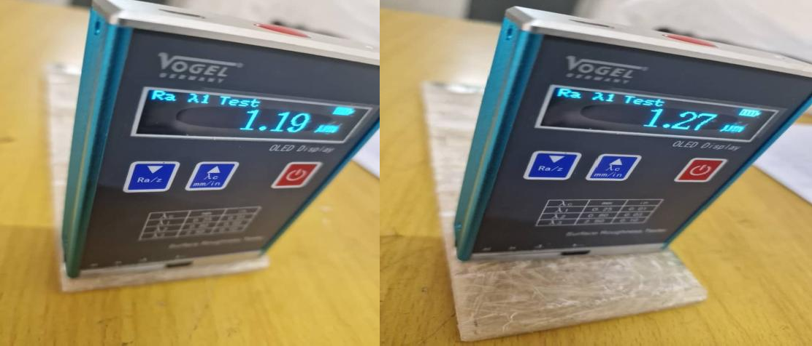
Experiment
One experiment Two
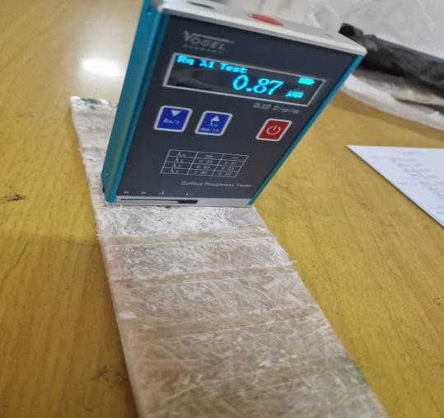
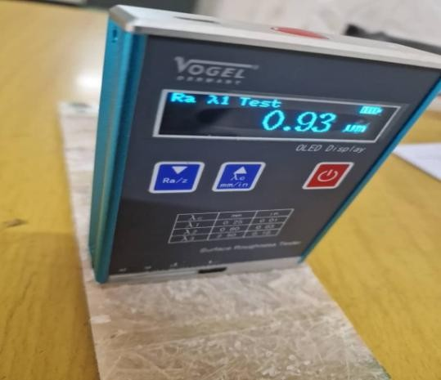
Experiment Three Experiment Four
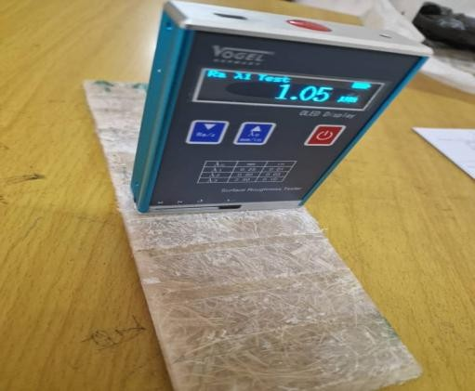
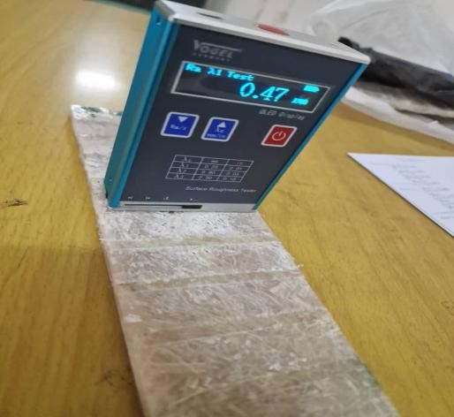
Experiment Five Experiment Six

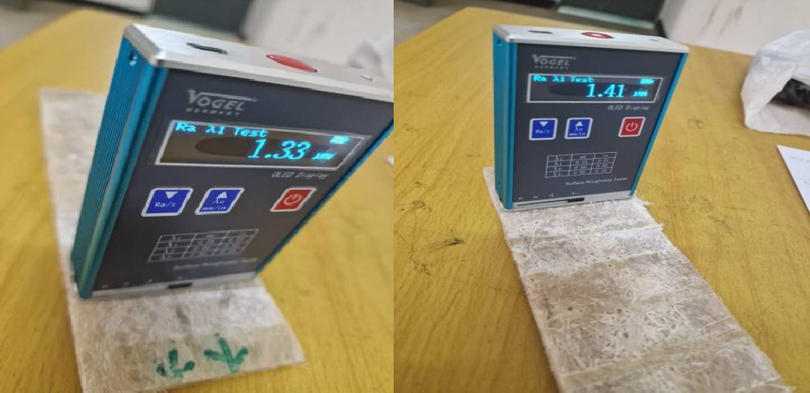
Experiment Eight Experiment Nine
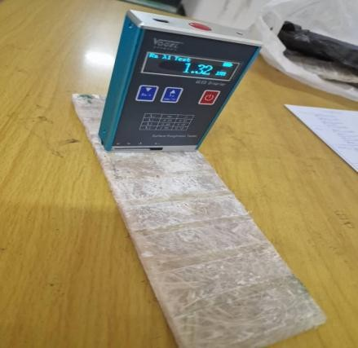
Experiment Seven

Sample 3
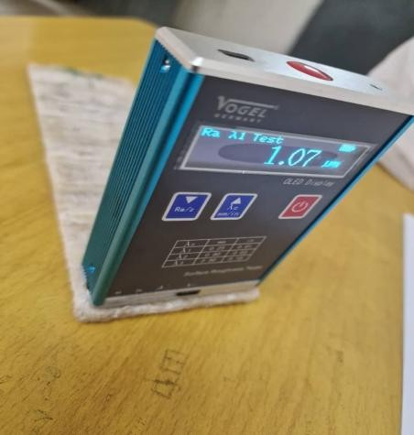
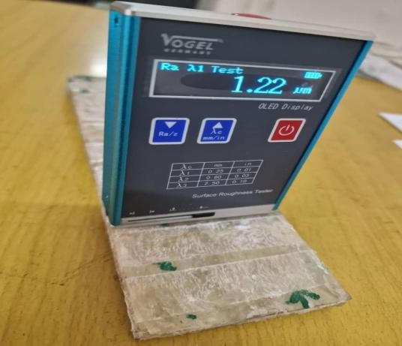
Experiment One Experiment Two

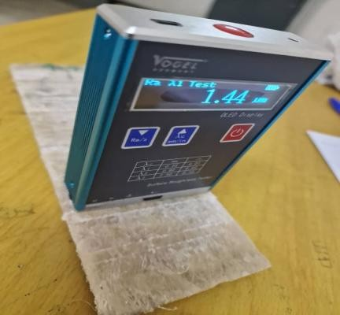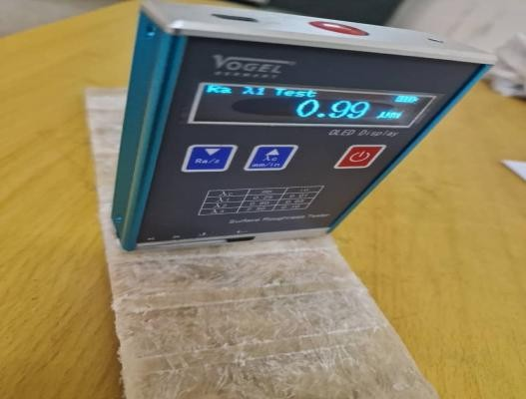
Experiment Three Experiment Four
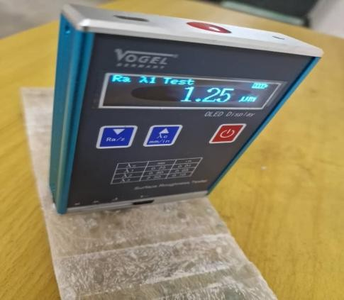
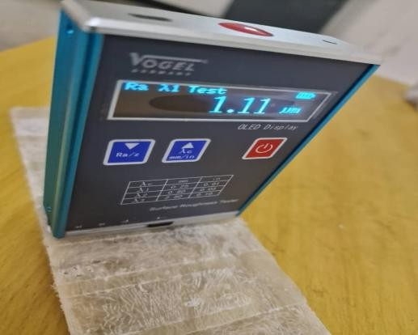
Experiment Five Experiment Six

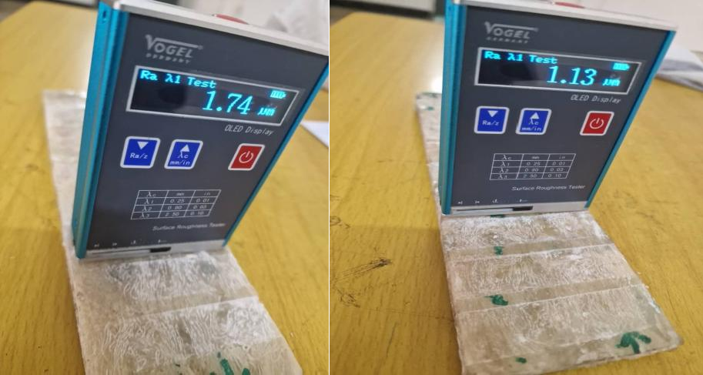

Experiment Seven Experiment Eight

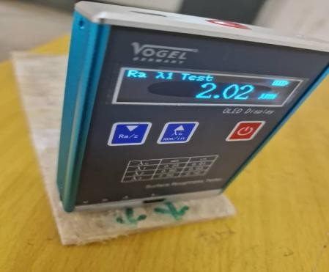
Experiment Nine Supplementary 4

CNC Part-Program
G90- Absolute positioning system G17- X, Y plane
G21-Metric measurement G40- Tool
G90 G21 G17 G40 M06 T0101
M03 S1000 G00 X26 Y0 Z5 Z-1
G01 Y90 F100 G00 Z5
X52 Y0 Z-1.5

G01 Y90 F200 G00 Z-5
X78 Y0 Z-2
GO1 Y90 F300 G00 Z-5
MO5
MO3 , S1400 G00 X104 Y0 Z-1.5
G0 Y90 F100 G00 Z-5 X130 Y0
Z-2
G01 Y90 F200 G00 Z-5
X156 Y0 Z-1
G01 X90 F300 G00 Z-5
M05
MO3 S2000 GOO X182 Y0 Z-2

G01 X90 F100 G00 Z-5
X208 Y0 Z-1
G01 Y90 F200 G00 Z-5
X234 Y0 Z-1.5
G01 Y90 F 300 G00 Z20
X50 Y0 M05 M30
Supplementary 5

ANN and GA Results

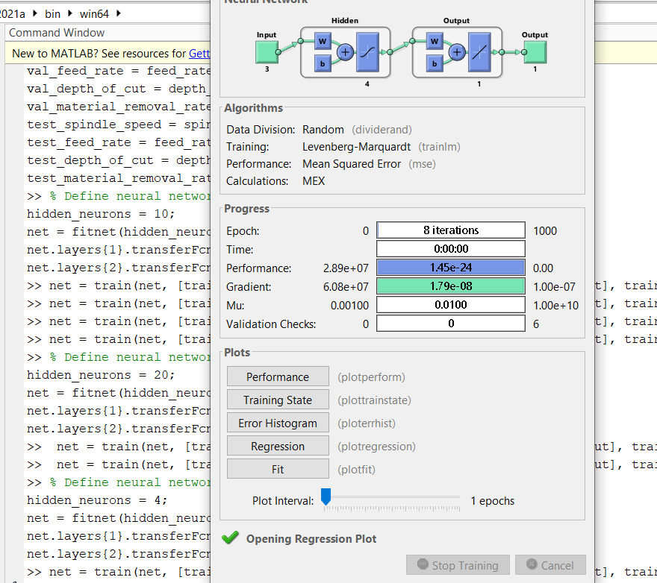

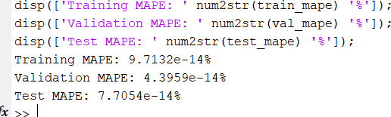

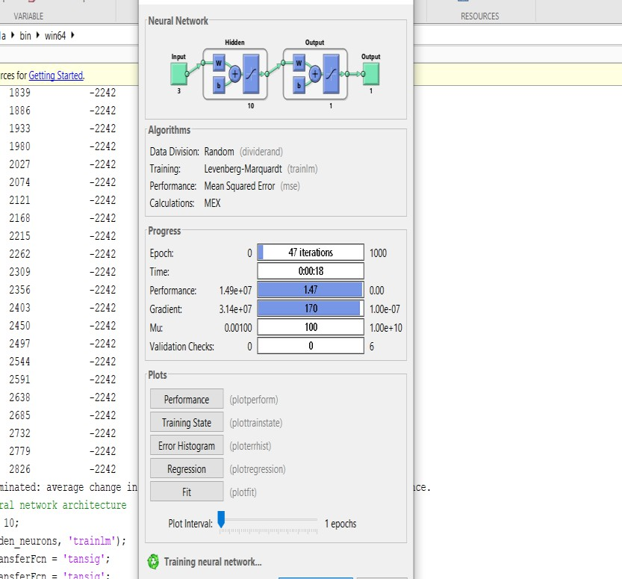

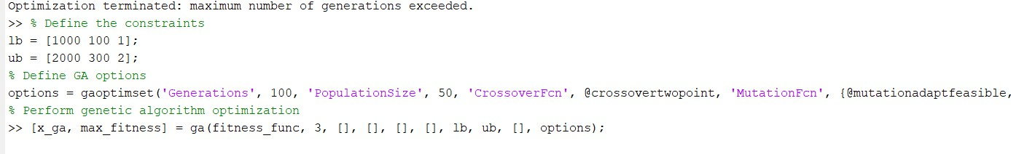
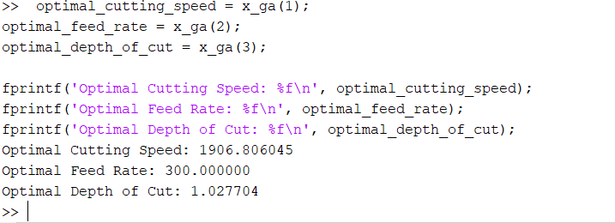

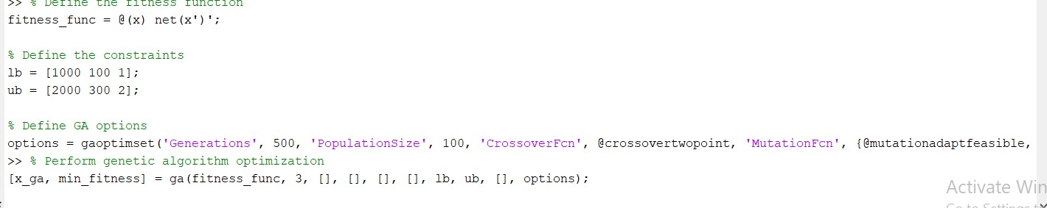

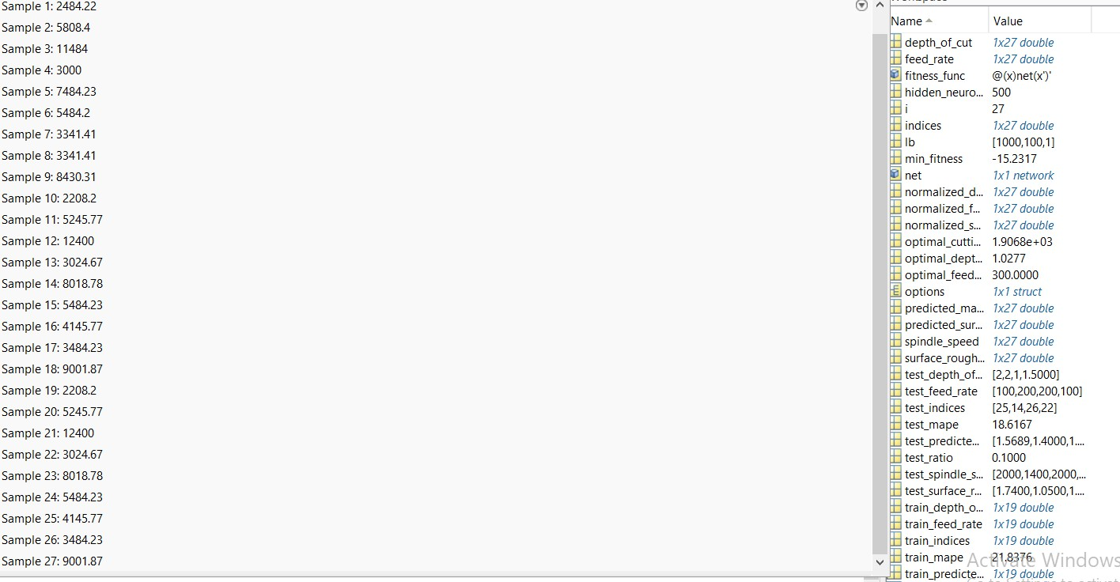

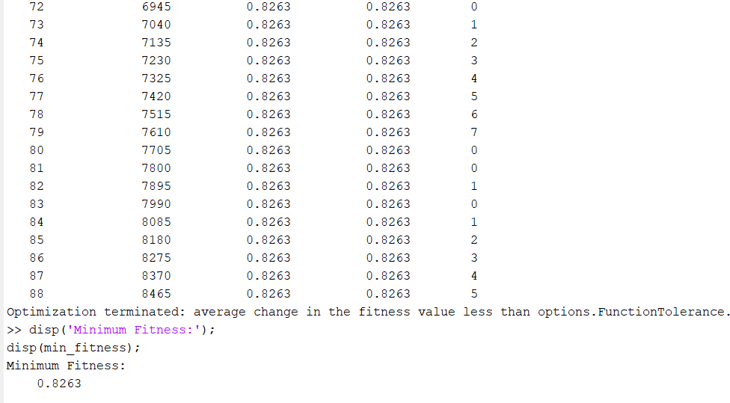
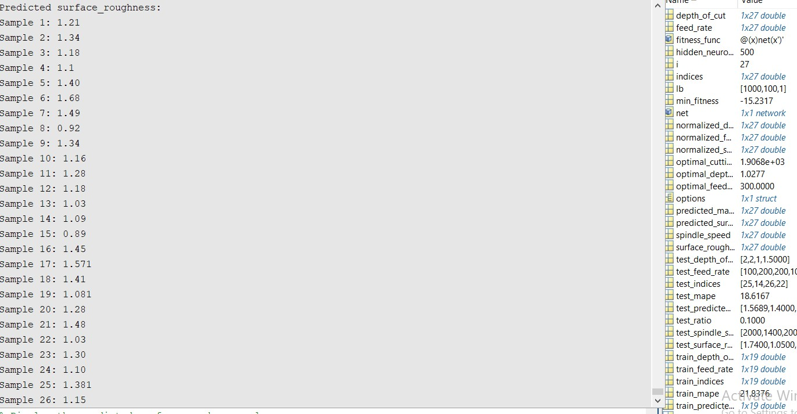

Supplementary 6

MATLAB Code
For surface Roughness
% Input parameters
spindle_speed = [1000 1000 1000 1400 1400 1400 2000 2000 2000 1000 1000 1000 1400 1400
1400 2000 2000 2000 1000 1000 1000 1400 1400 1400 2000 2000 2000];
feed_rate = [100 200 200 100 200 300 100 200 300 100 200 200 100 200 300 100 200 300 100
200 200 100 200 300 100 200 300];
depth_of_cut = [1 1.5 2 1.5 2 1 2 1 1.5 1 1.5 2 1.5 2 1 2 1 1.5 1 1.5 2 1.5 2 1 2 1 1.5];
% Response parameter
surface_roughness = [1.23 1.35 1.22 1.13 1.55 1.73 1.57 0.68 1.32 1.19 1.27 0.87 0.93 1.05 0.47
1.32 1.53 1.41 1.07 1.22 1.44 0.99 1.25 1.11 1.74 1.33 2.0];
>> % Divide the dataset into training, test, and validation sets rng(1); % Set random seed for reproducibility
indices = randperm(length(spindle_speed)); train_ratio = 0.7; % Training set ratio val_ratio = 0.15; % Validation set ratio test_ratio = 0.15; % Test set ratio
train_indices = indices(1:round(train_ratio * length(spindle_speed)));
val_indices = indices(round(train_ratio * length(spindle_speed)) + 1 : round((train_ratio + val_ratio) * length(spindle_speed)));
test_indices = indices(round((train_ratio + val_ratio) * length(spindle_speed)) + 1 : end);
% Split the data
train_spindle_speed = spindle_speed(train_indices);

train_feed_rate = feed_rate(train_indices); train_depth_of_cut = depth_of_cut(train_indices); train_surface_roughness = surface_roughness(train_indices); train_surface_roughness = surface_roughness(train_indices); val_spindle_speed = spindle_speed(val_indices); val_feed_rate = feed_rate(val_indices);
val_depth_of_cut = depth_of_cut(val_indices); val_surface_roughness = surface_roughness(val_indices); test_spindle_speed = spindle_speed(test_indices); test_feed_rate = feed_rate(test_indices); test_depth_of_cut = depth_of_cut(test_indices);
test_surface_roughness = surface_roughness(test_indices);
% Define neural network architecture hidden_neurons = 10;
net = fitnet(hidden_neurons, 'trainlm'); net.layers{1}.transferFcn = 'tansig'; net.layers{2}.transferFcn = 'tansig';
% Define the hyperparameter grid
param_grid = struct('MaxNumSplits', [5, 10, 15], 'MinLeafSize', [1, 5, 10]);
% Perform grid search
cv = cvpartition(numel(train_surface_roughness), 'KFold', 5); % 5-fold cross-validation best_accuracy = 0; % Variable to store the best accuracy
best_params = []; % Variable to store the best hyperparameters
% Perform grid search

cv = cvpartition(numel(train_surface_roughness), 'KFold', 5); % 5-fold cross-validation best_accuracy = 0; % Variable to store the best accuracy
best_params = []; % Variable to store the best hyperparameters for i = 1:numel(param_grid.MaxNumSplits)
for j = 1:numel(param_grid.MinLeafSize)
% Train the model using the current hyperparameters
model = fitctree(train_spindle_speed,train_feed_rate,train_depth_of_cut, train_surface_roughness, 'CrossVal', 'on', 'CVPartition', cv, 'OptimizeHyperparameters',
{'MaxNumSplits', 'MinLeafSize'}, 'HyperparameterOptimizationOptions', struct('AcquisitionFunctionName', 'expected-improvement-plus'))
% Train neural network
net = train(net, [train_spindle_speed; train_feed_rate; train_depth_of_cut], train_surface_roughness);
% Predict using neural network
train_predicted_surface_roughness = net([train_spindle_speed; train_feed_rate; train_depth_of_cut]);
val_predicted_surface_roughness = net([val_spindle_speed; val_feed_rate; val_depth_of_cut]); test_predicted_surface_roughness = net([test_spindle_speed; test_feed_rate; test_depth_of_cut]);
% Calculate mean average percentage error (MAPE)
train_mape = mean(abs(train_surface_rougness - train_surface_roughness) ./ train_surface_roughness) * 100;
val_mape = mean(abs(val_surface_roughness - val_predicted_surface_roughness) ./ val_surface_rougness) * 100;
test_mape = mean(abs(test_surface_roughness - test_predicted_surface_roughness) ./ test_surface_rougness) * 100;

% Display MAPE
disp(['Training MAPE: ' num2str(train_mape) '%']); disp(['Validation MAPE: ' num2str(val_mape) '%']); disp(['Test MAPE: ' num2str(test_mape) '%']);
% Define the fitness function fitness_func = @(x) net(x')';
% Define the constraints lb = [1000 100 1];
ub = [2000 300 2];
options = gaoptimset('Generations', 500, 'PopulationSize', 100, 'CrossoverFcn', @crossovertwopoint, 'MutationFcn', {@mutationadaptfeasible, 0.01}, 'Display', 'iter');
% Perform genetic algorithm optimization
[x_ga, min_fitness] = ga(fitness_func, 3, [], [], [], [], lb, ub, [], options); optimal_cutting_speed = x_ga(1);
optimal_feed_rate = x_ga(2); optimal_depth_of_cut = x_ga(3);
fprintf('Optimal Cutting Speed: %f\n', optimal_cutting_speed); fprintf('Optimal Feed Rate: %f\n, optimal_feed_rate); fprintf('Optimal Depth of Cut: %f\n', optimal_depth_of_cut);
% Normalize the input data
normalized_spindle_speed = normalize(spindle_speed); normalized_feed_rate = normalize(feed_rate); normalized_depth_of_cut = normalize(depth_of_cut);
% Predict using the trained neural network

predicted_surface_rougness = net([normalized_spindle_speed; normalized_feed_rate; normalized_depth_of_cut]);
% Display the predicted surface roughness values fprintf("Predicted surface_roughness:\n");
for i = 1:length(predicted_surface_roughness)
fprintf("Sample %d: %.2f\n", i, predicted_surface_roughness(i)); Predicted surface_roughness:
end
For MRR
% Input parameters
spindle_speed = [1000 1000 1000 1400 1400 1400 2000 2000 2000 1000 1000 1000 1400 1400
1400 2000 2000 2000 1000 1000 1000 1400 1400 1400 2000 2000 2000];
feed_rate = [100 200 200 100 200 300 100 200 300 100 200 200 100 200 300 100 200 300 100
200 200 100 200 300 100 200 300];
depth_of_cut = [1 1.5 2 1.5 2 1 2 1 1.5 1 1.5 2 1.5 2 1 2 1 1.5 1 1.5 2 1.5 2 1 2 1 1.5];
% Response parameter
material_removal_rate = [2000 6000 12000 3000 8000 6000 4000 4000 9000 2000 6000 12000
3000 8000 6000 4000 4000 9000 2000 6000 12000 3000 8000 6000 4000 4000 9000];
% Divide the dataset into training, test, and validation sets rng(1); % Set random seed for reproducibility
indices = randperm(length(spindle_speed)); train_ratio = 0.7; % Training set ratio val_ratio = 0.15; % Validation set ratio test_ratio = 0.15; % Test set ratio

train_indices = indices(1:round(train_ratio * length(spindle_speed)));
val_indices = indices(round(train_ratio * length(spindle_speed)) + 1 : round((train_ratio + val_ratio) * length(spindle_speed)));
test_indices = indices(round((train_ratio + val_ratio) * length(spindle_speed)) + 1 : end);
% Split the data
train_spindle_speed = spindle_speed(train_indices); train_feed_rate = feed_rate(train_indices); train_depth_of_cut = depth_of_cut(train_indices);
train_material_removal_rate = material_removal_rate(train_indices); val_spindle_speed = spindle_speed(val_indices);
val_feed_rate = feed_rate(val_indices); val_depth_of_cut = depth_of_cut(val_indices);
val_material_removal_rate = material_removal_rate(val_indices); test_spindle_speed = spindle_speed(test_indices);
test_feed_rate = feed_rate(test_indices); test_depth_of_cut = depth_of_cut(test_indices);
% Define neural network architecture hidden_neurons = 4;
net = fitnet(hidden_neurons, 'trainlm'); net.layers{1}.transferFcn = 'tansig'; net.layers{2}.transferFcn = 'purelin';
% Define the hyperparameter grid
param_grid = struct('MaxNumSplits', [5, 10, 15], 'MinLeafSize', [1, 5, 10]);
% Perform grid search

cv = cvpartition(numel(train_material_removal_rate), 'KFold', 5); % 5-fold cross-validation best_accuracy = 0; % Variable to store the best accuracy
best_params = []; % Variable to store the best hyperparameters
% Perform grid search
cv = cvpartition(numel(train_surface_roughness), 'KFold', 5); % 5-fold cross-validation best_accuracy = 0; % Variable to store the best accuracy
best_params = []; % Variable to store the best hyperparameters for i = 1:numel(param_grid.MaxNumSplits)
for j = 1:numel(param_grid.MinLeafSize)

% Train the model using the current hyperparameters
model = fitctree(train_spindle_speed,train_feed_rate,train_depth_of_cut, train_material_removal_rate, 'CrossVal', 'on', 'CVPartition', cv, 'OptimizeHyperparameters',
{'MaxNumSplits', 'MinLeafSize'}, 'HyperparameterOptimizationOptions', struct('AcquisitionFunctionName', 'expected-improvement-plus'));
% Train neural network
net = train(net, [train_spindle_speed; train_feed_rate; train_depth_of_cut],

train_material_removal_rate);
% Predict using neural network
train_predicted_material_removal_rate train_depth_of_cut]); | = | net([train_spindle_speed; | train_feed_rate;
val_predicted_material_removal_rate val_depth_of_cut]); | = | net([val_spindle_speed; | val_feed_rate;
test_predicted_material_removal_rate test_depth_of_cut]); | = | net([test_spindle_speed; | test_feed_rate;

% Calculate mean average percentage error (MAPE)
train_mape = mean(abs(train_material_removal_rate - train_predicted_material_removal_rate) ./ train_material_removal_rate) * 100;
val_mape = mean(abs(val_material_removal_rate - val_predicted_material_removal_rate) ./ val_material_removal_rate) * 100;
test_mape = mean(abs(test_material_removal_rate - test_predicted_material_removal_rate) ./ test_material_removal_rate) * 100;
% Display MAPE
disp(['Training MAPE: ' num2str(train_mape) '%']); disp(['Validation MAPE: ' num2str(val_mape) '%']); disp(['Test MAPE: ' num2str(test_mape) '%']);
% Define the fitness function fitness_func = @(x) net(x')';
% Define the constraints lb = [1000 100 1];
ub = [2000 300 2];
% Define GA options
options = gaoptimset('Generations', 100, 'PopulationSize', 50, 'CrossoverFcn', @crossovertwopoint, 'MutationFcn', {@mutationadaptfeasible, 0.01}, 'Display', 'iter');

optimal_cutting_speed = x_ga(1); optimal_feed_rate = x_ga(2); optimal_depth_of_cut = x_ga(3);

fprintf('Optimal Cutting Speed: %f\n', optimal_cutting_speed); fprintf('Optimal Feed Rate: %f\n', optimal_feed_rate); fprintf('Optimal Depth of Cut: %f\n', optimal_depth_of_cut);
% Normalize the input data
normalized_spindle_speed = normalize(spindle_speed); normalized_feed_rate = normalize(feed_rate); normalized_depth_of_cut = normalize(depth_of_cut);
% Predict using the trained neural network
predicted_material_removal_rate = net([normalized_spindle_speed; normalized_feed_rate; normalized_depth_of_cut]);
% Display the predicted material removal rate values fprintf("Predicted material_removal_rate:\n");
for i = 1:length(predicted_material_removal_rate)
fprintf("Sample %d: %.2f\n", i, predicted_material_removal_rate(i)); end

