Delphi Expert Panel Characteristics and Recruitment
Purpose and Scope
This supplementary file expands the Delphi expert panel roster in response to the editorial request for additional information on expert field, professional position/title, educational background, region, institution type, recruitment method, inclusion and exclusion criteria, and participation across Delphi rounds. The classifications below are derived from the recorded expert positions and affiliations in the expert roster.
Expert Panel Composition
The Delphi panel consisted of 60 experts. The panel covered clinical medicine and hospital leadership, medical education and faculty development, public health and health management, bioethics, medical informatics, artificial intelligence, intelligent medical engineering, biomedical engineering, medical library and information services, and higher-education administration.
Panel-level background data from the first-round questionnaire showed that the experts were predominantly senior professionals, with more than 85% of respondents reporting doctoral-level education.
The expert panel also included members from institutions located in eastern, western, southern, northern, and central China. This coverage across the major geographic orientations of China supported the geographic representativeness of the panel and strengthened the breadth of expert perspectives informing the consensus.
Expert count | 60 experts
Field coverage | Clinical medicine and hospital leadership; medical education and faculty development; public health and health management; bioethics; medical informatics; artificial intelligence; intelligent medical engineering; biomedical engineering; medical library and information services; higher-education administration.
Regional distribution | Beijing n=17; Guangdong n=12; Liaoning n=4; Shaanxi n=4; Shanghai n=4; Sichuan n=3; Chongqing n=2; Hubei n=2; Inner Mongolia n=2; Anhui n=1; Fujian n=1; Henan n=1; Hunan n=1; Jiangsu n=1; Jiangxi n=1; Jilin n=1; Ningxia n=1; Tianjin n=1; Zhejiang n=1  （The expert panel included members from institutions across eastern, southern, western, and northern China, ensuring broad geographic coverage of the country.）
Institution types | Medical university/medical school/health-science center n=19; University-affiliated hospital/clinical center n=31; Comprehensive/engineering university or research unit n=8; Public health, medical library or information agency n=2
Educational background | The first-round background questionnaire indicated that more than 85% of respondents reported doctoral-level education, supporting the senior academic profile of the panel.
Expert Identification, Selection Criteria, and Recruitment
The expert panel was assembled using purposive sampling supplemented by expert recommendation. The working group first mapped the expertise required for this consensus study, including medical education, clinical teaching and practice, education management, public health, health management, artificial intelligence, biomedical engineering, medical informatics, bioethics, and medical information services. Candidate experts were then identified from medical universities, university-affiliated hospitals, comprehensive or engineering universities, public health institutions, and medical information or library-service units.
Eligibility was judged according to professional relevance and capacity to evaluate AI-literacy competencies for medical educators, rather than by a single numerical threshold. Experts were invited if they had recognized academic, clinical, administrative, technical, or professional expertise in at least one relevant area; familiarity with medical education, health care, AI, or digital transformation; and the ability to provide independent judgments on the importance, uniqueness, feasibility, and classification of the proposed competency items.
To ensure multidisciplinary and geographic balance, the working group reviewed the candidate list against several representation dimensions before issuing invitations: discipline, current professional role, institution type, educational background, geographic region, and experience with AI-related research or practice in medical education or health care. Geographic coverage was considered explicitly; experts were purposively selected from institutions located across eastern, western, southern, northern, and central China, thereby covering the major geographic orientations of the country and improving the representativeness and breadth of the expert panel. The first-round questionnaire also collected background information on educational level, professional title, current role, specialty area, relevant work experience, attention to AI applications, and AI-related research or practice; these data confirmed that the panel covered a broad range of senior professional, doctoral-level, disciplinary, institutional, and geographic perspectives.
Invited experts received information about the study purpose, the two-round Delphi procedure, the voluntary nature of participation, anonymized use of response data, and disclosure of name and affiliation in the supplementary expert roster. Experts were enrolled only after agreeing to the consent and disclosure statements presented at the beginning of the Delphi questionnaire.
Inclusion and Exclusion Criteria
Experts were eligible if they met the following criteria: (1) professional expertise in medical education, clinical medicine, health professions education, education management, AI or digital health, medical informatics, biomedical engineering, public health, ethics, or a related area; (2) sufficient professional experience to judge the relevance and feasibility of AI-literacy competencies for medical educators; (3) ability to complete the Delphi questionnaire independently; and (4) willingness to participate voluntarily and provide informed consent for anonymized data analysis and roster disclosure as supplementary material.
Experts were excluded if they declined participation, withdrew consent, were unable to complete the required Delphi questionnaire, provided duplicate or invalid responses, lacked a clear professional connection to the topic, or had a conflict that made participation inappropriate.
Participation Across Delphi Rounds
A 60-member expert panel was purposively assembled from institutions located in eastern, southern, western, and northern China, ensuring broad geographic coverage of the invited panel. Valid Round 1 questionnaires returned by responding experts were used for the first-round Delphi analysis.
The present roster documents the expert panel and the same 60-expert target roster across the Delphi process. It does not contain standardized highest-degree information or a separate individual round-by-round completion log. Therefore, individual degree data and round-specific response or retention rates should be reported from survey-platform records or expert self-report rather than inferred from affiliation or professional title.

Consent and Public Disclosure Evidence
At the beginning of each Delphi questionnaire, experts were shown an informed-consent and public-disclosure statement. The statement explained the study purpose, the voluntary nature of participation, anonymized use of response data, the right to discontinue or request deletion of submitted data, and submission of expert name and affiliation as supplementary appendix material at manuscript submission. Continuing to complete and submit the questionnaire was stated to constitute informed consent for use of the survey data.
Screenshots of the Round 1 and Round 2 questionnaire consent interfaces are provided below, together with an English summary of the relevant consent and disclosure language.
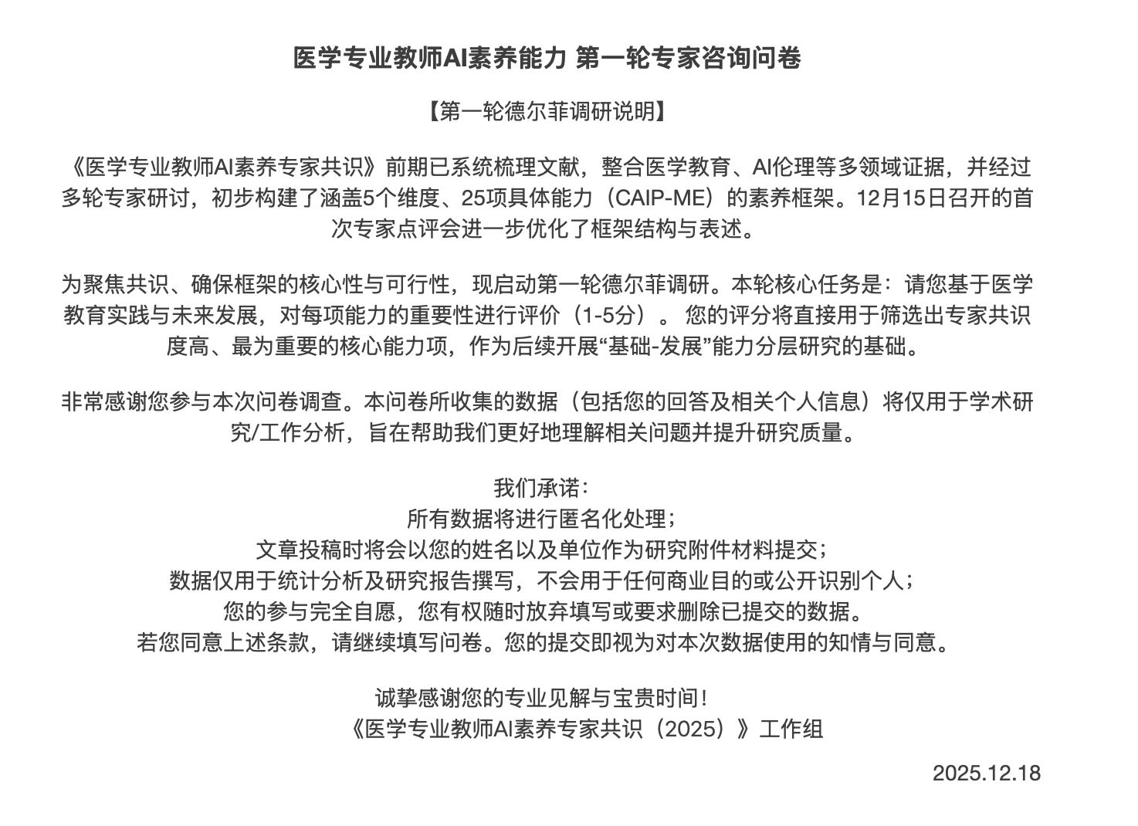
Figure 1. Round 1 Delphi questionnaire informed-consent and public-disclosure interface.

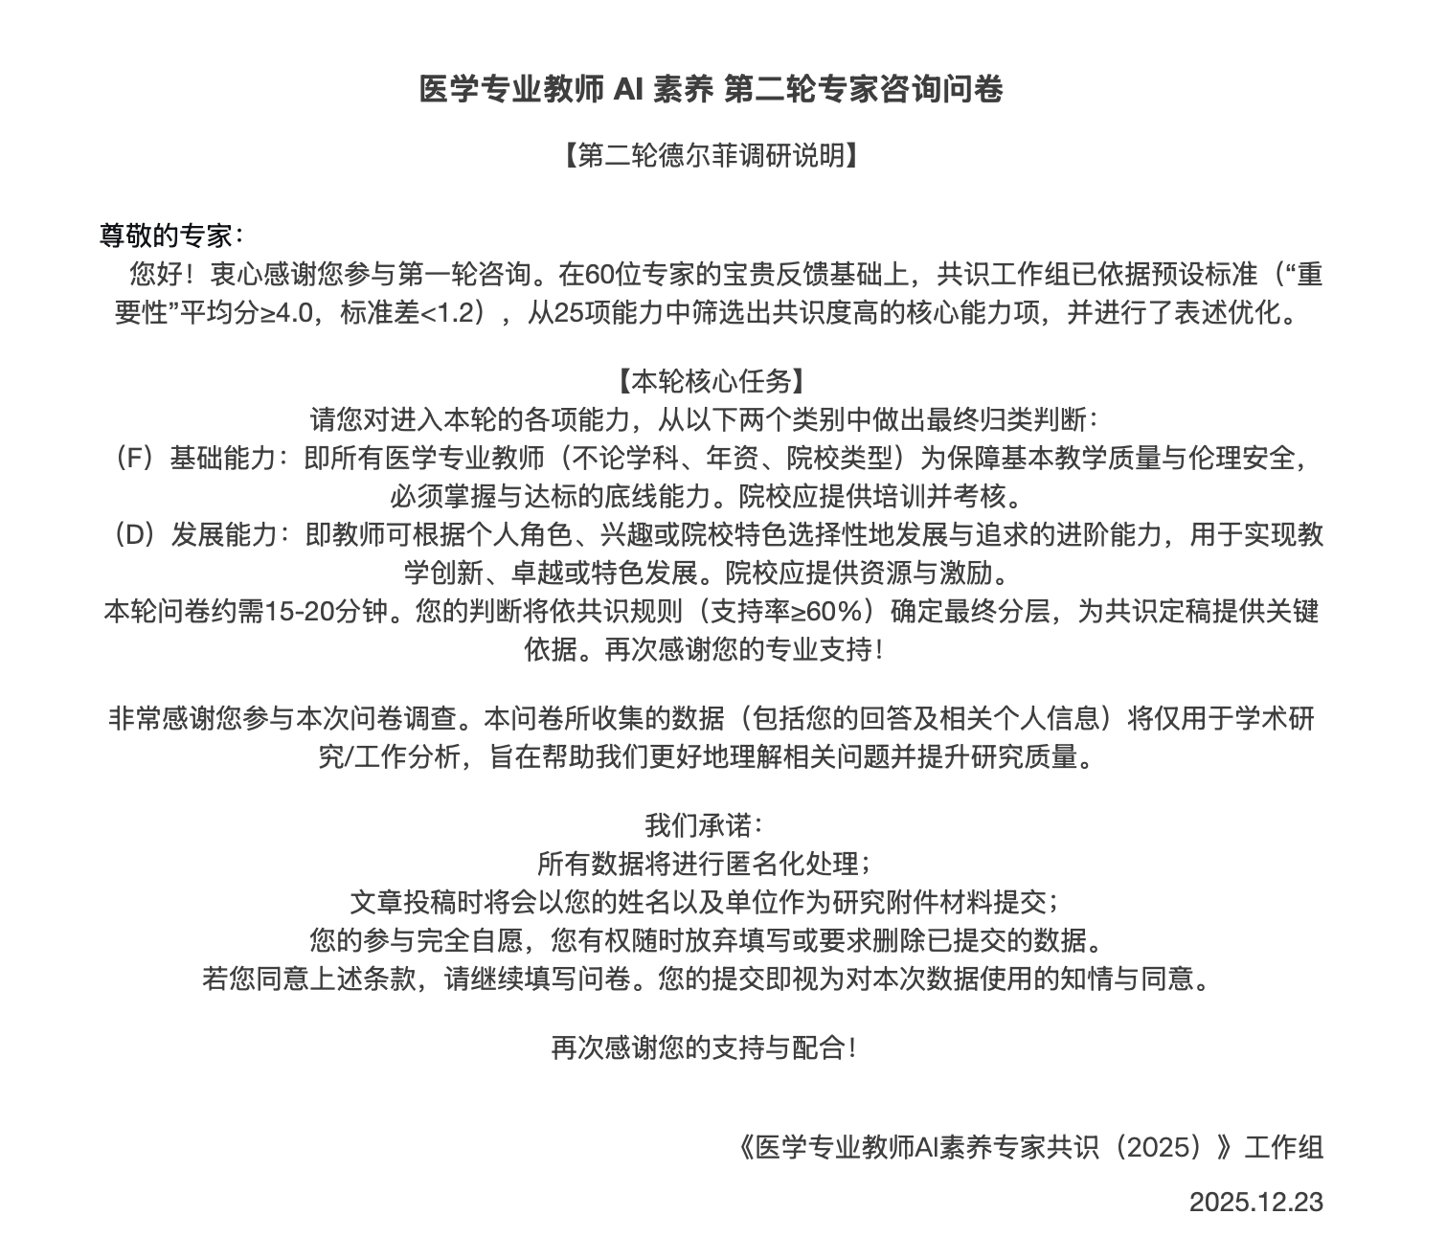
Figure 2. Round 2 Delphi questionnaire informed-consent and public-disclosure interface.

Table 1. Expert Panel Characteristics Derived From Positions and Affiliations
No. | Expert name | Field/expertise area | Recorded position/title and affiliation | Region | Institution type
1 | Mengchun Gong | Biomedical engineering; AI/medical technology | Director, GMC Lab, School of Biomedical Engineering, Guangdong Medical University | Guangdong | Medical university/medical school/health-science center
2 | Fei Ma | Medical oncology; clinical medicine | Director, Department of Medical Oncology, Cancer Hospital, Chinese Academy of Medical Sciences | Beijing | University-affiliated hospital/clinical center
3 | Le Ma | Public health; medical education | Vice Dean, School of Public Health, Xi'an Jiaotong University | Shaanxi | Medical university/medical school/health-science center
4 | Li Ma | Medical university leadership; medical education | President, Southern Medical University | Guangdong | Medical university/medical school/health-science center
5 | Yonghui Ma | Bioethics; medicine and health humanities | Director, Center for Bioethics, School of Medicine, Xiamen University | Fujian | Medical university/medical school/health-science center
6 | Ruiting Ma | Clinical research governance; mental health institution administration | Director, Office of the Good Clinical Practice (GCP) Institution, Inner Mongolia Mental Health Center (Brain Hospital) | Inner Mongolia | University-affiliated hospital/clinical center
7 | Wei Wang | Faculty development; medical education | Director, Center for Faculty Development, Chinese Academy of Medical Sciences and Peking Union Medical College | Beijing | Medical university/medical school/health-science center
8 | Jing Wang | Academic affairs; medical education administration | Director, Academic Affairs Office, Chinese Academy of Medical Sciences and Peking Union Medical College | Beijing | Medical university/medical school/health-science center
9 | Zhengning Wang | Medical university leadership; medical education | President, China Medical University | Liaoning | Medical university/medical school/health-science center
10 | Jingbo Wang | Hospital leadership; clinical medicine | President, Tangdu Hospital, Air Force Medical University | Shaanxi | University-affiliated hospital/clinical center
11 | Jinghui Lu | Medical university leadership; medical education | Party Secretary, Guangdong Medical University | Guangdong | Medical university/medical school/health-science center
12 | Yinghong Shi | Hospital leadership; clinical medicine | Vice President, Zhongshan Hospital, Fudan University | Shanghai | University-affiliated hospital/clinical center
13 | Rui Shi | Health information technology; medical informatics | Director, Department of Information Technology, West China Hospital, Sichuan University | Sichuan | University-affiliated hospital/clinical center
14 | Xiao Long | Plastic and aesthetic surgery; clinical medicine | Director, Department of Plastic and Aesthetic Surgery, Peking Union Medical College Hospital, Chinese Academy of Medical Sciences | Beijing | University-affiliated hospital/clinical center
15 | Li Liu | Health management; clinical service administration | Director, Health Management Center, Nanfang Hospital, Southern Medical University | Guangdong | University-affiliated hospital/clinical center
16 | Hui Liu | Medical information; clinical informatics | Director, Institute of Medical Information, Peking Union Medical College Hospital, Chinese Academy of Medical Sciences | Beijing | University-affiliated hospital/clinical center
17 | Zhangsuo Liu | Nephrology; clinical medicine | Professor, Department of Nephrology, The First Affiliated Hospital of Zhengzhou University | Henan | University-affiliated hospital/clinical center
18 | Lili Liu | Hospital leadership; clinical medicine | Executive President, Ningxia Hospital of Peking University First Hospital | Ningxia | University-affiliated hospital/clinical center
19 | Ben Lü | University leadership; higher education administration | Vice President, Central South University | Hunan | Comprehensive/engineering university or research unit
20 | Ling Lü | Hospital leadership; clinical medicine | Party Secretary, The Affiliated Hospital of Xuzhou Medical University | Jiangsu | University-affiliated hospital/clinical center
21 | Jiayue Sun | Information science and engineering; AI/technology | Professor, School of Information Science and Engineering, Northeastern University | Liaoning | Comprehensive/engineering university or research unit
22 | Hao Wu | Hospital leadership; clinical medicine | Party Secretary, The First Affiliated Hospital of Chongqing Medical University | Chongqing | University-affiliated hospital/clinical center
23 | Chuang Zhang | Information technology; university leadership; AI/education | Professor, Beijing University of Posts and Telecommunications; Vice President, Beijing Wuzi University | Beijing | Comprehensive/engineering university or research unit
24 | Ming Zhang | Medicine; medical education | Professor, Faculty of Medicine, Xi'an Jiaotong University | Shaanxi | Medical university/medical school/health-science center
25 | Hang Li | Medical education administration | Director, Education Office, Peking Union Medical College Hospital, Chinese Academy of Medical Sciences | Beijing | University-affiliated hospital/clinical center
26 | Wei Li | Health science library; medical information services | Deputy Director, Peking University Health Science Library | Beijing | Public health, medical library or information agency
27 | Qin Li | Medical technology; biomedical education | Vice Dean, School of Medical Technology, Beijing Institute of Technology | Beijing | Medical university/medical school/health-science center
28 | Sheyu Li | Endocrinology and metabolism; clinical medicine | Professor, Department of Endocrinology and Metabolism, West China Hospital, Sichuan University | Sichuan | University-affiliated hospital/clinical center
29 | Dinggang Shen | Biomedical engineering; AI/medical technology | Dean, School of Biomedical Engineering, ShanghaiTech University | Shanghai | Comprehensive/engineering university or research unit
30 | Xiang Zhou | Health information technology; medical informatics | Director, Department of Information Technology, Peking Union Medical College Hospital, Chinese Academy of Medical Sciences | Beijing | University-affiliated hospital/clinical center
31 | Wenhao Zhou | Pediatric/women and children's hospital leadership; clinical medicine | President, Guangzhou Women and Children's Medical Center, Guangzhou Medical University | Guangdong | University-affiliated hospital/clinical center
32 | Haotian Lin | Ophthalmology; clinical medicine | Director, Zhongshan Ophthalmic Center, Sun Yat-sen University | Guangdong | University-affiliated hospital/clinical center
33 | Li Luo | Public health; medical education administration | Party Secretary, School of Public Health, Fudan University | Shanghai | Medical university/medical school/health-science center
34 | Mingjie Luo | Ophthalmology research; clinical research | Associate Researcher, Zhongshan Ophthalmic Center, Sun Yat-sen University | Guangdong | University-affiliated hospital/clinical center
35 | Baorong Chi | Academic degree governance; higher education administration | Deputy Chair, University Degree Committee, Jilin University | Jilin | Comprehensive/engineering university or research unit
36 | Hui Chen | Intelligent medical engineering; biomedical engineering | Director, Department of Intelligent Medical Engineering, School of Biomedical Engineering, Capital Medical University | Beijing | Medical university/medical school/health-science center
37 | Shi Chen | Endocrinology; clinical medicine | Professor, Department of Endocrinology, Peking Union Medical College Hospital, Chinese Academy of Medical Sciences | Beijing | University-affiliated hospital/clinical center
38 | Wei Chen | Hospital leadership; clinical medicine | Vice President, The First Affiliated Hospital, Sun Yat-sen University | Guangdong | University-affiliated hospital/clinical center
39 | Qingcai Chen | Intelligent computing; AI/medical technology | Director, Intelligent Computing Research Center, Harbin Institute of Technology (Shenzhen) | Guangdong | Comprehensive/engineering university or research unit
40 | Mingxing Hou | Hospital leadership; clinical medicine | Vice President, The Affiliated Hospital of Inner Mongolia Medical University | Inner Mongolia | University-affiliated hospital/clinical center
41 | Lan Yao | Health management; public health and medical education | Dean, School of Health Management, Tongji Medical College, Huazhong University of Science and Technology | Hubei | Medical university/medical school/health-science center
42 | Li Hong | Pediatric hospital leadership; clinical medicine | Vice President, Shanghai Children's Medical Center, School of Medicine, Shanghai Jiao Tong University | Shanghai | University-affiliated hospital/clinical center
43 | Peng Xiang | Artificial intelligence and informatization; medical informatics | Director, Department of Artificial Intelligence and Informatization, The Second Affiliated Hospital, Zhejiang University School of Medicine | Zhejiang | University-affiliated hospital/clinical center
44 | Siyuan Fan | Neurology; clinical medicine | Associate Professor, Department of Neurology, Peking Union Medical College Hospital | Beijing | University-affiliated hospital/clinical center
45 | Gang Zhao | Medical school leadership; medical education | Dean, School of Medicine, Northwest University | Shaanxi | Medical university/medical school/health-science center
46 | Yuhong Zhao | Clinical medicine; hospital-based teaching/research | Professor, Shengjing Hospital, China Medical University | Liaoning | University-affiliated hospital/clinical center
47 | Xingcun Zhao | Medical university leadership; medical education | President, Guangzhou Medical University | Guangdong | Medical university/medical school/health-science center
48 | Deliang Wen | Medical university leadership; medical education | President, Jinzhou Medical University | Liaoning | Medical university/medical school/health-science center
49 | Ping Qing | Teaching affairs; medical education administration | Director, Department of Teaching Affairs, West China Medical Center, Sichuan University | Sichuan | Medical university/medical school/health-science center
50 | Zhouping Tang | Hospital leadership; clinical medicine | Party Secretary, Tongji Hospital, Tongji Medical College, Huazhong University of Science and Technology | Hubei | University-affiliated hospital/clinical center
51 | Peng Xia | Nephrology; clinical medicine | Associate Professor, Department of Nephrology, Peking Union Medical College Hospital | Beijing | University-affiliated hospital/clinical center
52 | Bo Xu | Intelligent oncology; AI and clinical oncology | Director, Intelligent Oncology Laboratory, Chongqing University | Chongqing | Comprehensive/engineering university or research unit
53 | Jianping Weng | Medical university leadership; medical education | President, Anhui Medical University | Anhui | Medical university/medical school/health-science center
54 | Sheng Nie | Nephrology; clinical medicine | Associate Professor, Department of Nephrology, Nanfang Hospital, Southern Medical University | Guangdong | University-affiliated hospital/clinical center
55 | Xiaojing Guo | Breast pathology; clinical medicine | Director, Department of Breast Pathology, Tianjin Medical University Cancer Institute and Hospital | Tianjin | University-affiliated hospital/clinical center
56 | Chunjing Tao | Medical science and engineering; biomedical education | Vice Dean, School of Medical Science and Engineering, Beihang University | Beijing | Medical university/medical school/health-science center
57 | Zhihang Peng | Public health informatics; disease control | Deputy Director, Information Center, Chinese Center for Disease Control and Prevention | Beijing | Public health, medical library or information agency
58 | Zhirong Zeng | University leadership; higher education administration | Vice President, Shaoguan University | Guangdong | Comprehensive/engineering university or research unit
59 | Hui Dai | Hospital leadership; clinical medicine | Party Secretary, Ganzhou Hospital of Nanfang Hospital, Southern Medical University | Jiangxi | University-affiliated hospital/clinical center
60 | Huadan Xue | Radiology; clinical medicine | Deputy Director, Department of Radiology, Peking Union Medical College Hospital, Chinese Academy of Medical Sciences | Beijing | University-affiliated hospital/clinical center

