PRISMA 2020 flow diagram of literature retrieval and screening process.
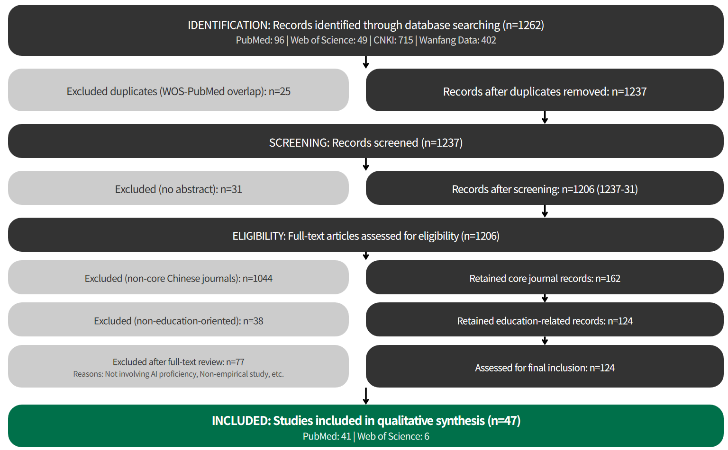
Figure. PRISMA 2020 flow diagram of literature retrieval and screening process. Literature was retrieved from PubMed, Web of Science, CNKI, and Wanfang Data with the search period spanning from January 1, 2020, to March 1, 2025, restricted to Chinese and English publications. After duplicate removal, abstract elimination, non-core journal exclusion, and full-text assessment for educational orientation and topic relevance, 47 eligible studies (PubMed: 41; WOS: 6) were finally included.
Notably, although 48 core Chinese-language records (Wanfang: 36; CNKI: 12) were retained after the core-journal screening phase, none met the final eligibility criteria. The main reasons were that these studies either addressed AI applications in clinical settings without explicit implications for medical educator competency development, or employed non-empirical methodologies such as commentaries, policy reviews, or conference summaries that lacked substantive data on proficiency constructs.

