Supplementary Information
Fig. S1. Sensitivity of the peak release concentration at the GBI to the radionuclide-colloid distribution coefficient for the four target radionuclides (Nb-94, I-129, U-238, and Pu-239).
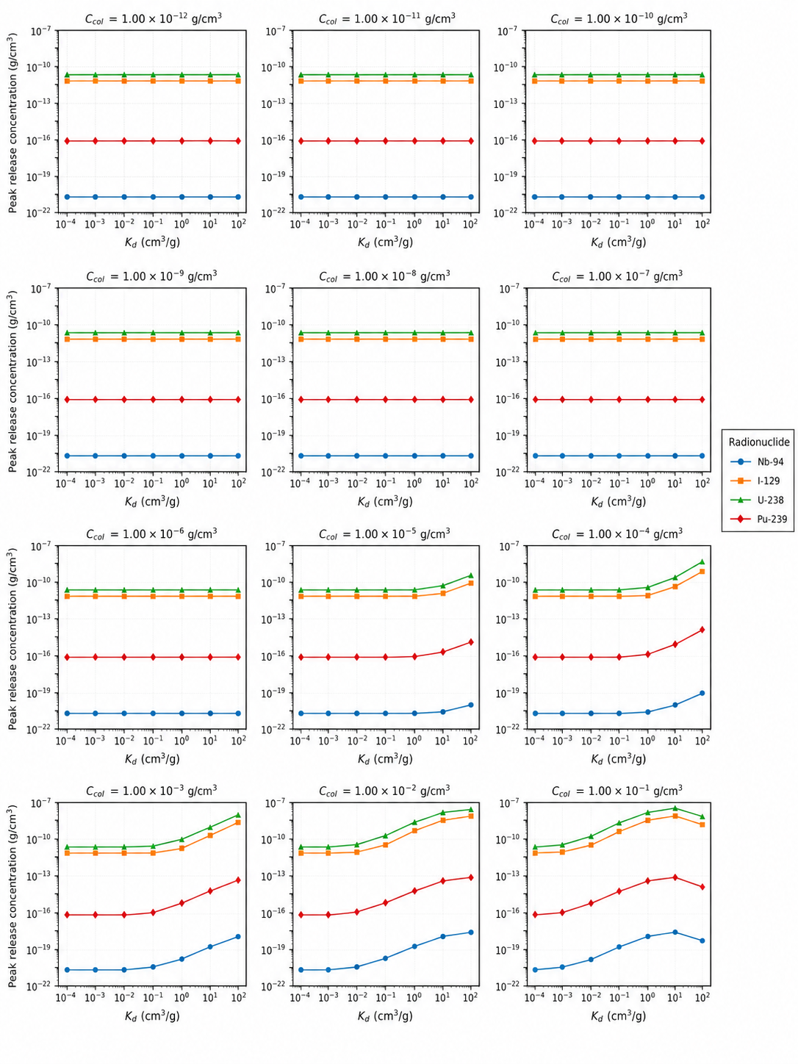
Fig. S2. Sensitivity of the peak release concentration at the GBI to the colloid concentration for the four target radionuclides (Nb-94, I-129, U-238, and Pu-239).
