Supplementary Information (SI) for
Screening of Bacillus bacterial strains with capability of degrading T-2 toxin
Thanh Duy Nguyenª, Yaoying Luª, Xiaojing Chen^{b}, Linlin Ma^{a,c} and Yunjiang Feng^{a,c,*}
ª Institute for Biomedicine and Glycomics, Griffith University, Southport, QLD 4215, Australia
^{b} Bioproton Pty Ltd., Acacia Ridge, QLD 4110, Australia
^{c} School of Environment and Science, Griffith University, Nathan, QLD 4111, Australia
* Corresponding author contact details: Institute for Biomedicine and Glycomics, Griffith University, Southport, QLD 4215, Australia. Tel: + 61 7 3735 8367. E-mail: y.feng@griffith.edu.au
Contents
Figure S1. HPLC spectrum of large-scale, T2-spiked culture of BC2 after 56 h of incubation S3
Figure S2. ¹H NMR spectrum (800 MHz, DMSO-d₆) for HT-2 toxin (1) S4
Figure S3. ¹³C NMR spectrum (200 MHz, DMSO-d₆) for HT-2 toxin (1) S5
Figure S4. COSY spectrum (800 MHz, DMSO-d₆) for HT-2 toxin (1) S6
Figure S5. HSQC spectrum (800 MHz, DMSO-d₆) for HT-2 toxin (1) S7
Figure S6. HMBC spectrum (800 MHz, DMSO-d₆) for HT-2 toxin (1) S8
Figure S7. ROESY spectrum (800 MHz, DMSO-d₆) for HT-2 toxin (1) S9
Figure S8. ¹H NMR spectrum (800 MHz, DMSO-d₆) for compound 2 S10
Figure S9. ¹³C NMR spectrum (200 MHz, DMSO-d₆) for compound 2 S11
Figure S10. COSY spectrum (800 MHz, DMSO-d₆) for compound 2 S12
Figure S11. HSQC spectrum (800 MHz, DMSO-d₆) for compound 2 S13
Figure S12. HMBC spectrum (800 MHz, DMSO-d₆) for compound 2 S14
Figure S13. ¹H NMR spectrum (800 MHz, DMSO-d₆) for T-2 toxin S15
Figure S14. ¹³C NMR spectrum (200 MHz, DMSO-d₆) for T-2 toxin S16

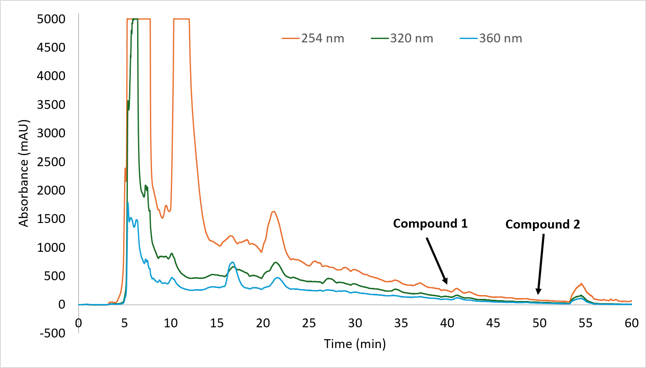
Figure S1. HPLC spectrum of large-scale, T2-spiked culture of BC2 after 56 h of incubation. The culture was collected and centrifuged. The obtained supernatant was partially purified by C18 solid-phase extraction with water and methanol. The methanol portion was dried (100 mg) and subjected to reverse-phase HPLC (above chromatogram). HT-2 toxin (compound 1) was identified at fraction 41, and compound 2 (tetradepsipeptide) was identified at fraction 50
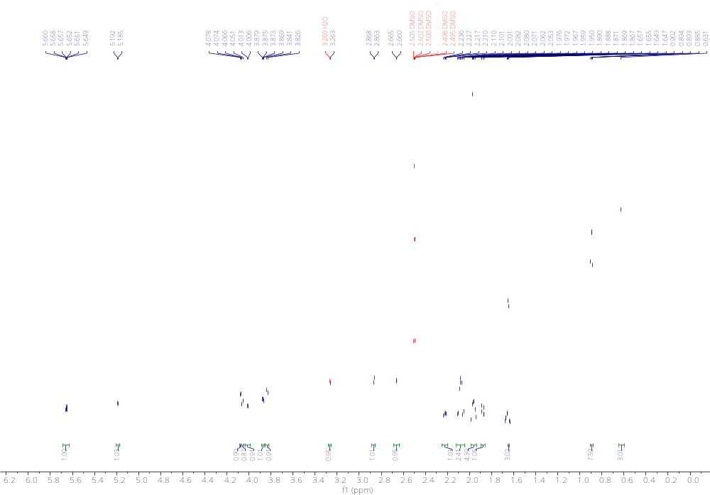
Figure S2. ¹H NMR spectrum (800 MHz, DMSO-d₆) for HT-2 toxin (1)
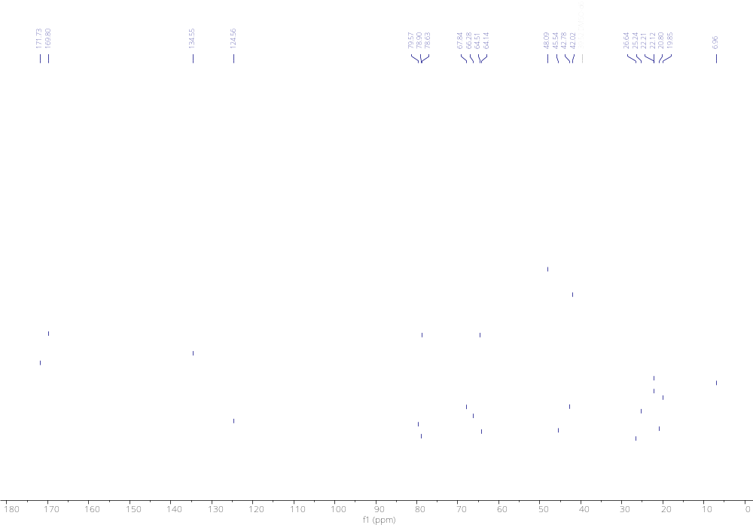
Figure S3. ¹³C NMR spectrum (200 MHz, DMSO-d₆) for HT-2 toxin (1)
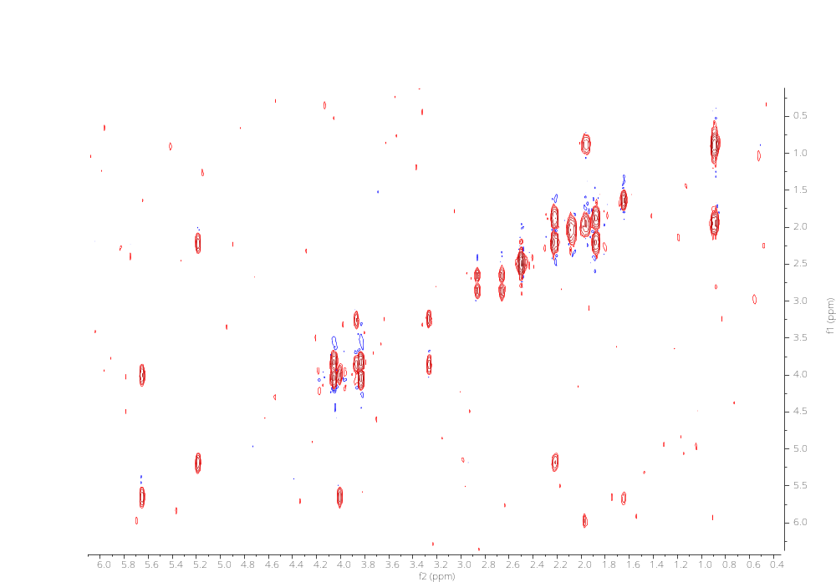
Figure S4. COSY spectrum (800 MHz, DMSO-d₆) for HT-2 toxin (1)
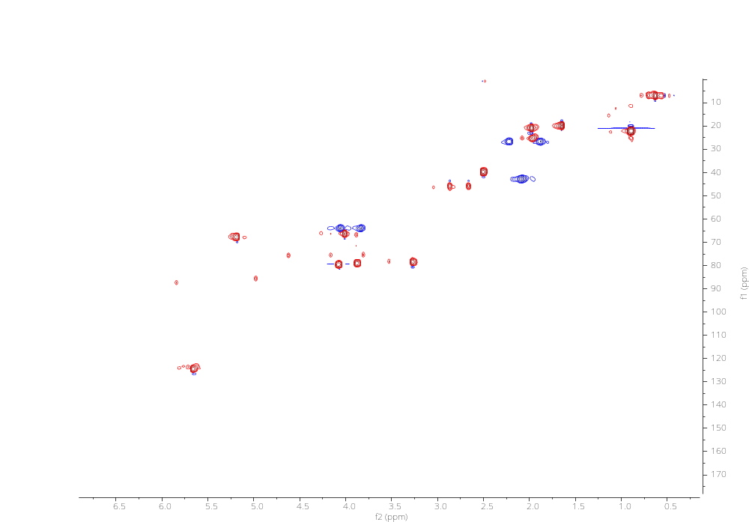
Figure S5. HSQC spectrum (800 MHz, DMSO-d₆) for HT-2 toxin (1)
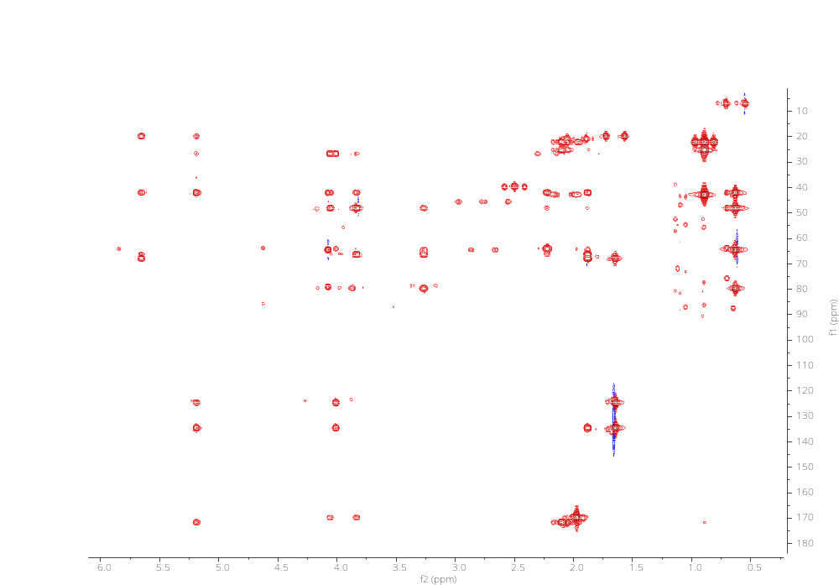
Figure S6. HMBC spectrum (800 MHz, DMSO-d₆) for HT-2 toxin (1)
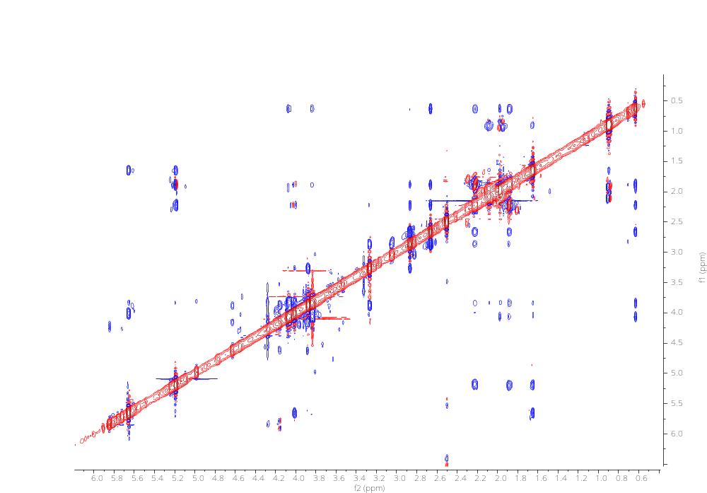
Figure S7. ROESY spectrum (800 MHz, DMSO-d₆) for HT-2 toxin (1)
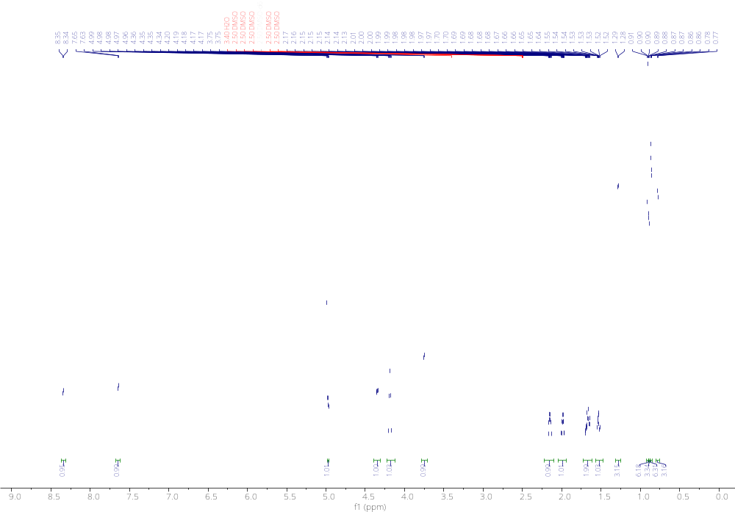
Figure S8. ¹H NMR spectrum (800 MHz, DMSO-d₆) for compound 2
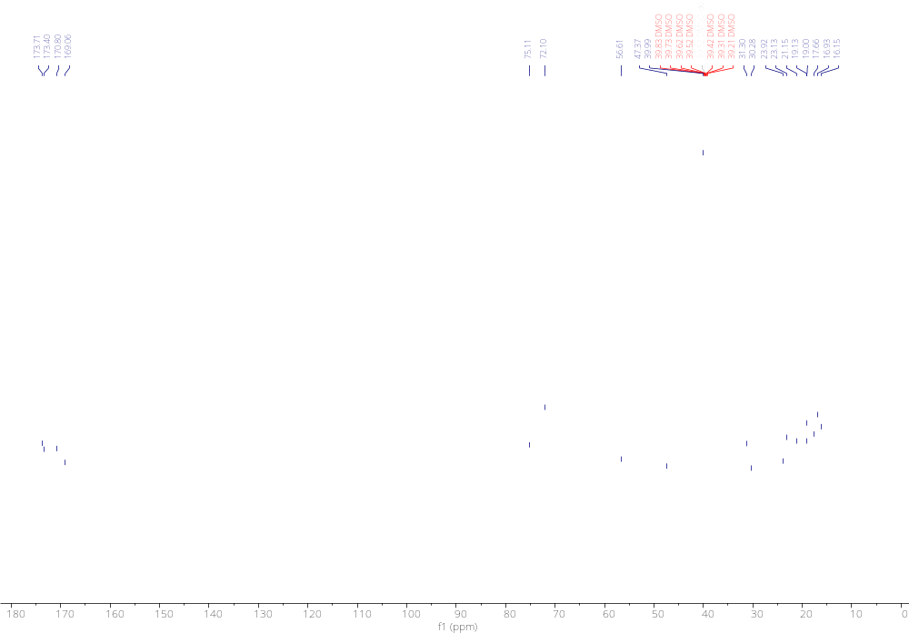
Figure S9. ¹³C NMR spectrum (200 MHz, DMSO-d₆) for compound 2
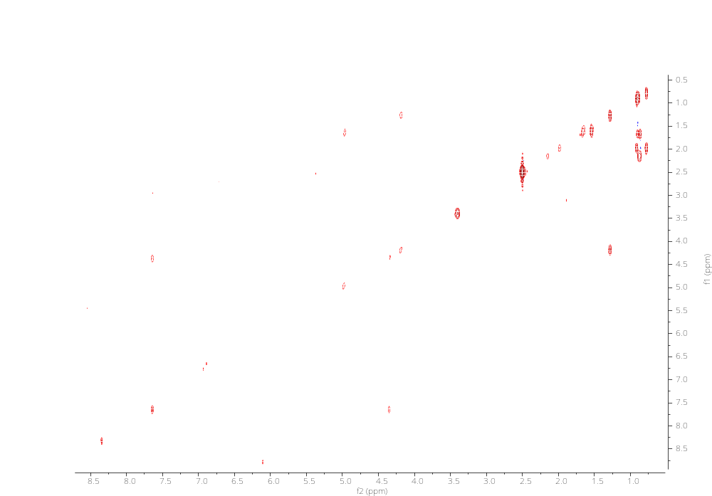
Figure S10. COSY spectrum (800 MHz, DMSO-d₆) for compound 2
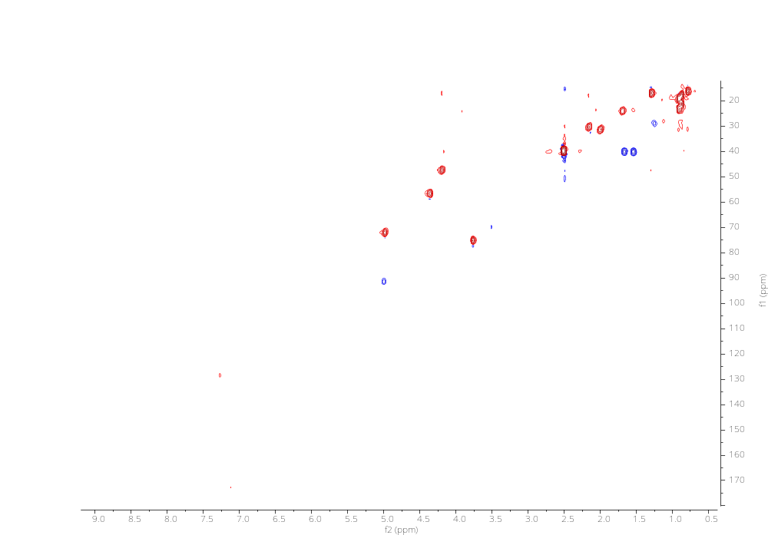
Figure S11. HSQC spectrum (800 MHz, DMSO-d₆) for compound 2
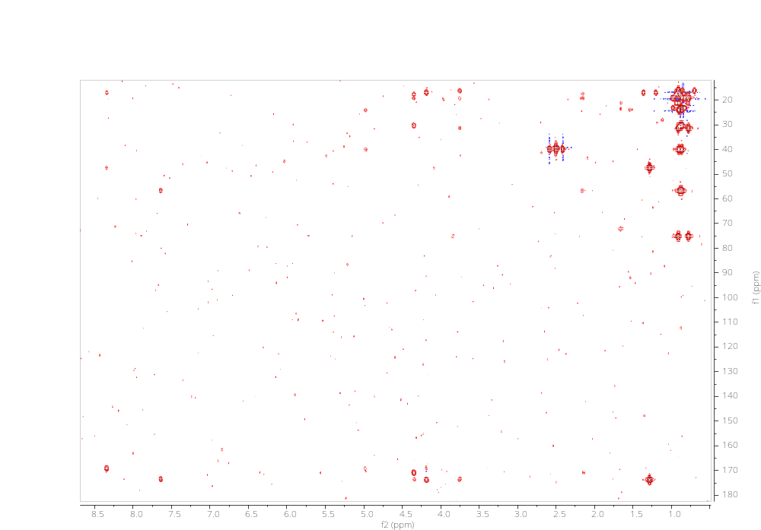
Figure S12. HMBC spectrum (800 MHz, DMSO-d₆) for compound 2
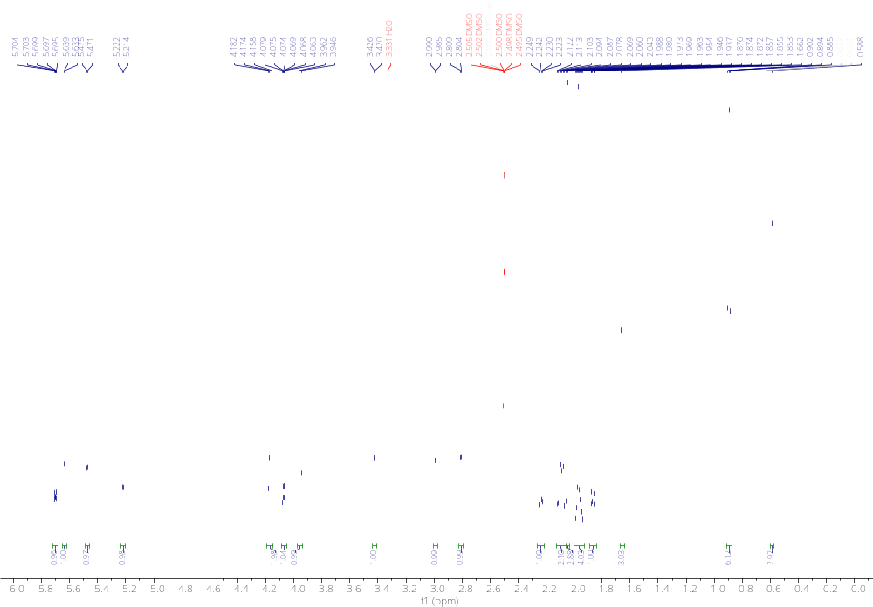
Figure S13. ¹H NMR spectrum (800 MHz, DMSO-d₆) for T-2 toxin
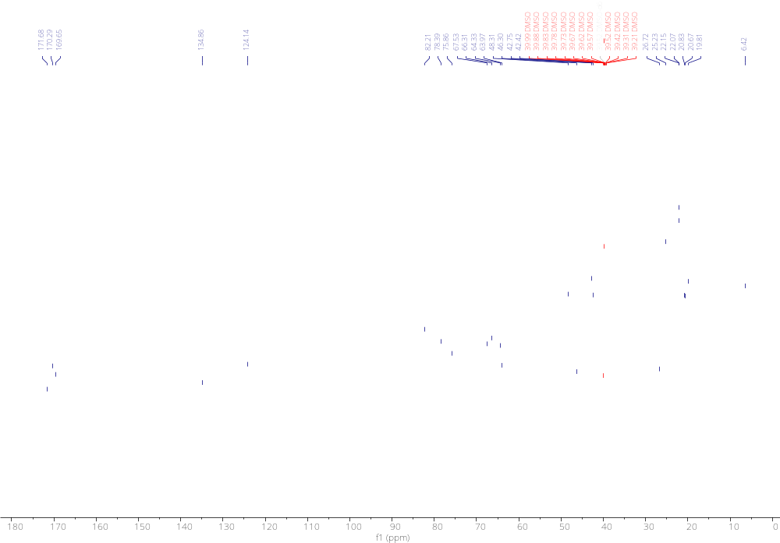
Figure S14. ¹³C NMR spectrum (200 MHz, DMSO-d₆) for T-2 toxin

