Figure Legends

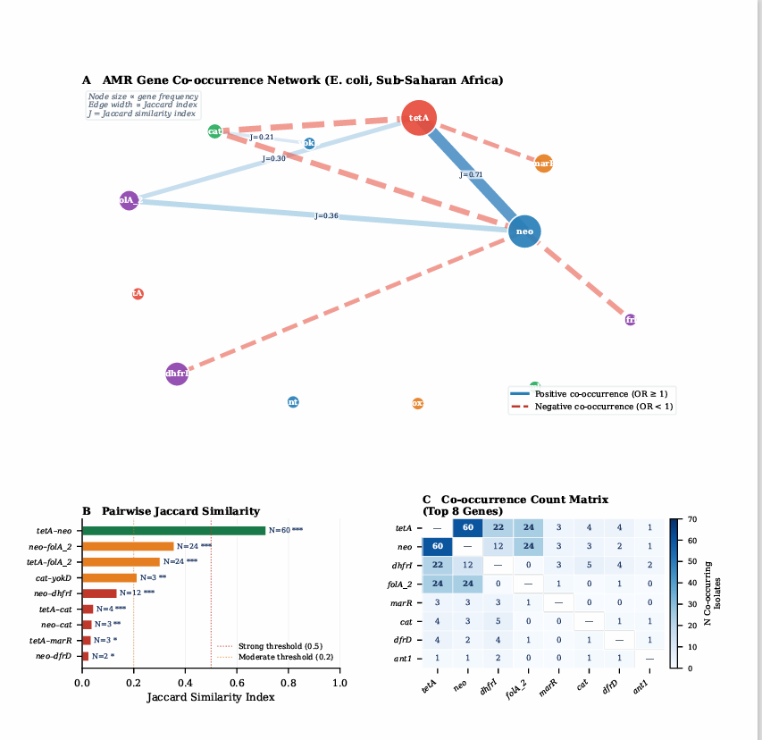
Figure 1. Resistance forecast model to 2030. (A) Linear regression-based forecasts for streptomycin, tetracycline, and trimethoprim. Observed resistance proportions (filled circles) are shown with fitted OLS regression lines (solid) and 95% prediction intervals (shaded). Forecast period (2019–2030) shown as dashed extension. Critical resistance threshold (90%) indicated by horizontal dashed red line. (B) Overall combined resistance forecast with 95% prediction interval. Note: y-axis bounded at [0, 1]. Antibiotics with R² < 0.15 or < 3 time-points excluded.
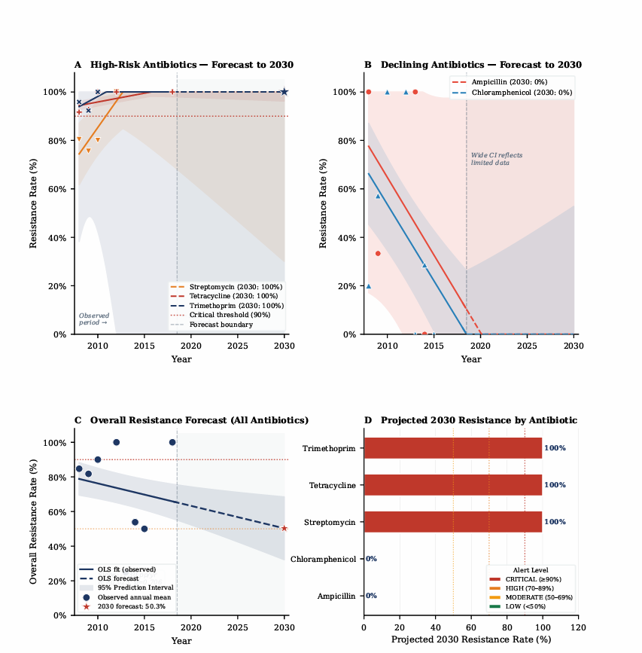
Figure 2. Comparison of study resistance rates with WHO GLASS 2022 Sub-Saharan Africa benchmarks. (A) Grouped bar chart showing study resistance rate (dark blue) and GLASS Africa (2020–2021) estimate (light blue) for five comparable antibiotics. Error bars for study estimates are 95% Wilson score confidence intervals. (B) Forest plot representation of source-stratified meta-analysis (k = 8 strata). Each row represents one source × antibiotic stratum; diamond represents the inverse-variance pooled estimate (p̄ = 50.1%). Squares are proportional to stratum weight; horizontal lines are 95% confidence intervals. I² = 100%, Cochran's Q p < 0.0001.

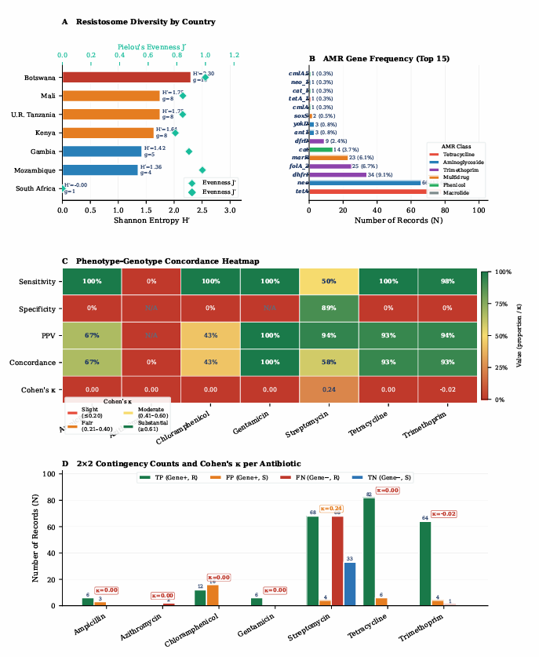

Figure 3 Resistosome Diversity + Phenotype–Genotype Concordance

Figure 4 Source-Specific Profiling + Logistic Regression ORs + AMR Class
Supplementary Tables
Supplementary Table 1 (ST1). Per-Antibiotic Annual Resistance Rates by Year (2008–2018)
Year | Ampicillin R% | Chloramphenicol R% | Streptomycin R% | Tetracycline R% | Trimethoprim R% | Overall R% | N Records
2008 |  | 42.3 | 79.0 | 96.6 | 91.0 | 84.7 | 131
2009 | 75.0 | 50.0 | 77.8 | 91.3 | 96.3 | 81.8 | 181
2010 |  |  | 86.5 | 100.0 |  | 90.0 | 30
2012 |  |  | 100.0 |  |  | 100.0 | 13
2013 |  |  | 0.0 | 100.0 |  | 25.0 | 4
2014 | 62.5 | 0.0 | 66.7 | 100.0 | 100.0 | 53.8 | 13
2015 |  |  |  | 100.0 |  | 50.0 | 2
2018 |  |  | 100.0 |  |  | 100.0 | 1
Values represent annual resistance proportion (%) per antibiotic. indicates no records for that antibiotic in that year or fewer than 3 observations. Values are not adjusted for between-country or between-source composition differences. Overall R%: all antibiotics combined for that year.
Supplementary Table 2 (ST2). Source × Country Resistance Summary (Key Combinations)
Source × Country | N Records | Overall R% | Streptomycin R% | Tetracycline R% | Trimethoprim R%
GI – Kenya | 136 | 79.4 | 76.9 | 94.1 | 95.2
GI – Mali | 95 | 87.4 | 87.9 | 100.0 | 100.0
GI – Mozambique | 33 | 87.9 | 88.2 |  | 100.0
GI – Gambia | 29 | 89.7 | 91.7
GI – Tanzania | 17 | 41.2 | 42.3 | 100.0
GI – Botswana | 13 | 100.0 | 100.0
Blood – Kenya | 5 | 80.0 |  | 100.0
Respiratory – Tanzania | 5 | 20.0
Resistance rates for key source × country combinations with n ≥ 3 records. indicates combination not present or n < 3. GI, gastrointestinal system. Resistance rates are unadjusted proportions.

Supplementary Table 3 (ST3). Record-Level Co-resistance Summary (Key Antibiotic Pairs)
Co-resistance Pair | N Isolates AB1 Resistant | N Co-resistant | Co-resistance % (of AB1-R)
Streptomycin + Tetracycline | 136 | 80 | 58.8
Streptomycin + Trimethoprim | 136 | 64 | 47.1
Tetracycline + Trimethoprim | 82 | 49 | 59.7
Tetracycline + Streptomycin | 82 | 80 | 97.6
Trimethoprim + Tetracycline | 65 | 49 | 75.4
Chloramphenicol + Streptomycin | 12 | 6 | 50.0
Ampicillin + Streptomycin | 6 | 4 | 66.7
Co-resistance rates calculated at the record level (one record = one isolate × one AST result). 'N Isolates AB1 Resistant' = denominator (N records resistant to the first antibiotic listed). Co-resistance % = proportion of AB1-resistant records also testing resistant to AB2. Jaccard indices not computed for record-level pairs (isolate-level Jaccard shown in Table 7). = data not applicable or insufficient (< 3 co-tested records).

Abbreviations
AMR, antimicrobial resistance; AST, antimicrobial susceptibility testing; AUC, area under the curve; CARD, Comprehensive Antibiotic Resistance Database; CI, confidence interval; CV, cross-validation; DDR, double-drug resistant; df, degrees of freedom; EMBL-EBI, European Molecular Biology Laboratory–European Bioinformatics Institute; F1, F1-score (harmonic mean of precision and recall); FN, false negative; FP, false positive; GI, gastrointestinal; GLASS, Global Antimicrobial Resistance and Use Surveillance System; H′, Shannon entropy index; I², I-squared (percentage of variance due to heterogeneity); J′, Pielou's evenness index; κ, Cohen's kappa coefficient; LMIC, low- and middle-income countries; LR, logistic regression; MDR, multi-drug resistant (resistance to ≥3 antibiotic classes); MK, Mann-Kendall (non-parametric trend test); ML, machine learning; MRG, mobile resistance gene; NPV, negative predictive value; OLS, ordinary least squares; OR, odds ratio; pp, percentage points; PPV, positive predictive value (precision); Q, Cochran's Q statistic; R, resistant; RF, Random Forest; ROC, receiver operating characteristic; SDR, single-drug resistant; SSA, Sub-Saharan Africa; TN, true negative; TP, true positive; UTI, urinary tract infection; WHO, World Health Organization; XDR, extensively drug-resistant (resistance to ≥5 antibiotic classes).

