Supplemental Material
 | PA (n=5) | NA (n= 5) | Significance
Female† | 3 (60) | 4 (80) | >0.999^{ξ}
Age ‡ | 44.6 (6.77) | 73.8 (16.51) | 0.006 [-47.60 to -10.80] ^{ξ}
Caucasian† | 4 (80) | 4 (80) | >0.999^{ξ}
BMI ‡ | 40.4 (11.92) | 27.6 (9.71) | 0.100 [-3.06 to 28.66] ^{ξ}
Smoker† | 1 (20) | 1 (20) | >0.999^{ξ}
Severe asthma† | 4 (80) | 5 (100) | >0.999^{ξ}
Maintenance OCS† | 0 (0) | 0 (0) | >0.999^{ξ}
Sputum TCC‡ | 0.92x10⁶ (0.60X10⁶) | 0.85x10⁶ (0.6x10⁶) | 0.858 [-0.81 to 0.95] ^{ξ}
Sputum macrophage (%)‡§ | 43.84 (10.10) | 23.73 (7.10) | 0.007 [7.38 to 32.84] ^{ξ}
Sputum neutrophil (%)‡§ | 52.30 (10.50) | 76.52 (9.62) | 0.005 [-38.91 to -9.53] ^{ξ}
Sputum eosinophil (%)‡§ | 0.00 (0) | 0.59 (0.82) | 0.146[-1.44 to 0.26] ^{ξ}
Viral infection† | 3 (60) | 4 (80) | >0.999^{ξ}
†Number (%), ‡ Mean (SD), ^{ζ}t-test [95% confidence interval], ^{ξ}Fisher’s exact test
Abbreviation: PA: paucigranulocytic asthma; NA: neutrophilic asthma; BMI: body mass index; OCS: oral corticosteroid; TCC: total cell count
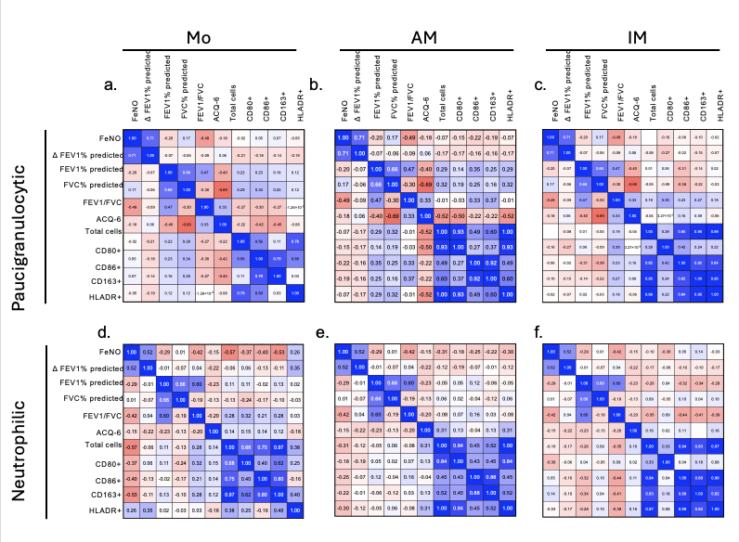
Supplemental figure 1. Macrophages upon exacerbations do not correlate with clinical outcomes. Heatmaps show Pearson’s correlations between FeNO, spirometric measures, ACQ-6, and cell populations across monocyte (a, d), alveolar macrophage (b, e), and interstitial macrophage (c, f). Results are stratified by granulocytic phenotype, with paucigranulocytic participants shown in the top row and neutrophilic participants in the bottom row. Blue indicates positive correlation and red indicates negative correlation, with color intensity proportional to Pearson’s correlation magnitude.
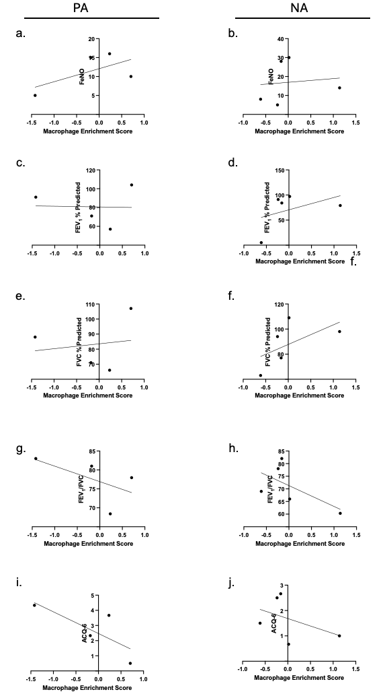
Supplemental figure 2. Macrophage enrichment does not correlate with clinical outcomes when stratified by asthma phenotype. Pearson’s correlation between macrophage enrichment score and (a, b) FeNO, (c, d) Percent of predicted FEV₁, (e, f) Percent of predicted FVC, (f, h) FEV₁/FVC, (I, j) ACQ-6. Graphs on the left represent paucigranulocytic asthma, graphs on the right represent neutrophilic asthma.
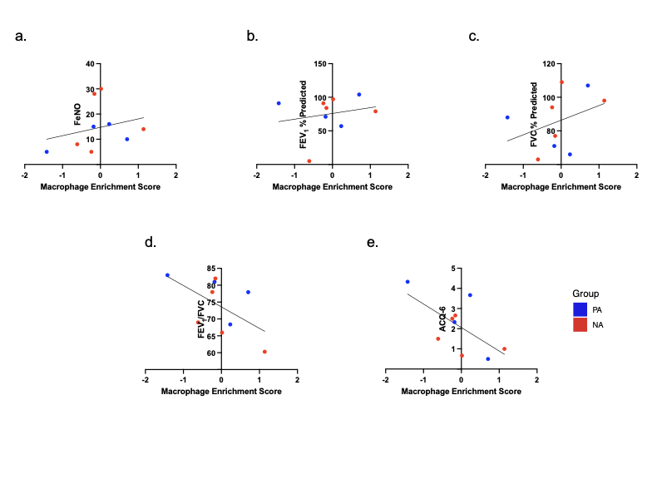
Supplemental figure 3. Macrophage enrichment upon exacerbation does not correlate with clinical outcomes at visit 3. Pearson’s correlation between macrophage enrichment score and (a,) FeNO, (b) Percent of predicted FEV₁, (c) Percent of predicted FVC, (d) FEV₁/FVC, (e) ACQ-6. Blue denotes paucigranulocytic asthma subjects and red denotes neutrophilic asthma subjects. n=5/group.

