Supplementary Material
Table S1. Common method bias and full-collinearity diagnostics
Diagnostic | Value
Harman first unrotated component variance | 48.11%
Components with eigenvalue greater than 1 | 5
Cumulative variance explained by first two components | 56.88%
Cumulative variance explained by first three components | 63.43%
SIPA full-collinearity VIF | 2.111
DMGC full-collinearity VIF | 2.123
PBSE full-collinearity VIF | 2.030
PTQ full-collinearity VIF | 2.340
Maximum full-collinearity VIF | 2.340
Source: Authors’ calculations based on the survey data.

Table S2. Indicator-level descriptive, loading, and collinearity diagnostics
Construct | Indicator | Mean | SD | Skewness | Kurtosis | VIF | Tolerance
SIPA | Q6 | 3.358696 | 1.014448 | -0.26008 | -0.54343 | 3.903493 | 0.256181
SIPA | Q7 | 3.483696 | 1.040048 | -0.42755 | -0.49449 | 4.301576 | 0.232473
SIPA | Q8 | 3.467391 | 1.034393 | -0.34611 | -0.48402 | 3.976872 | 0.251454
SIPA | Q9 | 3.63587 | 1.009797 | -0.5058 | -0.21499 | 3.485072 | 0.286938
SIPA | Q10 | 3.559783 | 0.938963 | -0.37522 | -0.26408 | 4.065156 | 0.245993
SIPA | Q11 | 3.418478 | 0.993908 | -0.41322 | -0.36301 | 3.551594 | 0.281564
SIPA | Q12 | 3.478261 | 0.974856 | -0.475 | -0.12333 | 3.156979 | 0.316758
SIPA | Q13 | 3.684783 | 0.867499 | -0.30468 | -0.51052 | 2.796874 | 0.357542
SIPA | Q14 | 3.440217 | 0.967625 | -0.21331 | -0.56059 | 3.2409 | 0.308556
SIPA | Q15 | 3.445652 | 0.962285 | -0.29041 | -0.38731 | 2.811515 | 0.35568
SIPA | Q16 | 3.61413 | 0.968361 | -0.4367 | -0.33462 | 2.323065 | 0.430466
DMGC | Q17 | 4.032609 | 0.898707 | -0.74942 | -0.10765 | 1.995563 | 0.501112
DMGC | Q18 | 4.375 | 0.800017 | -1.23505 | 1.033713 | 1.735081 | 0.576342
DMGC | Q19 | 4.211957 | 0.864395 | -1.09229 | 0.95585 | 2.443492 | 0.40925
DMGC | Q20 | 4.184783 | 0.822223 | -1.01119 | 1.096905 | 2.65108 | 0.377205
DMGC | Q21 | 4.244565 | 0.782299 | -0.94462 | 1.0243 | 3.253509 | 0.30736
DMGC | Q22 | 4.179348 | 0.820108 | -1.00442 | 1.106878 | 2.890299 | 0.345985
DMGC | Q23 | 3.809783 | 0.981641 | -0.73064 | 0.168805 | 2.531334 | 0.395049
DMGC | Q24 | 3.913043 | 0.936826 | -0.83306 | 0.495216 | 3.117985 | 0.32072
DMGC | Q25 | 3.940217 | 0.953402 | -0.91241 | 0.539514 | 2.485624 | 0.402313
DMGC | Q26 | 3.826087 | 1.020111 | -0.64363 | -0.27977 | 2.838932 | 0.352245
DMGC | Q27 | 3.842391 | 0.987433 | -0.77989 | 0.220584 | 1.91134 | 0.523193
PBSE | Q28 | 3.684783 | 1.023541 | -0.54065 | -0.22238 | 2.901533 | 0.344645
PBSE | Q29 | 3.777174 | 1.007795 | -0.57599 | -0.31253 | 2.723624 | 0.367158
PBSE | Q30 | 3.744565 | 0.999985 | -0.52874 | -0.3348 | 2.560383 | 0.390567
PBSE | Q31 | 3.592391 | 1.020097 | -0.23772 | -0.67396 | 3.47799 | 0.287522
PBSE | Q32 | 3.728261 | 0.992907 | -0.51489 | -0.31984 | 3.284658 | 0.304446
PBSE | Q33 | 3.532609 | 1.055313 | -0.43924 | -0.27549 | 4.097327 | 0.244062
PBSE | Q34 | 3.505435 | 1.07122 | -0.31089 | -0.61855 | 2.97926 | 0.335654
PBSE | Q35 | 3.48913 | 1.086374 | -0.37253 | -0.51781 | 3.156402 | 0.316816
PBSE | Q36 | 3.559783 | 1.059287 | -0.40956 | -0.37619 | 4.621783 | 0.216367
PBSE | Q37 | 3.570652 | 0.994744 | -0.33224 | -0.40395 | 4.151354 | 0.240885
PBSE | Q38 | 3.646739 | 0.969587 | -0.43981 | -0.31028 | 4.995235 | 0.200191
PBSE | Q39 | 3.782609 | 0.956154 | -0.3855 | -0.75888 | 3.188421 | 0.313635
PBSE | Q40 | 3.717391 | 0.967517 | -0.43071 | -0.42766 | 4.920742 | 0.203221
PBSE | Q41 | 3.684783 | 0.951609 | -0.44573 | -0.35248 | 5.144194 | 0.194394
PBSE | Q42 | 3.940217 | 0.824298 | -0.59834 | 0.030195 | 1.541069 | 0.6489
PTQ | Q43 | 3.527174 | 1.075977 | -0.48352 | -0.3982 | 2.645281 | 0.378032
PTQ | Q44 | 3.347826 | 1.17752 | -0.2995 | -0.8051 | 2.711724 | 0.368769
PTQ | Q45 | 3.418478 | 1.142275 | -0.31971 | -0.73196 | 2.503459 | 0.399447
PTQ | Q46 | 3.548913 | 1.090345 | -0.53571 | -0.33723 | 3.554763 | 0.281313
PTQ | Q47 | 3.353261 | 1.173566 | -0.32887 | -0.71781 | 3.860429 | 0.259039
PTQ | Q48 | 3.777174 | 0.980309 | -0.73538 | 0.15634 | 2.696339 | 0.370873
Source: Authors’ calculations based on the survey data.
Table S3. Discriminant validity diagnostics
Panel A. Fornell–Larcker criterion
Construct | SIPA | DMGC | PBSE | PTQ
SIPA | 0.839 | 0.616 | 0.603 | 0.667
DMGC | 0.616 | 0.752 | 0.627 | 0.653
PBSE | 0.603 | 0.627 | 0.816 | 0.635
PTQ | 0.667 | 0.653 | 0.635 | 0.859
Panel B. Heterotrait–monotrait ratio
Construct | SIPA | DMGC | PBSE | PTQ
SIPA | 1.000 | 0.648 | 0.629 | 0.712
DMGC | 0.648 | 1.000 | 0.660 | 0.702
PBSE | 0.629 | 0.660 | 1.000 | 0.675
PTQ | 0.712 | 0.702 | 0.675 | 1.000
Note. Diagonal entries are the square roots of AVE; off-diagonal entries are Pearson correlations. Source: Authors’ calculations based on the survey data.

Table S4. Structural collinearity and effect-size diagnostics
Endogenous construct | Predictor | VIF | Tolerance
PBSE | DMGC | 1.611 | 0.621
PBSE | SIPA | 1.611 | 0.621
PTQ | SIPA | 1.841 | 0.543
PTQ | DMGC | 1.931 | 0.518
PTQ | PBSE | 1.884 | 0.531
Effect-size diagnostics
Endogenous construct | Predictor | f² | Interpretation
PBSE | DMGC | 0.199 | Medium
PBSE | SIPA | 0.143 | Small
PTQ | SIPA | 0.147 | Small
PTQ | DMGC | 0.100 | Small
PTQ | PBSE | 0.078 | Small
Note. Structural VIF values were calculated separately for the PBSE and PTQ equations. Cohen’s f² values describe the incremental contribution of each predictor to the corresponding endogenous construct. Source: Authors’ calculations based on the structural analysis.

Table S5. Robustness and sensitivity analyses
Specification | N | Indirect B | Bootstrap SE | 95% CI for indirect effect | Direct B
Primary model | 184 | 0.145 | 0.058 | [0.054, 0.279] | 0.404
Q42 excluded | 184 | 0.133 | 0.057 | [0.046, 0.263] | 0.416
Influential cases excluded | 177 | 0.151 | 0.057 | [0.061, 0.283] | 0.332
HC3 robustness for the primary structural paths
Path | B | β | HC3 SE | p | 95% CI
DMGC to PBSE | 0.497 | 0.412 | 0.100 | < .001 | [0.300, 0.695]
SIPA to PBSE | 0.346 | 0.349 | 0.087 | < .001 | [0.174, 0.518]
SIPA to PTQ | 0.394 | 0.340 | 0.110 | < .001 | [0.178, 0.610]
DMGC to PTQ | 0.404 | 0.287 | 0.110 | 0.0018 | [0.188, 0.620]
PBSE to PTQ | 0.292 | 0.250 | 0.092 | 0.0018 | [0.110, 0.474]
Note. Each indirect effect was estimated using 5,000 case-bootstrap replications. Q42 exclusion was used only as a measurement sensitivity analysis. Influence exclusions were used only in the sensitivity specification. HC3 confidence intervals are based on heteroskedasticity-consistent standard errors. Source: Authors’ calculations based on the survey data.

Table S6. Explanatory and predictive assessment
Endogenous construct | R² | Adjusted R² | Predictive Q² | RMSE | Benchmark RMSE | MAE | Benchmark MAE
PBSE | 0.469 | 0.463 | 0.452 | 0.604 | 0.816 | 0.437 | 0.656
PTQ | 0.573 | 0.566 | 0.552 | 0.638 | 0.953 | 0.493 | 0.790
Note. Predictive Q², RMSE, and MAE were calculated using 50 repetitions of 10-fold cross-validation. Benchmark errors use the training-sample mean. Source: Authors’ calculations based on the structural analysis.

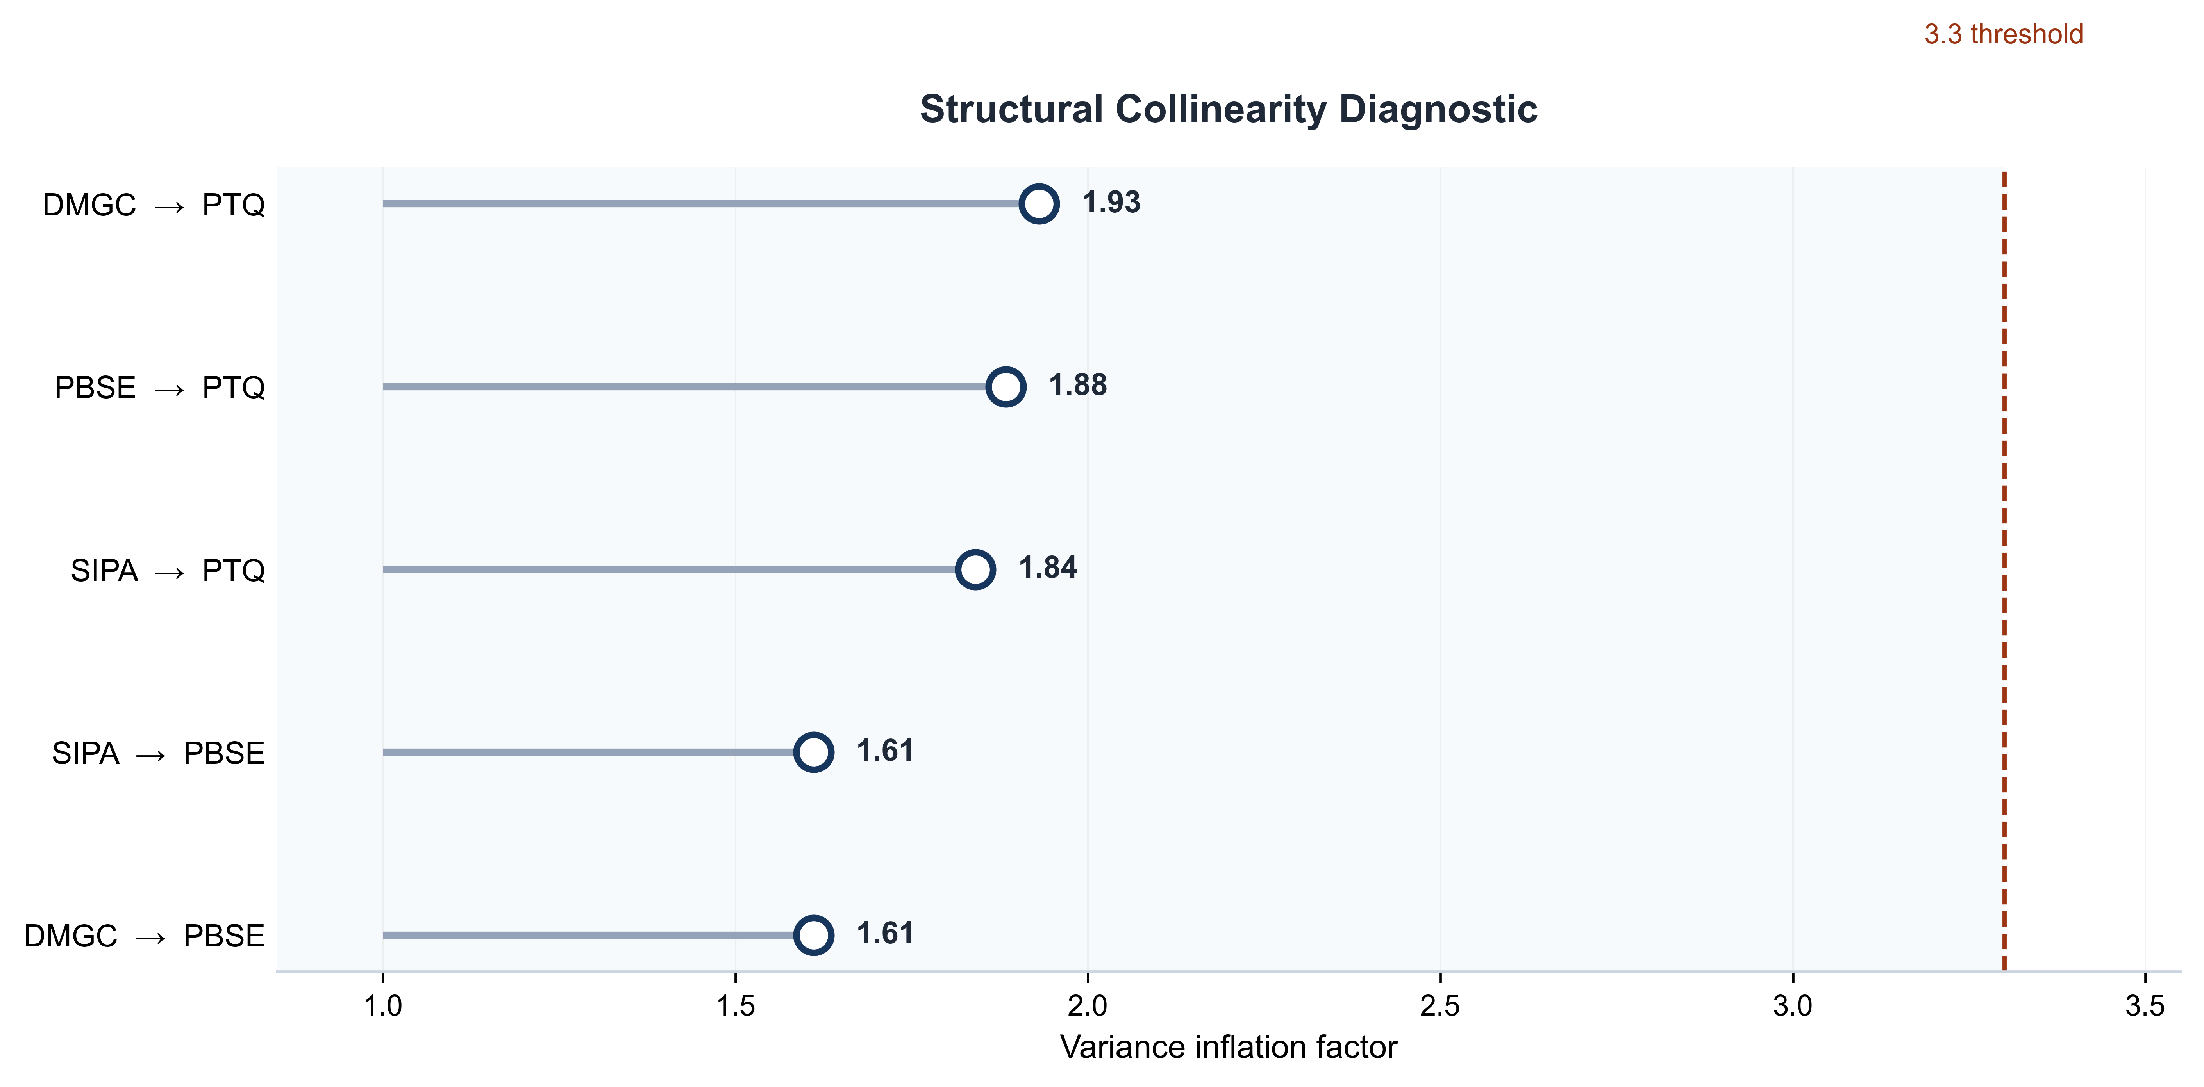
Figure S1. Structural VIF diagnostic
Source: Authors’ calculations based on the structural analysis.

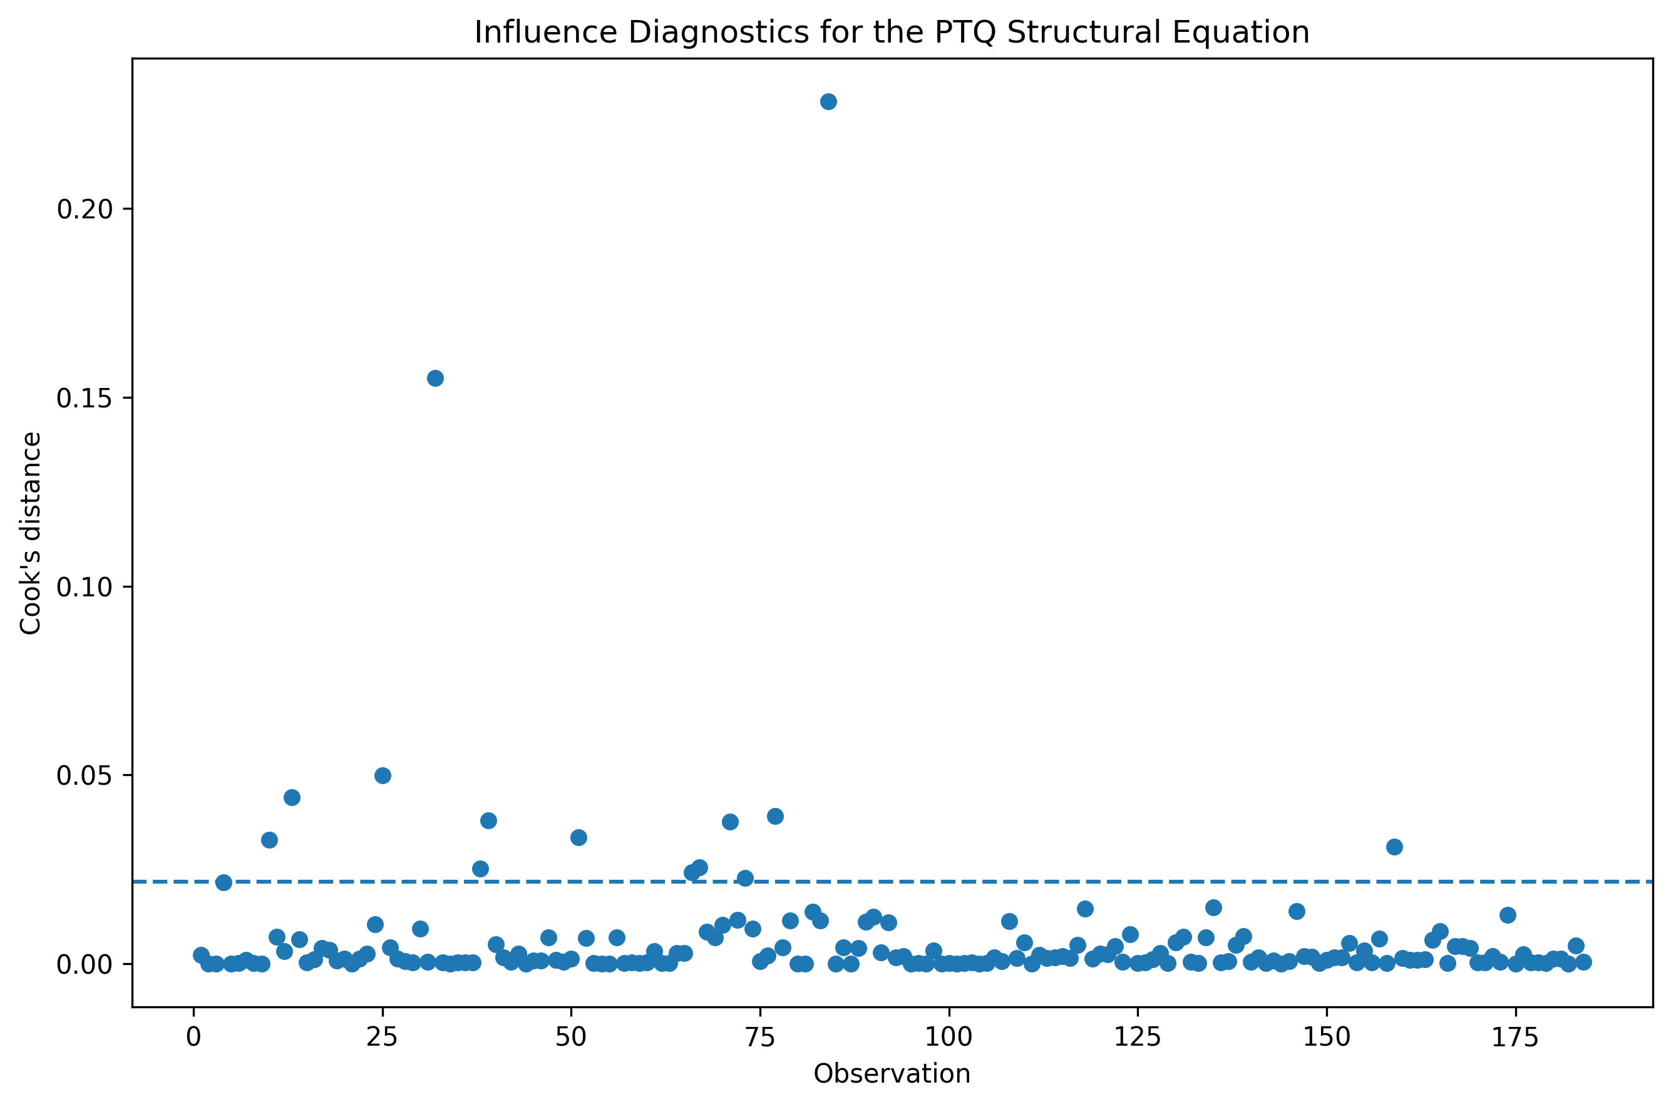
Figure S2. Influence diagnostics for the PTQ structural equation
Source: Authors’ calculations based on the survey data.

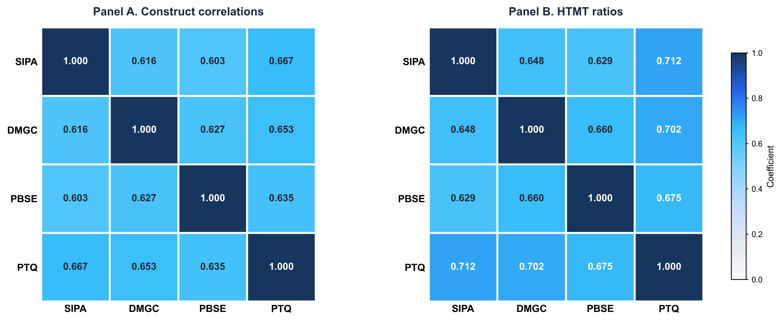
Figure S3. Construct correlations and HTMT ratios
Source: Authors’ calculations based on the survey data.

