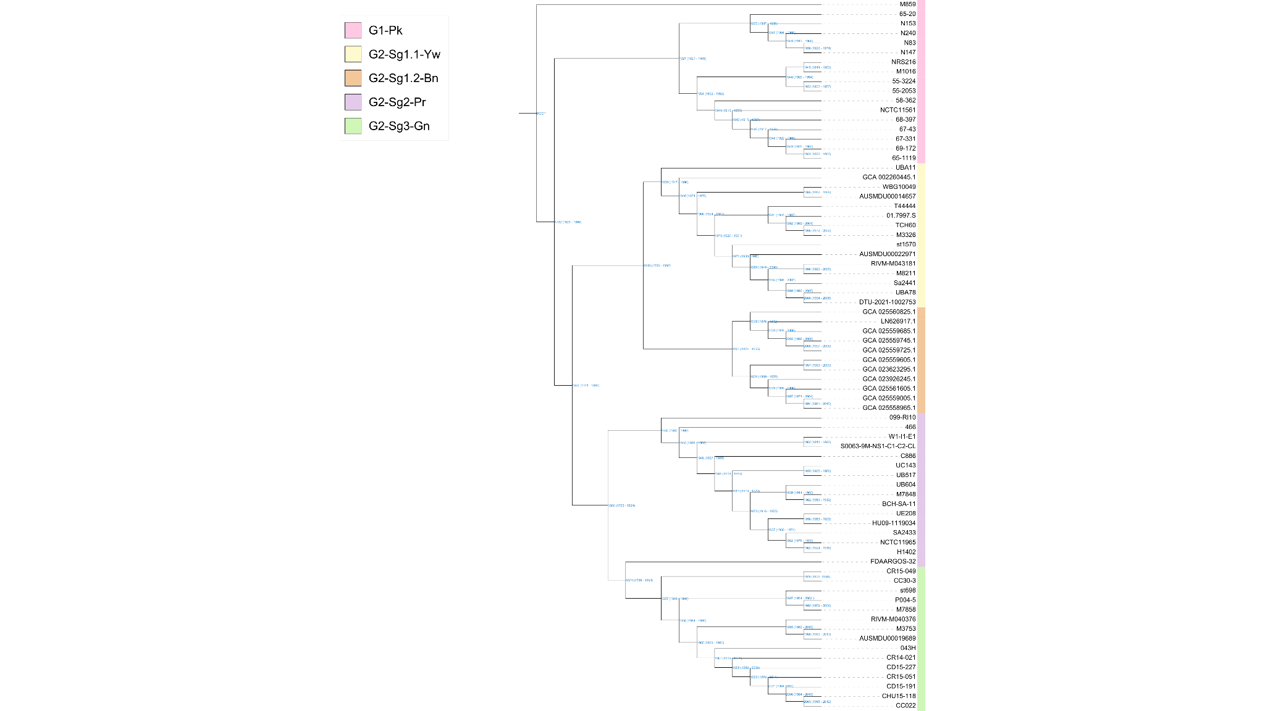

Extended Data Fig. 1│Bayesian time-scaled phylogeny of S. aureus ST30 isolates. Maximum clade credibility tree inferred using BEAST from 74 ST30 genomes. Branch colors indicate the phylogenetic groups G1-Pk (pink), G2-Sg1.1-Yw (yellow), G2-Sg1.2-Bn (brown), G2-Sg2-Pr (purple) and G2-Sg3-Gn (green). Node annotations indicate the estimated year of divergence, with 95% highest posterior density (HPD) intervals shown in parentheses.

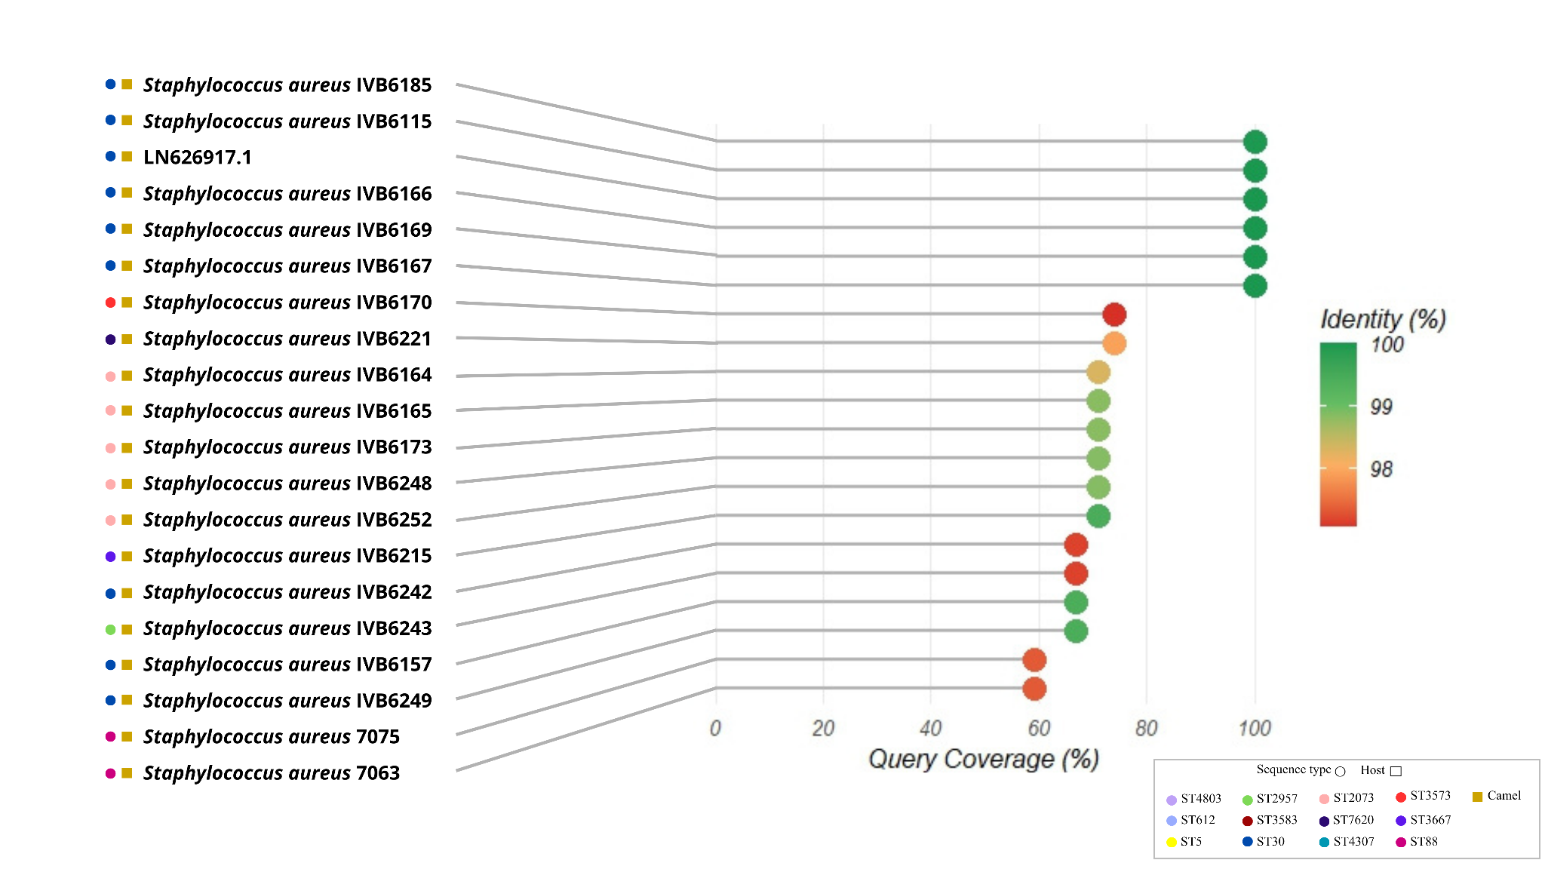

Extended Data Fig. 2│Nucleotide sequence identity and coverage of SaPIcam3-related sequence among staphylococcal genomes. The SaPIcam3 sequence from the reference genome GCF_025559685.1 was used as the BLAST query. Query coverage (%) is represented on the horizontal axis, and sequence identity (%) is indicated by the color scale. Colored circles adjacent to isolate names indicate sequence type (ST), whereas squares indicate host origin, as defined in the figure.

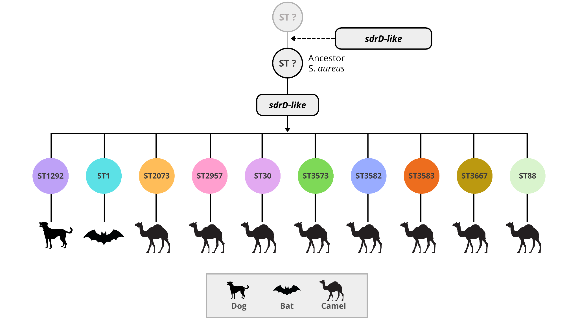

Extended Data Fig. 3│Distribution of sdrD-like gene among S. aureus genomes. Schematic representation of the spread of the sdrD-like gene identified by sequence similarity searches across S. aureus genomes. Isolates carrying sdrD-like sequences are shown according to the sequence type (ST) represented with different colors. Animal host represented among these isolates were camels, bats and dogs, as represented in the figure. Only camel-derived ST30 isolates clustered into the phylogenetic group G2-Sg1.2-Bn carried sdrD-like gene in the complete SaPIcam3.

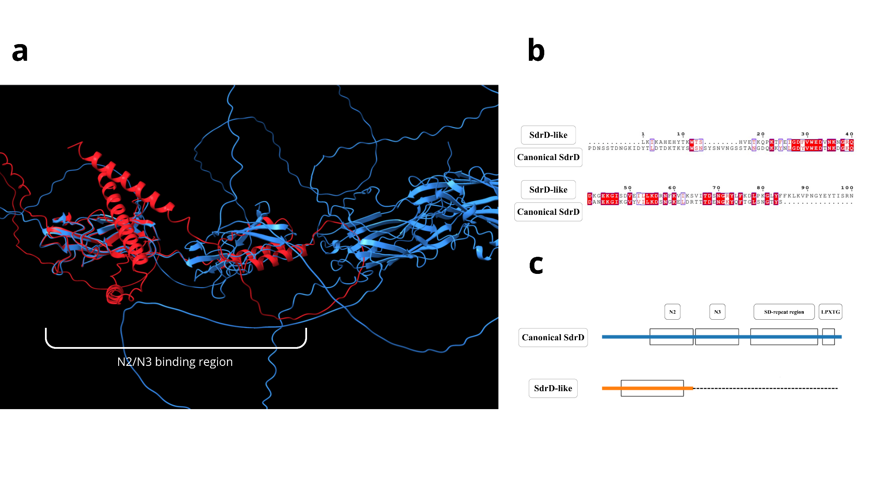
Extended Data Fig. 4│Predicted structural organization of the Sdr-like sequence. a, Predicted three-dimensional structure of the SdrD-like sequence. b, Structural annotation showing the identified regions and domains. c, Representation of the predicted N2 and N3 domains.

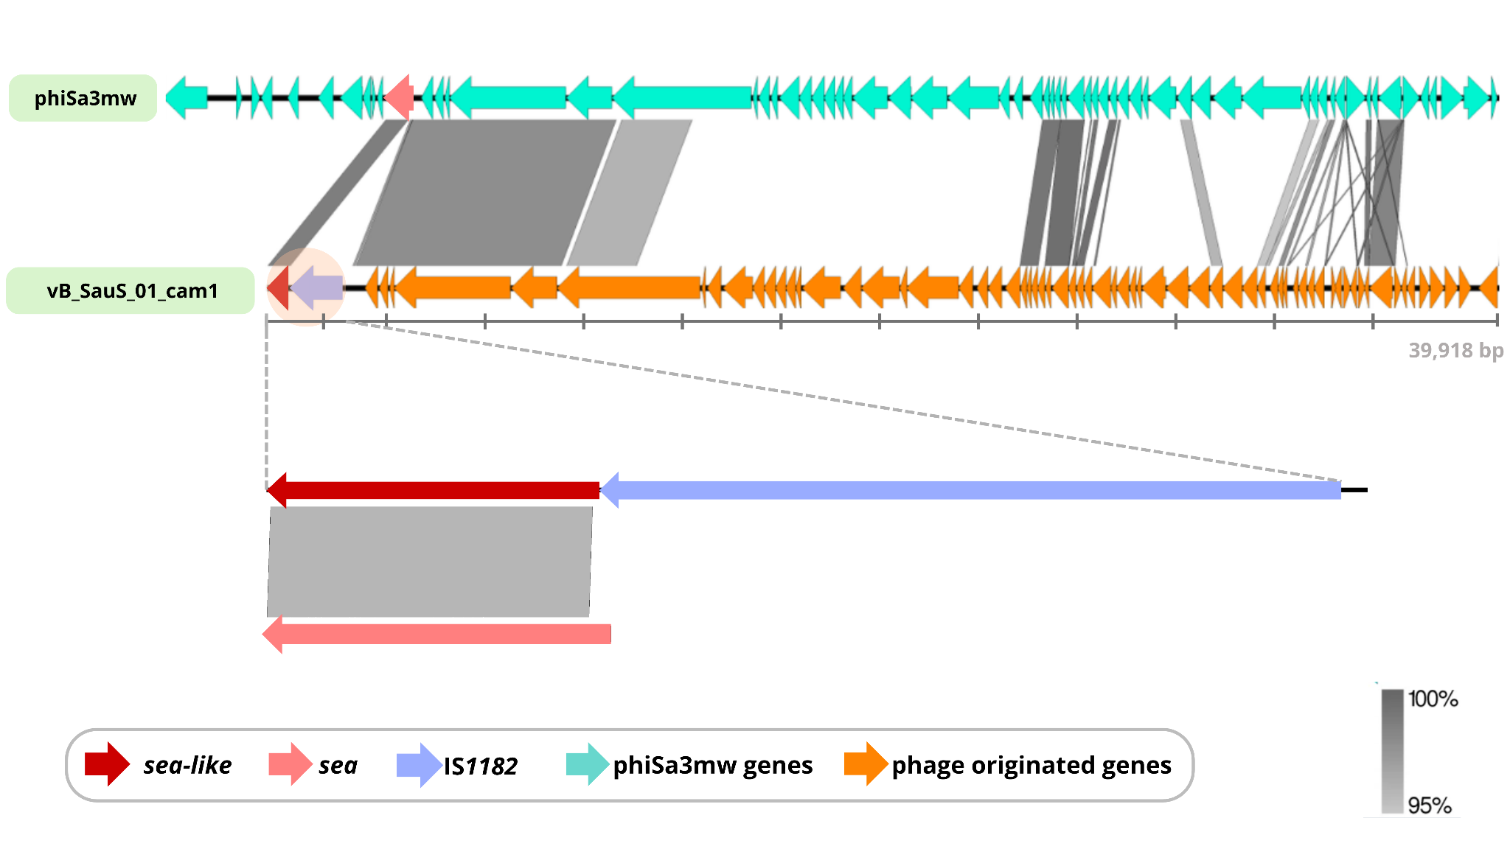

Extended Data Fig. 5│Comparative genomic organization of vB_SauS_01_cam1 and phiSa3mw. The vB_SauS_01_cam1 sequence from the reference genome GCF_025559685.1 was aligned with the sequence of phiSa3mw from S. aureus MW2 (GenBank accession BA000033.2). Arrows indicate predicted ORFs and their transcriptional orientation with colors corresponding to the functional categories indicated in the figure. Gray-shaded regions between the prophages indicate nucleotide sequence identity. The enlarged region shows the genomic organization surrounding the sea-like gene in vB_SauS_01_cam1 and the corresponding sea region in phiSa3mw, including the IS1182 insertion. The color scale indicates nucleotide sequence identity.
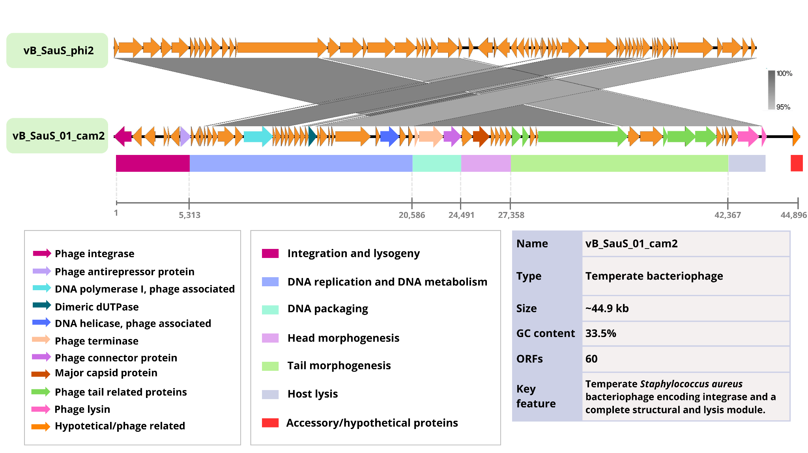

Extended Data Fig. 6│Comparative genomic organization of vB_SauS_01_cam2 and vB_SauS_phi2. The vB_SauS_01_cam2 sequence from the reference genome GCF_025559685.1 was compared with vB_SauS_phi2, identified by PHASTEST as its closest related phage. Predicted ORFs are represented by arrows indicating their transcriptional orientation, with colors corresponding to functional categories indicated in the figure. Gray-shaded regions between the prophages indicate nucleotide sequence identity. Functional modules of vB_SauS_01_cam2 are represented below the genomic map according to their predicted functions. The color scale indicates nucleotide sequence identity.
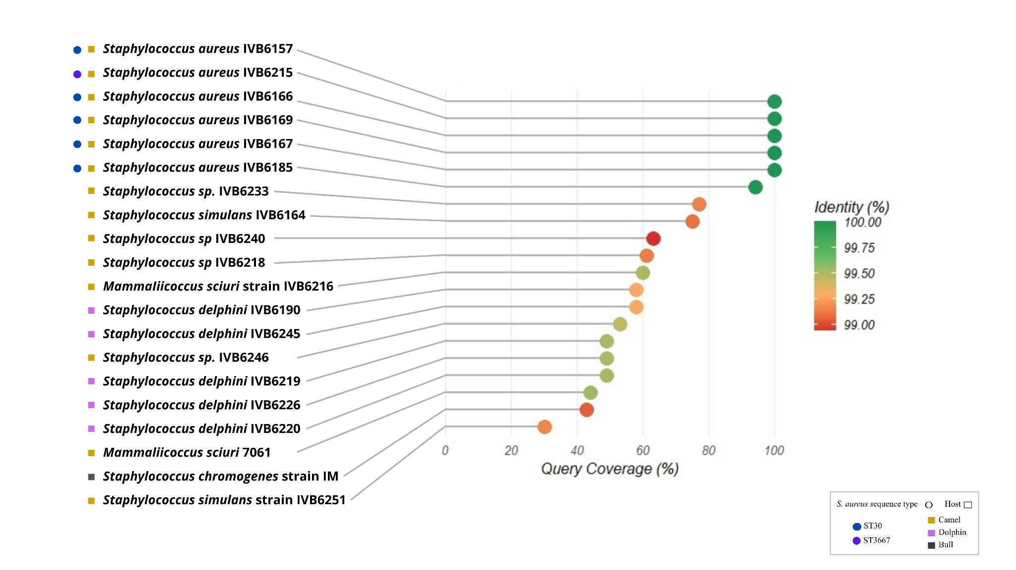

Extended Data Fig. 7│ Nucleotide sequence identity and coverage of SCCcam-related sequences among staphylococcal genomes. The SCCcam sequence from the camel-associated lineage (reference genome GCF_025559685.1) was used as the BLAST query. Query coverage (%) is represented on the horizontal axis, and sequence identity (%) is indicated by the color scale. Colored circles adjacent to isolate names indicate S. aureus sequence types (STs), whereas squares indicate host origin, as defined in the figure.

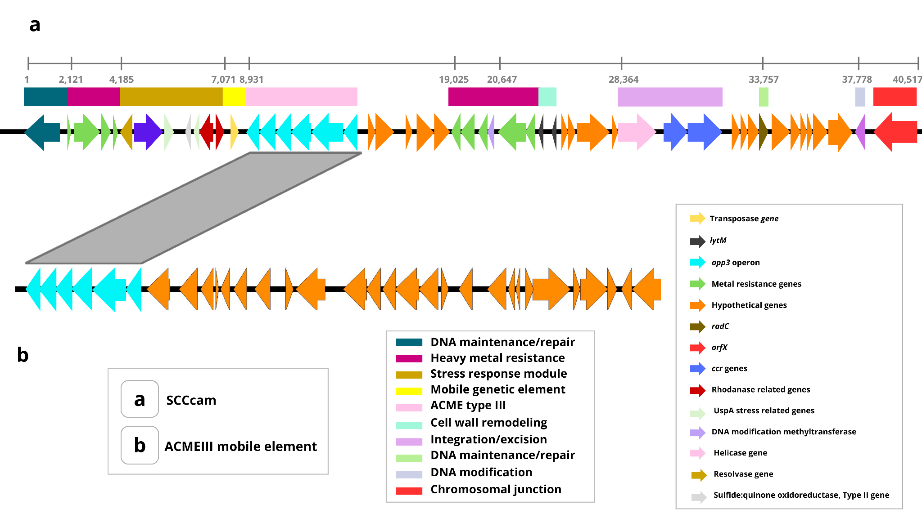

Extended Data Fig. 8│Genomic organization of SCCcam and its ACME type III region. a, Schematic representation of SCCcam identified in the camel-associated lineage. Predicted ORFs are represented by arrows indicating their transcriptional orientation and are color-coded according to their predicted function. Colored blocks above the genomic map indicate functional modules, as defined in the figure. b, Partial representation of the SCC-associated ACME III reported in S. aureus ST80³¹, showing predicted ORFs and their transcriptional orientation. Gray-shaded regions indicate sequence identity between the corresponding genomic regions. Functional categories and selected genes are indicated by the colored keys.

