SUPPLEMENTARY INFORMATION

Metabolic Burden and Response to Repeated Intranasal Esketamine in Treatment-Resistant Depression: A Longitudinal Multidomain Biomarker Study

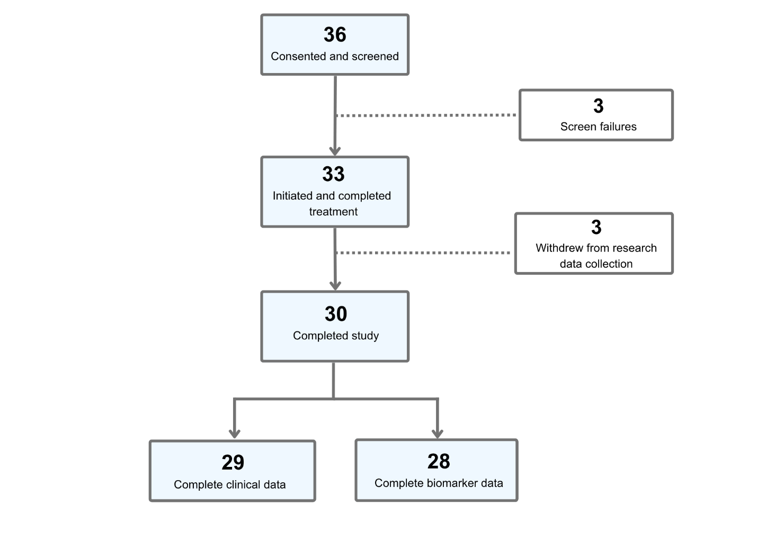
Supplementary Figure 1. Participant disposition.

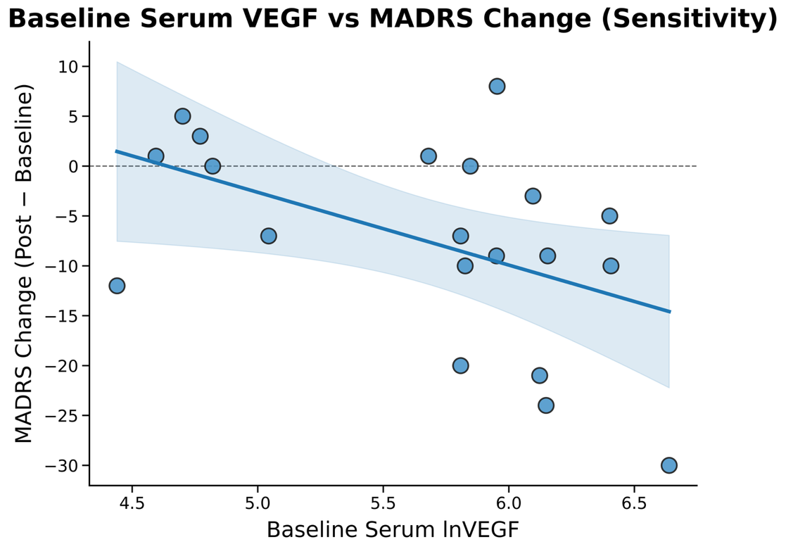

Supplementary Figure 2. Association between baseline log-transformed serum VEGF (lnVEGF) and change in Montgomery-Åsberg Depression Rating Scale (MADRS) scores following repeated intranasal esketamine treatment in sensitivity analyses excluding participants with diabetes or prescribed glucose-altering medications (n=20).

Supplementary Table 1. Clinical criteria for metabolic measures and calculation of the composite metabolic burden score.
Metabolic Biomarker | Clinical Threshold¹
Increased waist circumference | ≥102 cm in males; ≥88 cm in females
Elevated serum triglycerides | ≥1.7 mmol/L or pharmacological treatment for elevated triglycerides
Reduced HDL cholesterol | <1.03 mmol/L in males; <1.29 mmol/L in females, or pharmacological treatment for reduced HDL cholesterol
Elevated blood pressure | ≥130 mmHg systolic blood pressure or ≥85 mmHg diastolic blood pressure, or antihypertensive treatment with history of hypertension
Elevated fasting glucose | ≥5.6 mmol/L or pharmacological treatment for elevated glucose
¹Thresholds adapted from National Cholesterol Education Program Adult Treatment Panel III (NCEP ATP III) criteria and converted into SI units [42,43].
HDL, high-density lipoprotein

Supplementary Table 2. Concomitant medications during repeated intranasal esketamine treatment (N=30).
Psychotropic Medications | Participants, n¹
Serotonin/dopamine antagonists (antipsychotics)² | 17
Bupropion | 13
GABA-A receptor PAM (benzodiazepines) | 13
Selective serotonin reuptake inhibitors (SSRIs)³ | 13
Lisdexamfetamine, Methylphenidate, Modafinil | 10
Serotonin-norepinephrine reuptake inhibitors (SNRIs)⁴ | 8
Lamotrigine | 6
GABA-A receptor PAM (Z-drugs) | 5
Lithium | 5
Mirtazapine | 5
Trazodone | 5
Gabapentin, Pregabalin | 4
Topiramate | 4
Vortioxetine, Vilazodone | 4
Dual orexin receptor antagonists (DORAs) | 3
Nortriptyline | 3
Dextromethorphan/bupropion | 1
Methotrimeprazine | 1
Prazosin | 1
Solriamfetol | 1
Non-psychotropic Medications | Participants, n
Antihypertensive and cardiovascular medications | 9
Allergy and respiratory medications | 7
Gastrointestinal medications | 7
Analgesic and anti-inflammatory medications | 6
Glucose-altering medications⁵ | 6
Hormonal and reproductive medications | 5
Lipid-lowering medications | 4
Thyroid hormone medications | 3
Genitourinary medications | 2
Migraine-specific medications | 1
¹Values represent the number of individual participants receiving at least one medication in the listed class during the study. Participants may be represented in more than one medication class.
²Includes olanzapine, quetiapine, brexpiprazole, aripiprazole, lurasidone, risperidone, cariprazine.
³Includes sertraline, escitalopram, fluoxetine, paroxetine.
⁴Includes levomilnacipran, venlafaxine, duloxetine, desvenlafaxine.
⁵Includes metformin, semaglutide, empagliflozin, insulin, gliclazide. Three additional participants were prescribed glucagon-like peptide-1 (GLP-1) receptor agonists but were instructed to hold these medications throughout esketamine treatment.
GABA-A, gamma-aminobutyric acid type A receptor; PAM, positive allosteric modulator

Supplementary Table 3. Baseline metabolic, inflammatory and neurotrophic biomarkers as predictors of change in MADRS scores.
Full Sample (n=29) | B | β | p | p_{FDR}¹ | BCa 95% CI lower | BCa 95% CI upper | Adjusted R² | n
Metabolic Biomarkers
Waist circumference (cm) | -0.135 | -0.295 | 0.046 | 0.103 | -0.291 | -0.019 | 0.020 | 29
Triglycerides (mmol) | 4.262 | 0.221 | 0.220 | 0.395 | -3.022 | 12.707 | -0.016 | 29
HDL cholesterol (mmol) | -0.058 | -0.003 | 0.905 | 0.905 | -12.855 | 10.320 | -0.069 | 29
Systolic blood pressure (mmHg) | -0.086 | -0.180 | 0.412 | 0.529 | -0.249 | 0.173 | -0.036 | 29
Diastolic blood pressure (mmHg) | -0.198 | -0.211 | 0.344 | 0.515 | -0.539 | 0.213 | -0.021 | 29
Fasting glucose (mmol) | -0.880 | -0.086 | 0.491 | 0.553 | -5.360 | 3.142 | -0.061 | 29
BMI (kg/m²) | -0.298 | -0.259 | 0.107 | - | -0.752 | 0.084 | -0.005 | 28
Inflammatory and Neurotrophic Biomarkers
lnCRP | -1.561 | -0.162 | 0.496 | 0.598 | -5.502 | 2.398 | -0.044 | 28
lnIL-6 | -3.520 | -0.311 | 0.063 | 0.188 | -7.801 | 0.397 | 0.031 | 29
lnTNF-α | -0.895 | -0.052 | 0.598 | 0.598 | -7.458 | 3.129 | -0.066 | 29
lnIL-10 | -3.645 | -0.162 | 0.265 | - | -11.670 | 2.876 | -0.041 | 29
lnCCL2/MCP-1 | 0.243 | 0.007 | 0.972 | - | -10.437 | 15.219 | -0.069 | 29
lnIFN-γ | -4.768 | -0.337 | 0.057 | - | -10.754 | 0.007 | 0.037 | 26
lnNLR | -5.004 | -0.239 | 0.301 | - | -15.190 | 2.742 | -0.009 | 28
lnSSI | -2.247 | -0.129 | 0.701 | - | -11.844 | 4.877 | -0.053 | 28
Serum lnBDNF | -1.914 | 0.061 | 0.658 | 0.658 | -11.527 | 11.155 | -0.065 | 29
Serum lnVEGF | -4.122 | -0.340 | 0.074 | 0.148 | -9.667 | -0.184 | 0.054 | 29
Plasma lnBDNF | -0.545 | -0.060 | 0.672 | - | -4.275 | 1.678 | -0.065 | 29
Plasma lnVEGF | -5.440 | -0.261 | 0.111 | - | -15.279 | 3.854 | -0.007 | 28
Sensitivity Analysis (n=20)² | B | β | p | p_{FDR} | BCa 95% CI lower | BCa 95% CI upper | Adjusted R² | n
Metabolic Biomarkers
Waist circumference (cm) | -0.234 | -0.368 | 0.120 | 0.297 | -0.494 | 0.071 | 0.036 | 20
Triglycerides (mmol) | 6.134 | 0.269 | 0.183 | 0.297 | -4.088 | 17.534 | -0.024 | 20
HDL cholesterol (mmol) | -0.260 | -0.010 | 0.905 | 0.905 | -20.438 | 13.623 | -0.105 | 20
Systolic blood pressure (mmHg) | -0.093 | -0.174 | 0.527 | 0.593 | -0.308 | 0.289 | -0.073 | 20
Diastolic blood pressure (mmHg) | -0.223 | -0.218 | 0.421 | 0.541 | -0.675 | 0.380 | -0.053 | 20
Fasting glucose (mmol) | -11.817 | -0.362 | 0.198 | 0.297 | -27.061 | 5.843 | 0.034 | 20
BMI (kg/m²) | -0.512 | -0.298 | 0.251 | - | -1.506 | 0.413 | -0.017 | 20
Inflammatory and Neurotrophic Biomarkers
lnCRP | -3.110 | -0.274 | 0.360 | 0.388 | -8.447 | 3.870 | -0.037 | 20
lnIL-6 | -4.522 | -0.353 | 0.122 | 0.366 | -10.765 | 2.519 | 0.026 | 20
lnTNF-α | -2.980 | -0.140 | 0.388 | 0.388 | -18.044 | 5.206 | -0.089 | 20
lnIL-10 | -7.738 | -0.216 | 0.410 | - | -25.018 | 12.846 | -0.057 | 20
lnCCL2/MCP-1 | -2.038 | -0.051 | 0.806 | - | -18.189 | 23.547 | -0.102 | 20
lnIFN-γ | -9.448 | -0.455 | 0.117 | - | -16.304 | 4.916 | 0.095 | 17
lnNLR | -7.108 | -0.289 | 0.340 | - | -21.071 | 5.712 | -0.012 | 20
lnSSI | -3.277 | -0.164 | 0.676 | - | -16.147 | 8.522 | -0.075 | 20
Serum lnBDNF | -0.340 | -0.007 | 0.986 | 0.986 | -26.995 | -23.974 | -0.105 | 20
Serum lnVEGF | -7.780 | -0.499 | 0.022 | 0.043 | -13.579 | -0.994 | 0.171 | 20
Plasma lnBDNF | -3.193 | -0.234 | 0.263 | - | -8.120 | 4.117 | -0.046 | 20
Plasma lnVEGF | -17.550 | -0.569 | 0.018 | - | -28.744 | -6.846 | 0.183 | 19
¹FDR correction was applied within each biological domain for individual biomarkers comprising the respective composite measures (metabolic, inflammatory, and neurotrophic).
²Sensitivity analysis excluded participants with a diagnosis of diabetes or those prescribed glucose-altering treatments.
BCa, bias-corrected and accelerated; BDNF, brain-derived neurotrophic factor; BMI, body mass index; CI, confidence interval; CCL2/MCP-1, chemokine (C-C motif) ligand 2/monocyte chemoattractant protein-1; CRP, C-reactive protein; FDR, false discovery rate; HDL, high-density lipoprotein; IFN-γ, interferon-gamma; IL-6, interleukin-6; IL-10, interleukin-10; ln, log-transformed; MADRS, Montgomery-Åsberg Depression Rating Scale; NLR, neutrophil to lymphocyte ratio; SSI, systemic immune-inflammation index; TNF- α, tumour necrosis factor alpha; VEGF, vascular endothelial growth factor

Supplementary Table 4. Changes in metabolic, inflammatory, and neurotrophic biomarkers following repeated intranasal esketamine treatment.
Full Sample (n=28) | Baseline | Post-treatment | Mean Change | 95% CI | p | p_{FDR}¹ | Cohen's d | n
Inflammatory and Neurotrophic Biomarkers
lnCRP | 2.3 (1.9) | 1.8 (1.1) | -0.11 | (-0.91, 0.42) | 0.386 | 0.403 | -0.174 | 24
lnIL-6 | 2.6 (1.6) | 2.8 (1.8) | 0.08 | (-0.7, 0.23) | 0.273 | 0.403 | 0.224 | 25
lnTNF-α | 8.4 (2.9) | 9.0 (3.3) | 0.07 | (-0.02, 0.16) | 0.105 | 0.403 | 0.309 | 25
lnIL-10 | 2.6 (0.9) | 2.9 (1.2) | 0.08 | (-0.03, 0.19) | 0.117 | - | 0.297 | 24
lnCCL2/MCP-1 | 172.5 (47.7) | 176.6 (51.0) | 0.02 | (-0.07, 0.11) | 0.629 | - | 0.090 | 25
lnIFN-γ | 0.7 (0.7) | 0.8 (0.8) | 0.12 | (-0.13, 0.37) | 0.298 | - | 0.210 | 23
lnNLR | 2.6 (1.1) | 2.8 (1.5) | -0.22 | (0.28, -0.73) | 0.254 | - | -0.178 | 26
lnSSI | 709.8 (337.2) | 792.1 (477.6) | 0.07 | (-0.09, 0.22) | 0.333 | - | 0.176 | 25
Serum lnBDNF | 34613 (8436) | 34792 (8610) | -0.002 | (-0.07, 0.05) | 0.967 | 0.947 | -0.013 | 27
Serum lnVEGF | 328.9 (202.8) | 331.0 (199.2) | -0.009 | (-0.10, 0.06) | 0.843 | 0.947 | -0.044 | 27
Plasma lnBDNF | 880.4 (772.6) | 2167.8 (3253.0) | 0.37 | (-0.10, 0.84) | 0.086 | - | 0.312 | 27
Plasma lnVEGF | 27.1 (9.4) | 36.1 (25.5) | 0.17 | (-0.01, 0.07) | 0.072 | - | 0.336 | 25
Sensitivity Sample (n=20)² | Baseline | Post-treatment | Mean Change | 95% CI | p | p_{FDR} | Cohen's d | n
Metabolic Biomarkers
Waist circumference (cm) | 96.5 (15.9) | 96.5 (16.8) | 0.01 | (-2.13, 2.05) | 0.999 | 0.996 | 0.001 | 20
Triglycerides (mmol) | 1.26 (0.43) | 1.58 (1.11) | 0.32 | (0.03, 1.21) | 0.084 | 0.331 | 0.30 | 19
HDL cholesterol (mmol) | 1.47 (0.4) | 1.56 (0.8) | 0.08 | (-0.07, 0.55) | 0.585 | 0.695 | 0.15 | 19
Systolic blood pressure (mmHg) | 124.6 (19.4) | 118.6 (15.0) | -5.98 | (-11.1, -1.49) | 0.014 | 0.080 | -0.54 | 20
Diastolic blood pressure (mmHg) | 77.2 (10.1) | 74.4 (8.5) | -2.8 | (-5.65, -0.28) | 0.035 | 0.128 | -0.45 | 20
Fasting glucose (mmol) | 5.1 (0.3) | 3.5 (0.9) | -1.63 | (-2.12, -1.19) | < 0.001 | < 0.001 | -1.60 | 17
Inflammatory and Neurotrophic Biomarkers
Pro-inflammatory composite³ | -0.079 | -0.081 | -0.002 | (-0.13, 0.14) | 0.984 | - | -0.007 | 19
lnCRP | 2.18 (1.83) | 1.79 (1.15) | -0.07 | (-0.31, 0.17) | 0.575 | 0.880 | -0.128 | 18
lnIL-6 | 2.41 (1.61) | 2.44 (1.70) | 0.011 | (-0.13, 0.15) | 0.870 | 0.880 | 0.036 | 18
lnTNF-α | 7.98 (2.44) | 8.38 (3.08) | 0.029 | (-0.08, 0.12) | 0.570 | 0.880 | 0.126 | 18
lnIL-10 | 2.45 (0.77) | 2.74 (1.34) | 0.059 | (-0.05, 0.22) | 0.374 | - | 0.205 | 17
lnCCL2/MCP-1 | 173.6 (44.1) | 178.6 (53.3) | 0.016 | (-0.09, 0.11) | 0.743 | - | 0.07 | 18
lnIFN-γ | 0.7 (0.48) | 0.8 (0.46) | 0.128 | (-0.03, 0.30) | 0.123 | - | 0.37 | 18
lnNLR | 2.48 (1.02) | 2.96 (1.76) | 0.101 | (-0.08, 0.28) | 0.274 | - | 0.242 | 18
lnSSI | 696 (362) | 809 (540) | 0.091 | (-0.08, 0.24) | 0.276 | - | 0.247 | 18
Neurotrophic composite⁴ | 0.058 | 0.102 | 0.044 | (-0.11, 0.20) | 0.587 | - | 0.121 | 19
Serum lnBDNF | 34967 (7151) | 35720 (7412) | 0.021 | (-0.03, 0.09) | 0.505 | 0.745 | 0.154 | 19
Serum lnVEGF | 344 (194) | 353 (196) | 0.012 | (-0.12, 0.09) | 0.794 | 0.996 | 0.046 | 19
Plasma lnBDNF | 1081 (824) | 2759 (3667) | 0.428 | (-0.14, 1.07) | 0.156 | - | 0.310 | 19
Plasma lnVEGF | 28.6 (10.1) | 40.8 (28.6) | 0.223 | (-0.006, 0.51) | 0.075 | - | 0.388 | 18
¹FDR correction was applied within each biological domain for individual biomarkers comprising the respective composite measures (metabolic, inflammatory, and neurotrophic).
²Sensitivity analysis excluded participants with a diagnosis of diabetes or those prescribed glucose-altering treatments.
³Pro-inflammatory composite included CRP, IL-6, and TNF-α.
⁴Neurotrophic composite included serum BDNF and VEGF.
BDNF, brain-derived neurotrophic factor; CI, confidence interval; CCL2/MCP-1, chemokine (C-C motif) ligand 2/monocyte chemoattractant protein-1; CRP, C-reactive protein; FDR, false discovery rate; HDL, high-density lipoprotein; IFN-γ, interferon-gamma; IL-6, interleukin-6; IL-10, interleukin-10; ln, log transformed; NLR, neutrophil to lymphocyte ratio; SSI, systemic immune-inflammation index; TNF- α, tumour necrosis factor alpha; VEGF, vascular endothelial growth factor

Supplementary Table 5. Correlations between changes in metabolic, inflammatory, and neurotrophic biomarkers and changes in MADRS scores following repeated intranasal esketamine treatment.

Full Sample (n=28) | r/rho |  | 95% CI | p |  | p_{FDR}¹ | N
Metabolic Biomarkers
Waist circumference (cm) |  | 0.189 | (-0.092, 0.463) |  | 0.443 | 0.879 | 27
Triglycerides (mmol) |  | -0.395 | (-0.683, 0.001) |  | 0.034 | 0.275 | 25
HDL cholesterol (mmol) |  | 0.196 | (-0.216, 0.549) |  | 0.406 | 0.879 | 25
Systolic blood pressure (mmHg) |  | -0.091 | (-0.455, 0.299) |  | 0.696 | 0.879 | 27
Diastolic blood pressure (mmHg) |  | 0.387 | (-0.221, 0.519) |  | 0.298 | 0.879 | 27
Fasting glucose (mmol) |  | 0.034 | (-0.393, 0.450) |  | 0.850 | 0.879 | 22
Inflammatory and Neurotrophic Biomarkers
Pro-inflammatory composite² |  | -0.200 | (-0.539, 0.285) |  | 0.324 | - | 24
lnCRP |  | -0.143 | (-0.524, 0.287) |  | 0.472 | 0.569 | 23
lnIL-6 |  | 0.149 | (-0.271, 0.521) |  | 0.545 | 0.569 | 24
lnTNF-α |  | -0.315 | (-0.638, 0.101) |  | 0.132 | 0.391 | 24
lnIL-10 |  | -0.074 | (-0.472, 0.349) |  | 0.761 | - | 23
lnCCL2/MCP-1 |  | -0.228 | (-0.579, 0.193) |  | 0.255 | - | 24
lnIFN-γ |  | 0.105 | (-0.331, 0.504) |  | 0.655 | - | 22
lnNLR |  | 0.327 | (-0.079, 0.639) |  | 0.207 | - | 25
lnSSI |  | 0.238 | (-0.173, 0.579) |  | 0.442 | - | 25
Neurotrophic composite³ |  | 0.256 | (-0.147, 0.572) |  | 0.168 | - | 26
Serum lnBDNF |  | 0.118 | (-0.171, 0.415) |  | 0.418 | 0.569 | 26
Serum lnVEGF |  | 0.155 | (-0.191, 0.441) |  | 0.286 | 0.569 | 26
Plasma lnBDNF |  | 0.085 | (-0.312, 0.458) |  | 0.768 | - | 26
Plasma lnVEGF |  | -0.091 | (-0.469, 0.316) |  | 0.354 | - | 24
Sensitivity Sample (n=18)⁴ |  | r/rho | 95% CI |  | p | p_{FDR} | N
Metabolic Biomarkers
Waist circumference (cm) |  | 0.445 | (-0.219, 0.829) |  | 0.164 | 0.437 | 18
Triglycerides (mmolL) |  | -0.381 | (-0.707, 0.049) |  | 0.066 | 0.437 | 18
HDL cholesterol (mmolL) |  | 0.065 | (-0.481, 0.487) |  | 0.816 | 0.903 | 18
Systolic blood pressure (mmHg) |  | -0.048 | (-0.493, 0.597) |  | 0.789 | 0.903 | 18
Diastolic blood pressure (mmHg) |  | 0.151 | (-0.101, 0.719) |  | 0.151 | 0.437 | 18
Fasting glucose (mmolL) |  | 0.093 | (-0.472, 0.517) |  | 0.707 | 0.903 | 16
Inflammatory and Neurotrophic Biomarkers
Pro-inflammatory composite |  | -0.127 | (-0.565, 0.414) |  | 0.594 | - | 17
lnCRP |  | -0.131 | (-0.619, 0.419) |  | 0.635 | 0.635 | 17
lnIL-6 |  | 0.333 | (-0.198, 0.751) |  | 0.248 | 0.372 | 17
lnTNF-α |  | -0.328 | (-0.747, 0.178) |  | 0.231 | 0.372 | 17
lnIL-10 |  | -0.043 | (-0.609, 0.653) |  | 0.865 | - | 16
lnCCL2/MCP-1 |  | -0.190 | (-0.614, 0.354) |  | 0.418 | - | 17
lnIFN-γ |  | 0.053 | (-0.628, 0.659) |  | 0.862 | - | 15
lnNLR |  | 0.373 | (-0.116, 0.793) |  | 0.373 | - | 18
lnSSI |  | 0.284 | (-0.222, 0.778) |  | 0.496 | - | 18
Neurotrophic composite |  | 0.138 | (-0.340, 0.508) |  | 0.531 | - | 18
Serum lnBDNF |  | 0.097 | (-0.241, 0.434) |  | 0.571 | 0.635 | 18
Serum lnVEGF |  | 0.196 | (-0.333, 0.631) |  | 0.422 | 0.635 | 18
Plasma lnBDNF |  | 0.089 | (-0.433, 0.481) |  | 0.697 | - | 18
Plasma lnVEGF |  | -0.029 | (-0.447, 0.415) |  | 0.861 | - | 17
¹FDR correction was applied within each biological domain for individual biomarkers comprising the respective composite measures (metabolic, inflammatory, and neurotrophic).
²Pro-inflammatory composite included CRP, IL-6, and TNF-α.
³Neurotrophic composite included serum BDNF and VEGF.
⁴Sensitivity analysis excluded participants with a diagnosis of diabetes or those prescribed glucose-altering treatments.
BDNF, brain-derived neurotrophic factor; CI, confidence interval; CCL2/MCP-1, chemokine (C-C motif) ligand 2/monocyte chemoattractant protein-1; CRP, C-reactive protein; HDL, high-density lipoprotein; IFN-γ, interferon-gamma; IL-6, interleukin-6; IL-10, interleukin-10; ln, log transformed; NLR, neutrophil to lymphocyte ratio; SSI, systemic immune-inflammation index; TNF- α, tumour necrosis factor alpha; VEGF, vascular endothelial growth factor

