Regardless of Age, Locomotor Habituation is Observed with Exposure to Virtually-Induced Fall-Related Anxiety
Journal: Aging Clinical and Experimental Research

Kelly Poretti, PhD,^{1,2} Quentin Sanders, PhD,³ Nathalia Piexoto, PhD,⁴ Toby J. Ellmers, PhD,⁵ Christopher K. Rhea, PhD,⁶ Tiphanie E. Raffegeau, PhD¹

Corresponding Author:
Tiphanie E. Raffegeau, PhD
School of Kinesiology, George Mason University, Manassas, VA, USA
Email: traffege@gmu.edu

Supplementary Material

Supplementary Figures
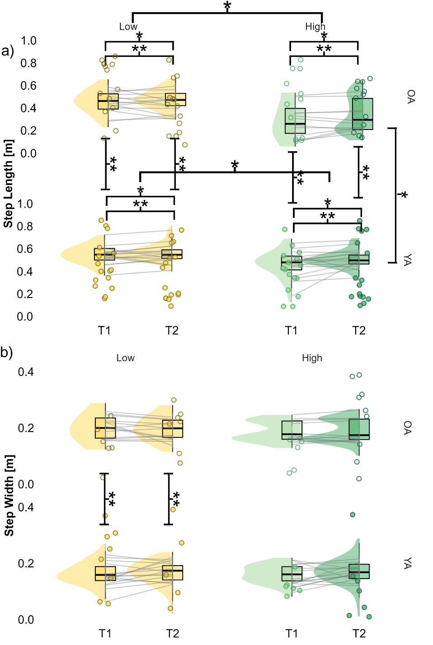
Figure S1(a-b): Habituation of (a) step length and (b) step width between low and high virtual elevations in young and older adults. Older adult (OA) data is represented in the figures at the top, while young adult (YA) data is in the figures at the bottom. Scattered dots represent individual data points. Variability of the data is represented by raincloud plots with low VR elevations presented on the left side in yellow and high VR elevations represented on the right side in green. T1 is located on the left side, while T2 is located on the right side of each quadrant of the overall figure. Means are indicated as the solid black horizontal line on the violin plots. Significant differences are represented with asterisks and brackets, where a single asterisk indicates main effects of group, height, and/or time and a double asterisk represents an interaction of age and height and/or an interaction of elevation and time.

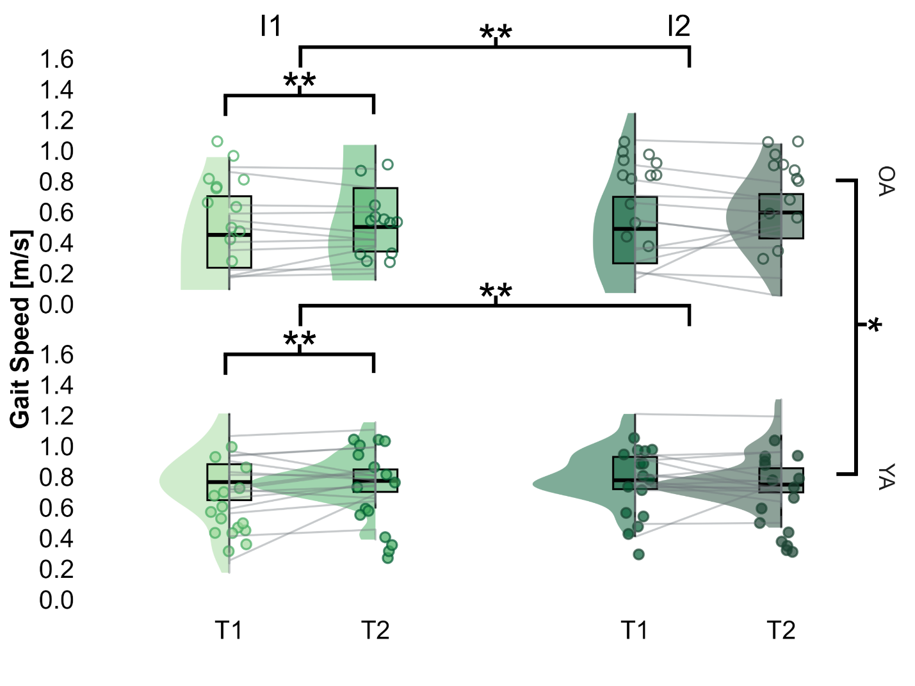
Figure S2: Age-related differences in adaptations of gait speed to fall-related anxiety over time and across repeated exposures. Compensatory changes to gait speed from the beginning of a five-minute exposure (T1) and the end of an exposure (T2) as well as between the first five-minute exposure (E1) and the second exposure (E2) to anxiety-inducing virtual settings. Older adult (OA) data is represented in the figures at the top, while young adult (YA) data is represented in the figures at the bottom. Scattered dots represent subject means, while variability is represented by the raincloud plots. T1 is located on the left, while T2 located on the right. Main effects of group are indicated with a double asterisk and brackets, while significant interactions of exposure and time are indicated with a single asterisk.

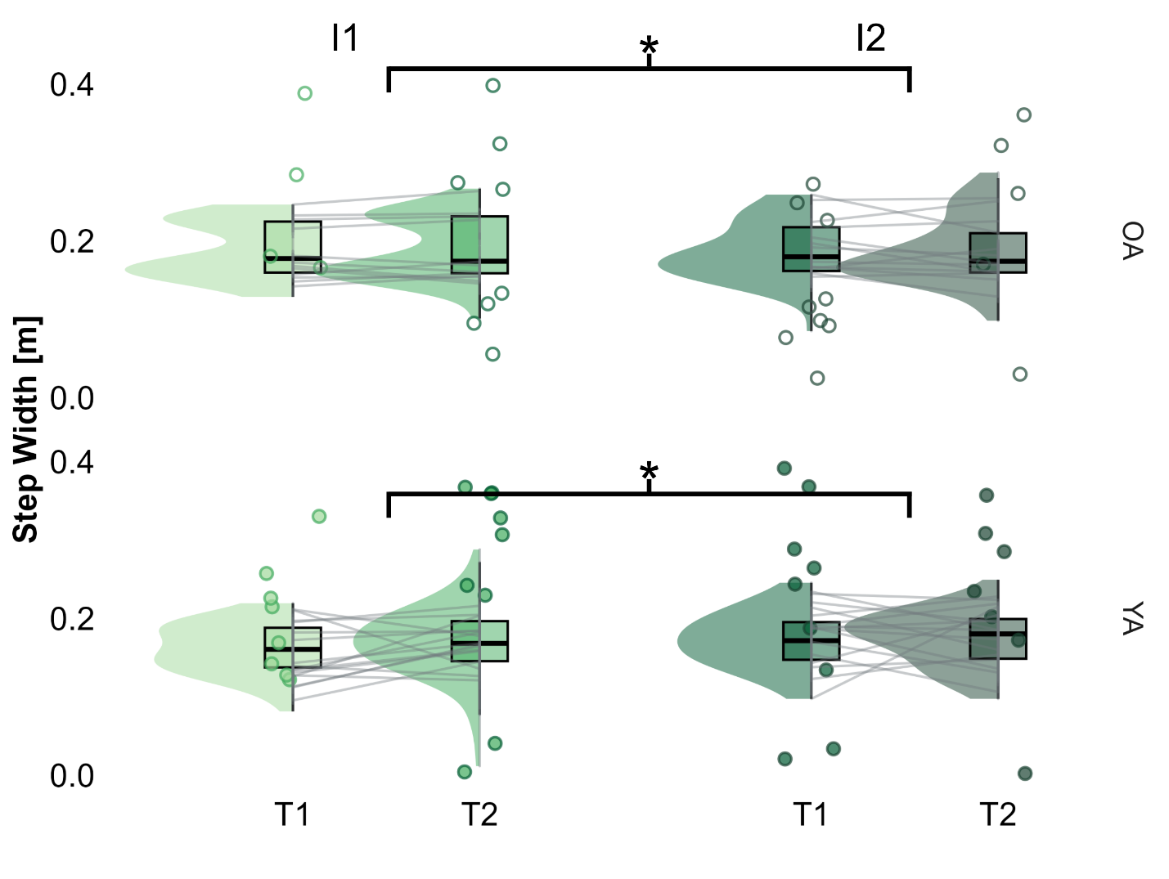

Figure S3: Age-related differences in adaptations of step width to fall-related anxiety over time and across repeated exposures. Compensatory changes to step width from the beginning of a five-minute exposure (T1) and the end of an exposure (T2) as well as between the first five-minute exposure (E1) and the second exposure (E2) to anxiety-inducing virtual settings. Older adult (OA) data is represented in the figures at the top, while young adult (YA) data is represented in the figures at the bottom. Scattered dots represent subject means, while variability is represented by the raincloud plots. T1 is located on the left, while T2 located on the right. Significant main effects of group, exposure, and/or time are indicated with a single asterisk and brackets, while significant interaction effects of exposure and time are indicated with a double asterisk.

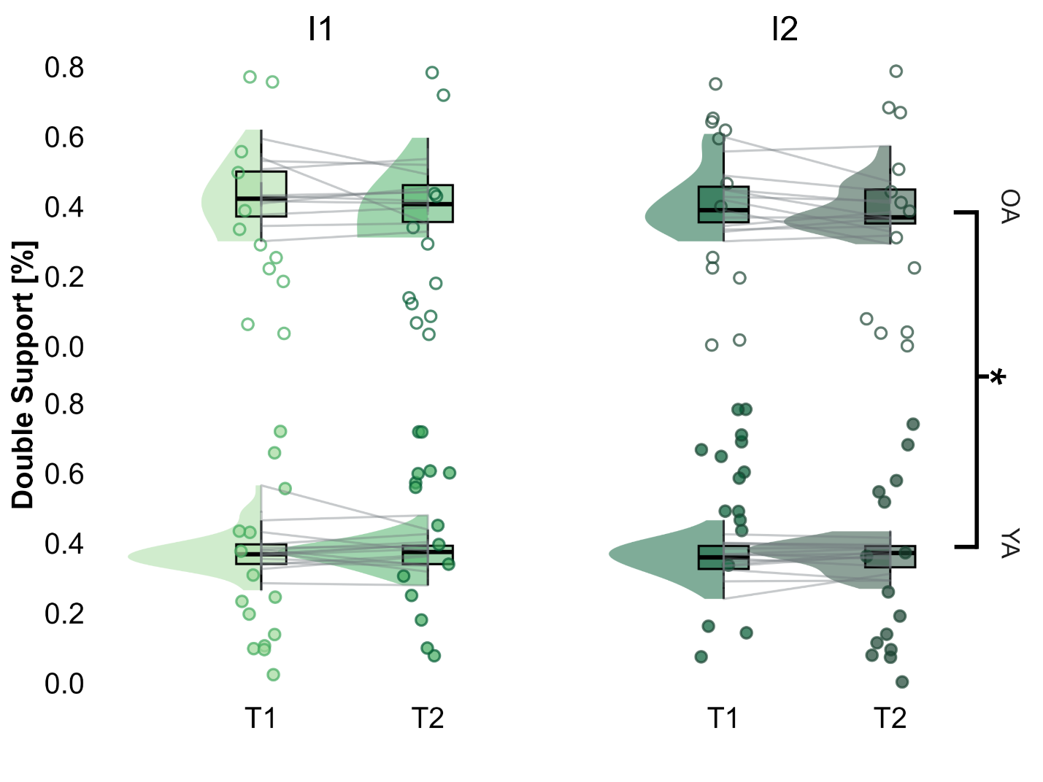
Figure S4: Age-related differences in adaptations to double support percentage to fall-related anxiety over time and across repeated exposures. Compensatory changes to double support percentage from the beginning of a five-minute exposure (T1) and the end of an exposure (T2) as well as between the first five-minute exposure (E1) and the second exposure (E2) to anxiety-inducing virtual settings. Older adult (OA) data is represented in the figures at the top, while young adult (YA) data is represented in the figures at the bottom. Scattered dots represent subject means, while variability is represented by the raincloud plots. T1 is located on the left, while T2 located on the right. Significant main effects of group are indicated with a single asterisk and brackets.

Supplementary Analysis of Heart Rate Variability

Results
A total of 8 participants, including four older adults and four young adults, were included in a preliminary exploration of HRV adaptation. Our results did not reveal any significant interactions when looking at differences in changes across time between low and high virtual settings. Additionally, our results did not reveal any significant interactions when looking at differences in changes across time between exposures to the high virtual elevation. However, the sample size for this portion of the study is preliminary; power analysis using G*Power software indicated a required total sample of 18 to achieve 80% power. Our results revealed significant main effects of group F(1, 6.0) = 9.368, p = .009, β = .249, in our LMER model comparing group, time, and elevation, with older adults exhibiting increased HRV compared to young adults (Figure 14a). Our preliminary results revealed a main effect of group F(1, 6.0) = 13.08, p = .005, β = .255, with older adults exhibiting increased HRV compared to young adults (Figure 14b). In older adults, differences between exposures, G = .442, resulted in a small-to-medium effect, while differences over time (between T1 and T2), G = .600, resulted in a medium-to-large effect. In young adults, differences between exposures, G = .159, and over time, G = .076, resulted in negligible effects.

Discussion of HRV Results
It should also be noted that the observed older adult savings are coupled with an inverse relationship in their physiological arousal levels, contrary to their young adult counterparts. Older adults exhibited increased levels of physiological arousal in response to the high elevation setting compared to young adults, and over time, became gradually less aroused. Coupled with walking with faster, longer steps, the decrease in arousal suggests that perhaps the decreased physiological arousal might be associated with adaptation in older adults’ perceptions of threat due to exposure to fall-related anxiety. Similar associations between physiological stress and balance performance while standing [41] and walking at virtual high elevations and at physical high [43] have noted increases in physiological arousal measures such as heart rate, heart rate variability, and electrodermal activity, that are associated with poorer balance and gait parameters, aligning with results from the present study. Reductions in physiological arousal specific to older adults in the present study indicate age-related differences in habituation to fall-related anxiety, where only older adults became accustomed to the arousal provoked by the fall-related anxiety over time. The consistent levels of arousal over time, in the young adults, suggest the cause of this is likely due to decreased levels of motivation compared to older adults. In a previous study that looked at habituation across a one-minute exposure, young adults exhibited exposure-specific adaptations [17], however the analysis was part of a larger study, where procedures included additional tasks that were perhaps more attention-demanding for young adults. Young adult data was collected from a sample of Kinesiology students from the university who were incentivized with extra credit towards their courses. It was not until all young adult data was collected that older adult data was collected, and older adults were recruited from the local community and incentivized with monetary compensation for completion of the study procedures. It is feasible that a difference in motivation led to a lack of age-related differences in our results. Based on the inverted-U hypothesis, our results suggest that the lower levels of arousal in young adults resulted in sub-optimal gait performance, while the higher levels of arousal in older adults resulted in optimal gait performance. Opposing arousal levels in young and older adults may have allowed the two groups to have such different levels of performance that allowed them to adapt their gait in similar ways. However, our physiological arousal results represent a preliminary analysis that is underpowered, which may not be generalizable to a larger sample. Thus, it remains important to continue to investigate the age-related differences in adaptation to better understand older adult falls.

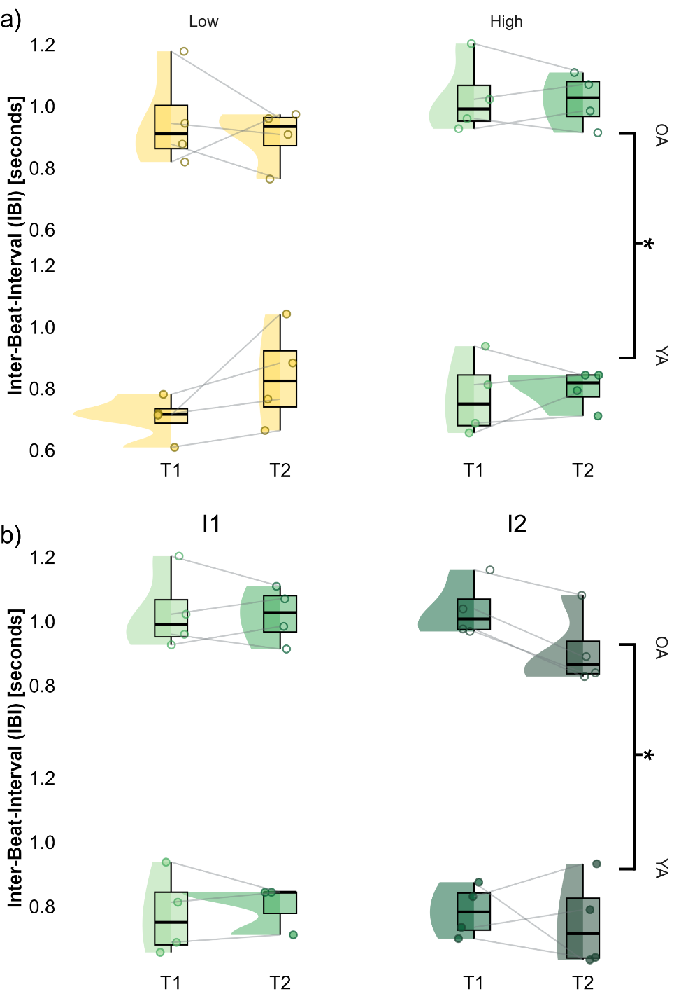
Figure S5(a-b): Age-related differences in physiological adaptations to fall-related anxiety over time and across repeated exposures. (a) Changes to heart rate variability, as measured by the inter-beat-interval, from the beginning of a trial (T1) to the end of a trial (T2) as well as between low-elevation and high-elevation settings. (b) Changes to heart rate variability from the beginning of a five-minute exposure (T1) and the end of an exposure (T2) as well as between the first five-minute exposure (E1) and the second exposure (E2) to anxiety-inducing (i.e. high elevation) virtual settings. Older adult (OA) data is represented in the figures above the horizontal line, while young adult (YA) data is represented in the figures below. Scattered dots represent subject means, while variability is represented by the violin plots. T1 is represented by the yellow-colored violin plots, while T2 is represented by the green-colored plots. Significant main effects of group are indicated with a single asterisk and brackets.

