Appendix
- Simulation state graph:
Our model (Fig. S1) extends the classic SEIR model by further dividing the infectious subpopulation into pre-symptomatic (Ipre), asymptomatic (Iasym), symptomatic (Isym), and hospitalized (severely symptomatic, IH. In addition, this model also accounts for isolation-based interventions (e.g., isolating individuals in response to testing or contact tracing).
- Validating our social connection graph:
The social graph is modeled to represent the Israeli population while considering family units, schools, workplaces and other social interactions. In order to validate our choices, we calculated the positive and hospitalization impact factor during the spread of the virus in our simulation. The results presented in Fig. S2 match our observations during the pandemic in Israel [figure 3-a main text].

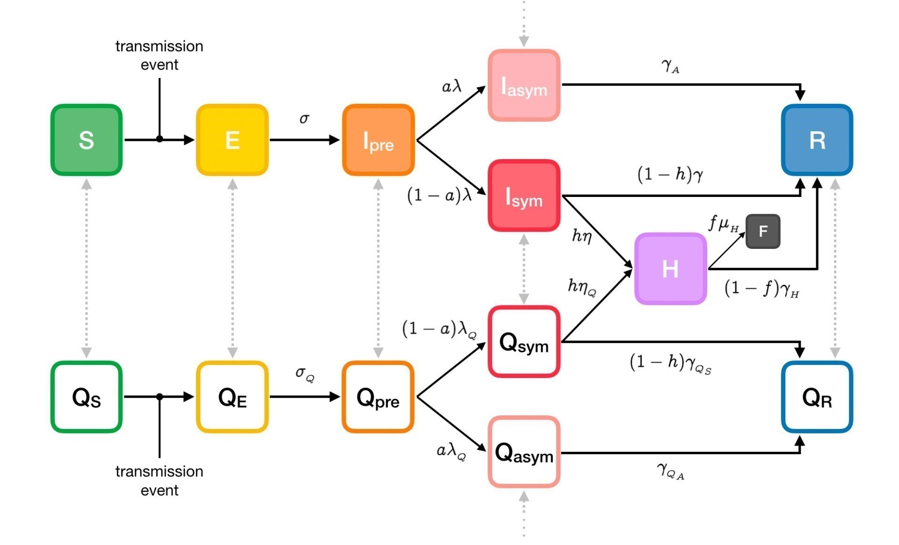
Fig. S1 seir+ model state machine
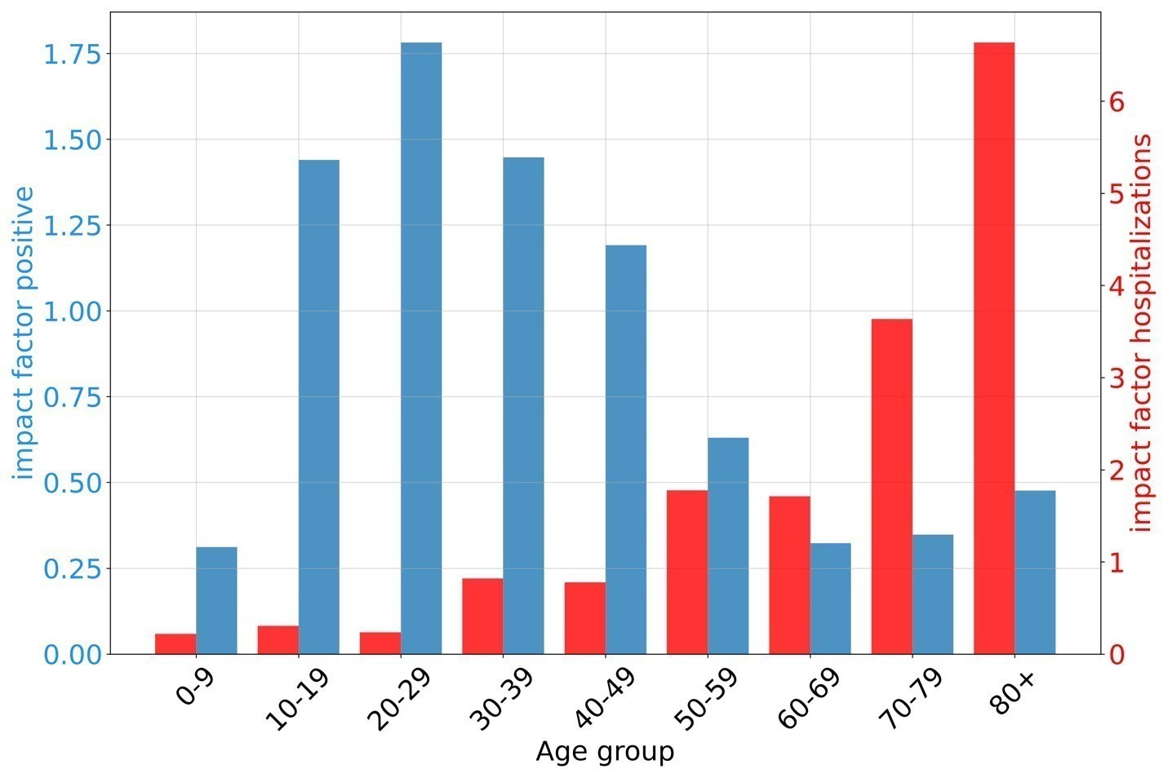
Fig. S2 - positive and hospitalization impact factors from the simulation for each age group

