Metal–1,10-Phenanthroline-5,6-dione Complexes Target Multidrug-Resistant Acinetobacter baumannii: Antibacterial and Pharmacodynamic Insights

Ingrid Vianez Peregrino¹, Gabriela Seabra¹, Luiz Felipe Vieira dos Santos Amorim¹, Roberta Ferreira Ventura Mendes¹, Michael Devereux², Malachy McCann³, Lívia de Souza Ramos⁴, André Luis Souza dos Santos^{4,*} and Ana Paula Ferreira Nunes^{1,*}

¹ Laboratory of Bacterial Resistance (RESBAC), Department of Pathology, Federal University of Espírito Santo (UFES), Vitória, Espírito Santo, Brazil
² Physical to Life Sciences, Centre for Biomimetic and Therapeutic Research, Focas Research Institute, Technological University Dublin, Dublin, Ireland
³ Chemistry Department, Maynooth University, Maynooth, Ireland
⁴ Laboratory of Advanced Studies on Emerging and Resistant Microorganisms (LEAMER), Department of General Microbiology, Institute of Microbiology Paulo de Góes, Federal University of Rio de Janeiro (UFRJ), Rio de Janeiro, Brazil

* Corresponding authors:
André Luis Souza dos Santos
Federal University of Rio de Janeiro (UFRJ)
Av. Carlos Chagas Filho, 373, Centro de Ciências da Saúde, Bloco I, Cidade Universitária, Rio de Janeiro - RJ, 21941-902
andre@micro.ufrj.br

Ana Paula Ferreira Nunes
Federal University of Espírito Santo (UFES)
Av. Marechal Campos, 1468, Centro de Ciências da Saúde (CCS), Maruípe, Vitória - ES, 29047-105
ana.p.nunes@ufes.br

Table S1. Minimum inhibitory concentration (MIC) values of carbapenems and phendione-based complexes against six multidrug-resistant Acinetobacter baumannii clinical isolates and the ATCC 19606 strain.
Code strains | MIC, [µg/mL]
Code strains | Meropenem | Imipenem | Ag-phendione | Cu-phendione
3B | 32 | 128 | 1.56 | 0.78
30B | 64 | 64 | 0.78 | 1.56
38B | 16 | 32 | 1.56 | 1.56
78B | 32 | 32 | 1.56 | 1.56
98B | 64 | 64 | 1.56 | 1.56
101B | 64 | 128 | 1.56 | 1.56
ATCC 19606 | 1 | 1 | 1.56 | 1.56

Table S2. Checkerboard synergy analysis of meropenem (MEM) combined with phendione-based complexes against five additional Acinetobacter baumannii clinical isolates.
Strains | MIC of single agents (μg/mL) |  |  | MIC of the combination  (FICI value)
Strains | MEM | Ag-phendione | Cu-phendione |  | MEM/Ag-phendione | MEM/Cu-phendione
24B | 16 | 0.78 | 1.56 |  | 8/0.39 (1)^{b} | 8/0.39 (0.75)^{b}
96B | 64 | 1.56 | 1.56 |  | 16/0.78 (0.75)^{b} | 32/0.78 (1)^{b}
97B | 64 | 0.78 | 1.56 |  | 16/0.39 (0.75)^{b} | 32/0.78 (1)^{b}
108B | 32 | 1.56 | 1.56 |  | 8/0.78 (0.75)^{b} | 16/0.39 (0.75)^{b}
125B | 32 | 0.78 | 1.56 |  | 4/0.39 (0.62)^{b} | 16/0.19 (0.62)^{b}
MEM – meropenem; ª – synergy; ^{b} – additivity

Table S3. Checkerboard synergy analysis of imipenem (IMP) combined with phendione-based complexes against five additional Acinetobacter baumannii clinical isolates.
Strains | MIC of single agents (μg/mL) |  |  | MIC of the combination  (FICI value)
Strains | IMP | Ag-phendione | Cu-phendione |  | IMP/Ag-phendione | IMP/Cu-phendione
24B | 16 | 1.56 | 0.78 |  | 8/0.19 (0.62)^{b} | 8/0.39 (1)^{b}
96B | 64 | 0.78 | 1.56 |  | 32/0.39 (1)^{b} | 32/0.78 (1)^{b}
97B | 64 | 1.56 | 1.56 |  | 8/0.78 (0.62)^{b} | 8/0.78 (0.62)^{b}
108B | 64 | 1.56 | 1.56 |  | 16/0.78 (0.75)^{b} | 32/0.39 (0.75)^{b}
125B | 32 | 0.78 | 0.78 |  | 8/0.39 (0.75)^{b} | 16/0.39 (1)^{b}
IMP – imipenem; ª – synergy; ^{b} – additivity

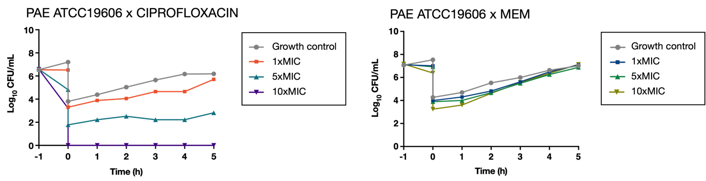
Fig. S1 Post-antibiotic effect (PAE) induced by a 1-hour exposure to ciprofloxacin (left panel) and meropenem (right panel) against A. baumannii ATCC 19606. At time zero (T₀), antibiotics were removed by a 1:1000 dilution in fresh, drug-free medium, and cultures were subsequently re-incubated. An untreated growth control, processed in parallel without prior antibiotic exposure, was included.

