Supplementary
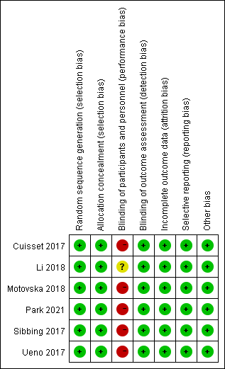
Supplementary Figure 1. The risk assessment of bias for randomized controlled trial included.

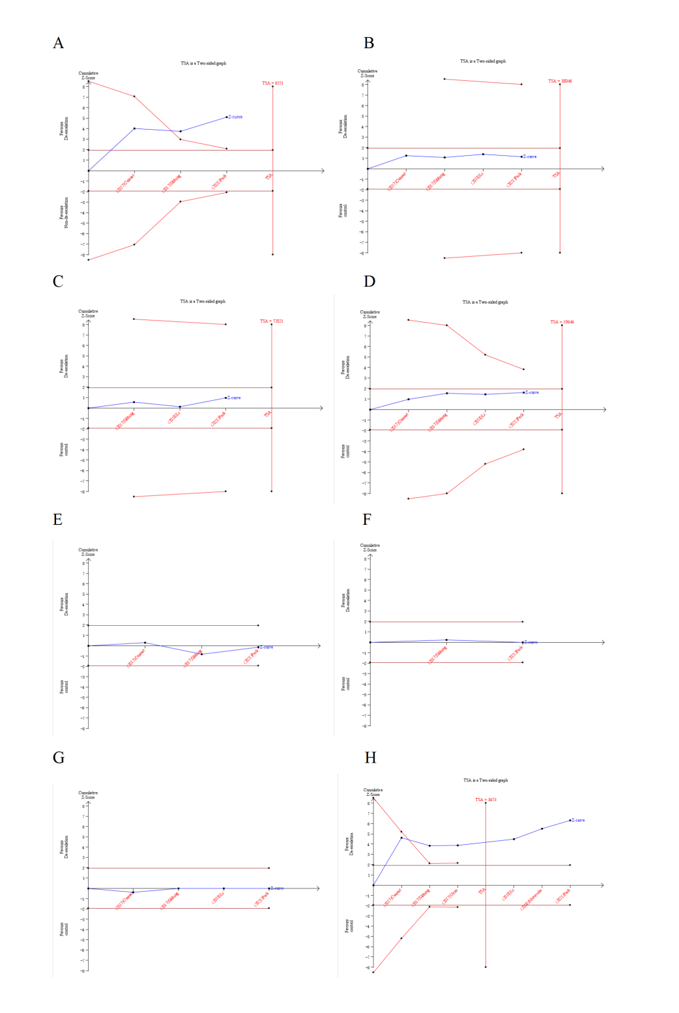
Supplementary Figure 2. The size of information required for each endpoint. (A) the composite endpoint, (B) cardiovascular death, (C) myocardial infarction, (D) stroke, (E) revascularization, (F) all-cause death, (G) stent thrombosis, (H) bleeding.
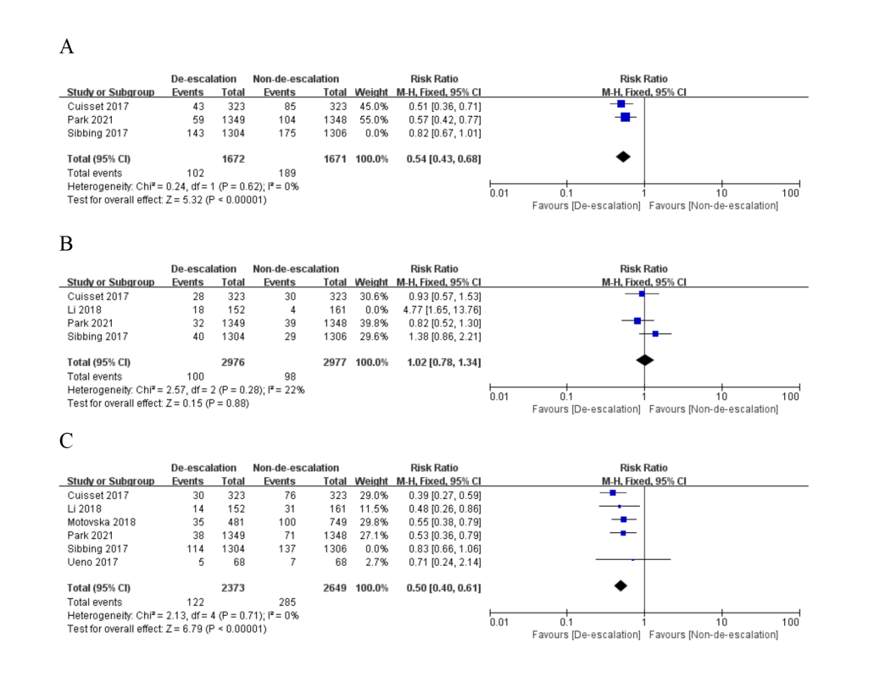
Supplementary Figure 3. Sensitivity analyses from (A) the composite endpoint, (B) revascularization endpoint, and (C) bleeding endpoint.

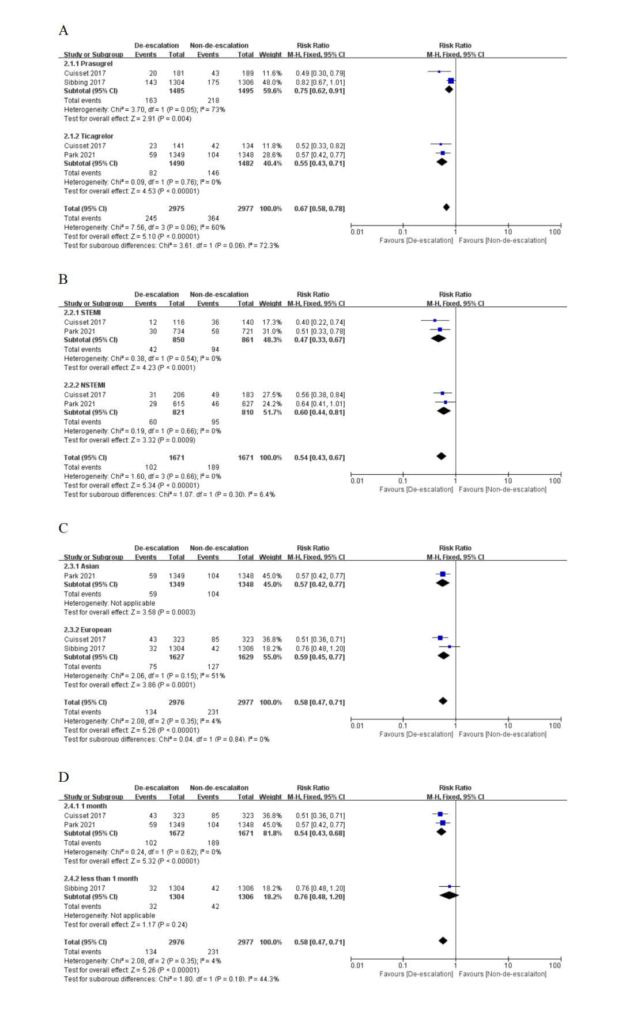
Supplementary Figure 4. Subgroup analyses from the composite endpoint of (A) prasugrel and ticagrelor, (B) patients with ST elevation myocardial infarction and non-ST elevation myocardial infarction, (C) yellow and white race and (D) switching drugs at 1 month and less than 1 month.

Supplementary Table 1. Search strategy of Pubmed database.
# | Searches | Results
#1 | (((((Acute Coronary Syndrome) OR (Acute Coronary Syndromes)) OR (Coronary Syndrome, Acute)) OR (Coronary Syndromes, Acute)) OR (Syndrome, Acute Coronary)) OR (Syndromes, Acute Coronary) | 2680
#2 | ((((((((((((((Prasugrel Hydrochloride) OR (Hydrochloride, Prasugrel)) OR (Prasugrel HCl)) OR (HCl, Prasugrel)) OR (CS 747)) OR (747, CS)) OR (CS-747)) OR (CS747)) OR (Prasugrel)) OR (Efient)) OR (Effient)) OR (LY 640315)) OR (640315, LY)) OR (LY640315)) OR (LY-640315) | 334
#3 | ((((((Ticagrelor) OR (Brilique)) OR (AZD 6140)) OR (AZD6140)) OR (AZD-6140)) OR (Brilinta)) OR (3-(7-((2-(3,4-Difluorophenyl) cyclopropyl) amino)-5-(propylthio)-3H-(1-3)-triazolo(4,5-d) pyrimidin-3-yl)-5-(2-hydroxyethoxy) cyclopentane-1,2-diol) | 469
#4 | ((((((((((((((((Clopidogrel) OR (SC 25989C)) OR (SC 25990C)) OR (SR 25989)) OR (Clopidogrel-Mepha)) OR (Clopidogrel Mepha)) OR (Clopidogrel Sandoz)) OR (Iscover)) OR (Clopidogrel Napadisilate)) OR (Clopidogrel Hydrochloride)) OR (PCR 4099)) OR (PCR-4099)) OR (Clopidogrel Besylate)) OR (Clopidogrel Besilate)) OR (Clopidogrel, (+) (S)-isomer)) OR (Plavix)) OR (Clopidogrel Bisulfate) | 1692
#5 | de-escalation | 84
#6 | Switch | 5073
#7 | #1 AND #2 OR #3 AND #4 AND #5 OR #6 AND (randomizedcontrolledtrial[Filter])) | 5077

Supplementary Table 2. Search strategy of Cochrane Library database.
# | Searches | Results
#1 | MeSH descriptor: [Acute Coronary Syndrome] this term only | 2118
#2 | Acute Coronary Syndromes OR Coronary Syndrome, Acute OR Coronary Syndromes, Acute OR Syndrome, Acute Coronary OR Syndromes, Acute Coronary: ti, ab, kw | 8154
#3 | #1 OR #2 | 8154
#4 | MeSH descriptor: [Prasugrel Hydrochloride] this term only | 454
#5 | Hydrochloride, Prasugrel OR Prasugrel HCl OR HCl, Prasugrel OR CS 747 OR 747, CS OR CS-747 OR CS747 OR Prasugre OR Efient OR Effient OR LY 640315 OR 640315, LY OR LY640315 OR LY-640315: ti, ab, kw | 1308
#6 | #4 OR #5 | 1308
#7 | MeSH descriptor: [Ticagrelor] this term only | 788
#8 | MeSH descriptor: [Clopidogrel] this term only | 2076
#9 | De-escalation | 585
#10 | switch | 6823
#11 | #3 AND #6 OR #7 AND #8 AND #9 OR #10 | 7335

Supplementary Table 3. Search strategy for Web of science database.
# | Searches | Results
#1 | TS= (Acute Coronary Syndrome OR Acute Coronary Syndromes OR Coronary Syndrome, Acute OR Coronary Syndromes, Acute OR Syndrome, Acute Coronary OR Syndromes, Acute Coronary) | 78738
#2 | TS= (Prasugrel Hydrochloride OR Hydrochloride, Prasugrel OR Prasugrel HCl OR HCl, Prasugrel OR CS 747 OR 747, CS OR CS-747 OR CS747 OR Prasugrel OR Efient OR Effient OR LY 640315 OR 640315, LY OR LY640315 OR LY-640315) | 5040
#3 | TS= (Ticagrelor OR Brilique OR AZD 6140 OR AZD6140 OR AZD-6140 OR Brilinta OR 3-(7-((2-(3,4-Difluorophenyl) cyclopropyl) amino)-5-(propylthio) -3H-(1-3)-triazolo (4,5-d) pyrimidin-3-yl)-5-(2-hydroxyethoxy) cyclopentane-1, 2-diol) | 5606
#4 | TS= (Clopidogrel OR SC 25989C OR SC 25990C OR SR 25989 OR Clopidogrel-Mepha OR Clopidogrel Mepha OR Clopidogrel Sandoz OR Iscover OR Clopidogrel Napadisilate OR Clopidogrel Hydrochloride OR PCR 4099 OR PCR-4099 OR Clopidogrel Besylate OR Clopidogrel Besilate OR Clopidogrel, (+) (S)-isomer OR Plavix OR Clopidogrel Bisulfate) | 29927
#5 | TS= (de-escalation or switch) | 951057
#6 | #3 OR #2 | 8129
#7 | TS= (randomized controlled trial OR random) | 1696279
#8 | #7 AND #6 AND #5 AND #4 AND #1 | 31
Supplementary Table 4. Summary of GRADE evidence quality for endpoints.
Efficacy and safety of de-escalation of anti-platelet therapy after percutaneous coronary intervention in patients with acute coronary syndrome.
Patient or population: patients with ACS
Intervention: de-escalation and non-de-escalation
Endpoints | Illustrative comparative risks* (95% CI) |  | Relative effect  (95% CI) | No of Participants  (studies) | Quality of the evidence  (GRADE) | Comments
Endpoints | Assumed risk | Corresponding risk
 | Control | De-escalation and control
composite of ischemic and bleeding  Follow-up: mean 12 months | Study population |  | RR 0.67  (0.58 to 0.78) | 5953  (3 studies) | ⊕⊕⊝⊝  low^{1,2}
 | 111 per 1000 | 70 per 1000  (61 to 81)
 | Moderate
 | 85 per 1000 | 54 per 1000  (47 to 62)
 | 50 per 1000 | 27 per 1000  (19 to 38)
 | Moderate
 | 32 per 1000 | 17 per 1000  (12 to 24)
Cardiovascular death  Follow-up: mean 12 months | Study population |  | RR 0.69  (0.36 to 1.32) | 6266  (4 studies) | ⊕⊕⊕⊝  moderate¹
Cardiovascular death  Follow-up: mean 12 months | 7 per 1000 | 5 per 1000  (3 to 9)
Cardiovascular death  Follow-up: mean 12 months | Moderate
Cardiovascular death  Follow-up: mean 12 months | 10 per 1000 | 7 per 1000  (4 to 13)
Myocardial infarction  Follow-up: mean 12 months | Study population |  | RR 0.82  (0.54 to 1.24) | 5620  (3 studies) | ⊕⊕⊕⊝  moderate¹
Myocardial infarction  Follow-up: mean 12 months | 17 per 1000 | 14 per 1000  (9 to 21)
Myocardial infarction  Follow-up: mean 12 months | Moderate
Myocardial infarction  Follow-up: mean 12 months | 15 per 1000 | 12 per 1000  (8 to 19)
Stroke  Follow-up: mean 12 months | Study population |  | RR 0.59  (0.3 to 1.13) | 6266  (4 studies) | ⊕⊕⊕⊝  moderate¹
Stroke  Follow-up: mean 12 months | 8 per 1000 | 5 per 1000  (2 to 9)
Stroke  Follow-up: mean 12 months | Moderate
Stroke  Follow-up: mean 12 months | 8 per 1000 | 5 per 1000  (2 to 9)
Revascularization  Follow-up: mean 12 months | Study population |  | RR 1.16  (0.90 to 1.51) | 6266  (4 studies) | ⊕⊕⊝⊝  low^{1,3}
Revascularization  Follow-up: mean 12 months | 33 per 1000 | 38 per 1000  (29 to 49)
Revascularization  Follow-up: mean 12 months | Moderate
Revascularization  Follow-up: mean 12 months | 27 per 1000 | 31 per 1000  (24 to 41)
All-cause death  Follow-up: mean 12 months | Study population |  | RR 1  (0.56 to 1.8) | 5307  (2 studies) | ⊕⊕⊕⊝  moderate¹
All-cause death  Follow-up: mean 12 months | 8 per 1000 | 8 per 1000  (5 to 15)
All-cause death  Follow-up: mean 12 months | Moderate
All-cause death  Follow-up: mean 12 months | 8 per 1000 | 8 per 1000  (4 to 14)
Stent thrombosis  Follow-up: mean 12 months | Study population |  | RR 1  (0.4 to 2.51) | 6266  (4 studies) | ⊕⊕⊕⊝  moderate¹
Stent thrombosis  Follow-up: mean 12 months | 3 per 1000 | 3 per 1000  (1 to 7)
Stent thrombosis  Follow-up: mean 12 months | Moderate
Stent thrombosis  Follow-up: mean 12 months | 2 per 1000 | 2 per 1000  (1 to 5)
Bleeding  Follow-up: mean 12 months | Study population |  | RR 0.61  (0.52 to 0.71) | 7632  (6 studies) | ⊕⊕⊝⊝  low^{1,4}
Bleeding  Follow-up: mean 12 months | 107 per 1000 | 65 per 1000  (55 to 76)
Bleeding  Follow-up: mean 12 months | Moderate
Bleeding  Follow-up: mean 12 months | 119 per 1000 | 73 per 1000  (62 to 84)
*The basis for the assumed risk (e.g. the median control group risk across studies) is provided in footnotes. The corresponding risk (and its 95% confidence interval) is based on the assumed risk in the comparison group and the relative effect of the intervention (and its 95% CI).
CI: Confidence interval; RR: Risk ratio;
GRADE Working Group grades of evidence
High quality: Further research is very unlikely to change our confidence in the estimate of effect.
Moderate quality: Further research is likely to have an important impact on our confidence in the estimate of effect and may change the estimate.
Low quality: Further research is very likely to have an important impact on our confidence in the estimate of effect and is likely to change the estimate.
Very low quality: We are very uncertain about the estimate.
¹ non-blinded design
² I²=73% and P _{heterogeneity} =0.02
³ I²=71% and P _{heterogeneity}=0.02
⁴ I²=61% and P _{heterogeneity}=0.02

