SUPPLEMENTARY METHODS
Companion to: Multi-View Deep Learning for Classification of Maxillary Canine Impaction Severity Using CBCT-Derived Images
Model training implementation
Images corresponding to each view were converted to RGB and resized to 224 × 224 pixels, matching the input resolution of the pretrained network. Per-view DenseNet-121 classifiers were fine-tuned for up to 100 epochs using the AdamW optimizer with weight decay 1e-4, batch size 16, dropout 0.5 on the classification head, and early stopping on validation loss (patience 15). A two-phase discriminative learning-rate schedule was used: in Phase 1 (epochs 1–10) the backbone was frozen and only the classification head was trained at a learning rate of 4e-3; in Phase 2 (epochs 11 onward) the backbone was unfrozen and trained at 4e-5 while the head learning rate was reduced tenfold to 4e-4. A ReduceLROnPlateau scheduler decayed the learning rate when validation loss stalled.
Image augmentation during training included random rotations (±15°), color jitter (brightness 0.2, contrast 0.2, saturation 0.15, hue 0.02), random perspective (distortion scale 0.1, probability 0.3), Gaussian blur (kernel size 3, sigma 0.1–1.5), and small random affine translations (±5%). Random horizontal flipping (p = 0.5) was applied to panoramic, frontal cephalometric, and cross-sectional views; it was disabled for the lateral cephalometric view because left–right anatomy must be preserved.
Class imbalance was addressed using the PyTorch WeightedRandomSampler class, which oversampled minority severity classes according to inverse-frequency sampling probabilities. Sampler-based oversampling was used without additional inverse-frequency loss weighting. This strategy was selected to avoid excessive amplification of the minority mild-impaction class (n = 13 teeth), because combining oversampling with inverse-frequency loss weighting would have produced an estimated 22-fold increase in its effective contribution during training and may have increased the risk of overfitting.
The CORAL (Consistent Rank Logits) ordinal loss penalizes classifying a severe case as normal more heavily than classifying it as mild, reflecting the clinical reality that adjacent-category errors are less costly than extreme errors. The head-to-head comparison against standard cross-entropy training on the panoramic view is reported in Supplementary Table SII.
Meta-learner fusion details
Tooth-level predictions were produced by a learned fusion step in which a Gaussian Naive Bayes (GNB) classifier combined the four per-view class probabilities (a 12-dimensional input vector: four views × three classes), using a stacked-generalization approach. The GNB meta-learner was trained on out-of-fold per-view predictions to avoid information leakage. Logistic regression with class-balanced weighting was tested as a sensitivity analysis; GNB outperformed at this sample size by 2.7 percentage points in accuracy (91.2% vs 88.5%) and 7.7 percentage points in mild-class sensitivity (76.9% vs 69.2%).
SUPPLEMENTARY TABLES
Table SI. Architecture and pretrained-weights comparison on the lateral cephalogram
Configuration | Accuracy | AUC | Quadratic κ
DenseNet-121 + ImageNet | 72.7% | 0.88 | 0.74
DenseNet-121 + RadImageNet | 46.7% | 0.72 | 0.31
DenseNet-121 + scratch | 39.3% | 0.66 | 0.10
ResNet-18 + ImageNet | 51.9% | 0.75 | 0.44
EfficientNet-B0 + ImageNet | 60.0% | 0.80 | 0.48
Custom CNN + scratch | 34.1% | 0.67 | 0.10
Lateral cephalogram image-level performance, pooled out-of-fold predictions from 5-fold cross-validation.

Table SII. CORAL ordinal regression vs. cross-entropy ablation (panoramic view)
Loss function | n | Accuracy | AUC | Quadratic κ | Sens (Normal) | Sens (Mild) | Sens (Severe)
Cross-entropy (CE) | 148 | 87.2% | 0.91 | 0.89 | 97.4% | 35.0% | 92.3%
CORAL ordinal regression | 148 | 88.5% | 0.94 | 0.92 | 97.4% | 50.0% | 90.4%
Loss-function ablation on the panoramic view (DenseNet-121 + ImageNet backbone, otherwise identical hyperparameters and class-balancing strategy). Per-class sensitivity is reported one-versus-rest.
SUPPLEMENTARY FIGURES
Fig. S1. Flow diagram of patient, canine, and image selection for model development and evaluation. 74 patients contributed 148 maxillary canines, and 592 CBCT-derived images were included after applying inclusion and exclusion criteria. Each tooth received a reference-standard severity label by consensus between two calibrated examiners. Model diagnostic accuracy was evaluated using 5-fold tooth-level stratified cross-validation.
Fig. S2. Overview of the multi-view CNN pipeline for maxillary canine impaction severity classification. CBCT volumes are reconstructed into four two-dimensional views, each cropped to a 224 × 224-pixel region centered on the canine and adjacent lateral incisor, classified by a per-view DenseNet-121 + CORAL ordinal model, and combined by a Gaussian Naive Bayes multi-view fusion step.

Fig. S3. Per-fold stability of the multi-view convolutional neural network model. Performance was evaluated using five-fold, tooth-level stratified cross-validation. Out-of-fold predictions were pooled across 148 teeth, and 95% confidence intervals were estimated using 2,000 bootstrap resamples.
Fig. S4. Confusion matrix for tooth-level classification of maxillary canine eruption and impaction severity using the multi-view CNN model. Rows represent the true classes, and columns represent the predicted classes. Each cell reports the number of teeth and the corresponding row-normalized percentage. The model correctly classified 71 of 76 normally erupting canines (93.4%), 10 of 13 mildly impacted canines (76.9%), and 54 of 59 severely impacted canines (91.5%). Misclassifications occurred only between adjacent severity categories; no normally erupting canines were classified as severely impacted, and no severely impacted canines were classified as normal. Overall tooth-level accuracy was 91.2% across 148 teeth, with a macro-averaged AUC of 0.94 and a quadratic weighted Cohen’s κ of 0.95. AUC, area under the receiver operating characteristic curve; CNN, convolutional neural network.
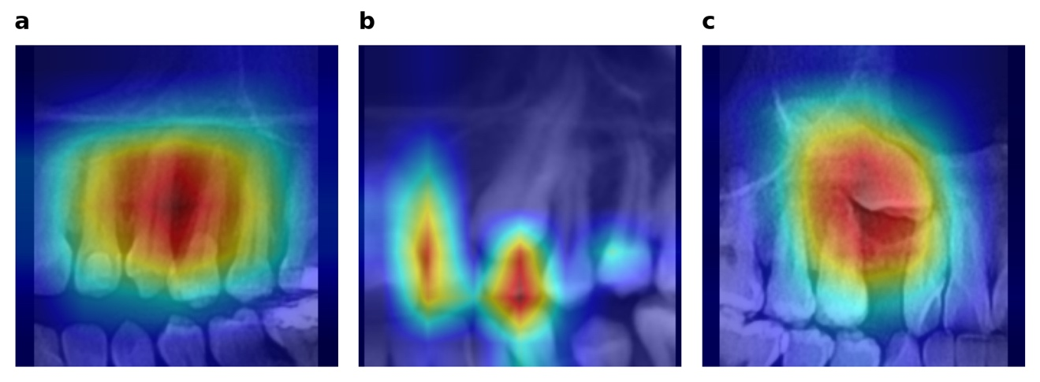
Fig. S5. Grad-CAM attention maps for the panoramic images of the three representative teeth shown in Figure 2. (a) Normal eruption (P056, tooth #11); (b) Mild impaction (P077, tooth #11); (c) Severe impaction (P043, tooth #6).

