Supplementary Information
Supplementary Information 1. Table of all primers used in the current work for assessment of viral infections from submitted samples. All relevant primer information was derived from West et al. (2026).
Primer Name | Sequence (5'-3') | Notes
qPCR
qPCR_TriMV_CP_fwd | AGCTTTCACCACAGGAACAG | New forward primer for TriMV qPCR
qPCR_TriMV_CP_rev | TCGTCATCTCTCCGCAAATTC | New reverse primer for TriMV qPCR
qPCR_WSMV_F4 | CTTTGCGGAAACGCTTACAG | New forward primer for WSMV qPCR
qPCR_WSMV_R4 | CTCTCGCTTCCCTTGGTATTC | New reverse primer for WSMV qPCR
Multiplex PCR
WSMV_multiplex_F | CTTTGCGGAAACGCTTACAG | Forward primer to amplify WSMV in multiplex diagnostic assays (same sequence as qPCR_WSMV_F4)
WSMV_multiplex_R | GCTAGCATTGAATCCTGCAAAT | Reverse primer to amplify WSMV in multiplex diagnostic assays
TriMV_CP_fullF | TCTGGTGCTGATCAATCTGG | Forward primer to amplify TriMV in multiplex diagnostic assays
TriMV_CP_fullR | CTAACGGGTACCAAACATGG | Reverse primer to amplify TriMV in multiplex diagnostic assays
LAMP Bioassays
WSF3 | GCTTGACGTGACAGAGGATG | Forward outer primer for WSMV LAMP assays.
WSB3 | TGGCTCGAAGTGATGGCT | Backward outer primer for WSMV LAMP assays.
WSLB | GCAAGGACAATGAGCAGCAA | Backward loop primer for WSMV LAMP assays.
WSFIP-T | TGCTCTGTTCTCTGGGCTCGTTTTTTACCTTACTTCCAGGATGGGT | Forward inner primer for WSMV LAMP assays with TTTT linker.
WSBIP-T | TGGCGTGTTGTGAACAATGCAGTTTTCGCAGCTTTGTACATCGGT | Backward inner primer for WSMV LAMP assays with TTTT linker.
Tr123F3 | GTTCCATATTGGATTTATTGGTG | Forward outer primer for TriMV LAMP assays.
Tr123B3 | GTGTCTCATAACCGCTCTA | Backward outer primer for TriMV LAMP assays.
Tr123LF | CGTCCATGATGACAATTTCTTGTG | Forward loop primer for TriMV LAMP assays.
Tr123FIPT | CGCATCGTCTATCGTCATATTAACTTTTTTATAGTAAACTCAGCGAGTGA | Forward inner primer with TTTT linker for TriMV LAMP assays.
Tr123BIPT | AACTTAAATGAAGGAGAGGCACAATTTTGTGTTGGTTTCGCTTCGT | Backward inner primer with TTTT linker for TriMV LAMP assays.

Supplemental Information 2. WSMV and TriMV diagnostic results of virus symptomatic plants, modified from West et al. (2026). All samples were tested using primers listed in Supplemental Information 1. Wheat streak mosaic virus (WSMV) and Triticum mosaic virus (TriMV) assays have been simplified to binomial ratings of present (+) or absent (-).
Year | Date Received | Location | Variety | Result
 |  |  |  | WSMV | TriMV
2021 | 4/6/2021 | Finney County, KS | Guardian | + | +
2021 | 5/3/2021 | Finney County, KS | Guardian | + | +
2021 | 5/13/2021 | Weld County, CO | Langin | + | -
2021 | 5/25/2021 | Kit Carson County, CO | Byrd CL+ | + | -
2021 | 6/8/2021 | Weld County, CO | Unknown | - | -
2021 | 6/8/2021 | Washington County, CO | Unknown | + | -
2021 | 6/11/2021 | Genoa County, CO | Langin | - | -
2021 | 6/11/2021 | Kiowa County, CO | Unknown | + | -
2021 | 6/11/2021 | Weld County, CO | Guardian | + | +
2021 | 6/14/2021 | Sedgwick County, CO | Unknown | + | -
2021 | 6/14/2021 | Phillips County, CO | Unknown | + | -
2021 | 6/14/2021 | Morgan County, CO | Byrd CL+ | + | -
2021 | 6/15/2021 | Weld County, CO | Unknown | + | -
2022 | 4/20/2022 | Sedgwick County, CO | Byrd CL+ | + | +
2022 | 5/26/2022 | Yuma County, CO | Canvas | - | -
2022 | 6/6/2022 | Finney County, KS | Byrd CL+ | + | +
2023 | 6/5/2023 | Prowers County, CO | Brawl CL+ | - | -
2023 | 6/5/2023 | Prowers County, CO | Snowmass 2.0 | - | -
2023 | 6/5/2023 | Prowers County, CO | Amplify SF | + | +
2023 | 6/5/2023 | Prowers County, CO | Kivari AX | - | +
2023 | 6/5/2023 | Prowers County, CO | Guardian | - | -
2023 | 6/5/2023 | Prowers County, CO | Gabriel | - | +
2023 | 6/5/2023 | Prowers County, CO | Kivari AX | + | +
2023 | 6/5/2023 | Weld County, CO | Snowmass 2.0 | - | +
2023 | 6/5/2023 | Weld County, CO | Whistler | - | +
2023 | 6/5/2023 | Weld County, CO | Guardian | - | +
2023 | 6/5/2023 | Weld County, CO | Amplify SF | - | +
2023 | 6/5/2023 | Weld County, CO | Kivari AX | - | +
2023 | 6/6/2023 | Yuma County, CO | Guardian | - | +
2023 | 6/6/2023 | Yuma County, CO | Gabriel | - | +
2023 | 6/6/2023 | Yuma County, CO | Amplify | + | +
2023 | 6/6/2023 | Yuma County, CO | Canvas | + | +
2024 | 4/22/2024 | Washington County, CO | Amplify SF | - | +
2024 | 4/22/2024 | Washington County, CO | Amplify SF | - | +
2024 | 4/22/2024 | Washington County, CO | Amplify SF | - | +
2024 | 4/22/2024 | Washington County, CO | Amplify SF | - | +
2024 | 4/22/2024 | Washington County, CO | Amplify SF | - | +
2024 | 4/22/2024 | Washington County, CO | Amplify SF | - | +
2024 | 4/22/2024 | Washington County, CO | Amplify SF | - | +
2024 | 4/22/2024 | Washington County, CO | Amplify SF | - | +
2024 | 4/29/2024 | Weld County, CO | Canvas | + | +
2024 | 4/29/2024 | Weld County, CO | Canvas | - | +
2024 | 4/29/2024 | Cheyenne County, NE | Amplify SF | + | +
2024 | 4/29/2024 | Cheyenne County, NE | Amplify SF | + | +
2024 | 4/29/2024 | Cheyenne County, NE | Amplify SF | + | +
2024 | 4/29/2024 | Cheyenne County, NE | Amplify SF | + | +
2024 | 4/30/2024 | Washington County, CO | TAM 204 | - | +
2024 | 4/30/2024 | Washington County, CO | TAM 204 | - | +
2024 | 4/30/2024 | Washington County, CO | TAM 204 | - | +
2024 | 4/30/2024 | Washington County, CO | TAM 204 | - | +
2024 | 5/7/2024 | Unknown | SY Monument | - | +
2024 | 5/8/2024 | Sedgwick County, CO | Canvas | + | +
2024 | 5/8/2024 | Sedgwick County, CO | Canvas | - | +
2024 | 5/8/2024 | Logan County, CO | Windham | - | +
2024 | 5/24/2024 | Washington County, CO | Amplify SF | - | +
2024 | 5/24/2024 | Washington County, CO | Canvas | - | +
2024 | 5/24/2024 | Washington County, CO | Gabriel | - | +
2024 | 5/24/2024 | Washington County, CO | Gabriel | + | +
2024 | 5/24/2024 | Washington County, CO | Gabriel | + | +
2025 | 4/30/2025 | Kit Carson County, CO | Sheridan | - | +
2025 | 4/30/2025 | Washington County, CO | Canvas | - | +
2025 | 4/30/2025 | Arapahoe County, CO | Amplify SF | - | +
2025 | 4/30/2025 | Adams County, CO | AP Solid | - | +
2025 | 4/30/2025 | Kit Carson County, CO | AP Solid | + | +
2025 | 4/30/2025 | Adams County, CO | Amplify SF | - | -
2025 | 4/30/2025 | Arapahoe County, CO | AP Solid | - | +
2025 | 4/30/2025 | Yuma County, CO | Whistler | - | +
2025 | 4/30/2025 | Kit Carson County, CO | Kivari AX | + | +
2025 | 4/30/2025 | Kit Carson County, CO | Windom | - | +
2025 | 4/30/2025 | Kit Carson County, CO | Kivari AX | + | +
2025 | 4/30/2025 | Kit Carson County, CO | Guardian | - | +
2025 | 4/30/2025 | Adams County, CO | Canvas | - | +
2025 | 4/30/2025 | Adams County, CO | Sheridan | - | +
2025 | 4/30/2025 | Arapahoe County, CO | Amplify | - | +
2025 | 4/30/2025 | Arapahoe County, CO | Gabriel | - | +
2025 | 5/15/2025 | Weld County, CO | Gabriel | - | +
2025 | 5/15/2025 | Weld County, CO | Snowmass 2.0 | - | +
2025 | 5/15/2025 | Weld County, CO | Canvas | - | +
2025 | 5/15/2025 | Weld County, CO | Windom SF | - | +
2025 | 5/15/2025 | Weld County, CO | Amplify SF | - | +
2025 | 5/15/2025 | Weld County, CO | Guardian | - | +
2025 | 5/15/2025 | Weld County, CO | Gabriel | - | -
2025 | 5/15/2025 | Weld County, CO | Sheridan | - | -
2025 | 5/15/2025 | Washington County, CO | Gabriel | - | -
2025 | 5/15/2025 | Washington County, CO | Gabriel | + | +
2025 | 5/15/2025 | Washington County, CO | Canvas | + | +
2025 | 6/9/2025 | Washington County, CO | Amplify | - | +
2025 | 6/9/2025 | Kiowa County, CO | Langin | - | +
2025 | 6/9/2025 | Weld County, CO | Sheridan | - | +
2025 | 6/9/2025 | Weld County, CO | Canvas | - | +
2025 | 6/9/2025 | Weld County, CO | Amplify | - | +
2025 | 6/9/2025 | Weld County, CO | Gabriel | - | -
2025 | 6/9/2025 | Weld County, CO | Guardian | - | +
2025 | 6/9/2025 | Weld County, CO | Amplify | + | -
2025 | 6/9/2025 | Weld County, CO | Gabriel | - | -
2025 | 6/9/2025 | Weld County, CO | Guardian | - | +
2025 | 6/9/2025 | Weld County, CO | Amplify | - | +
2025 | 6/9/2025 | Weld County, CO | Kivari AX | - | +
2025 | 6/9/2025 | Weld County, CO | Snowmass 2.0 | - | +
2025 | 6/9/2025 | Kiowa County, CO | Amplify | - | +
2025 | 6/9/2025 | Genoa County, CO | Canvas | - | +
2025 | 6/9/2025 | Genoa County, CO | Langin | - | +
2025 | 6/9/2025 | Genoa County, CO | Monarch | - | +
2025 | 6/9/2025 | Genoa County, CO | Gabriel | - | -
2025 | 6/9/2025 | Genoa County, CO | Gabriel | - | -

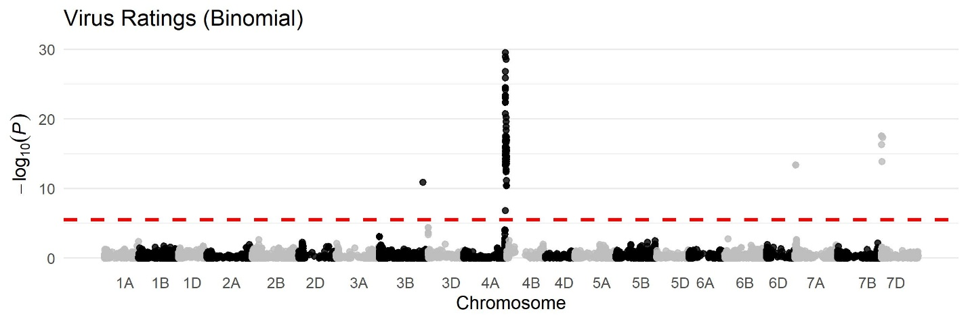
Supplemental Information 3. Manhattan plot of binomial virus visual ratings from the PostDCS GWAS showing significant marker-trait association peaks across the wheat genome. The x-axis indicates chromosome and relative position on each chromosome. The y-axis shows the negative log p-value for each marker assessed. The red dashed line marks the Bonferroni-adjusted significance threshold.

Supplemental Information 4. Representative SNPs defining the proximal, peak, and distal positions of regions identified in PostDCS GWAS for binomial virus ratings taken in Julesburg, Colorado in 2025. For each chromosome, the SNP most proximal to the short‑arm telomere (proximal), the SNP with highest -log(p) value (peak), and the SNP most distal from the short-arm telomere (distal), along with physical position, allele frequency, –log(p), and proportion of phenotypic variance explained are reported. Peak markers are only reported for regions where less than three marker-trait associations were identified.
Chrª | Relative Position^{b} | SNP^{c} | Position (Mbp)^{d} | f^{e} | -Log(p)^{f} | PV^{g}
3B | Peak | S3B_762831893 | 762.8 | 0.25 | 10.9 | 6.97%
4A | Proximal | S4A_731571263 | 731.6 | 0.22 | 14.9 | 9.68%
4A | Peak | S4A_733574833 | 733.6 | 0.28 | 29.5 | 19.81%
4A | Distal | S4A_754074044 | 754.1 | 0.32 | 11.2 | 7.14%
7A | Peak | S7A_11406700 | 11.4 | 0.35 | 13.4 | 8.68%
7D | Proximal | S7D_7952270 | 8.0 | 0.29 | 17.6 | 11.56%
7D | Peak | S7D_7952270 | 8.0 | 0.29 | 17.6 | 11.56%
7D | Distal | S7D_23280506 | 23.3 | 0.28 | 17.4 | 11.39%
Legend: ª Chromosome, ^{b} position relative to the distal telomere of the short arm, ^{c} single nucleotide polymorphism, ^{d} position in mega-basepairs from the distal telomere of the short arm, ^{e} frequency of the minor allele, ^{f} negative log₁₀ of estimated p-value, ^{g} percent accounted for of the total variance.
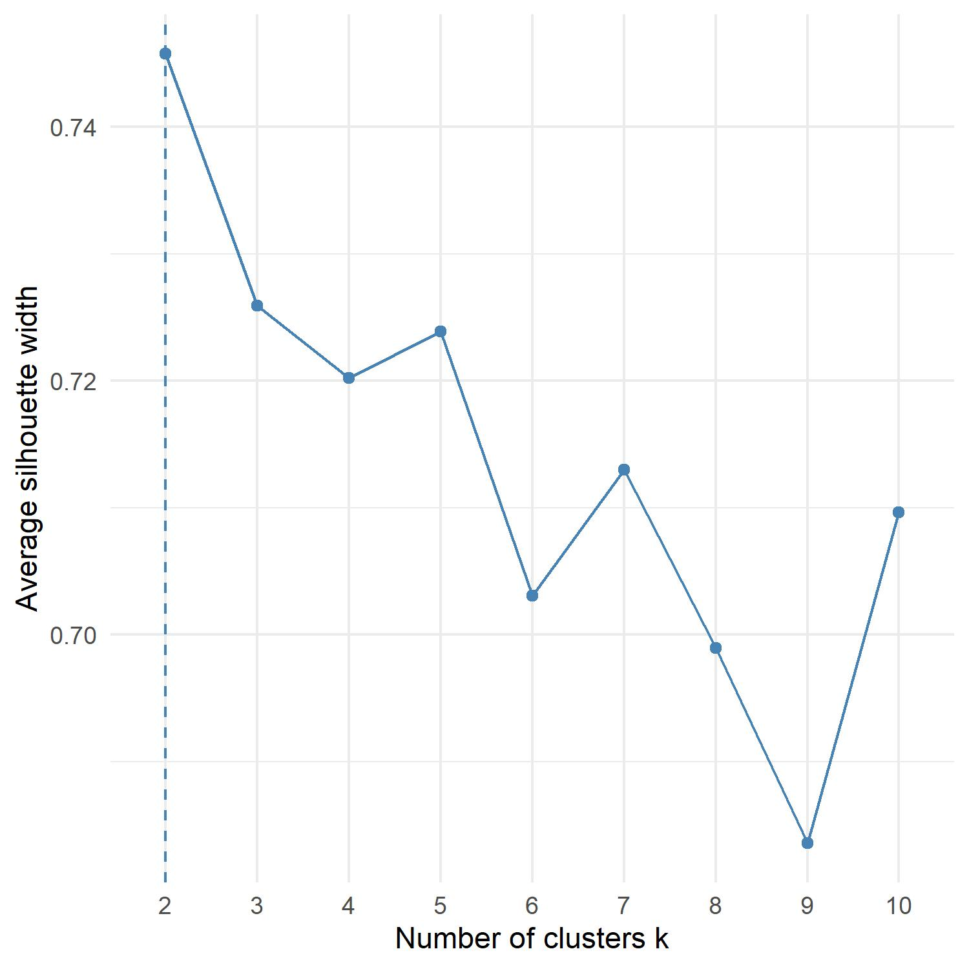
Supplementary Information 5. Silhouette analysis of the 4AL region. Silhouette analysis was conducted from $\{k|2≤k≤10\}$. The maximum achieved average silhouette width was observed at $k=2$.

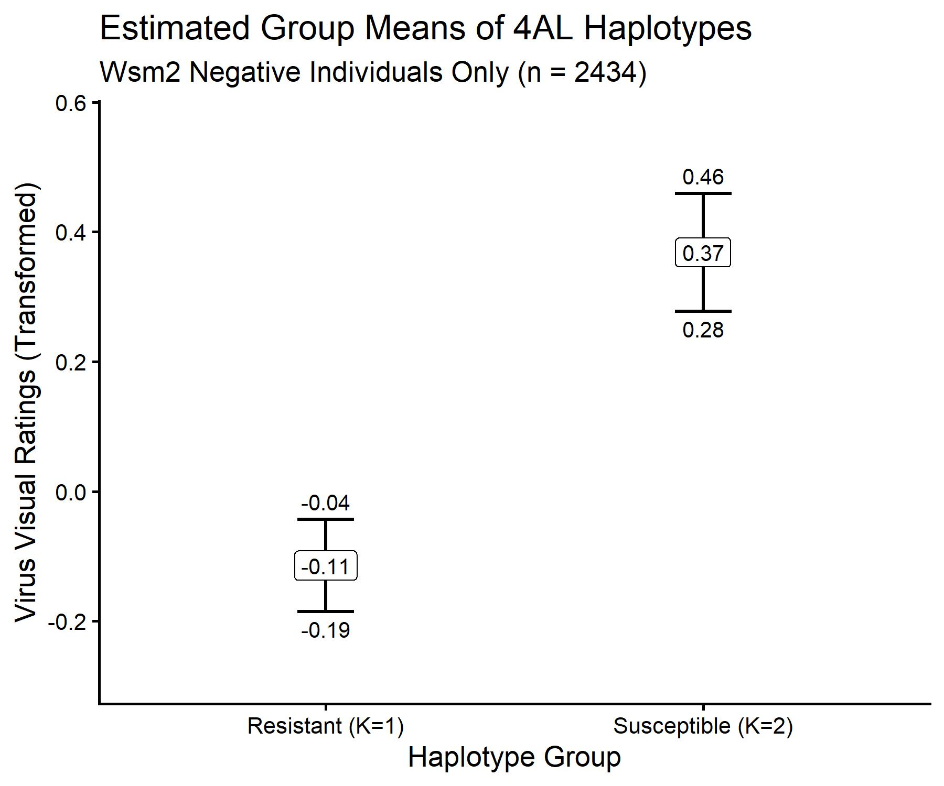
Supplemental Information 6. Group BLUEs for the resulting haplotype groups in PostDCS lines negative for Wsm2, with haplotype group on the x axis and transformed virus visual rating on the y axis. The value at each point is the point estimate of the haplotype group mean, and the values just outside each bar give the point estimates of the lower and upper bounds of a 95% confidence interval.

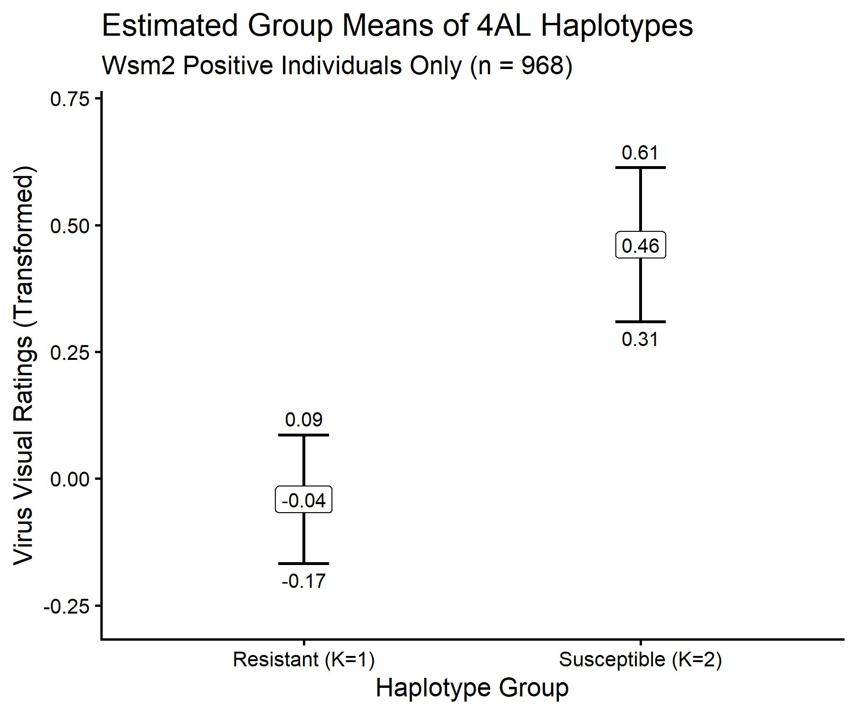
Supplemental Information 7. Group BLUEs for the resulting haplotype groups in PostDCS lines positive for Wsm2, with haplotype group on the x axis and transformed virus visual rating on the y axis. The value at each point is the point estimate of the haplotype group mean, and the values just outside each bar give the point estimates of the lower and upper bounds of a 95% confidence interval.

