Online Resource 7 Box blots for the association between ΔCt for miRNAs and ALS phenotype (bulbar/spinal).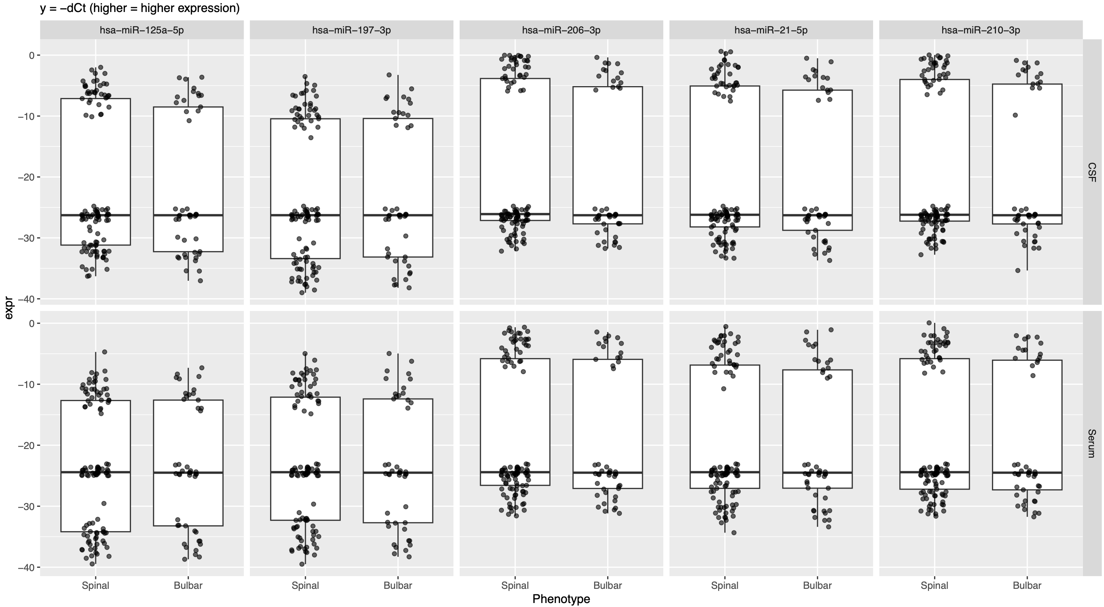

Online Resource 8 Hallmark GSEA of predicted miRNA targets (FDR<0.05). In both contrasts, the only significant term is HALLMARK_UV_RESPONSE_DN with positive NES, indicating a stable cellular stress-response signature in ALS.

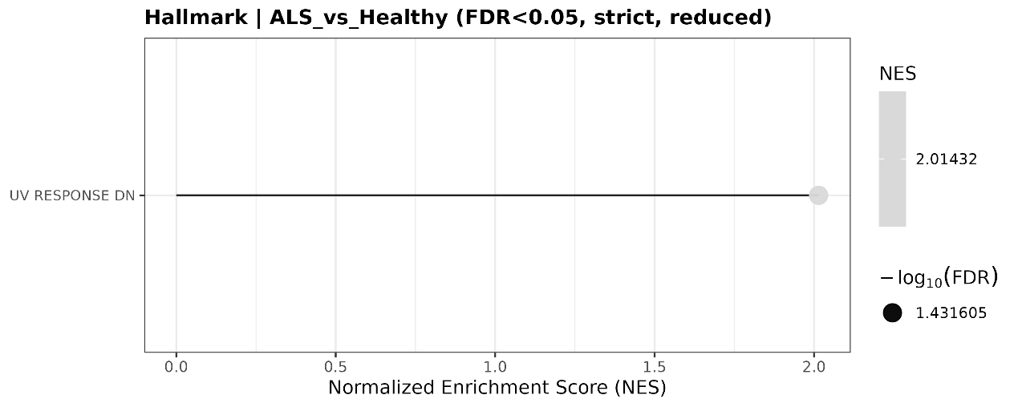
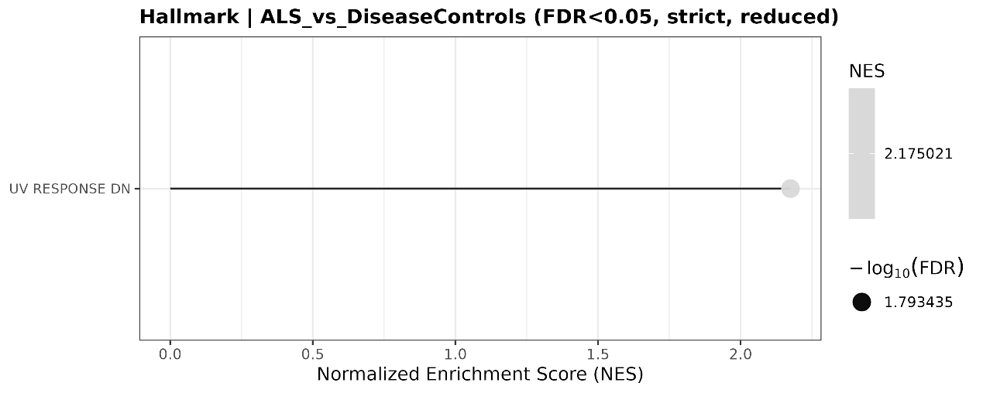

Online Resource 9 Chord plot, GO BP GSEA of predicted miRNA targets in ALS vs disease-controls (FDR<0.05). Results show strong signals in genes related to tissue morphogenesis, development-related processes (skeletal system development, heart-valve development), regulation of muscle differentiation and nucleobase-containing compound catabolic process.

