Online Resource 2 (CSF) Violin plots showing the distributions of ΔCt values in CSF for ALS and disease-controls by miRNA. Lower ΔCt corresponds to higher expression. The label of each panel reports FDR and log2FC (= −ΔΔCt) (and, where available, the AUC from the corresponding classification analysis).

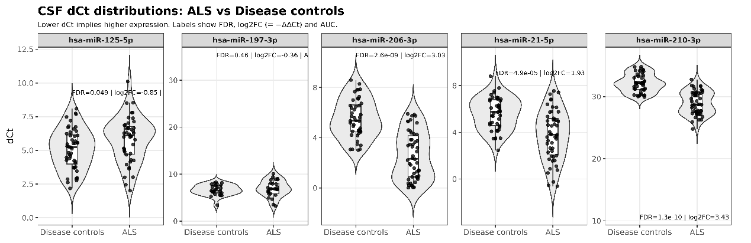

Online Resource 3 (Serum) Violin plots showing the ΔCt distributions for ALS and healthy controls by miRNA (serum). Labels include FDR and log2FC (= −ΔΔCt).

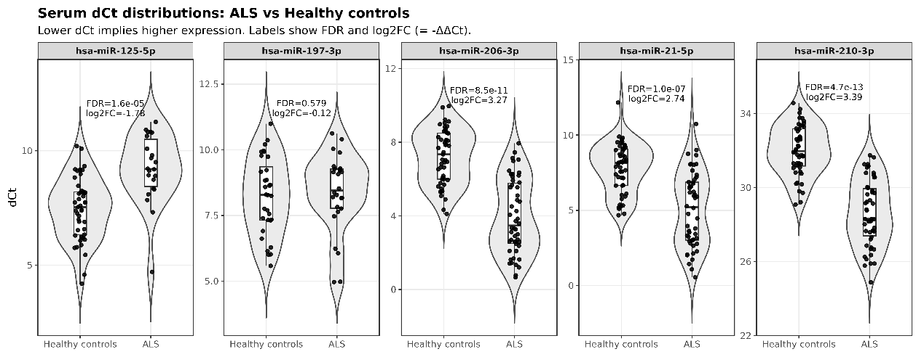

Online Resource 4 (Serum) Violin plots showing the ΔCt distributions for ALS and disease-controls by miRNA (serum). Labels include FDR and log2FC (= −ΔΔCt).

