Supplementary Information
Using Cellulose Nanofibers as the Sole Binder for Cement-Free Construction Materials
Małgorzata Szafraniec^{1,*}, Linfei Li², Eric N. Landis³
¹ Lublin University of Technology, Department of General Construction, Lublin, 20-618, Poland
² Florida International University, Department of Civil & Environmental Engineering, Miami, 33178, USA
³University of Maine, Department of Civil and Environmental Engineering, Orono, ME 04469-5711, USA

*m.szafraniec@pollub.pl

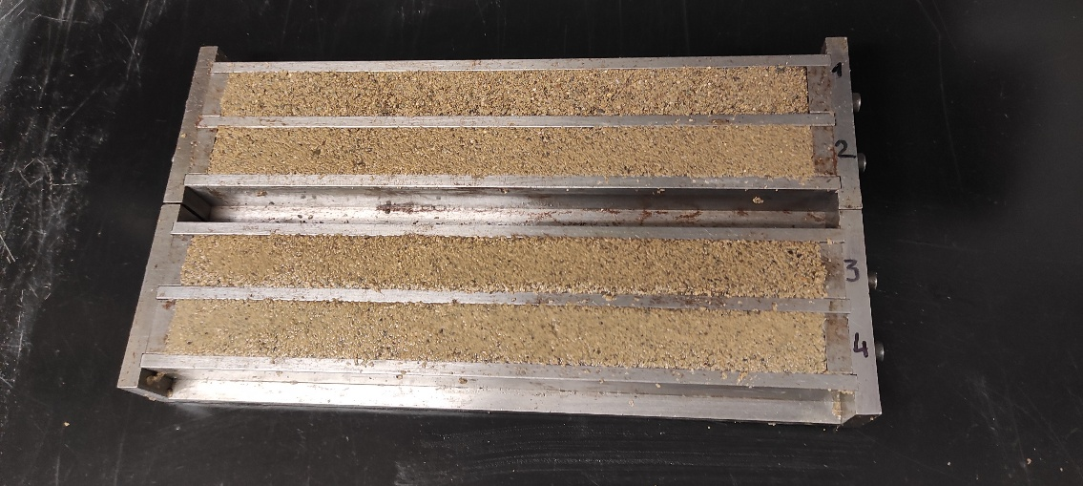
Supplementary Figure S1. Specimens during preparation. Four molds (285 × 25 × 25 mm) after filling, prior to oven-drying at 60°C.

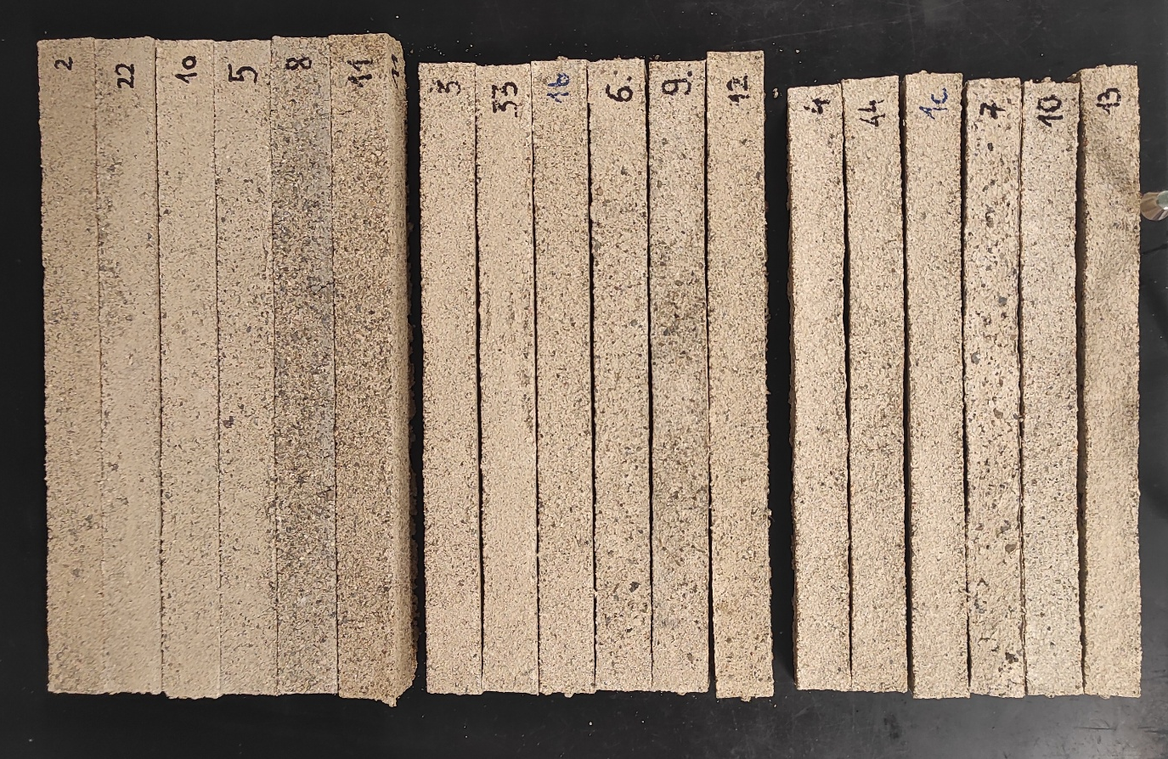
Supplementary Figure S2. Demoulded specimens after drying. All 18 specimen types arranged by CNF solids group. Shrinkage increases with CNF content.

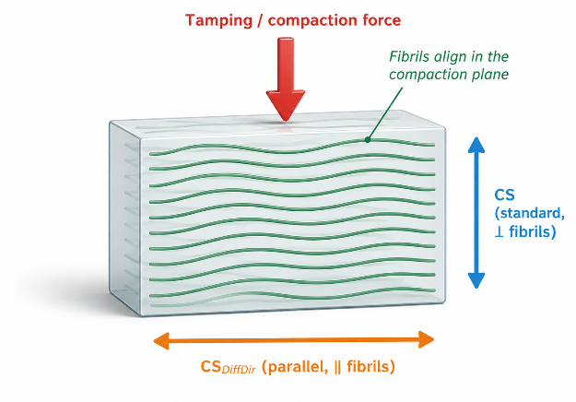
(a)
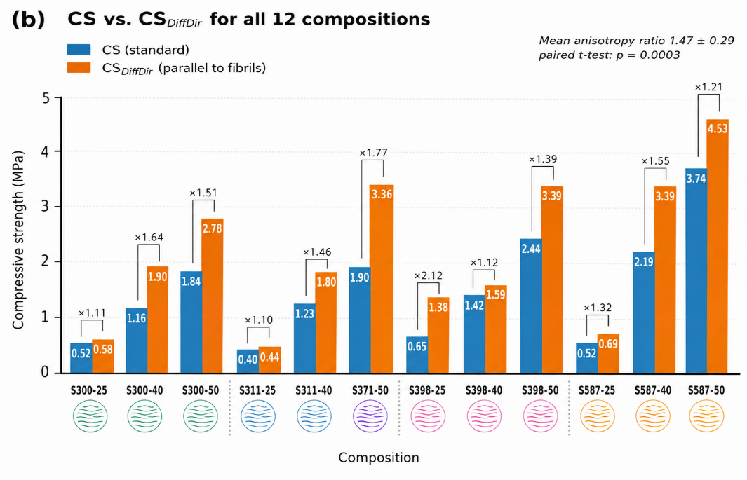
(b)
Supplementary Figure S3. Mechanical anisotropy. (a) Schematic of compaction and expected fibril alignment. (b) Bar chart comparing CS (standard, perpendicular to compaction) and CS_{DiffDir} (parallel to compaction) for all 12 compositions with anisotropy ratios annotated.

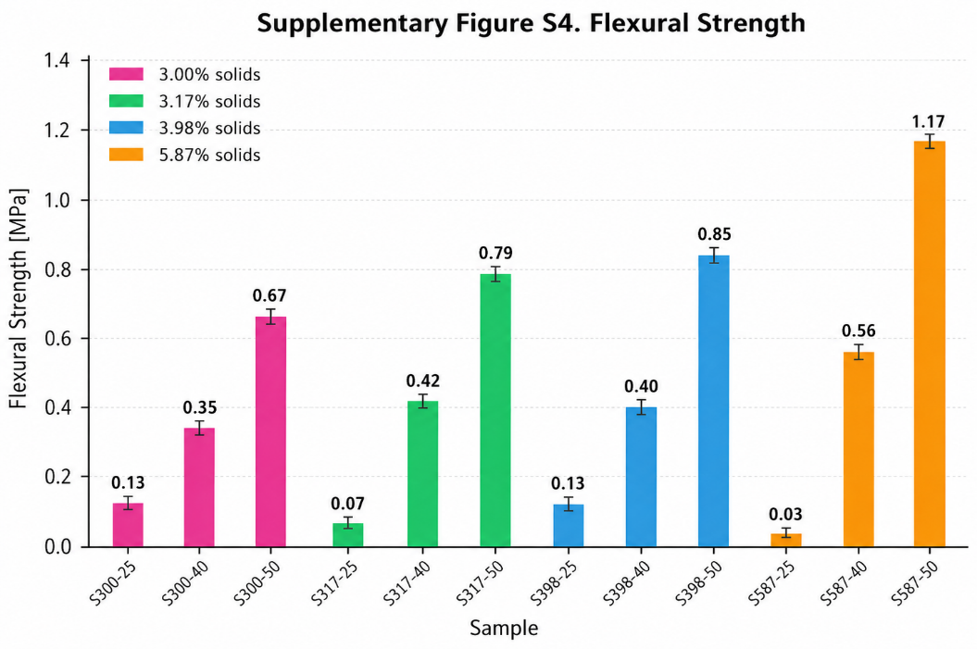
Supplementary Figure S4. Flexural strength (FS) of all 12 primary compositions. n = 1 per composition. Colours as in Figure 1. Range: 0.03 MPa (S587-25) to 1.17 MPa (S587-50).

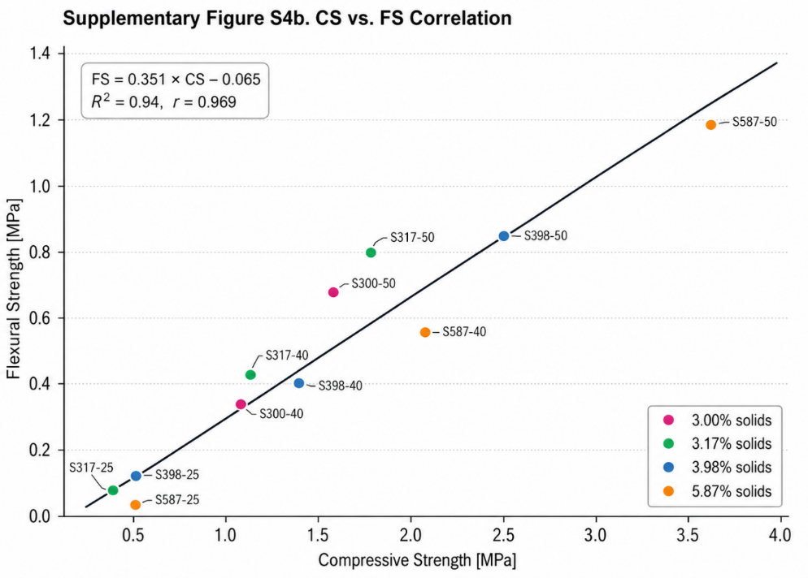
Supplementary Figure S5. CS vs. FS correlation. Linear fit: FS = 0.351 × CS – 0.065; R2 = 0.94, r = 0.969, p < 0.001. Points coloured as in Figure 1.

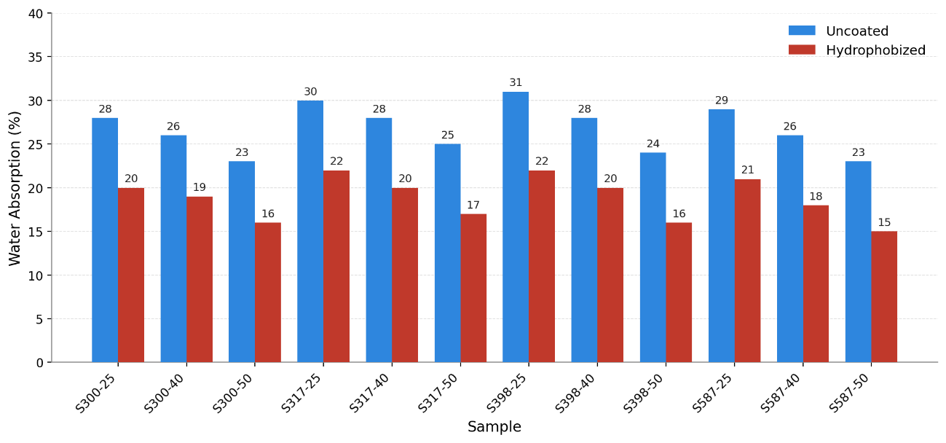
Supplementary Figure S6. Water absorption (WA) of all 12 primary compositions before (uncoated) and after hydrophobic treatment. Blue bars: uncoated specimens; red bars: after hydrophobic treatment (RAIN GUARD Eco-Pod). Values are percentage mass gain after 24 h water immersion.

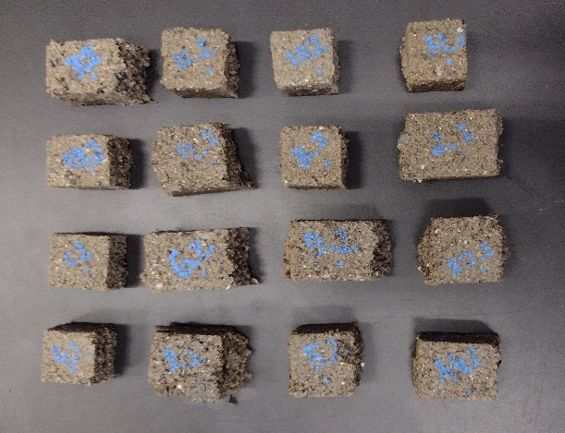
Supplementary Figure S7. Photograph of compression test cubes (~25 × 25 × 25 mm) cut from beams, labeled by composition.

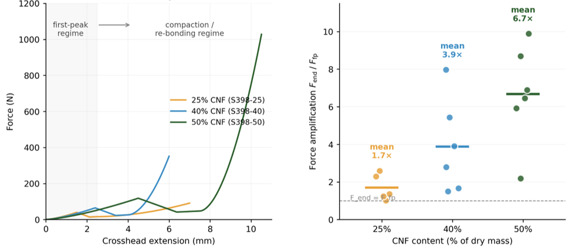
Supplementary Figure S8. Post-peak ductility under wet conditions (WA+CS₂). (a) Representative force-extension curves for three CNF contents (S398-25, S398-40, S398-50). All specimens were saturated by the WA protocol prior to compression and loaded continuously past the first peak up to a 17 mm crosshead extension. After the initial peak, force decreased briefly and then rose monotonically as the specimens compacted (re-bonding regime). (b) End-of-test force amplification F_{end}/F_{fp} for all 17 specimens, grouped by CNF content. Horizontal bars: group means. Dashed line at unity marks the threshold above which post-peak resistance exceeds the first peak.

Supplementary Table S1. Compression test protocols. Summary of the six loading protocols applied to the CNF-sand specimens. n gives the number of specimens per composition.
Protocol | Condition | Loading endpoint | n
Dry CS | Oven-dried, ambient | First peak | 3
CS_{DiffDir} | Dry, loaded parallel to tamping | First peak | 3
WA+CS | Water-saturated | First peak | 2
WA+Oven_{CS} | Saturated, then re-dried (oven) | First peak | 2
H+WA+Oven_{CS} | Hydrophobized, saturated, re-dried | First peak | 2
WA+CS₂ | Water-saturated (extended) | 17 mm crosshead extension | 17 total

Supplementary Table S2. Dimensional shrinkage after drying. Average linear shrinkage of demoulded specimens relative to mould dimensions, by CNF content. Values are means across compositions in each group.
CNF content | Length reduction (%) | Width reduction (%) | Height reduction (%)
25% | 1.3 | – | –
40% | 6.7 | 6.0 | 7.3
50% | 12.0 | 11.3 | 10.7

Supplementary Table S3. Fine-sand and replicate variants. Compressive strength of the fine-sand (suffix F) and replicate (suffix R) specimens, excluded from the primary factorial analysis. Reference CS values are the corresponding primary (coarse-sand) compositions from Table 2. Differences were not significant (two-sample t-tests).
Composition | Variant | Variant CS (MPa) | Primary CS (MPa) | Difference | p
S317-25F | Fine sand (0–2 mm) | 0.61 | 0.42 | +45.2% | 0.097–0.358
S317-40F | Fine sand (0–2 mm) | 1.27 | 1.23 | +3.3%
S317-50F | Fine sand (0–2 mm) | 2.06 | 1.92 | +7.3%
S317-25R | Replicate | 0.68 | 0.42 | significant | 0.018
S317-40R | Replicate | 1.05 | 1.23 | −14.6% | 0.39
S317-50R | Replicate | 1.77 | 1.92 | −7.8% | 0.34

Supplementary Table S4. Raw WA+CS₂ dataset for all 17 saturated specimens. WA = water absorption at start of test; F_{fp} = first-peak force; CS_{fp} = first-peak compressive strength on the initial cross-section; ε_{onset} = compaction strain at the onset of the rising regime; ε_{end} = compaction strain at the end of the test; F_{end} = force at the end of the test; F_{end}/F_{fp} = post-peak force amplification. Sample S587-25 (no. 8) disintegrated during the WA+CS₂ test and is omitted from this dataset; it remains intact under the dry CS protocol (Table 2).
Sample | WA [%] | F_{fp} [N] | CS_{fp} [MPa] | ε_{onset} [%] | ε_{end} [%] | F_{end} [N] | F_{end} / F_{fp}
S300-25 | 23 | 27.0 | 0.05 | 42 | 58 | 70 | 2.6
S300-40 | 29 | 24.6 | 0.08 | 47 | 53 | 196 | 8.0
S300-50 | 28 | 35.3 | 0.10 | 48 | 52 | 349 | 9.9
S317-25 | 25 | 37.1 | 0.04 | 45 | 55 | 50 | 1.3
S317-40 | 28 | 41.5 | 0.08 | 49 | 51 | 162 | 3.9
S317-50 | 30 | 59.2 | 0.15 | 36 | 64 | 350 | 5.9
S317-25R | 24 | 35.8 | 0.05 | 41 | 59 | 36 | 1.0
S317-40R | 30 | 38.3 | 0.07 | 40 | 60 | 107 | 2.8
S317-50R | 28 | 76.5 | 0.13 | 45 | 55 | 527 | 6.9
S317-25F | 23 | 29.0 | 0.05 | 45 | 55 | 36 | 1.2
S317-40F | 29 | 58.8 | 0.09 | 44 | 56 | 88 | 1.5
S317-50F | 31 | 52.1 | 0.11 | 46 | 54 | 114 | 2.2
S398-25 | 23 | 39.8 | 0.06 | 40 | 60 | 91 | 2.3
S398-40 | 28 | 64.6 | 0.12 | 48 | 52 | 351 | 5.4
S398-50 | 28 | 118.2 | 0.19 | 48 | 52 | 1028 | 8.7
S587-40 | 29 | 98.8 | 0.18 | 47 | 53 | 164 | 1.7
S587-50 | 28 | 82.4 | 0.17 | 45 | 55 | 532 | 6.5

Supplementary Table S5. Pearson correlation coefficients. Pearson correlation coefficients (r) between the principal measured variables (n = 12 primary compositions). CS = dry compressive strength; FS = flexural strength; WA = water absorption.
Variable pair | r | Interpretation
CS vs. FS | 0.969 | Near-perfect; single load-bearing phase
CS protocols (mutual) | > 0.89 | All compressive protocols intercorrelated
CS vs. CNF_{eff} | 0.928 | Strongest single predictor of strength
CS vs. shrinkage | 0.912 | Shrinkage as proxy for binder content
CS vs. density | −0.768 | Inverse (density-strength paradox)
Weight loss vs. CNF | 0.989 | Drying loss scales with cellulose content
CS vs. WA | 0.333 | Weak; different governing features

