Supplementary Table S1 Primer sequences used for quantitative real-time PCR.
Gene | Forward primer (5' to 3') | Reverse primer (5' to 3')
Rat KLF5 | AGCTCACCTGAGGACTCATA | GTGCGCAGTGCTCAGTTCT
Rat CPT1A | AGGTCTGGCTCTACCACGAT | CTCTGTCCTCCCTTCTCGGA
Rat PPARα | GTCCTCTGGTTGTCCCCTTG | TGGGGAGAGAGGACAGATGG
Rat PGC-1α | TCATTCAGCAGCTGGATGGC | GGGTGTGGTTTGCATGGTTC
Rat GAPDH | GTGGCTGAACCAAGGAG | GGATGCAGGGATGATGTT
Human KLF5 | GGAGAAACGACGCATCCACTAC | GAACCTCCAGTCGCAGCCTTC
Human CPT1A | AGCATATGTATCGCCTCGCC | AGGCTTTTCTTTCCAGCCCA
Human PPARα | GAGAAGCTGTCACCACAGTAGCTT | AAAACGAATCGCGTTGTGTGA
Human PGC-1α | GATGAAGGGTACTTTTCTGCCCC | GCTGATGCTGCTTGCACAAA
Human GAPDH | CACCCACTCCTCCACCTTTG | CCACCACCCTGTTGCTGTAG

Supplementary Table S2 Inclusion and Exclusion Criteria
- Inclusion criteria
No. Inclusion criteria
1 | Age ≥ 18 years.
2 | For the SA-AKI group: diagnosed with sepsis according to the Sepsis-3 criteria at enrollment, and developed acute kidney injury meeting the KDIGO diagnostic criteria within 7 days of sepsis onset; for the control group: concurrent hospitalized patients without sepsis and without acute kidney injury, with normal baseline renal function.
3 | Sufficient serum samples available for KLF5 concentration detection.
4 | Written informed consent obtained from the patient or a legally authorized representative, as required by the ethics committee.
5 | Complete renal biochemical indices available, including serum creatinine (Scr) and blood urea nitrogen (BUN), to support the calculation of estimated glomerular filtration rate (eGFR).
- Exclusion criteria
No. Exclusion criteria Definition / details
1 | Baseline chronic kidney disease | Defined as a baseline estimated glomerular filtration rate < 60 mL/min/1.73 m² calculated using the CKD-EPI equation, or a known history of chronic kidney disease, particularly stage 3 or higher.
2 | Pre-existing AKI before enrollment | Patients were excluded if they already fulfilled the KDIGO diagnostic criteria for AKI at the time of sepsis diagnosis (T0), including an increase in serum creatinine of ≥ 0.3 mg/dL (equivalent to 26.5 μmol/L) from the known baseline value; an increase in serum creatinine to ≥ 1.5 times the baseline value; or urine output < 0.5 mL/kg/h for 6 h.
3 | Other definite non-sepsis-related causes of AKI | Patients were excluded if AKI was considered to be primarily caused by conditions other than sepsis, including obvious prerenal factors before or at enrollment (such as severe dehydration or cardiogenic shock); postrenal obstruction; clear nephrotoxic exposure 4(such as recent high-dose contrast medium, aminoglycoside antibiotics, or chemotherapeutic agents); or acute exacerbation of primary renal diseases (such as glomerulonephritis, vasculitis, or thrombotic microangiopathy).
4 | Recent nephrotoxic drug exposure or acute kidney disease | Patients with a history of nephrotoxic drug exposure within 1 week before enrollment, or acute kidney diseases such as acute tubular necrosis, were excluded.
5 | Severe comorbidities or confirmed hereditary diseases | Patients with congenital or acquired severe disability, confirmed hereditary disease, or major systemic diseases involving the cardiovascular, endocrine/metabolic, respiratory, digestive, urinary, musculoskeletal, or nervous systems were excluded.
6 | History of organ transplantation | Patients with a previous history of kidney transplantation or other solid-organ transplantation were excluded.
7 | Pregnancy or lactation | Pregnant or lactating women were excluded.
8 | Inability to obtain informed consent | Patients were excluded if written informed consent could not be obtained from the patient or a legally authorized representative, when required.
9 | Other unsuitable conditions | Patients were excluded if the investigators judged that they were unsuitable for participation for any other reason.

Supplementary Figure S1 Selection of LPS for cell-treatment experiments.
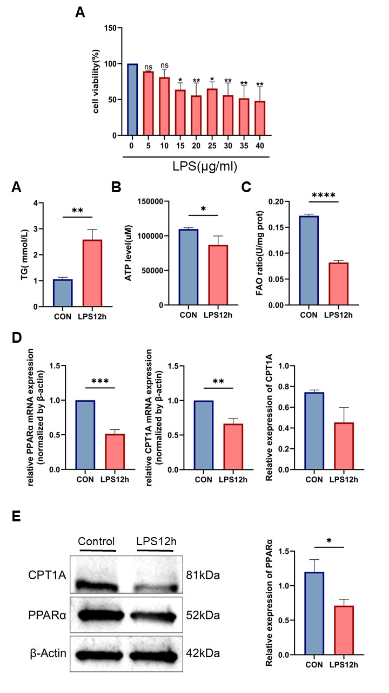
A.Cell viability after treatment with increasing LPS concentrations. ***P＜0.001
Supplementary Figure S2 FAO Function is Severely Impaired in HK-2 Cells.
A. The triglyceride (TG) contents of HK-2 cells. B. Intracellular ATP level test for HK-2 cells. C. Determination of cellular fatty-acid oxidation (FAO) rate. D. qRT-PCR detection for the mRNA expression of PPARα and CPT1A. E. Protein levels of CPT1A and PPARα detected by Western blot.Data are presented as mean ± SEM of no fewer than three independent biological replicates. *P < 0.05, **P < 0.01, ***P < 0.001, ****P < 0.0001

