Supplementary materials

Analytical method
For sample preparation, wastewater samples of 50 mL were centrifuged (4654× g, 30 min, 4 ◦C). The supernatant was concentrated by ultrafiltration Centricon Plus-70 Centrifugal filters (100 kDa and 30 kDa; 1500× g, 35 min, 4 ◦C) and immediately proceeded to viral RNA extraction using the Maxwell® RSC PureFood GMO and Authentication Kit (Promega, Madison, WI, USA). For quantification, the eluted RNA was used for a one-step reverse transcription digital PCR. 10 μL of purified RNA was used as template for each reaction. For SARS-CoV-2 and PMMoV, reverse transcription was performed at 50°C for 40 min, followed by enzyme activation at 95°C for 2 min, and 45 amplification cycles consisting of 95°C for 5 s and 60°C for 30 s. For influenza viruses and RSV, the same cycling conditions were applied, except that the annealing/extension step was performed at 55°C for 30 s instead of 60°C. Primers, probes and sequences used are summarized in the supplementary material table S1.
Regarding limits of detection (LOD) and limits of quantification (LOQ), the following RNA reference materials was used: EURM-019 SARS-CoV-2 RNA (European Commission Joint Research Centre, Certified Reference Materials Catalogue) and AmpliRun® Influenza and RSV RNA Controls (Vircell, Spain). LOD and LOQ values were estimated using the R scripts developed by Merkes et al. [25].
Table S1: Target, primer, probes, final concentration (final cc.) and sequenced used in the analytical method.
Target | Primer/probe | Final cc. | Sequence (5’ – 3’) | Ref
Influenza A¹ | InfA-F | 400 nM | GACCRATCCTGTCACCTCTGAC | A
 | InfA-R | 400 nM | AGGGCATTYTGGACAAAKCGTCTA | A
 | InfA-P | 250 nM | 6-FAM/TGCAGTCCTCGCTCACTGGGCACG/ZEN/IB®FQ | A
Influenza B² | InfB-F | 400 nM | AAATACGGTGGATTAAATAAAAGCAA | B
 | InfB-R | 400 nM | CCAGCAATAGCTCCGAAGAAA | B
 | InfB-P | 250 nM | HEX/CACCCATATTGGGCAATTTCCTATGGC/ZEN/IB®FQ | B
RSV A³ | RSVQA1 | 400 nM | GCTCTTAGCAAAGTCAAGTTGAATGA | C
 | RSVQA2 | 400 nM | TGCTCCGTTGGATGGTGTATT | C
 | RSVQA | 250 nM | Cy5/ACACTCAACAAAGATCAACTTCTGTCATCCAGC/TAO/IB®RQ | C
RSV B⁴ | RSVQB1 | 400 nM | GATGGCTCTTAGCAAAGTCAAGTTAA | D
 | RSVQB2 | 400 nM | TGTCAATATTATCTCCTGTACTACGTTGAA | D
 | RSVQB | 250 nM | ROX/TGATACATTAAATAAGGATCAGCTGCTGTCATCCA/IB®RQ | D
SARS-CoV2 (N2) | nCoV_N2-F | 800 nM | TTACAAACATTGGCCGCAAA | E
 | nCoV_N2-R | 800 nM | GCGCGACATTCCGAAGAA | E
 | nCoV_N2-P | 250 nM | ACAATTTGCCCCCAGCGCTTCAG* | E
SARS-CoV2 (E) | E_Sarbeco-F | 800 nM | ACAGGTACGTTAATAGTTAATAGCGT | F
 | E_Sarbeco-R | 800 nM | ATATTGCAGCAGTACGCACACA | F
 | E_Sarbeco-P | 250 nM | ACACTAGCCATCCTTACTGCGCTTCG* | F
Pepper Mild Mottle Virus | PMMV-rev-F | 800 nM | GAGTGGTTTGACCTTAACGTTTGA | G
 | PMMV-R | 800 nM | TTGTCGGTTGCAATGCAAGT | G
 | PMMV-P | 250 nM | CCTACCGAAGCAAATG* | G
A: CDC Realtime RTPCR (rRTPCR) Protocol for Detection and Characterization of Swine Influenza (version 2009);
B: Van Elden LJ, Nijhuis M, Schipper P, Schuurman R, van Loon AM. Simultaneous detection of influenza viruses A and B using real-time quantitative PCR. J Clin Microbiol. 2001 Jan;39(1):196-200;
C: Hu A, Colella M, Tam JS, Rappaport R, Cheng SM. Simultaneous detection, subgrouping, and quantitation of respiratory syncytial virus A and B by real-time PCR. J Clin Microbiol. 2003 Jan;41(1):149-54.;
D: Adapted from Bragstad K, Vinner L, Hansen MS, Nielsen LP, Fomsgaard A. Development of a real-time reverse transcription-PCR assay for the universal detection of human respiratory syncytial virus. Journal of Virological Methods. 2007;146(1–2):22–28;
E: CDC 2019-Novel Coronavirus (2019-NCoV) Real-Time RT-PCR Primers and Probes.
F: Corman V.M., Landt O., Kaiser M., Molenkamp R., Meijer A., Chu D.K., Bleicker T., Brünink S., Schneider J., Schmidt M.L., et al. Detection of 2019 novel coronavirus (2019-nCoV) by real-time RT-PCR. Eurosurveillance. 2020;25:2000045;
G: Zhang T., Breitbart M., Lee W.H., Run J.-Q., Wei C.L., Soh S.W.L., Hibberd M., Liu E.T., Rohwer F., Ruan Y. RNA Viral Community in Human Feces: Prevalence of Plant Pathogenic Viruses. PLoS Biol. 2005;4:e3.

Virus subtypes
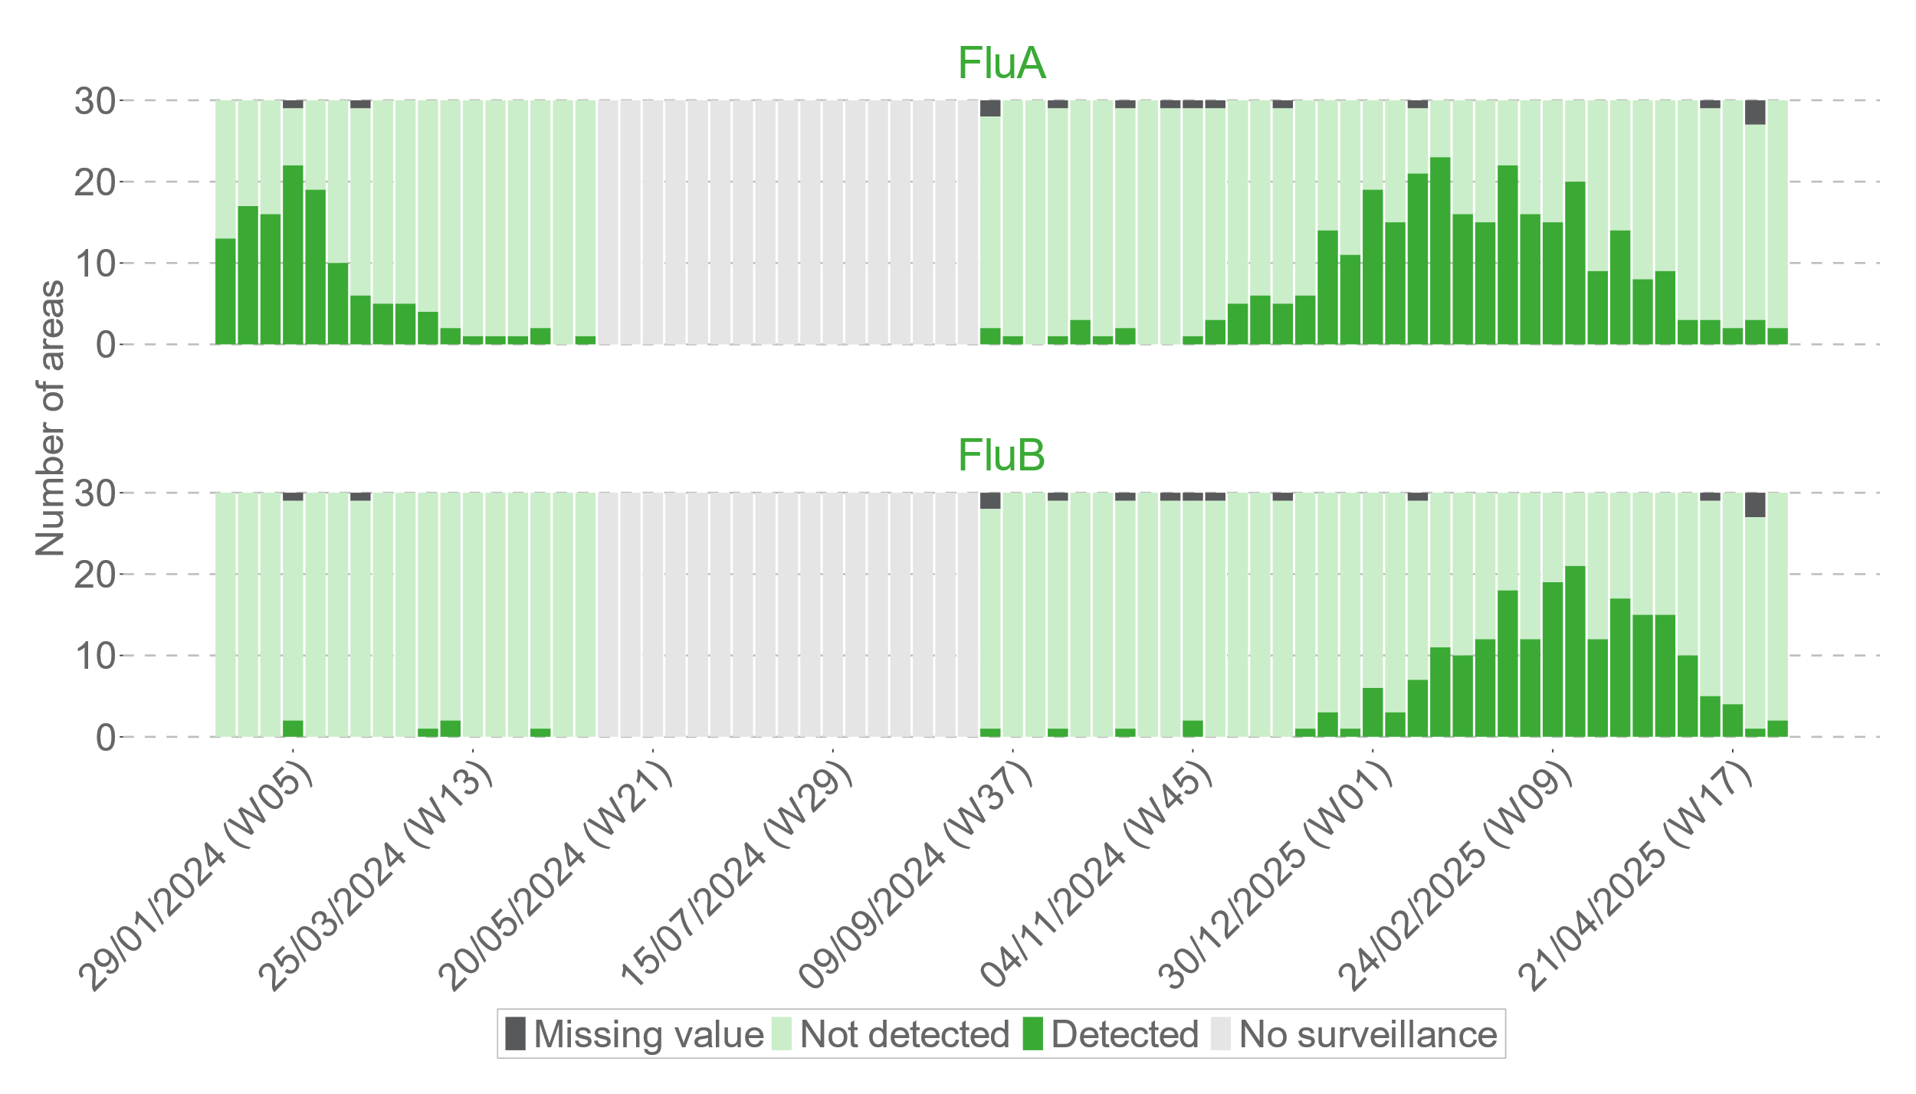
Figure S1: Number of areas with influenza detected (coloured bars), not detected (light coloured bars) and with a missing value (light grey bars). Influenza surveillance is suspended during the summer period (light grey bars).

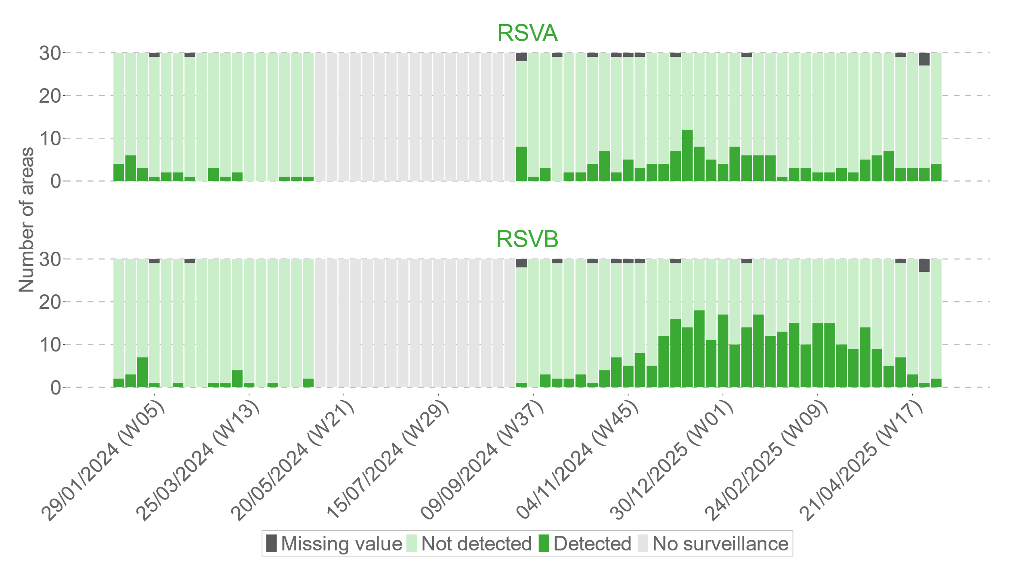
Figure S2: Number of areas with RSV detected (coloured bars), not detected (light coloured bars), and with a missing value (dark grey bars). RSV surveillance is suspended during the summer period (light grey bars).

Regional distribution
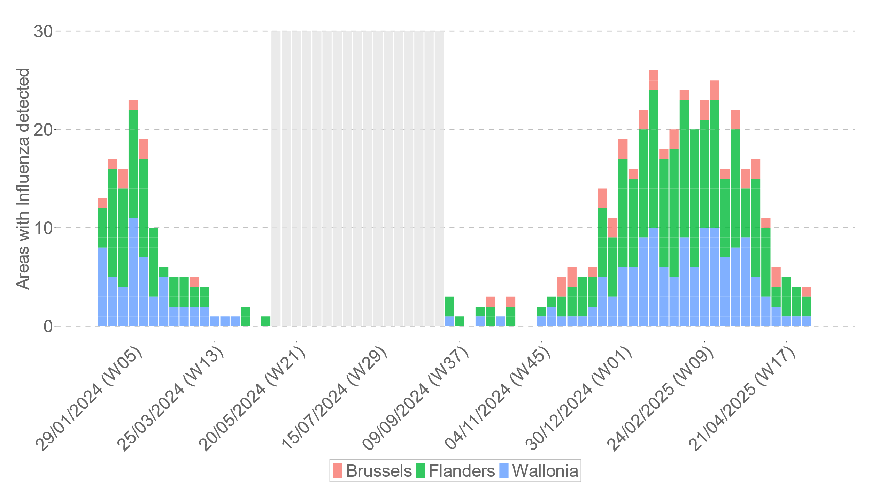
Figure S3: Number of areas with influenza detected in the region of Brussels (red), Flanders (green), and Wallonia (blue). Influenza surveillance is suspended during the summer period (grey).

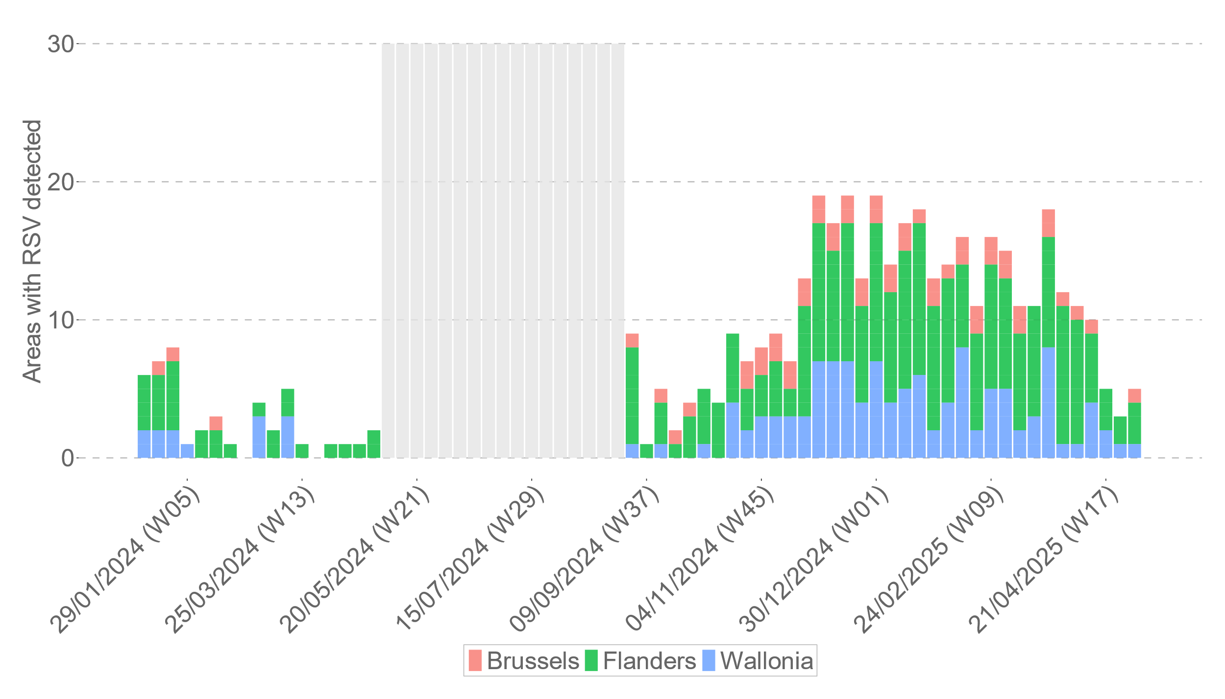
Figure S4: Number of areas with RSV detected in the region of Brussels (red), Flanders (green), and Wallonia (blue). RSV surveillance is suspended during the summer period (grey).

