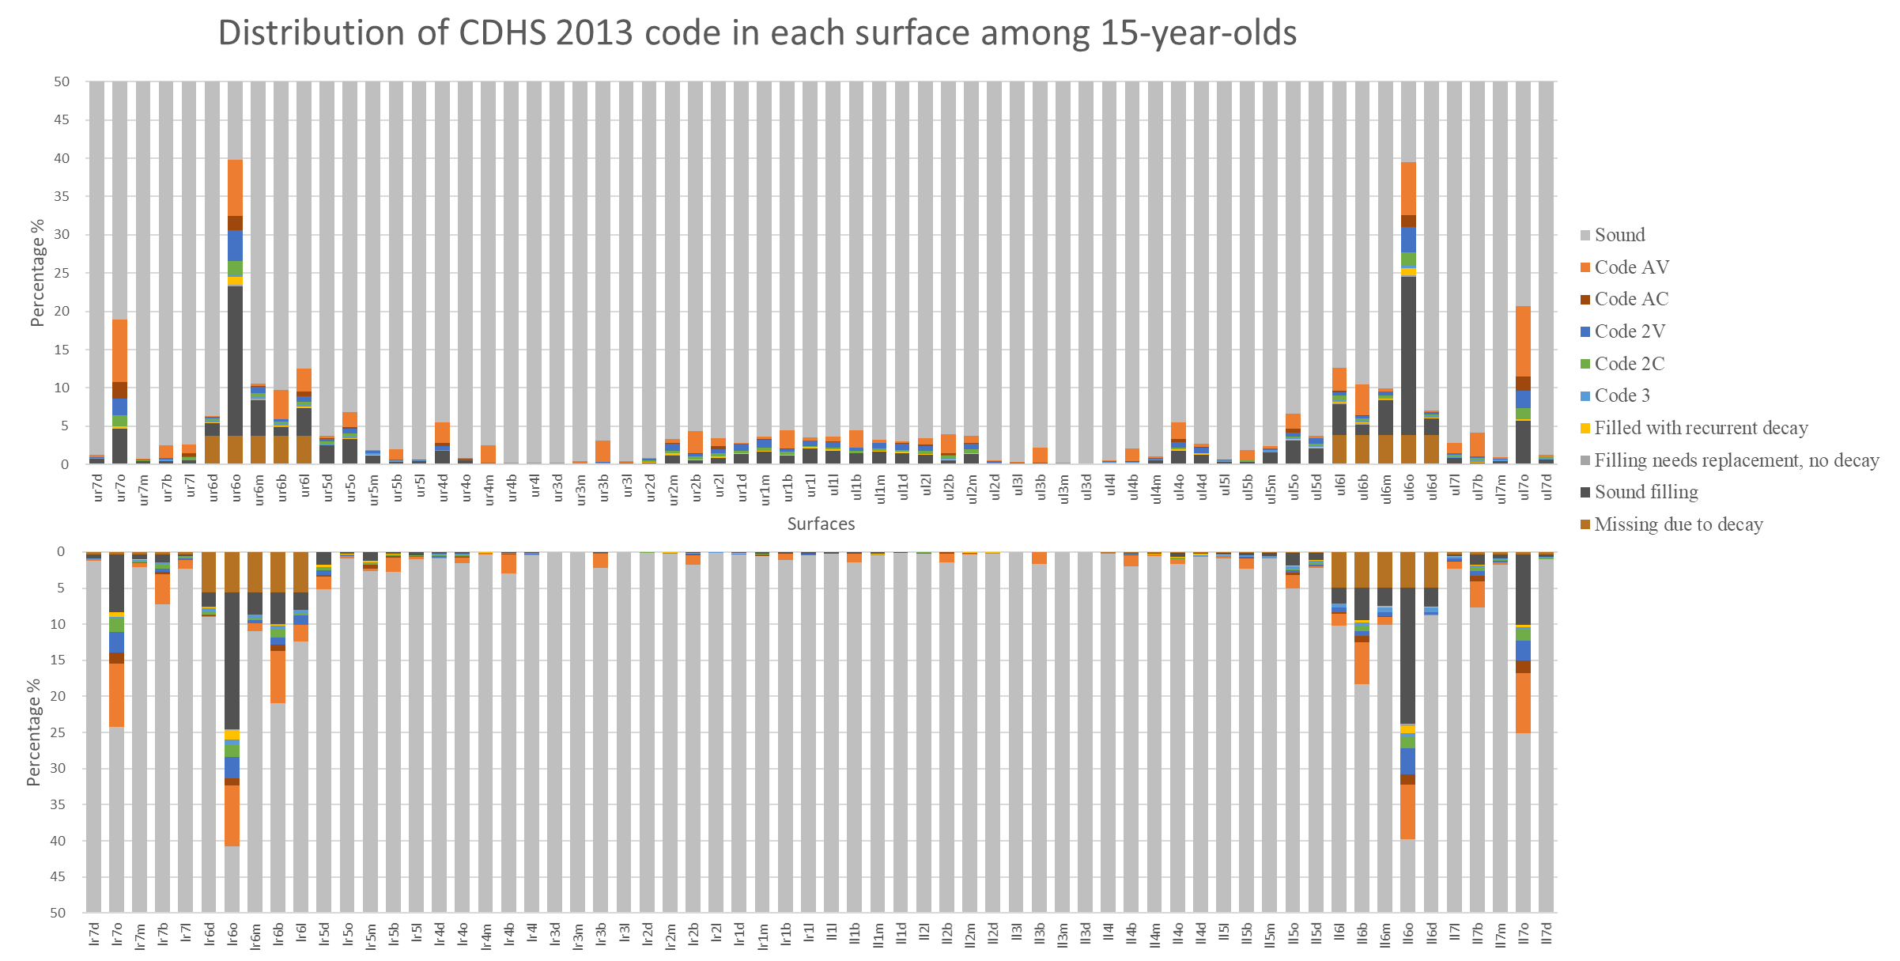
Appendix Figure 2. Distribution of CDHS 2013 code in each surface of 15-year-olds (n = 2,160)

