Supplementary Material
Title: Development and validation of an explainable machine learning model for predicting the risk of depression among nursing interns

Supplementary Tables
Supplementary Table S1. Depression LASSO Regression Analysis Results
Variables | Coefficient
Gender | -0.002
Single-Parent Family | 0.047
Family Relationship | 0.003
Academic Performance | 0.007
Reason for Choosing Nursing Profession | 0.008
History of Mental Illness | 0.211
Family History of Mental Illness | 0.001
Stress Level | 0.112
Social Support | -0.010
Sleep Disorder | 0.182

Supplementary Table S2. Analysis of Multicollinearity
Variables | Tolerance | VIF
Gender | 0.920 | 1.087
Single-Parent Family | 0.924 | 1.083
Family Relationship | 0.908 | 1.102
Academic Performance | 0.938 | 1.066
Reason for Choosing Nursing Profession | 0.941 | 1.063
History of Mental Illness | 0.926 | 1.079
Family History of Mental Illness | 0.925 | 1.081
Stress Level | 0.94 | 1.064
Social Support | 0.943 | 1.060
Sleep Disorder | 0.908 | 1.102
VIF:variance inflation factor and tolerance

Supplementary Table S3. Multivariate logistic regression analysis of risk of depression among intern nursing students.
Variable | Category | β | SE | Wald χ² | P | OR (95% CI)
Single parent family | No | Reference
 | Yes | 0.918 | 0.341 | 7.237 | 0.007 | 2.505(1.261–4.838)
Academic performance | Good | Reference
 | Average | 0.256 | 0.286 | 0.797 | 0.372 | 1.291(0.745–2.300)
 | Poor | 1.592 | 0.666 | 5.710 | 0.017 | 4.911(1.251–17.662)
History of mental illness | No | Reference
 | Yes | 1.908 | 0.458 | 17.329 | <0.001 | 6.740 (2.732–16.636)
Stress level | Low | Reference
 | Moderate | 1.202 | 0.291 | 17.016 | <0.001 | 3.326 (1.870–5.876)
 | High | 2.048 | 0.421 | 23.678 | <0.001 | 7.755 (3.378–17.729)
Social support | Low | Reference
 | Moderate | -0.994 | 0.452 | 4.831 | 0.028 | 0.370 (0.157–0.938)
 | High | -1.905 | 1.161 | 2.692 | 0.101 | 0.149 (0.007–1.031)
Sleep disorder | No | Reference
 | Yes | 2.139 | 0.272 | 62.007 | <0.001 | 8.492 (5.063–14.751)
OR, odds ratio; CI, confidence interval.

Supplementary Table S4. Optimal hyperparameter values for the machine learning models.
Model | Hyperparameter | Optimal value
SVM | sigma | 0.1
SVM | C | 0.5
GBM | n.trees | 450
GBM | interaction.depth | 5
GBM | shrinkage | 0.1
GBM | n.minobsinnode | 20
NN | size | 10
NN | decay | 0.1
RF | mtry | 2
RF | numRandomCuts | 2
XGBoost | nrounds | 10
XGBoost | max_depth | 5
XGBoost | eta | 0.1
XGBoost | gamma | 0.5
XGBoost | colsample_bytree | 0.5
XGBoost | min_child_weight | 1
XGBoost | subsample | 0.6
SVM:suport vector machine; GBM:gradient boosting machine; NN: neural network; RF:Random forest.

Supplementary Table S5. Comparison of characteristics between training set and internal validation set
Variable | Category | Total Population (n = 1,233) n (%) | Training Set (n = 864) n (%) | Internal Validation Set (n = 369) n (%) | χ2 | P
Depression | No | 1086 (88.1) | 762 (88.2) | 324 (87.8) | 0.009 | 0.922
 | Yes | 147 (11.9) | 102 (11.8) | 45 (12.2)
Nation | Han | 1067 (86.5) | 758 (87.7) | 309 (83.7) | 3.202 | 0.074
 | Ethnic minorities | 166 (13.5) | 106 (12.3) | 60 (16.3)
Gender | Male | 365 (29.6) | 263 (30.4) | 102 (27.6) | 0.992 | 0.319
 | Female | 868 (70.4) | 601 (69.6) | 267 (72.4)
Educational level | Secondary vocational | 15 (1.2) | 12 (1.4) | 3 (0.8) | 0.909 | 0.635
 | Junior college | 1139 (92.4) | 795 (92.0) | 344 (93.2)
 | Bachelor's degree and above | 79 (6.4) | 57 (6.6) | 22 (6.0)
Romantic relationship | No | 837 (67.9) | 584 (67.6) | 253 (68.6) | 0.072 | 0.789
 | Yes | 396 (32.1) | 280 (32.4) | 116 (31.4)
Personality traits | Introverted | 331 (26.8) | 231 (26.7) | 100 (27.1) | 0.514 | 0.773
 | Extroverted | 191 (15.5) | 138 (16.0) | 53 (14.4)
 | Ambiverted | 711 (57.7) | 495 (57.3) | 216 (58.5)
Place of residence | Rural | 932 (75.6) | 655 (75.8) | 277 (75.1) | 0.042 | 0.837
 | Urban | 301 (24.4) | 209 (24.2) | 92 (24.9)
Internship duration | <3 months | 30 (2.4) | 23 (2.7) | 7 (1.9) | 1.572 | 0.456
 | 3–6 months | 250 (20.3) | 181 (20.9) | 69 (18.7)
 | >6 months | 953 (77.3) | 660 (76.4) | 293 (79.4)
Internship Department | Internal medicine | 335 (27.2) | 235 (27.2) | 100 (27.1) | 0.046 | 0.997
 | Surgery | 313 (25.4) | 218 (25.2) | 95 (25.7)
 | Critical care | 133 (10.8) | 93 (10.8) | 40 (10.8)
 | Other | 452 (36.7) | 318 (36.8) | 134 (36.3)
Single-parent family | No | 1103 (89.5) | 770 (89.1) | 333 (90.2) | 0.237 | 0.626
 | Yes | 130 (10.5) | 94 (10.9) | 36 (9.8)
Only-child | No | 1000 (81.1) | 694 (80.3) | 306 (82.9) | 0.979 | 0.322
 | Yes | 233 (18.9) | 170 (19.7) | 63 (17.1)
Perceived family economic level | Low | 21 (1.7) | 11 (1.3) | 10 (2.7) | 4.258 | 0.119
 | Medium | 617 (50.0) | 426 (49.3) | 191 (51.8)
 | High | 595 (48.3) | 427 (49.4) | 168 (45.5)
Father's educational level | Primary school and below | 474 (38.4) | 332 (38.4) | 142 (38.5) | 1.007 | 0.800
 | Junior high school | 507 (41.1) | 350 (40.5) | 157 (42.5)
 | High school/Vocational school | 178 (14.4) | 130 (15.0) | 48 (13.0)
 | Junior college and above | 74 (6.0) | 52 (6.0) | 22 (6.0)
Mother's educational level | Primary school and below | 584 (47.4) | 420 (48.6) | 164 (44.4) | 4.496 | 0.213
 | Junior high school | 437 (35.4) | 290 (33.6) | 147 (39.8)
 | High school/Vocational school | 151 (12.2) | 110 (12.7) | 41 (11.1)
 | Junior college and above | 61 (4.9) | 44 (5.1) | 17 (4.6)
Family harmony | Harmonious | 761 (61.7) | 533 (61.7) | 228 (61.8) | 0.477 | 0.788
 | Average | 419 (34.0) | 296 (34.3) | 123 (33.3)
 | Disharmonious | 53 (4.3) | 35 (4.1) | 18 (4.9)
Parental Child-Rearing Style | Authoritative | 509 (41.3) | 362 (41.9) | 147 (39.8) | 1.188 | 0.756
 | Authoritarian | 170 (13.8) | 120 (13.9) | 50 (13.6)
 | Neglectful | 140 (11.4) | 93 (10.8) | 47 (12.7)
 | Permissive | 414 (33.6) | 289 (33.4) | 125 (33.9)
Drinking | No | 1112 (90.2) | 777 (89.9) | 335 (90.8) | 0.128 | 0.720
 | Yes | 121 (9.8) | 87 (10.1) | 34 (9.2)
Smoking | No | 1076 (87.3) | 748 (86.6) | 328 (88.9) | 1.047 | 0.306
 | Yes | 157 (12.7) | 116 (13.4) | 41 (11.1)
Academic performance | Good | 372 (30.2) | 253 (29.3) | 119 (32.2) | 1.083 | 0.582
 | Average | 833 (67.6) | 591 (68.4) | 242 (65.6)
 | Poor | 28 (2.3) | 20 (2.3) | 8 (2.2)
Class officer | No | 877 (71.1) | 614 (71.1) | 263 (71.3) | 0.000 | 0.996
 | Yes | 356 (28.9) | 250 (28.9) | 106 (28.7)
Reason for Choosing Nursing Profession | Personal preference | 593 (48.1) | 426 (49.3) | 167 (45.3) | 2.114 | 0.549
 | Parental influence | 331 (26.8) | 225 (26.0) | 106 (28.7)
 | Major reassignment | 43 (3.5) | 28 (3.2) | 15 (4.1)
 | Other | 266 (21.6) | 185 (21.4) | 81 (22.0)
History of mental illness | No | 1188 (96.4) | 830 (96.1) | 358 (97.0) | 0.426 | 0.514
 | Yes | 45 (3.6) | 34 (3.9) | 11 (3.0)
Family history of mental illness | No | 1017 (82.5) | 715 (82.8) | 302 (81.8) | 0.092 | 0.761
 | Yes | 216 (17.5) | 149 (17.2) | 67 (18.2)
Stress level | Low | 1014 (82.2) | 712 (82.4) | 302 (81.8) | 0.664 | 0.717
 | Medium | 159 (12.9) | 108 (12.5) | 51 (13.8)
 | High | 60 (4.9) | 44 (5.1) | 16 (4.3)
Social support | Low | 61 (4.9) | 48 (5.6) | 13 (3.5) | 3.677 | 0.159
 | Medium | 1104 (89.5) | 773 (89.5) | 331 (89.7)
 | High | 68 (5.5) | 43 (5.0) | 25 (6.8)
Sleep Disorder | No | 849 (68.9) | 605 (70.0) | 244 (66.1) | 1.655 | 0.198
 | Yes | 384 (31.1) | 259 (30.0) | 125 (33.9)

Supplementary Table S6. Comparison of AUC values of each depression prediction model in the internal validation set based on DeLong test
Model Comparison | Z | P
GBM Model as Reference
GBM vs. LR | 4.471 | < 0.001
GBM vs. SVM | 5.379 | < 0.001
GBM vs. NN | 6.337 | < 0.001
GBM vs. RF | 8.015 | < 0.001
GBM vs. XGBoost | 3.171 | 0.002
LR Model as Reference
LR vs. SVM | 1.432 | 0.152
LR vs. GBM | -4.471 | < 0.001
LR vs. NN | 2.299 | 0.021
LR vs. RF | 4.415 | < 0.001
LR vs. XGBoost | -3.444 | < 0.001
AUC:area under the curve;LR:Logistic regression;SVM:suport vector machine; GBM:gradient boosting machine NN: neural network;RF:Random forest.

Supplementary Table S7. Comparison of baseline characteristics between the modeling set and external validation set of nursing interns
Feature | External Validation Set,  n (%) (n=383) | Modeling Set,  n (%) (n=1233) | χ² | P
Depression
No | 347 (90.6) | 1086 (88.1) | 1.609 | 0.205
Yes | 36 ( 9.4) | 147 (11.9)
Gender
Male | 101 (26.4) | 365 (29.6) | 1.334 | 0.248
Female | 282 (73.6) | 868 (70.4)
Nation
Han | 360 (94.0) | 1067 (86.5) | 15.024 | <0.001
Ethnic minorities | 23 ( 6.0) | 166 (13.5)
Educational Level
Secondary Vocational School | 60 (15.7) | 15 ( 1.2) | 260.586 | <0.001
Junior College | 228 (59.5) | 1139 (92.4)
Bachelor's Degree and Above | 95 (24.8) | 79 ( 6.4)
Romantic Relationship Status
No | 294 (76.8) | 837 (67.9) | 10.550 | 0.001
Yes | 89 (23.2) | 396 (32.1)
Personality Traits
Introverted | 91 (23.8) | 331 (26.8) | 2.196 | 0.334
Extroverted | 55 (14.4) | 191 (15.5)
Ambiverted | 237 (61.9) | 711 (57.7)
Place of Residence
Rural | 238 (62.1) | 932 (75.6) | 25.776 | <0.001
Urban | 145 (37.9) | 301 (24.4)
Internship Duration
<3 months | 302 (78.9) | 30 ( 2.4) | 1047.734 | <0.001
3–6 months | 27 ( 7.0) | 250 (20.3)
>6 months | 54 (14.1) | 953 (77.3)
Internship Department
Internal Medicine | 106 (27.7) | 335 (27.2) | 4.465 | 0.215
Surgery | 115 (30.0) | 313 (25.4)
Critical Care | 33 ( 8.6) | 133 (10.8)
Other | 129 (33.7) | 452 (36.7)
Single-Parent Family
No | 341 (89.0) | 1103 (89.5) | 0.019 | 0.889
Yes | 42 (11.0) | 130 (10.5)
Only Child
No | 302 (78.9) | 1000 (81.1) | 0.808 | 0.369
Yes | 81 (21.1) | 233 (18.9)
Perceived Family Economic Level
Low | 6 ( 1.6) | 21 ( 1.7) | 52.712 | <0.001
Medium | 272 (71.0) | 617 (50.0)
High | 105 (27.4) | 595 (48.3)
Father's Educational Level
Primary School and Below | 97 (25.3) | 474 (38.4) | 27.569 | <0.001
Junior High School | 175 (45.7) | 507 (41.1)
High School/Vocational School | 70 (18.3) | 178 (14.4)
Junior College and Above | 41 (10.7) | 74 ( 6.0)
Mother's Educational Level
Primary School or Below | 127 (33.2) | 584 (47.4) | 24.386 | <0.001
Junior High School | 173 (45.2) | 437 (35.4)
High School/Vocational School | 56 (14.6) | 151 (12.2)
College or Above | 27 ( 7.0) | 61 ( 4.9)
Family Relationship
Harmony | 261 (68.1) | 761 (61.7) | 8.097 | 0.017
Average | 115 (30.0) | 419 (34.0)
Disharmony | 7 ( 1.8) | 53 ( 4.3)
Parental Child-Rearing Style
Authoritative | 190 (49.6) | 509 (41.3) | 10.715 | 0.013
Authoritarian | 39 (10.2) | 170 (13.8)
Neglectful | 47 (12.3) | 140 (11.4)
Permissive | 107 (27.9) | 414 (33.6)
Drinking
No | 364 (95.0) | 1112 (90.2) | 8.094 | 0.004
Yes | 19 ( 5.0) | 121 ( 9.8)
Smoking
No | 352 (91.9) | 1076 (87.3) | 5.675 | 0.017
Yes | 31 ( 8.1) | 157 (12.7)
Academic Performance
Good | 119 (31.1) | 372 (30.2) | 0.769 | 0.681
Average | 258 (67.4) | 833 (67.6)
Poor | 6 ( 1.6) | 28 ( 2.3)
Class Officer
No | 249 (65.0) | 877 (71.1) | 4.885 | 0.027
Yes | 134 (35.0) | 356 (28.9)
Reason for Choosing Nursing Profession
Personal Preference | 166 (43.3) | 593 (48.1) | 4.031 | 0.258
Parental Influence | 122 (31.9) | 331 (26.8)
Adjustment of Major | 13 ( 3.4) | 43 ( 3.5)
Other | 82 (21.4) | 266 (21.6)
History of Mental Illness
No | 375 (97.9) | 1188 (96.4) | 1.779 | 0.182
Yes | 8 ( 2.1) | 45 ( 3.6)
Family History of Mental Illness
No | 328 (85.6) | 1017 (82.5) | 1.868 | 0.172
Yes | 55 (14.4) | 216 (17.5)
Stress Level
Low | 289 (75.5) | 1014 (82.2) | 9.624 | 0.008
Medium | 73 (19.1) | 159 (12.9)
High | 21 ( 5.5) | 60 ( 4.9)
Social Support
Low | 9 ( 2.3) | 61 ( 4.9) | 5.154 | 0.076
Medium | 349 (91.1) | 1104 (89.5)
High | 25 ( 6.5) | 68 ( 5.5)
Sleep Disorder
No | 287 (74.9) | 849 (68.9) | 4.884 | 0.027
Yes | 96 (25.1) | 384 (31.1)

Supplementary Table S8. Predictive performance of the GBM model across different subgroups in the external validation set.
Feature | Subgroup | GBM  AUC (95% CI)
Nation | Han | 0.905(0.888-0.922)
 | Ethnic minorities | 0.614(0.544-0.683)
Gender | Male | 0.920(0.891-0.948)
 | Female | 0.882(0.861-0.904)
Educational Level | Secondary Vocational School | 0.937(0.902-0.972)
 | Junior College | 0.887(0.865-0.909)
 | Bachelor's Degree and Above | 0.962(0.943-0.981)
Place of Residence | Rural | 0.959(0.943-0.975)
 | Urban | 0.862(0.837-0.886)
Internship Duration | <3 months | 0.862(0.844-0.879)
 | 3–6 months | 0.912(0.879-0.945)
 | >6 months | 0.890(0.866-0.914)

2 Supplementary Figures
Supplementary Figure S1. Performance evaluation of the GBM model for predicting depression risk in the external validation set: (A) ROC curve; (B) Calibration curve; (C) Decision curve analysis

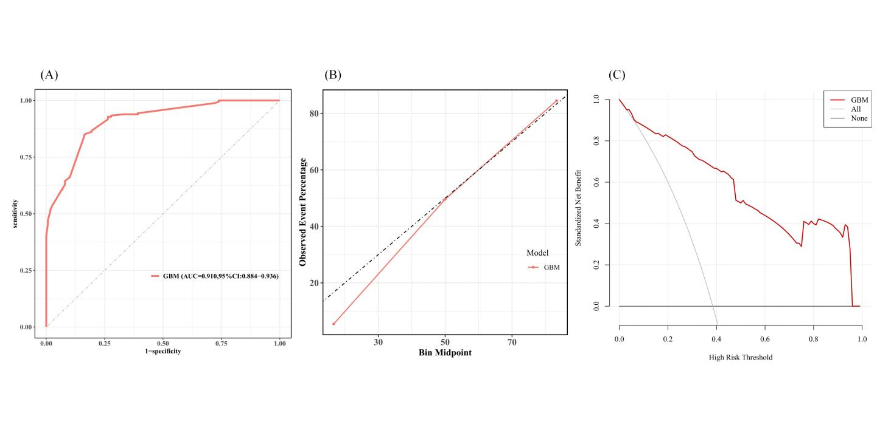

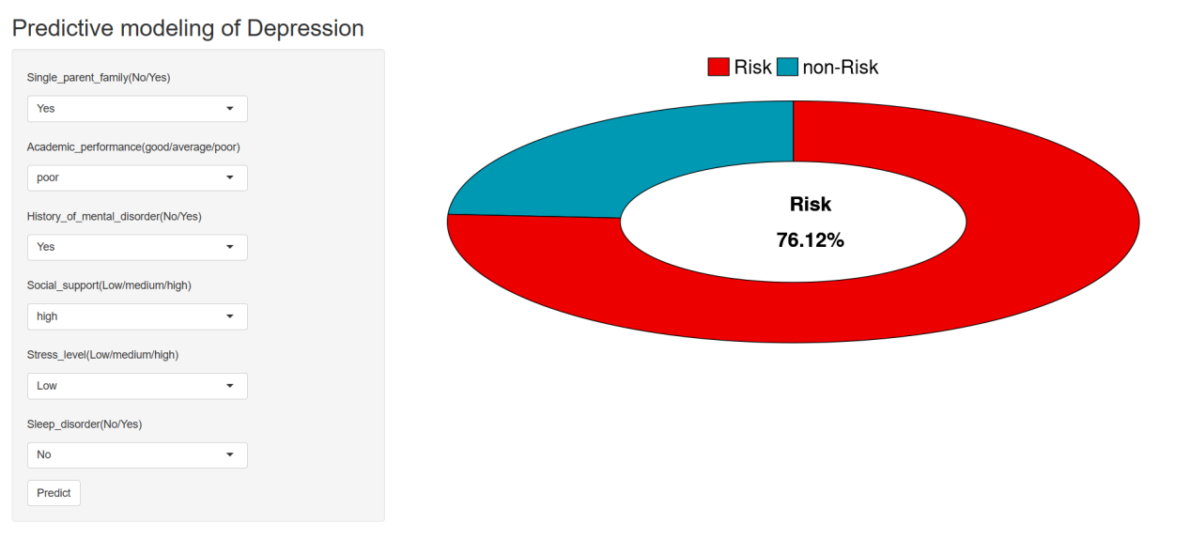
Supplementary Figure S2. The interface of the online calculator for predicting depression risk in nursing interns

