Supporting information for
Strikingly Distinctive NH₃-SCR Behavior over Cu-SSZ-13 in the Presence of NO₂
Yulong Shan¹, Guangzhi He^{1,}*, Jinpeng Du², Yu Sun^{1,4}, Zhongqi Liu^{1,4}, Yu Fu^{1,4}, Fudong Liu³, Xiaoyan Shi^{1,4}, Yunbo Yu^{1,2,4}, Hong He^{1,2,4,}*

* Corresponding author: Email: gzhhe@rcees.ac.cn, honghe@rcees.ac.cn

(15 pages, 10 figures, 2 tables)

Fig. S1 NO_{x}, NO and NO₂ conversion of Cu-SSZ-13 with different Cu loadings under FSCR conditions. [NO]=[NO₂]=250 ppm, [NH₃]=500 ppm, [O₂]=5 vol.% [H₂O]=3.5 vol.%. GHSV = 800,000 h⁻¹.
Generally, the NO_{x} conversion was significantly inhibited at low temperatures (< 200 ℃, Fig. S1a) due to the formation of NH₄NO₃, which has been reported by previous studies. ^{1, 2} The inhibition effect results from the negligible degree of NO reduction at low temperatures (Fig. S1b), while NO₂ conversion primarily contributed to the NO_{x} reduction (Fig. S1c). This is because NO primarily reacted at active Cu sites, while the formed NH₄NO₃ made the Cu species inaccessible to NO. Moreover, large amounts of NH₄NO₃ are easily formed on the Al-rich zeolite that was used in this work. In addition, it should be noted that the NO₂ conversion decreased with increasing Cu loading. As the temperature increased to the decomposition temperature of NH₄NO₃, the deNO_{x} efficiency was rapidly elevated and the both the NO and NO₂ conversion levels increased with the increase in Cu loading.
Fig. S2 NH₃-TPD profiles of Cu-SSZ-13 with different Cu loadings
Fig. S2 shows the NH₃-TPD profiles of Cu-SSZ-13 with various Cu loadings. There are two primary NH₃ desorption peaks at ~ 230 and ~360 ℃, which are ascribed to NH₃ adsorbed on Lewis acid sites (LASs, primarily Cu sites) and Brønsted acid sites (BASs, primarily -Si-OH-Al-), respectively.^{3, 4} The total amount of NH₃ desorption from LASs and BASs was calculated and shown in Table S2. The number of BASs increased while LASs decreased with decreasing Cu loading. This demonstrated that active Cu²⁺ sites occupied the BASs in zeolite, converting BASs into LASs, which is consistent with previous studies.^{3, 5} Therefore, the LASs and BASs are in inverse proportion. As consequence, the NO₂ reaction rates decreased with increasing Cu loadings but increased with the amount of BASs.
Fig. S3 NH₃-SCR performance of Cu-SSZ-13 with different Cu loadings under NO₂-SCR conditions. [NO₂]=350 ppm, [NH₃]=500 ppm, [O₂]=5 vol.% [H₂O]=3.5 vol.%. GHSV = 2,400,000 h⁻¹.
During the NO₂-SCR reaction, the NO₂ conversion decreased markedly with increasing Cu loading, indicating that NO₂ rarely reacted at Cu sites. The activation energies of the NO₂-SCR reaction are between 16-22 kJ/mol, indicating facile reaction between NO₂ and NH₃ over Cu-SSZ-13. The reaction between NO₂ and NH₃ always resulted in NH₄NO₃ formation through the following reaction:^{6, 7}
2NO₂ + 2NH₃ = NH₄NO₃ + N₂ + H₂O
Fig. S4 NO₂ reaction rates as a function of (a) Cu loading and (b) Brønsted acid sites under NO₂-SCR conditions. (c) NO₂ turnover frequency (TOF) as a function of Brønsted acid sites under NO₂-SCR conditions.
Under NO₂-SCR conditions, the NO₂ reaction rate decreased with the increase in Cu loading (Fig. S4a) while increasing with the increase in BASs (Fig. S4b), indicating that the BASs rather than the Cu²⁺ sites participated in the reduction of NO₂. Moreover, the TOF of NO₂ as a function of BASs is approximately constant (Fig. S4c), suggesting a single-site catalysis process. Actually, NO₂ disproportionation could occur on the BASs to form nitrates and nitrites, which then react with NH₃ to form NH₂NO and NH₄NO₃. The NH₂NO could easily decompose to N₂ and H₂O. This process was also observed in previous studies.^{8, 9}
 | 2NO₂ + ZH → ZHO + HNO₃ | （1）
 | HNO₃ + NH₃ → NH₄NO₃ | （2）
 | ZNO + NH₃ → ZHNONH₂ | （3）
 | ZHNONH₂ → ZH +N₂+H₂O | （4）

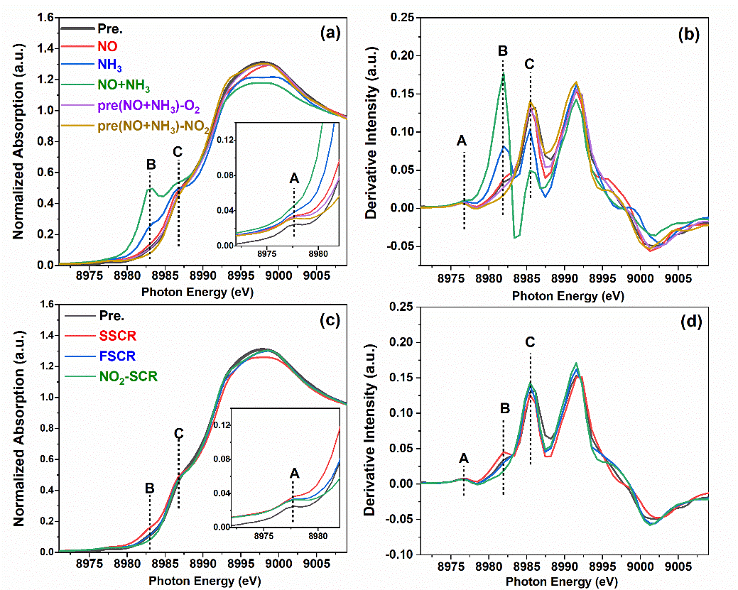
Fig. S5 Cu K-edge XANES (a, c) and the first derivative spectra (b, d) of Cu-SSZ-13 treated under different atmospheres. The Cu-SSZ-13 sample was treated by (i) NO adsorption, (ii) NH₃ adsorption, (iii) NO+NH₃ co-adsorption, (iv) NO+NH₃ co-adsorption followed by reaction with O₂, (v) NO+NH₃ co-adsorption followed by reaction with NO₂. (vi) SSCR reactants, (vii) FSCR reactants and (viii) NO₂-SCR reactants. The pretreated Cu-SSZ-13 is depicted with the label Pre.

Reduction and oxidation of copper species by SCR reactants
Furthermore, we conducted in-situ/operando XAFS experiments on Cu-SSZ-13 samples to investigate the state of copper species under different conditions. The Cu-SSZ-13 was characterized by XAFS after different SCR reactant treatments at 200 ℃. As shown in Fig. S5a, results showed a weak pre-edge peak A at ~8977.5 eV, which was assigned to the 1s → 3d transition of d⁹ Cu²⁺ ions.^{10, 11} The B and C features at ~8983 and ~8987 eV are attributed to the 1s → 4p transitions of linearly coordinated Cu⁺ ions and fourfold coordinated Cu²⁺ ions, respectively.^{12, 13} These three features were also clearly observed in the first derivative form of the XANES spectra (Fig. S5b). Compared with the pretreated Cu-SSZ-13, both NO and NH₃ induced the partial reduction of Cu²⁺ to Cu⁺, indicating that both NO and NH₃ can be activated by Cu²⁺ species through transferring electrons to Cu²⁺. Moreover, Cu²⁺ ions were more easily reduced by NH₃ due to the facile formation of linear [Cu(NH₃)₂]⁺ species.^{14, 15} This is because, compared with NO, NH₃ molecules interact more strongly with Cu²⁺ sites due to the ligand effect between NH₃ and Cu²⁺, which was observed in many studies.^{16, 17} Moreover, it is noted that more [Cu(NH₃)₂]⁺ species were formed when Cu-SSZ-13 was exposed to the NO+NH₃ mixture, indicating that NO can further assist the reduction of Cu²⁺ species by NH₃. The reduction of Cu²⁺ by a NO+NH₃ mixture is generally thought of as the reduction cycle of the SSCR reaction.^{16, 18}
Z₂Cu²⁺ + 3NH₃ + NO → ZCu⁺(NH₃)₂ + ZH + N₂ + H₂O (5)
(Z represents zeolite framework with negative charge)
To investigate the reactivity of [Cu(NH₃)₂]⁺ species in an oxidizing atmosphere, the O₂ and NO₂ was separately induced to oxidize Cu⁺ ions after treatment by NO+NH₃ mixture. After oxidation by O₂, the peak of [Cu(NH₃)₂]⁺ sharply decreased, concomitant with the appearance of Cu²⁺ ions at ~8977 and ~8987 eV, similar to the XANES profiles of pretreated Cu-SSZ-13. Nevertheless, a slight amount of [Cu(NH₃)₂]⁺ species still existed as indicated by peak B, which is identified more clearly in the first derivative form of the XANES spectra (Fig. S5b). This observation is consistent with previous studies showing that not all Cu⁺ can be completely oxidized even in an O₂ atmosphere.^{12, 15} Moreover, this phenomenon is more clearly proved by the observation of the further decrease in peak B in Fig. S5a and S5b after deeper oxidation by NO₂, which demonstrated that NO₂ can further oxidize the residual [Cu(NH₃)₂]⁺ species since NO₂ has stronger oxidizing power. The complete disappearance of peak B suggests that all the [Cu(NH₃)₂]⁺ species are oxidized by NO₂. Compared with Cu⁺ species, Cu²⁺ has more ligands and NO₂ adsorption to form nitrates on Cu²⁺ species is facile. In addition, higher valence facilitates the interaction between Cu²⁺ ions and the framework. As a result, the Cu²⁺ ions are likely bound to the framework to form fw-Cu²⁺ (framework fixed Cu²⁺) species, inhibiting the mobility of the copper species.

State of copper species during SSCR, FSCR and NO₂-SCR reactions
To uncover the state and coordination of Cu species under real SCR conditions, we conducted XAFS measurements and depicted the XANES profiles and their first derivative form for Cu-SSZ-13 under SSCR, FSCR and NO₂-SCR conditions, with the results shown in Fig. S5c and S5d. Under SSCR conditions, both features A and B were clearly observed, indicating the coexistence of large amounts of [Cu(NH₃)₂]⁺ species and Cu²⁺ ions, which suggests the occurrence of redox between Cu²⁺ and Cu⁺ ions under SSCR conditions.^{19, 20} This was also observed in the WT-EXAFS results (Fig. 3). Under FSCR conditions, however, the XANES profile was more like that of pretreated Cu-SSZ-13, demonstrating that most of the copper species were Cu⁺ ions, although there was still a slight amount of Cu⁺ ions. This result suggests that the oxidation of Cu⁺ is more rapid than the reduction process under FSCR conditions due to the higher oxidizing ability of NO₂. This is disadvantageous to the SSCR reaction or NO reduction under FSCR conditions, since the existence of more Cu²⁺ ions means tight coordination with the zeolite and the weak mobility of active copper species. Under NO₂-SCR conditions, furthermore, almost all of the copper species were in the Cu²⁺ state while few Cu⁺ species were observed, as indicated by the presence of peak A and the absence of peak B. This demonstrated that the NO₂-SCR is independent of the redox of copper species or that the oxidation rate of Cu⁺ is much higher than the reduction process, which is consistent with the kinetic results (Fig. 2). The in-situ/operando XAFS results show that more Cu²⁺ ions exist under NO₂-SCR conditions than in the pretreated Cu-SSZ-13, indicating that NO₂ can oxidize the copper species even though they reacted with NH₃ at Brønsted acid sites. This demonstrated that the dynamic [Cu(NH₃)₂]⁺ species dominated under SSCR conditions while the fw-Cu²⁺ primarily existed under FSCR and NO₂-SCR conditions.
Fig. S6 Fourier-transformed (FT) k³-weighted EXAFS spectra (phase uncorrected) of Cu-SSZ-13 treated under different atmosphere.
Table S1 EXAFS fitting parameters for Cu-SSZ-13 exposed to different atmospheres
Sample | Shell | CN | R(Å) | σ² | ∆E₀ | R factor
pretreated | Cu-O | 3.7±0.4 | 1.93±0.01 | 0.0061 | 0.5±2.6 | 0.0124
SSCR reaction | Cu-O(N) | 3.5±0.1 | 1.95±0.01 | 0.0073 | 3.7±1.0 | 0.0124
FSCR reaction | Cu-O(N) | 3.7±0.1 | 1.94±0.01 | 0.0068 | 1.9±0.8 | 0.0124
NO₂-SCR reaction | Cu-O(N) | 3.7±0.1 | 1.95±0.01 | 0.0068 | 1.6±0.9 | 0.0124
Figure S6 shows the Fourier-transformed (FT) EXAFS spectra (without phase correction) of Cu-SSZ-13 under various conditions. The first-shell peak is generally attributed to the scattering of O or N atoms, which derived from the zeolite framework O or adsorbed NH₃ in this work.^{10, 11} The second shell is primarily attributed to the zeolite framework T atoms (Si or Al).^{10, 21} The appearance of the second shell scattering feature indicated the interaction between copper species and the zeolite framework. On the contrary, the absence of the second shell scattering feature suggests high mobility for the copper species. The parameters resulting from the experimental data and the simulated fittings of EXAFS spectra are listed in Table S1.
Compared with the pretreated sample, the Cu-SSZ-13 exposed to SSCR conditions showed decreased intensity for the first-shell peak, with the coordination number (CN) decreasing from 3.7 to 3.5. The decrease in CN indicated the reduction of Cu²⁺ species to [Cu(NH₃)₂]⁺ species. The absence of the second shell scattering feature for NH₃-treated Cu-SSZ-13 also proved the formation of dynamic [Cu(NH₃)₂]⁺ species, which are unconnected with the zeolite framework. However, when NO₂ was involved in the SCR reaction (FSCR or NO₂-SCR), the feature of the second shell appeared, indicating the scattering of framework atoms (Si or Al). The Cu²⁺ species with high charge dominated in the presence of NO₂ with high oxidation ability. This high charge for the copper species intensified the electrostatic force between the copper species and zeolite framework, leading to the active sites becoming fixed on the zeolite.
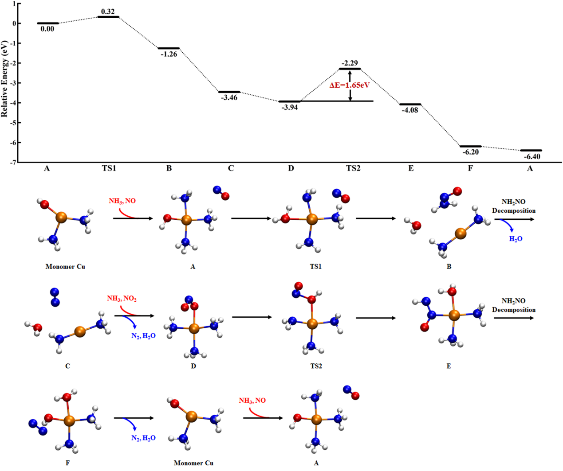
Fig. S7. Gibbs free energy profile of the fast SCR cycle at the Cu-monomer site as well as optimized geometries of the reactants, transition states, intermediates, and products for all elementary steps. The zeolite framework is omitted for clarity. Orange, red, blue, and white circles denote Cu, O, N, and H atoms, respectively.
Fig. S7 shows the NH₂NO reaction pathway over the Cu-monomer site, which includes the reduction and oxidation half-cycles. The Cu²⁺OH(NH₃)₂ species are first reduced to Cu⁺(NH₃)₂ by NH₃ and NO with the energy barrier of 0.32 eV, accompanied by the formation of two H₂O and one N₂ (See Monomer Cu→C in Fig. S7). This process is clearly seen in the operando XAFS results, in which plenty of Cu²⁺ were reduced to Cu⁺ in the presence of NH₃ and NO. Then, as an oxidizing agent, NO₂ oxidizes Cu⁺(NH₃)₂ species to Cu²⁺NO₂(NH₃)₃ with coordination by another NH₃. The adsorbed NO₂ reacts with one NH₃ ligand, resulting in the formation of NH₂NO and Cu²⁺OH(NH₃)₂. Subsequently, NH₂NO is decomposed into N₂ and H₂O to complete the whole reaction cycle. The NH₂NO is easily decomposed into N₂ and H₂O with a low energy barrier of 0.60 eV (Figure S9). The rate-determining step of the NH₂NO reaction pathway over the Cu-monomer site is the oxidation of Cu⁺(NH₃)₂ by NO₂ with another NH₃ coordination, with an extremely high energy barrier of 1.65 eV, which is comparable with the value reported by Janssens et al..²²
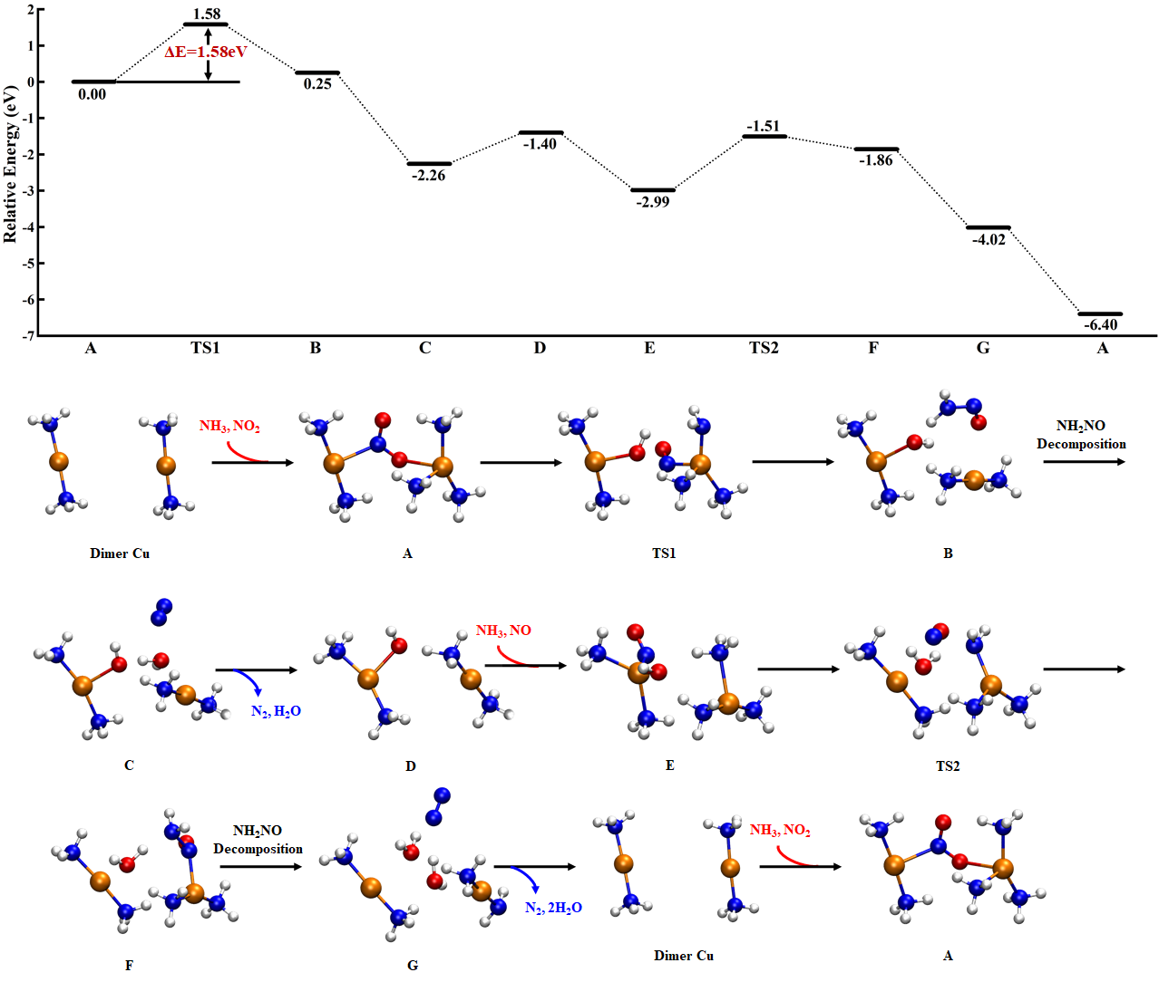
Fig. S8. Gibbs free energy profile of the fast SCR cycle at the Cu-dimer site as well as optimized geometries of the reactants, transition states, intermediates, and products for all elementary steps. The zeolite framework is omitted for clarity. All legends are the same as those in Figure S8.
It has been proved that Cu dimers play a key role in the standard SCR reaction.^{12, 14, 15} Therefore, we then calculated the fast SCR pathway with the participation of the Cu dimer. First, the adsorption of NO₂ leads to the formation of an NO₂-bridging dimer-Cu (see A in Figure S8). Subsequently, NO₂ is activated and reacts with one adsorbed NH₃ molecule, leading to the formation of Cu²⁺OH(NH₃)₂ and an NH₂NO species (see B in Figure S8). The NH₂NO is then easily decomposed into N₂ and H₂O with a low energy barrier of 0.60 eV (Figure S9). Then, one NO and one NH₃ are adsorbed on Cu²⁺OH(NH₃)₂ and Cu⁺(NH₃)₂, respectively. The adsorbed NH₃ reacts with the -OH group at the other Cu site to generate an H₂O molecule and an -NH₂ species. The -NH₂ species further reacts with the adsorbed NO to form NH₂NO (see F in Fig. S8). Accompanied by the decomposition of NH₂NO into N₂ and H₂O, the Cu-dimer site is regenerated. The highest energy barrier of the FSCR cycle over the Cu-dimer site is 1.58 eV, corresponding to the reaction of adsorbed NO₂ with an NH₃ ligand.
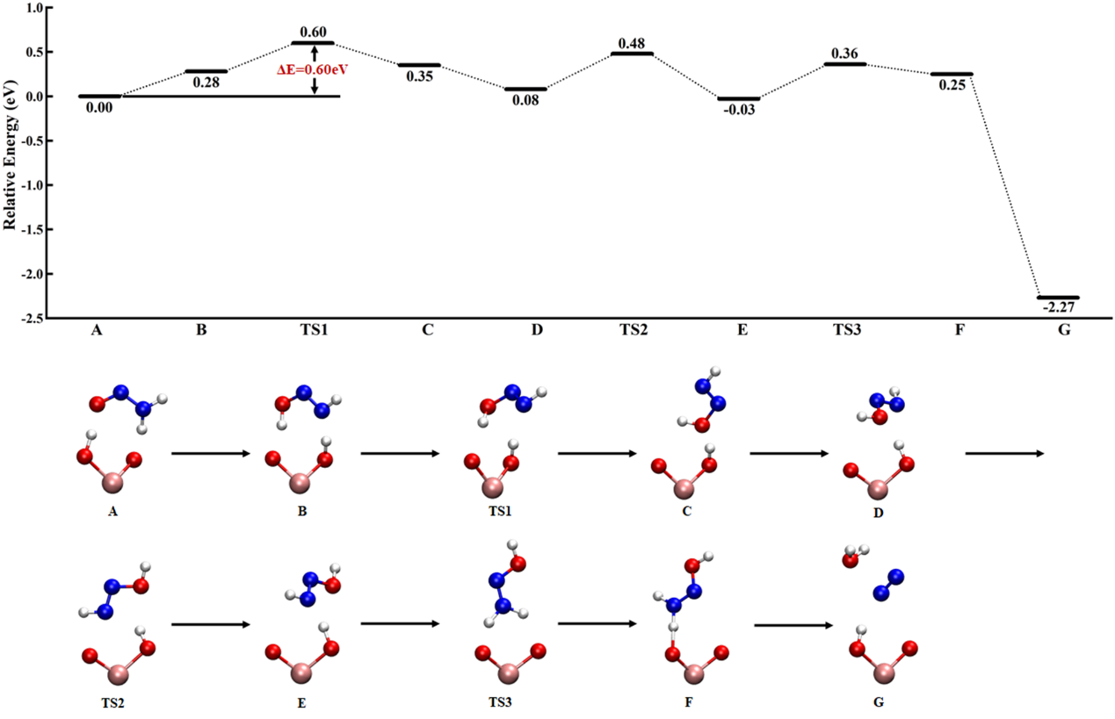
Fig. S9 Gibbs free energy profile of NH₂NO decomposition with the assistance of Brønsted acid sites as well as optimized geometries of the reactants, transition states, intermediates, and products for all elementary steps. Except for the Al-O(H) groups involved in the reaction, all other atoms of the zeolite framework are omitted for clarity. Pink, red, blue, and white circles denote Al, O, N, and H atoms, respectively.

Table S2 Elemental analysis and physicochemical properties of Cu-SSZ-13 with various Cu contents
Sample | Cu  wt.% | Cu/Al | Si/Al | NH₃ storage  (mmol/g) | L  (mmol/g) | B  (mmol/g) | BET  (m²/g)
Cu0.4-SSZ-13 | 0.4 | 0.03 | 5.1 | 2.135 | 0.328 | 1.806 | 626
Cu1.0-SSZ-13 | 1.0 | 0.08 | 5.0 | 2.260 | 0.662 | 1.666 | 575
Cu1.7-SSZ-13 | 1.7 | 0.14 | 5.2 | 2.287 | 1.145 | 1.141 | 566
Cu2.6-SSZ-13 | 2.6 | 0.22 | 5.5 | 2.359 | 1.361 | 0.998 | 592
Cu3.8-SSZ-13 | 3.8 | 0.31 | 5.1 | 2.376 | 1.523 | 0.853 | 544

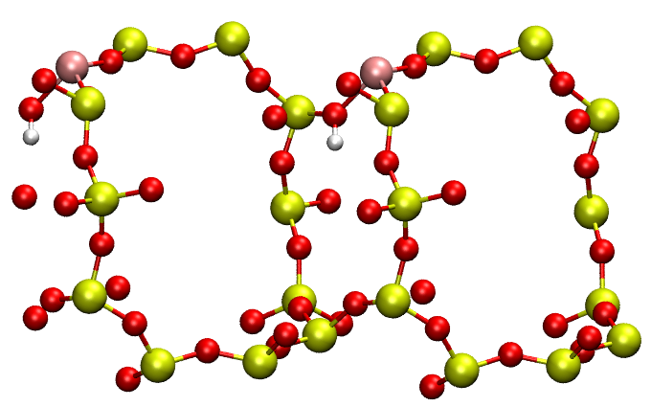
Fig. S10 The SSZ-13 zeolite model used in the DFT calculations. Yellow, pink, red, and white circles denote Si, Al, O, and H atoms, respectively.

References
1. Xie, L.; Liu, F.; Liu, K.; Shi, X.; He, H., Inhibitory effect of NO₂ on the selective catalytic reduction of NO_{x} with NH₃ over one-pot-synthesized Cu–SSZ-13 catalyst. Catal. Sci. Technol. 2014, 4 (4), 1104-1110.
2. Shan, Y.; Shi, X.; He, G.; Liu, K.; Yan, Z.; Yu, Y.; He, H., Effects of NO₂ Addition on the NH₃-SCR over Small-Pore Cu–SSZ-13 Zeolites with Varying Cu Loadings. J. Phys. Chem. C 2018, 122 (45), 25948-25953.
3. Wang, D.; Gao, F.; Peden, C. H. F.; Li, J.; Kamasamudram, K.; Epling, W. S., Selective Catalytic Reduction of NO_{x} with NH₃ over a Cu-SSZ-13 Catalyst Prepared by a Solid-State Ion-Exchange Method. Chem. Commun. 2014, 6, 1579-1583.
4. Luo, J.; Gao, F.; Kamasamudram, K.; Currier, N.; Peden, C. H. F.; Yezerets, A., New insights into Cu/SSZ-13 SCR catalyst acidity. Part I: Nature of acidic sites probed by NH₃ titration. J. Catal. 2017, 348, 291-299.
5. Villamaina, R.; Liu, S.; Nova, I.; Tronconi, E.; Ruggeri, M. P.; Collier, J.; York, A.; Thompsett, D., Speciation of Cu Cations in Cu-CHA Catalysts for NH₃-SCR: Effects of SiO₂/Al₂O₃ Ratio and Cu-Loading Investigated by Transient Response Methods. ACS Catal. 2019, 9, 8916-8927.
6. Grossale, A.; Nova, I.; Tronconi, E., Ammonia blocking of the “Fast SCR” reactivity over a commercial Fe-zeolite catalyst for Diesel exhaust aftertreatment. J. Catal. 2009, 265 (2), 141-147.
7. Grossale, A.; Nova, I.; Tronconi, E.; Chatterjee, D.; Weibel, M., NH₃–NO/NO₂ SCR for Diesel Exhausts Aftertreatment: Reactivity, Mechanism and Kinetic Modelling of Commercial Fe- and Cu-Promoted Zeolite Catalysts. Top. Catal. 2009, 52 (13-20), 1837-1841.
8. Liu, K.; Yan, Z.; Shan, W.; Shan, Y.; Shi, X.; He, H., Quantitative determination of the Cu species, acid sites and NH₃-SCR mechanism on Cu-SSZ-13 and H-SSZ-13 at low temperatures. Catal. Sci. Technol. 2020, 10 (4), 1135-1150.
9. Liu, C.; Malta, G.; Kubota, H.; Kon, K.; Toyao, T.; Maeno, Z.; Shimizu, K.-i., In Situ/Operando IR and Theoretical Studies on the Mechanism of NH₃–SCR of NO/NO₂ over H–CHA Zeolites. J. Phys. Chem. C 2021, 125 (25), 13889-13899.
10. Martini, A.; Borfecchia, E.; Lomachenko, K. A.; Pankin, I. A.; Negri, C.; Berlier, G.; Beato, P.; Falsig, H.; Bordiga, S.; Lamberti, C., Composition-driven Cu-speciation and reducibility in Cu-CHA zeolite catalysts: a multivariate XAS/FTIR approach to complexity. Chem. Sci. 2017, 8 (10), 6836-6851.
11. Borfecchia, E.; Lomachenko, K. A.; Giordanino, F.; Falsig, H.; Beato, P.; Soldatov, A. V.; Bordiga, S.; Lamberti, C., Revisiting the nature of Cu sites in the activated Cu-SSZ-13 catalyst for SCR reaction. Chem. Sci. 2015, 6 (1), 548-563.
12. Negri, C.; Selleri, T.; Borfecchia, E.; Martini, A.; Lomachenko, K. A.; Janssens, T. V. W.; Cutini, M.; Bordiga, S.; Berlier, G., Structure and Reactivity of Oxygen-Bridged Diamino Dicopper(II) Complexes in Cu-Ion-Exchanged Chabazite Catalyst for NH₃-Mediated Selective Catalytic Reduction. J. Am. Chem. Soc. 2020, 142 (37), 15884-15896.
13. Pappas, D. K.; Borfecchia, E.; Dyballa, M.; Pankin, I. A.; Lomachenko, K. A.; Martini, A.; Signorile, M.; Teketel, S.; Arstad, B.; Berlier, G.; Lamberti, C.; Bordiga, S.; Olsbye, U.; Lillerud, K. P.; Svelle, S.; Beato, P., Methane to Methanol: Structure-Activity Relationships for Cu-CHA. J. Am. Chem. Soc. 2017, 139 (42), 14961-14975.
14. Gao, F.; Mei, D.; Wang, Y.; Szanyi, J.; Peden, C. H., Selective Catalytic Reduction over Cu/SSZ-13: Linking Homo- and Heterogeneous Catalysis. J. Am. Chem. Soc. 2017, 139 (13), 4935-4942.
15. Paolucci, C.; Khurana, I.; Parekh, A. A.; Li, S.; Shih, A. J.; Li, H.; Iorio, J. R. D.; Albarracin-Caballero, J. D.; Yezerets, A.; Miller, J. T.; Delgass, W. N.; Ribeiro, F. H.; Schneider, W. F.; Gounder, R., Dynamic multinuclear sites formed by mobilized copper ions in NO_{x} selective catalytic reduction. Science 2017, 357, 898-903.
16. Paolucci, C.; Parekh, A. A.; Khurana, I.; Di Iorio, J. R.; Li, H.; Albarracin Caballero, J. D.; Shih, A. J.; Anggara, T.; Delgass, W. N.; Miller, J. T.; Ribeiro, F. H.; Gounder, R.; Schneider, W. F., Catalysis in a Cage: Condition-Dependent Speciation and Dynamics of Exchanged Cu Cations in SSZ-13 Zeolites. J. Am. Chem. Soc. 2016, 138 (18), 6028-48.
17. Zhang, Y.; Peng, Y.; Li, K.; Liu, S.; Chen, J.; Li, J.; Gao, F.; Peden, C. H. F., Using Transient FTIR Spectroscopy to Probe Active Sites and Reaction Intermediates for Selective Catalytic Reduction of NO on Cu/SSZ-13 Catalysts. ACS Catal. 2019, 6, 6137-6145.
18. Paolucci, C.; Verma, A. A.; Bates, S. A.; Kispersky, V. F.; Miller, J. T.; Gounder, R.; Delgass, W. N.; Ribeiro, F. H.; Schneider, W. F., Isolation of the Copper Redox Steps in the Standard Selective Catalytic Reduction on Cu-SSZ-13. Angew. Chem. Ind. Ed. 2014, 126 (44), 12022-12027.
19. Liu, C.; Kubota, H.; Amada, T.; Kon, K.; Toyao, T.; Maeno, Z.; Ueda, K.; Ohyama, J.; Satsuma, A.; Tanigawa, T.; Tsunoji, N.; Sano, T.; Shimizu, K.-i., In Situ Spectroscopic Studies on the Redox Cycle of NH₃–SCR over Cu‐CHA Zeolites. ChemCatChem 2020, 12, 1-11.
20. Bates, S. A.; Verma, A. A.; Paolucci, C.; Parekh, A. A.; Anggara, T.; Yezerets, A.; Schneider, W. F.; Miller, J. T.; Delgass, W. N.; Ribeiro, F. H., Identification of the active Cu site in standard selective catalytic reduction with ammonia on Cu-SSZ-13. J. Catal. 2014, 312, 87-97.
21. Sushkevich, V. L.; Safonova, O. V.; Palagin, D.; Newton, M. A.; van Bokhoven, J. A., Structure of copper sites in zeolites examined by Fourier and wavelet transform analysis of EXAFS. Chemical Science 2020, 11 (20), 5299-5312.
22. Janssens, T. V. W.; Falsig, H.; Lundegaard, L. F.; Vennestrøm, P. N. R.; Rasmussen, S. B.; Moses, P. G.; Giordanino, F.; Borfecchia, E.; Lomachenko, K. A.; Lamberti, C.; Bordiga, S.; Godiksen, A.; Mossin, S.; Beato, P., A Consistent Reaction Scheme for the Selective Catalytic Reduction of Nitrogen Oxides with Ammonia. ACS Catal. 2015, 5 (5), 2832-2845.

