Supplementary Information
Table of Contents
Fig. S1 2
Fig. S2 5
Fig. S3 6
Fig. S4 7
Fig. S5 8
Fig. S6 8
Fig. S7 9
Fig. S8 10
Table S1. 11
Table S2. 11

B
A
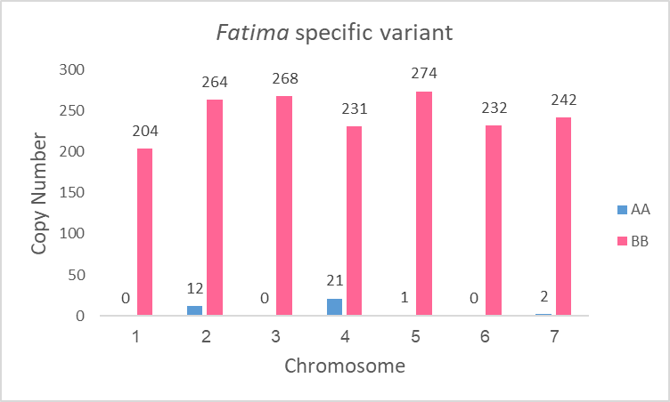
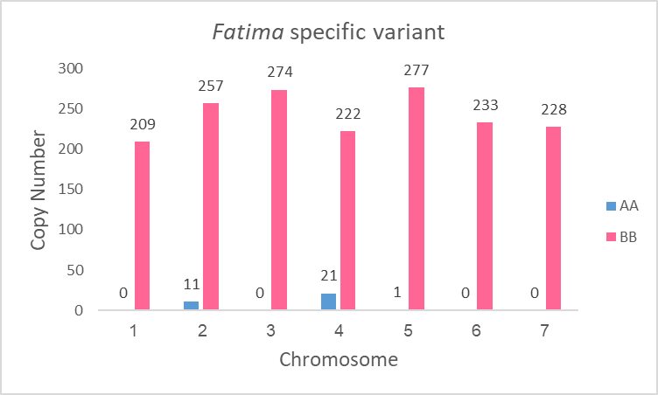
Fig. S1 Distribution of Fatima specific variant in chromosomes 1-7 of sub-genome A (blue) and sub-genome B (pink) in wild emmer (A) and bread wheat (B). Unmapped Fatima insertions are not shown.

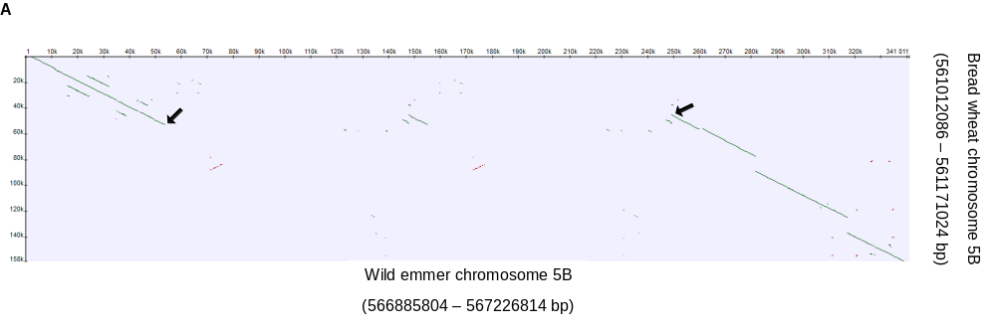
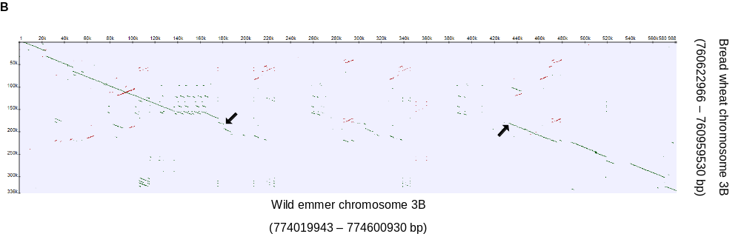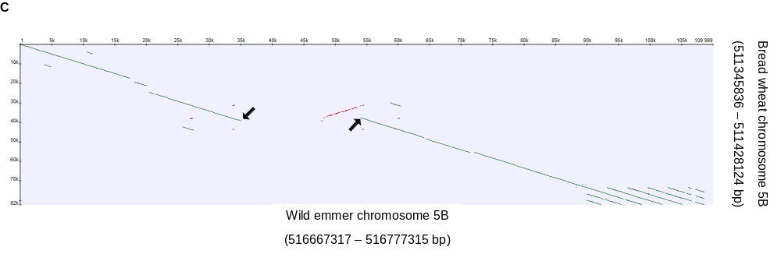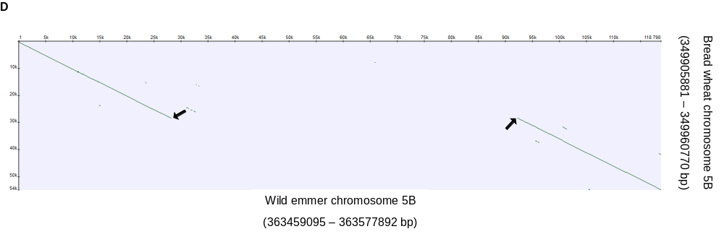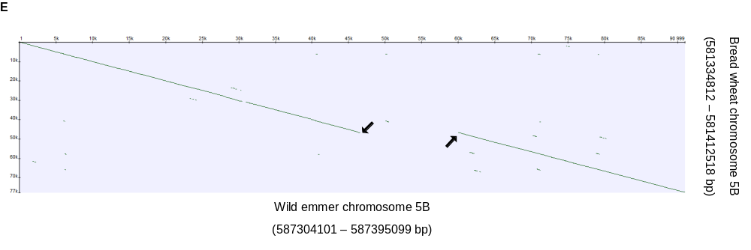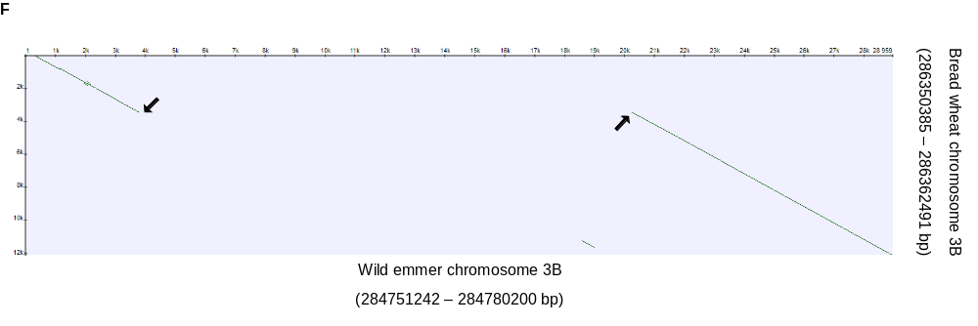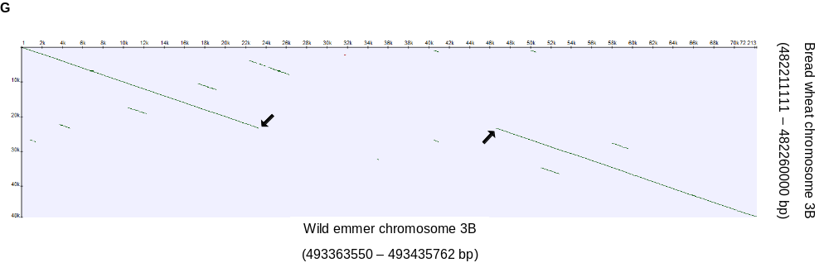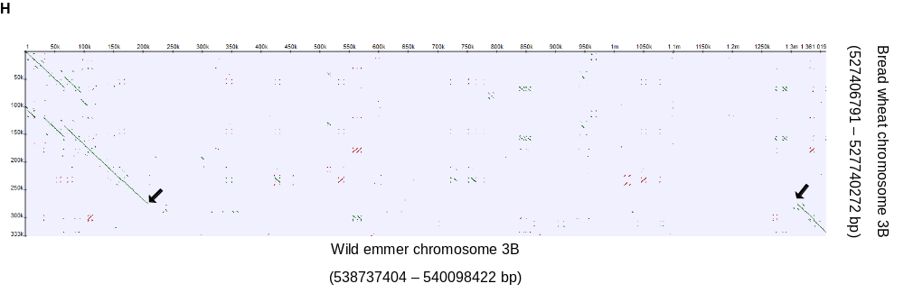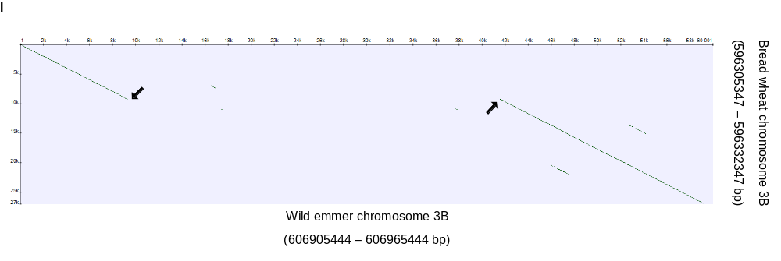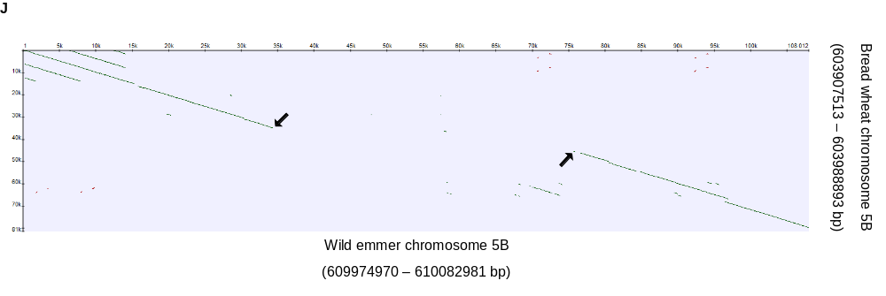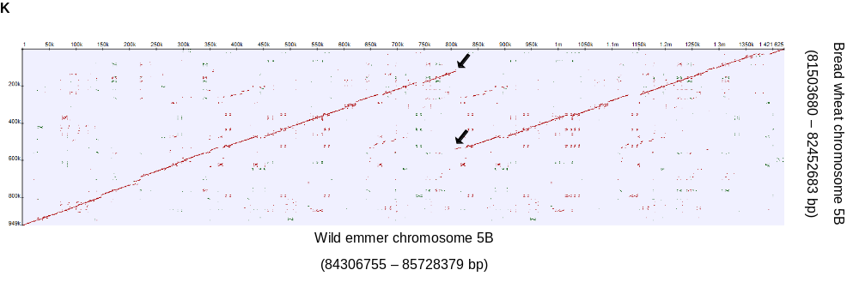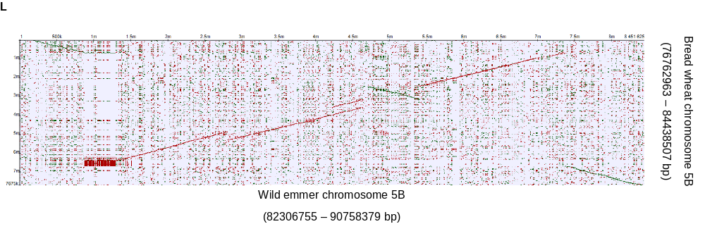
Fig. S2 Dot plot representations of genomic loci containing sequence variations identified between wild emmer (x axis) and bread wheat (y axis) in loci 5B₁ (A) 3B₁ (B) 5B₂ (C) 5B₃ (D) 5B₄ (E) 3B₂ (F) 3B₃ (G) 3B₄ (H) 3B₅ (I) 5B₅ (J) 5B₆ (K) and a ~6.5 Mb inversion including the genomic locus 5B₆ (L). The parameters for the sequence alignments were minimum repeat length of 100 bp and 95% repeats identity.
Green- direct repeats, red- inverted repeats. Indels break points\ borders are indicated by black arrows. The numbers in brackets refer to the coordinates of the selected sequences in the WEWSeq_v.1.0 assembly (for wild emmer) and in the IWGSC assembly (for bread wheat).

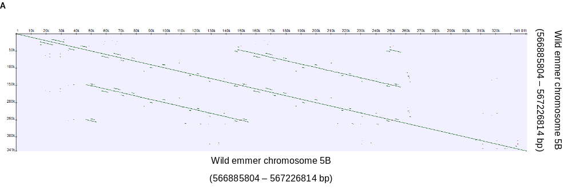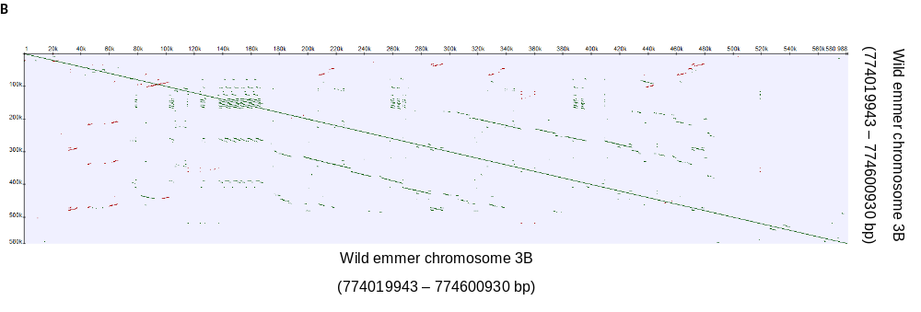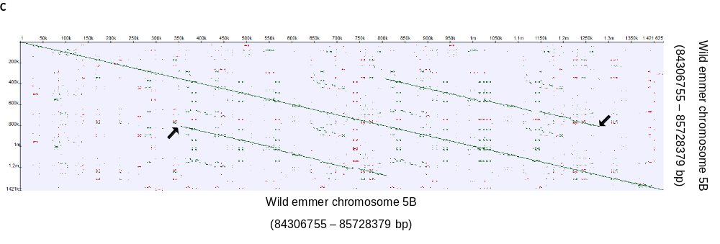
Fig. S3 Dot plot representations of genomic loci containing segmental duplication in wild emmer genome. In 5B₁ (A) and 5B₂ (B) loci, the deleted sequences and the Indels borders were found to contain sequence duplications. (C) Recent sequence duplication in locus 5B₆ identified in wild emmer relative to bread wheat. The parameters for the sequence alignments of the genomic loci against themselves were minimum repeat length of 100bp and 95% repeats identity.
Green- direct repeats, red- inverted repeats. Indels break points\ borders are indicated by black arrows. The numbers in brackets refers to the coordinates of the selected sequences in the WEWSeq_v.1.0 assembly.
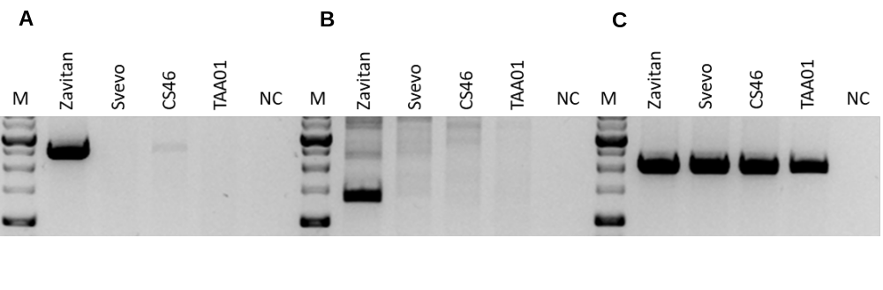
Fig. S4 PCR analysis using primers designed based on an Indel identified between wild emmer and bread wheat in locus 5B₁ (Table 1).
- Forward primer designed based on the 7.6 kb segment in bread wheat genome which shows high nucleotide identity to both the 5' region and the 3' region flanking the wild emmer 5B₁ locus eliminated sequence from the wild emmer genome and reverse primer designed based on the eliminated sequence. Expected product length 2436 bp (see Additional file 1: Table S2).
- Forward primer designed based on the eliminated sequence and reverse wild emmer specific primer designed based on the Indel 3' flanking region of 5B₁ which shows high nucleotide identity to the 7.6 kb segment in bread wheat 5B₁ locus. Expected product length 1345 bp (see Additional file 1: Table S2).
- Forward primer as was used for the reaction described for (A) and reverse primer designed based on the Indel 3' flanking. Expected product length 1998 bp (see Additional file 1: Table S2).
“M” represents the size marker, “NC” represents for negative control, ddH₂0 was used as template in PCR reactions. The PCR analysis was performed for accessions of wild emmer (Zavitan), durum (Svevo) and bread wheat (CS46 and TAA01), see Additional file 1: Table S1 for detailed plant accessions list.

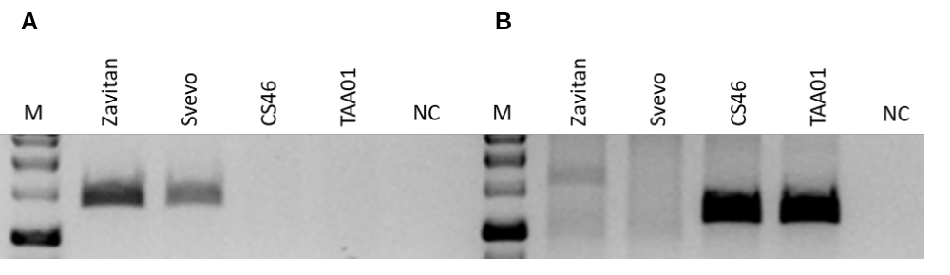

Fig. S5 PCR analysis using primers designed based on Indel identified between wild emmer and bread wheat in locus 5B₃ (Table 1).
- Forward primer designed based on the deleted sequence and reverse primer based on the Indel 3' flanking. Expected product length 1361 bp (see Additional file 1: Table S2).
- Forward primer based on the Indel 5' flanking and the same reverse primer as was used for the reaction described for (A). Expected product length 1169 bp (see Additional file 1: Table S2).
“M” represents the size marker, “NC” represents for negative control, ddH₂0 was used as template in PCR reactions. The PCR analysis was performed for accessions of wild emmer (Zavitan), durum (Svevo) and bread wheat (CS46 and TAA01), see Additional file 1: Table S1 for detailed plant accessions list.

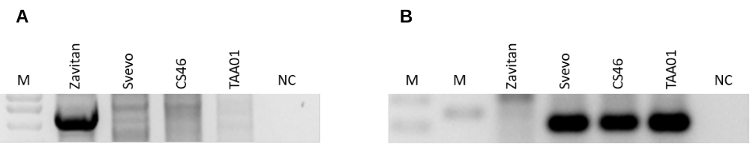

Fig. S6 PCR analysis using primers designed based on Indel identified between wild emmer and bread wheat in locus 3B₄ (Table 1).
- Forward primer designed based of the 5' flanking sequence of 3B₄ and reverse primer designed based on the deleted sequence. Expected product length 4413 bp (see Additional file 1: Table S2).
- Forward primer as was used for the reaction described for (A) and revers primer designed from the 3' flanking of 3B₄. Expected product length 219 bp (see Additional file 1: Table S2).
“M” represents the size markers, “NC” represents for negative control, ddH₂0 was used as template in PCR reactions. The PCR analysis was performed for accessions of wild emmer (Zavitan), durum (Svevo) and bread wheat (CS46 and TAA01), see Additional file 1: Table S1 for detailed plant accessions list. The PCR analysis in (A) and (B) were visualized on separate agarose gels.
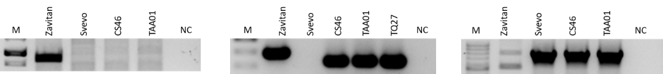
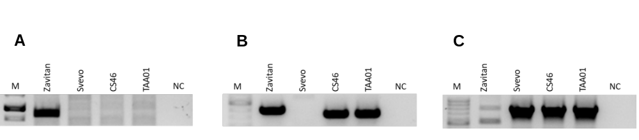

Fig. S7 PCR analysis using primers designed based on introgression identified between wild emmer and bread wheat in locus 5B₅ (Table 1).
PCR validations were carried out using primers designed based on the flanking sequences of the Indel coupled with primers designed from the 41 kb wild emmer specific segment. Expected product length was 879 bp (A) and 391bp, indicated by red arrow (B) (Additional file 1: Table S2). The lower bends in (B) are consistent with a shorter segment identified in-silico in the D sub-genome of the bread wheat and similar in size to the PCR product observed for Ae. tauschii. (C) Forward primer designed based on the 11kb bread wheat specific sequence and the revers primer was the same primer as was used for (B), designed based on sequence located downstream to the Indel. Expected product length 787bp, indicated by red arrow (Additional file 1: Table S2). Non-specific amplification was observed for wild emmer (validated by sequencing).
“M” represents the size marker, “NC” represents for negative control, ddH₂0 was used as template in PCR reactions. The PCR analysis was performed for accessions of wild emmer (Zavitan), durum (Svevo), bread wheat (CS46 and TAA01) and Ae. tauschii (TQ27), see Additional file 1: Table S1 for detailed plant accessions list. The PCR analysis in (A), (B) and (C) were visualized on separate agarose gels.

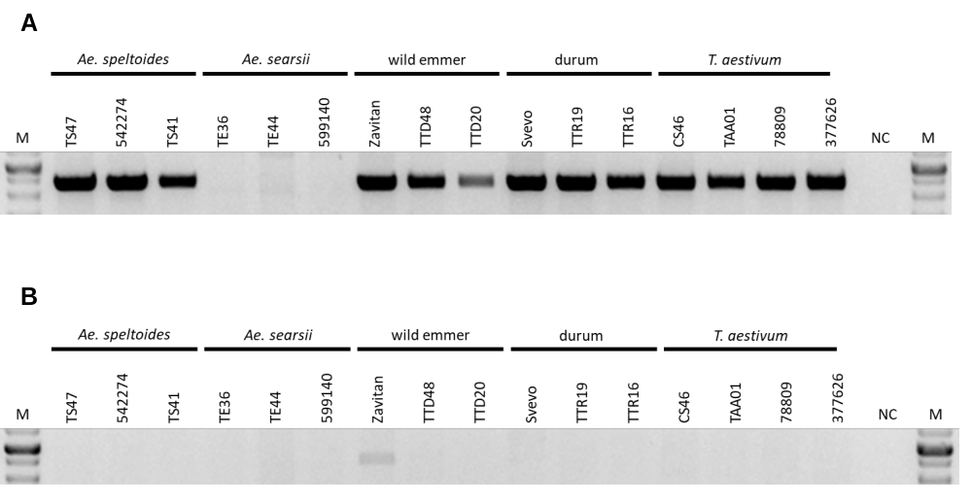

Fig. S8 PCR analysis using primers designed based on copy number variation of long tandem repeat identified between wild emmer and bread wheat in locus 5B₆ (Table 1).
- Forward primer designed from the 5' flanking (in wild emmer genome) of the sequence that underwent copy number variation and reverse primer designed from the 5' region of the repeat unit (in wild emmer genome). Expected product length 2315 bp (Additional file 1: Table S2).
- Forward primer designed based on sequence located in the 3' end (in wild emmer genome) of the segment that underwent copy number variation and the reverse primer that was used for the reaction in (A). Expected product length 2415 bp (Additional file 1: Table S2).
“M” represents the size marker, “NC” represents negative control, ddH₂0 was used as template in PCR reactions. The PCR analysis was performed for different accessions of wheat allopolyploids (3 wild emmer accessions, 3 durum accessions and 4 bread wheat accessions) and for the available species which are closely related to the diploid B sub-genome donor (3 Ae. speltoides accessions and 3 Ae. searsii accessions). see Additional file 1: Table S1 for detailed plant accessions list. The PCR analysis in (A) and (B) were visualized on separate agarose gels.

Table S1. Plant accessions used in PCR analyses.

Origin | Accession | Species
Unknown | TS47 | Ae. speltoides (BB)
Turkey | 542274 | Ae. speltoides (BB)
Israel | TS41 | Ae. speltoides (BB)
Syria | TE36 | Ae. searsii (BB)
Jordan | TE44 | Ae. searsii (BB)
Jordan | 599140 | Ae. searsii (BB)
Israel | Zavitan | T. turgidum ssp. dicoccoides (AABB)
Iran | TTD48 | T. turgidum ssp. dicoccoides (AABB)
Israel | TTD20 | T. turgidum ssp. dicoccoides (AABB)
Italy | Svevo | T. turgidum ssp. durum (AABB)
Israel | TTR19 | T. turgidum ssp. durum (AABB)
Israel | TTR16 | T. turgidum ssp. durum (AABB)
Unknown | CS46 | T. aestivum (AABBDD)
Unknown | TTA01 | T. aestivum (AABBDD)
Georgia | 78809 | T. aestivum (AABBDD)
Former Yugoslavia | 377626 | T. aestivum (AABBDD)
Israel | TQ27 | Ae. tauschii (DD)

Table S2. Primer used for PCR analyses.
Indel | Species¹ | Forward primer | Reverse primer | Annealing temperature | Product length
5B₁ | wild emmer | GAGCCACGTAAACAAACAAGCT | ACCACGTCATCCTGGCTTTTAT | 60°C | 2436bp
5B₁ | wild emmer | GGTACGTTTGATGACTTGTGGC | CCTAAAGGCGTTGCTATTCGTG | 60°C | 1345bp
5B₁ | wild emmer, durum, bread wheat | GAGCCACGTAAACAAACAAGCT | GACGTCATGTTGTACCACTCCT | 60°C | 1998bp
5B₃ | wild emmer, durum | GGCTTAAACCTTCTTGATCGGC | TTGTGGAGTTCTGTAGACGCAT | 60°C | 1361bp
5B₃ | bread wheat | TTTGGTAGCGACTTGATCCGAA | TTGTGGAGTTCTGTAGACGCAT | 60°C | 1169bp
3B₄ | wild emmer | ATGAACGCTCCACATCCTCC | CACTCCAAAGCTCCCGAAGA | 60°C | 4413bp
3B₄ | durum, bread wheat | ATGAACGCTCCACATCCTCC | CGGAGTTGTGCTAGAGAGAGAG | 60°C | 219bp
5B₅ | wild emmer | CTAAGTGCGGCGGTCAAATT | CTCTTCAATGGTGTTCGGCC | 59°C | 879bp
5B₅ | wild emmer | CGCCGGTTAGTAAAAGCACC | GGGATCGGTTTGTGAGGAGA | 59°C | 391bp
5B₅ | durum, bread wheat | TAAATTGGGCTCTCACGGGT | GGGATCGGTTTGTGAGGAGA | 59°C | 787bp
5B₆ | wild emmer, durum, bread wheat | GGTTTTGCCCAACTCCGAAT | CCGGTTTGGCATCCTTTTGT | 59°C | 2315bp
5B₆ | wild emmer | ACCCCTCAACCCTGTAAACC | CCGGTTTGGCATCCTTTTGT | 59°C | 2415bp

¹ Amplification was seen in the mentioned species.

