Supplementary Tables
Table S1. Summary of Illumina sequencing data for the de novo assembly of mitogenome of parental species, S. tuberosum and S. commersonii. and their somatic hybrid
Category | Somatic Hybrid |  | S. tuberosum |  |  |  |  | S. commersonii
Total raw read numbers | 17,750,412 |  | 19,368,194 |  |  |  |  | 22,056,066
Total raw bases | 5,342,874,012 |  | 5,807,568,326 |  |  |  |  | 6,597,040,721
Total trimmed read numbers | 15,483,215 |  | 16,424,842 |  |  |  |  | 19,292,972
Total trimmed bases | 3,602,925,285 |  | 4,065,781,506 |  |  |  |  | 4,831,428,596
Mitogenome types | 1 | 2 | 1 | 2 | 3 | 4 | 5 | 1 | 2
Mapped read numbers on Mitogenome | 152,191 | 23,070 | 41,344 | 36,484 | 31,161 | 5,411 | 12,729 | 130,811 | 80,817
Average coverage (x) | 81.73 | 98.48 | 33.07 | 34.99 | 65.58 | 26.16 | 61.47 | 90.87 | 88.27

Table S2. The list of primers used for validation of the mitogenomes obtained by de novo assembly.
Species | Primers No. | Direction | Sequences (5' to 3') | Expected amplicon size (bp) | Positions | Locations | Mt type
S. tuberosum | st_1_1 | Forward | TTTGTTGTGCGAAGAGTGCG | 840 | nad5 intron | 31443-31462 | I
S. tuberosum | st_1_1 | Reverse | GTGCTCTAGCAATTGCGCTC | 840 | nad5 intron | 32263-32282 | I
S. tuberosum | st_1_2 | Forward | CGAAAAGCGAGATGAGCGTG | 1,004 | nad4 intron | 87446-87465 | I
S. tuberosum | st_1_2 | Reverse | CAGAAATCCCGCATTGAGCG | 1,004 | nad4 intron | 88430-88449 | I
S. tuberosum | st_1_3 | Forward | GAGCGGGAATACGTCGCTTA | 375 | atp1~orf101 | 144881-144900 | I
S. tuberosum | st_1_3 | Reverse | GTTCCGTGGGTTCAGTTTGC | 375 | atp1~orf101 | 145236-145255 | I
S. tuberosum | st_1_4 | Forward | CATAAGCGTGAAAGAGCCGC | 747 | nad7~trnM-CAU | 190188-190207 | I
S. tuberosum | st_1_4 | Reverse | GGACGAGACGCTAACCTACG | 747 | nad7~trnM-CAU | 190915-190934 | I
S. tuberosum | st_1_5 | Forward | CGATCGGGCCTTACTCACTC | 805 | nad1~orf125 | 228542-228561 | I
S. tuberosum | st_1_5 | Reverse | CATTCTTTCGCGTGCCGTAG | 805 | nad1~orf125 | 229327-229346 | I
S. tuberosum | st_1_6 | Forward | AGTCCAGGAGGCTAGTCTGG | 1,263 | trnM-CAU~trnL-CAA | 271567-271586 | I
S. tuberosum | st_1_6 | Reverse | CTCGAATGCGCTTACCTTGC | 1,263 | trnM-CAU~trnL-CAA | 272810-272829 | I
S. tuberosum | st_3_1 | Forward | CGCTTACGAAATGAAGCCCG | 472 | orfB~trnV-GAC | 9946-9965 | III
S. tuberosum | st_3_1 | Reverse | GGGGTCTCCCCCTATCAACT | 472 | orfB~trnV-GAC | 10398-10417 | III
S. tuberosum | st_3_2 | Forward | GCGATCAAGTCGTTCGCTTC | 738 | orf140~ccmFc | 63636-63655 | III
S. tuberosum | st_3_2 | Reverse | TGCGTTTCACGCTTTTCAGG | 738 | orf140~ccmFc | 64354-64373 | III
S. tuberosum | st_3_3 | Forward | GGAATCCTTGCTCCTGGCTT | 822 | trnS-UGA~rRNA | 104592-104611 | III
S. tuberosum | st_3_3 | Reverse | CGTCGATCGAACGAAAACCG | 822 | trnS-UGA~rRNA | 105394-105413 | III
S. tuberosum | st_5_1 | Forward | ATGGAGTGGGGAATAGCCCT | 364 | nad2 | 30449-30468 | V
S. tuberosum | st_5_1 | Reverse | CGGATTTGCGTGAACTAGCG | 364 | nad2 | 30793-30812 | V
S. commersonii | sc_1_1 | Forward | CATTCTTTCGCGTGCCGTAG | 805 | orf125~nad1 | 41432-41451 | I
S. commersonii | sc_1_1 | Reverse | CGATCGGGCCTTACTCACTC | 805 | orf125~nad1 | 42217-42236 | I
S. commersonii | sc_1_2 | Forward | CTAGCGCTTCGCGTTCTTTC | 1,414 | ccmFc intron | 76622-76641 | I
S. commersonii | sc_1_2 | Reverse | TTCCCACAGGTGCCCTTTTT | 1,414 | ccmFc intron | 78016-78035 | I
S. commersonii | sc_1_3 | Forward | GGAATCCTTGCTCCTGGCTT | 822 | trnS-UGA~orf123 | 107505-107524 | I
S. commersonii | sc_1_3 | Reverse | CGTCGATCGAACGAAAACCG | 822 | trnS-UGA~orf123 | 108307-108326 | I
S. commersonii | sc_1_4 | Forward | TTTGTTGTGCGAAGAGTGCG | 840 | nad5 | 290814-290833 | I
S. commersonii | sc_1_4 | Reverse | GTGCTCTAGCAATTGCGCTC | 840 | nad5 | 291634-291653 | I
S. commersonii | sc_2_1 | Forward | TGATTGGTTCCAGCCATCCC | 1,185 | trnN-GUU~trnC-GCA | 42577-42596 | II
S. commersonii | sc_2_1 | Reverse | CGGCTATCCGAAAAACGCAG | 1,185 | trnN-GUU~trnC-GCA | 43742-43761 | II
S. commersonii | sc_2_2 | Forward | CAGAAATCCCGCATTGAGCG | 1,004 | nad4 intron | 54393-54412 | II
S. commersonii | sc_2_2 | Reverse | CGAAAAGCGAGATGAGCGTG | 1,004 | nad4 intron | 55377-55396 | II
Somatic hybrid | sh_1_1 | Forward | CAGAAATCCCGCATTGAGCG | 1,004 | nad4 intron | 1436-1455 | I
Somatic hybrid | sh_1_1 | Reverse | CGAAAAGCGAGATGAGCGTG | 1,004 | nad4 intron | 2420-2439 | I
Somatic hybrid | sh_1_2 | Forward | GTGCTCTAGCAATTGCGCTC | 840 | nad5 | 53335-53354 | I
Somatic hybrid | sh_1_2 | Reverse | TTTGTTGTGCGAAGAGTGCG | 840 | nad5 | 54155-54174 | I
Somatic hybrid | sh_1_4 | Forward | CGATCGGGCCTTACTCACTC | 805 | nad1 intron | 174594-174613 | I
Somatic hybrid | sh_1_4 | Reverse | CATTCTTTCGCGTGCCGTAG | 805 | nad1 intron | 175379-175398 | I
Somatic hybrid | sh_1_6 | Forward | GGACGAGACGCTAACCTACG | 747 | nad1 intron | 297263-297282 | I
Somatic hybrid | sh_1_6 | Reverse | CATAAGCGTGAAAGAGCCGC | 747 | nad1 intron | 297990-298009 | I
Somatic hybrid | sh_1_7 | Forward | CTAAGGCACGCTCGATAGCA | 518 | nad1 intron | 312815-312834 | I
Somatic hybrid | sh_1_7 | Reverse | GTGCGAAGCAAGTCTATGCG | 518 | nad1 intron | 313313-313332 | I
Somatic hybrid | sh_1_8 | Forward | TGATTGGTTCCAGCCATCCC | 1,185 | trnN-GUU~trnC-GCA | 388059-388078 | I
Somatic hybrid | sh_1_8 | Reverse | CGGCTATCCGAAAAACGCAG | 1,185 | trnN-GUU~trnC-GCA | 389224-389243 | I
Somatic hybrid | sh_2_1 | Forward | ATGGAGTGGGGAATAGCCCT | 364 | nad2 intron | 30432-30451 | II
Somatic hybrid | sh_2_1 | Reverse | CGGATTTGCGTGAACTAGCG | 364 | nad2 intron | 30776-30795 | II

Table S3. Mitogenome homology analysis between mitogenomes of somatic hybrid and those of S. tuberosum and S. commersonii. Homologous sequences (synteny regions) among mitogenomes were identified by reciprocal BLASTN searches with cutoff e-value of 1E-1 and minimum length of 1,000 bp.
Synteny 1 | Synteny 2 | Position of Synteny 1 | Position of Synteny 2 | Match length (bp) (>1kb) | % identity | Match strand
Somatic hybrid mt type1 | S. commersonii mt type1 | 88105-216829 | 128725-1 | 128725 | 100.00 | -
Somatic hybrid mt type1 | S. commersonii mt type1 | 278990-344663 | 200840-135167 | 65674 | 100.00 | -
Somatic hybrid mt type1 | S. commersonii mt type1 | 34476-78250 | 310512-266738 | 43775 | 99.99 | -
Somatic hybrid mt type1 | S. commersonii mt type1 | 216830-235476 | 338427-319782 | 18647 | 99.98 | -
Somatic hybrid mt type1 | S. commersonii mt type1 | 327804-345853 | 298594-316643 | 18050 | 99.98 | +
Somatic hybrid mt type1 | S. commersonii mt type1 | 262324-279325 | 266740-249741 | 17002 | 99.94 | -
Somatic hybrid mt type1 | S. commersonii mt type1 | 34476-46391 | 140108-152023 | 11916 | 100.00 | +
Somatic hybrid mt type1 | S. commersonii mt type1 | 249405-261273 | 72589-84456 | 11869 | 99.93 | +
Somatic hybrid mt type1 | S. commersonii mt type1 | 228699-235476 | 135310-128535 | 6778 | 99.94 | -
Somatic hybrid mt type1 | S. commersonii mt type1 | 88105-91710 | 319972-316373 | 3606 | 99.75 | -
Somatic hybrid mt type1 | S. commersonii mt type1 | 287198-288259 | 50861-49800 | 1062 | 99.62 | -
Somatic hybrid mt type1 | S. commersonii mt type1 | 165969-167030 | 192632-191571 | 1062 | 99.62 | -
Somatic hybrid mt type1 | S. commersonii mt type2 | 278990-339722 | 148164-87432 | 60733 | 100.00 | -
Somatic hybrid mt type1 | S. commersonii mt type2 | 345483-398439 | 1-52957 | 52957 | 99.99 | +
Somatic hybrid mt type1 | S. commersonii mt type2 | 1-46391 | 52958-99347 | 46391 | 100.00 | +
Somatic hybrid mt type1 | S. commersonii mt type2 | 262712-279325 | 213676-197065 | 16614 | 99.93 | -
Somatic hybrid mt type1 | S. commersonii mt type2 | 261124-262711 | 1588-1 | 1588 | 100.00 | -
Somatic hybrid mt type1 | S. commersonii mt type2 | 165969-167030 | 139956-138895 | 1062 | 99.62 | -
Somatic hybrid mt type1 | S. tuberosum mt type1 | 5366-64359 | 80231-21281 | 59002 | 99.81 | -
Somatic hybrid mt type1 | S. tuberosum mt type1 | 167350-224380 | 221298-278325 | 57041 | 99.90 | +
Somatic hybrid mt type1 | S. tuberosum mt type1 | 345428-398439 | 142902-89884 | 53022 | 99.93 | -
Somatic hybrid mt type1 | S. tuberosum mt type1 | 291040-343586 | 197157-144614 | 52549 | 99.92 | -
Somatic hybrid mt type1 | S. tuberosum mt type1 | 271938-288256 | 204731-221041 | 16319 | 99.93 | +
Somatic hybrid mt type1 | S. tuberosum mt type1 | 327804-339722 | 39214-51132 | 11919 | 99.95 | +
Somatic hybrid mt type1 | S. tuberosum mt type1 | 34476-46391 | 148478-160393 | 11916 | 99.96 | +
Somatic hybrid mt type1 | S. tuberosum mt type1 | 186393-193895 | 289511-297014 | 7504 | 99.96 | +
Somatic hybrid mt type1 | S. tuberosum mt type1 | 144035-150653 | 6011-12629 | 6619 | 99.96 | +
Somatic hybrid mt type1 | S. tuberosum mt type1 | 1-5368 | 89883-84517 | 5368 | 99.96 | -
Somatic hybrid mt type1 | S. tuberosum mt type1 | 225165-229915 | 278310-283048 | 4754 | 99.01 | +
Somatic hybrid mt type1 | S. tuberosum mt type1 | 153212-157219 | 197726-201749 | 4032 | 99.03 | +
Somatic hybrid mt type1 | S. tuberosum mt type1 | 158407-161348 | 15557-12622 | 2942 | 99.66 | -
Somatic hybrid mt type1 | S. tuberosum mt type1 | 261124-263926 | 141260-144057 | 2806 | 99.22 | +
Somatic hybrid mt type1 | S. tuberosum mt type1 | 230188-232569 | 283074-285465 | 2392 | 99.12 | +
Somatic hybrid mt type1 | S. tuberosum mt type1 | 165969-167320 | 219983-221334 | 1352 | 99.78 | +
Somatic hybrid mt type1 | S. tuberosum mt type1 | 36276-38463 | 2016-4205 | 2227 | 73.73 | +
Somatic hybrid mt type1 | S. tuberosum mt type1 | 335735-337922 | 4205-2016 | 2227 | 73.73 | -
Somatic hybrid mt type1 | S. tuberosum mt type1 | 55528-56767 | 2095-3336 | 1257 | 78.04 | +
Somatic hybrid mt type1 | S. tuberosum mt type2 | 5366-64359 | 80231-21281 | 59002 | 99.81 | -
Somatic hybrid mt type1 | S. tuberosum mt type2 | 345428-398439 | 142902-89884 | 53022 | 99.93 | -
Somatic hybrid mt type1 | S. tuberosum mt type2 | 291040-343586 | 197157-144614 | 52549 | 99.92 | -
Somatic hybrid mt type1 | S. tuberosum mt type2 | 167350-193895 | 221298-247843 | 26546 | 99.96 | +
Somatic hybrid mt type1 | S. tuberosum mt type2 | 271938-288256 | 204731-221041 | 16319 | 99.93 | +
Somatic hybrid mt type1 | S. tuberosum mt type2 | 327804-339722 | 39214-51132 | 11919 | 99.95 | +
Somatic hybrid mt type1 | S. tuberosum mt type2 | 34476-46391 | 148478-160393 | 11916 | 99.96 | +
Somatic hybrid mt type1 | S. tuberosum mt type2 | 144035-150653 | 6011-12629 | 6619 | 99.96 | +
Somatic hybrid mt type1 | S. tuberosum mt type2 | 1-5368 | 89883-84517 | 5368 | 99.96 | -
Somatic hybrid mt type1 | S. tuberosum mt type2 | 153212-157219 | 197726-201749 | 4032 | 99.03 | +
Somatic hybrid mt type1 | S. tuberosum mt type2 | 158407-161348 | 15557-12622 | 2942 | 99.66 | -
Somatic hybrid mt type1 | S. tuberosum mt type2 | 261124-263926 | 141260-144057 | 2806 | 99.22 | +
Somatic hybrid mt type1 | S. tuberosum mt type2 | 165969-167320 | 219983-221334 | 1352 | 99.78 | +
Somatic hybrid mt type1 | S. tuberosum mt type2 | 36276-38463 | 2016-4205 | 2227 | 73.73 | +
Somatic hybrid mt type1 | S. tuberosum mt type2 | 335735-337922 | 4205-2016 | 2227 | 73.73 | -
Somatic hybrid mt type1 | S. tuberosum mt type2 | 55528-56767 | 2095-3336 | 1257 | 78.04 | +
Somatic hybrid mt type1 | S. tuberosum mt type3 | 106905-144241 | 107012-69680 | 37338 | 99.91 | -
Somatic hybrid mt type1 | S. tuberosum mt type3 | 67860-97178 | 33383-4074 | 29320 | 99.88 | -
Somatic hybrid mt type1 | S. tuberosum mt type3 | 232568-261273 | 52834-81548 | 28718 | 99.85 | +
Somatic hybrid mt type1 | S. tuberosum mt type3 | 101191-106956 | 112800-107031 | 5770 | 99.74 | -
Somatic hybrid mt type1 | S. tuberosum mt type3 | 97114-101190 | 795136 | 4077 | 99.88 | -
Somatic hybrid mt type1 | S. tuberosum mt type3 | 65335-67467 | 37744-35612 | 2133 | 100.00 | -
Somatic hybrid mt type1 | S. tuberosum mt type3 | 111290-112878 | 35523-33935 | 1589 | 100.00 | -
Somatic hybrid mt type1 | S. tuberosum mt type4 | 193896-224380 | 1-30482 | 30495 | 99.84 | +
Somatic hybrid mt type1 | S. tuberosum mt type4 | 186393-193895 | 41668-49171 | 7504 | 99.96 | +
Somatic hybrid mt type1 | S. tuberosum mt type4 | 225165-229915 | 30467-35205 | 4754 | 99.01 | +
Somatic hybrid mt type1 | S. tuberosum mt type4 | 230188-232569 | 35231-37622 | 2392 | 99.12 | +
Somatic hybrid mt type2 | S. commersonii mt type1 | 4007-49206 | 200505-245734 | 45230 | 99.929 | +
Somatic hybrid mt type2 | S. commersonii mt type1 | 1-4342 | 245735-250076 | 4342 | 100 | +
Somatic hybrid mt type2 | S. commersonii mt type2 | 4007-49206 | 147829-193058 | 45230 | 99.929 | +
Somatic hybrid mt type2 | S. commersonii mt type2 | 1-4342 | 193059-197400 | 4342 | 100 | +
Somatic hybrid mt type2 | S. tuberosum mt type5 | 14370-49206 | 14384-49230 | 34862 | 99.639 | +
Somatic hybrid mt type2 | S. tuberosum mt type5 | 1-10427 | 1-10422 | 10427 | 99.866 | +
Somatic hybrid mt type2 | S. tuberosum mt type5 | 12536-14437 | 11736-13637 | 1902 | 99.895 | +
Somatic hybrid mt type2 | S. tuberosum mt type5 | 11161-12543 | 10329-11711 | 1383 | 99.783 | +

Table S4. The GenBank accession numbers of mitogenomes used for comparative analysis
No | Scientific name | GenBank accession nos.
1 | Capsicum annuum cultivar Jeju | KJ865410
2 | Capsicum annuum cultivar CMS line FS4401 | KJ865409
3 | Hyoscyamus niger | KM207685
4 | Nicotiana attenuata | MF579563
5 | Nicotiana sylvestris cultivar TW 137 | KT997964
6 | Nicotiana tabacum | BA000042
7 | Olea europaea subsp. cuspidata | MG372116
8 | Physochlaina orientalis | MK490961
9 | Solanum commersonii | MF989960, MF989961
10 | Solanum lycopersicum | MF034192
11 | Solanum pennellii | MF034194
12 | Solanum tuberosum | MF989953, MF989954, MF989955, MF989956,MF989957
13 | Solanum tuberosum cultivar Cicero | MN114537, MN114538, MN114539
14 | Somatic hybrid | MF989958, MF989959

Table S5. Distribution of direct and palindrome repeats (above 100 bp) of somatic hybrids and its parental species, S. tuberosum and S. commersonii. The repeat sequences were searched using Vmatch program with minimum repeat length of 20 bp (http://www.vmatch.de/) and selected by length cutoff value of 100 bp.
Species | Mt type | No. | Repeat length (bp) | First region start | First region end | Second region start | Second region end | Direction
S. tuberosum | I | 1 | 11916 | 39216 | 51132 | 148477 | 160393 | Palindromic
S. tuberosum | I | 2 | 7500 | 240343 | 247843 | 289514 | 297014 | Direct
S. tuberosum | I | 3 | 519 | 60859 | 61378 | 204194 | 204713 | Palindromic
S. tuberosum | III | 1 | 1589 | 33934 | 35523 | 101038 | 102627 | Direct
S. tuberosum | III | 2 | 146 | 7403 | 7549 | 55208 | 55354 | Direct
S. tuberosum | III | 3 | 124 | 21764 | 21888 | 67512 | 67636 | Palindromic
S. commersonii | I | 1 | 16857 | 135166 | 152023 | 298596 | 315453 | Palindromic
S. commersonii | I | 2 | 10094 | 125171 | 135265 | 316418 | 326512 | Direct
S. commersonii | I | 3 | 1024 | 49807 | 50831 | 191578 | 192602 | Direct
S. commersonii | I | 4 | 432 | 206888 | 207320 | 277091 | 277523 | Direct
S. commersonii | I | 5 | 407 | 266297 | 266704 | 316217 | 316624 | Direct
S. commersonii | I | 6 | 336 | 200504 | 200840 | 249740 | 250076 | Direct
S. commersonii | I | 7 | 206 | 125171 | 125377 | 266498 | 266704 | Direct
S. commersonii | I | 8 | 156 | 27717 | 27873 | 263826 | 263982 | Palindromic
S. commersonii | I | 9 | 146 | 122986 | 123132 | 320177 | 320323 | Palindromic
S. commersonii | I | 10 | 146 | 122986 | 123132 | 128930 | 129076 | Palindromic
S. commersonii | I | 11 | 140 | 59264 | 59404 | 280952 | 281092 | Direct
S. commersonii | I | 12 | 135 | 59107 | 59242 | 280756 | 280891 | Direct
S. commersonii | I | 13 | 128 | 49816 | 49944 | 124023 | 124151 | Palindromic
S. commersonii | I | 14 | 128 | 124023 | 124151 | 191587 | 191715 | Palindromic
S. commersonii | I | 15 | 123 | 81363 | 81486 | 200295 | 200418 | Direct
S. commersonii | I | 16 | 111 | 210802 | 210913 | 277017 | 277128 | Direct
S. commersonii | I | 17 | 110 | 84451 | 84561 | 274021 | 274131 | Palindromic
S. commersonii | II | 1 | 336 | 147828 | 148164 | 197064 | 197400 | Direct
Somatic hybrids | I | 1 | 11916 | 34475 | 46391 | 327806 | 339722 | Palindromic
Somatic hybrids | I | 2 | 11846 | 132386 | 144232 | 249413 | 261259 | Palindromic
Somatic hybrids | I | 3 | 1643 | 261123 | 262766 | 345427 | 347070 | Palindromic
Somatic hybrids | I | 4 | 1024 | 165998 | 167022 | 287227 | 288251 | Direct
Somatic hybrids | I | 5 | 206 | 91452 | 91658 | 262359 | 262565 | Direct
Somatic hybrids | I | 6 | 206 | 91452 | 91658 | 345628 | 345834 | Palindromic
Somatic hybrids | I | 7 | 173 | 88104 | 88277 | 235285 | 235458 | Direct
Somatic hybrids | I | 8 | 165 | 93697 | 93862 | 362978 | 363143 | Palindromic
Somatic hybrids | I | 9 | 156 | 234933 | 235089 | 362997 | 363153 | Direct
Somatic hybrids | I | 10 | 156 | 188956 | 189112 | 265081 | 265237 | Palindromic
Somatic hybrids | I | 11 | 146 | 93697 | 93843 | 234933 | 235079 | Palindromic
Somatic hybrids | I | 12 | 140 | 63895 | 64035 | 157425 | 157565 | Direct
Somatic hybrids | I | 13 | 136 | 132386 | 132522 | 346934 | 347070 | Direct
Somatic hybrids | I | 14 | 135 | 64096 | 64231 | 157587 | 157722 | Direct
Somatic hybrids | I | 15 | 128 | 92678 | 92806 | 288114 | 288242 | Palindromic
Somatic hybrids | I | 16 | 128 | 92678 | 92806 | 166885 | 167013 | Palindromic
Somatic hybrids | I | 17 | 124 | 79354 | 79478 | 247237 | 247361 | Direct
Somatic hybrids | I | 18 | 123 | 258179 | 258302 | 279411 | 279534 | Palindromic
Somatic hybrids | I | 19 | 123 | 135343 | 135466 | 279411 | 279534 | Direct
Somatic hybrids | I | 20 | 110 | 70856 | 70966 | 132268 | 132378 | Palindromic

Table S6. Distribution of tandem repeats of somatic hybrids and its parental species, S. tuberosum and S. commersonii. Tandem repeats were searched using Tandem Repeats Finder program with parameters such as match 2, mismatch 7, indels 7, minimum alignment score 80, maximum period size 10, maximum TR size 50 (https://tandem.bu.edu/trf/trf.html).
Species | Mt type | No. | Position | Consensus sequence (5′ → 3′) | Consensus size (bp) | Copy Number | Matches (%) | Location
S. tuberosum | I | TR1 | 20082-20107 | GGATAATAGGATA | 13 | 2 | 100 | nad1~nad5
S. tuberosum | I | TR2 | 79413-79498 | GTATGATGAGCTTGAGTCGAGTCACAAAAAAGG | 33 | 2 | 94 | rps4~nad4
S. tuberosum | I | TR3 | 82108-82134 | GTAGATTCA | 9 | 3 | 100 | rps4~nad4
S. tuberosum | I | TR4 | 122042-122096 | CCTCTCCTTTCAGGCGAGCTACTTCGTA | 28 | 2 | 85 | rrn26
S. tuberosum | I | TR5 | 126111-126151 | TGATTCGTGTAG | 12 | 3 | 75 | orf261~orfx
S. tuberosum | I | TR6 | 126106-126160 | AGTTCTGATTCGTGTAGTGATTC | 23 | 2 | 100 | orf261~orfx
S. tuberosum | I | TR7 | 243363-243409 | GGAAGTGTCCGATCATAGCACGAT | 24 | 2 | 86 | rpl16
S. tuberosum | I | TR8 | 264985-265019 | GAATAGTCATCGCTTT | 16 | 2 | 89 | orf104~trnM-CAU
S. tuberosum | I | TR9 | 292534-292580 | GGAAGTGTCCGATCATAGCACGAT | 24 | 2 | 86 | rpl16
S. tuberosum | III | TR1 | 4013-4138 | GAGCGAGAGGAACGGACAACAGATAAAGAGTTGTAGCTAGGTCCTATAGAAATTGGAATAA | 61 | 2 | 100 | trnS-GGA~sdh4
S. tuberosum | III | TR2 | 19487-19548 | CTAATACTAATCTAATATAATAGT | 24 | 2 | 80 | trnV-GAC~ccmFN
S. tuberosum | III | TR3 | 61785-61863 | GGGGTTAACCTGTCGATCAACTCATTTC | 28 | 2 | 96 | orf140~ccmFc
S. tuberosum | III | TR4 | 83738-83781 | CTAGTAAATAAGATATTGTTTC | 22 | 2 | 100 | orf169~orf102
S. tuberosum | III | TR5 | 106964-107082 | GGGAGAGGGAGGCTGAAAAGGAGGCTCGACCTACA | 35 | 3 | 97 | orf123~trnD-GUC
S. tuberosum | V | TR1 | 3227-3264 | TATAAGCAACTCTTTAGTG | 19 | 2 | 89 | orf103~ccmB
S. tuberosum | V | TR2 | 14201-14254 | AATATAGAATAAAAGGATTTCAAGTCT | 27 | 2 | 96 | orf127~trnE-UUC
S. tuberosum | V | TR3 | 23411-23440 | CTTTATGATATTAAG | 15 | 2 | 100 | orf103~sdh3
S. commersonii | I | TR1 | 5769-5803 | TTCAAACAGATGACTA | 16 | 2 | 89 | trnM-CAU~orf104
S. commersonii | I | TR2 | 27369-27415 | TCGTGCTATAAGCGGACAATTCCA | 24 | 2 | 86 | rpl16
S. commersonii | I | TR3 | 49443-49546 | CTTCTCTTCAATCCACAACAACTATTAACGATT | 33 | 3 | 97 | nad1~atp6
S. commersonii | I | TR4 | 86646-86689 | CTAGTAAATAAGATATTGTTTC | 22 | 2 | 100 | orf169~orf102
S. commersonii | I | TR5 | 191255-191279 | ACTACTTCG | 9 | 2 | 100 | atp6
S. commersonii | I | TR6 | 207521-207573 | TCCAATATGGAATAAAAGGATTTCTAC | 27 | 2 | 100 | rpl10~rpl2
S. commersonii | I | TR7 | 219897-219926 | CTTTATGATATTAAG | 15 | 2 | 100 | orf103~sdh3
S. commersonii | I | TR8 | 236403-236446 | TATTAGTAAGGTTGTCAAATTT | 22 | 2 | 100 | trnH-GUG~orf109
S. commersonii | I | TR9 | 248966-249003 | TATAAGCAACTCTTTAGTG | 19 | 2 | 89 | orf103~ccmB
S. commersonii | I | TR10 | 263350-263404 | ATAGTAGATCACCTTTTGCTTAGCTTA | 27 | 2 | 92 | orf185~atp1
S. commersonii | II | TR1 | 16692-16732 | GAATCACTACAC | 12 | 3 | 75 | orfx~orf140
S. commersonii | II | TR2 | 16683-16737 | ATCAGAACTGAATCACTACACGA | 23 | 2 | 100 | orfx~orf140
S. commersonii | II | TR3 | 20747-20801 | ACGAAGTCACTCGACTAAAAGGAGAGGT | 28 | 2 | 85 | rrn26
S. commersonii | II | TR4 | 59056-59141 | TCGACTCAAGCTCATCATACCCTTTTTGTGAC | 32 | 2 | 94 | nad4~rps4
S. commersonii | II | TR5 | 138579-138603 | ACTACTTCG | 9 | 2 | 100 | atp6
S. commersonii | II | TR6 | 154845-154897 | TCCAATATGGAATAAAAGGATTTCTAC | 27 | 2 | 100 | rpl10~rpl2
S. commersonii | II | TR7 | 167221-167250 | CTTTATGATATTAAG | 15 | 2 | 100 | orf103~sdh3
S. commersonii | II | TR8 | 183727-183770 | TATTAGTAAGGTTGTCAAATTT | 22 | 2 | 100 | trnH-GUG~orf109
S. commersonii | II | TR9 | 196290-196327 | TATAAGCAACTCTTTAGTG | 19 | 2 | 89 | orf103~ccmB
S. commersonii | II | TR10 | 210674-210728 | ATAGTAGATCACCTTTTGCTTAGCTTA | 27 | 2 | 92 | orf185~atp1
Somatic hybrids | I | TR1 | 6099-6184 | TCGACTCAAGCTCATCATACCCTTTTTGTGAC | 32 | 2 | 94 | nad4~rps4
Somatic hybrids | I | TR2 | 81695-81756 | TATTAGATTAGTATTAGACTATTA | 24 | 2 | 80 | ccmFn~trnV-GAC
Somatic hybrids | I | TR3 | 130141-130184 | GAAACAATATCTTATTTACTAG | 22 | 2 | 100 | orf102~orf169
Somatic hybrids | I | TR4 | 143974-144051 | AGTTCTAGACTTCTCACTATCAGTC | 25 | 3 | 63 | ccmFc~atp6
Somatic hybrids | I | TR5 | 167284-167387 | AGAAGAATCGTTAATAGTTGTTGTGGATTGAAG | 33 | 3 | 97 | atp6
Somatic hybrids | I | TR6 | 189415-189461 | GGAAGTGTCCGATCATAGCACGAT | 24 | 2 | 86 | rpl16
Somatic hybrids | I | TR7 | 211027-211061 | GAATAGTCATCGCTTT | 16 | 2 | 89 | trnG-GCC~trnM-CAU
Somatic hybrids | I | TR8 | 241510-241588 | GGGGTTAACCTGTCGATCAACTCATTTC | 28 | 2 | 96 | orf261~ccmFc
Somatic hybrids | I | TR9 | 265660-265714 | TTAAGCAAAACAAAAGGTGATCTACTA | 27 | 2 | 92 | atp1~orf185
Somatic hybrids | I | TR10 | 288551-288575 | AAGTAGTCG | 9 | 2 | 100 | atp6~atp6
Somatic hybrids | I | TR11 | 362174-362214 | GAATCACTACAC | 12 | 3 | 75 | orfx~orf140
Somatic hybrids | I | TR12 | 362165-362219 | ATCAGAACTGAATCACTACACGA | 23 | 2 | 100 | orfx~orf140
Somatic hybrids | I | TR13 | 366229-366283 | ACGAAGTCACTCGACTAAAAGGAGAGGT | 28 | 2 | 85 | rrn26
Somatic hybrids | II | TR1 | 3232-3269 | TATAAGCAACTCTTTAGTG | 19 | 2 | 89 | orf103~ccmB
Somatic hybrids | II | TR2 | 11023-11075 | TCCAATATGGAATAAAAGGATTTCTAC | 27 | 2 | 100 | rpl10~rpl2
Somatic hybrids | II | TR3 | 23399-23428 | CTTTATGATATTAAG | 15 | 2 | 100 | orf103~sdh3

Table S7. Mitochondrial gene contents of somatic hybrid, and its parental species, S. tuberosum and S. commersonii with other 10 Solanaceous plants
Group of genes | Genes | Somatic hybrid | Solanum tubersoum | Solanum tubersoum cv. Cicero | Solanum commersonii | Solanum lycopersicum | Solanum pennellii | Capsicum annum | Capsicum annum (CMS) | Hyoscyamus niger | Physochlaina orientalis | Nicotiana attenuata | Nicotiana sylvestris | Nicotiana tabacum
Group of genes | Genes | MF989958-MF989959 | MF989953-MF989957 | MN114537-MN114539 | MF989960-MF989961 | MF034192 | MF034194 | KJ865410 | KJ865409 | KM207685 | MK490961 | MF579563 | KT997964 | BA000042
Complex I | nad1 | + | + | + | + | + (newly annotated) | + | + | + | + | + | + | + | +
Complex I | nad2 | + | + | + | + | + (newly annotated) | + | + | + | + | + | + | + | +
Complex I | nad3 | + | + | + | + | + | + | + | + | + | + | + | + | +
Complex I | nad4 | + | + | + | + | + | + | + | + | + | + | + | + | +
Complex I | nad4L | + | + | + | + | + | + | + | + | + | + | + | + | +
Complex I | nad5 | + | + | + | + | + (newly annotated) | + | + | + | + | + | + | + | +
Complex I | nad6 | + | + | + | + | + | + | + | + | + | + | + | + | +
Complex I | nad7 | + | + | + | + | + | + | + | + | + | + | + | + | +
Complex I | nad9 | + | + | + | + | + | + | + | + | + | + | + | + | +
Complex II | sdh3 | + | + | + | + | + | + | + | + | + | + | + | + | +
Complex II | sdh4 | + | + | + | + | + | + | + | + | + | + | + | + (newly annotated) | +
Complex III | cob | + | + | + | + | + | + | + | + | + | + | + | + | + (orf125e)
Complex IV | cox1 | + | + | + | + | + | + | + | + | + | + | + | + | +
Complex IV | cox2 | + | + | + | + | + (newly annotated) | + | + | + | + | + | + | + | +
Complex IV | cox3 | + | + | + | + | + | + | + | + | + | + | + | + | +
Complex V | atp6 | + | + (newly annotated) | + | + | + | + | + | + | + | + | + | + | +
Complex V | atp8 | + (orfB) | + (orfB) | + | + (orfB) | + | + | + (orfB) | + (orfB) | + | + | + | + (newly annotated) | + (orfB)
Complex V | atp9 | + | + | + | + | + | + | + | + | + | + | + | + | +
Cytochrome c | ccmB | + | + | + | + | + | + | + | + | + | + | + | + | +
Cytochrome c | ccmC | + | + | + | + | + | + | + | + | + | + | + | + | +
Cytochrome c | ccmFc | + | + | + | + | + | + | + | + | + | + | + | + | +
Cytochrome c | ccmFN | + | + | + | + | + | + | + | + | + | + | + | + | +
Ribosomal proteins | rps1 | + | + | + | + | + | + | + (orf152a) | + (orf141) | + | + | + | + (newly annotated) | + (orf216)
Ribosomal proteins | rps3 | + | + | + | + | + | + | + | + | + | + | + | + | +
Ribosomal proteins | rps4 | + | + | + | + | + | + | + | + | + | + | + | + | +
Ribosomal proteins | rps7 | - | - | - | - | - | - | - | - | - | - | - | - | -
Ribosomal proteins | rps10 | + | + | + | + | + | + | + | + | + | + | + | + | +
Ribosomal proteins | rps12 | + | + | + | + | + | + | + | + | + | + | + | + | +
Ribosomal proteins | rps13 | + | + | + | + | + | + | + | + | + | + | + | + | +
Ribosomal proteins | rps14 | - (pseudo) | - (pseudo) | - (pseudo) | - (pseudo) | - (pseudo) | - (pseudo) | - (pseudo) | - (pseudo) | - (pseudo) | - (pseudo) | + | + | +
Ribosomal proteins | rps19 | + | + | + | + | + | + | + | + | + | + | + | + | +
Ribosomal proteins | rpl2 | + | + | + | + | + | + | + | + | + | + | + | + | +
Ribosomal proteins | rpl5 | + | + | + | + | + | + | + | + | + | + | + | + | +
Ribosomal proteins | rpl10 | + | + | + | + | + | + | + | + | + | + | + | + (newly annotated) | + (orf159b)
Ribosomal proteins | rpl16 | + | + | + | + | + | + | + | + | + | + | + | + | +
Maturase | matR | + | + | + | + | + | + | + | + | + | + | + | + | +
Transferase | mttB | + (orfX) | + (orfX) | + | + (orfX) | + | + | + (orfX) | + (orfX) | + | + | + | + (newly annotated) | + (orfX)

Table S8. Ks, Ka, and Ks/Ka values of mitogenome genes in 13 species of Solanaceous family
Gene | Ka | Ks | Ka/Ks
nad1 | 0.000605 | 0.0034 | 0.177807
nad2 | 0.00015 | 0.001732 | 0.086614
nad3 | 0.002724 | 0.010256 | 0.265623
nad4 | 0 | 0.00182 | 0
nad4L | 0 | 0.002661 | 0
nad5 | 0.00203 | 0.004723 | 0.429901
nad6 | 0.002726 | 0.022226 | 0.12264
nad7 | 0.000798 | 0.009426 | 0.084713
nad9 | 0.002885 | 0.008224 | 0.350774
sdh3 | 0.018436 | 0.025944 | 0.710623
sdh4 | 0.002524 | 0.01663 | 0.151786
cob | 0.000648 | 0.017161 | 0.037789
cox1 | 0.000727 | 0.013552 | 0.053667
cox2 | 0.003402 | 0.016462 | 0.206627
cox3 | 0.000686 | 0.003018 | 0.22741
atp1 | 0.001735 | 0.024229 | 0.071603
atp4 | 0.002764 | 0.004153 | 0.665451
atp6 | 0.118573 | 0.227817 | 0.520474
atp8 | 0.004267 | 0.00798 | 0.53465
atp9 | 0.001909 | 0.002644 | 0.722063
ccmB | 0.001009 | 0.002891 | 0.349057
ccmC | 0.020385 | 0.028959 | 0.703919
ccmFc | 0.003612 | 0.003523 | 1.025376
ccmFN | 0.008582 | 0.012708 | 0.675331
rps3 | 0.003433 | 0.007444 | 0.461225
rps4 | 0.001839 | 0.014764 | 0.124589
rps10 | 0.00687 | 0.01348 | 0.50961
rps12 | 0.000567 | 0.005936 | 0.095457
rps13 | 0.003527 | 0.020055 | 0.175884
rpl2 | 0.008308 | 0.009895 | 0.839535
rpl5 | 0.007471 | 0.026117 | 0.286071
rpl10 | 0.00322 | 0.016574 | 0.194259
rpl16 | 0.004826 | 0.011405 | 0.423143
matR | 0.006611 | 0.009624 | 0.68687
mttB | 0.005367 | 0.001521 | 3.527888

Table S9. Best model evaluation of nucleotide sequence evolution by jModelTest (ver. 2.1.10)
 | Model | f(a) | f(c) | f(g) | f(t) | kappa | titv | Ra | Rb | Rc | Rd | Re | Rf | pInv | gamma
AIC | GTR+I+G | 0.270 | 0.210 | 0.220 | 0.310 | 0.000 | 0.000 | 1.806 | 2.430 | 0.628 | 1.298 | 2.431 | 1.000 | 0.860 | 0.800
BIC | GTR+I+G | 0.270 | 0.210 | 0.220 | 0.310 | 0.000 | 0.000 | 1.806 | 2.430 | 0.628 | 1.298 | 2.431 | 1.000 | 0.860 | 0.800

Table S10. Distribution of SNP and Indel variations on 45S nrDNA sequences among three species.
No. | 45S rDNA position of Somatic hybrid | S. tuberosum | S. commersonii | Somatic hybrid | Variation type
1 | 191 | T | C | C/T | SNP
2 | 1814 | A | C | A/C | SNP
3 | 1819 | C | CA | C/CA | InDel
4 | 1821 | G | A | A/G | SNP
5 | 1846 | TT | TTA | TT/TTA | InDel
6 | 1858 | GG | GGGGCGACGCGCGCCGGTC | GG/GGGGCGACGCGCGCCGGTC | InDel
7 | 1863 | CTTGCGC | CGCCTCC | CTTGCGC/CGCCTCC | InDel
8 | 1883 | A | G | A/G | SNP
9 | 1884 | CGACTTGC | CCT | CCT/CGACTTGC | InDel
10 | 1895 | CTT | CGA | CGA/CTT | InDel
11 | 1900 | G | T | G/T | SNP
12 | 1905 | CGTTTTTG | C | C/CGTTTTTG | InDel
13 | 1915 | GGCCAA | GGA | GGA/GGCCAA | InDel
14 | 1922 | G | C | C/G | SNP
15 | 1971 | CT | CAC | CT/CAC | InDel
16 | 1977 | TCGCGCCCCGTTCGCGGATCGCCCG | TT | TT/TCGCGCCCCGTTCGCGGATCGCCCG | InDel
17 | 2029 | A | G | A/G | SNP
18 | 2209 | G | A | A/G | SNP
19 | 2211 | A | G | A/G | SNP
20 | 2212 | CCTT | CCGCAAGGCGCG | CCTT/CCGCAAGGCGCG | InDel
21 | 2313 | A | G | A/G | SNP
22 | 2318 | A | G | A/G | SNP
23 | 2351 | C | T | C/T | SNP
24 | 2355 | T | C | C/T | SNP
25 | 2363 | T | C | C/T | SNP
26 | 2380 | CCATG | CGCCTCCGTGC | CCATG/CGCCTCCGTGC | InDel
27 | 2526 | T | C | C/T | SNP
28 | 2859 | T | C | C/T | SNP
29 | 2960 | T | C | C | SNP
30 | 2986 | C | C | C/T | SNP
31 | 3139 | C | C | C/T | SNP
32 | 3763 | A | G | A/G | SNP
33 | 3811 | T | C | C/T | SNP

Supplementary Figures
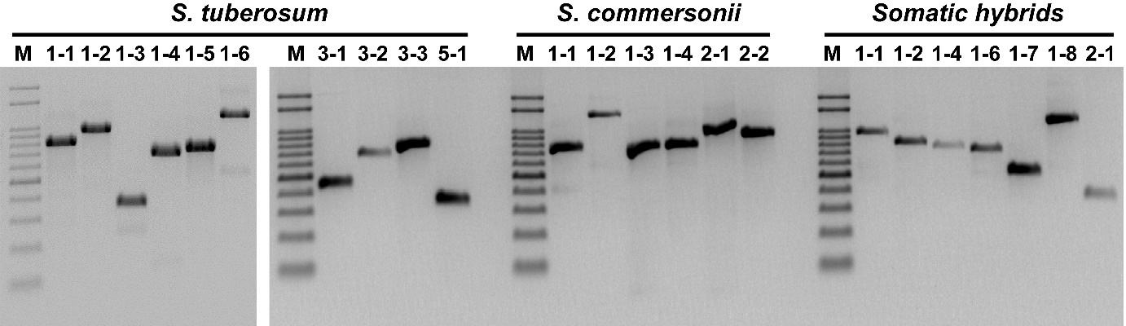
Figure S1. Validation of complete mitogenome sequence using type-specific PCR primers. The detailed mt type specific PCR primers information was shown in (Table S1). The agarose gel electrophoresis divided into left and right was a different agarose gel.

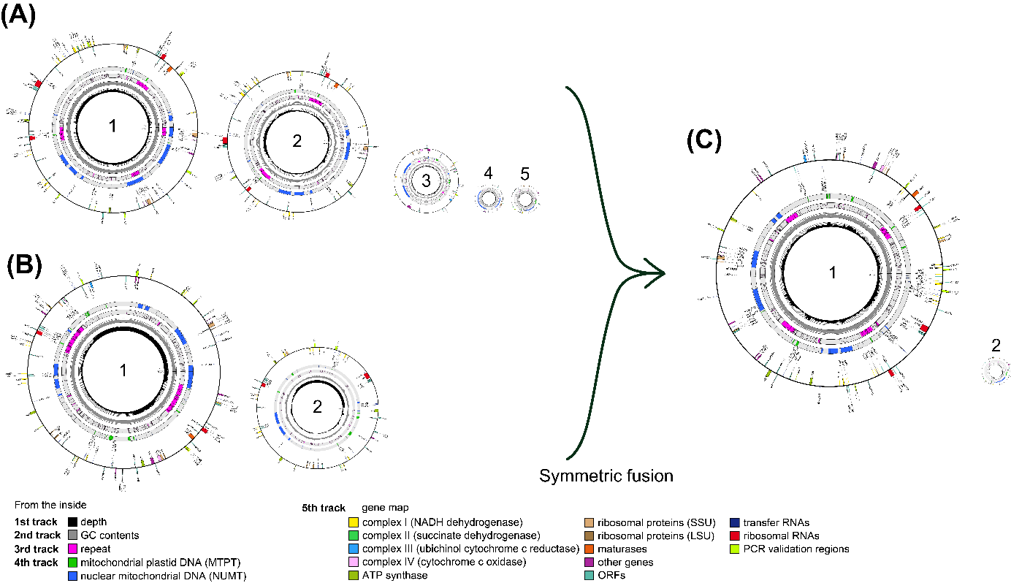
Figure S2. The circular mitogenome maps. (A) Solanum tuberosum, (B) S. commersonii, and (C) somatic hybrids between S. tuberosum and S. commersonii. The first track (innermost circle) indicates mapping depth of PE reads (each grey circle 20x, maximum 100x); The second track indicates GC contents (each grey circle 20%, maximum 100%, window size 100 bp); The third track indicates the distribution of repeats (Tables S5 and S6); the fourth track indicates sequences considered to be derived from chloroplast (green) and nuclear genome (blue)(Table 1); the fifth track (outmost circle) indicates position of predicted genes (protein-coding, rRNA and tRNA genes). The positions of PCR primers used for validation are marked as a green fluorescent color.

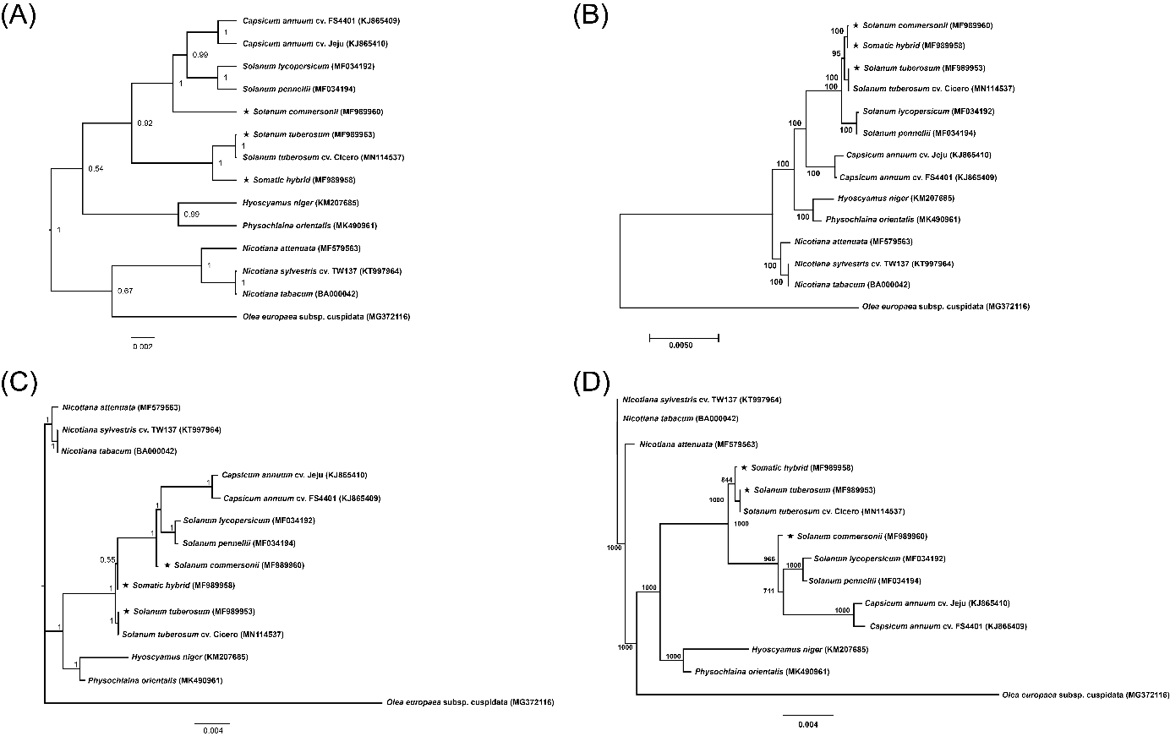
Figure S3. Bayesian and maximum likelihood (ML) phylogenetic trees of 13 Solanaceae species and 1 Oleaceae species based on commonly conserved 35 protein-coding sequences in mitogenomes. The bootstrap and posterior probability value were on the node. (A) Bayesian phylogenetic tree was constructed using BEAST program (ver. 2.6.2) with general time reversible (GTR) + gamma (Γ) nucleotide substitution model, relaxed clock log normal strict model, and 10 million MCMC chain length options. (B) ML phylogenetic tree was constructed using MEGA7 program with GTR + Γ + I (invariable) nucleotide substitution model and 1,000 bootstrapping options. (C) Bayesian phylogenetic tree was constructed using MrBayes with nucleotide model= 4by4, Nst = 6, inverse gamma (invgamma) distribution for likelihood model, and 5 million MCMC chain length options. (D) ML phylogenetic tree was constructed using PhyML (ver. 3.0) with GTR nucleotide substitution model and 1,000 bootstrapping options.

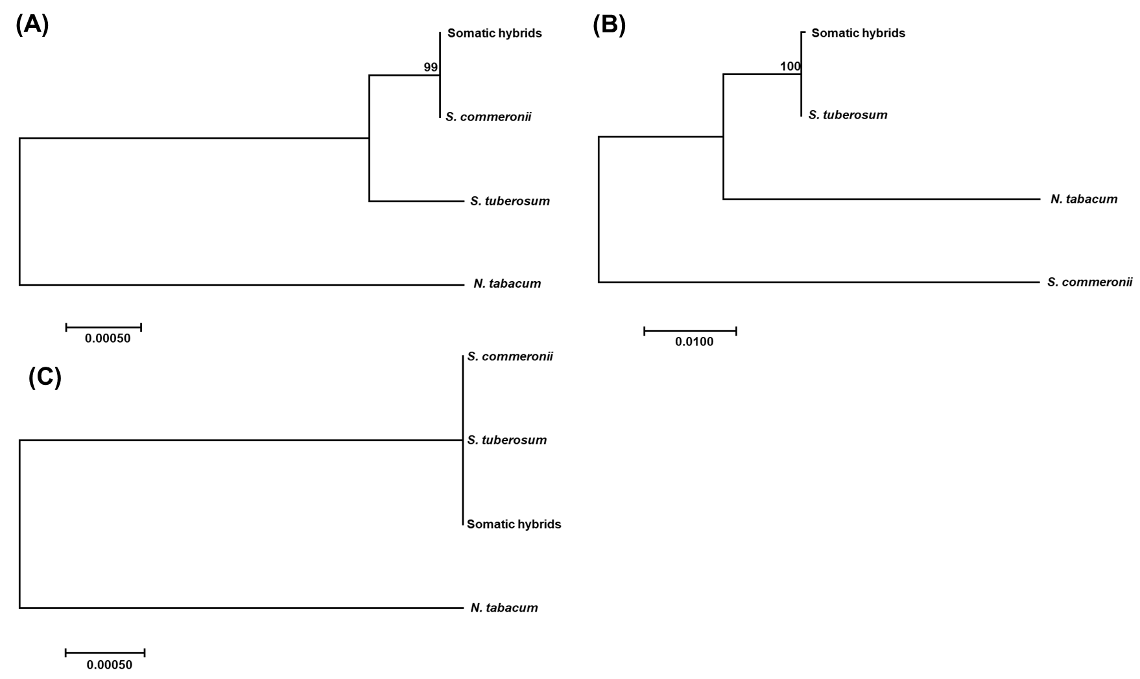
Figure S4. Maximum likelihood phylogenetic tree of somatic hybrid, and its parental species, S. tuberosum and S. commersonii using protein coding genes (CDS). (A) tree based on 12 CDSs originated from S. commeronii (nad1, nad2, nad7, nad9, sdh4, cob, cox1, ccmC, ccmFc, rps10, rpl2, matR). (B) tree based on 2 CDSs originated from S. tuberosum (atp6, ccmFN). (C) tree based on 21 CDSs undistinguishable (nad3, nad4, nad4L, nad5, nad6, sdh3, cox2, cox3, atp1, atp4, atp8, atp9, ccmB, rps3, rps4, rps12, rps13, rpl5, rpl10, rpl16, mttB).

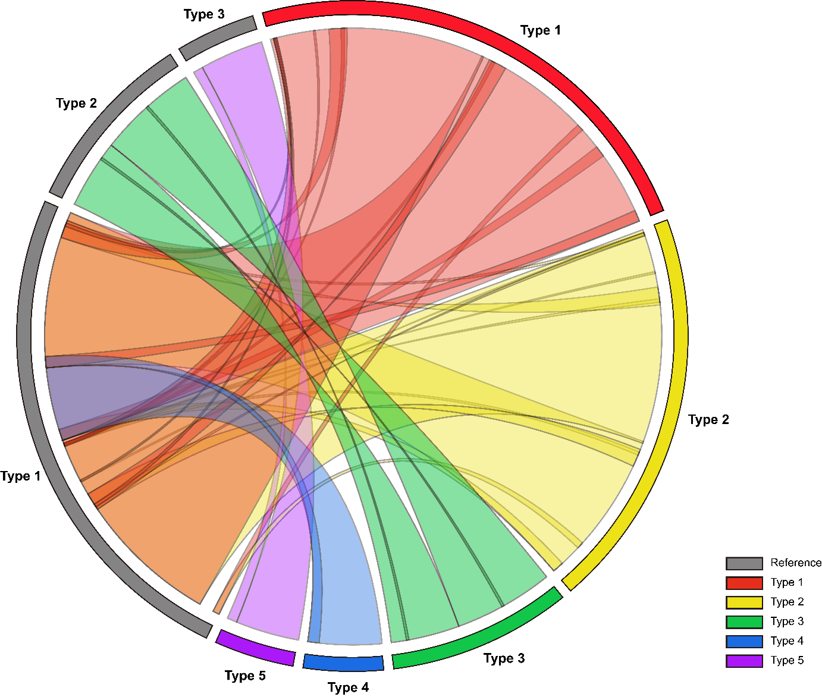Figure S5. Chord diagram of Solanum tuberosum mitogenome homology at intra-species level (S. tuberosum vs. S. tuberosum cv. Cicero). Diagram was drawn by circos R package. Genome synteny were identified by BLASTN search (cutoff E-value 1E-1, minimum match length 1,000 bp).

