Supplementary Information (SI)

S1. Calculation of Removal Efficiency and Adsorption Capacity
The dye removal efficiency (R, %) and the equilibrium adsorption capacity (q_{e}, mg/g) were determined using Eq. (37) and Eq. (43), respectively:
$\text{R=(1-}\frac{{\text{C}}_{\text{e}}}{{\text{C}}_{\text{0}}}\text{)×100\%}$ （S1）
$\text{q}\text{e}\text{=}\frac{\text{V(}{\text{C}}_{\text{0}}\text{-}{\text{C}}_{\text{e}}\text{)}}{\text{m}}$ （S2）
where C₀ and C_{e} represent the initial and equilibrium mass concentrations of the target dyes (mg/L), respectively; V is the volume of the dye solution (L); and m denotes the dry mass of the GO/CS hydrogel dosage (g).

S2. Adsorption Isotherm Models
To evaluate the intermolecular interactions at the solid-liquid interface and elucidate the energetic heterogeneity of the adsorbent surface, four classic isotherm models—namely Langmuir, Freundlich, Temkin, and Dubinin-Radushkevich (D-R)—were employed to fit the experimental data [43]. Their respective equations are expressed as follows:
Langmuir Model:
$\frac{\text{1}}{{\text{q}}_{\text{e}}}\text{=}\frac{\text{1}}{{\text{q}}_{\text{max}}}\text{+}\frac{\text{1}}{{\text{C}}_{\text{e}}}\text{(}\frac{\text{1}}{{\text{q}}_{\text{max}}{\text{K}}_{\text{L}}}\text{)}$ （S3）
where q_{e} is the equilibrium adsorption capacity (mg/g); q_{max} is the theoretical maximum monolayer adsorption capacity (mg/g); C_{e} is the equilibrium mass concentration of the dye (mg/L); and K_{L} is the Langmuir adsorption constant (L/mg).
Freundlich Model:
$\text{ln}{\text{q}}_{\text{e}}\text{=ln}{\text{K}}_{\text{F}}\text{+}\frac{\text{1}}{\text{n}}\text{ln}{\text{C}}_{\text{e}}$ （S4）
where K_{F} is the Freundlich constant related to the adsorption capacity, and 1/n is the dimensionless heterogeneity factor representing the adsorption intensity.
Temkin Model:
${\text{q}}_{\text{e}}\text{=}{\text{B}}_{\text{1}}\text{ln}{\text{K}}_{\text{T}}\text{+Bln}{\text{C}}_{\text{e}}$ （S5）
${\text{B}}_{\text{1}}\text{=}\frac{\text{RT}}{\text{b}}$ （S6）
where K_{T} is the Temkin equilibrium binding constant (L/mol); B₁ is the Temkin constant related to the heat of adsorption (J/mol); R is the ideal gas constant (8.314 J/(mol·K); and T is the absolute temperature (K).
Dubinin-Radushkevich (D-R) Model:
$\text{ln}{\text{Q}}_{\text{e}}\text{=ln}{\text{Q}}_{\text{m}}\text{-}{\text{K}}_{\text{D}}{\text{ε}}^{\text{2}}$ （S7）
$\text{ε=RTln(1+}\frac{\text{1}}{{\text{C}}_{\text{e}}}\text{)}$ （S8）
$\text{E=}\frac{\text{1}}{\sqrt{\text{(2K)}}}$ （S9）
where K_{D} is the activity coefficient related to the mean free energy of adsorption (mol²/kJ²); q_{m} is the theoretical monolayer saturation capacity (mol/g); varepsilon represents the Polanyi potential; and T is the absolute temperature (K). E denotes the mean free energy of adsorption (kJ/mol), which serves as a criterion to distinguish between physical adsorption (E<8 kJ/mol) and chemical adsorption (E > 8 kJ/mol).

S3. Adsorption Kinetics and Mass Transfer Models
To decouple the rate-controlling steps and the internal mass transfer resistance during the adsorption process, the experimental data were analyzed using the pseudo-first-order, pseudo-second-order, intra-particle diffusion, and Bangham models [44]:Pseudo-first-order and Pseudo-second-order Models:
$\text{ln(}{\text{q}}_{\text{e}}\text{-}{\text{q}}_{\text{t}}\text{)=ln}{\text{q}}_{\text{e}}\text{-}\frac{{\text{K}}_{\text{1}}}{\text{2.303}}$ （S10）
$\frac{\text{t}}{{\text{q}}_{\text{t}}}\text{=}\frac{\text{1}}{{\text{K}}_{\text{2}}{{\text{q}}_{\text{e}}}^{\text{2}}}\text{+}\frac{\text{1}}{{\text{q}}_{\text{e}}}\text{t}$ （S11）
where q_{t} is the adsorption capacity at time t (mg/g); k₁(min⁻¹) and k₂ (g/(mg·min)) are the rate constants of the pseudo-first-order and pseudo-second-order kinetic models, respectively.
Intra-particle Diffusion Model (Weber-Morris):
${\text{q}}_{\text{t}}\text{=}{\text{K}}_{\text{id}}{\text{t}}^{\text{0.5}}\text{+C}$ （S12）

where k_{id} is the intra-particle diffusion rate constant mg/(g·min^{0.5}), and C is the intercept proportional to the boundary layer thickness.
Bangham Model:
$$\text{loglog[}\frac{{\text{C}}_{\text{0}}}{{\text{C}}_{\text{0}}\text{-}{\text{q}}_{\text{t}}\text{m}}\text{]=log[}\frac{{\text{k}}_{\text{0}}\text{m}}{\text{2.303}}\text{]+αlogt}$$
（S13）
where k_{B} and α are the Bangham constants corresponding to the pore diffusion behavior.

S4.Adsorption Thermodynamic Parameters
The standard Gibbs free energy change (Δ G), enthalpy change (ΔH), and entropy change (ΔS) of the adsorption system were evaluated using the following van't Hoff equations [49]:
$$\text{ln}{\text{K}}_{\text{c}}\text{=-}\frac{\text{∆H}}{\text{RT}}\text{+}\frac{\text{∆S}}{\text{R}}$$
（S14）
$$\text{∆G=-RTln}{\text{K}}_{\text{c}}$$
（S15）
${\text{K}}_{\text{c}}\text{=}\frac{{\text{C}}_{\text{Ae}}}{{\text{C}}_{\text{e}}}$ （S16）
where K_{c} is the dimensionless thermodynamic equilibrium constant (Note: K_{c} must be converted into a dimensionless form using density and molecular weight calibrations prior to thermodynamic calculations).

S5. Supplementary Figures Captions

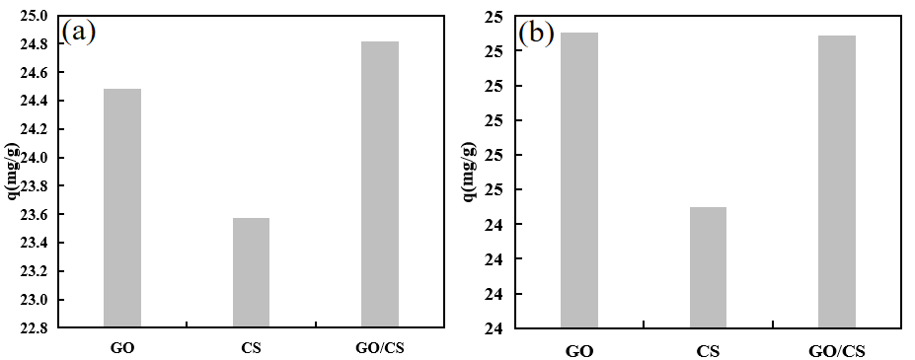
Fig. S1 Comparison of macroscopic adsorption capacities of pristine GO, pure CS, and GO/CS composite hydrogel for (a) MB and (b) MG.

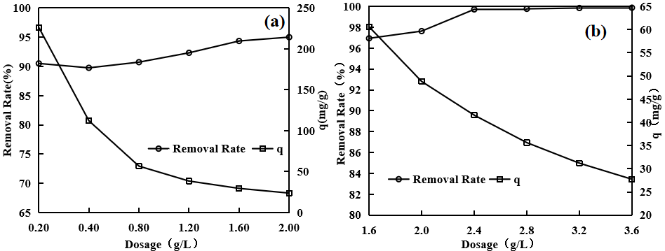
Fig. S2 Effect of composite hydrogel dosage on the adsorption performance toward (a) MB and (b) MG.

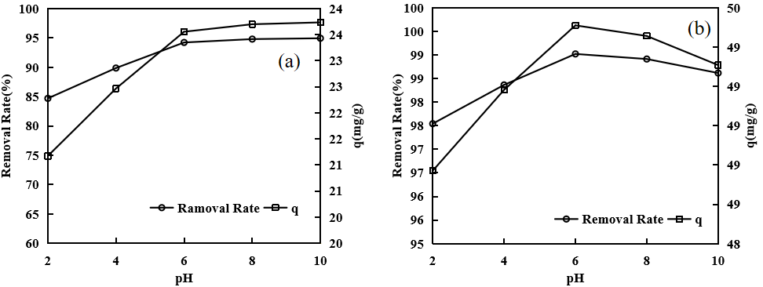

Fig. S3 Effects of initial solution pH on the adsorption of (a) MB and (b) MG onto GO/CS.

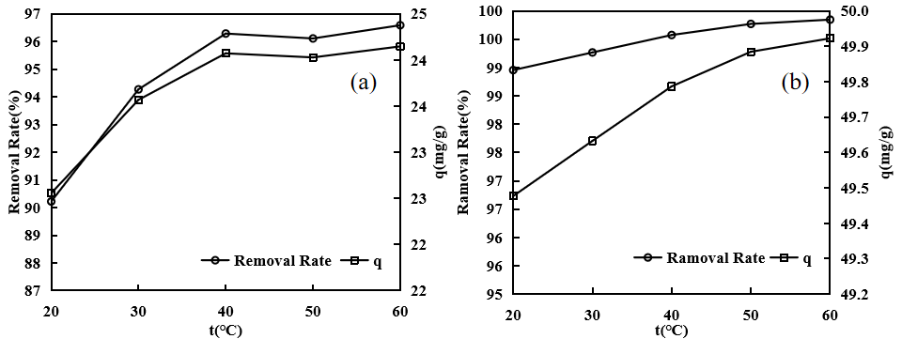
Fig. S4 Effect of reaction temperature on the adsorption of (a) MB and (b) MG by GO/CS.

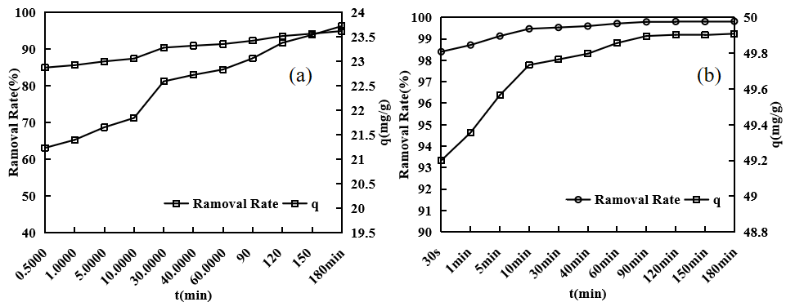
Fig. S5 Kinetic effect of contact time on the sequestration performance of GO/CS for (a) MB and (b) MG.
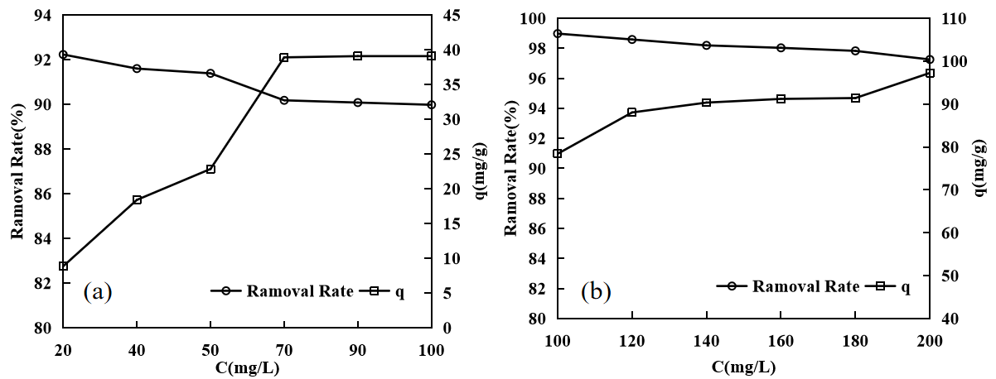
Fig. S6 Effect of initial dye concentration on the capture capacity of GO/CS for (a) MB and (b) MG.

Fig. S7 Linear van't Hoff thermodynamic fitting for the adsorption of MB onto the GO/CS system.

Fig. S8 Linear van't Hoff thermodynamic fitting for the adsorption of MG onto the GO/CS system.
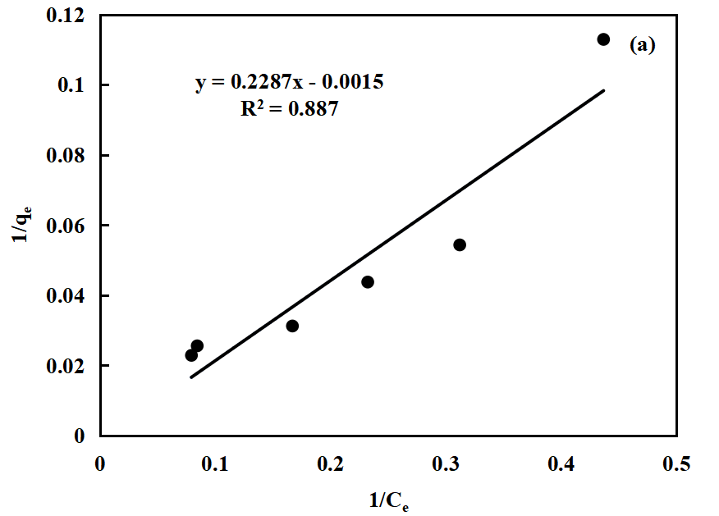 | 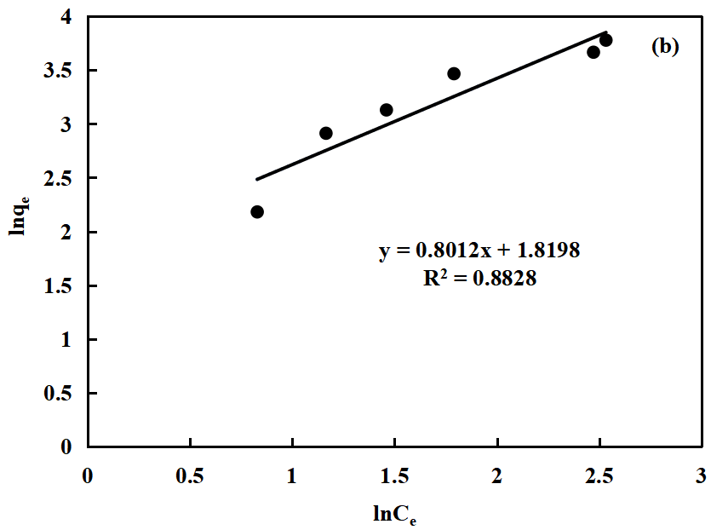
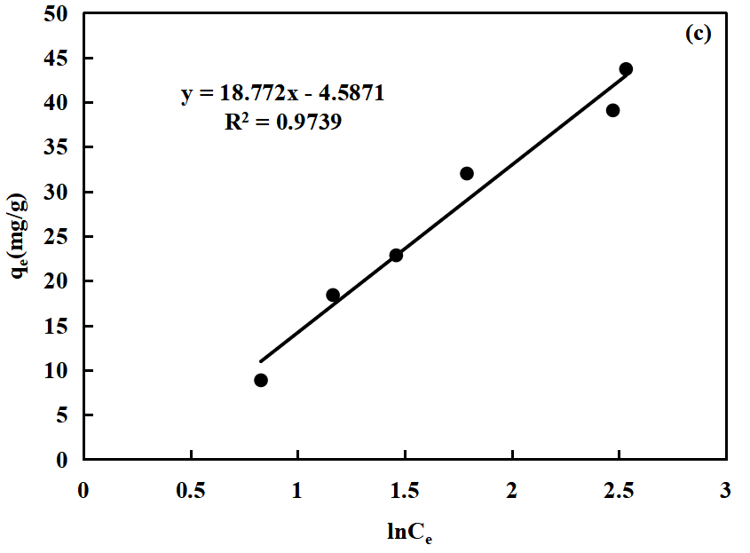 | 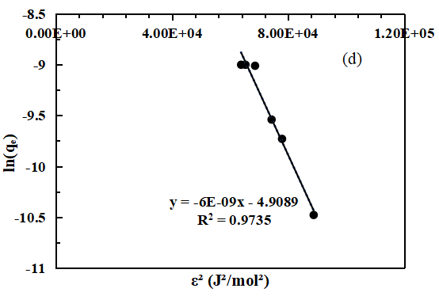
Fig. S9 Non-linear/linear fitting evaluation of adsorption isotherms for MB: (a) Langmuir, (b) Freundlich, (c) Temkin, and (d) Dubinin-Radushkevich (D-R) models.

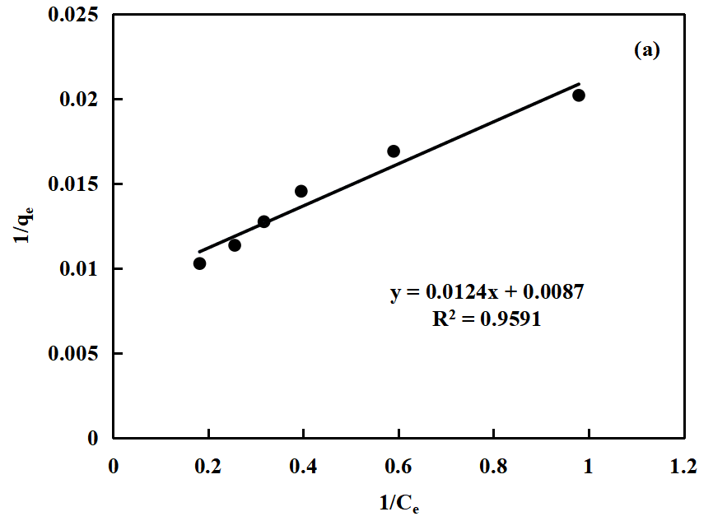 | 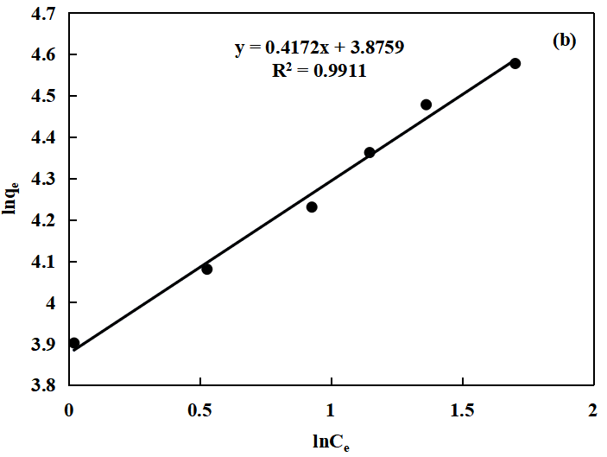
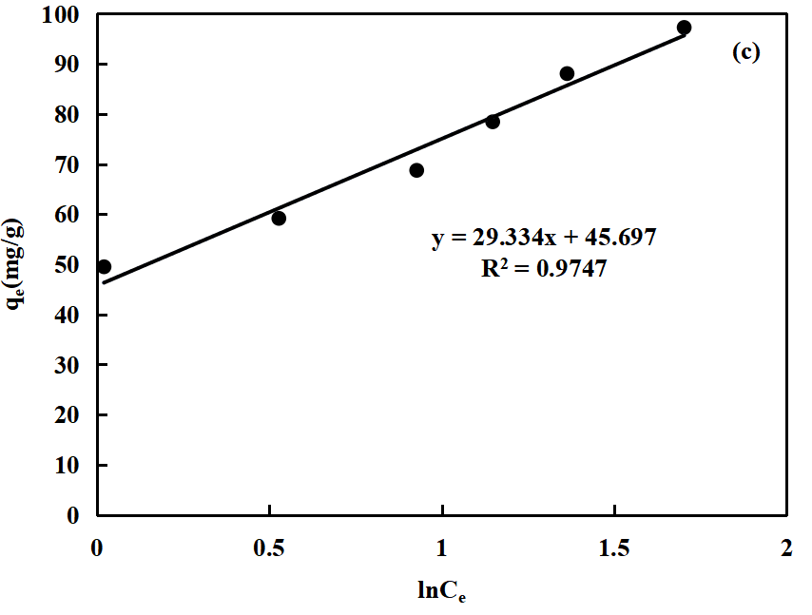 | 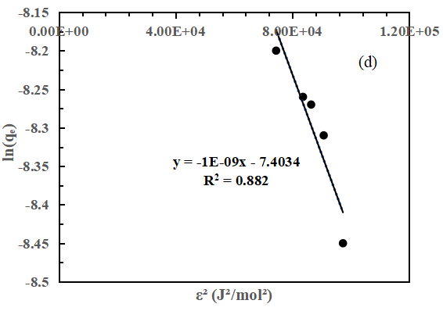
Fig. S10 Non-linear/linear fitting evaluation of adsorption isotherms for MG: (a) Langmuir, (b) Freundlich, (c) Temkin, and (d) Dubinin-Radushkevich (D-R) models.

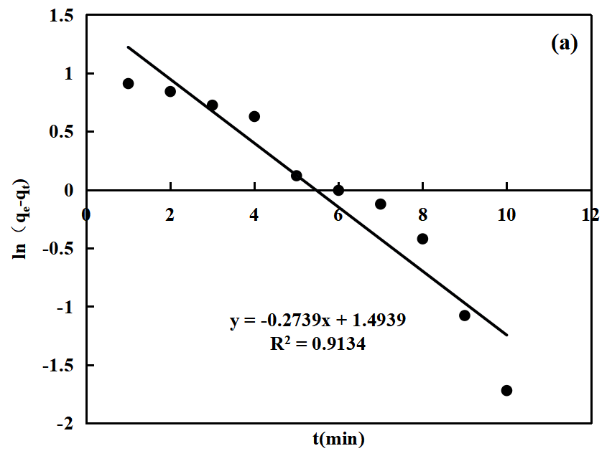 | 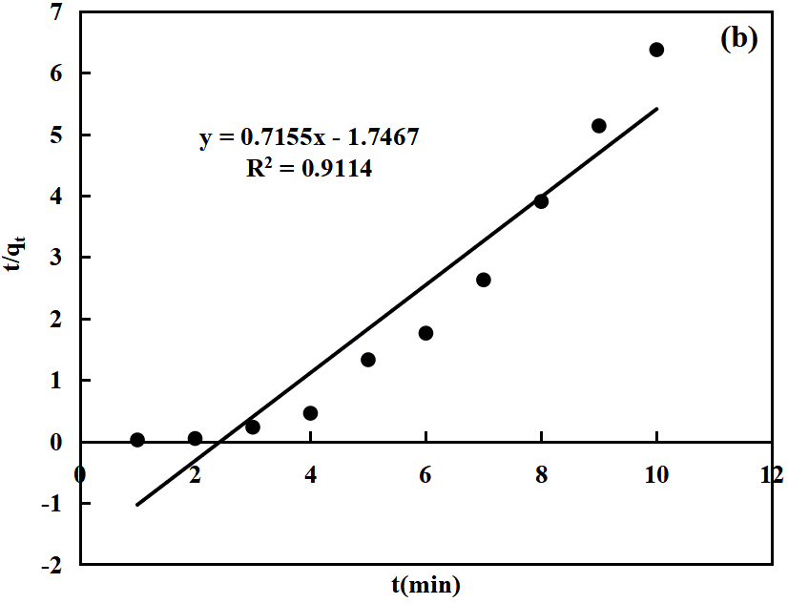
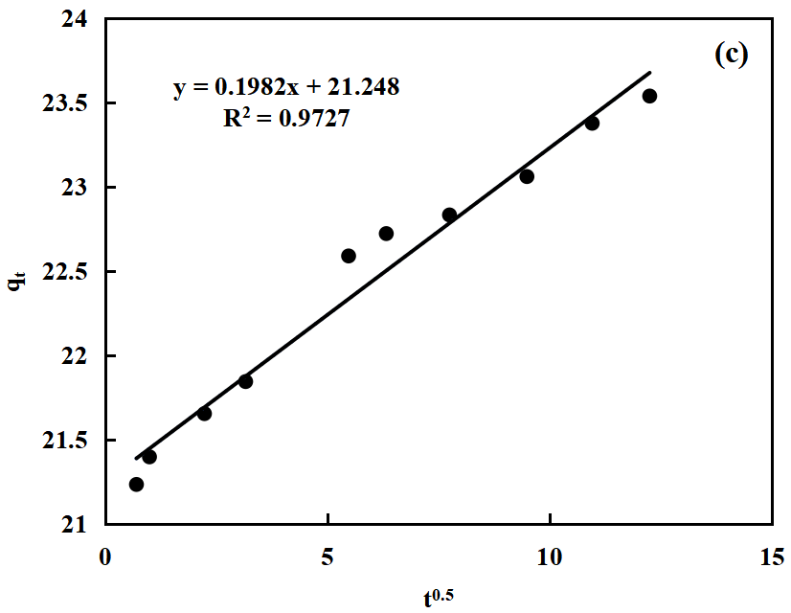 | 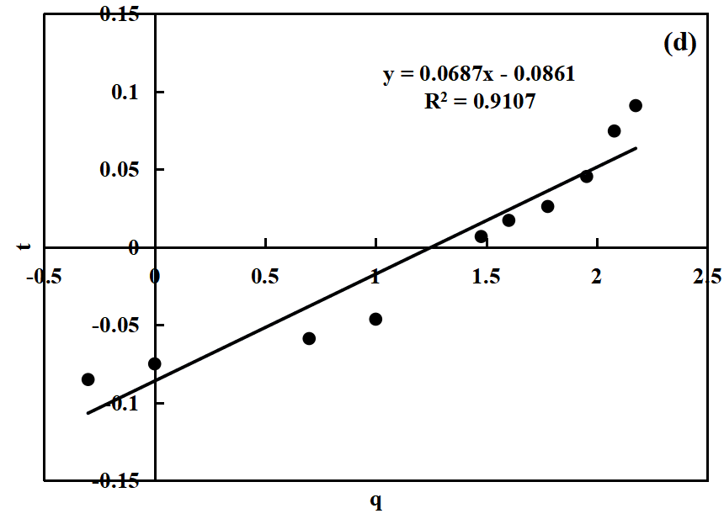
Fig. S11 Multi-scale kinetic and mass transfer resistance model fittings for MB adsorption: (a) pseudo-first-order, (b) pseudo-second-order, (c) intra-particle diffusion, and (d) Bangham pore diffusion models.

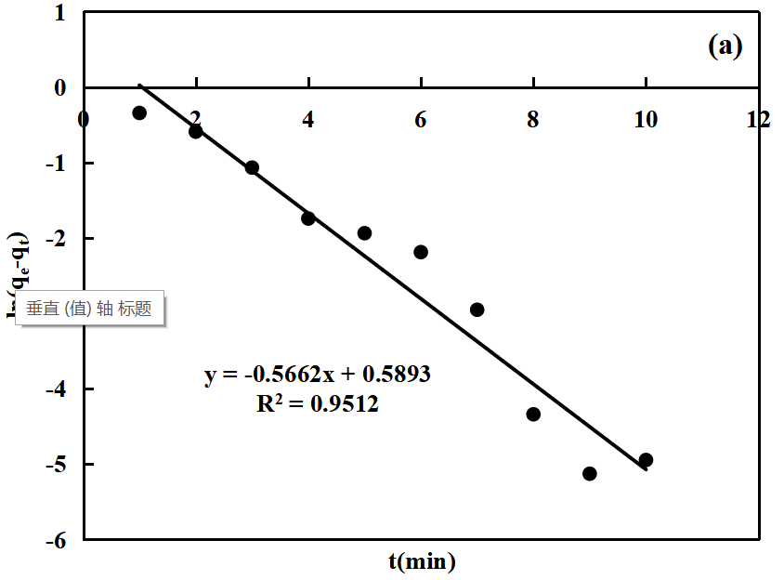 | 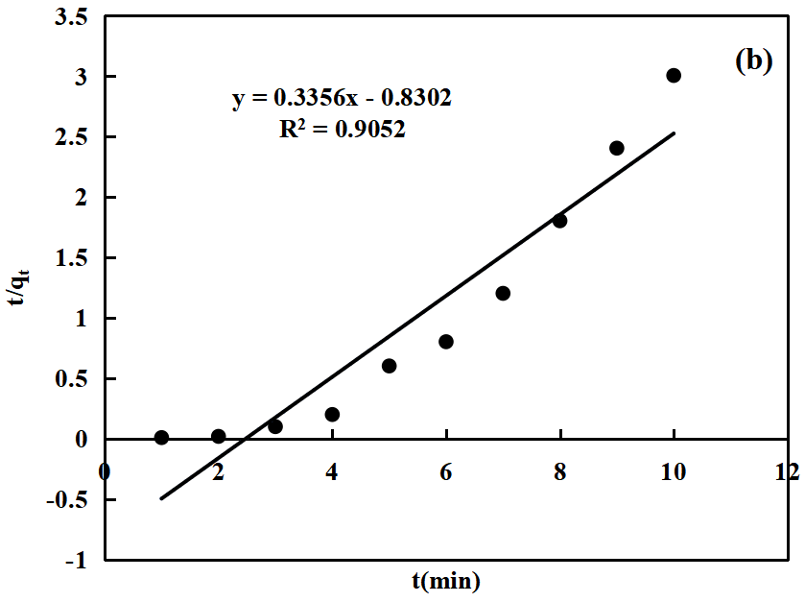
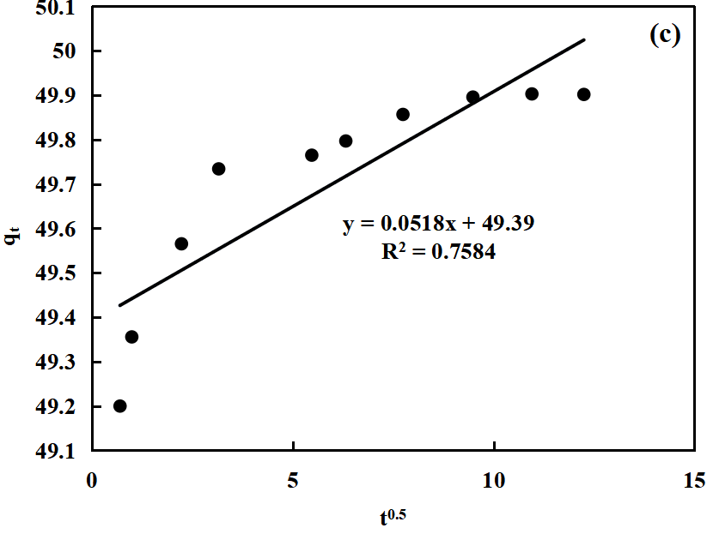 | 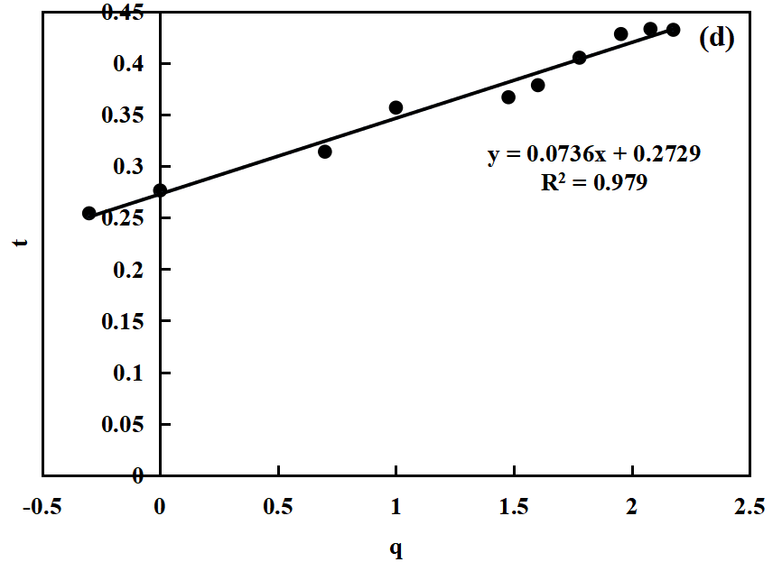
Fig. S12 Multi-scale kinetic and mass transfer resistance model fittings for MG adsorption: (a) pseudo-first-order, (b) pseudo-second-order, (c) intra-particle diffusion, and (d) Bangham pore diffusion models.

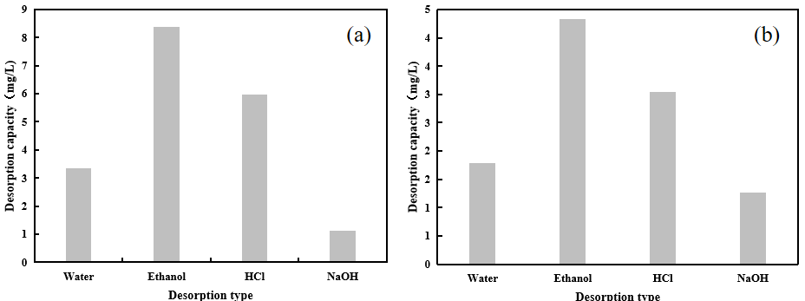
Fig. S13 Comparative evaluation of elution efficiencies of different physicochemical eluents for the desorption of (a) MB and (b) MG from the composite skeleton.

