Breaking the Evidence Bottleneck: A Hybrid Artificial Intelligence and Human Pipeline to Map the over Thirty-Five Years Immunomodulatory Legacy of Lactobacillus rhamnosus GG
Melissa Rocca¹, Daniele Noviello², Chiara Amoroso³, Maurizio Vecchi^{2,3}, Flavio Caprioli^{2,3} Federica Facciotti¹

Supplementary material: Supplementary Figures S1-S5; Supplementary Tables ST1-ST11

Supplementary figures
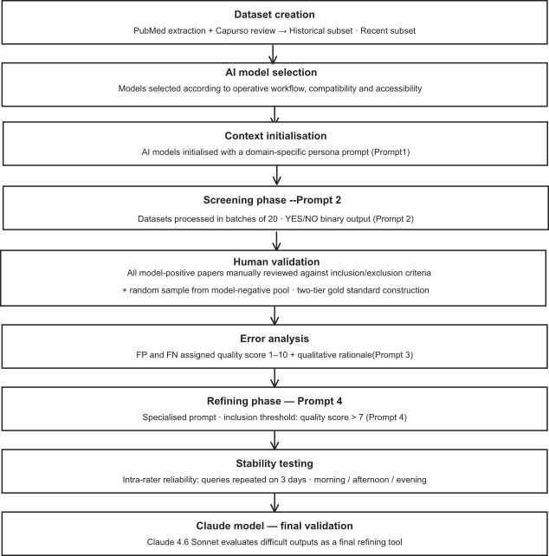

Figure S1 Schematic flowchart of the multi-stage LLM-assisted biocuration and validation pipeline. The sequential diagram illustrates the methodological architecture developed to screen, evaluate, and refine the Lactobacillus rhamnosus GG (LGG) literature datasets. The workflow proceeds through nine operational tiers: (1) Dataset creation, involving PubMed extraction cross-referenced with benchmark literature; (2) AI model selection, based on accessibility and functional compatibility; (3) Context initialisation, establishing domain-specific persona parameters (Prompt 1); (4) Screening phase, executing batch-processing for binary classification (Prompt 2); (5) Human validation, constructing a two-tier gold standard benchmark; (6) Error analysis, generating quality scores (1–10) and qualitative rationales for misclassified documents (Prompt 3); (7) Refining phase, applying a strict inclusion threshold (Prompt 4); (8) Stability testing, evaluating intra-rater reliability across distinct diurnal temporal intervals; and (9) Claude model validation, utilizing Claude 4.6 Sonnet as a final deterministic arbiter for high-uncertainty outputs.

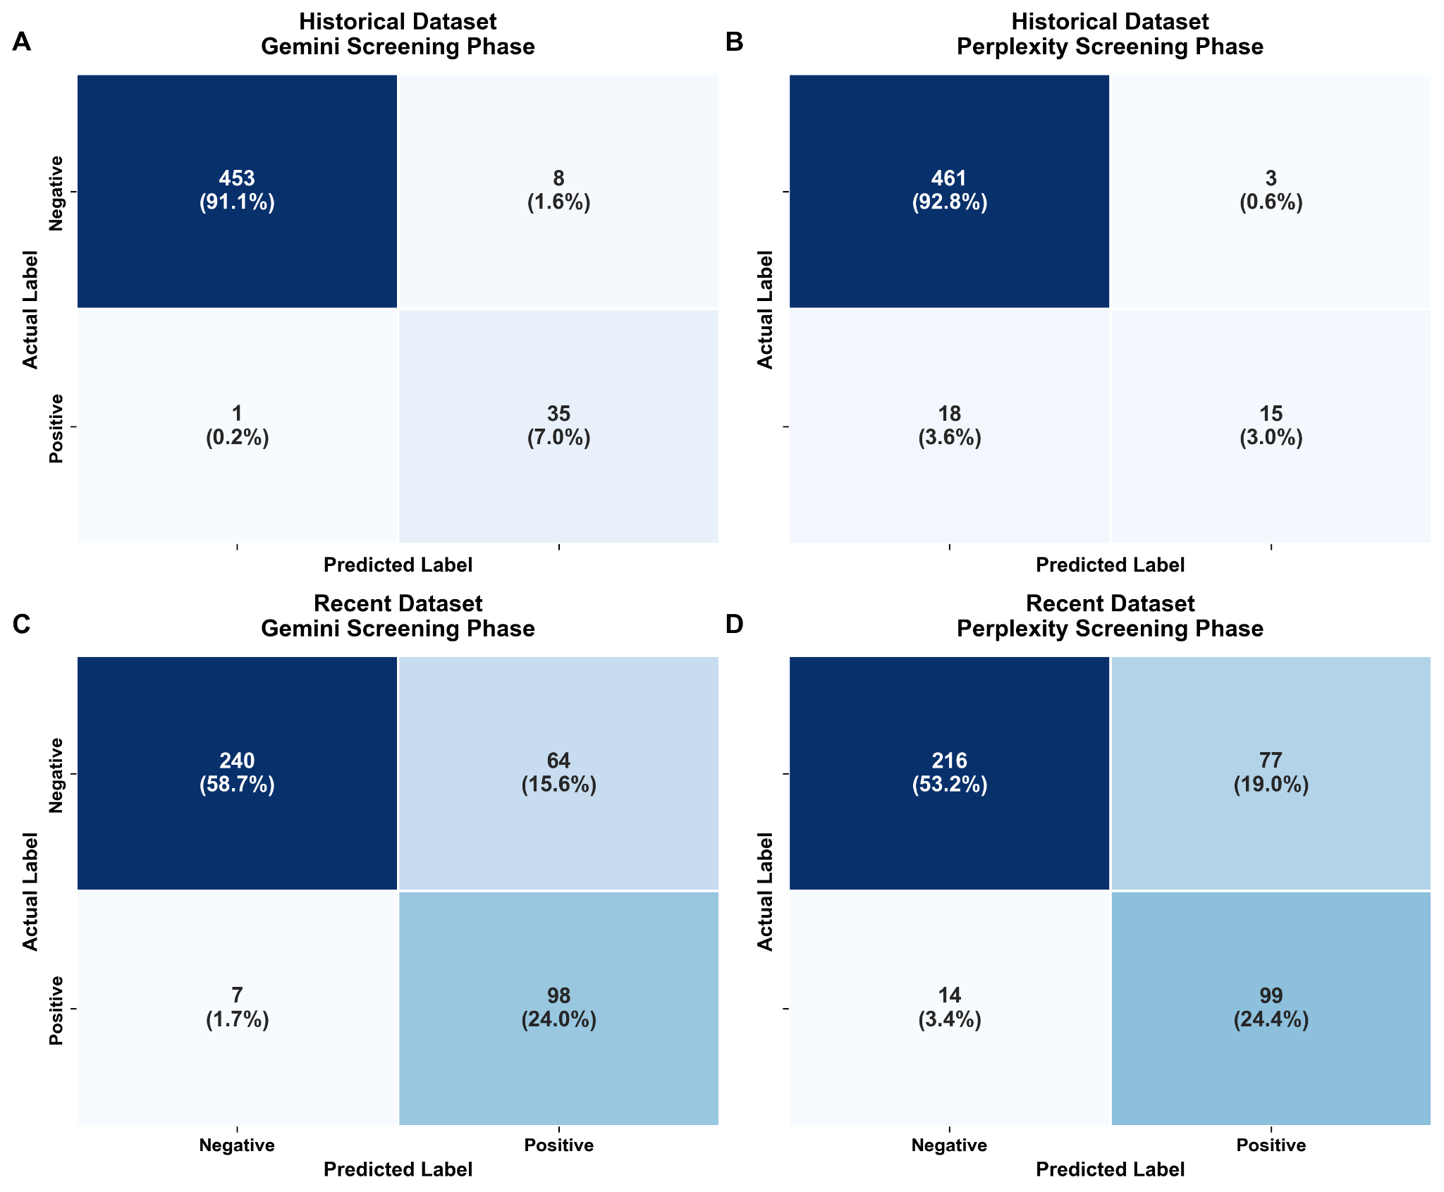
Figure S2. Binary classification performance profiling via confusion matrices during the primary Screening Phase. The panel grid illustrates the baseline performance of Large Language Models (LLMs) in separating relevant from non-relevant scientific abstracts across historical and contemporary literature cohorts. (A) Gemini performance on the Historical dataset (1989–2019). (B) Perplexity performance on the Historical dataset. (C) Gemini performance on the Recent dataset (2019–2026). (D) Perplexity performance on the Recent dataset. Inside each cell, absolute study counts (n) are cross-referenced with their respective percentage weight relative to the total dataset size. The matrix diagonals map exact algorithmic alignment with human-curated ground truth (True Negatives, top-left; True Positives, bottom-right).

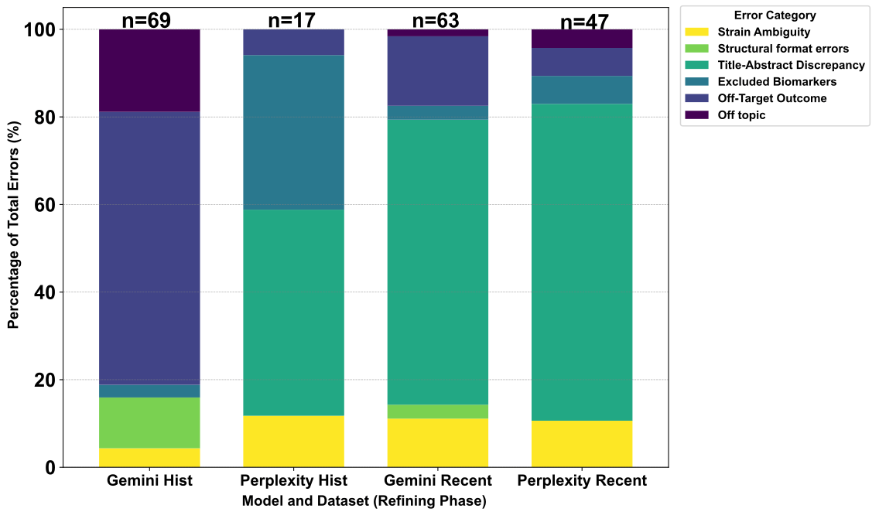

Figure S3. Qualitative distribution and deconvolution of screening errors in the refining phase. The 100% stacked bar chart illustrates the relative percentage contribution of distinct error modes across models and publication eras (Gemini Historical, n=69; Perplexity Historical, n=17; Gemini Recent, n=63; Perplexity Recent, n=47). Error profiles are stratified into six human-validated categories: Strain Ambiguity (yellow), Structural format errors (light green), Title-Abstract Discrepancy (teal), Excluded Biomarkers (blue-grey), Off-Target Outcome (dark blue), and Off topic (purple). Total absolute error counts (n) are reported above each respective column, mapping the shift from operational/formatting constraints toward semantic boundary complexities in contemporary literature subsets.

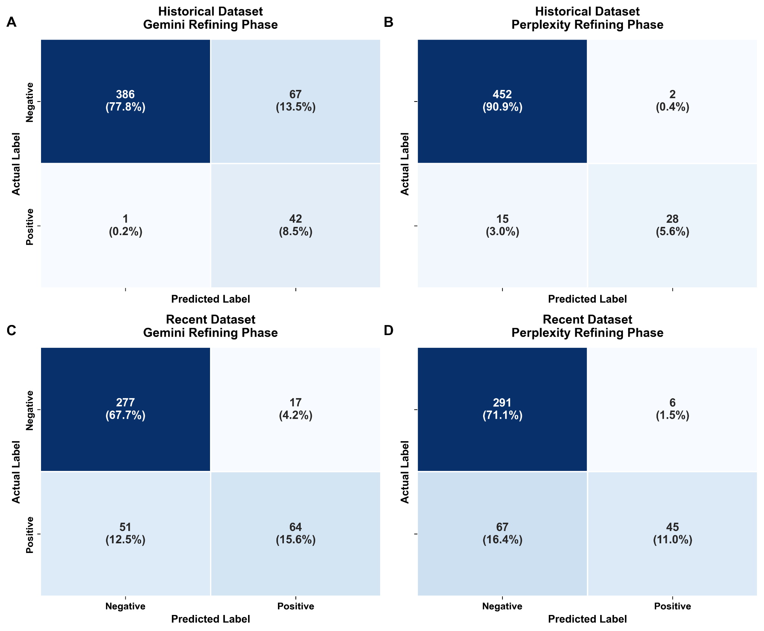
Figure S4. Multi-model confusion matrices tracking classification performance during the Refining Phase. The panels show the evolution of model accuracy and error resolution after deploying specialized prompting structures (Prompt 4) utilizing a strict quality selection threshold (Score > 7). Plots are stratified by model and publication era: (A) Gemini Refining on Historical data, (B) Perplexity Refining on Historical data, (C) Gemini Refining on Recent data, and (D) Perplexity Refining on Recent data. Values specify absolute document counts (n) and relative percentage distributions, highlighting the programmatic reduction of classification errors following targeted prompt optimization.

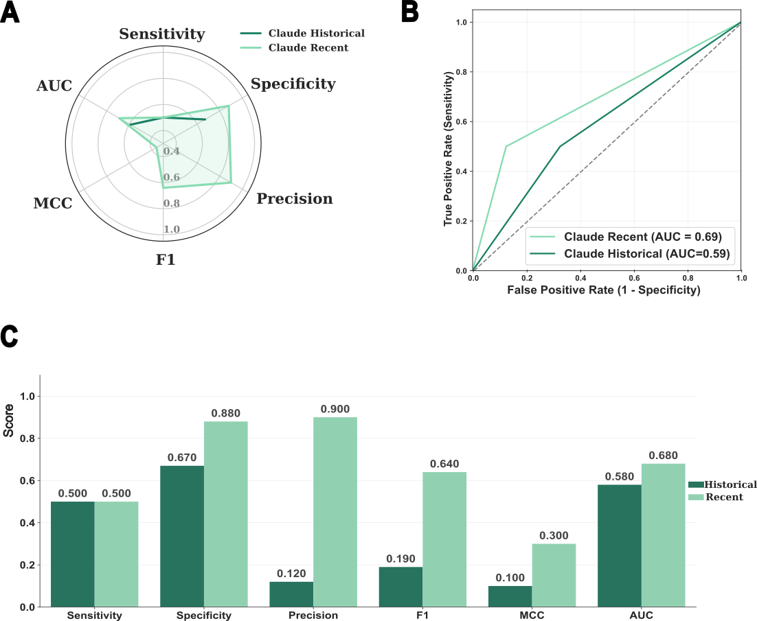
Figure S5. Comprehensive classification performance and evaluation metrics of Claude within the literature processing workflow (A) Radar chart mapping Claude's classification behavior across the historical and recent literature datasets. Performance is balanced and compared across six core statistical dimensions: Sensitivity, Specificity, Precision, F1-Score, Matthews Correlation Coefficient (MCC), and Area Under the ROC Curve (AUC), normalized on a 0.0 to 1.0 scale. (B) Bar chart detailing the explicit numerical values for each statistical metric achieved by Claude. Dark green bars represent the historical dataset performance, while light green bars illustrate the recent literature dataset performance (C) ROC curve analysis comparing Claude's classification performance between the historical dataset (AUC = 0.59, dark green line) and the recent dataset (AUC = 0.69, light green line).

Supplementary Tables: ST1-ST11

Table ST1: Excel sheet, Historical dataset
Table ST2: Excel sheet, Recent dataset

Table ST3 Performance metrics of Gemini and Perplexity for the Prompt 2

Metrics | Historical Dataset |  | Recent Dataset
 | Gemini | Perplexity | Gemini | Perplexity
Sensitivity | 0.972 | 0.455 | 0.933 | 0.876
Specificity | 0.983 | 0.994 | 0.789 | 0.737
Accuracy | 0.982 | 0.958 | 0.826 | 0.776
Precision | 0.814 | 0.833 | 0.605 | 0.562
F1-Score | 0.886 | 0.588 | 0.734 | 0.685
MCC | 0.887 | 0.596 | 0.627 | 0.551
AUC | 0.977 | 0.724 | 0.861 | 0.807
Table ST4 Cohen Kappa’s values across both datasets for all models
Metrics | Historical Dataset |  | Recent Dataset
 | Gemini | Perplexity | Gemini | Perplexity
Prompt 2 | 0.876 | 0.568 | 0.614 | 0.524
Prompt 3 | 0.489 | 0.749 | 0.548 | 0.460

Table ST5 Sensitivity, specificity, precision, F1-Score, MCC and AUC values of Gemini and Perplexity Prompt 3 divided into the two subsets.

Metrics | Historical Dataset |  | Recent Dataset
 | Gemini | Perplexity | Gemini | Perplexity
Sensitivity | 0.977 | 0.651 | 0.557 | 0.402
Specificity | 0.852 | 0.996 | 0.942 | 0.980
Precision | 0.385 | 0.933 | 0.790 | 0.882
F1-Score | 0.553 | 0.767 | 0.653 | 0.552
MCC | 0.563 | 0.763 | 0.563 | 0.515
AUC | 0.946 | 0.647 | 0.749 | 0.700

Table ST6: OPA, Fleiss’ Kappa coefficient and interpretation for the two subsets (historical and recent) for Gemini and Perplexity. *OPA: Overall Percentage Agreement

Metrics | Historical Dataset |  | Recent Dataset
 | Gemini | Perplexity | Gemini | Perplexity
OPA* | 68.33% | 80% | 73.33% | 83.33%
Fleiss’ Kappa | 0.367 | 0.600 | 0.467 | 0.667

Table ST7 Values of ICC2 and p for Gemini and Perplexity on the two datasets

Metrics | Historical Dataset |  | Recent Dataset
 | Gemini | Perplexity | Gemini | Perplexity
ICC2 | 0.415 | 0.297 | 0.523 | 0.317
95% CI | [0-23-0.60] | [0.10-0.50] | [0.10-0.50] | [0.13-0.52]
p-value | 6.5*10⁻⁶ | 1.1*10⁻³ | 4.5*10⁻⁹ | 1.3*10⁻⁴
Table ST8 Mean scores and SD of Gemini and Perplexity
Metrics | Historical Dataset |  | Recent Dataset
 | Gemini | Perplexity | Gemini | Perplexity
Mean Score | 0.617 | 0.409 | 0.543 | 0.378
SD | 0.258 | 0.197 | 0.295 | 0.207
Min | 0.1 | 0.1 | 0.1 | 0.1
Max | 1.0 | 0.9 | 1.0 | 0.9

Table ST9 Sensitivity, specificity, precision, F1-Score, MCC and AUC values of Claude across the two subsets.

Metrics | Historical Dataset | Recent Dataset
Sensitivity | 0.500 | 0.500
Specificity | 0.674 | 0.875
Precision | 0.118 | 0.895
F1-Score | 0.190 | 0.642
MCC | 0.100 | 0.360
AUC | 0.587 | 0.688

Table ST10 Cohen Kappa’s values across both datasets for Claude *Pilot study on complex subsample (n=100)
 | Historical dataset | Recent dataset
Prompt 3 | 0.07 | 0.3

Table ST11: Summary of immunological outcomes

Cytokine | Modulation | Predominant  patwhay | Historical  studies (n) | Recent  studies (n) | Dataset
TNF | Down | NF-κB inhibition, TLR signaling | 19 | 49 | H&R
IL-6 | Down | NF-κB/MAPK, JAK/STAT3 | 5 | 43 | H&R
IL-1β | Down | NLRP3 inflammasome, NF-κB/MAPK | 0 | 36 | R
IL-10 | Up | Treg induction, STING/NF-κB | 9 | 27 | H&R
IFN- γ | Up/Down | Th1/NK activation, Treg/Th1 balance | 13 | 16 | H&R
IL-22 | Up | AhR/ILC3 activation | 0 | 4 | R
Type I IFN | Up | cGAS-STING, RIG-I, NOD2 | 0 | 2 | R
IgA | Up | Mucosal IgA secretion | 7 | 6 | H&R

