Supplementary Materials
Synthesis of MnO₂ Nanostructures for Supercapacitor is an Efficient Electrode Material to Improve Energy Storage: Effect of Annealing Temperature

Suprimkumar D. Dhas^{a,h*,1}, Pragati N. Thonge^{b}, Aqsa Ghazalª, Aravind H. Patil^{c}, Teja M. Patil^{d}, Tushar T. Bhosale^{e}, D. Karthigaimuthu^{f}, Saifan M. Shaikh^{g}, Falah Awwad^{a,h*}
ªIndustry 4.0, UAEU Science & Innovation Park, United Arab Emirates University, Al Ain, UAE
^{b}School of Life Science, Punyashlok Ahilyadevi Holkar, Solapur University, Solapur, Maharashtra 413-255, India
^{c}Center of Technology Development, Korea Polar Research Institute, Incheon 21990, Republic of Korea
^{d}Department of Physics, Bhogawati Mahavidyalaya, Kurukali, Maharastra 416-211. India
^{e}Thin film Nanomaterials Laboratory, Department of Physics, Shivaji University, Kolhapur, Maharashtra 416004, India
^{f}Department of Mechanical and Aerospace Engineering, United Arab Emirates University, Al Ain 15551, United Arab Emirates
^{g}Jaysingpur College, Jaysingpur, 416101, Maharashtra, India
^{h}Electrical and Communication Engineering Department, United Arab Emirates University, Al Ain, UAE

*Corresponding authors:
Dr. Suprimkumar D. Dhas
E-mail: suprimkumardhas@gmail.com
Prof. (Dr.) Falah Awwad
E-mail: F_awwad@uaeu.ac.ae

Preparation of MO-1, MO-2 and MO-3 working electrodes
Initially, the preparation of nickel foam (NF) with a thickness of 1.6 mm involved ultrasonic cleaning. This cleansing process utilized ethanol, hydrochloric acid at a concentration of 4 M, and double-distilled water, each for a duration of 30 min. The purpose was to effectively eliminate the oxide layer along with any residual impurities, as indicated in reference [1]. In the construction of the working electrodes, a composite was prepared comprising 80% active electrode materials, including MO-1, MO-2, and MO-2 NSs. This was complemented by 10% activated carbon and a 10% PVDF inclusion as a binder, mixed in NMP. Prior to electrochemical assessments, this blend was homogenised into a uniform slurry by sonication for 30 minutes. Following sonication, this slurry was uniformly spread over a 1 cm2 area of the NF, which had been previously cleaned and dried. The drying process entailed heating at 80 °C for 3 h, resulting in a thin coating of approximately 3 mg of the active material on the NF. Electrochemical evaluations were conducted on electrodes fabricated from MO-1, MO-2 and MO-3 NPs. An SCE served as the reference in a three-electrode system to examine the electrochemical performance of the MO-1/NF, MO-2/NF, and MO-3/NF electrodes. The configuration was completed with MO-1/NF, MO-2/NF and MO-3/NF as the working electrodes, platinum as the counter electrode, and a 1 M KOH solution as the electrolyte.
Electrochemical Measurement
The MO-1/NF, MO-2/NF, and MO-3/NF electrodes are tailored and applied as working electrodes (1 cm × 1 cm), with an effective working area of 1 cm × 1 cm. A platinum foil (10 mm × 10 mm) is employed as the counter electrode and SCE (saturated calomel electrode) as reference electrode, which apply to a three-electrode system in 1 M KOH solution. The ZIVE electrochemistry workstation is used for the electrochemical measurements. CV tests are conducted in a potential range of 0−0.5 V (versus SCE) at scan rates of 10-100 mV/s. The cycling behaviour is particularly up to 5000 cycles, and GCD tests are carried out at various current densities with a potential range of 0−0.5 V (versus SCE). EIS is used to test the capacitive property at OCV (open circuit voltage) over a frequency range of 1 to 10⁵ Hz.
The ASSCs are assembled with MO-1/NF as the positive electrode and AC/NF as the negative electrode. To prepare the negative electrode, 80 wt% AC, 10 wt% carbon black, and 10 wt% PVDF in NMP solvent. The homogeneous slurry was coated onto an NF via drop casting and then dried for 4 h. The two electrodes of the ASSCs are separated by a separator (NKK, MPF30AC-100), and 1 M KOH is used as the electrolyte.

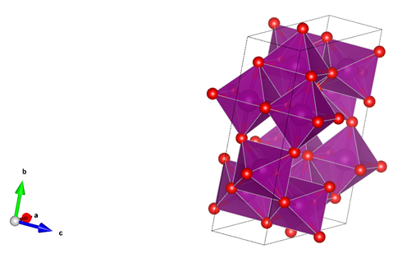
Fig. S1: 3-D crystal structure of MnO₂ polyhedral shape

.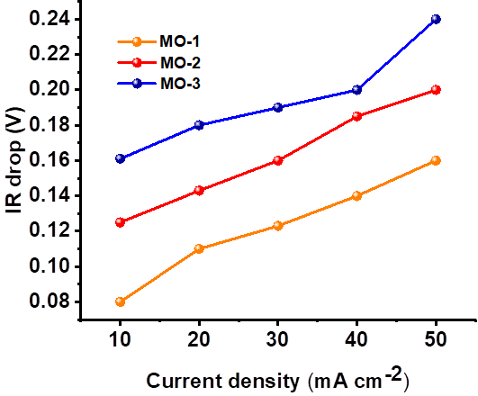
Fig. S2: Comparative plot of IR drop versus current of MO-1, MO-2 and MO-3 electrodes.
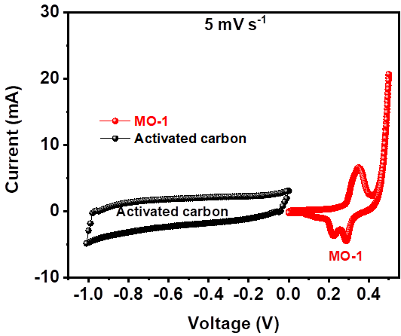
Fig. S3: Separate CV curves of the Mo-1 and AC electrode at a scan rate of 5 mV/s.

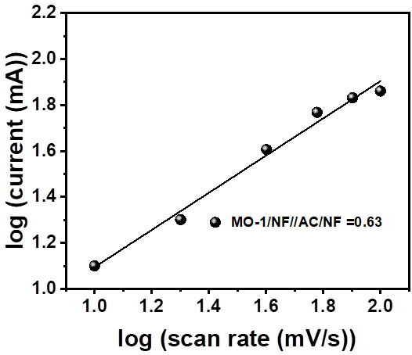
Fig. S4: The plot of log (current) Verses log (scan rate) of the ASSCs device.
Table S1: Summarized parameters such as electrode material, morphology, electrolyte used, specific capacitance, and cyclic stability of the MnO₂-based materials.
Electrode Composition | Morphology | Electrolyte Used | Specific Capacitance (F/g) | Capacitance retention (%)/over the cycle number | Reference
MnO₂ | Nanospheres | 1 M Na₂SO₄ | 206.2 @ 1.25 A/g | 72.3% /1,000 | [1]
MnO₂/rGO | Microspheres | 1 M Na₂SO₄ | 462 F/g @1 A/g | - | [2]
α-MnO₂ | Nanowires | 1 M Na₂SO₄ | 180 @1 A/g | 78% /2,000 | [3]
α-MnO₂ | Hollow spheres | 1 M Na₂SO₄ | 167 @2.5 mA | 89% /350 | [4]
Defective MnO₂ | Porous structure | 1 M Na₂SO₄ | 202 @1 A/g | 89.4% / 4,000 cycles | [5]
α-MnO₂ | Nanorods | 1 M Na₂SO₄ | 152 @2.5 mA | 87% / 1000 | [6]
MnO₂/C | Composite | 1 M Na₂SO₄ | 152 @ 1 A/g | 83.9% /10,000 | [3]
δ-MnO₂ | Nanosheets | 1 M Na₂SO₄ | 306 @0.2 A/g | 83% /1,000 | [7]
MnOx@rGO | Microspheres | 6 M KOH | 402 | 90%/10,000 | [8]
Ni–MnO₂ | Composite | 1 M Na₂SO₄ | 379 @1 A/g | 85%/10,000 | [9]
B-doped MnO₂ | NSs | 0.5 M Na₂SO₄ | 269 @50 mV/s | - | [9]
Au–MnO₂ nanowires | Nanowires | 1 M Na₂SO₄ | 249@1 mV/s | 97% /1,000 | [9]
β-MnO₂ | Nanorods | 1 M Na₂SO₄ | 125 | - | [10]
Mn₂O₃@MnO₂ | Core–shell nanofibers | 1 M Na₂SO₄ | 225 @ 0.2 A/g | 86.5% /5,000 | [11]
Β-MnO₂ | Nanorods array | 1 M Na₂SO₄ | 237.3 @10 A/g | 79.8% /2,000 cycles | [12]
CQD-MnO₂ | Marshmallow-like | 1 M Na₂SO₄ | 189 @ 0.14 A/g | 100 % / 1200 cycle | [13]
MnO₂/CNS | Nanosheet arrays | 1 M Na₂SO₄ | 339 @ 0.5 A/g | 96.1% /5000 cycles | [14]
MnO_{x}/PPy | nanowires core/sheath structure | 1 M Na₂SO₄ | 1091.4 @ 1 A/g | 97.4% /10,000 | [15]
Cu(OH)₂@MnO₂/CF | nanorods array | 6 M KOH | 708.6 mF cm⁻² @2 mA cm⁻² | 85.17%/5000 | [16]
MnO₂ | polyhedral | 2 M KOH | 280 F/g @10 mA/g | 98.3%/5000 | This Work

References
[1] Liu J, Bao J, Zhang X, Gao Y, Zhang Y, Liu L, et al. MnO₂-based materials for supercapacitor electrodes: challenges, strategies and prospects. RSC Advances 2022;12:35556–78. https://doi.org/10.1039/d2ra06664e.
[2] Chang H. W, Huang Y. C, Chen J. L, Chen C. L, Chen J. M, Wei D. H, et al. Soft X-ray absorption spectroscopic investigation of MnO₂/graphene nanocomposites used in supercapacitor. Catalysis Today 2022;388–389:63–9. https://doi.org/10.1016/j.cattod.2020.12.030.
[3] Yin B, Zhang S, Jiao Y, Liu Y, Qu F, Wu X. Facile synthesis of ultralong MnO₂ nanowires as high performance supercapacitor electrodes and photocatalysts with enhanced photocatalytic activities. CrystEngComm 2014;16:9999–10005. https://doi.org/10.1039/c4ce01302f.
[4] Huang M, Li F, Dong F, Zhang YX, Zhang LL. MnO₂-based nanostructures for high-performance supercapacitors. Journal of Materials Chemistry A 2015;3:21380–423. https://doi.org/10.1039/c5ta05523g.
[5] Singu BS, Yoon KR. Porous manganese oxide nanospheres for pseudocapacitor applications. Journal of Alloys and Compounds 2017;695:771–8. https://doi.org/10.1016/j.jallcom.2016.08.239.
[6] Tang N, Tian X, Yang C, Pi Z. Facile synthesis of α-MnO₂ nanostructures for supercapacitors. Materials Research Bulletin 2009;44:2062–7. https://doi.org/10.1016/j.materresbull.2009.07.012.
[7] Zhu YP, Xia C, Lei Y, Singh N, Schwingenschlögl U, Alshareef HN. Solubility contrast strategy for enhancing intercalation pseudocapacitance in layered MnO₂ electrodes. Nano Energy 2019;56:357–64. https://doi.org/10.1016/j.nanoen.2018.11.063.
[8] Jing F, Ma Z, Wang J, Fan Y, Qin X, Shao G. Oxygen vacancy inducing phase transition during charge storage in MnO_{x}@rGO supercapacitor electrode. Chemical Engineering Journal 2022;435:135103. https://doi.org/10.1016/j.cej.2022.135103.
[9] Zhang X, Liu X, Zeng Y, Tong Y, Lu X. Oxygen Defects in Promoting the Electrochemical Performance of Metal Oxides for Supercapacitors: Recent Advances and Challenges. Small Methods 2020;4:1–18. https://doi.org/10.1002/smtd.201900823.
[10] Raihana PA, Wulandari W. 王向荣 1 ， 秦鹏 2 ， 刘福祥 1 （ 1. 2016;45:626–30.
[11] Lu W, Li Y, Yang M, Jiang X, Zhang Y, Xing Y. Construction of Hierarchical Mn₂O₃@MnO₂Core-Shell Nanofibers for Enhanced Performance Supercapacitor Electrodes. ACS Applied Energy Materials 2020;3:8190–7. https://doi.org/10.1021/acsaem.0c00392.
[12] Zhu J, Zhang D, Zhu Z, Wu Q, Li J. Review and prospect of MnO₂-based composite materials for supercapacitor electrodes. Ionics 2021;27:3699–714. https://doi.org/10.1007/s11581-021-04139-1.
[13] Xu J, Hou K, Ju Z, Ma C, Wang W, Wang C, et al. Synthesis and Electrochemical Properties of Carbon Dots/Manganese Dioxide (CQDs/MnO₂) Nanoflowers for Supercapacitor Applications . Journal of The Electrochemical Society 2017;164:A430–7. https://doi.org/10.1149/2.1241702jes.
[14] Zhao K, Xu Z, He Z, Ye G, Gan Q, Zhou Z, et al. Vertically aligned MnO₂ nanosheets coupled with carbon nanosheets derived from Mn-MOF nanosheets for supercapacitor electrodes. Journal of Materials Science 2018;53:13111–25. https://doi.org/10.1007/s10853-018-2562-3.
[15] Fu J, Zhang Y, Zhao H, Jiang R, Zhang R. Core/sheath structured ultralong MnO_{x}/PPy nanowires feature improved conductivity and stability for supercapacitor. Journal of Colloid and Interface Science 2020;559:39–44. https://doi.org/10.1016/j.jcis.2019.10.006.
[16] Wang H, Yan G, Cao X, Liu Y, Zhong Y, Cui L, et al. Hierarchical Cu(OH)₂@MnO₂ core-shell nanorods array in situ generated on three-dimensional copper foam for high-performance supercapacitors. Journal of Colloid and Interface Science 2020;563:394–404. https://doi.org/10.1016/j.jcis.2019.12.095.

