Supplementary material
Probabilistic assessment of windblown sand hazard across a desert photovoltaic site using terrain-downscaled reanalysis winds

Figure S1.
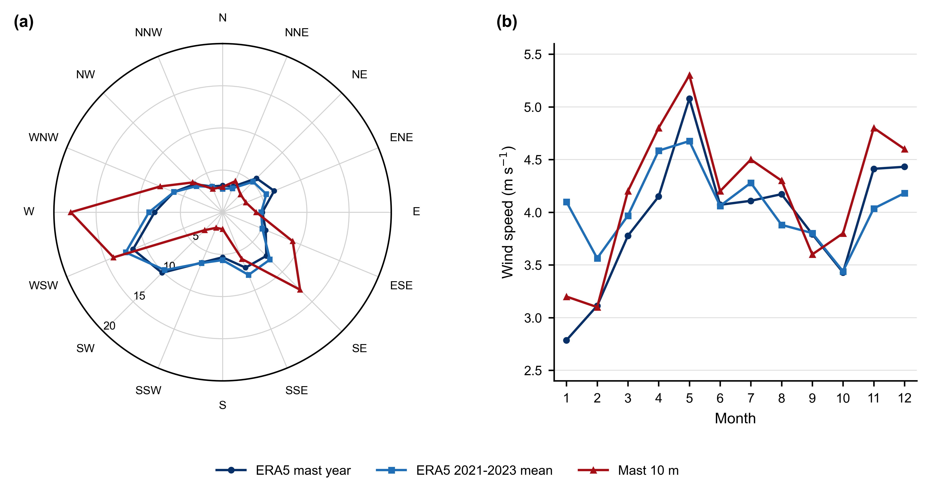
Figure S1. Comparison of the meteorological mast and ERA5 at the mast location from 1 March 2021 to 28 February 2022: (a) wind-direction frequency; (b) monthly mean wind speed.

Figure S2.
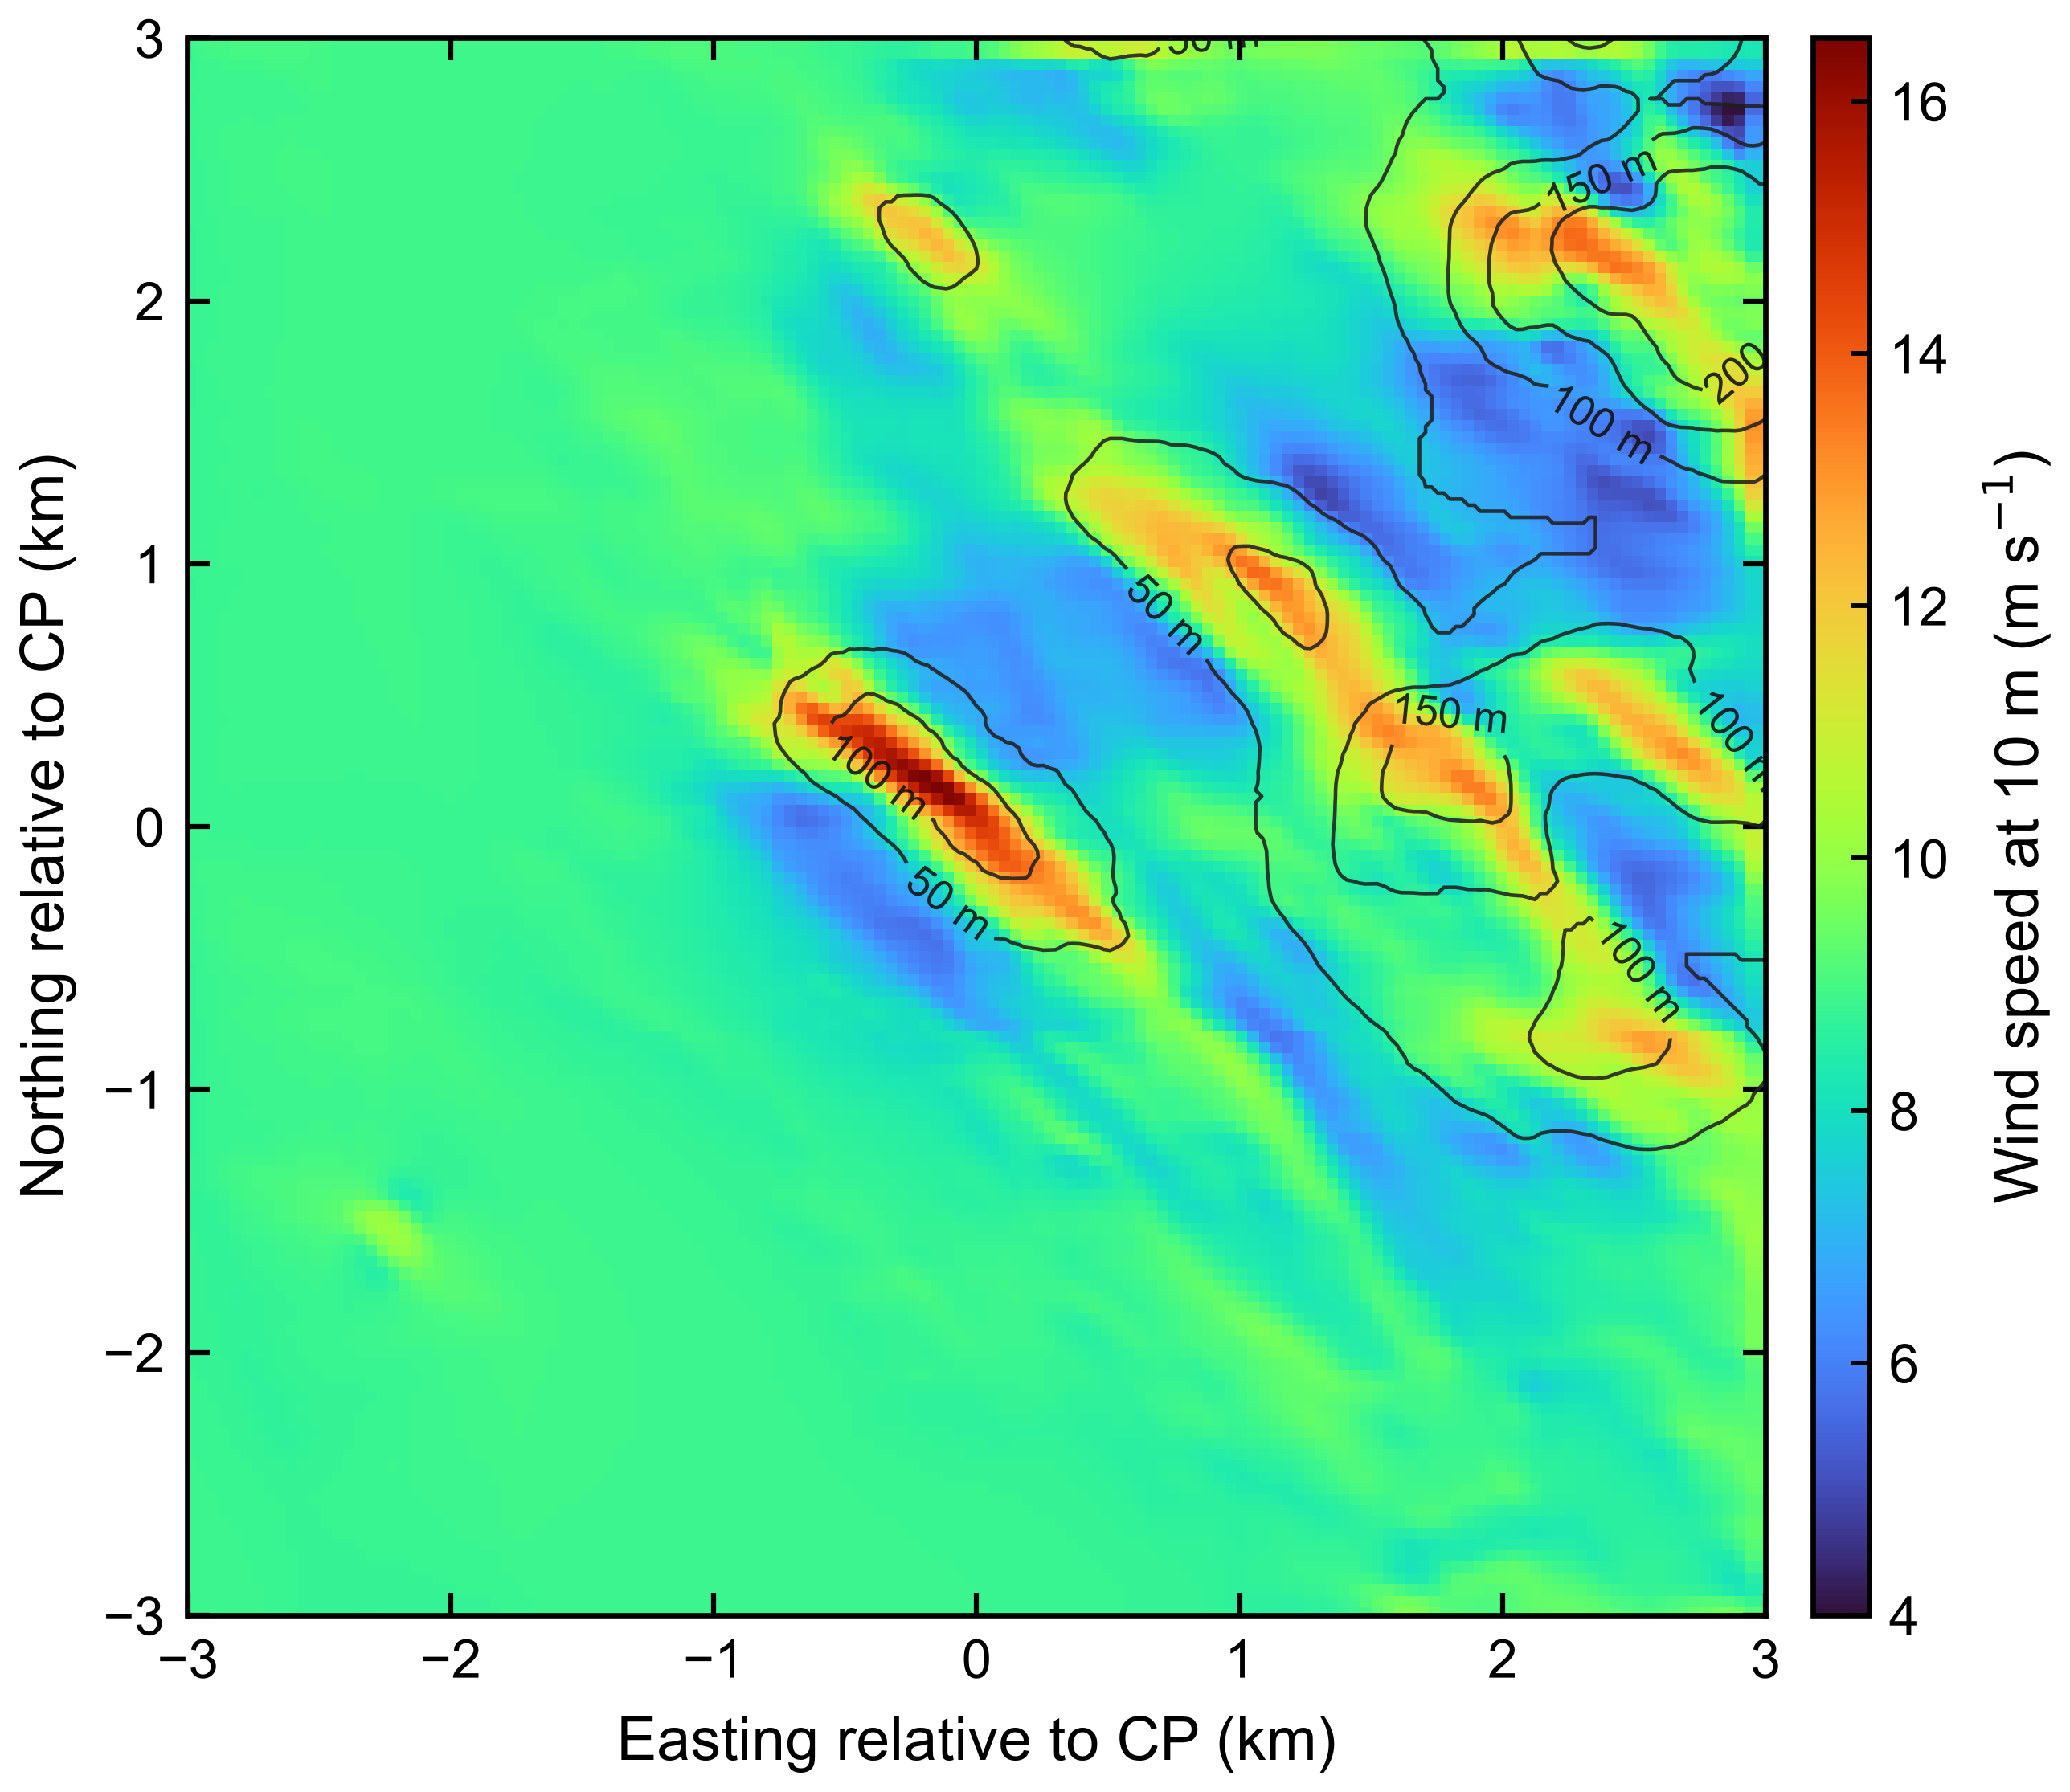
Figure S2. Modelled 10 m wind-speed field for Askervein case MF03-D/TU03B on the 43 m output grid under an upstream reference wind of 8.9 m s⁻¹ from 210°. Coordinates are relative to the hill centre point (CP). Dark labelled contours show terrain elevation at 50 m intervals.

Figure S3.
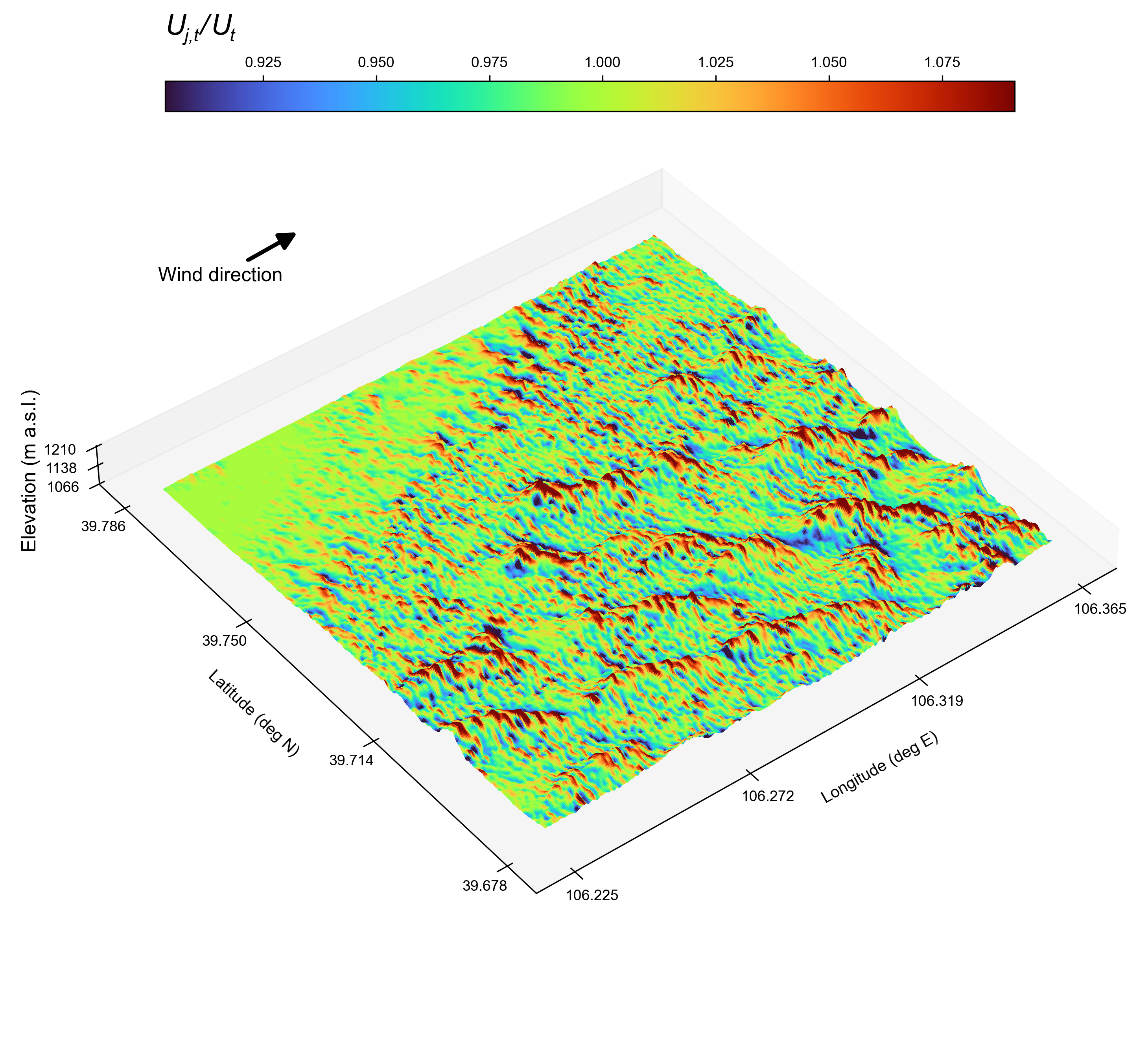
Figure S3. Downscaled-to-input 10 m wind-speed ratio at 12:00 on 7 December 2023 over the 12 × 12 km dune window. ERA5 input was 11.62 m s⁻¹ from 249.35°. Values above and below 1 denote terrain-induced acceleration and deceleration, respectively.

Figure S4.
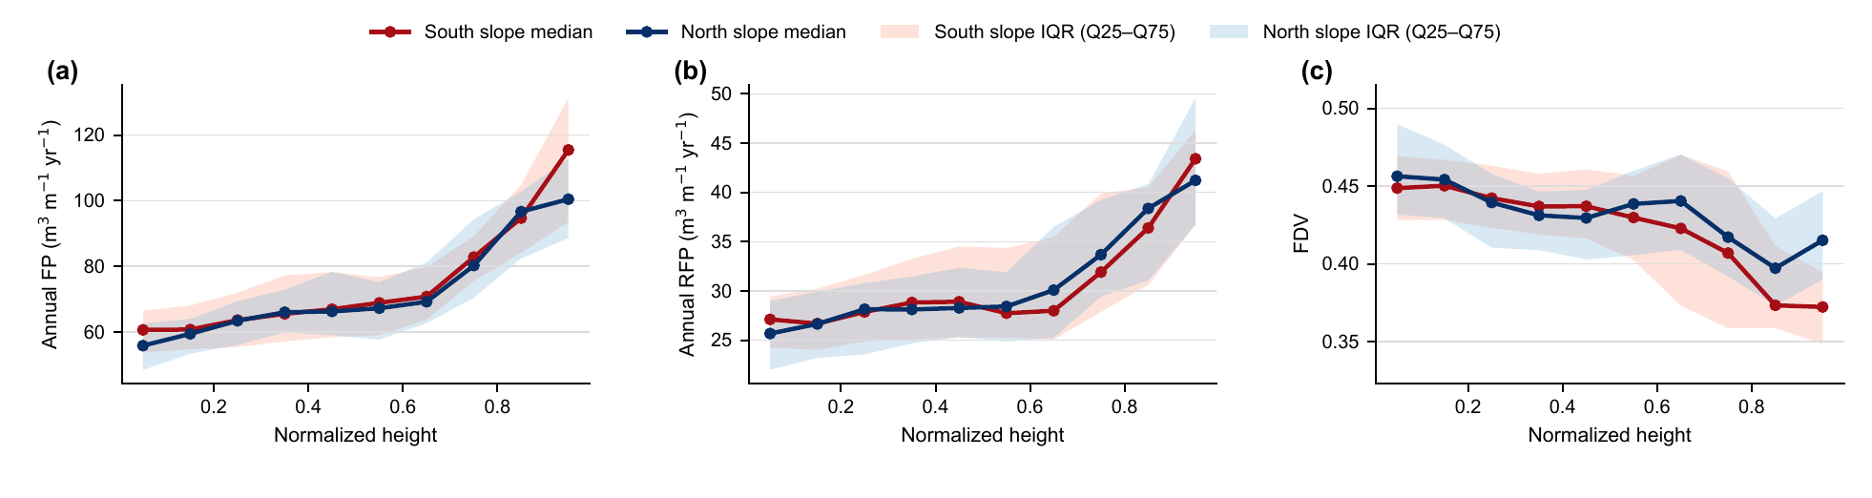
Figure S4. Dependence of (a) annual FP, (b) annual RFP, and (c) FDV on normalized height for 2976 valid cells in the representative dune. Lines are slope-specific medians and shading is the interquartile range (Q₂₅–Q₇₅). The south slope is windward for the prevailing 245° incoming-wind sector.

Figure S5.
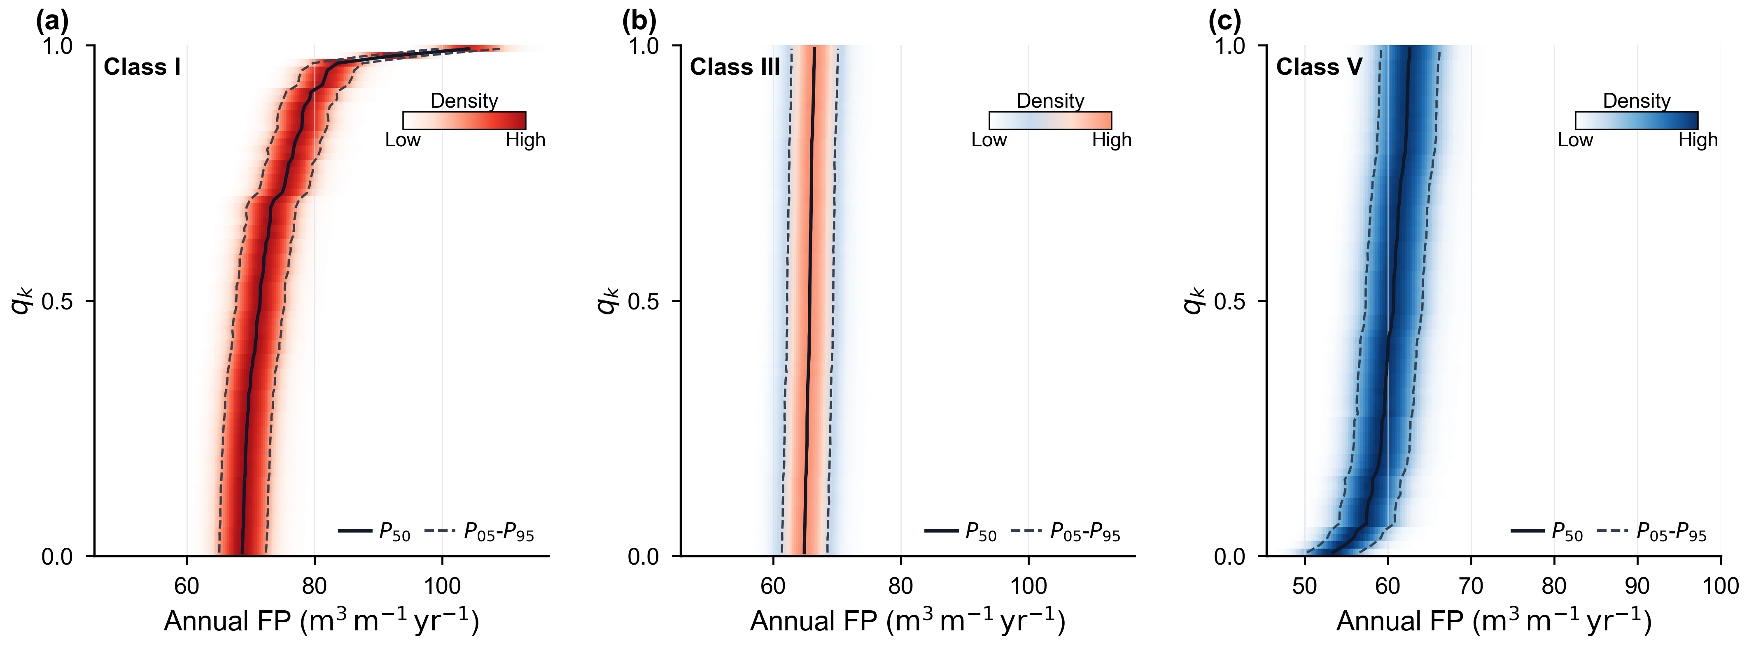
Figure S5. Class-specific annual FP probability-density structures: (a) Class I; (b) Class III; and (c) Class V. Within each panel, subarrays are ordered by P₅₀ and q_{k} denotes the empirical within-class quantile. Color intensity represents annual FP density; solid lines denote P₅₀ and dashed lines denote P₀₅-P₉₅.

