Supplementary Information

Reflective, water-permeable diatomite masks doubling output voltage of water-floating single-walled carbon nanotube thermoelectric generators
Shuya Ochiai, Tsuyoshi Takizawa, Masayuki Takashiri*
Research Institute of Science and Technology, Tokai University, Hiratsuka, Kanagawa 259-1292, Japan
* Corresponding author. Email: takashiri@tokai.ac.jp
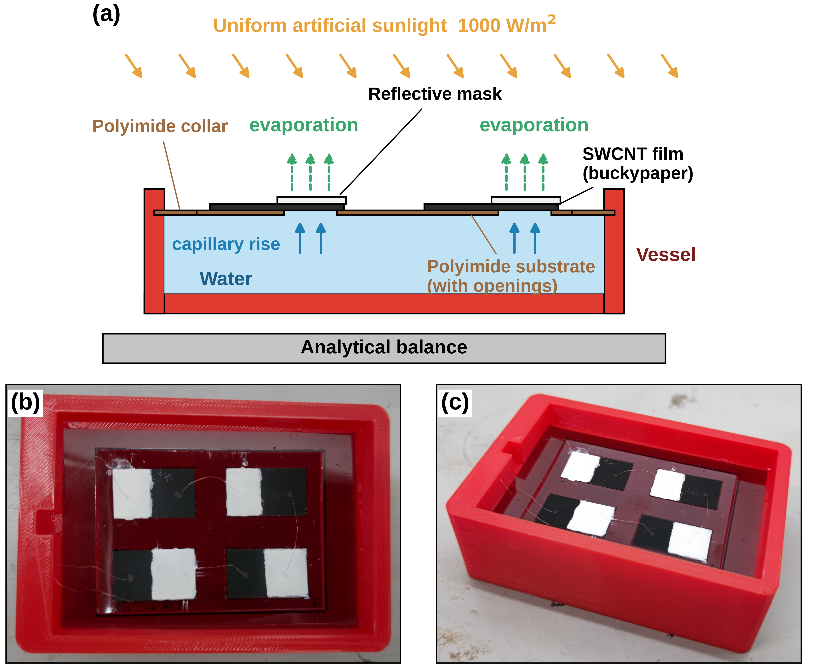
Figure S1. Vessel used for the evaporated-mass measurement. (a) Cross-section of the vessel, the polyimide collar, and the floating device on the analytical balance. The vessel measures 82 mm × 55 mm × 20 mm and holds approximately 80 mL of water. The collar measures 90 mm × 60 mm with a central window of 70 mm × 50 mm, and the device fills that window, so the vessel holds no free water surface. The wetted regions of the SWCNT film exposed through the substrate openings form the only path from the water to the air. The cross-section is drawn along the 70-mm direction of the device and therefore cuts two of the four thermoelectric pairs. (b) Top view and (c) oblique view of the assembled vessel.
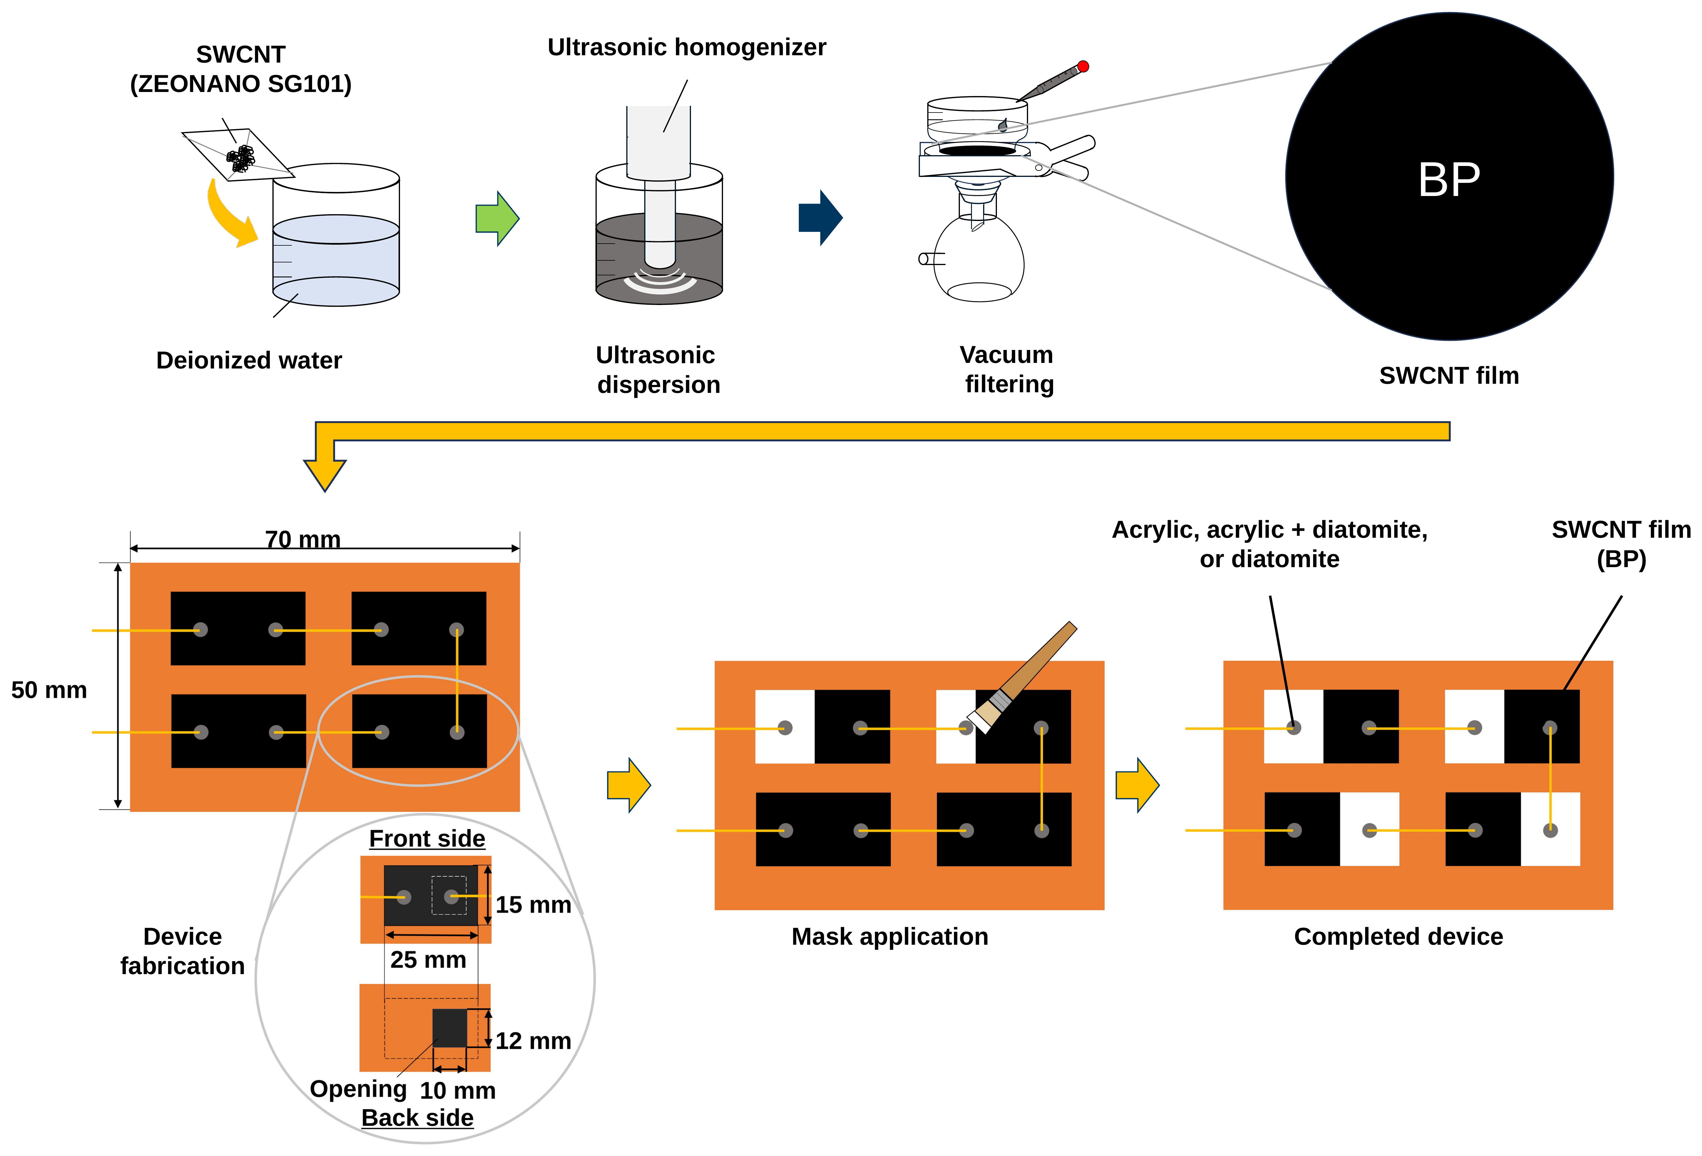
Figure S2. Fabrication sequence of the water-floating SWCNT-TEGs. SWCNT powder (ZEONANO SG101) was dispersed in deionized water with an ultrasonic homogenizer, and the dispersion was vacuum-filtered to give a freestanding SWCNT film (buckypaper, BP). The circle labeled BP is an enlarged view of the film deposited on the filter, and the two leader lines mark the region it enlarges. Four films were then mounted on a polyimide substrate of 70 mm × 50 mm carrying rectangular openings. The wiring was completed before the masks were applied, so the masks lie outside the current path. The mask material was then brushed onto the cooling region of each film; the panel labeled Mask application shows the coating half applied. The last panel is a schematic of the completed device, in which the white regions denote the mask: acrylic resin, acrylic + diatomite, or diatomite. The enlarged view of one thermoelectric pair is given in Fig. S3.
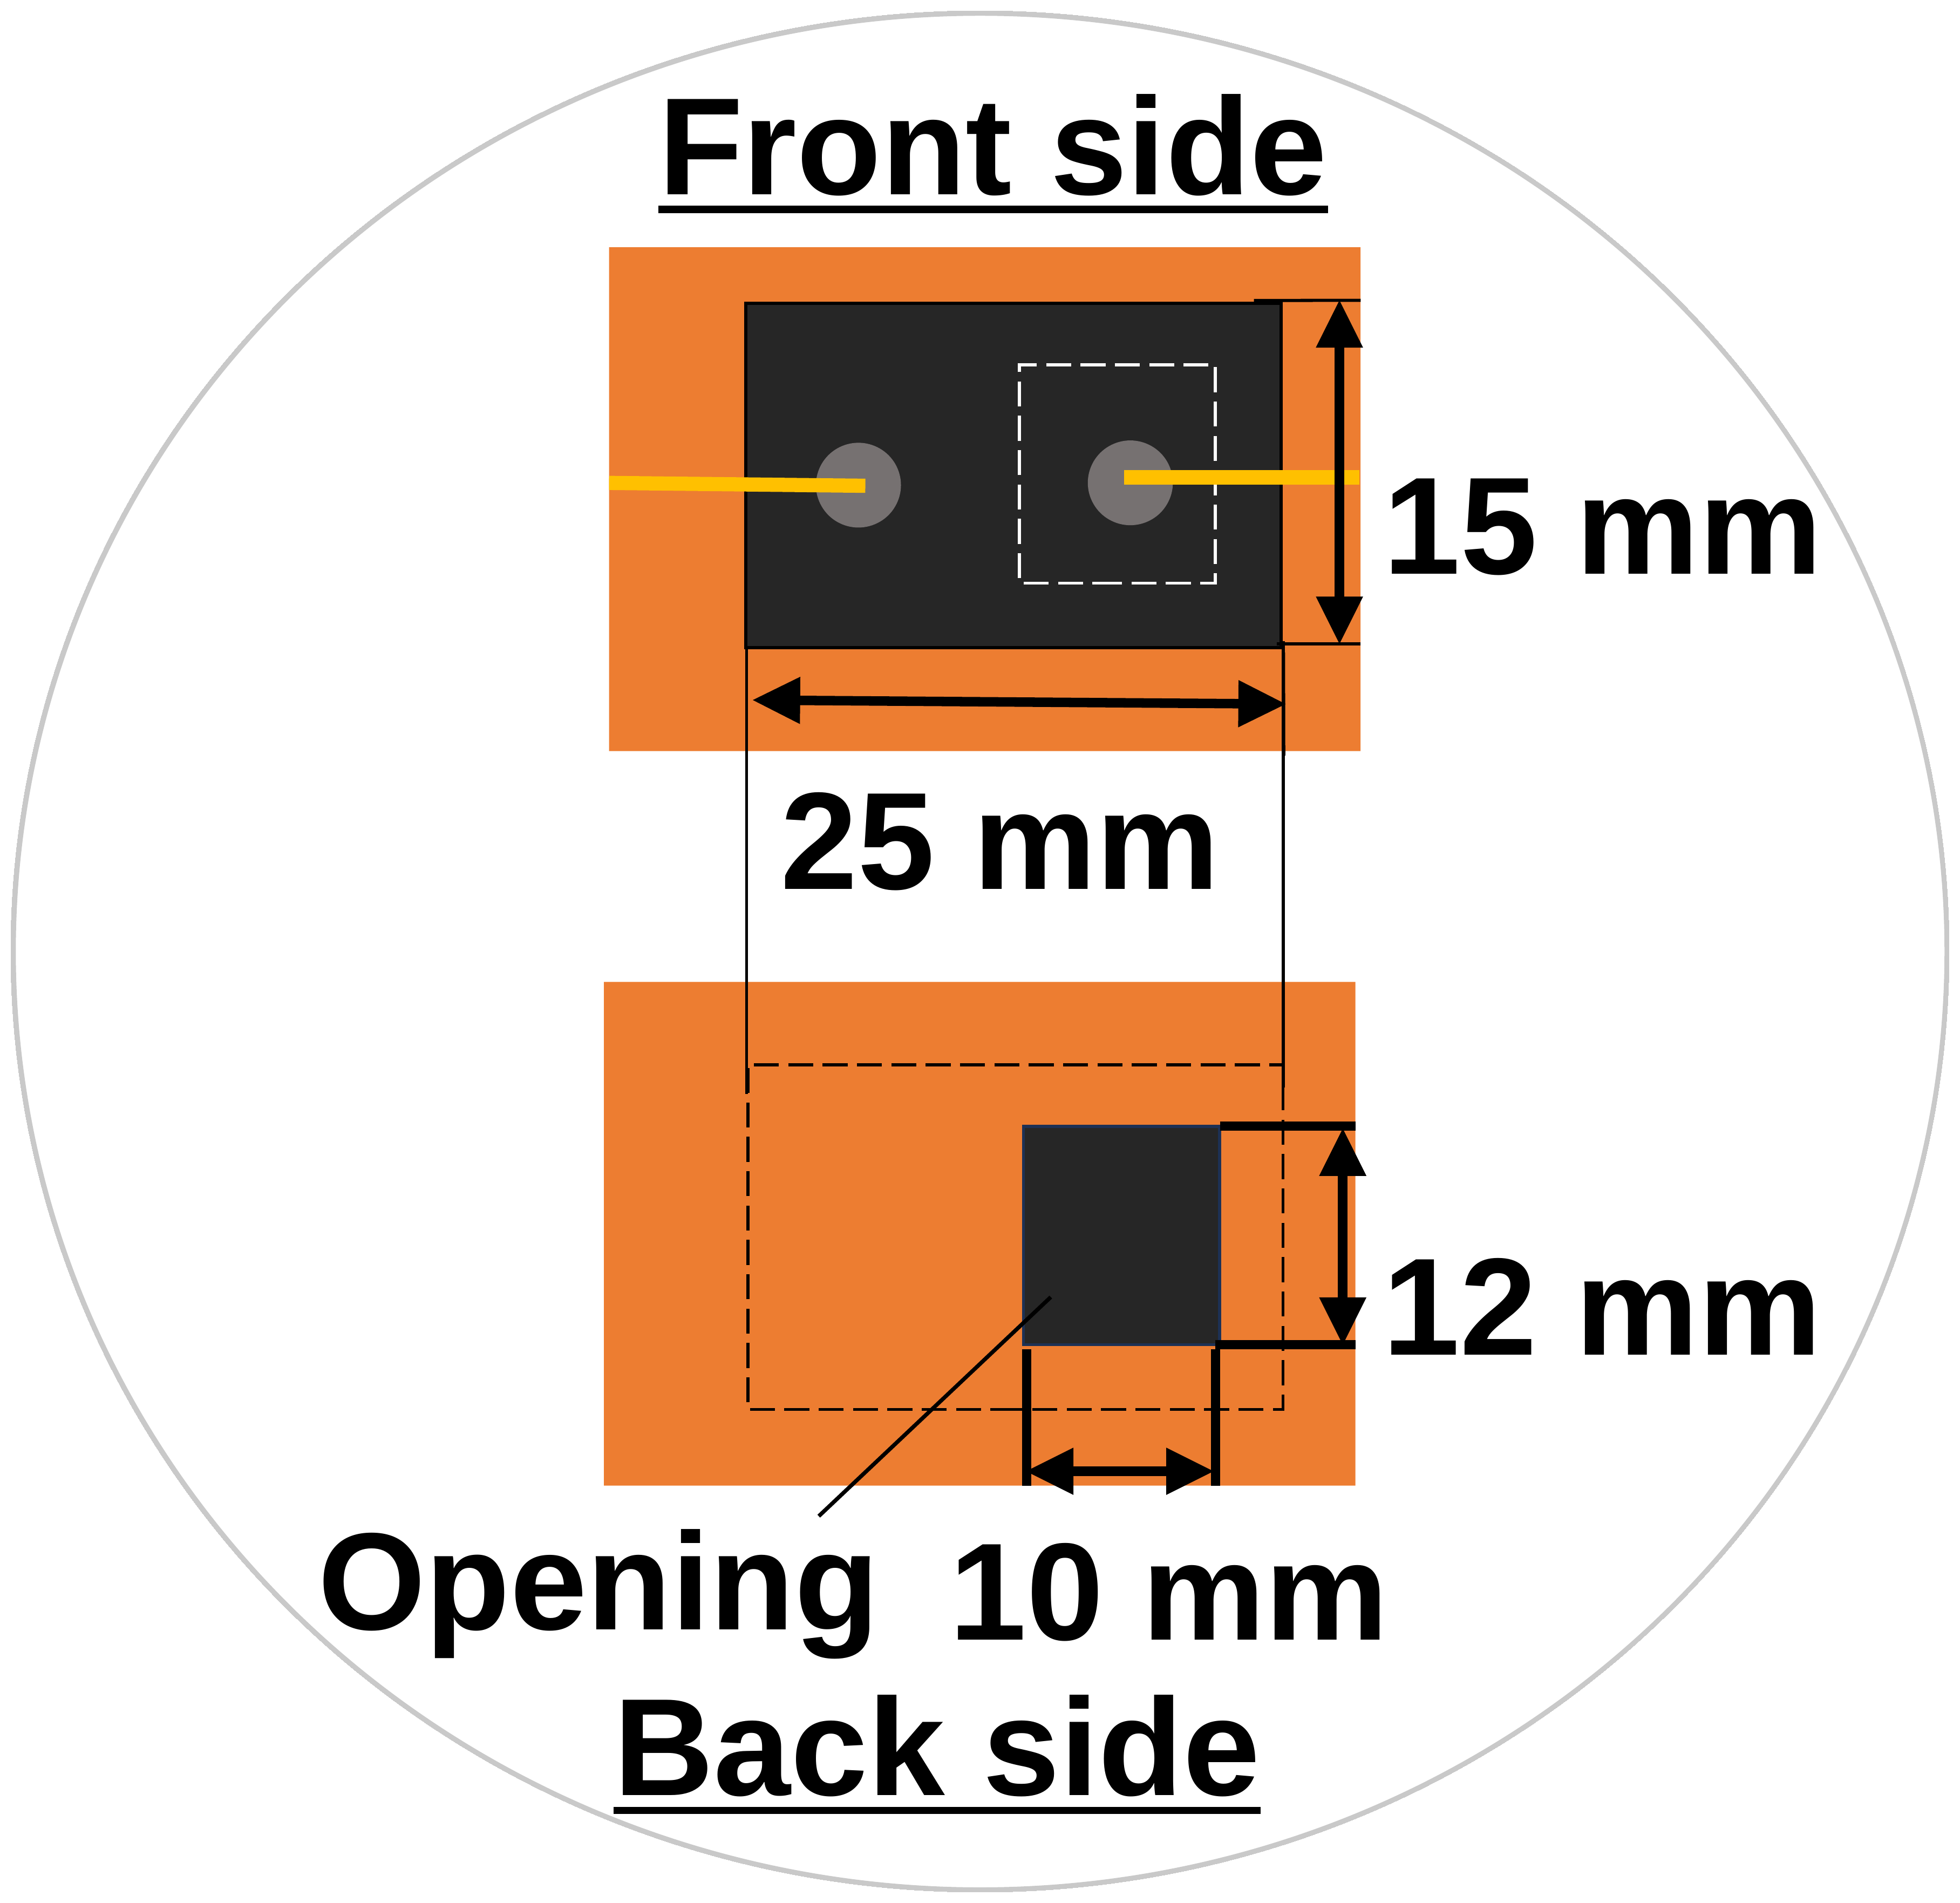
Figure S3. Geometry of one thermoelectric pair. The front side carries an SWCNT film of 25 mm × 15 mm, and the back side shows the substrate opening of 10 mm × 12 mm through which water reaches the film. The opening lies beneath the cooling region, so capillary rise and evaporation are confined to that region while the hot region carries no opening. The four openings give a total wetted area of 4.8 cm².

