Supplementary Materials
This file accompanies the main manuscript and provides four supplementary figures referenced in Sections 3.2.2, 4.2, 4.3, and 5.3 of the main text. Figures are numbered S1–S4, distinct from the numbered figures (1–8) in the main manuscript, and are referenced by that numbering throughout.
Supplementary Figure S1
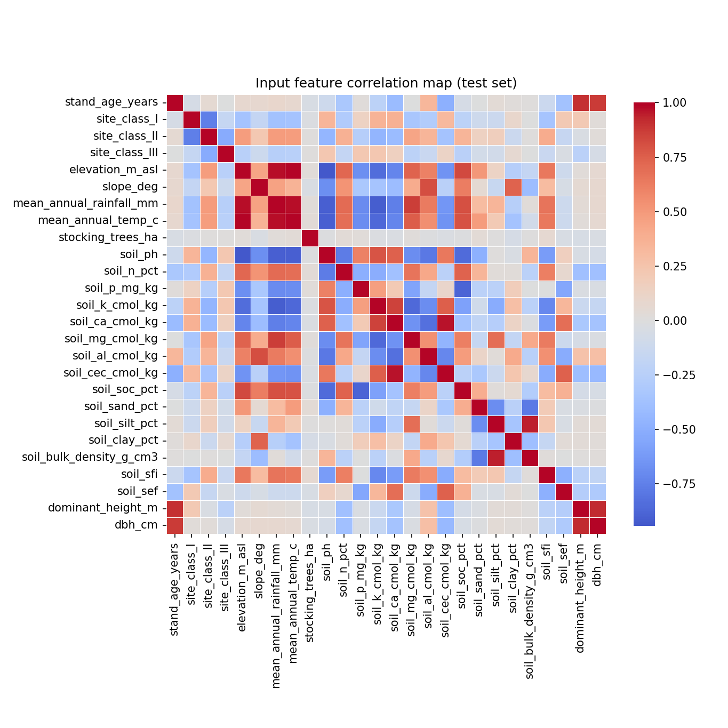
Figure S1. Pairwise Pearson correlation matrix of the 26 input predictors used by the GrowthMLP, computed on the test set. Strong positive correlations cluster among topography and climate variables (elevation, mean annual rainfall, mean annual temperature) and among soil chemical variables (potassium, calcium, magnesium, cation exchange capacity), while strong negative correlations link these two blocks. Stand age correlates strongly with the two dendrometric predictors (dominant height, DBH), motivating the age-curve interpretation caveat discussed in Section 5.3. This matrix supports the a priori predictor-group definitions used for the ablation grid (Section 3.2.2) and the plot-level split rationale (Section 3.6.1).
Supplementary Figure S2
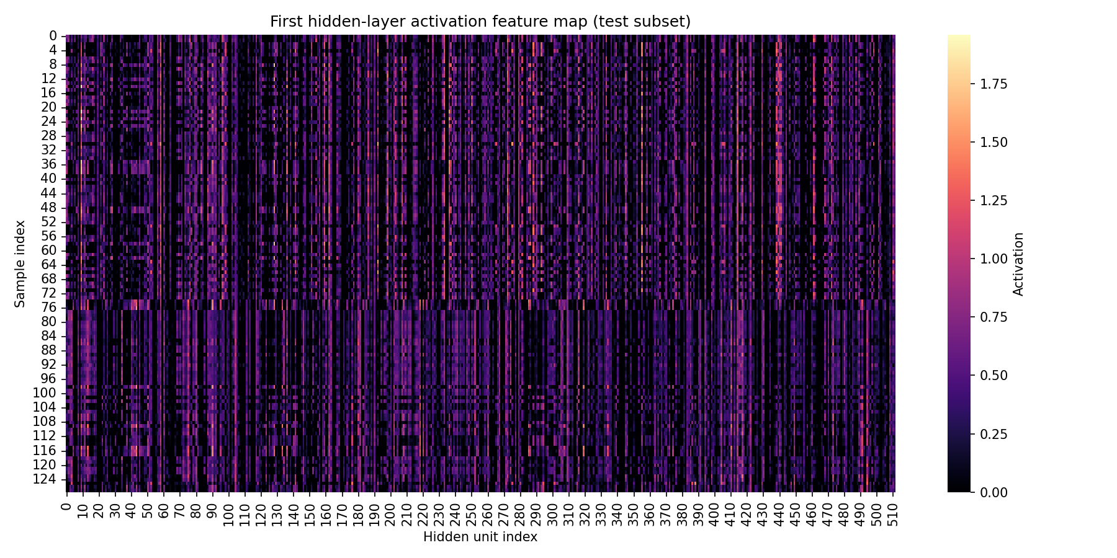
Figure S2. First-hidden-layer activation feature map for a subset of 128 test-set trees under the selected best configuration (arch_512-256-128). Each row is one tree; each column is one of the 512 first-hidden-layer units after ReLU activation. Vertically banded columns of consistently high activation (e.g., near units 90, 240, and 440) indicate hidden units that respond broadly across most test-set trees, while the largely dark background indicates substantial ReLU sparsity, consistent with the dropout regularization described in Section 3.4. This diagnostic complements the aggregate performance metrics in Section 4.2 by showing how the network's learned internal representation behaves on held-out data.
Supplementary Figure S3
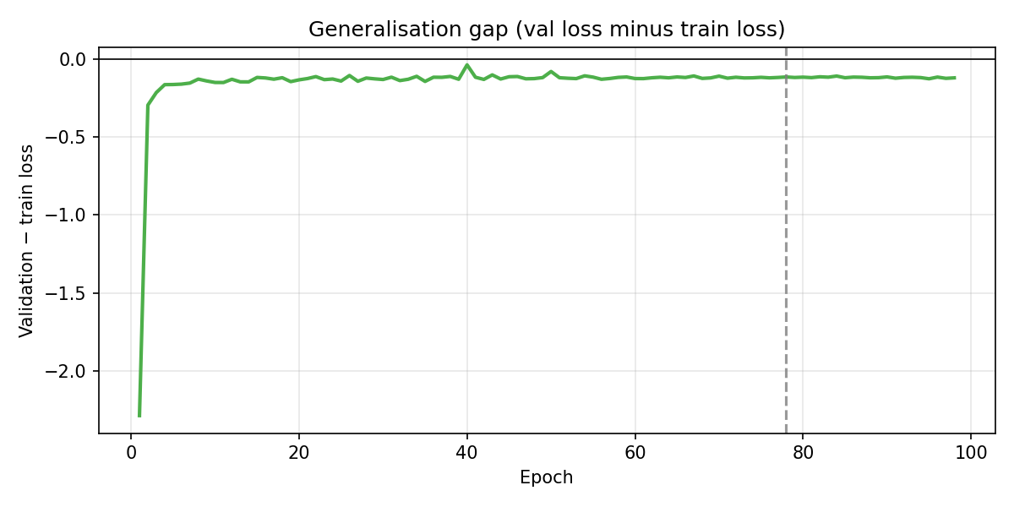
Figure S3. Generalization gap (validation Smooth L1 loss minus training Smooth L1 loss) across training epochs for the selected best configuration (arch_512-256-128). The gap is negative throughout training — validation loss stayed below training loss — and stabilizes near −0.13 after roughly epoch 10, remaining flat through the best epoch (78, dashed line) and beyond. This flat, non-widening gap is the numerical basis for the limited-overfitting conclusion reported alongside the train/validation/test R² values in Section 4.2, and complements the raw loss curves in Figure 3 of the main text.
Supplementary Figure S4
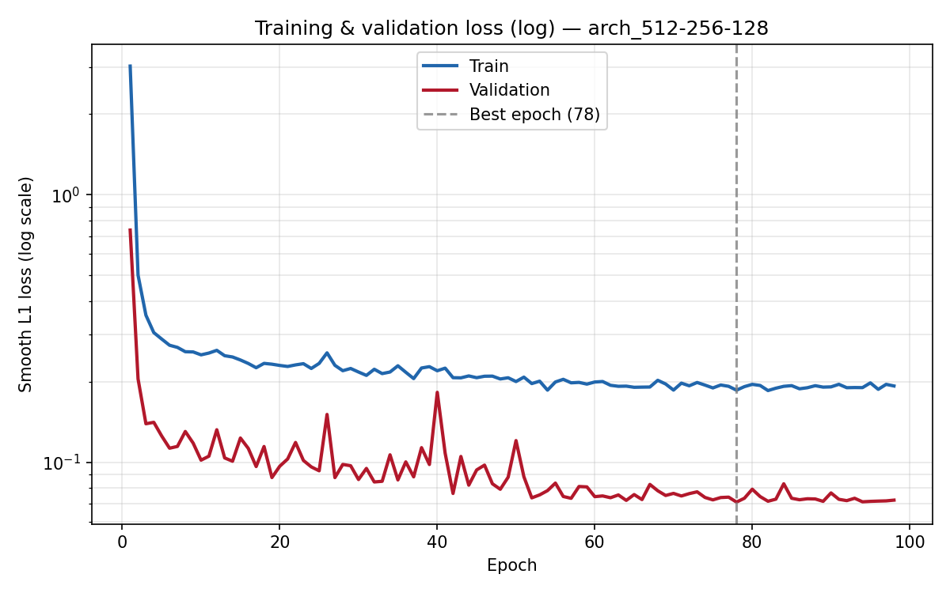
Figure S4. Training and validation Smooth L1 loss on a logarithmic vertical scale across epochs for the selected best configuration (arch_512-256-128), with the best epoch (78, dashed line) marked. The log scale expands the low-loss region near convergence, making the modest, non-widening train-validation gap easier to inspect than on the linear scale used in Figure 3 of the main text, and shows that most of the loss reduction occurred within the first ~10 epochs.

