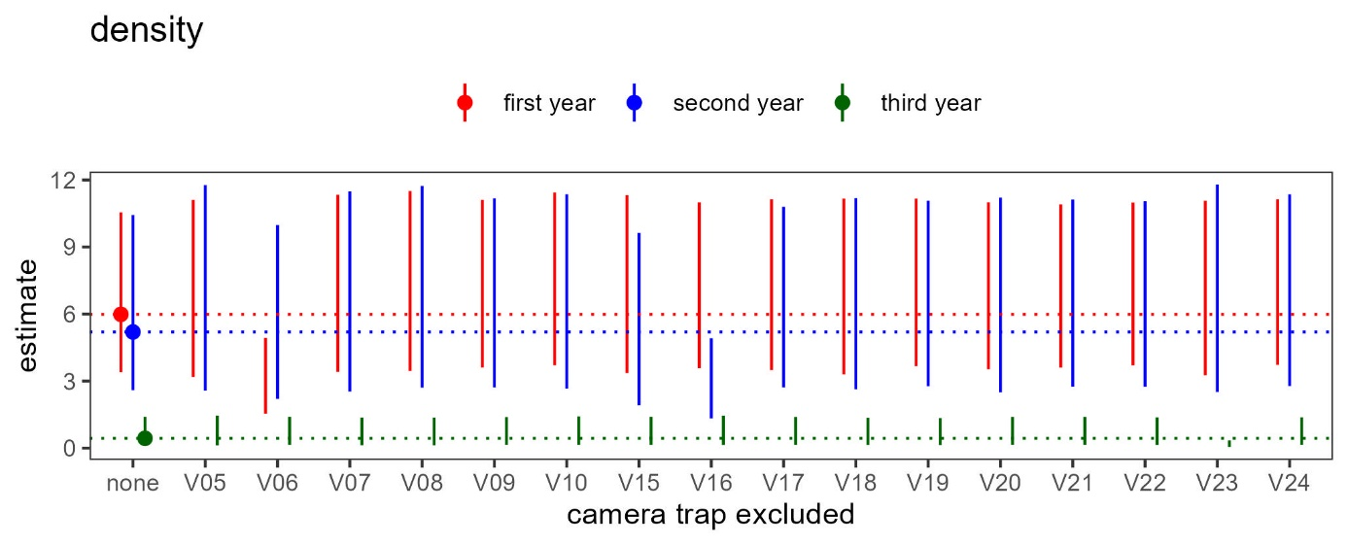
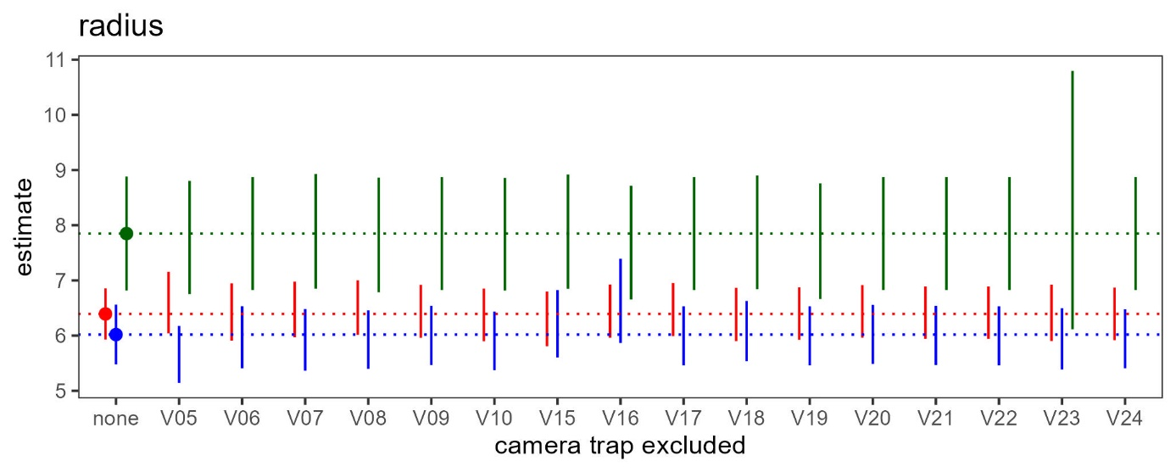
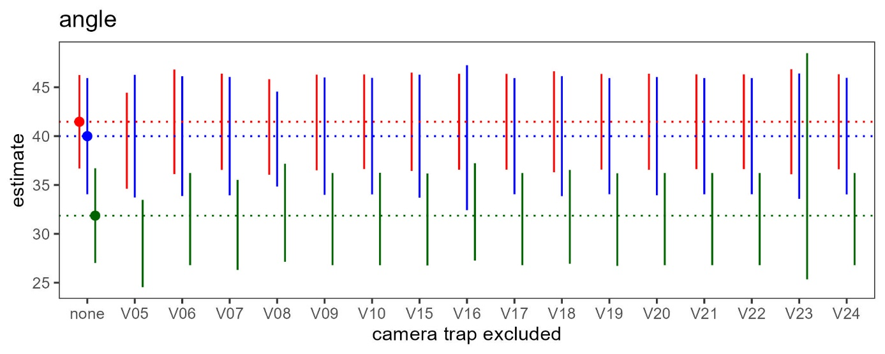
Fig. 1 Output of the Random Encounter Model when individual cameras are excluded from the analysis (sensitivity analysis). The line segments represent the 95% confidence intervals. The horizontal lines indicate the central estimates from the analysis including all cameras (“none” excluded). See the manuscript for the output on the parameters ‘active speed’ and ‘density. (Continued on next page)

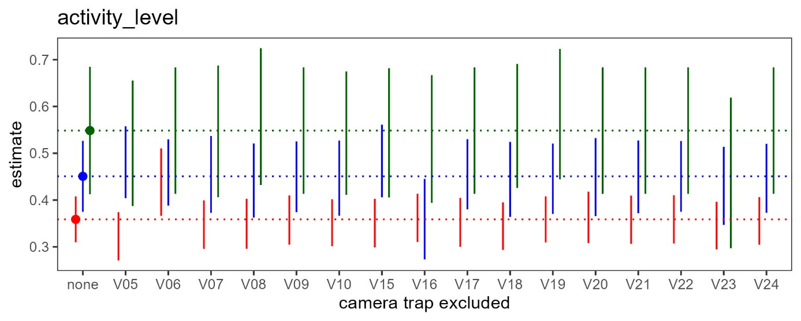
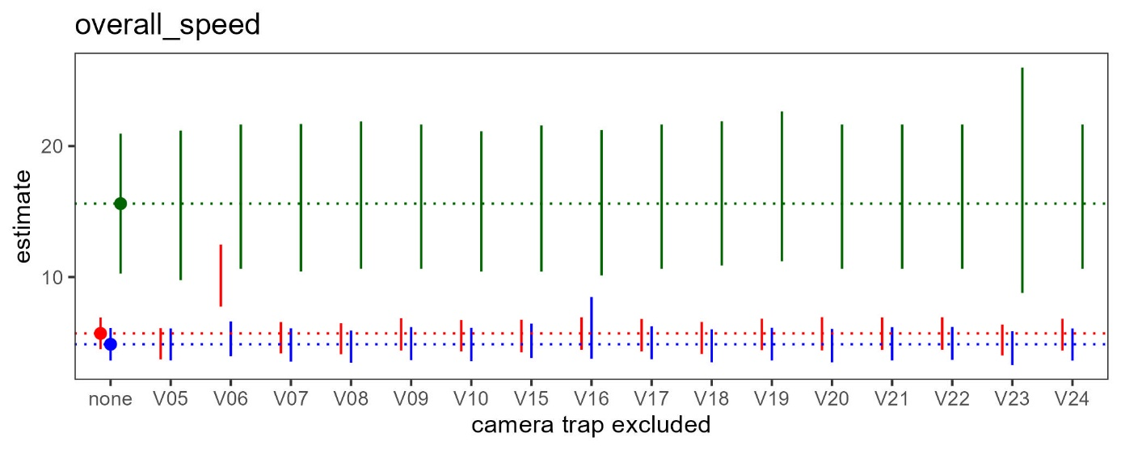
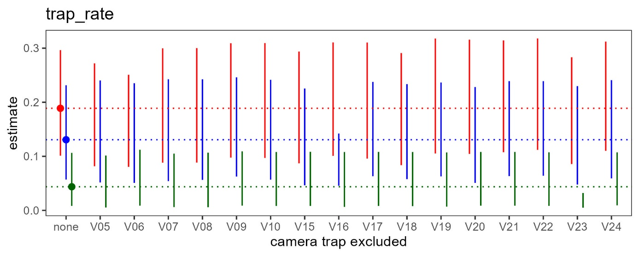
Fig. 1 (Continued)

