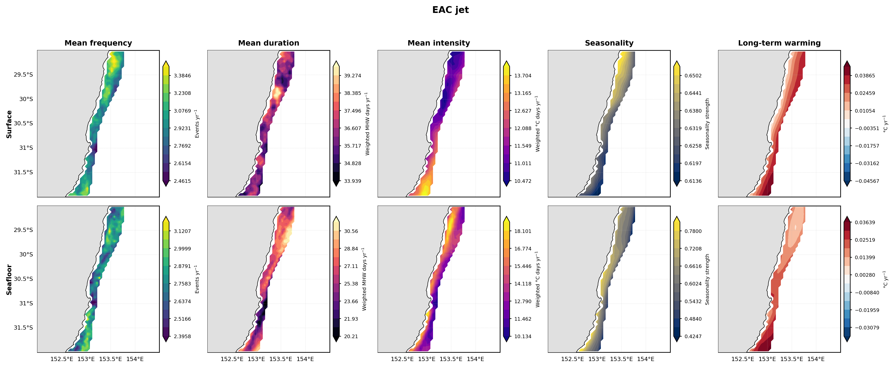
Figure S1: Input metrics used to calculate the spatial hazard index (SHI) for the EAC jet region over the shelf (30-200 m isobaths). Columns show mean MHW frequency, mean duration, mean intensity, seasonality, and the resulting SHI. The upper row represents surface-derived metrics and the lower row represents seafloor-derived metrics

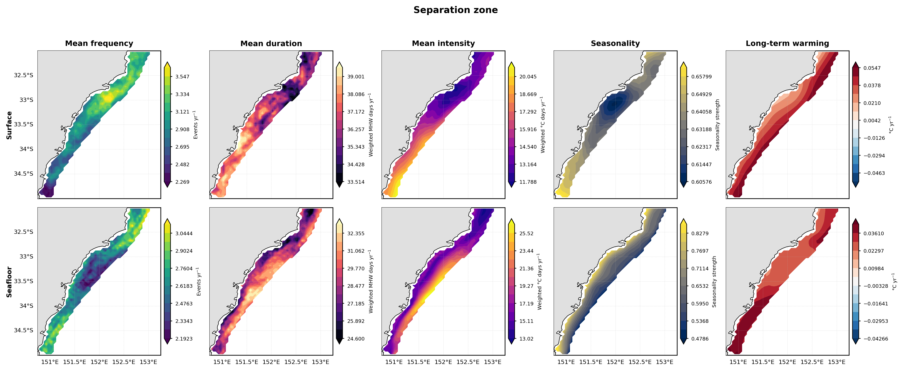
Figure S2: Input metrics used to calculate the spatial hazard index (SHI) for the separation zone over the shelf (30-200 m isobaths). Columns show mean MHW frequency, mean duration, mean intensity, seasonality, and the resulting SHI. The upper row represents surface-derived metrics and the lower row represents seafloor-derived metrics

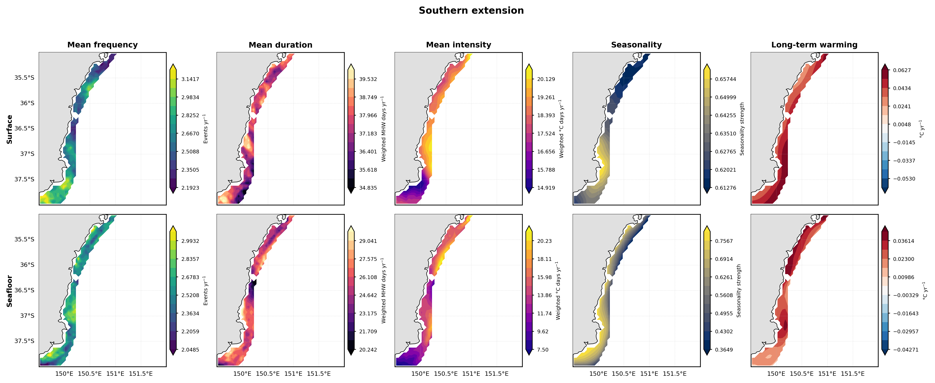
Figure S3: Input metrics used to calculate the spatial hazard index (SHI) for the southern extension over the shelf (30-200 m isobaths). Columns show mean MHW frequency, mean duration, mean intensity, seasonality, and the resulting SHI. The upper row represents surface-derived metrics and the lower row represents seafloor-derived metrics
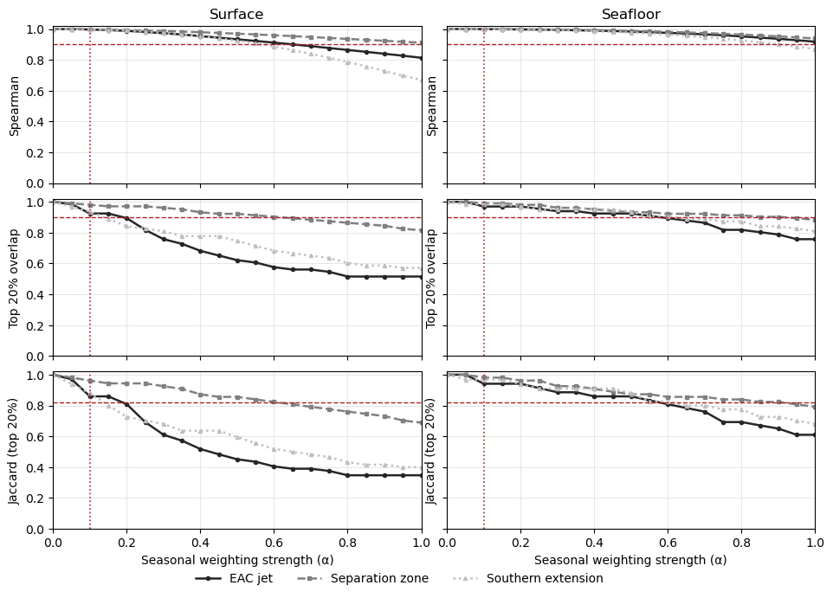
Figure S4: Sensitivity analysis showing how regional MHW hazard patterns respond to increasing values of the seasonality weighting parameter, α, for surface and seafloor. Rows show the three diagnostics tools as the Spearman rank correlation, overlap of the upper 20% grid cells, and Jaccard index. The shaded lines represent the three different study regions of the EAC jet, separation zone, and southern extension. Horizontal dashed red lines indicate the selected stability thresholds for each diagnostic, and the vertical dotted red line indicates the α value where one of the regions or depths deviate over that threshold.
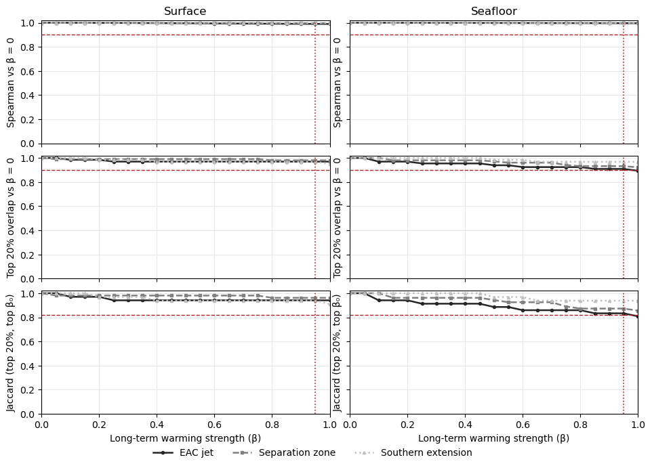
Figure S5: Sensitivity analysis showing how regional MHW hazard patterns respond to increasing values of the long-term trend weighting parameter, k, for surface and seafloor. Rows show the three diagnostics tools as the Spearman rank correlation, overlap of the upper 20% grid cells, and Jaccard index. The shaded lines represent the three different study regions of the EAC jet, separation zone, and southern extension. Horizontal dashed red lines indicate the selected stability thresholds for each diagnostic, and the vertical dotted red line indicates the α value where one of the regions or depths deviate over that threshold.

