Synthesis, crystal Structure, computational analysis, and biological evaluation of a mononuclear copper(II) Schiff base complex
Siva Arumugam, Sebastian Arockiasamy*

Supplementary Figures:

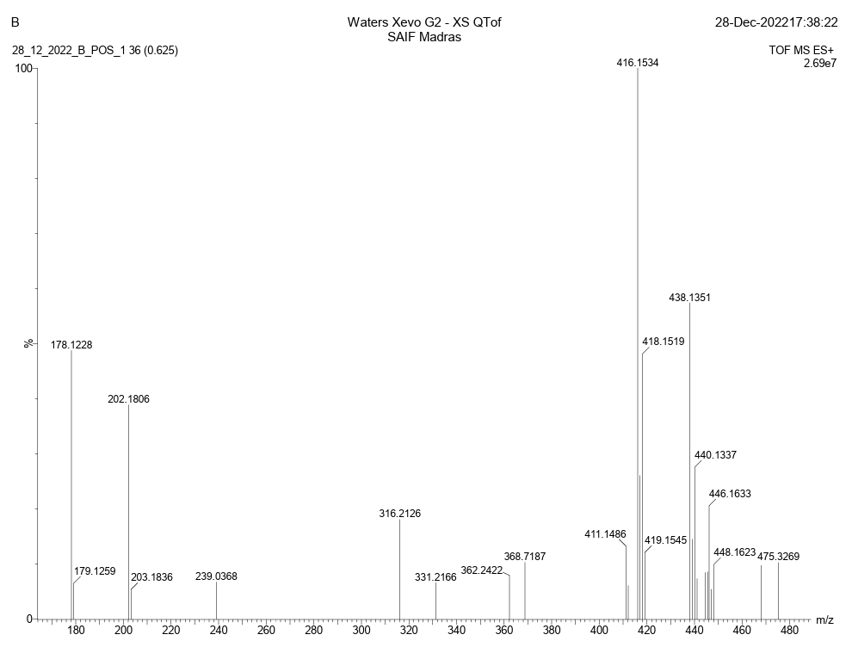

Fig. S1. ESI Mass spectral pattern of Cu(II) complex

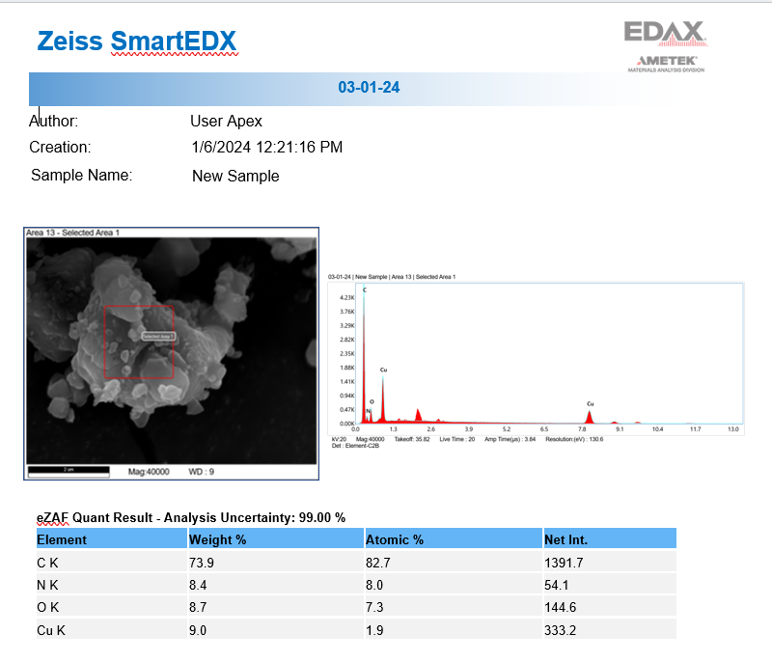

Fig. S2. EDX spectrum of Cu(II) complex

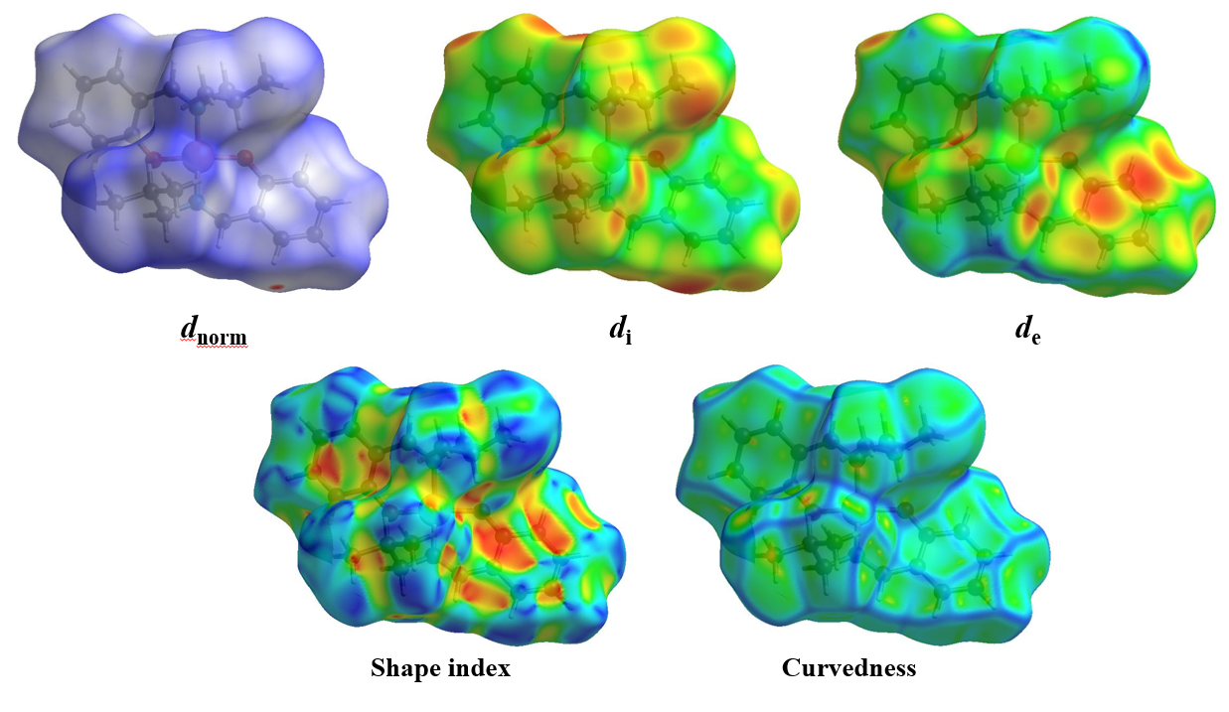

Fig. S3. Molecular Hirshfeld surface maps mapped with d_{norm} (color scale: -1.6706 to -0.2862 a.u), internal distance (d_{i}), external distance (d_{e}), shape index, and curvedness for the copper(II) complex
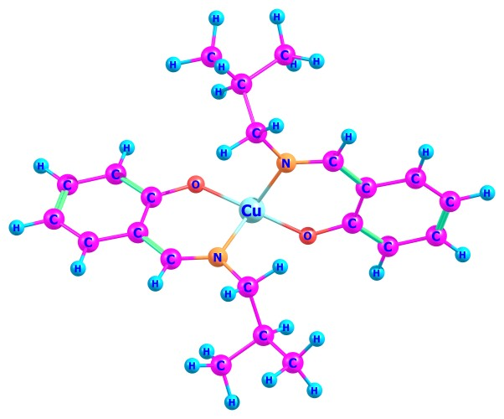

Fig. S4. The optimized structure Cu(II) complex
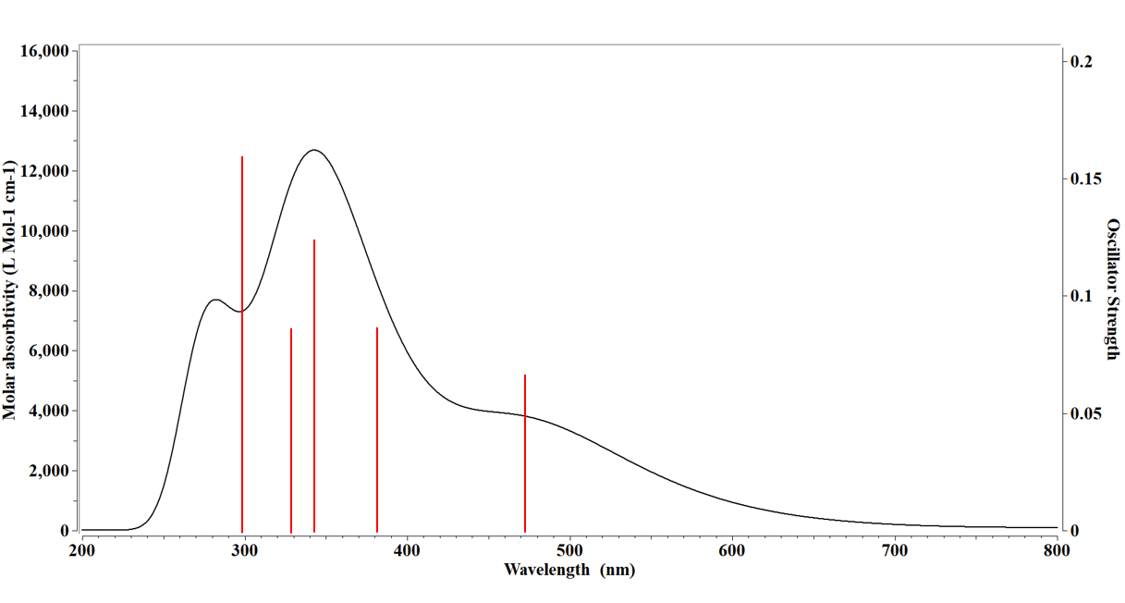

Fig. S5. Theoretically simulated electronic absorption (UV-Vis) spectrum of the copper(II) complex computed using unrestricted TD-DFT at the B3LYP/6-311G(d,p) level in a methanol solvent matrix.

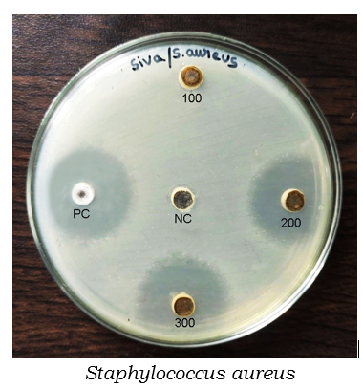
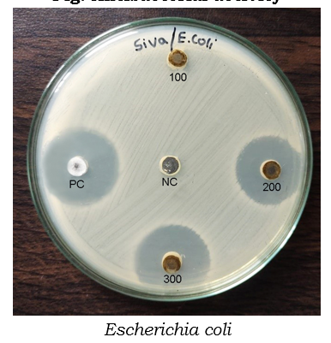

Fig. S6. Antibacterial study of copper complex

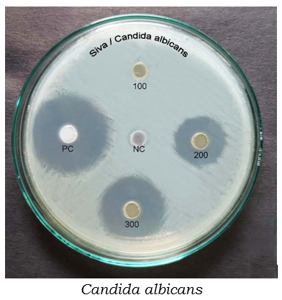
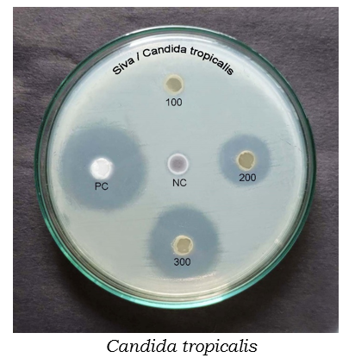
Fig. 7. Antifungal study of copper complex
Supplementary tables

Table S1. Predicted DFT thermochemical parameters for the optimized structure of the copper(II) complex
Thermodynamic Quantity | Value (Hartree/ a.u)
Electronic Energy + Zero-point Energy (E₀) | -1311.170369
Total Thermal Energy (E_{tot}) | -1311.143460
Thermal Enthalpy (H) | -1311.142516
Gibbs Free Energy (G) | -1311.230191
Vibrational parameters | Value (cal/mol.K)
Constant-Volume Heat Capacity (C_{v}) | 102.783
Standard Entropy (S) | 184.526

Thermochemical analysis and stability
To evaluate the thermodynamic stability and vibrational profile of the optimized molecular structure, a comprehensive frequency calculation and thermochemical analysis were performed at the DFT level. The calculated electronic ground-state energies and thermodynamic parameters for the copper(II) complex are summarized in Table S1. The electronic energy, corrected for zero-point energy (E₀) was found to be −1311.170369 Hartree, while the total thermal energy (E_{tot}) and thermal enthalpy (H) were determined to be −1311.143460 Hartree and -1311.142516 Hartree, respectively. The total Gibbs free energy (G) of the system was calculated as −1311.230191 Hartree, with the predicted standard entropy (S) of 184.526 cal/mol·K and a constant-volume heat capacity (C_{v}) of 102.783 cal/mol·K. The vibrational frequency analysis yielded only positive real frequencies with no imaginary components, confirming that the optimized configuration corresponds to a true local minimum on the potential energy surface. These values collectively indicate high thermodynamic stability of the mononuclear distorted tetrahedral framework, supporting its structural integrity.

Table S2. Computed frontier molecular orbital energies and quantum chemical parameters for Cu(II) complex.

Parameters complex

E_{HOMO} -5.40
E_{LUMO} -3.25
Energy gap, ΔE=E_{LUMO-}E_{HOMO} 2.15
Ionisation potential, I=-E_{HOMO} 5.40
Electron affinity, A=-E_{LUMO} 3.25
Hardness (η) = (I-A)/2 -1.07
Softness, S =1/2ɳ -0.54
Chemical potential= -(I+A)/2 -4.325
Absolute electronegativity, χ=(I+A)/2 4.325
Electrophilicity, ω= χ2/2ɳ -10.04
Dipole moment 4.25

Table S3. Calculated wavelengths, oscillator strengths (f > 0.05), main orbital transition contributions (>25%) of absorption spectra of the copper(II) complex in methanol using unrestricted TD-DFT.

Wavelength (nm) Assignment
Complex Experimental Theoretical f Major contributions, (%, Orbital)

Coppe(II) 225, 240 278 0.18 HOMO-6 → LUMO (41, β)
Complex 270, 301 329 0.08 HOMO-1 → LUMO+1(66, β)
343 0.12 HOMO → LUMO+1(47, α)
HOMO → LUMO+2 (33, β)
361 381 0.08 HOMO-4 → LUMO (59, β)
472 0.06 HOMO-4 → LUMO (26, β)

