Supplementary information
Jui-Kai Chen¹, Jheng-Hao Lin¹, Yu-Ting Liu², Ming-Tao Lee^{1,2}*
¹National Synchrotron Radiation Research Center, Scientistific Research Division, Hsinchu 300092, Taiwan
²National Central University, Department of Physics, Taoyuan 320001, Taiwan

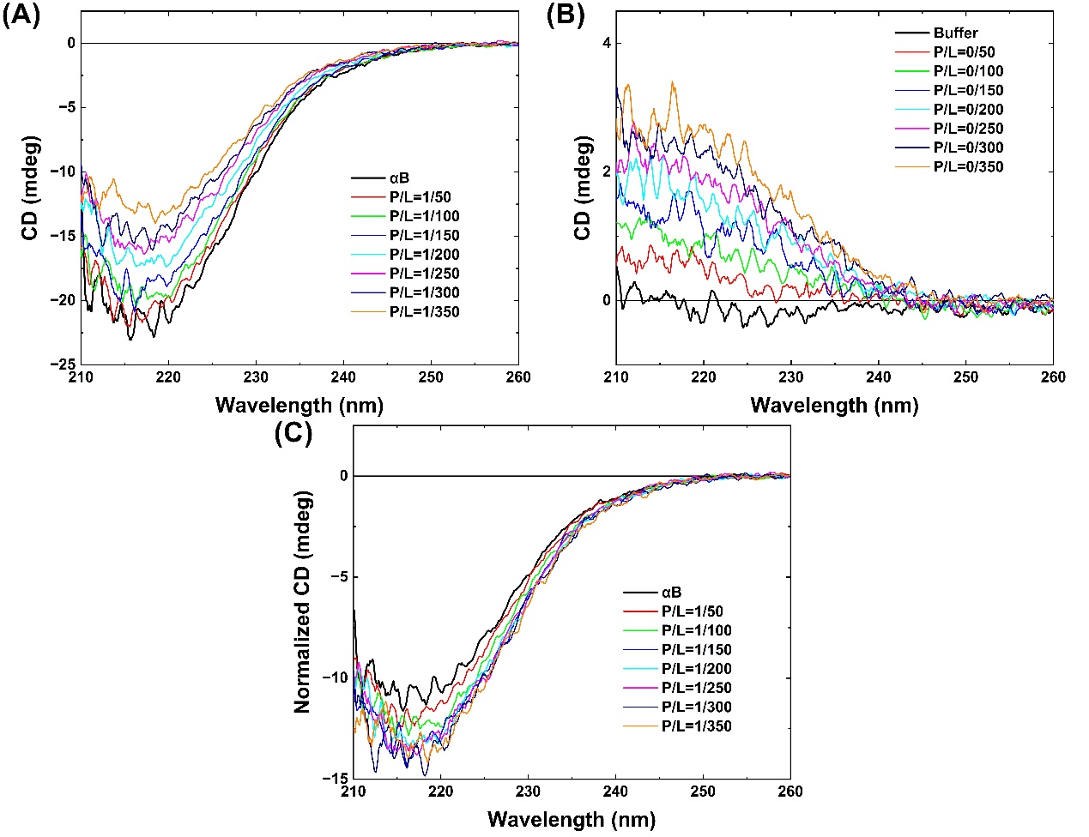
Figure S1
Representative CD spectra of successively titrating (A) DOPC vesicles to αB-crystallin solution, and (B) DOPC vesicles to buffer solution alone. (C) Background removes by subtracting CD spectra of (A) from (B) one by one and correction of dilution effect on concentration for normalization.

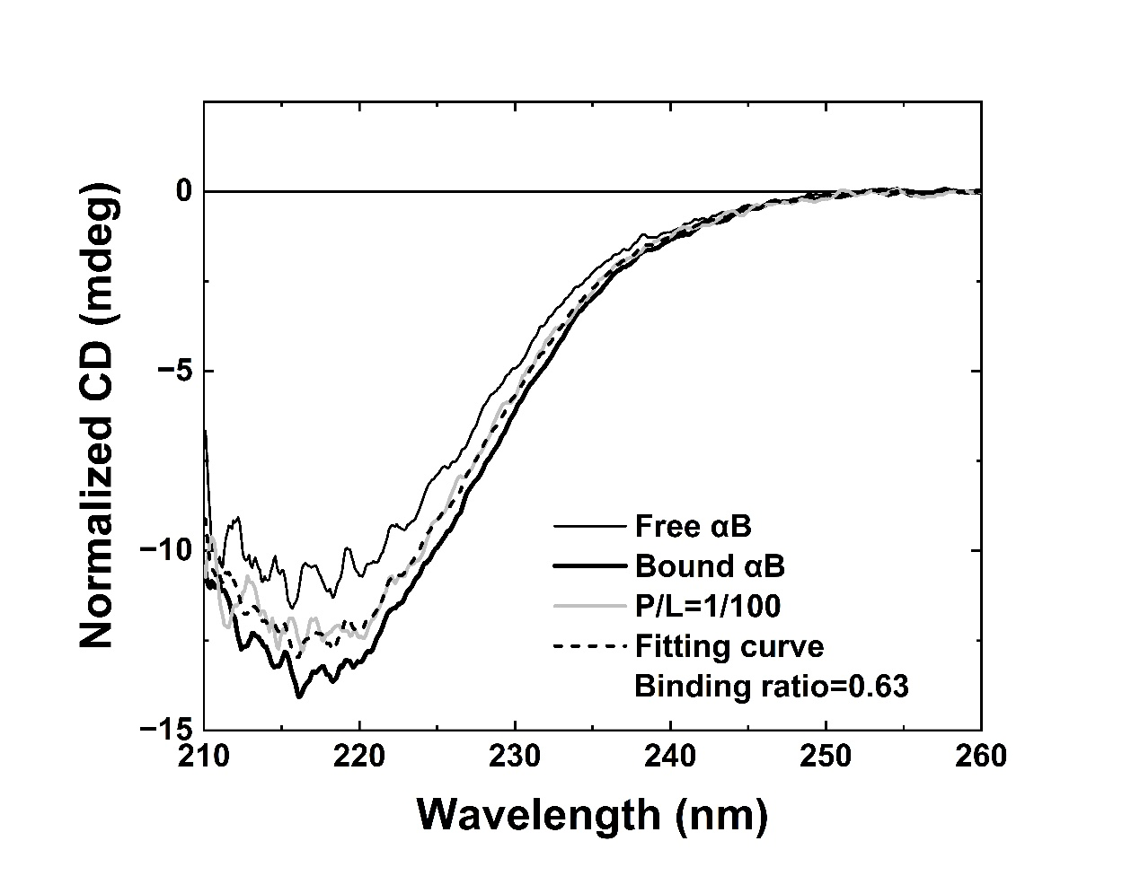
Figure S2
CD spectra of αB-crystallin/DOPC=1/100 (gray solid line), αB-crystallin in solution (free state of αB-crystallin, black solid line), αB-crystallin bound to DOPC membranes (bound state of αB-crystallin, black and bold solid line), and the fitting curve based on two-state model for αB-crystallin/DOPC=1/100 measured spectrum (black dash line).

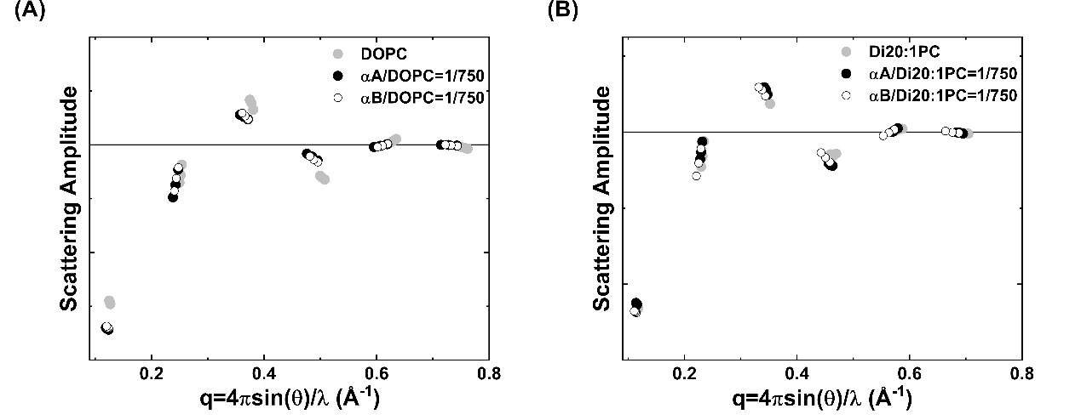
Figure S3
Representative phasing diagrams for X-ray diffraction measurements of (A) α-crystallins/DOPC and (B) α-crystallins/Di20:1PC. The phases were chosen according to the swelling method, i.e. a form factor Fourier-constructed from the diffraction amplitudes measured at one humidity level will go through all the data points.

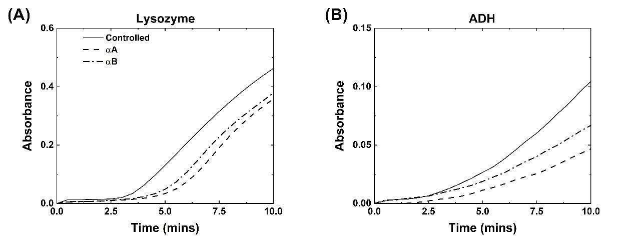
Figure S4
Time evolution of absorbance measurements of (A) lysozyme (B) ADH in the absence (controlled) and presence of α-crystallins.
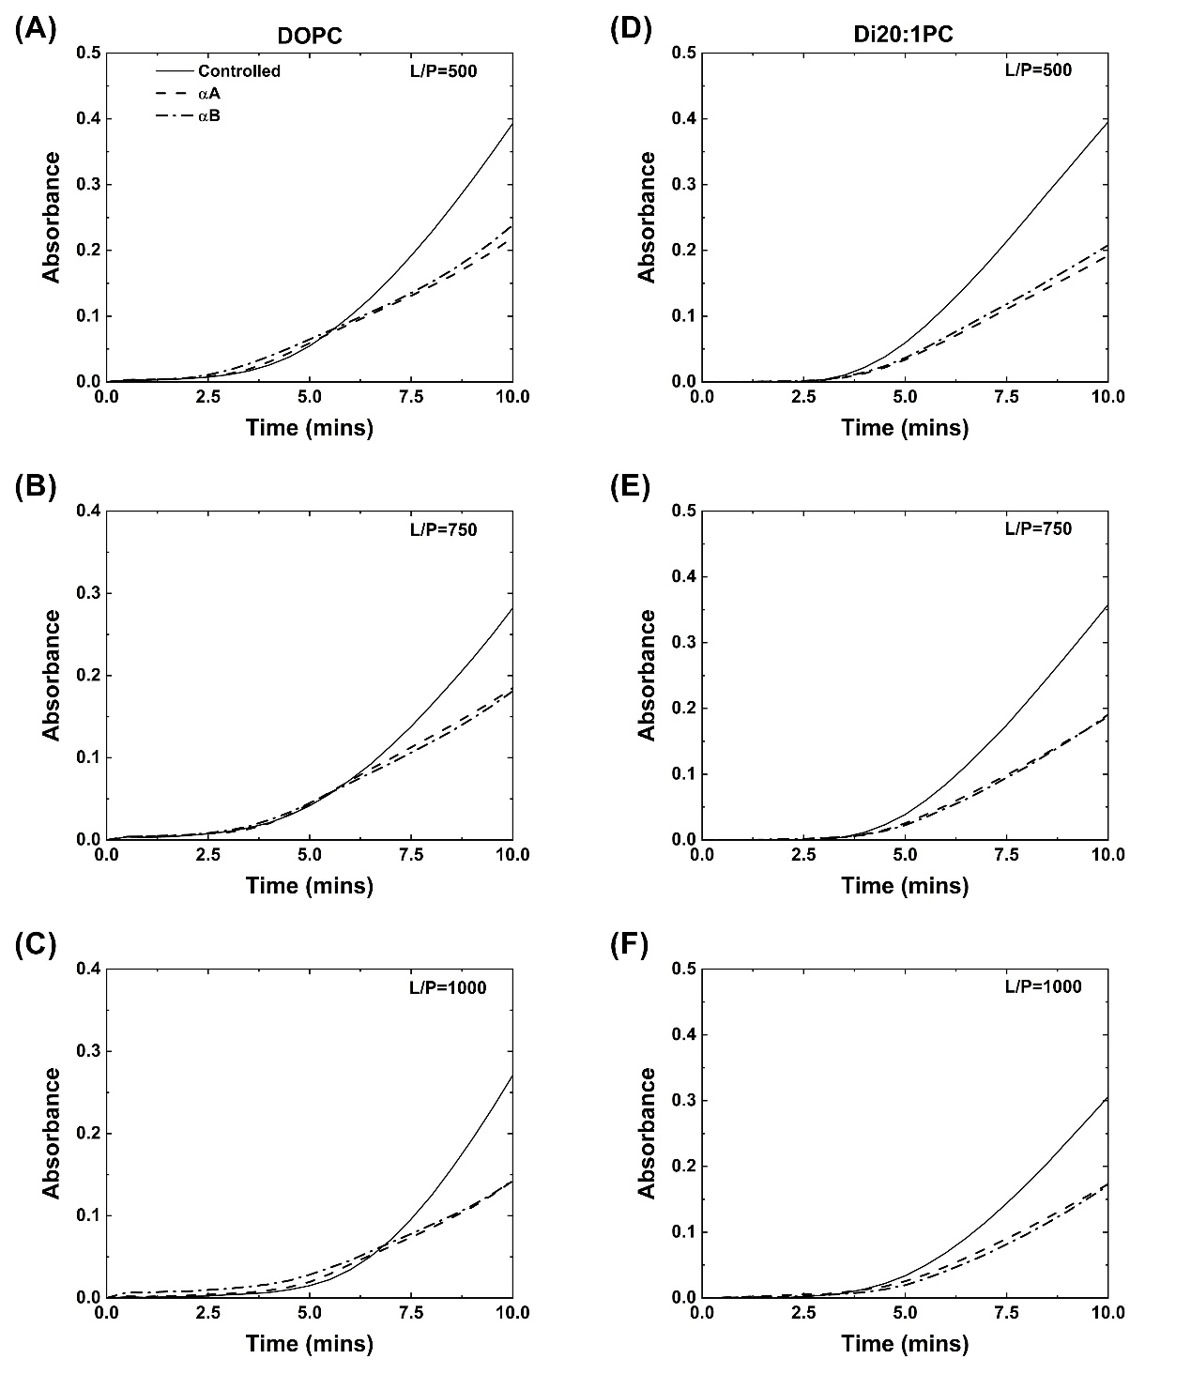
Figure S5
Time evolution of absorbance measurements of lysozyme with DOPC vesicles in the absence (controlled) and presence of α-crystallins: (A) L/P=500 (B) L/P=750 (C) L/P=1000; Di20:1PC vesicles in the absence (controlled) and presence of α-crystallins: (D) L/P=500 (E) L/P=750 (F) L/P=1000.
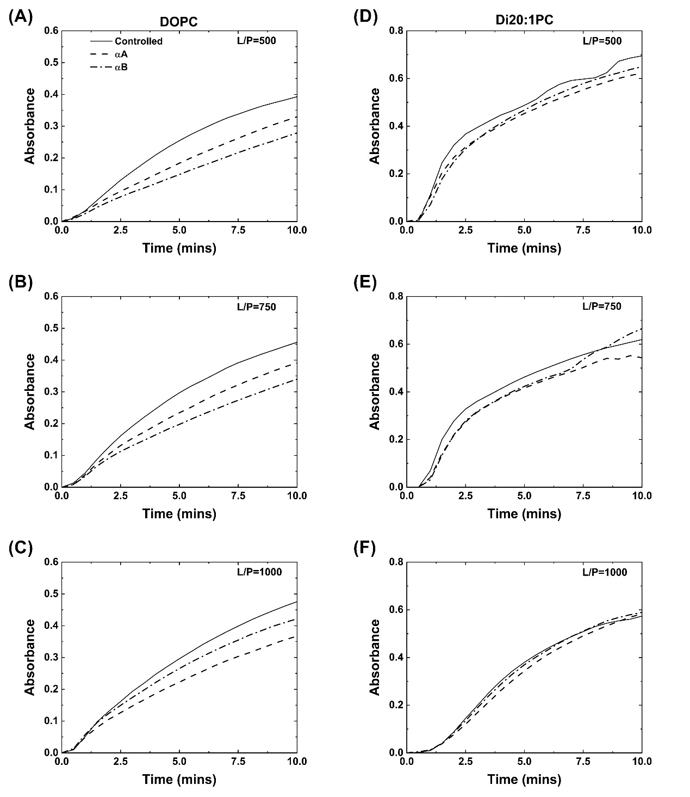
Figure S6
Time evolution of absorbance measurements of ADH with DOPC vesicles in the absence (controlled) and presence of α-crystallins: (A) L/P=500 (B) L/P=750 (C) L/P=1000; Di20:1PC vesicles in the absence (controlled) and presence of α-crystallins: (D) L/P=500 (E) L/P=750 (F) L/P=1000.

