Earth, Planet, and Space

Supporting Information for

Data-Driven Microseismic Clustering Using Machine Learning

Ryoya Tsuboi¹, Yusuke Mukuhira², Kyosuke Okamoto³, Hiroshi Asanuma³

1: Graduate School of Environmental Science, Tohoku University
2: Institute of Fluid Science, Tohoku University
3: National Institute of Advanced Industrial Science and Technology

Content of this file
Fig. S1 to S10

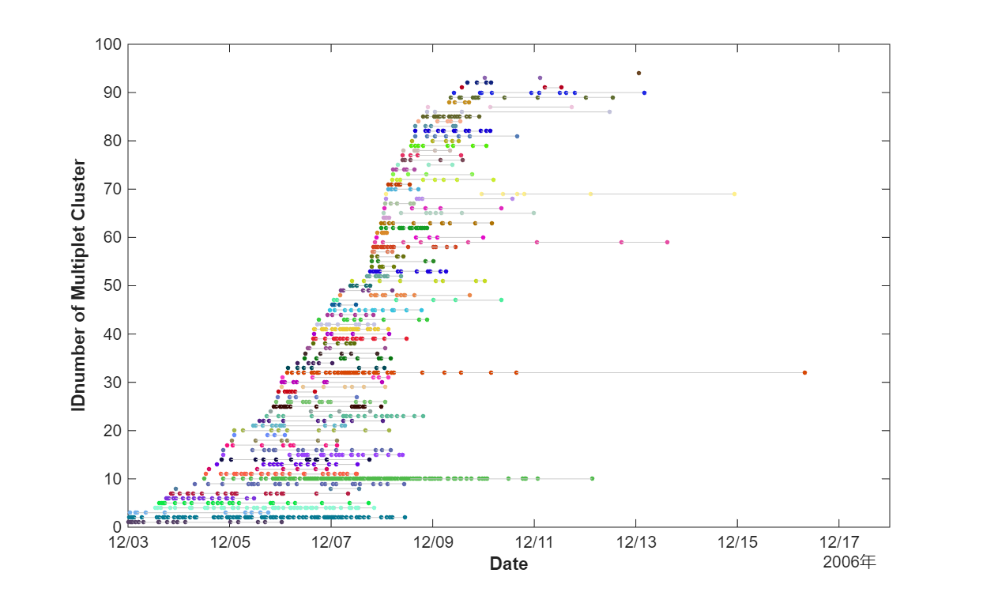
Fig. S1 Time series evolution of microseismic clusters defined by Asanuma et al., 2008. Each color correlates cluster ID.

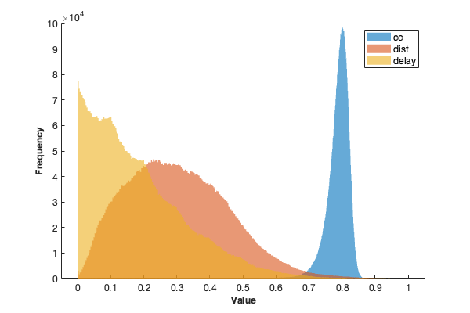
Fig. S2 Distribution of three exparanable parameters, cross correlation coefficient, Euclidean distances, and inter event time.

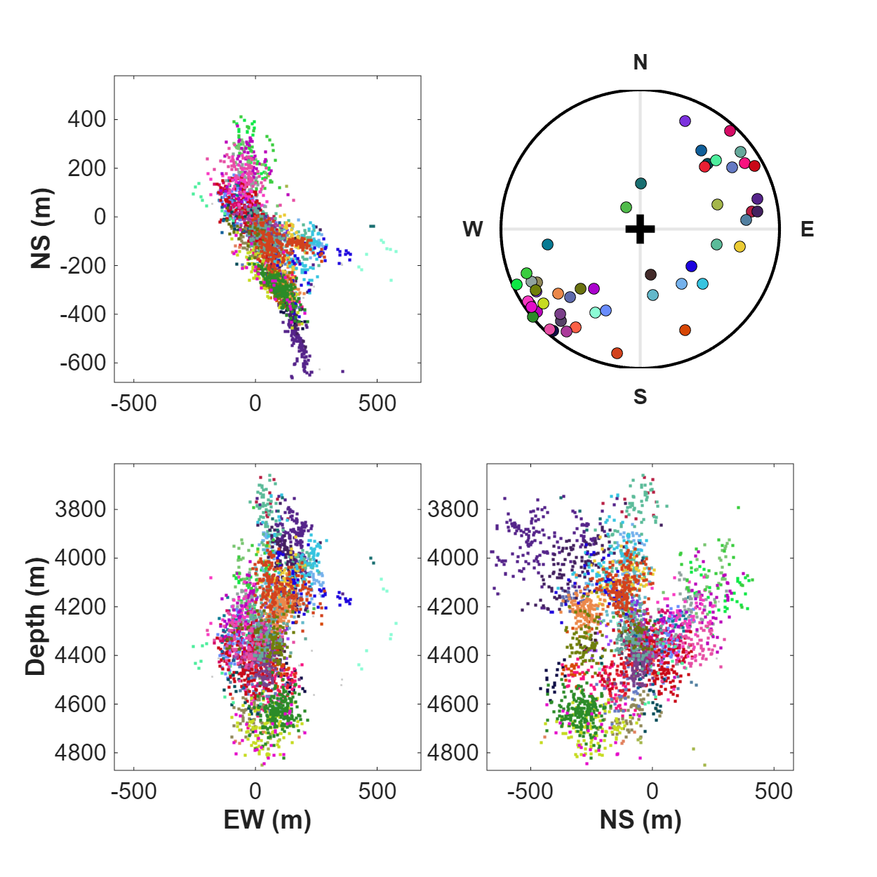
Fig. S3 K-means clustering results on absolute hypocenter location by single event determination method (Asanuma et al. 2007).

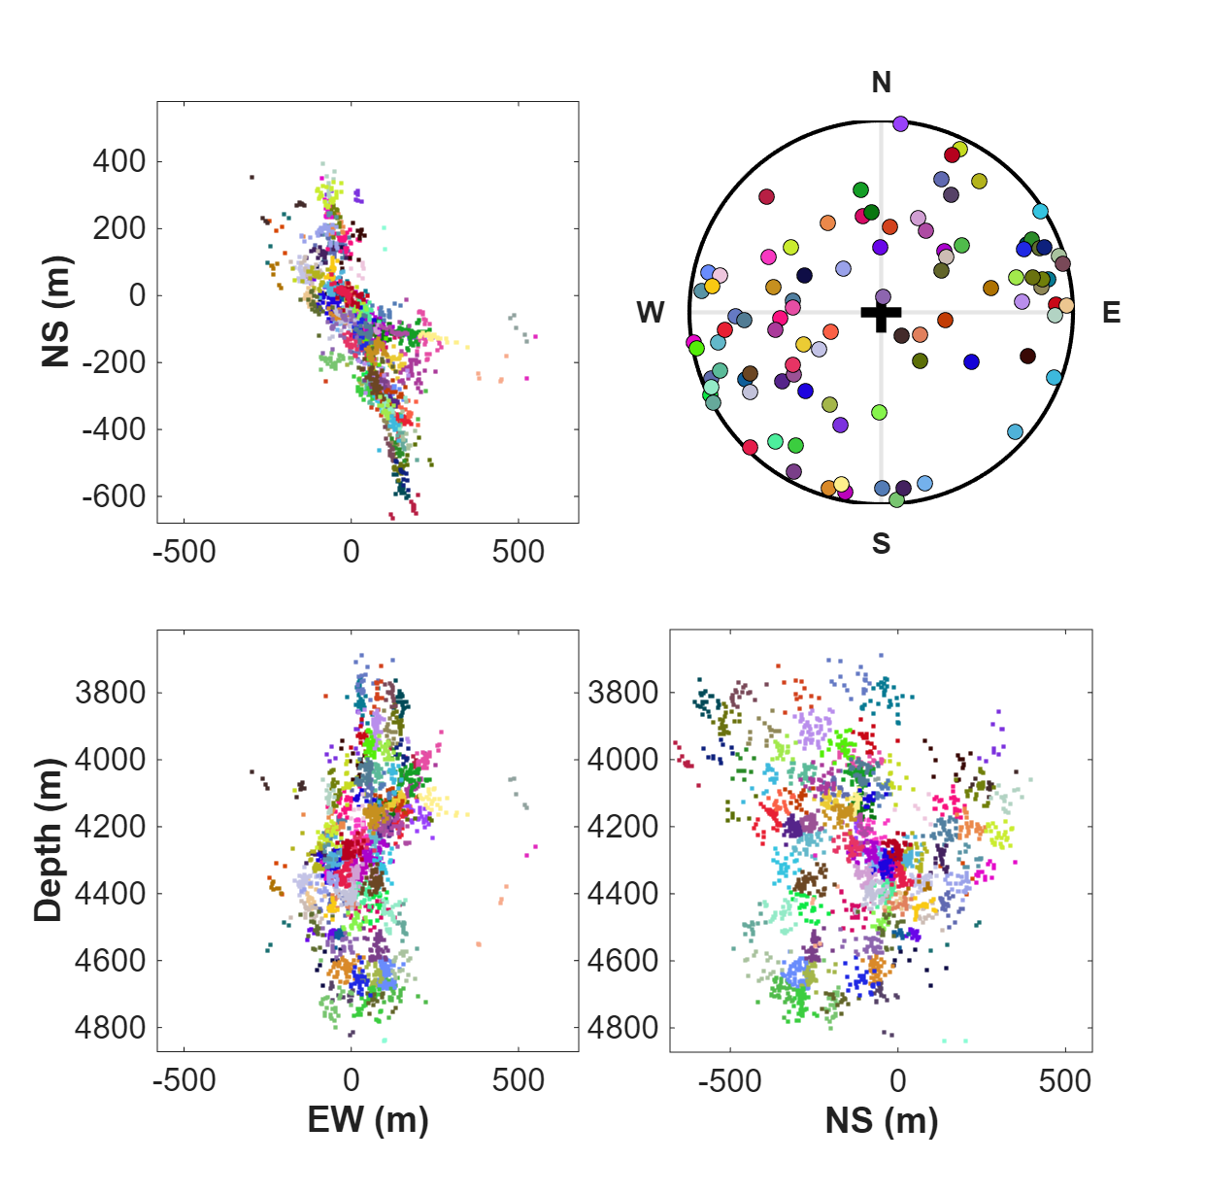
Fig. S4 K-means clustering results on relocated hypocenter by double difference based method. All events, which includes single events identified in conventional multiple analysis, were included.

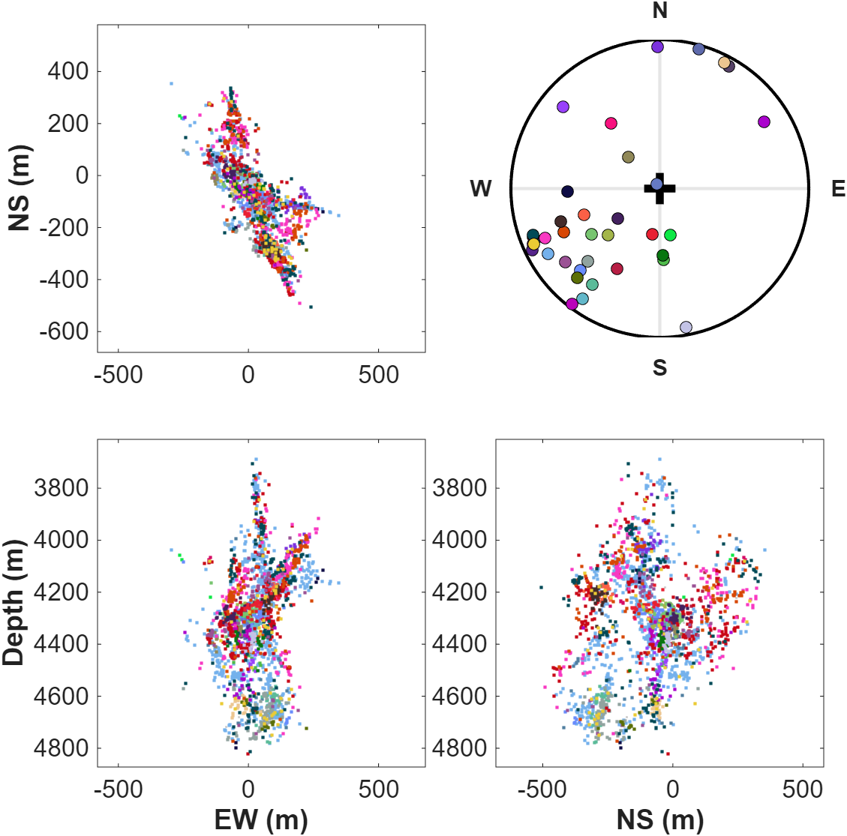
Fig. S5 Clustering results by AHC on the dissimilarity matrix based on sololy waveform similarity. Clustering results are projected into map view (top left), and EW (bottom left) and NS (bottom right) cross sections. The top-right panel shows the lower hemisphere projection of the poles of identified microseismic clusters. The color of the dots corresponds to the clusters.

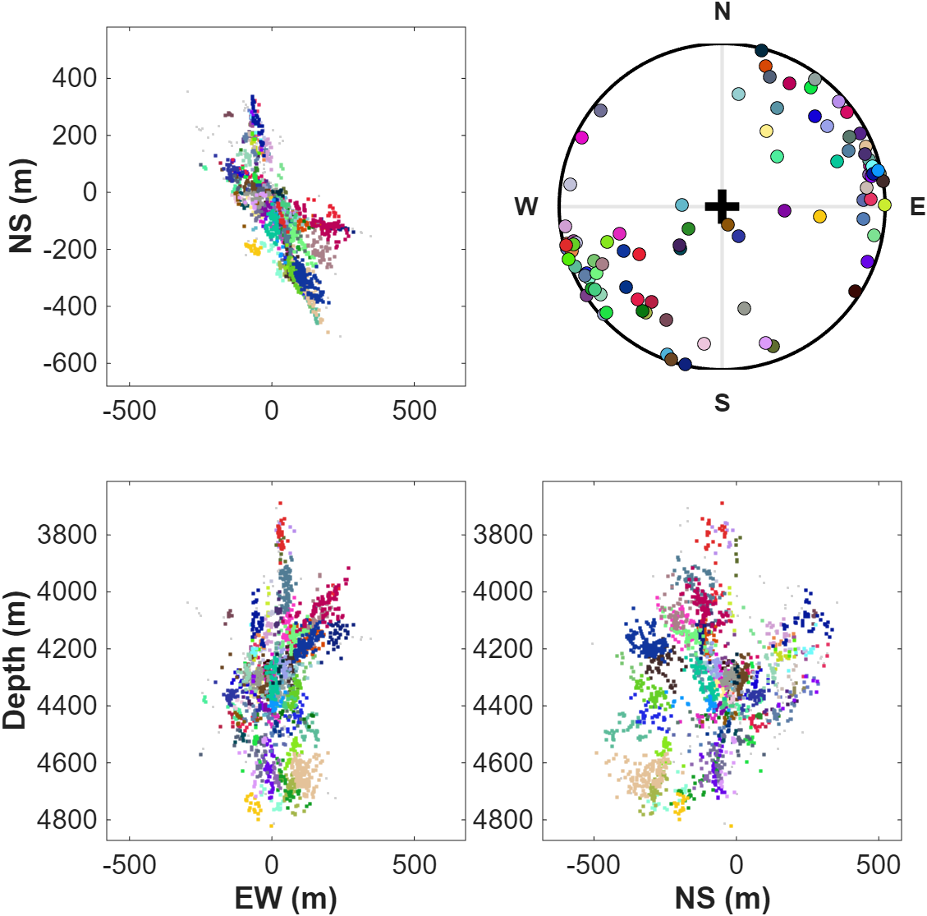
Fig. S6 Clustering results by AHC on the dissimilarity matrix based on sololy spatial information. Clustering results are projected into map view (top left), and EW (bottom left) and NS (bottom right) cross sections. The top-right panel shows the lower hemisphere projection of the poles of identified microseismic clusters. The color of the dots corresponds to the clusters.

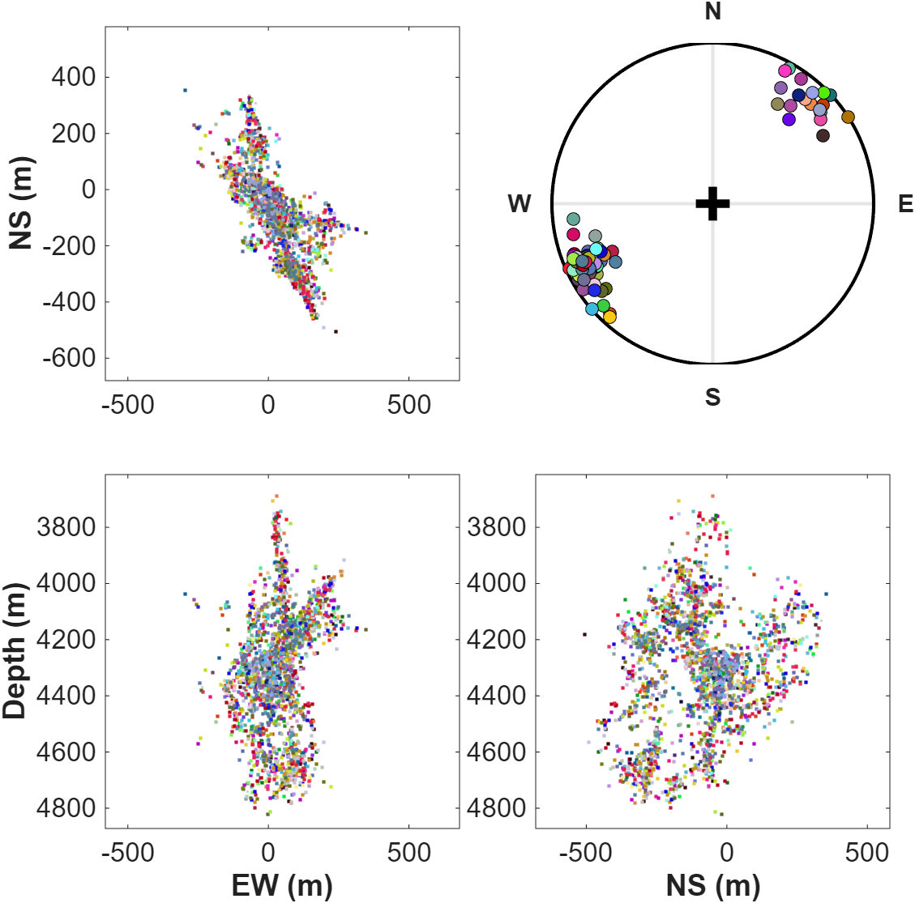
Fig. S7 Clustering results by AHC on the dissimilarity matrix based on sololy time information. Clustering results are projected into map view (top left), and EW (bottom left) and NS (bottom right) cross sections. The top-right panel shows the lower hemisphere projection of the poles of identified microseismic clusters. The color of the dots corresponds to the clusters.

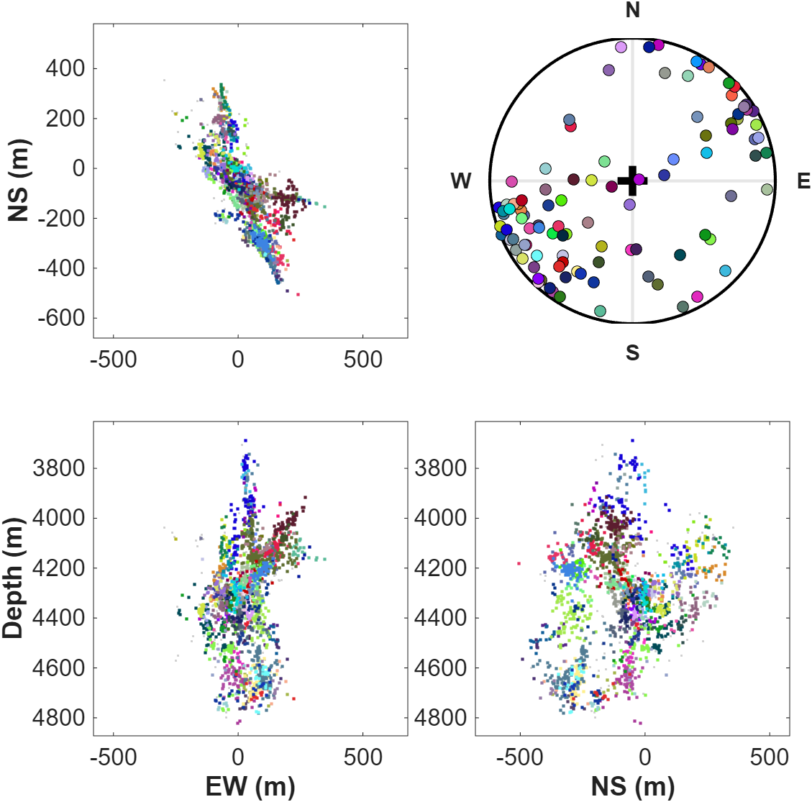
Fig. S8 Clustering results by AHC on the dissimilarity matrix based on waveform similarity and spatial information. Clustering results are projected into map view (top left), and EW (bottom left) and NS (bottom right) cross sections. The top-right panel shows the lower hemisphere projection of the poles of identified microseismic clusters. The color of the dots corresponds to the clusters.

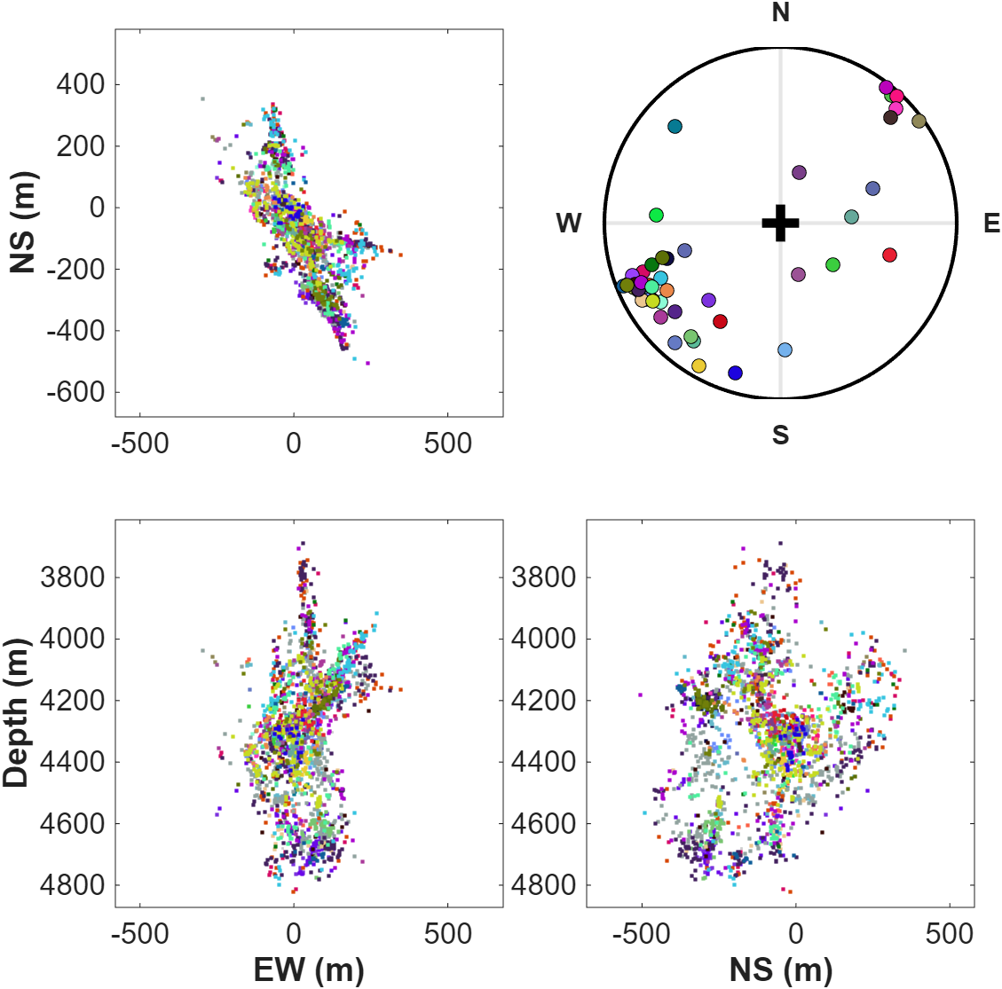
Fig. S9 Clustering results by AHC on the dissimilarity matrix based on waveform similarity and time information. Clustering results are projected into map view (top left), and EW (bottom left) and NS (bottom right) cross sections. The top-right panel shows the lower hemisphere projection of the poles of identified microseismic clusters. The color of the dots corresponds to the clusters.

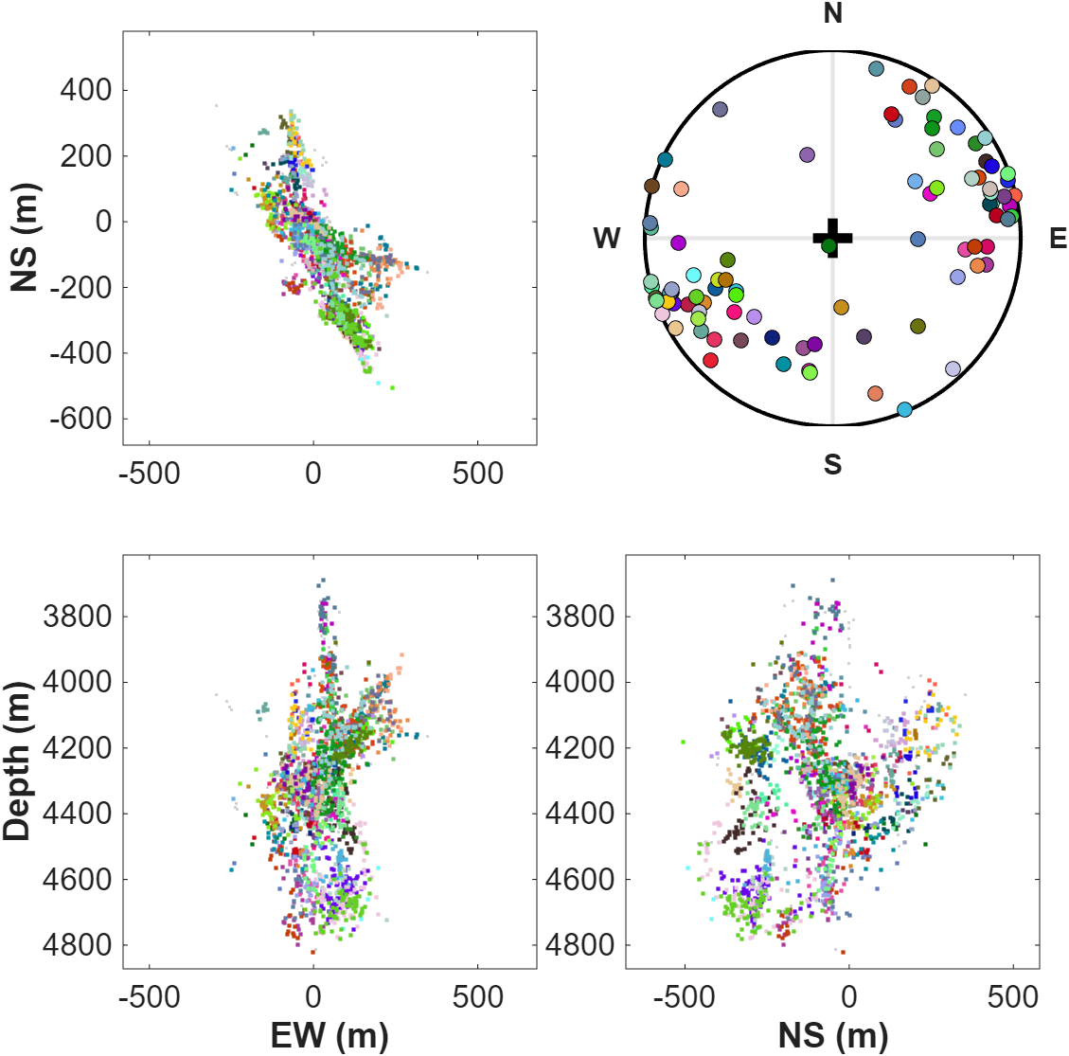
Fig. S10 Clustering results by AHC on the dissimilarity matrix based on spatial and time information. Clustering results are projected into map view (top left), and EW (bottom left) and NS (bottom right) cross sections. The top-right panel shows the lower hemisphere projection of the poles of identified microseismic clusters. The color of the dots corresponds to the clusters.

