Supporting information for
Global pattern and drivers of carbon mineralization in cropland soils depends on agricultural managements
Ziyu Fan¹, Zhaohuan Wang^{1,2}, Qian Tian^{1,2}, Fang Yang^{1,2}, Qingyin Zhang^{1,3*}

¹ State Key Laboratory of Soil Erosion and Dryland Farming on the Loess Plateau, College of Soil and Water Conservation Science and Engineering (Institute of Soil and Water Conservation), Northwest A & F University, Yangling 712100, China
² College of Natural Resources and Environment, Northwest A&F University, Yangling 712100, China
³ Institute of Soil and Water Conservation, Chinese Academy of Sciences and Ministry of Water Resources, Yangling 712100, China

Corresponding author:
* Qingyin Zhang, Email address: qyzhang@nwafu.edu.cn

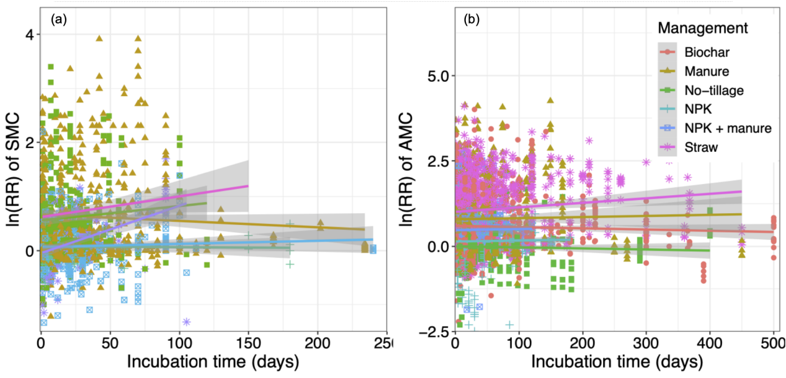
Fig. S1 Relationship of cropland managements effect on (a) specific mineralizable carbon (SMC) and (b) accumulative mineralizable carbon (AMC) with laboratory incubation time.

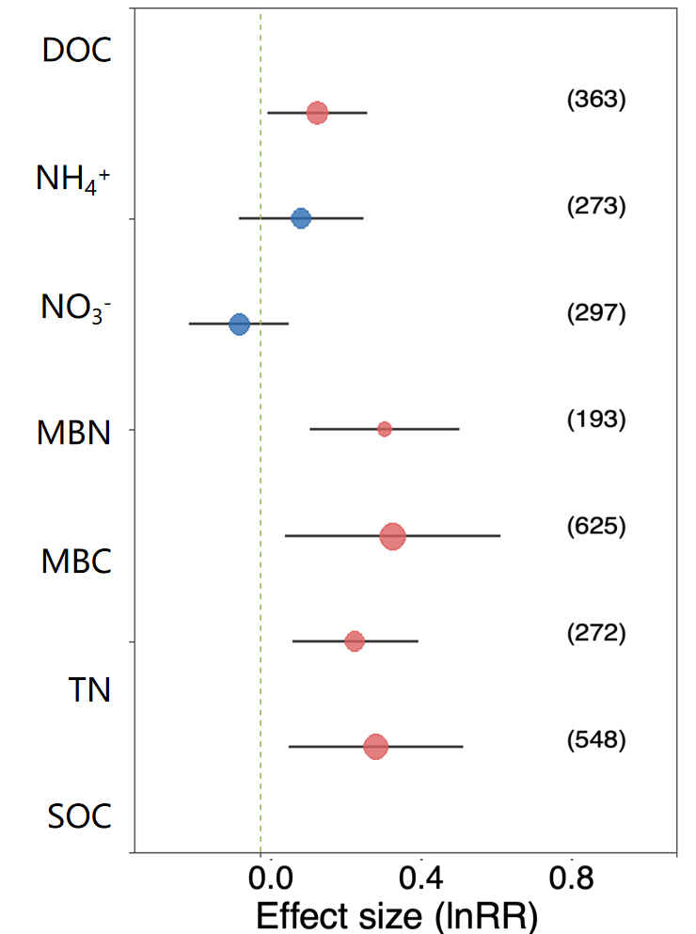
Fig. S2 Effects of cropland managements on soil properties. The plot represents the weighted effect size of different variables with 95% confidence intervals (CIs). The observation of each variable is displayed beside each bar in parentheses. SOC, soil organic carbon; TN, total nitrogen; MBC, microbial biomass carbon; MBN, microbial biomass nitrogen; NO₃⁻, nitrate nitrogen; NH₄⁺, ammonium nitrogen; DOC, dissolved organic carbon.Point color intensity reflects the level of statistical significance (blue: low, red: high), and point size is scaled to the sample size of each observation.

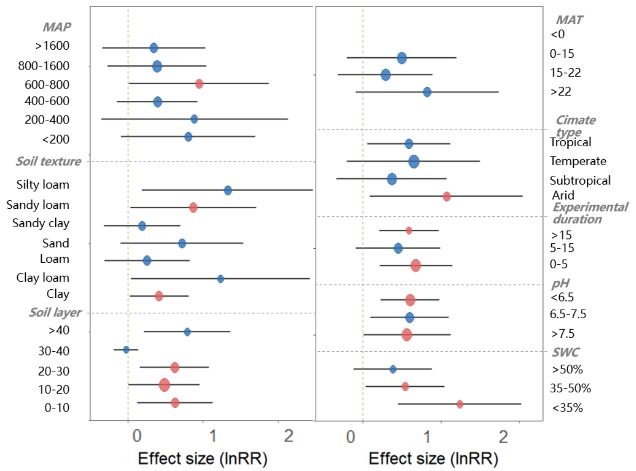
Fig. S3 Effects of soil texture, soil sampling depth, climate zones, Mean Annual Temperature (MAT), Mean Annual Precipitation (MAP), experimental duration, initial soil pH and soil water content (SWC) on SOC mineralization under biochar amendment management expressed as the mean effect size (circles) with 95% confidence intervals (bars).Point color intensity reflects the level of statistical significance (blue: low, red: high), and point size is scaled to the sample size of each observation.

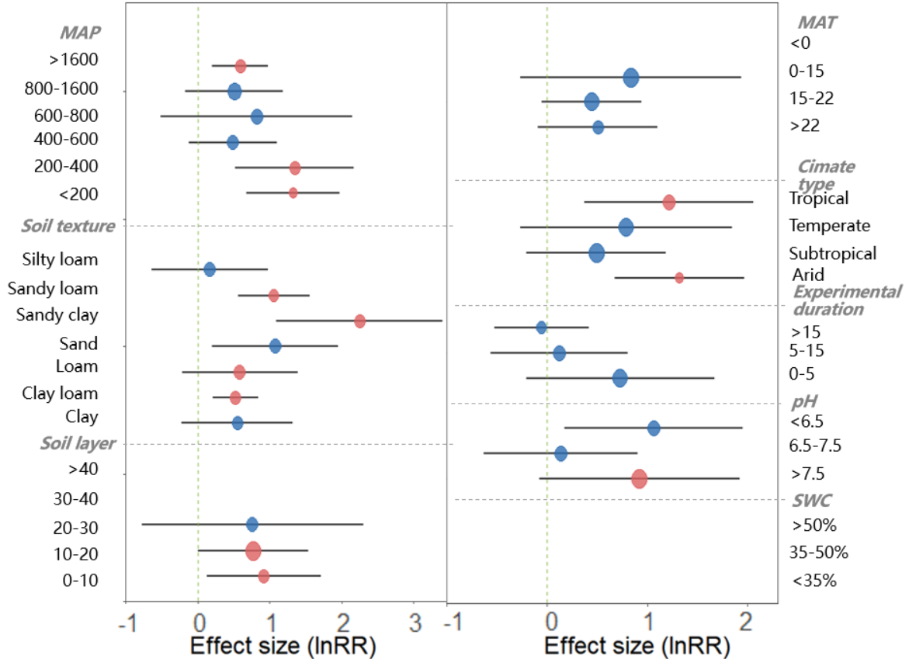
Fig. S4 Effects of soil texture, soil sampling depth, climate zones, Mean Annual Temperature (MAT), Mean Annual Precipitation (MAP), experimental duration, initial soil pH and soil water content (SWC) on SOC mineralization under manure amendment management expressed as the mean effect size (circles) with 95% confidence intervals (bars).Point color intensity reflects the level of statistical significance (blue: low, red: high), and point size is scaled to the sample size of each observation.

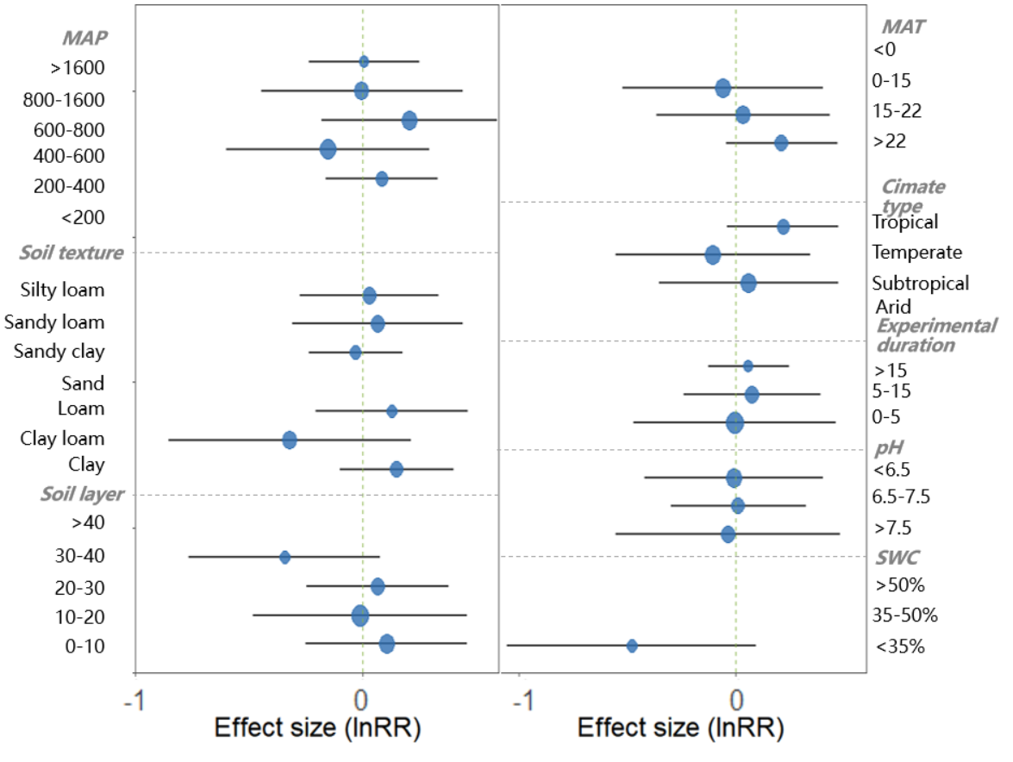
Fig. S5 Effects of soil texture, soil sampling depth, climate zones, Mean Annual Temperature (MAT), Mean Annual Precipitation (MAP), experimental duration, initial soil pH and soil water content (SWC) on SOC mineralization under no-tillage management expressed as the mean effect size (circles) with 95% confidence intervals (bars).Point color intensity reflects the level of statistical significance (blue: low, red: high), and point size is scaled to the sample size of each observation.

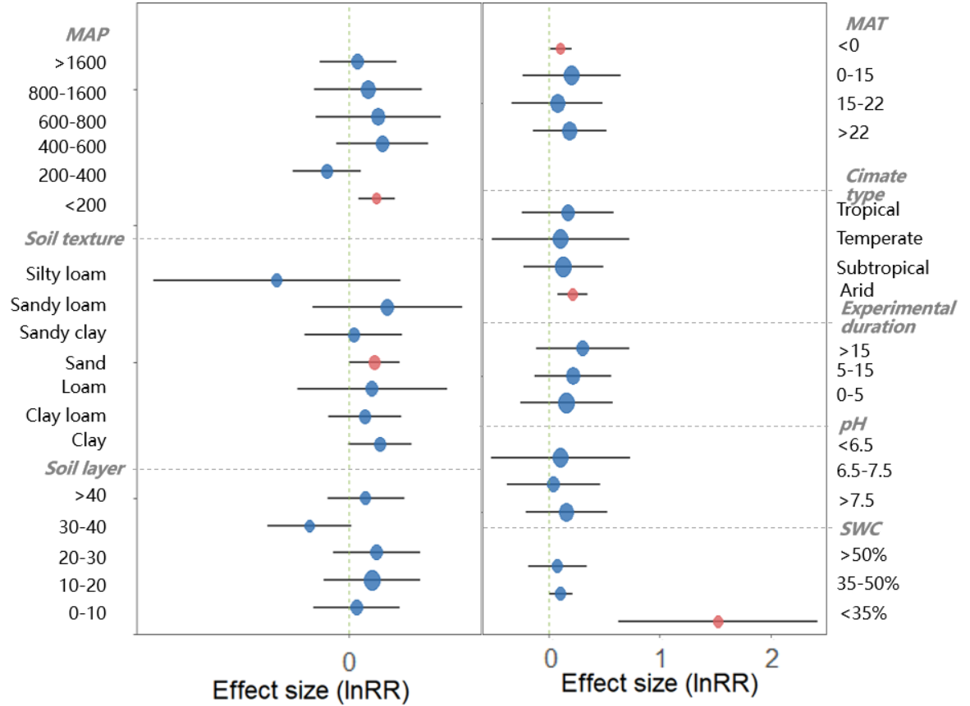
Fig. S6 Effects of soil texture, soil sampling depth, climate zones, Mean Annual Temperature (MAT), Mean Annual Precipitation (MAP), experimental duration, initial soil pH and soil water content (SWC) on SOC mineralization under NPK fertilization management expressed as the mean effect size (circles) with 95% confidence intervals (bars).Point color intensity reflects the level of statistical significance (blue: low, red: high), and point size is scaled to the sample size of each observation.

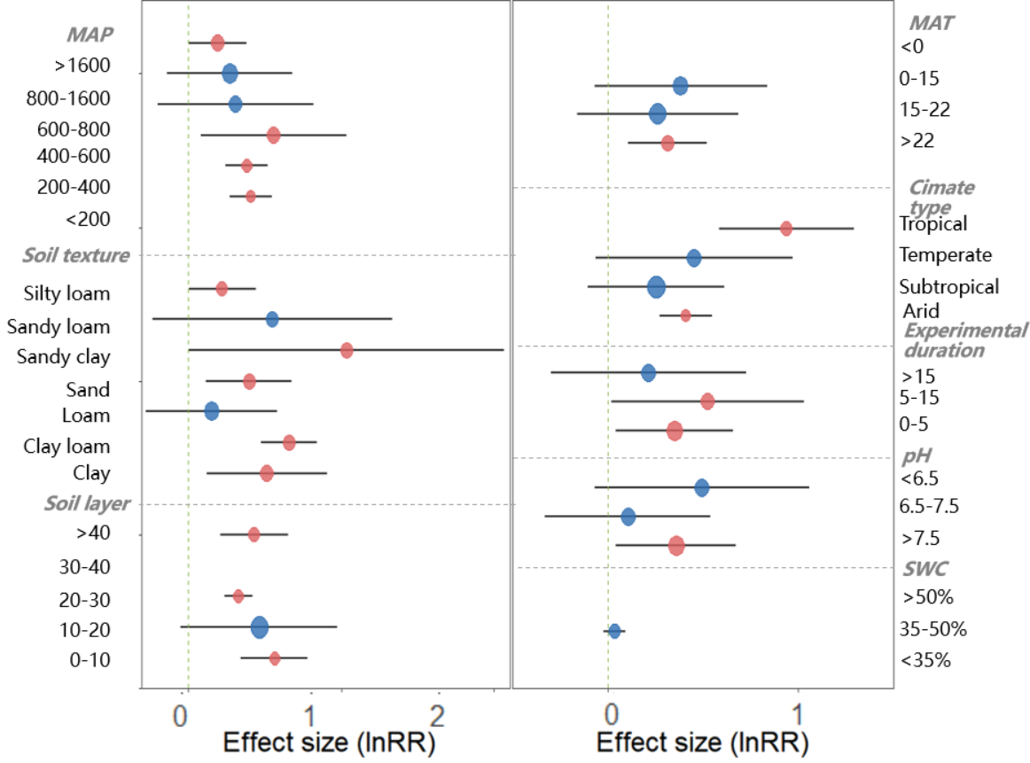
Fig. S7 Effects of soil texture, soil sampling depth, climate zones, Mean Annual Temperature (MAT), Mean Annual Precipitation (MAP), experimental duration, initial soil pH and soil water content (SWC) on SOC mineralization under NPK fertilization + manure amendment management expressed as the mean effect size (circles) with 95% confidence intervals (bars).Point color intensity reflects the level of statistical significance (blue: low, red: high), and point size is scaled to the sample size of each observation.

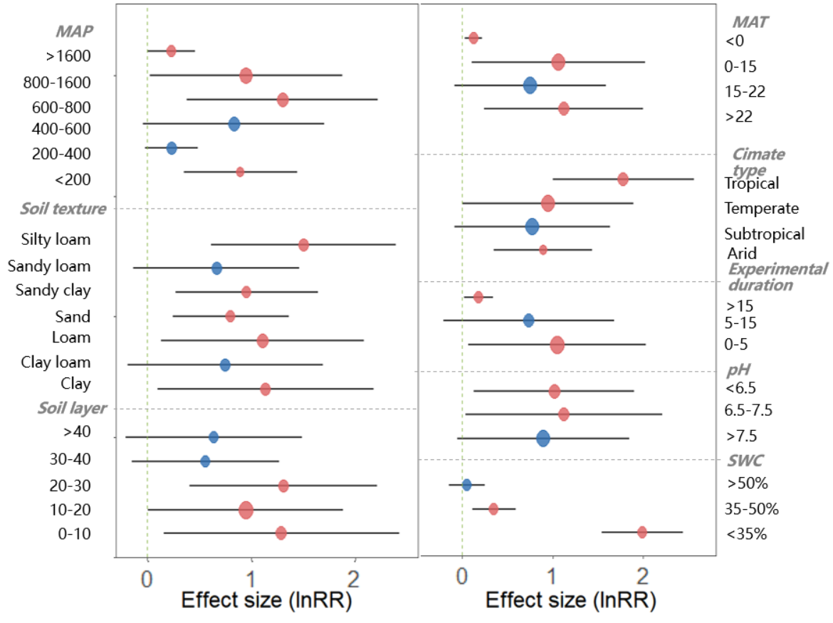
Fig. S8 Effects of soil texture, soil sampling depth, climate zones, Mean Annual Temperature (MAT), Mean Annual Precipitation (MAP), experimental duration, initial soil pH and soil water content (SWC) on SOC mineralization under straw amendment management expressed as the mean effect size (circles) with 95% confidence intervals (bars).Point color intensity reflects the level of statistical significance (blue: low, red: high), and point size is scaled to the sample size of each observation.

