Effect of early life exposure of polystyrene microplastics on behavior and DNA methylation in later life stage of zebrafish

Jeongeun Im, Hyun-Jung Eom, and Jinhee Choi*

School of Environmental Engineering, University of Seoul, 163 Siripdaero, Dongdaemun-gu, Seoul 02504, Republic of Korea

*Corresponding Author. E-mail: jinhchoi@uos.ac.kr

Supplementary Material
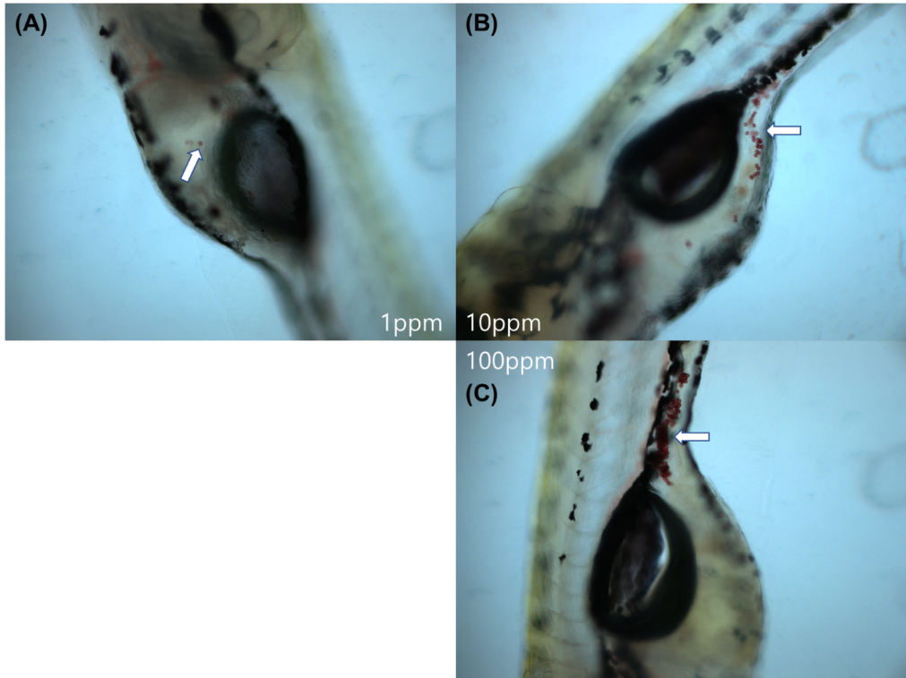
Figure S1. Images of micrographs of larva exposed to three different concentrations of PSMPs. (A) 1mg/L, (B) 10mg/L, (C) 100 mg/L. White points highlight the ingested PSMPs in digestive system.
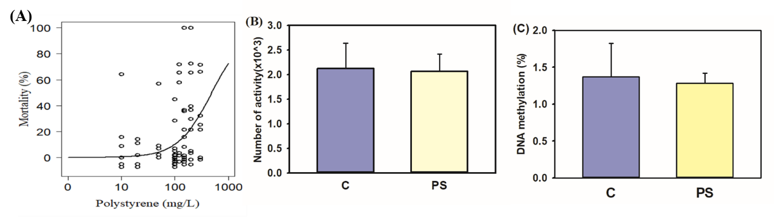
Figure S2. Mortality (A), locomotive behavior (B), and global DNA methylation level (C) in zebrafish embryos exposed to 50 mg/L PSMPs for 4 days. Locomotive behavior is expressed as the amount of activity in a Zebrabox under dark conditions for 30 mins. Error bars represent the mean ± standard error. Asterisks (*) indicate significant differences compared to the control group.

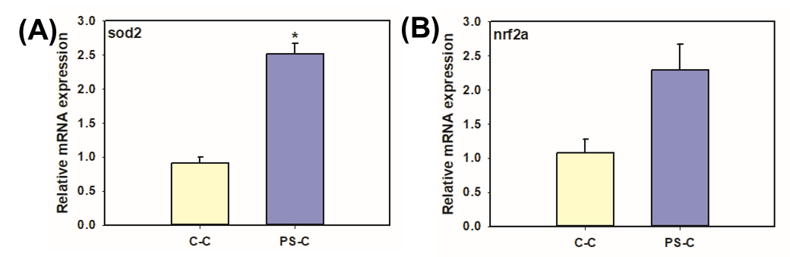
Figure S3. Oxidative stress (sod2; A and nrf2a; B) genes expression of adult zebrafish exposed to PSMPs in the early life. The results are expressed as the mean value compared to the C-C group (n = 3; mean ± standard error of the mean; *p < 0.05).
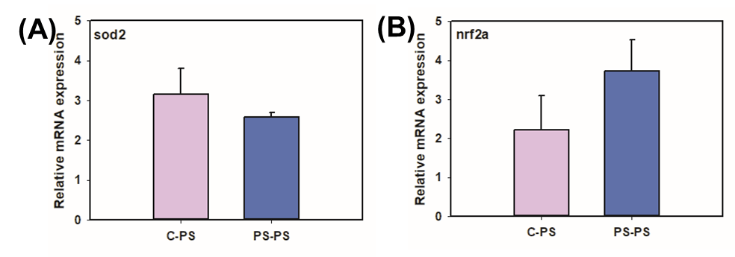
Figure S4. Oxidative stress (sod2; A and nrf2a; B) genes expression of adult zebrafish exposed to PSMPs at the embryonic stage and re-exposed at the adult stage. The results are expressed as the mean value compared to the C-PS group (n = 3; mean ± standard error of the mean).

